A PRACTICAL APPROACH TO INTEGRATING LAND USE AND TRANSPORT
Authors
Steve Higgs (PGDipREP, BSoc.Sc (Hons), BSc, NZPI)  Regional Planning Manager  NZ Transport Agency  Christchurch  steve.higgs@nzta.govt.nz | John Hassan (LLB, BA)  Partner  Chapman Tripp  Wellington  john.hassan@chapmantripp.com

Disclaimer: This paper reflects the views of its authors and does not represent the views or the policy of the New Zealand Transport Agency
Abstract
This paper presents a case study on an issue that has given rise to significant conflict in Resource Management Act 1991 (RMA) planning and development processes in recent years. In a number of cases major commercial, industrial and residential development proposals which have sought RMA approval have been challenged before the Environment Court because of their consequences on the strategic transport network.
The RMA emphasises integrated management of the effects of development, yet experience has tended to be of a disintegrated approach to land development and the transport infrastructure intended to serve greater community needs.
A 93 hectare mixed use urban development was proposed for the north western part of Belfast, northern Christchurch, in a location which would have significant effect on the strategic and local transport networks. However parties worked through the issues to achieve a transport solution that provided opportunities to develop Belfast earlier than otherwise anticipated, consistent with the future vision of Belfast.
This paper reflects on a methodology to link land use development with the funding and construction of an Interim Bypass. It examines the key concepts that led to this outcome, including working within legislative constraints, managing partnerships and integrating transport with land use patterns.

What is land development – transport infrastructure integration?
Before discussing the Belfast case study, it is worth considering what is intended by the integration of land use development and transport infrastructure planning and provision.
Integration is a well used planning term, but is not necessarily well understood. In its ordinary sense, “integration” is the act of combining parts into a whole. In a planning sense, it relates to the process of incorporating social, cultural, and environmental and infrastructure elements into urban developments in a way that creates good living environments and minimises costs on the wider community.
A key district planning function of territorial authorities under the RMA is to achieve “integrated management of the effects of the development of land and associated resources”. Those associated resources include the strategic transport network serving the community’s social, economic and cultural wellbeing.
The funding and provision of land transportation networks, including the State highway system, is governed by the Land Transport Management Act 2003 (LTMA), amended this year with the establishment of the New Zealand Transport Agency (NZTA).
Integration is, therefore, a common thread in the relevant legislation governing land development planning, and transport infrastructure provision and funding. In this paper, we discuss the legislative and planning basis for this principle and how well the legislation allows for it to be achieved.
Setting the scene
Belfast is a suburb of Christchurch located approximately 10 kilometres north of the City Centre.
Belfast is typical of most small New Zealand towns, historically built as a ribbon development along key transport routes. It is positioned at the juncture of State Highway 1 (linking Waimakariri District via the Northern Motorway and bypassing Christchurch to the west via the International Airport and southern Christchurch suburbs) and State Highway 74 linking the Lyttelton Port to the North (Figure 1). Main North Road is a four lane median divided road carrying approximately 34,000 vehicles. Johns Road is two lanes and carries approximately 17,000 vehicles daily.
The eastern boundary of Belfast is the Main Trunk Rail Line used for freight and passenger trips to and from Picton. There is a significant heavy industry area east of State Highway 74, including a tannery and freezing works. Longer term it’s envisaged that these industries will either downsize or relocate out of Belfast. More recently, retail activity and a residential activity (Northwood) have established in southern Belfast, effectively joining Belfast to Christchurch.
The vision for Belfast is to eventually remove the through traffic from Main North and Johns Roads, freeing the space for enhanced public transport, walking and cycling. Lower traffic volumes would also benefit community development by reducing severance presently occurring along the strategic road corridor.
Options for strategic road infrastructure improvements include building a Northern Arterial east of Belfast linking the Motorway to Queen Elizabeth II Drive, and a Full Western Belfast Bypass linking the Motorway to Johns Road, west of Belfast.
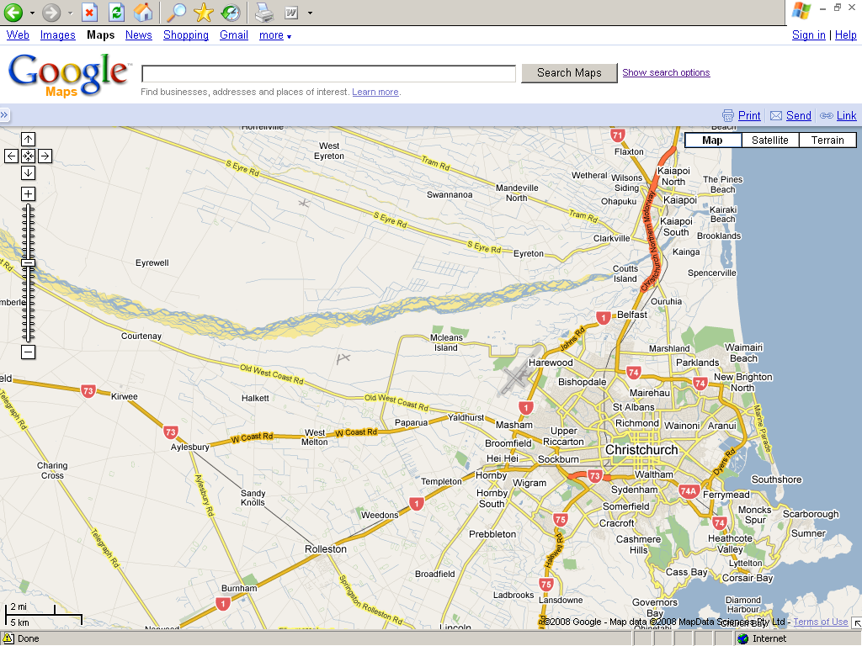
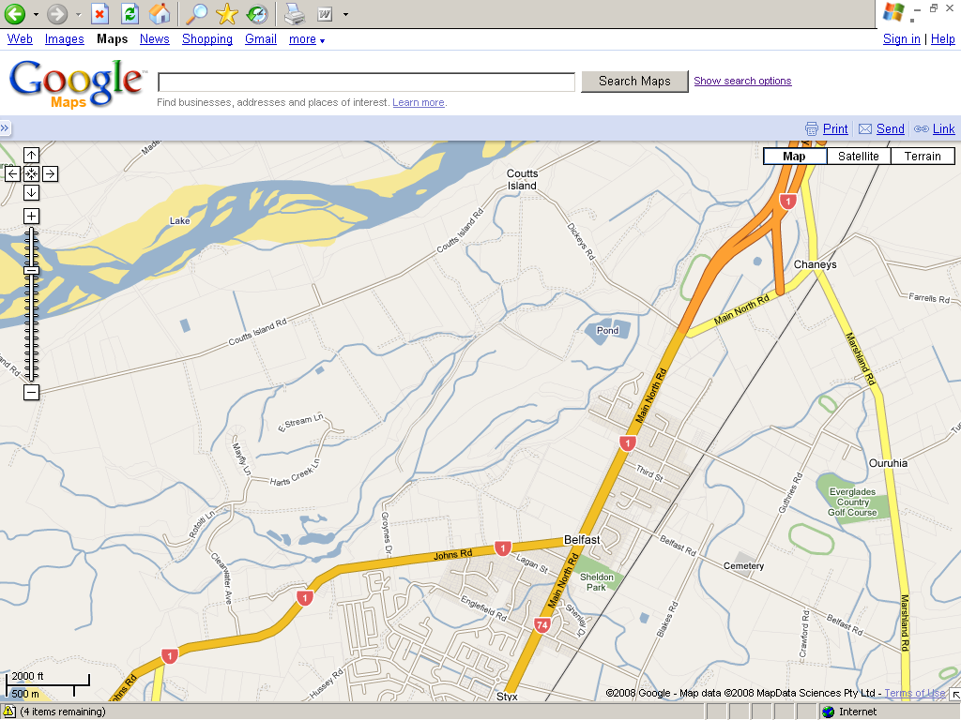
Significant residential growth areas are identified in the Greater Christchurch Urban Development Strategy (UDS) for residential growth, and it’s anticipated that business land will be available to the east and north. Belfast can therefore be considered as an area of potential change and growth in the short term. In anticipation of change, the City Council has initiated strategic planning for the area through the Belfast Area Plan.
Development Site
Figure 1: Location of “Belfast 293” site

Background to the mixed use development proposal
The matter originated from submissions made on the notified Christchurch City District Plan. The lead developer of the Belfast s293 site made a submission to the Council, then seeking a Rural 3A zone (Rural residential with a minimum two hectare allotment size). The Council rejected that submission and the developer then appealed to the Environment Court seeking the same rezoning relief.
The Court issued an interim decision, expressing concern that rural residential densities would not achieve the District Plan's objectives to promote consolidated urban growth and that a higher density development would better achieve the RMA’s purpose. This was consistent with the approach the Court had taken in an earlier enquiry under section 293 of the RMA concerning land at Masham, Christchurch. The Court signalled a preference for urban development that incorporated good urban design principles, such as elements of mixed density, mixed use, good transport connectivity and integration of key infrastructure (e.g. sewer and stormwater).
Full urban development of the Belfast s293 site was expected to generate significant effects on the State highway network, already close to capacity. Hence, Transit (together with Land Transport New Zealand (LTNZ)) joined in opposition. The Regional Council (Environment Canterbury) supported Transit’s concerns (as well as being concerned about public transport implications). The City Council also raised concerns about its own transport networks.
The mixed use rezoning proposal
The Belfast s293 site is in multiple landownership. Two major land owners hold approximately 70% (40% held by the lead developer), with the balance 30% shared amongst various smaller landowners.
The full proposal was for approximately 10,400m² commercial floor space and 1500 households, undertaken two stages. Staging was the means then proposed by the developer to mitigate effects on the strategic network. Stage 1 was proposed to be limited to 400 households, with Stage 2 being held over until either the Western Bypass or Northern Arterial were constructed.
Transit’s traffic analysis showed that this staging would not have been adequate mitigation. Therefore, its position (supported by the two councils and LTNZ) was for no development until strategic transport infrastructure was in place.
In terms of integrated management, the Belfast s293 development represented both a threat and an opportunity.
As a substantial block of land, it was isolated from the community of Belfast by the increasingly busy State highway. An intensive mixed use redevelopment of the land would be effectively severed from, and poorly connected with, the rest of Belfast.
Conversely, a well-planned development presented several opportunities, so long as a solution to the State highway network could be found, including:
- Intensification of land use in relatively close proximity to Christchurch
- Optimisation of the existing transport infrastructure for alternative transport modes by improving bus services and walking and cycling opportunities, both within and beyond the development;
- Economic benefits to the community through early development opportunities; and
- Social benefits through community facilities and good connectivity with Belfast.
Negotiating a solution
There was a common understanding with the lead developer that:
- The development is in a good strategic location (assuming mitigation of transport network impacts);
- The only significant issues to resolve pertained to the transport network (and public transport);
- Government timeframes for investigating and building the required infrastructure were being planned, but timing was not certain; and
- Removal of the State highway network through the centre of Belfast would be of significant benefit to the well being of this community.
Discussions were opened with the lead developer, to provide a solution framed around the building of an Interim Bypass. That allowed parties to focus on a common vision as to the potential solution, although the means to that end, and its timing, were not then apparent. In assessing all options available at the time, it was considered that undertaking negotiations with the lead developer provided the greatest potential benefits as follows:
Table 1: Potential Benefits/ Costs of Decision Outcomes
Decision | Outcome | Benefits | Costs
Reject Application | No development | No effect on transport network. | Potential for development outside of Christchurch.  Lost opportunity to remove some through traffic.
Approve Application | Development  ≤ 400 dwgs | Some development.  Possible bus service. | Significant effect on transport network.  Severance  Limited connectivity.
Negotiate Solution | Full development | Minor effect on transport network.  Part of strategic network built.  Connectivity to Johns Road.  Improved bus service.  Internal network integration. | Additional local transport effects.  Significant short term effects.
Having reached that point, it was evident to Transit, LTNZ and the two Councils that they should be collaborative in exploring a satisfactory solution with the lead developer to comprehensively resolve wider land use and transport issues. Hence, these parties entered a “no surprises” Memorandum of Understanding to ensure all relevant matters were included in agreements reached between Transit and the lead developer.

Evolving legislative framework and planning approaches concerning integration
Integration is a common philosophy in the relevant legislation applying to all relevant elements of the equation – land development planning and infrastructure provision and funding. The Belfast case was a test of how well the RMA and LTMA could allow for the delivery of a truly integrated solution.

Common legislative philosophy of integrated management
Firstly, on the matter of common legislative philosophies:
- The RMA’s sustainable management purpose is well known. It includes enabling our communities to provide for their social, cultural and economic wellbeing. The purpose also emphasises “avoiding, remedying, or mitigating adverse effects”. This purpose is supported by the district planning function of Councils "to achieve the integrated management of the effects of the use, development or protection of land, and associated resources”.
- The LTMA, which pertains to the programming, funding and provision of transport infrastructure, expresses a similar philosophy, i.e. its purpose is “to contribute to the aim of achieving an affordable, integrated, safe, responsive, and sustainable land transport system”.
- Likewise, although not directly relevant in the Belfast case, the Local Government Amendment Act 2002 (LGAA) introduced a broader self governance mandate for local authorities based upon the sustainability doctrines of economy, environment, social and cultural wellbeing.
Despite those common intentions for integrated management, in terms of land use and transport infrastructure, experience has been often to the contrary.
For example, in Transit v Papakura District Council (known as the Hingaia Structure Plan), the Environment Court commented about difficulties in finding solutions within the RMA framework. That Plan Change sought to introduce residential and mixed use development into an area of previously zoned rural. Transit was concerned that rezoning of land would contribute to adverse effects on the State highway network, particularly the Papakura Interchange on State Highway 1. After the appeal hearing commenced, the parties reached a settlement. In this context, the Court observed:
"It is on this basis that the Court sees this a mechanism by which an outcome acceptable to all parties might be achieved. It is, of course, a method outside the RMA process...”
“We consider that communication and working together to solve the current problems is far more likely to achieve an acceptable outcome than a confrontational, statutory or plan based approach. The reason for that is that the problems are complex and are not easily susceptible to the type of approach adopted in legislation, by the Court or by a council in a plan ….”
"That may not always be the case, but we would suggest that in areas such as roading infrastructure for Auckland this is probably an inevitable comment."
In terms of delivery of integrated management, the administration of the legislation has often fallen well short. This is not surprising, given the scale of challenges presented, notably:
- The scale of investment required and, associated with this, the significant planning horizons required for transport infrastructure improvements where these are funded through central and regional community sources; and
- The different commercial imperatives of development risk and opportunity, where the drivers of investment decisions are often immediate and short-term.
Given those challenges, delivery of integrated management of land development and transport infrastructure is not just dependent on the tools which the legislation provides. These are important, but so also is the need for all stakeholders to be fully committed to securing this highly challenging outcome.

The legislative tools and how these can achieve integrated management
Achieving integrated management of land development and transport infrastructure relies on effective use of available tools for:
- Sequencing of land development and infrastructure improvements; and
- Funding of infrastructure improvements.
On the question of sequencing, an important amendment was made to the RMA in 2005. It provides that:
“Every regional council shall have the following functions for giving effect to this Act in its region … the strategic integration of infrastructure with land use through objectives, policies and methods”.
That change was reinforced by a strengthening of the power of regional policy statements to direct the content of district plans.
Prior to those changes to the RMA, there was also a growing recognition in planning practice of the importance of taking a structured and strategic approach to district planning in order to achieve integrated management.
Following the introduction of the RMA, planning became less focused on the management of spatial activities and more concerned with managing the effects of activities on the environment. This has been observed to have created an environment that gave limited recognition to the interdependence between land use, transport and funding and how these matters can be worked together (Ward et al, 2007).
More recently, as planning practice under the RMA has matured, however, a more traditional planning approach has re-emerged with a greater emphasis on urban form (Zöllner, 2003).
Interestingly, this trend has been mirrored in transport planning. The transport sector, through the application of the LTMA, has signalled it may not provide road infrastructure in response to land use change as a preferred option. There has been greater emphasis on the importance of maximising the use of existing transport infrastructure though looking at alternative means of travel. With likely higher fuel costs, resiliency within the transport sector is becoming an increasing priority, which can in part be achieved through land use policy that encourages higher density and mixed activity forms of development (Donovan et al, 2008).
Hence, through changes in both land use planning generally and in the transport sector, awareness of the importance of managing how land use and transport interacts is becoming increasingly important to the funding of development. In the Christchurch context, this ideology forms a key principle of the UDS.
The recent transport sector reforms under the LTMA have provided a further reinforcement of this approach. A particular feature of this is the enhanced position of regional councils in planning and programming of transport infrastructure development.
For instance, regional councils are responsible for establishing a regional transport committee (RTC). As the NZTA explains in its recently released Planning Programming and Funding Manual (PPFM1), RTCs are responsible for preparing and approving regional land transport strategies (RLTS). RLTSs provide the strategic link between national strategies and policies, and the regional land transport programmes (RLTPs). In the PPFM1, the NZTA explains that it aims to achieve its objectives by working collaboratively with, and relying on the processes of, other organisations.
Clearly, through recent changes to the RMA and LTMA, regional councils will have a greater integrated planning role along with their role (in conjunction with the NZTA and territorial authorities) as funding partners for land transport activities in their areas.
It is our view, therefore, that on the matter of sequencing of land development and transport infrastructure improvements, the legislation – both RMA and LTMA – offers tools that are sharper and better fit for purpose. Where relevant stakeholders have the commitment to achieve better integration, they have a much better means for delivery of what the RMA and LTMA intend in this regard. Is this sustainable development in action? Freeman (2007) argues that the concept of sustainable development requires the integration of a number of values and that land use and transport integration is a step in the right direction.
However, that still leaves the question of funding, without which planning initiatives may lead nowhere.
On the matter of funding, the tools could not be fairly described as sharp or precise, although that perhaps depends on the skills of those using them:
- The LTMA enables the Transport Agency to collect and distribute funds (national, regional) for its statutory land transport objectives and according to its planning and programming regimes.
- The LGAA (in this sense similar to the LTMA) enables local authorities to collect and distribute funds for their objectives. This includes the taking of developer contributions for infrastructure, including local roads but not State highways.
- The RMA allows for district (and regional) plans to include rules to empower the taking of financial contributions. In the Belfast case, the Environment Court endorsed a rule, the effect of which would be to allow contributions to be taken to fund a State highway bypass, spreading this across land development units within the development according to a specified formula.
The diagram in Figure 2 illustrates these points, i.e.:
- Integration can be seen as the connection of the three sides of the triangle – land development in sequence with transport infrastructure provision and funding;
- The stakeholders – developers, territorial authorities, regional councils and the Transport Agency – each have incentives to connect those sides;
- Recent legislative reforms – to the RMA and LTMA – enhance the policy drivers and sharpen the available tools to those ends, including through enhanced leadership from regional councils; however
- True integration remains a very challenging goal, and can only be hoped to be achieved only if all stakeholders are prepared to take the investment risks to make the necessary connections.

Figure 2: Joining the dots for land and transport integration
Key components of the ‘Belfast s293’ agreement
The legislative and planning discussion highlights the limited guidance tools available to promote integrated transport and land use solutions. The strongest link between all legislation is the funding, as it is a means of mitigating effects under the RMA and achieving the LTMA objectives. Given the difficulties expressed by the Court in Hingaia, parties have to step outside formal legislative processes to achieve a solution. As we next discuss, this was the approach in relation to the Belfast case.
Development staging
The Belfast agreement was achieved after 3 years, and involved extensive negotiation between the developer and Transit, with further negotiations with the two Councils, Land Transport New Zealand and a second major developer.
The agreement is designed as a working document that not only establishes the contractual arrangements between the parties, but also a working relationship identified through key principles. The principles outline working in good faith, requirements to meet, and process for amendment to the agreement. The agreement was constructed openly and in dialogue with the two Councils.
The agreement links the development of the Belfast s293 site with progress towards construction of an Interim Bypass. It generally allows for some development to occur while the lead developer undertakes the investigation, consenting and building of an Interim Bypass which consists of a two lane 80km/hr highway connecting Johns Road to Dickeys Road. The alignment of the Bypass is shown in Figure 3. This is to be distinguished from the ‘Full’ Western Bypass, which will be investigated by NZTA and connects Johns Road to the Northern Motorway.
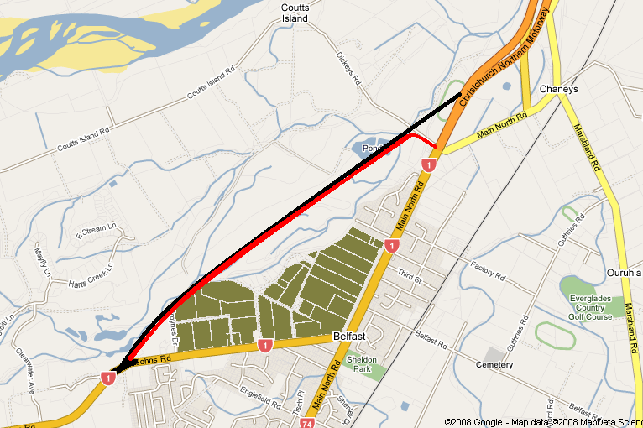
Key
Interim Bypass
Full Bypass
Belfast s293 Site
Figure 3: Interim and Full West Belfast Bypass
Figure 3: Interim and Full West Belfast Bypass

The key components of development staging are as follows:
Year | Subdivision | Land Use | Contractual Obligations
0 | 937 residential allotments |  | Improve intersection (MNR/ JR)
2 |  | 300 Households  2700m2 Comm. GFLA | Lodge Consents
5 |  | 600 Households  2700m2 Comm. GFLA | Obtain Consents
7 | Full Subdivision | Full Development  1500HH/ 10,400 GFLA | Construct Bypass
Alongside these milestones, the NZTA will undertake an investigation of the Full Bypass between Johns Road and the Northern Motorway in conjunction with progression of the Interim Bypass. This will assist with the Interim Bypass investigation by:
- Placing the Interim Bypass as part of a strategic picture, therefore adding an additional level of robustness with the consent investigation and lodgement process;
- Providing an opportunity for Transit to designate part or all of the route, thereby assisting with consenting requirements; and
- Ability, if required, for Transit to assist with property acquisition through Public Works Act as a last resort.
Underpinning this agreement is a package of rules, including financial contributions, in the Christchurch City Plan. The package is essential to achieving an integrated transport solution much wider than the Bypass. The package includes Outline Development Plans for the development which promotes the integration of public transport, walking and cycling within the development and connectivity beyond the development.
Basis for the funding package
As discussed earlier, the funding solution proved the most difficult because of the legislative difficulties. Whilst both the RMA and LTMA funding provisions are used, the method for combining them required an agreement outside legislation. There are essentially three components to the financing arrangements:
- The lead developer and landowners enter commercial arrangements to fund their share of the bypass, through borrowing and financing from the development (Private Contractual Arrangements);
- Transit part funds through its own funding source (LTMA); and
- The Christchurch City Council acts as funding collector where required through the financial contribution rule in its District Plan (RMA).
The funding package was developed from costs estimates between Transit, the City Council and the developer. While there were cost differences between the developer and government agencies, the developer estimates were considered reasonable given advantages of working outside of public sector restrictions.
The lead landowner is responsible for negotiating and reaching commercial agreement with other land owners. The funding arrangements allows for a greater number of subdivided lots than permitted land use. The District Plan rules as proposed allow an initial subdivision of 937 as a means of financing the bypass, while the number of building consents that will be issued will be limited to 600 until construction of the bypass is underway.
From NZTA’s perspective there are potentially significant funding risks as it has no control over commercial negotiations, nor future commercial arrangements. Therefore the rules package becomes of significant importance as a means to control the rate of development and funding for the Bypass. Therefore the rules package (including the financial contributions rule) in the Christchurch City Plan is of significant importance. It underpins the funding arrangements, and controls the rate of development.
The financial contribution rules provide some security to the lead developer as it does not control the full development, and not all landowners have signed up to the commercial arrangements. Financial contribution rules would enable the City Council to collect a contribution from landowners who had not otherwise paid. The financial contribution rules are currently the subject of High Court appeals, in relation to whether the rules should include an interest component reflecting the borrowing costs of the lead developer.
Lessons learned
Reaching the agreement has been long, arduous and expensive. Depending upon the complexity of issues, it is not necessarily an easier or cheaper option to litigation. As we previously have identified, there has to be a genuine willingness to embark down this path.
The alternative was to continue to litigate an outcome, but this is seen as a lesser alternative for the following reasons as shown in Table 1:
- The key significant issue was timing of development against infrastructure provision. With a funding solution this issue was potentially resolvable;
- There was one significant constraint, whereas other potentially future development sites around Christchurch had multiple constraints, or were less favourably located;
- The site location was consistent with the principles of the UDS; and
- Were the authorities to have lost, then limited development (i.e. up to 400 dwellings) would not have provided for integrated urban development; only part of the development completed, with the reminder on hold until the construction of significant transport infrastructure.
Even if the authorities were to have “won” such a case, the outcome would have been to prevent development being undertaken in an otherwise ideal location, increasing pressure from developments located further from the City Centre. It would also have meant that current infrastructure constraint would have remained unresolved until government funding was available.
On the other hand, if the Interim Bypass is constructed as a result of this agreement, then it is a resource well spent.
The experience has provided some useful insights into what factors will assist with improving land use and transport integration as follows:
- Working innovatively with the available tools as each issue will be unique. In this example a contractual agreement between the main contractors underpins the success or otherwise of this arrangement, which is supported through rules in the Christchurch City Plan, including financial contributions. It is also supported through commitments by NZTA in accordance with its objectives under the LTMA.
- A high degree of collaboration between local, regional and central government is essential to achieving complex outcomes. While ultimately successful, relationships were severely tested at times. In our view the chance of success requires trust between the agencies, a good understanding of the wider issues or agendas and a strongly understood common objective. The significant gain was developing a whole transport package, greater than a Bypass (including public transport, and other modes such as walking and cycling).
- The stronger integration mandate under the LTMA and RMA does provide a greater incentive for Councils to work together. This will likely be reinforced through the NZTA taking a greater interest in understanding the land use with its transport funding decisions. Clearly, as demonstrated in this example, there are benefits in working together on to achieve benefits wider than the interest of any individual agency.
- However, while the legislation has become more aligned, there is no explicit hierarchy between the legislation and there continues to be weak recognition between the various planning documents. The binding threads are the funding mechanisms, and this appears to be a key tool to influence outcomes. Again in our view success is greater where there is a positive will amongst the tiers of government and the development community to achieve a sustainable outcome.
Conclusions
The agreement represents significant work between local, regional and central government and developers to provide a model for development that incorporates provision for transport infrastructure.
There are advantages arising from agencies choosing to work together to obtain integrated outcomes. This process has shown that it is possible, despite the tensions that have existed.
It has also provided an opportunity for the land to be developed earlier and more comprehensively than might have otherwise been possible if government funding was relied upon.
Government policy is indicating that this is likely to be a preferred way of working in the future and legislation tools now require a higher degree of collaboration. However a willingness is still needed to use these tools successfully.
While the negotiations have reached a successful conclusion, there are still significant risks with this project. In many ways, it has only just commenced. The success will be measured on the delivery of the Bypass with a comprehensive urban development.
References
CCC (2008) Belfast Area Plan http://www.ccc.govt.nz/AreaPlans/Belfast.
Baily M, (2006) Doing a Subdivision of doing a Community? Planning Quarterly March 2006, p30 - 31.
Donovan S, et al (2008) Managing Challenges when Oil Prices Rise Planning LTNZ Research Report 357.
Freeman C, 2007 Sustainable Development: Still a Challenge? Planning Quarterly June 2007, p15 - 19.
Greater Christchurch Urban Development Strategy (2007) http://www.greaterchristchurch.org.nz/StrategyDocument/UDSActionPlan2007.pdf.
Ward M, Dixon J, Saddler B & Wilson J, (2007) Integrating Land Use and Transport Planning LTNZ Research Report 333.
Zöllner, E. (2003) A New Dawn for Urban Policy? Planning Quarterly June 2003, p15.
Acknowledgements
John Hassan acknowledges the assistance of Catherine Hewitt (LLB, BSc, Solicitor) and Amy Ingram (Secretary) in the preparation of this paper.

EnvC A61/2006 25 May 2006, Smith J.
Transit v Papakura DC EnvC A61/2006, 25 May 2006, Smith J, paragraphs [18], [24] and [26].
Nominally from the operative date of the Plan Change.

