Reducing Pedestrian Delays at Traffic Signals

Dr Shane Turner, Technical Director (Transport), Beca Infrastructure BE (Hons), PhD, MIPENZ, CPEng, IntPE shane.turner@beca.com

Chris Vallyon, Senior Transportation Analyst, Beca Infrastructure Ltd
chris.vallyon@beca.com

Shane Binder, Transport Engineer, Beca Infrastructure Ltd
shane.binder@beca.com

Steve Hodgson, Transport Modeller, Beca Infrastructure Ltd
steve.hodgson@beca.com

ABSTRACT
The traditional approach to road management in New Zealand has been to focus on improving the carrying capacity relating to vehicles, with an emphasis towards maximising the speed and volume of motorised traffic. Pedestrian concerns have been approached to some extent from a safety perspective, but little consideration has been given to improving pedestrian trip times and reliability. While most journeys made by pedestrians involve crossing roads, they are normally accommodated with the least amount of interruption to motorised vehicles, even where crossing facilities are provided, such as at traffic signals.

An alternative approach is to consider pedestrians as road users who contribute (in a sustainable way) to increasing the overall carrying capacity of a road corridor. This research study focused on CBD areas, where pedestrians form a substantial proportion of total road users. Furthermore, as door-to-door connections are problematic in CBD areas, even non-pedestrian trips will almost certainly involve a pedestrian component. Using micro-simulation models it is possible to demonstrate the benefits of improving pedestrian travel times at traffic signals and improve average delay to intersection users.

This research project focused on the peak pedestrian flow periods in central Wellington, Christchurch and Auckland, which typically occur in the middle of a normal weekday, during the ‘lunch-time rush.’ Micro-simulation models were developed to model pedestrian and vehicle delays for five road sections and intersections in three major centres. One or more of the following ‘pedestrian’ options were modelled at each signalised intersection or road link;traffic cycle optimisation (optimised to minimise delays to all intersection users); addition of Barnes' Dance (exclusive) pedestrian phase, pedestrian green phase extension and corridor bandwidth optimisation (optimised to provide green wave for average walking speed).

Pedestrian attitude surveys (811 in total) were also undertaken at all of the sites to assess pedestrian attitudes towards journey times, preferences towards crossing facilities, intersection waiting time perceptions and expectations, and compliance with crossing controls.

INTRODUCTION
Walking is a sustainable mode of travel. Most journeys involve a walking component, regardless of whether the main portion of the trip is made by foot, car, or using public transport. In New Zealand, around 40 percent of short journeys (less than 2 km) are made entirely on foot (ARTA, 2007) and most trips include a walking component as some part of the journey. A key issue of any pedestrian trip is the ability to safely and efficiently cross roads. It is estimated that pedestrians make 2.4 billion road crossings each year in New Zealand (ARTA, 2007).

The benefits of walking as a travel mode in a number of areas, including health, have been recognised by the New Zealand Government in a raft of policy statements and strategies since 2000. Of particular note is the publication of the “Getting There – By Foot, By Cycle” Strategy (2005) and the “New Zealand Transport Strategy (2002)”. The emphasis on walking (and cycling) and on a sustainable multi-modal approach to transport planning has been again reinforced this year with the release of the updated New Zealand Transport Strategy (2008) and the Government Policy Statement on Transport (2008). A key element of the “Getting There Strategy” is to reverse the downward trend in walking trips. To do so will require engineers, planners and the like to promote walking and to remove deterrents to walking.

Delays at crossing locations, whether controlled (traffic signals) or passive (crossing aides), can be a major deterrent to walking, particularly in built-up areas, such as the centre of our major cities, or across busy multi-lane roads. Poorly designed or poorly operated crossings facilities may act as a possible deterrent to pedestrian modes, potentially increase the segregation / cleavage caused by busy road corridors. Waiting time can be significant and can deter many pedestrians crossing the road or lead to unsafe crossing behaviour.

Like cyclists, pedestrians have often been marginalised in road management within New Zealand, with the focus typically being to increase the carrying capacity of the roads and intersections for motor vehicles only. The aim has generally been to maximise the speed and throughput volume for vehicular traffic. It can be argued that pedestrian level of service has gradually eroded over time due to increasing competition for road space, and a lack of balance in designing roads for all modes of travel. Where pedestrians have been factored into the roading design, as might occur at traffic signals, often pedestrians are accommodated so that there is the least amount of interruption to motorised traffic. In such circumstances often cycle times are long and pedestrian waiting times excessive. This is particularly evident in the CBD of our largest city, Auckland.

An alternative approach is to consider pedestrians as road users who contribute to increasing the overall carrying capacity of a road corridor through a healthy and completely sustainable transport mode choice. Overseas research suggests that we should be valuing the travel times and crossing delays of pedestrians at least as highly, if not more highly, than that of motor-vehicles, particularly in built-up areas of cities. This paper outlines research undertaken for LTNZ (now NZTA) on the likely benefits of improving pedestrian travel times and travel reliability, utilising micro-simulation models, pedestrian questionnaires and observational surveys.

LITERATURE REVIEW

Pedestrian Delays can result in Unsafe Intersections
Various studies have found that pedestrians are more flexible in their regard to road rules than other mode types. Pedestrians will use traffic signals as a guide, but if they become frustrated by long delays, they will likely ignore the signals entirely and cross when they perceive the risk to be acceptable, rather than accept continued delay. In this regard, pedestrian signals have a higher non-compliance rate than automotive traffic signals (and potentially, a much lower enforcement rate). Therefore, the primary measure of whether a set of signals is functioning adequately for pedestrian traffic would be the rate of non-compliance. Non-compliance to traffic signals posses a risk to the pedestrian and other road users, and as a result, frustration at pedestrian delay quite quickly translates into a road safety issue. As a result, much of the literature reviewed considers pedestrian delay entirely from the context of compliance / safety issue, rather than a factor of overall pedestrian travel times.

Ishaque & Noland (2007) stated that “In addition to fixed green-phase timings for pedestrians, long signal cycle durations, from optimising vehicle flows and from signal coordination for vehicles, have negative effects on pedestrian movements. Pedestrian non-compliance behaviour is encouraged by signal timings that are not favourable to them. This is the case both when a disproportionately large amount of time is made available to vehicular traffic and when pedestrian volumes are such that they do not fit into the time provided for by the pedestrian phase. Long signal cycles may pose a safety hazard for pedestrians and therefore one of the most effective measures to increase pedestrian safety and compliance is to make traffic signals as good as possible for pedestrians and that is by minimising their waiting times.

In an extensive 2 year study in London, Crompton (1979) found that at controlled crossings (in this case pelican crossings) 30-40% of pedestrians felt annoyed when the delay was in the range of 6-22s, but more than 70% felt annoyed when the delay was above 26 seconds.”… “A more recent study on children and adults showed that 30 seconds is the maximum both children and adults are willing to wait at a signalised intersection. The German Highway Capacity Manual specifically recommends that signal cycle times above 90 seconds should be avoided to reduce pedestrian delay.”

This was also confirmed by a literature review conducting by Martin (1996) who noted that increased waiting times resulted in an increase in the number of pedestrians crossing on the red signal. This issue was also addressed by Hunt, Lyons and Parker (2000), where it is noted that because pedestrians are more likely to become impatient when a red man continues to be shown during periods of low vehicle flow, the reduction of unnecessary delay for pedestrians would result in encouraging pedestrians to use crossings correctly and reduce risk taking.

Pedestrian Value of Time
To understand pedestrian behaviour, as with driver behaviour, it is important to understand perceived value of time. Perceived value of time has long been used as a component for predicting driver behaviour. It stands to reason that pedestrian behaviour, particularly compliance with signalised delays, can also be better understood and predicted when a perceived value of time is known. As Ishaque & Noland (2007) put it “To determine the value of cost trade-offs between various modes, the relative value of time of each mode must be determined first. The literature reviewed suggests a value of 2 for pedestrian’s walking time relative to a car occupant’s travel time. Some texts go even further and suggest higher values, e.g. 3:1. Another comparison could be the value of walking and waiting time. Again, some researchers suggest a 25% higher value for pedestrian waiting time.”

In New Zealand, the perceived value of time provided in the Economic Evaluation Manual for pedestrians is considerably lower than that of motorists. However, the Economic Evaluation Manual does make a clear distinction between work-related trips and recreational trips, and weights a much higher value upon work related activities (such as getting to work). Although value of time for pedestrians has primarily been used in relation to signalised delays and compliance issues, a case can also be made for considering the economic implications of excessive pedestrian delays, in much the same way one would measure the economic costs incurred by delays to motor vehicle traffic. Of course, where pedestrian counts are not undertaken, the economic cost of delay to pedestrians cannot be known, and the lack of pedestrian count data for most signalised crossing, is perhaps part of the problem.

In addition, it can be possible to reduce delay by coordinating adjacent signals. Although much of the literature related to the function of intersections in isolation, several texts made reference to the fact that pedestrians do not randomly arrive at an intersection. Instead they tend to arrive in cyclical patterns or ‘platoons’ resulting from interaction with adjacent signals, much like vehicle traffic. Therefore, pedestrian signal optimisation could benefit from viewing intersections in sequence, rather than in isolation. As with vehicles, this approach would provide the option to improve overall pedestrian travel times and reliability.

PEDESTRIAN DELAYS AT SIGNALS
In order to understand the effects of signals, and the potential effects of changes to signals, it is important to understand the actual delays experienced by pedestrians. There is an inherent difficulty in collecting this information as it is difficult to automate the process and the information is not available through existing permanent data collection methods. SCATS can inform of the maximum possible delay, by providing cycle times, but is unable to provide an idea of the actual delay as it has no means of recording the point during the cycle that pedestrians arrive at the intersection.

Observational studies were therefore necessary to determine the average length of time pedestrians waited at the surveyed intersections. The methodology adopted was designed to be simple, cost effective, and repeatable. A random person was selected as they approached the intersection (from any direction) and the delay time and crossing time kerbside recorded by stopwatch. After the person had completed a crossing, the next person to arrive at the intersection (from any direction) would be the next subject of the observational survey. The resulting methodology provides a randomized result, weighted by volume of the direction of origin, i.e. an approach with zero pedestrians arriving would be surveyed zero times, whereas an approach with 50% of the overall pedestrians would likely be surveyed around 50% of the time.

Table 1 shows that at the intersections studied in Christchurch the average waiting time is 25 seconds, while in Wellington and Auckland it is 45 seconds and 53 seconds respectively. In relative terms, therefore, both the Wellington and Auckland average wait time were observed to be around double that of Christchurch. Of course this is based on the sample sites and hence will vary around each city.
Table 1 Observed wait times
City | Number of Intersections surveyed | Observed pedestrians | Average pedestrian wait time (seconds)
Auckland | 5 | 289 | 53
Wellington | 2 | 333 | 45
Christchurch | 7 | 843 | 25
Combined Results | 14 | 1,465 | 41

PEDESTRIAN ATTITUDE SURVEYS
Surveys of pedestrian attitudes were conducted in Auckland, Wellington and Christchurch at the same 14 intersections used for the modelling, and at the same time as observation surveys of pedestrian behaviour. The surveys were conducted between the hours of noon and 1:30pm (pedestrian peak times) over the course of two weeks. Table 2 shows the number of pedestrians surveyed in each of the three cities.
Table 2 Surveys and locations
City | Surveys
Auckland | 456
Wellington | 115
Christchurch | 244
Total | 811

Perhaps the most indicative question was “Do you think more priority should be given to pedestrians in CBD areas?” Figure 1 summarises the findings. Roughly half of recipients interviewed nationwide answered ‘yes.’ However, for Auckland, the percentage of the people who answered ‘yes’ to giving more priority to pedestrians in the CBD was almost 75% of the total respondents. The findings indicate that the locations with the highest wait times also received the highest number of respondents believing more priority should be given to pedestrians.

Figure 1: View on pedestrian priority in CBD areas
Pedestrians were also asked to estimate their journey time (see Figure 2). Consistent with international findings, 73% of respondents across New Zealand reported a journey time of 10 minutes or less. The Wellington results were interesting in that a much higher proportion of pedestrians than the other two cities had a walk time in excessive of 15 minutes, with lower proportion of short trips. The results, particularly in Christchurch and Auckland, were average walk times are low, means that the delays experienced at intersections can have a significant effect on overall journey times. Each minute of delay within a highly signalized CBD environment equates to more than 10% of the average trip time, which is less than 10 minutes.

Figure 2 – Walking Times for each City
Several questions were asked regarding pedestrian attitudes toward traffic signals. Pedestrians were asked to state their preferred crossing types from a list of intersection types, including signalised, zebra, footbridge, pedestrian refuge, underpass, and other. Almost 60% of respondents stated that they preferred signalised intersections over other listed alternatives. Zebra crossings rated a much lower 23%. This may be the result of perceptions of improved safety where interactions with vehicles are regulated by signals. Interestingly, the two options for grade separation, considered the best option from a purely road safety point of view, rated very poorly. Footbridges scored 3% and underpasses 4%. This may be the result of additional distance (and stairs) for the former, and concerns regarding safety for the latter.

Knowledge of signal meaning was high, with 71% of respondents correctly answering that a flashing red man means “don’t start,” just 27% answering (incorrectly) that it means “hurry up,” and just 4% stating that they don’t know. Interestingly, in Auckland, the number of respondents answering “hurry up” rose to 33%. This may be the result of increased competition for time and space, and is consistent with observations of turning drivers on filtered turning movements honking their horn at pedestrians when the flashing red man appears. Where such instances occur, it is the result of a misunderstanding on the part of drivers, as the flashing red man means “don’t start,” and the pedestrians’ legal entitlement to right of way remains unchanged.

Respondents at each intersection were asked how long they felt they had to wait before crossing the road (see Figure 3). The average perceived delay times was found to be higher than actual average delay times for each intersection. This is consistent with delay being a subjective experience that is difficult to quantify. It is also consistent with the level of frustration being higher than the actual quantifiable loss of time.

Having been asked how long the respondent thought a typical wait time was, the respondents were then asked how long they thought was a reasonable waiting time to cross the intersection.

Figure 3 – Perceived waiting time

Figure 4 – Reasonable waiting time

The perceived waiting times were generally longer than those considered reasonable by respondents. This suggests that although respondents had difficulty in quantifying the experience of delay, the delay they were experiencing was often higher than they considered desirable, particularly in Auckland. By comparing the average perceived wait time with the perception of a reasonable wait time (see Table 3) it is possible to gain an understanding of the level of frustration and the desire for improved pedestrian priority.

The results are particularly noticeable for Auckland, where the difference between answers for perceived and reasonable times is the highest. In Christchurch, where the actual delay was much lower, a greater proportion considered the perceived delay to be acceptable. This is consistent with the answers provided in the survey, in which 75% of Auckland pedestrians felt more priority should be given to pedestrians in the CBD.
Table 3: Perceived versus Reasonable Average Wait Times
City | Reasonable | Perceived | Difference | Difference %
Auckland | 96 | 123 | 27 | 28%
Wellington | 67 | 76 | 9 | 13%
Christchurch | 44 | 50 | 6 | 14%
Combined | 69 | 83 | 14 | 20%

International experience and best practice guides suggest that pedestrians become frustrated after about 30 seconds delay. Analysis of the results in New Zealand supports international observations. A comparison of responses seems to indicate that somewhere between the 25 seconds actual delay experienced in Christchurch and the 53 seconds delay experienced in Auckland, there is a critical threshold after which frustration grows and time seems to stretch disproportionate to the actual additional delay.

Although the surveys did not attempt to quantify value for time, respondents were asked where they were going. The highest and second highest answers were “work” and “food / meal” respectively. It is likely that those travelling to and from work during their lunchbreaks are going to have limited time and therefore a value for time equivalent (if not higher) than those using other modes during this time period. This issue was discussed during the project’s steering group meetings, and a council officer present suggested the possibility that SCATs signal phases could be setup specifically to prioritise pedestrians during the lunch period.

One measure of frustration caused by signals is the frequency with which they are violated by pedestrians. This is not a perfect test as it is affected by traffic volume. Pedestrians will be more willing to ignore signals if the traffic volume is low enough that there is minimal perceived risk. However, international literature suggests that if the signal delays are high and pedestrians become frustrated the willingness to take risks increases and the rate at which pedestrians violate the signals intensifies, even in highly motorised environments.

Across New Zealand, almost half of pedestrians admitted to crossing ‘occasionally’ on a solid red man and a further 21% admitted to regularly crossing on a solid red. Observational studies indicated that compliance rates at intersections were similar to those reported by survey respondents. The findings confirmed that crossing compliance at intersections can be an issue in New Zealand, and this in turn may have safety consequences.

CASE STUDY LOCATIONS
A number of isolated and linked traffic signals from Christchurch, Auckland and Wellington have been selected for this study. Each intersection has been modelled using a micro-simulation model, and a number of improvement options tested to reduce pedestrian waiting times. A brief description of each case study sites follows:

Case Study 1 -Taranaki / Courtenay Place Intersection, Wellington
The intersection of Taranaki Street and Courtenay Place is located in the central business district in Wellington. This intersection consists of four approaching legs: Manners Street, Taranaki Street, Dixon Street and Courtney Place. Manners Street and Dixon Street are both on a one-way system.

Case Study 2 - Jervois Quay Mid-block Signals, Wellington
The pedestrian crossing on Jervois Quay is located in central Wellington, connecting the central business area and the harbour-side recreational area. There are two pedestrian signal crossings, which operate at the same time.

Case Study 3 - Vincent Street, Mayoral Drive, Auckland
The Vincent Street case study covers three signalised junctions, namely Vincent Street and Hopetoun Street; Vincent Street and Mayoral Drive; and Cook Street and Hobson Street. This cluster of intersection, while in the CBD, is not in the heart of the city, but the intersections still have significant pedestrian volumes. All four intersections have four arms. The Mayoral Drive and Vincent Street intersection has two free left turns and the Cook and Hobson Street intersection is on a one-way system with three approaches.

Case Study 4 - Lake Rd / Hurstmere Rd / The Strand, Takapuna, Auckland
This five-legged intersection of Lake Road, Hurstmere Road, The Strand, and Northcroft Street is in the heart of the Takapuna CBD, located in North Shore City. This intersection is presently a problematic site, due to excessive delays to vehicular traffic and pedestrians on all approaches, given its unusual layout and high number of approaches.

Case Study 5 - Albert Street / Customs Street / Fanshawe Street, Auckland
The four-legged intersection of Albert Street / Customs Street / Fanshawe Street is located at the northern end of the Auckland CBD, a block back form the harbour. This intersection has high vehicular and pedestrian volumes and also has a significant number of buses (on Albert Street).

Case Study 6 - Manchester & Hereford Street Corridors, Christchurch
Two road corridors, with a series of traffic signals, were selected in Christchurch; Manchester Street and Hereford Street. Manchester Street consists of five intersections between Armagh Street and Cashel Street while Hereford Street consists of three intersections between Oxford Terrace and Manchester Street. Corridors were selected so that the team could test the option of corridor bandwidth optimisation (i.e. optimising a corridor to provide green wave for average walking speed)

SIMULATION MODELLING RESULTS
Three different modelling software packages were used to build intersection models for the case study examples to simulate both vehicle and pedestrian behaviour and test various options to reduce pedestrian delay. Aimsun and S-Paramics were the two microsimulation platforms that were used to model intersections and corridors, while aaSidra was used for signal optimisation testing and provided detailed intersection performance.

S-Paramics was used to model the two single Wellington intersections and the Manchester and Herford Street transport corridors in Christchurch (see Figures 5 and 6 for screen shots of the Christchurch model). Due to the weakness of the S-Paramics software being able to model pedestrians on the road network the model was coded as two layers, one for vehicles and one for pedestrians. Even with this limitation the models clearly showed the benefits that changing signal times has on both vehicles and pedestrians.

The Manchester Street model was run for the inter-peak period where pedestrian demand is at it highest. The model was particularly useful in testing the effectiveness of the ‘green wave’ along Manchester Street. The model showed that pedestrians walking at a certain speed along Manchester Street will experience minimal delay waiting at the traffic signals. The corridor analysis also showed interaction between neighbouring intersections.

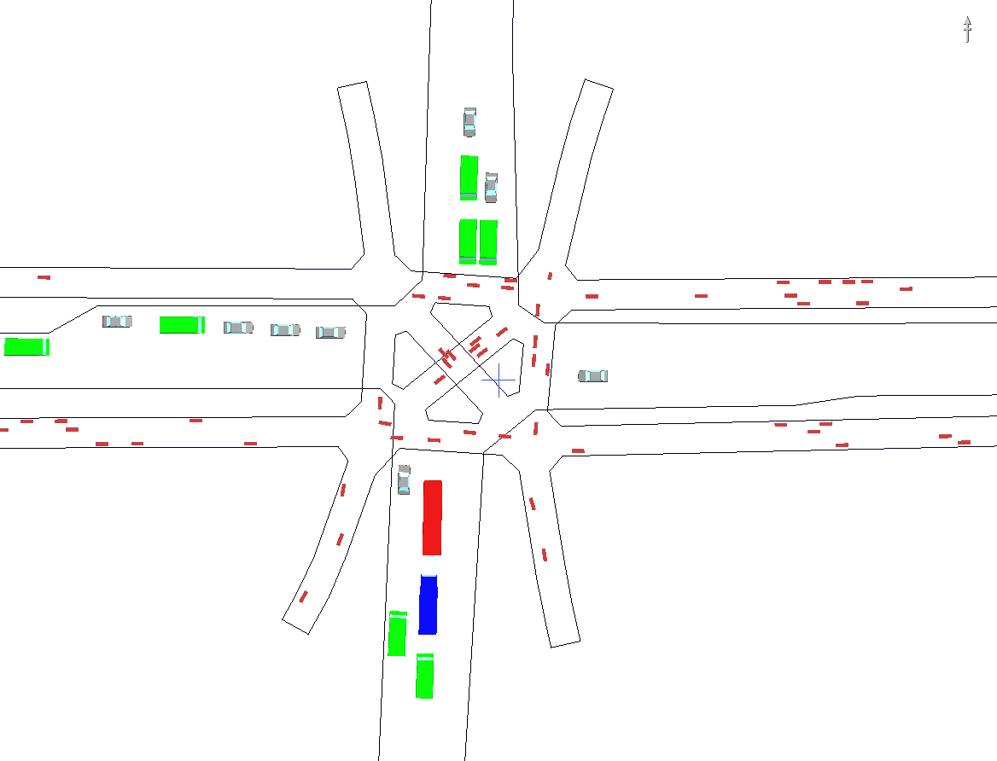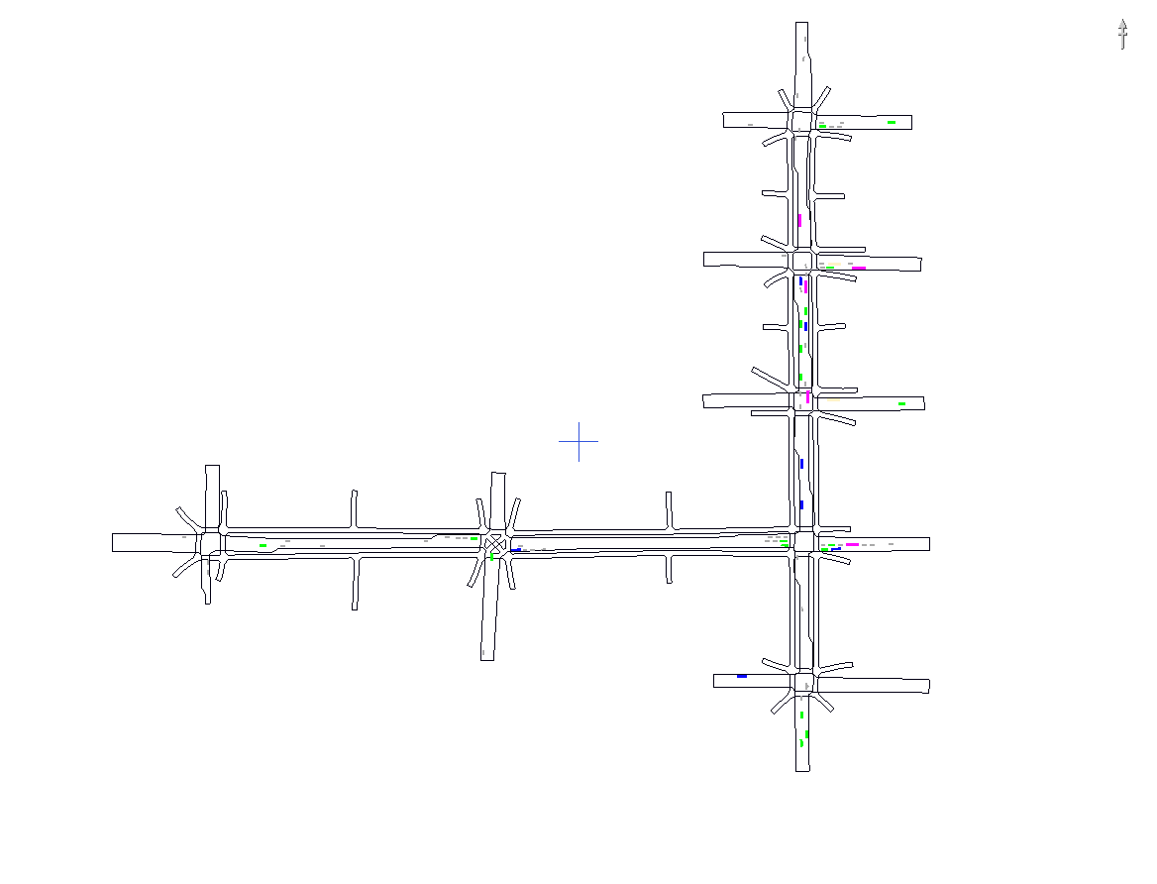

Figure 5 Colombo Street/Hereford Street Intersection Figure 6 Manchester and Herford Street Corridors

Aimsun was used to model all the selected intersections in Auckland. Coding in Aimsun allowed for a single layer model to be built with interaction between vehicles and pedestrians. However difficulty was experienced replicating the randomness of pedestrian behaviour at intersections. A way round this problem was to code parallel mini "car lanes" to simulate pedestrians so that when they walked down a footpath they were not in a uniformed line and crossed the road at the same time. Figure 7 shows the Vincent Street network (three intersections) modelled in Aimsun.

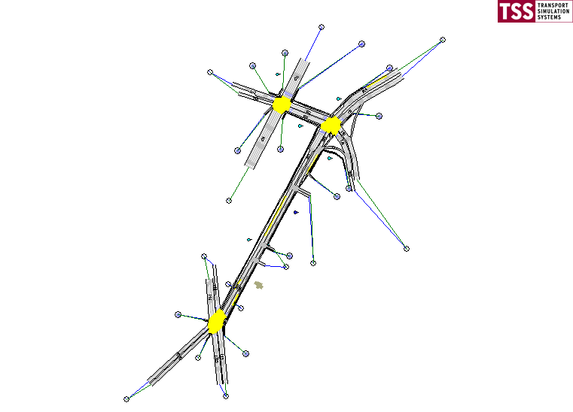
West Cook
Aotea Centre

Figure 7 – Vincent Street Corridor (Aimsun Model)

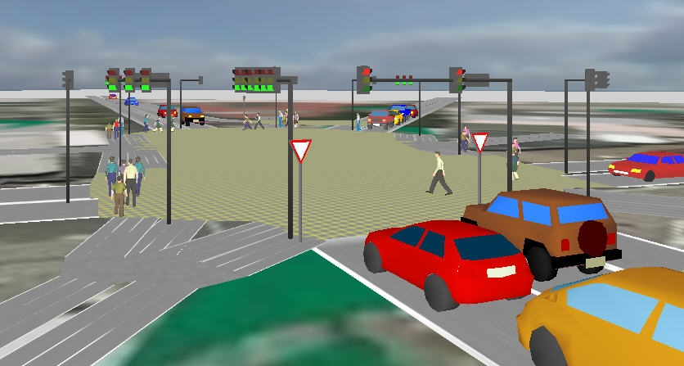
Figure 8 - Lake Road/Hurstmere Road/ The Strand Intersection Aimsun Model

A 3-D representation of the Lake Road/Hurstmere Road/The Strand intersection is shown in Figure 8. While this Aimsun model does show pedestrians using the crossings, as noted above, Aimsun does have problems modelling pedestrians, and so the movements shown in the animation are not accurate and can not be compared with normal pedestrian behaviour, as one might compared modelled and observed motor-vehicle interaction using such a model.

To test the accuracy of the microsimulation models and to calculate optimum signal timings the intersections (barring Manchester Street) were also set up in SIDRA. This allowed quick testing of the results of making changes to the signal timings and provided useful delay figures that are harder to extract from microsimulation models.

Signal Optimisation – Per Person Delay
The traditional approach to signal optimisation in New Zealand is generally to optimise for vehicles. This approach does not account for other road users and provides little understanding of the total delay generated by an intersection. As well as the usual vehicle information, pedestrian counts were undertaken and pedestrian average wait times were observed and recorded. The intersections were then optimised for a mid-day (lunchtime) period based on total delay, rather than vehicle delay.

This was found to substantially improve pedestrian delays, which could be further reduced through other intervention measures. For the purposes of the per person modelling, vehicle occupancy was assumed using an international value of 1.4 people per vehicle, though it was suggested by the steering group that this occupancy may be a little high for New Zealand.

As can be seen from Table 4, by optimising intersections on a ‘per person’ basis, it was possible to substantially reduce the delay for pedestrians. Although this resulted in an increase in vehicle delay, this was generally minor. In the case of Jervois Quay, the vehicle delay increase was 7 seconds. At the Taranaki / Courtney Place intersection the per-person optimisation also reduced vehicle delay.
Table 4 Reduction in pedestrian delay effect of ‘per person’ optimisation
City | Location | Delay reduction from optimisation | Optimisation + other measures
North Shore City | Lake Road / The Strand | 26% | 40%
Auckland City | Albert / Custom Street | 31% | 38%
Wellington City | Jervois Street / Queens Warf | 45% | 32%
Wellington City | Taranaki / Courtney Place | 30% | N/A

Once this had been established, the modellers looked at other options to further improve pedestrian delay. Typically this included combining two vehicle turning phases or increasing cycle time. Some options were then discarded due to safety concerns. In both Wellington intersections the per person optimisation on its own resulted in the greatest improvement.

The results of the modelling therefore suggest that the most effective means to improve pedestrian delay for an individual intersection involves optimisation on a per person basis. This can be undertaken once pedestrian counts and walk directions are known.

Pedestrian Corridor Modelling
Modelling was undertaken in order to better understand resulting delays resulting from differing travel speeds, in order to explore the optimum engineering speeds for a pedestrian green wave. Vehicles travel at relatively consistent speeds governed by speed limits and operational environment. Pedestrians, on the other hand, travel at a variety of individual travel speeds. One of the purposes of the corridor model was to understand and quantify how these differing speeds could affect pedestrian delay.

The modelling was undertaken using S-Paramics using separate model layers for vehicles and pedestrians. The models assume that pedestrians and cars comply with legal road laws. The models were set up to run using the existing phasings in place along the corridors and then randomly populated with pedestrians travelling at two different speeds, 5km/hr or 1.4m/s and 4km/hr or 1.1 m/s>
The Christchurch study section details are shown in Table 5. Based on a walk speed of 1.4m/s it would take pedestrians 346 seconds and 365 seconds respectively to walk the study section of Manchester Street and Hereford Street respectively, if they had a green man at each of the signalised crossings. At a walk speed of 1.1m/s this walk time increases to 440 seconds and 465 seconds respectively. Table 6 shows the average delay predicted by the models at signalised crossing along the route, along with the proportion of the overall journey time based on the above figures.

From Table 6 it can be seen that two different pedestrians travelling at different speeds will experience very different delays along the same stretch of road. A pedestrian travelling at 1.1m/s along Manchester Street, in either direction, will experience greater delays than a pedestrian travelling the same route and walking at 1.4m/s. In the case of Hereford Street the delays for both pedestrian speeds is less, due to fewer intersection, however, a noticeable difference emerges when pedestrians are travelling westbound along the route.

Table 5 Study Sections (Christchurch)
Model details | Location | Number of Intersections | Modelled Distance (m)
Manchester Street | Armagh Street to Cashel Street | 5 | 484
Hereford Street | Oxford street to Manchester Street | 3 | 511

Table 6 Pedestrian Delays at two Walk Speeds
Christchurch  Option 1 | Delay at 1.1m/s (seconds) | Delay at 1.4m/s (seconds) | % Delay at 1.1m/s | % Delay at 1.4m/s
Manchester Street  Southbound | 198 | 107 | 31% | 24%
Manchester Street  Northbound | 201 | 104 | 31% | 23%
Manchester Average | 199 | 106 | 31% | 23%
Hereford Street Eastbound | 87 | 78 | 16% | 18%
Hereford Street Westbound | 39 | 76 | 8% | 17%
Hereford Average | 12 | 77 | 12% | 17%

When the difference was observed in more detail, it became apparent that the primary source of delay resulted from pedestrians arriving at an intersection slightly too late to catch the green therefore waiting through a full cycle of lights. Those walking faster might arrive slightly before a green light and wait a short period; those walking slightly slower would arrive just after a green and therefore wait for quite some time.

This has important implications for those attempting to engineer a pedestrian green wave. When co-ordinating traffic lights for pedestrians it would be preferable to underestimate the speed of pedestrians rather then to overestimate, as those arriving too late for a green will face substantially longer delays, and therefore increase the overall pedestrian delay of the corridor.

In the case of the Hereford and Manchester corridors, several options were modelled in order to reduce pedestrian delay for both pedestrian walk speeds along both corridors. The most effective option was to increase cycle times along the corridor and to run the Barnes Dance twice in each cycle (after each street has had a turn) at the corner of Hereford Street and Colombo Street. As a result, it was possible to reduce the average pedestrian delay by almost half.

CONCLUSION
The results of international literature review, modelling, and pedestrian surveys, indicate that there is substantial room for improvement when it comes to improving pedestrian delays and that the current system of weighting delay toward vehicles actually increases the overall delays of road users at intersections. The project team modelled specific intersections (nominated by local participating governments) and conducted surveys which we then compared to observations. The research was limited to operational changes, rather than physical changes, as this narrowed the scope of research to relatively simple ‘quick-win’ solutions.

Observation and pedestrian surveys confirmed a threshold somewhere around 30 seconds for New Zealand pedestrians, which is consistent with research undertaken overseas. Short delays were more accurately estimated by pedestrians when answering surveys. Where delay at an intersection was high, the 'observed' delay was significantly in excess of the actual delay, and our surveyors noted an increase in people ignoring the signals as frustration developed into a willingness to accept personal risk.

By including pedestrian counts in signal optimisations it was possible to increase the per person capacity of an intersection (different from the conventional view that considers pedestrians as a 'delay' for vehicles). This is consistent with international literature which provides high values of time for pedestrian delays. The research shows that by including pedestrians in intersection travel time optimisation, a 30% reduction in pedestrian delay can be achieved.

Through modelling it was demonstrated that when planning a pedestrian green wave it is better to underestimate pedestrian speed rather than it is to overestimate it (essentially pedestrians arriving late to an intersection face greater delay than those arriving early). The optimum pedestrian green wave was therefore quite slow.

The research supported findings that the greater the delay, the greater the frustration, the more likely people are to violate signals. This was identified in the literature review and confirmed through questionnaires and observational surveys. The results suggested a correlation between Auckland having longest delays and most frustrated pedestrian desiring change. The research therefore support international findings that suggested excessive delay posed a significant safety risk for road user.

REFERENCES
AUCKLAND REGIONAL TRANSPORT AUTHORITY, (2007). Sustainable Transport Plan 2006 –2016, Auckland, page 9, 28, 48

HUNT, J, LYON and PARKER. ???? The operation and safety of pedestrian crossings in the United Kingdom. Proceedings 17th ARRB Conference, Part 5, p. 49

ISHAQUE, MM & NOLAND, RB, (2007). Trade-offs between vehicular and pedestrian traffic using micro-simulation methods, Transport Policy 14, p 124-138.

MARTIN, A., (1996). Factors Influencing Pedestrian Safety: A Literature Review, TRL Ltd http://www.tfl.gov.uk/assets/downloads/corporate/factors-influencing-pedestrian-safety.pdf

MOT (2002) New Zealand Transport Strategy: Version 1, MOT, Wellington, NZ

MOT (2005) Getting There – By Foot or Cycle, MOT, Wellington, NZ

MOT (2008) New Zealand Transport Strategy: Version 2, MOT, Wellington, NZ

MOT (2008) Government Policy State on Transport: Version 1, MOT, Wellington, NZ

