TECHNICAL PAPER

CROWN RANGE ZIG ZAGS UPGRADE - LINKING COMMUNITIES AND KEEPING OUR TOURISTS SAFE IN AN ALPINE ENVIRONMENT

Author & Presenter: Iain Banks, BEng, CPEng, MIPENZ

Transportation Team Leader, MWH Queenstown
Iain.Banks@mwhglobal.com

ABSTRACT

The Crown Range Road is situated in the Queenstown Lakes District. As one of only three highways into Queenstown it provides a crucial link between Queenstown and Wanaka. The section of the road from SH6 to the lookout on the Crown Terrace, known as the “Zig Zags”, is located in an area of the district classified as an 'outstanding natural landscape' and was notorious for its narrow road widths, sheer drop-offs and a number of hairpin bends.

The $2.1m Crown Range Zig Zags Upgrade Project, completed in July 2008, resulted in safety and efficiency improvements from carriageway widening and associated improvements including the installation of an innovative, environmentally friendly timber faced guardrail along the full length.

The construction process was successfully completed, overcoming the challenges of difficult road width, alignment and visibility. Construction was carried so as to minimise waste, cost and disruption. The road is now seen as a much more accessable and safe route between Queenstown and Wanaka and positive feedback has been received from both locals and tourists to this effect.

The project was commissioned by Queenstown Lakes District Council (QLDC) and was completed by consultant MWH New Zealand Ltd and contractor Fulton Hogan Ltd.

INTRODUCTION

The Crown Range Road is situated in the Queenstown Lakes District. As one of only three highways into Queenstown, and a much shorter route than the alternative via SH6, it provides a crucial link between Queenstown and Wanaka. It is also a major tourist route and provides access to the ski fields of Cardrona, Snow Farm and Snow Park as well as the township of Cardrona.

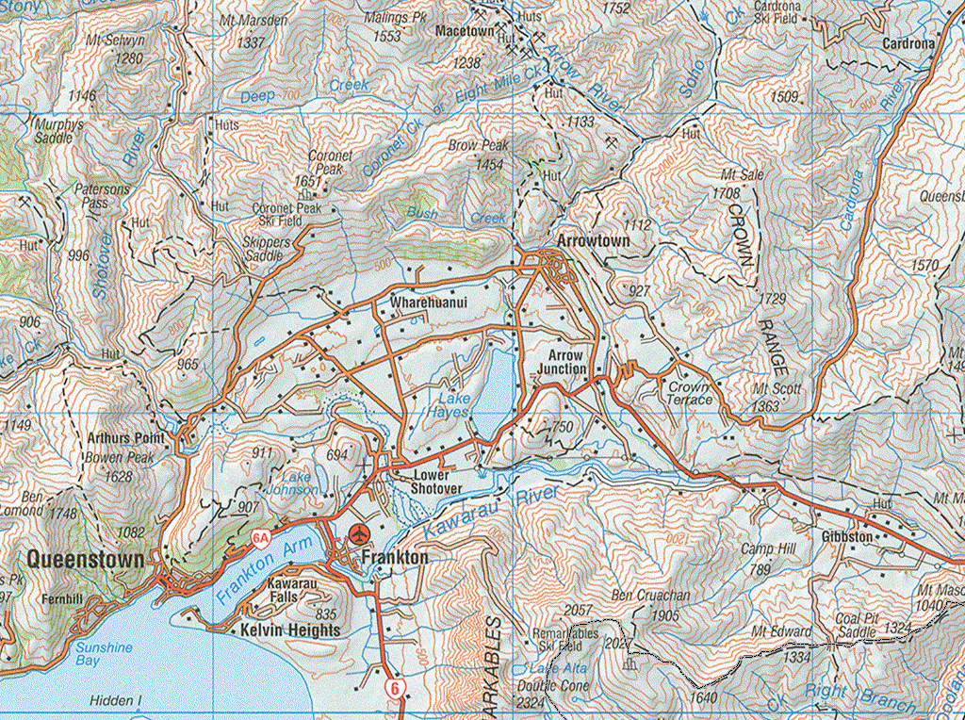
Zig Zags
To Wanaka
SH6 to Cromwell
Diagram 1 – Location Plan of Zig Zags

The section of the road known as the “Zig Zags” extends from SH6 to the lookout on the Crown Terrace, is a total length of 2.8km with a 260m elevation gain and includes seven hairpin bends. The road was famous as a beautiful, but dangerous, route with its narrow road widths, sheer drop-offs on the outside edge and a tortuous alignment. Due to these factors many tourists and locals alike avoided using the road, preferring the longer alternative via SH6.

The “Zig Zags” section had a relatively high accident rate (11 reported crashes in 5 years), and although none of these were serious or fatal, there was significant potential for a major incident to occur with a car or bus, particularly tourists unaccustomed to the road environment, going off the steep drop adjacent to the road.

Due to these factors Queenstown Lakes District Council (QLDC) commissioned a project to upgrade this section of the Crown Range Road.

QLDC’s overarching objectives for the project were: -
- To improve the safety and level of service of the road
- To complete the work in keeping with the outstanding natural beauty of the area and with minimal visual impact given the prominence of the road within the Wakatipu Basin
More specifically the brief was to:-
- Widen the seal to a target width of 6.0m (existing was 4.0m - 5.0m)
- Upgrade the hairpin curves to a 15kph design speed
- Upgrade/widen the hairpin curves to allow for a 12.7m vehicle (bus) to negotiate the curves in a single movement (crossing of the centreline to be avoided)
- Reduce the current crash rate (11 reported crashes in 5 years)
- Install a suitable crash barrier, this was to be a non-intrusive system which did not retract from the scenic significance of the road
- Reduce the high annual maintenance cost for this section
Additionally, the construction phase of the project was to take place without road closure and with minimal disruption to the travelling public. The project was to be completed prior to the start of the 2008 ski season when traffic volumes significantly increase.

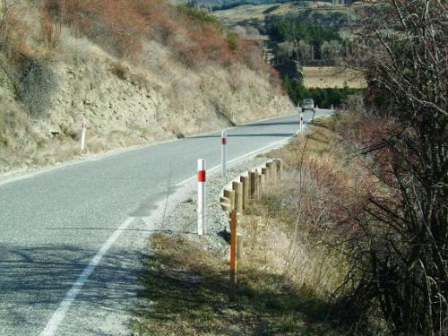
Figure 1 – Looking south along the bottom straight prior to the project commencing
DESIGN STAGE

The full design phase of the project was completed between August 2003 and December 2007. MWH were engaged by QLDC to complete this phase of the project. Throughout the preliminary and detailed design phases of the project the Client’s objectives were at the forefront of the design team’s mind.

The main aspects of the project were:-

- Widening of the existing road corridor through earthworks and retaining structures
- Pavement construction within the widened sections
- Drainage improvements
- Pavement marking and signage installation
- Installation of appropriate guardrail along the full length of the project

The existing topography of the area meant that some of the geometric improvements would be difficult to achieve so careful consideration of the potential options for earthworks and retaining structures had to be completed.

The importance of providing non intrusive features was critical to the decisions on where earthworks would be acceptable and where retaining structures, positioned either above or below the road, were preferred to reduce their visual impact. The potentially significant cost of major retaining structures was also a significant consideration. The final design for the widening was a combination of earthworks and gabion retaining walls. Gabion walls using local stone were designed predominantly on the downhill side of the road to reduce any negative visual impact. The gabions themselves were considered to be better suited to the steeper longitudinal slopes of the sites than alternative retaining structures and provided the most aesthetically pleasing solution. The majority of earthworks were confined to cuttings on the uphill side, which although initially visible, will eventually re-vegetate and return to the existing natural landscape.

The pavement for the widening was designed as a standard granular pavement with a two coat first coat seal. It was recognized during the design that sections of the existing pavement were beginning to shows signs of failure and that a full rehabilitation was likely to be required in the next few years, however, this was not proposed to be part of the project with the council preferring to complete short term patching to hold off the full rehabilitation for as long as possible.

The existing drainage along the road was limited to narrow water tables which were liable to blockage, particularly during the winter, and which also caused scouring and edgebreak in places along the uphill side of the road. The design solution was to install concrete dish a channel along the uphill side of the road with a number of new sumps installed, which discharged into existing culverts crossing the road. This provided an effective means of channeling the surface runoff as well as providing a defined edge on that side of the road to prevent future edgebreak. In addition the concrete dish channel is easier to clean out than an open water table during future maintenance.

The existing road had edgelines present to delineate the edge of the seal, however, due to the narrow width it had no centerline except on the hairpin bends. Due to the lack of centerline and the steep drop on the downhill side vehicles tended to drive up the middle of the road leading to the potential for head on collisions particularly on the bottom section where there were a number of curves with limited forward visibility. With the designed widening a new centerline was included to help delineate the two trafficable lanes and keep vehicles on the correct side of the road. There was already generally good signage along the length of the road although the design did include for upgrading some of these and removing some towards the bottom of the road where there was a clutter of signs.

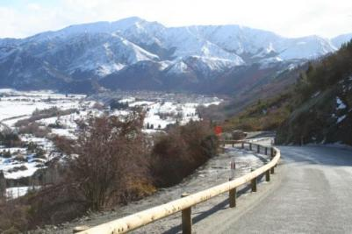
The final design aspect was possibly the most significant. The choice of guardrail was key to the final visual appearance of the completed project and was of significant importance to the client. Standard w-section rail was not considered suitable due to the visual impact and potential for sun glare to be visible throughout the Wakatipu Basin. Wire rope was not viable due to the tight horizontal alignment of a number of sections on the road. An alternative had to be found and in consultation with suppliers, timber faced rail was proposed. These rails are in use overseas but this was the first time they were used on a large scale project in New Zealand (the rails were specially imported from Europe for the project). They look like a natural log fence but are as strong as standard guardrail (they have been tested to European N2 standard). Extensive consultation was completed with the suppliers during the design phase to ensure that the rails would meet required standards and that they could be constructed within the restricted width available. The rails are considered to be environmentally friendly and sustainable given their use of natural materials and they are straight forward to replace if hit by a vehicle and damaged. Details of the rail are shown in Diagram 2 below. The design of the posts also included the use of plastic sleeves where the posts were installed within gabion baskets to allow for easy removal and maintenance if damaged.

Figure 2 – The completed guardrail

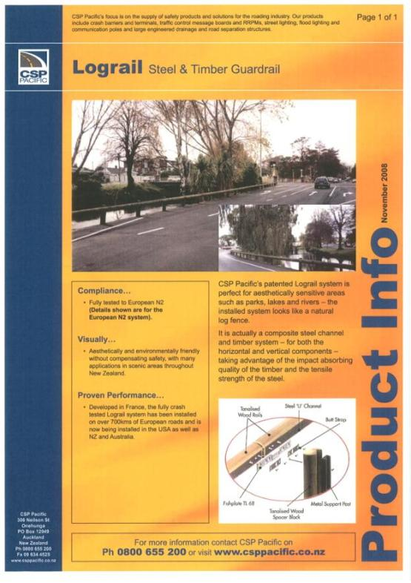
Diagram 2 – Steel Reinforced Timber Guardrail Details
CONSTRUCTION

The construction phase of the project was programmed and budgeted for in the 2007/08 financial year. Due to the difficult alignment and limited available space it was determined that Contractor input was preferable prior to the contract for construction being awarded. It was decided to procure the work using the weighted attributes method of evaluation with an allowance for alternative tenders to be submitted. In addition an interactive tender process was adopted where individual tenderers had the opportunity to meet with the client and consultant to discuss their submission and possible alternatives prior to tenders closing. This had the major advantage of tenderers being able to openly discuss particular aspects of the project and particularly the initial viability of alternatives before having to spend valuable time preparing a submission which might then have been rejected immediately by the client.

Through this process Fulton Hogan provided an alternative alignment for the top section of the road which would have potentially reduced the amount of work and disruption to traffic during construction. In the end this option was not adopted by the client as they felt the loss of 1 or 2 hairpin curves would reduce the unique and iconic nature of this section of road.

The non alternative tender from Fulton Hogan was, however, accepted and construction was completed between February and July 2008.

During construction a number of methodologies were adopted which provided overall value for money to the project. These included:

- Disposal of cut to waste material adjacent to the top section of the road which was then landscaped to blend in with the surrounding area. This prevented the need to cart waste material significant distances off site. In addition, a large volume of waste material which was actually suitable structural fill was carted to an adjacent QLDC project (also involving MWH and Fulton Hogan) on the Crown Terrace. By taking this material straight from cut on the Zig Zags to fill on the adjacent project considerable savings were made, in terms of time and money, for both projects.
- In order to reduce the overall timeframe of construction up to four separate work zones were in operation at any one time. Due to minimal sight distance on the narrow winding road and significant truck movements, planning of traffic control and scheduling of individual work phases were crucial to prevent major delays to the travelling public.
- Given the narrow width of the existing road, the movement and turning of trucks was a significant issue. In order to improve safety during construction and to reduce the haul route length, a turning area was constructed at the bottom of the Zig Zags. This was re-landscaped at the end of the project to prevent any long term visual damage.
- The inclusion of hydro seeding on steep cut faces was critical to the long term re-generation of the vegetation in the area. A special mix of seeding was used in order to ensure the re-vegetation was in keeping with existing flora.
- During the final installation of markings and signage, the visibility of the edge marker posts on the hairpins was raised as an issue. To address this, a white tubular post was manufactured and completed with appropriate reflective taping. Although not strictly in accordance with MOTSAM guidelines these posts have proven to be extremely effective at delineating the hairpins at night. The posts are also flexible which means they are not damaged when hit by vehicles and therefore provide a low maintenance solution.

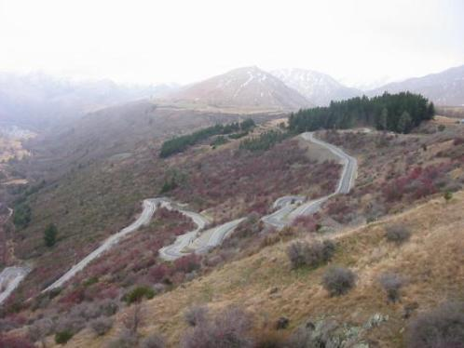
Figure 3 – Looking north at the completed project

PROJECT OUTCOMES AND KEY BENEFITS

The completed project has produced a number of positive outcomes and key benefits for both the Client and road users and these are summarised in this section.

Safety Improvements
The project has significantly improved safety due to widening the road to a minimum of 6m along with the installation of guardrail. The widening has allowed for the inclusion of a centerline which has reduced the risk of head on collisions and the guardrail has significantly reduced the likelihood of a vehicle leaving the road and rolling off the edge.

The safety benefits have been immediate and both locals and particularly tourists unfamiliar with this type of terrain can now traverse this section of road with much more confidence and peace of mind than previously.

The benefits are clear both in terms of driver perception and in more quantifiable terms with no reported crashes since completion compared to eleven reported crashes in the five years prior to construction. The original economic evaluation for the project calculated safety benefits in the order of $2.1m over the 25 year design life of the project. This initial indication of reduced crash rates shows that these benefits are already starting to be realised.

Letters commenting on the improvements have been received from a number of sources including Destination Queenstown, who noted the importance of the safety benefits to the tourism industry, and The New Zealand Motor Caravan Association who highlighted the benefits to their members in being able to more safely access this popular route between Queenstown and Wanaka.

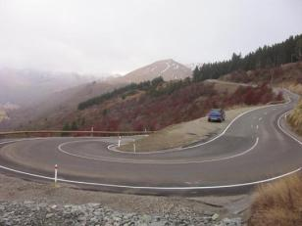
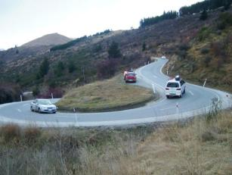

Figure 4 – One of the hairpins before Figure 5 – One of the hairpins after
construction construction
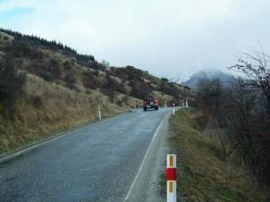
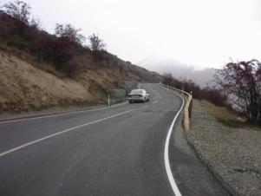
Figure 6 – Prior to construction Figure 7 – Post Construction

Quality of Life for Communities
The upgrade has improved the quality of life for local motorists, commuters and tourists. Particularly important for local motorists and commuters, travel times have been reduced as the road widening has made it easier for trucks, buses and other large vehicles to negotiate the hairpin curves, causing less delay. Similarly, increased areas for caravans and other slower drivers to pull over and let traffic past have resulted in reduced travel time and frustration.

The reduced travel times, reduced frustrations and improved safety have combined to make the route much more attractive to all users which in turn has positive impacts for both Queenstown and Wanaka communities and more significantly for the communities and attractions along the route such as Cardrona township and the ski fields.

Throughout the project the needs and preferences of the Queenstown Lakes District community and the environmental impact of the project were at the forefront of decision making for both design and construction. Consultation with affected stakeholders was an important aspect of the project and consultation was completed through the Council’s Utilities Committee. The feedback identified aesthetics and limited visual impact as primary concerns of the community and helped to determine the scale and detail of the project in the early design stages. By meeting the stated needs of the community the project has successfully added value to this stretch of road, and to the driver experience, without any negative outcomes.

Appropriate publicity, including advertising the alternative route to Wanaka via Cromwell on SH6 helped to reduce the number of complaints received during construction and decreased the volume of traffic travelling through the site. Good communication meant that a cycle race and a vintage car race successfully passed through the site during construction with no complaints received.

The completed project has had immediate benefits for all members of the community and particularly the local residents on the Crown Terrace. Further letters of support from the Cardrona Ratepayers and Residents Association and one of the local residents highlighted the improvements to the community.

Contribution to National Economy
Situated in one of New Zealand’s premier tourist destination areas, the Crown Range Road is a major tourist route between Queenstown and Wanaka.
By improving the infrastructure required to transport tourists safely and conveniently through this region, the project has contributed to the tourism industry - a key driver of the Queenstown economy.

The increased accessibility and safety of the route has made it significantly more attractive to tourists and the use of materials that are visually pleasing and in keeping with the surrounding landscape has been significant in highlighting to tourists from all round the world the importance of the natural environment in New Zealand and the efforts that are being made to maintain it.

Innovation
A number of innovative features were incorporated into the project during both the design and construction phases. These included:-

- The installation of steel reinforced timber guardrail – the first major use of this product in New Zealand. The success of the timber rail in this situation is likely to be a forerunner for future usage of the product.
- Careful consideration of the visual impact when determining the balance of earthworks and retaining structures to allow for the widening.
- The use of an interactive tender process to help encourage innovation and prevent tenderer’s wasting time discussing alternative tenders prior to having to submit them
- Disposal of cut to waste material adjacent to the top section and cut to fill on an adjacent project to reduce time and cost.
- Four separate work zones operating at the same time.
- Construction of temporary turn around area for trucks to reduce disruption to traffic.
- Use of a special mix of seeding in order to ensure the re-vegetation was in keeping with existing flora.
- Installation of tubular edge marker posts on the hairpin curves.
- The design of the posts in plastic sleeves where the posts were installed within gabion baskets to allow for easy removal and maintenance if damaged.
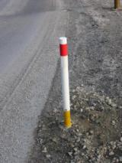

Figure 8 – One of the tubular Edge marker posts
Environmental
The Zig Zags are unique in New Zealand being a sealed road with seven hairpin curves and stunning views. The embankment they are located on is visible from throughout the Wakatipu basin and therefore it was paramount that the work was completed in a way that would ensure the minimal amount of impact on this important environment. This also meant that any project was going to be under extensive scrutiny from local travelling public and international tourists. The finished product had to be something that people could see as a significant improvement, delivered in a way that was not going to have detrimental effects on any stakeholders using the route during construction and be a substantial improvement after construction.

The existing mountainous terrain, narrow width and restricted alignment meant that a number of unusual obstacles had to be overcome in both completing a design that was achievable and constructing the project in a manner that was cost effective, while providing limited disruption to the travelling public.

In particular, the use of the timber faced rail was vital to the success of the project as the visual impact of the rail is minimal and it enhances the rural and rustic history of the area while still providing modern standards in safety.

Collaboration
A key success of this project was the collaboration between all parties involved throughout both the design and construction phases.

During the early design stages there was significant discussion between MWH and QLDC regarding the scale and detail of the project. Consultation with all affected stakeholders, including the community, was an important aspect of the project and was completed through the Council’s Utilities Committee to determine the needs and preferences of the community. This feedback identified aesthetics and limited visual impact as primary concerns of the community.
During the tender period, as discussed above, the use of an interactive process allowed for collaboration between QLDC, MWH and Fulton Hogan on design details, potential alternatives and possible cost savings.
Prior to construction significant planning was completed between all three parties to ensure adequate publicity about the project to reduce the impact on both adjacent residents and the community as a whole using the route during construction. This helped to reduce the number of complaints received during construction and decreased the volume of traffic travelling through the site by advertising the alternative route to Wanaka via Cromwell on SH6.

Throughout the construction phase the staff of both MWH and Fulton Hogan worked closely together to ensure the quality of work was to a high standard and that progress was maintained as per the required timeframe. Any issues discovered during construction were communicated early and resolved promptly which helped to avoid any disputes. Regular communication with QLDC on the progress of work ensured that any customer queries could be handled promptly and accurately by the council helpdesk staff.

Client’s Assessment
The completed project has achieved all of the client’s physical standard objectives.

Numerous positive comments have been received from both the client and the public about the road improvements, the visual appearance of the timber guardrail and the construction process. Although the scars from the earthworks are still present, the use of hydro seeding has meant that vegetation has started to grow back and it is expected that full growth re-generation will be achieved within 2-3 years.

The bulk of the construction was completed prior to the ski season with the road being fully open by this point and only minor works being completed with minimal disruption during July 2008. Due to the existing narrow alignment, and the fact the client would not accept long term full closures of the road, minor delays to the travelling public were inevitable. These were, however, kept to a minimum and short delays were considered necessary to reduce the overall construction time of the project. In addition the project was completed within budget with a final construction cost of $2.29m against an initial budget of $2.38m.

QLDC’s overall satisfaction with the project is evident in a letter they delivered to the project team. This letter was used as part of the submission to the 2009 Roading Excellence Awards in which the project was a finalist.

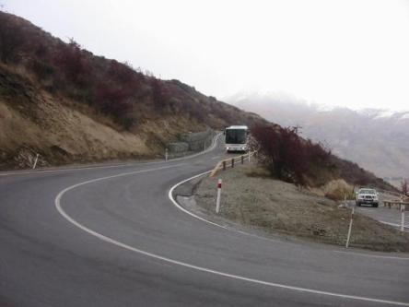

Figure 9 – The road now more safely accommodates large and small vehicles, with room for manoeuvre around the hairpin curves

SUMMARY AND CONCLUSIONS

The Zig Zags Upgrade Project demonstrates how the right engineering solutions can ensure an environmentally sensitive, visually stunning, but potentially very dangerous landscape can become more accessible and be traversed safely.

The client’s objectives were successfully met in respect of completion on time and to budget and more significantly as follows:-
- The project has significantly improved safety due to widening the road (to include the addition of a centreline) and the installation of guardrail.
- Protection of the environment and the visual impact of the finished product were extremely important to the client, hence decisions to use timber guardrail, minimise earthworks, use local stone in gabions, reduce the extent of gabions on the uphill side of the road and reinstate cut faces with hydroseeding using local seed.
- Accessibility has been significantly improved due to the road widening. The route is more attractive to tourists (of major importance to the local and national economy).
- The road has allowed for an improved quality of life for local residents and commuters using the route on a daily basis.
- Difficult construction due to the narrow road and alignment meant good management was required to complete the construction on time with minimal disruption to the travelling public.
- Sound engineering was required to reduce the amount of additional work required and the cost of carting material away from the site.

The final result is an improved safety record, a reduction in the high annual maintenance cost for this section of road and far greater accessibility to both tourists and local motorists.

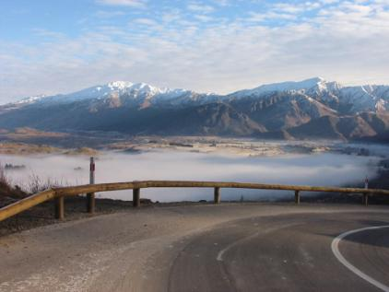
Figure 10 – The timber rail blending into the natural beauty of the area

ACKNOWLEDGEMENTS

Anna Sinclair – Fulton Hogan Project Engineer
Pete Reid – Fulton Hogan Contract Manager
Ian Marshall – QLDC Roading Manager
Mark Cruden – Former MWH Project Manager
David Van Staden – Former MWH Design Team Leader
Destination Queenstown
N.Z. Motor Caravan Association
Peter Clarke
Cardrona Ratepayers Association
CSP Pacific
Rhys Jones

