TECHNICAL PAPER

TECHNICAL PAPER -SYLVIA PARK: THE BIGGER PICTURE

Author and Presenter: Terry Church
Qualifications and Affiliations
Bachelor of Engineering Technology (Civil), UNITEC, Auckland (2003)
New Zealand Certificate in Engineering (Civil), UNITEC, Auckland (1998)
Member of the Transportation Group of the Institution of Professional Engineers New Zealand
Committee Member of the New Zealand’s Modelling User Group (NZMUGS)

Contact Details: terry@flownz.com
Terry is a Principal Transport Planner at Flow Transportation Specialists Limited. He has ten years experience in transport planning, modelling and economic evaluations in the United Kingdom and New Zealand. His work in New Zealand has involved the project management of various types of traffic and transportation projects, for local authorities, central government agencies and private developers.
Terry’s experience includes transport and traffic modelling using a variety of modelling suites including SATURN and S-Paramics, transport planning for various plan change applications, independent peer review of transport related projects, traffic operational assessments, and bus priority projects, as well as full procedure economic evaluations.

ABSTRACT
The Sylvia Park Shopping Centre made headlines on opening day in June 2006, not for its urban design and future transport solutions, but for its cheap TV’s and traffic chaos. A very successful marketing campaign caused severe congestion around the Shopping Centre, providing media plenty of ammunition to fire at Transport Planners. Ongoing traffic monitoring surveys that assess vehicle trip rates, passenger trips by train and bus, and vehicle occupancy has shown the Sylvia Park Shopping Centre to have vehicle trips rates much lower than that initially envisaged. As the Centre increased in retail area, vehicle trip rates have reduced. Furthermore, the privately funded rail station is now the third busiest rail station in Auckland.
Limited data exists nationally for Shopping Centres with a GFA of some 75,000 m². The current retail and entertainment GFA at Sylvia Park is 72,525 m². The arrival patterns of visitors to the site can easily be captured given that the Shopping Centre is located on a single site with 5 defined access points.
This paper provides a summary on traffic surveys completed for Sylvia Park, and how the resulting data supports and shows the assumptions used by Transport Planners for the design and consent stages of Sylvia Park were conservative. The surveys demonstrate how traffic flows for a typical day at Sylvia Park are lower than that initially envisaged. Traffic generation at Sylvia Park for each of the opening stages supports the concept that as retail floor area increases for shopping centres, trip rates decrease. This information assists transport planners when assessing future development at Sylvia Park.

introduction
This paper details the results of a number of transportation surveys undertaken as part of the traffic monitoring exercise undertaken for the Sylvia Park shopping centre in Auckland after the opening of subsequent stages of the development. Surveys included vehicle trip generation, bus and train patronage and also vehicle occupancy surveys. One of the main findings of this paper supports industry documentation, which is vehicle trip generation rates decrease with an increase in gross floor area (GFA) for shopping centres. This finding supports the assumptions made by the Transport Planners in respect to the transport assessment and design of Sylvia Park, and shows that the Sylvia Park Shopping Centre vehicle trip generation rates follow similar trends to that published in traffic generation guidelines such as the Institute of Traffic Engineers (ITE) manuals.
background
Located just off the Southern Motorway at Mt Wellington in Auckland, Sylvia Park is one of the largest shopping centres in New Zealand. The first stage of Sylvia Park opened on Thursday 8 June 2006 with the opening day and following weekend seeing a phenomenal amount of shoppers visiting the centre. Contributing to high customer numbers was an excellent marketing campaign, which included a promotion of televisions on sale for as little as $50. Traffic chaos in the vicinity of Sylvia Park ensued during the opening period, with certain vehicle entries to the centre needing to be closed at one stage and considerable queuing on the Southern Motorway.
The traffic congestion during the opening period received widespread media coverage. A selection of newspaper clippings are shown below in Figure 1.
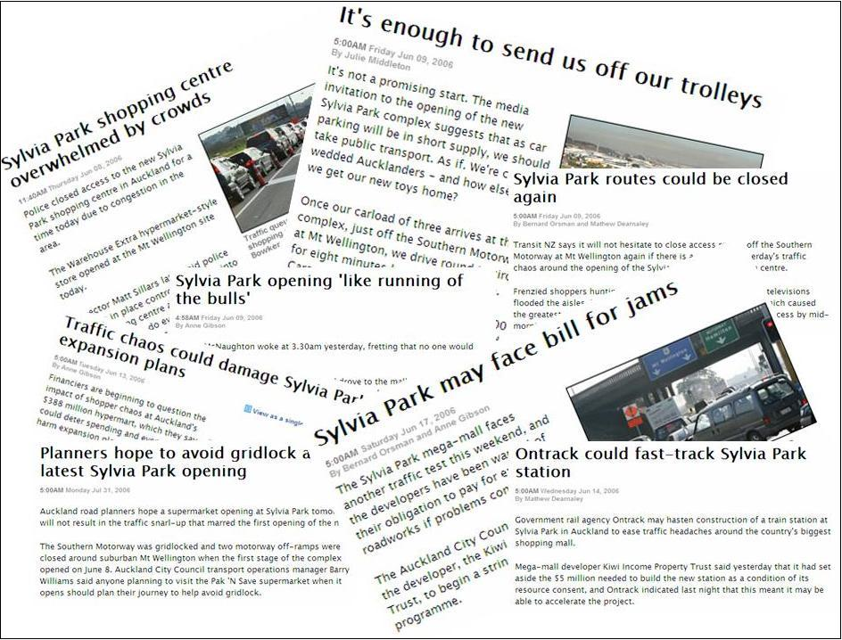
Figure 1: Media Coverage of Sylvia Park Traffic Issues during the Opening Period
surrounding road network
Figure 2 shows the location of Sylvia Park in relation to the surrounding road network, along with the various access points from the road network to the internal ring road, which in turn serves the various parking areas. It is noted that at the time of undertaking the surveys, Entry 4 (that connects to Waipuna Road) had yet to be constructed.
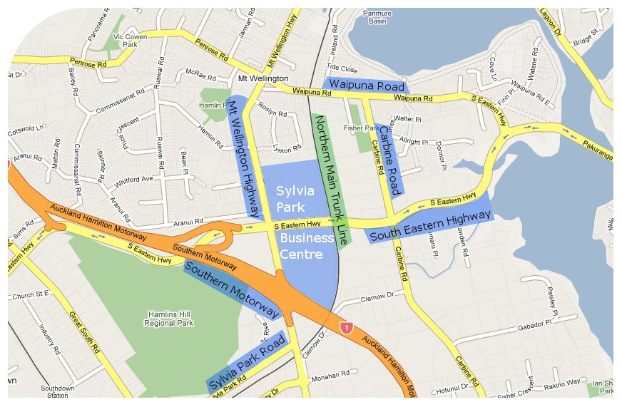
Figure 2: Sylvia Park Surrounding Road Network and Vehicle Entrance Points
5
4
3
2
1
Auckland CBD 12 km
Manukau City 10 km

Details of the surrounding road hierarchy as identified in the District Plan are provided in Table 1.
Table 1: Road Network Details
Road Name | Travel Direction | Number of Through Lanes | Vehicles per Day | Road Classification
Mt Wellington Highway | NB | 2 | 16,960 | Regional Arterial Road
Mt Wellington Highway | SB | 3 | 16,800 | Regional Arterial Road
Southern Motorway | NB | 2 | 49,530 | Strategic Route
Southern Motorway | SB | 2 | 49,713 | Strategic Route
Carbine Road | NB | 1/ 2 | 10,710 | District Arterial Road
Carbine Road | SB | 1/2 | 11,280 | District Arterial Road
South Eastern Highway | EB | 2 | 28,275 | Strategic Route
South Eastern Highway | WB | 2 | 28,279 | Strategic Route
Waipuna Road | EB | 2 | 4,965 | Regional Arterial Road
Waipuna Road | WB | 2 | 5,910 | Regional Arterial Road
Current statistics
Current statistics for Sylvia Park include:
- A total of 72,525 m² GFA of retail and entertainment activities
- Approximately 12 million customers per year
- 240,000 vehicle trips per week, comprising 120,000 vehicles in and 120,000 vehicles out
- Approximately 3,800 car parking spaces
- Train station and internal bus stop, which was privately funded by Kiwi Income Property Trust. The Sylvia Park railway station is the third busiest train station in Auckland
The Sylvia Park Business Centre Concept Plan G14-15 (Concept Plan) provides for up to 148,000 m² of development at the Sylvia Park Business Centre. The difference between the current retail area and the total area provided in the Concept Plan predominantly includes Commercial activities.
Transport Choices available
A number of transport choices are available to travel to/from Sylvia Park including:
- Private Vehicle – there are currently some 3,800 car parking spaces served by five accesses. All parking is provided for on site, with little opportunities available off site, due to the surrounding road network and industrial areas bordering the site.

- Bus – There are bus routes into the site with bus stops located on both sides of the internal ring road, at the front of the shopping centre. All of the buses travelling on Mt Wellington Highway travel into Sylvia Park and service the bus stops provided on site. These bus stops are located along the ring road allowing the buses to easily and quickly divert into the centre using Entrances 1 and 2. The bus routes and frequencies that pass through or adjacent to Sylvia Park are detailed below.
Table 2: Existing Bus Services
Road Name | Number of Routes | Routes | Peak Frequency | Off-Peak Frequency
Mt Wellington Highway (pass through Sylvia Park) | 7 | 50F, 52F, 502, 512, 522 717, 009 | 30 minutes | 30 minutes
Carbine Road | 7 | 530, 532, 757, 359, 506, 511, 61 | 1 hour | 2 hour
Waipuna Road | 6 | 530, 532, 757, 359, 506, 511 | 1 hour | 2 hour
- Train – A train station is located immediately adjacent to the shopping centre with services having commenced on 2 July 2007. An electronic time table showing train times is located inside the shopping centre. Passenger services between Britomart (Auckland CBD) and Papakura/Pukekohe (South Auckland) are presently servicing the Sylvia Park rail station via the adjoining south-eastern rail line. The commuter services are currently servicing the Sylvia Park rail station with 30 minute frequencies during the majority of the day, 1 hour frequencies at the beginning and end of each day, and 10 to 20 minute frequencies during the peak periods. Rail services on Saturday and Sunday service the Sylvia Park station with 30 minute frequencies during the majority of the day. Rail services have been added to the south-eastern rail line in part as a response to the increased demand for rail services from Sylvia Park
- Walking and cycling facilities including pedestrian waypoints throughout the site, and bicycle racks at various locations. A pedestrian and cycleway linkage has been constructed from the north eastern roundabout along the future northern access route from Sylvia Park to Rosyln Road. A pedestrian and cycleway linkage has also been provided along the eastern access to Carbine Road. These paths connect footpaths within the centre with footpaths outside the centre. In addition to providing pedestrian and cycle connectivity to the centre, these paths also provide a link between the Carbine Road area and the Waipuna Road area.
Resource Consent Condition 24
A condition of the resource consent for Sylvia Park included a requirement for the development and implementation of a Traffic Monitoring Plan. The purpose of this was to ensure that any traffic impacts related to the centre could be quantified and also mitigated if the need arose.
Data collected as part of the Traffic Monitoring Plan included:
- Entrance traffic count data
- Public transport patronage data (bus and train)
- Surrounding road network operation surveys that capture journey times and queue details
- Car parking occupancy surveys
The results of this data collection exercise are presented in the following sections of this report.
Data Collection
Development Stages
Data has been gathered in conjunction with different stages of Sylvia Park being opened. Development stages comprised of various stores and activities and these stages are summarised in the table below.
Table 3: Stage Details
Time Period | Stage | Key Activities | GFA | Parking Spaces | PT Options
June 2006 | Stage 1.1 | The Warehouse Xtra, Foodtown, southern precinct | 22,820 m² | 1,653 | Bus
August 2006 | Stage 1.2A | Pak’n Save | 29,015 m² | 2,106 | Bus
September 2006 | Stage 1.2B | Fashion precinct | 36,995 m² | 2,650 | Bus
October 2006 | Stage 1.3 | Entertainment and leisure activities | 60,070 m² | 2,650 | Bus
June 2007 | Stage 1.4 | Completion of retail, leisure, entertainment activities | 72,525 m² | 3,190 | Bus/Train
Mode Specific Data Collection
Following the completion of each of the above development stages, trip generation surveys were undertaken gathering information on vehicle trips and also bus patronage. The surveys were conducted during the Thursday evening (which is late night for shopping at Sylvia Park) and Saturday midday periods. Specific survey times and data collection methods are detailed below.
Vehicles entering and leaving the site (SCATS and video surveys):
- Thursday Evening Peak – from 4:00 pm to 8:30 pm
- Saturday Midday Peak – from 10:30 am to 16:00 pm
Bus Patronage (manual surveys):
- Thursday Evening Peak – from 4:00 pm to 8:30 pm
- Saturday Midday Peak – from 10:30 am to 4:00 pm
Surveys on train patronage and also vehicle occupancy were undertaken after completion of the final stage of development. Again, the surveys were conducted during the Thursday evening and Saturday midday periods. Specific survey times are detailed below.
Train Patronage (manual surveys):
- Monday to Friday – from 7:00 am to 6:00 pm
- Saturday and Sunday – from 7:00 am to 6:00 pm
Vehicle Occupancy (passengers per vehicle – manual surveys):
- Thursday Evening Peak – from 3:30 pm to 6:30 pm
- Saturday Midday Peak – from 11:30 am to 2:30 pm
Vehicle Trip generation results
Weekday Evening Peak Hour
Table 4 shows the vehicle trips in and out of Sylvia Park (the generator) during the weekday evening peak hour.
Table 4: Weekday Evening Vehicle Generation Results
Stage | GFA | Peak Hour Vehicle Trips | Distribution |  | Trip Rate (veh/100m²)
Stage | GFA | Peak Hour Vehicle Trips | % Entering | % Exiting | Trip Rate (veh/100m²)
Stage 1.1 | 22,820 m² | 1,371 | 43% | 57% | 6.01
Stage 1.2A | 29,015 m² | 1,726 | 42% | 58% | 5.95
Stage 1.2B | 36,995 m² | 1,774 | 46% | 54% | 4.80
Stage 1.3 | 60,070 m² | 2,379 | 50% | 50% | 3.96
Stage 1.4 | 72,525 m² | 2,883 | 56% | 44% | 3.98
As expected the number of vehicle trips generated by Sylvia Park increases as the shopping centre GFA increases. The distribution of traffic during the later stages (Stage 1.3 and 1.4) are consistent with the ITE manual that estimates vehicle distribution as 53% entering and 47% exiting. With regard to the adjacent road network weekday evening commuter peak hour (4:30 pm to 5:30 pm) 2,700 vehicle trips were recorded entering and exiting Sylvia Park following the opening of Stage 1.4.
The same information has been presented as a vehicle trip rate per 100 m² GFA and is shown in Figure 3. The surveyed trip rate is compared in this figure to the resource consent predicted trip rate of 5.67 vehicle trips per 100 m² GFA. The consent rate was based on a number of sources, but was predominantly derived by factoring a surveyed trip rate of a large Auckland based shopping centre, using the ITE Manual for guidance.
Figure 3: Vehicle Trip Rates - Weekday Evening Peak Hour

The surveyed vehicle trip rate decreases with the increase in GFA as each stage of the development was completed. The surveyed trip rate starts out slightly higher than the resource consent prediction (as expected due to the smaller development size), however the current development has a lower trip rate than predicted during the resource consent assessments.
Figure 4 provides a comparison against vehicle trip rates contained in the Institute of Transportation Engineers (ITE) Trip Generation Report (2003) for Shopping Centre and Supermarket uses. It is important to note that the American shopping centres from which the ITE trip rates are based do not typically include supermarkets. The two activities are separate. Like most shopping centres in New Zealand, shopping centres include supermarkets.
Figure 4: ITE Comparison - Weekday Vehicle Trip Generation Rate
The supermarket trend line has been extended to 15,000 m² GFA as this represents the amount of supermarket GFA at Sylvia Park at the time of surveys. The Sylvia Park weekday trip rate sits in between the ITE supermarket and shopping centre trip rates.
Weekend Midday Peak Hour
Table 5 shows the vehicle trips in and out of Sylvia Park (the generator) during the weekend midday peak hour.
Table 5: Weekend Midday Vehicle Generation Results
Stage | GFA | Peak Hour Vehicle Trips | Distribution |  | Trip Rate (veh/100m²)
Stage | GFA | Peak Hour Vehicle Trips | % Entering | % Exiting | Trip Rate (veh/100m²)
Stage 1.1 | 22,820 m² | 2,005 | 52% | 48% | 8.47
Stage 1.2A | 29,015 m² | 2,198 | 52% | 48% | 7.58
Stage 1.2B | 36,995 m² | 2,711 | 55% | 45% | 7.33
Stage 1.3 | 60,070 m² | 3,251 | 50% | 50% | 5.41
Stage 1.4 | 72,525 m² | 3,504 | 58% | 42% | 4.83
Again, the number of vehicle trips generated by Sylvia Park increases as the shopping centre GFA increases. The distribution of traffic during the later stages (Stage 1.3 and 1.4) is similar to the ITE manual that estimates vehicle distribution as 51% entering and 49% exiting. With regard to the adjacent road network Saturday midday peak hour (12:30 pm to 1:30 pm) 3,341 vehicle trips were recorded entering and exiting Sylvia Park following the opening of Stage 1.4.
Figure 5 presents the data as a vehicle trip rate per 100 m² GFA. The surveyed trip rate is compared to the resource consent predicted trip rate which was 7.05 vehicle trips per 100 m² GFA.
Figure 5: Vehicle Trip Rates - Weekend Midday Peak Hour
Similar to the weekday evening peak hour, the surveyed vehicle trip rate decreases with the increase in GFA as subsequent stages are completed. Again, the surveyed trip rate starts out slightly higher than the resource consent prediction, with the current level of development having a lower trip rate than predicted during the resource consent assessment. Figure 6 provides a comparison against vehicle trip rates contained in the ITE Trip Generation report (2003) for Shopping Centre and Supermarket uses.
Figure 6: ITE Comparison - Weekend Vehicle Trip Generation Rate
Bus Patronage
Weekday Evening
Table 6 shows the number of passengers boarding and alighting at Sylvia Park during the weekday evening period from 4:00 pm to 8:30 pm. With the opening of Stage 1.4, the final development stage, bus passenger numbers (boarding and alighting) were recorded to have increased almost fourfold since the opening of the first stage.
Table 6: Weekday Evening Bus Patronage by Stage (4:00 pm to 8:30 pm
 | Stage 1.1 | Stage 1.2A | Stage 1.2B | Stage 1.3 | Stage 1.4
Weekday Evening Alighting | 9 | 11 | 19 | 10 | 35
Weekday Evening Boarding | 15 | 36 | 35 | 31 | 59
Total Passengers | 24 | 47 | 54 | 41 | 94
Total Buses | 19 | 17 | 20 | 17 | 22
Average passengers per bus | 1.3 | 2.8 | 2.7 | 2.4 | 4.3
During the weekday evening commuter peak hour (4:30 pm to 5:30 pm) 39 people used the bus to travel to and from Sylvia Park following the opening of Stage 1.4.
Weekend Midday
Table 7Error: Reference source not found shows the number of passengers boarding and alighting at Sylvia Park during the weekend midday period from 10:30 am to 4:00 pm. With the opening of stage 1.4, the final development stage, bus passenger numbers (boarding and alighting) have more than doubled since the opening of the first stage.
Table 7: Weekend Midday Bus Patronage by Stage (10:30 am to 4:00 pm)
 | Stage 1.1 | Stage 1.2A | Stage 1.2B | Stage 1.3 | Stage 1.4
Weekend Midday Alighting | 36 | 28 | 37 | 72 | 77
Weekend Midday Boarding | 33 | 42 | 32 | 96 | 79
Total Passengers | 69 | 70 | 69 | 168 | 156
Total Buses | 19 | 21 | 16 | 22 | 23
Average passengers per bus | 3.6 | 3.3 | 4.3 | 7.6 | 6.8
During the weekend midday peak hour (12:30 pm to 1:30 pm) 25 people used the bus to travel to and from Sylvia Park following the opening of Stage 1.4.
TRAIN PATRONAGE
As noted previously the train station at Sylvia Park opened on 2 July 2007, just after the completion of Stage 1.4. Train passenger numbers were surveyed over a week, from 7:00 am to 6:00 pm each day. As can be seen in Table 8, Saturday sees the highest number of people, some 890, arriving and departing Sylvia Park by train.
Table 8: Weekly Train Patronage
 | Monday | Tuesday | Wednesday | Thursday | Friday | Saturday | Sunday
Total Alighting | 326 | 413 | 395 | 444 | 484 | 485 | 310
Total Boarding | 290 | 368 | 353 | 337 | 388 | 406 | 283
Total Passengers | 616 | 781 | 748 | 781 | 872 | 891 | 593
Total Trains | 55 |  |  |  |  | 34 | 22
Passengers per Train | 11 | 14 | 14 | 14 | 16 | 26 | 27
During the weekday evening commuter peak hour (4:30 pm to 5:30 pm) 110 people used the train to travel to and from Sylvia Park following the opening of Stage 1.4.
During the weekend midday peak hour (12:30 pm to 1:30 pm) 109 people used the train to travel to and from Sylvia Park following the opening of Stage 1.4.
Vehicle Occupancy
In order to better understand the total number of people/customers travelling to and from Sylvia Park by car, vehicle occupancy surveys were undertaken at the main access point to gauge the number of occupants in each car.
Vehicle occupancies were surveyed on a Thursday night, which is a late night shopping night, between 3:30 pm and 6:30 pm. During the weekday evening peak, single occupant vehicles make up the majority (approximately 65%) of vehicles arriving at Sylvia Park. During the weekday evening commuter peak hour (4:30 pm to 5:30 pm) the number of people per car was recorded to be 1.36 for Stage 1.4.
Vehicle occupancies were surveyed also on a Saturday between 11:30 am and 2:30pm. During Saturday vehicles with two occupants make up almost half of all vehicles travelling to and from Sylvia Park, with single occupant vehicles making up around 30% of vehicles travelling to and from Sylvia Park. During the weekend midday peak hour (12:30 pm to 1:30 pm) the number of people per car was recorded to be 1.99 for Stage 1.4.
 | 1/Vehicle | 2/Vehicle | 3/Vehicle | 4/Vehicle | 5/Vehicle
Weekday Evening | 46.7% | 25.3% | 7.3% | 2.5% | 0.2%
Weekend Midday | 31.7% | 47.3% | 13.8% | 6.0% | 1.1%
Table 9: Vehicle Occupancies
Overall Mode Split
The overall mode split for Sylvia Park during the weekday evening and weekend midday adjacent road network peak hours are summarised in Table 10Table 10.
Table 10: Mode Splits – Sylvia Park Stage 1.4 (2007)
 | Weekday Evening Peak  (4:30 pm to 5:30 pm) |  | Weekend Midday Peak  (12:30 pm to 1:30 pm)
 | People Trips | % | People Trips | %
Vehicle Driver | 2,700 | 70.5 | 3,341 | 49.0
Vehicle Passenger | 972 | 25.4 | 3,308 | 48.5
Bus | 29 | 0.8 | 25 | 0.4
Train | 110 | 2.9 | 109 | 1.6
Walk & Cycle | 19 | 0.5 | 34 | 0.5
Conclusion
In conclusion, the assumptions used by Transport Planners for the design and consent stages of Sylvia Park were conservative. The traffic surveys undertaken demonstrate how traffic flows for a typical day at Sylvia Park are lower than that initially envisaged Traffic generation at Sylvia Park for each of the opening stages supports the concept that as retail floor area increases for shopping centres, trip rates decrease.
References

Book
INSTITUTE OF TRANSPORTATION ENGINEERS (2003). Trip Generation 7th Edition, Fifth Printing, USA.

Report
FLOW TRANSPORTATION SPECILAISTS (2007). Sylvia Park Business Centre: Stage 1.4, Traffic Monitoring Report Update, December 2007, Reference AR061107-1, New Zealand
Acknowledgements
Flow Transportation Specialists
Kiwi Income Property Trust – Owners of Sylvia Park Centre

