PRACTICAL VIEWS ON NEW SURVEY TECHNOLOGY

AUTHOR
Scott Benjamin
BE (Civil), MSc, CEng, Member of AITPM Victorian Committee
General Manager, Austraffic (Victoria).
Email: scott.benjamin@austraffic.com.au

ABSTRACT

Over recent years a number of new traffic counting and monitoring technologies have been touted as revolutionising traffic engineering or traffic management with the provision of accurate and cost effective real time or historical data.

Bluetooth is one of these ‘new’ technologies and although it is becoming more common for traffic monitoring and travel time services, a detailed understanding of the practical limitations of the technology is not well understood. Key issues include: sample rate, repeatability, survey and privacy / surveillance issues.

Austraffic has a unique position in the Australian market having been significant users and developers of a range of counting technologies (such as tube and inductive loop based counting systems and a variety of camera based systems).

In the last 18 months we have undertaken extensive testing of Bluetooth and Wifi monitoring equipment and now offer ad-hoc and permanent sensor data monitoring services, with the difference being that we know the limitations, technical and legal.

The paper considers a range of tried and trusted technologies which could be combined and contrasted to provide a better picture of the historical and real time status of the transport network. The paper also outlines key issues with the utilisation of new forms of mass data like Bluetooth, where the weaknesses are and how these weaknesses can be mitigated or avoided altogether with sound survey methodologies.

INTRODUCTION
Austraffic is a traffic and transport survey collection and data management company which has introduced many new technologies into survey use over the last 30 years. Surveyors have a unique opportunity to test and validate new methodologies as we ultimately take responsibility for the quality of the data provided. Understanding comparability of different survey methodologies and outputs from new and different technologies is a necessity to ensure accurate and appropriate data can be delivered cost effectively.

This paper outlines some comparison between new and existing survey technologies. The list of comparisons is not exhaustive and has been formed to allow comparison and understanding of new Bluetooth (BT) MAC address monitoring technologies. This paper will focus on BT in particular as there are a wide range of BT solutions being marketed for survey, and or permanent monitoring solutions.

BACKGROUND – TECHNOLOGIES AVAILABLE
Traffic engineers, modellers and transport planners, need to carefully weigh up potential survey data sources. There will always be a trade-off between quality, price and timescales to collect data for a given project. Table 1 below outlines a sub-set of some of the most common survey needs (seen in blue at the top of the table) versus the common methodologies and technologies.

From our most recent experiences based on client request the two most common relatively new survey technologies are: 1) Camera based technologies (automated or manual review) and 2) BT surveys.

Austraffic have reviewed automated forms of camera based technologies, including Automatic Number Plate Recognition (ANPR) and machine based Image Recognition for counting and classification purposes. As a generalisation, we note from our reviews that the accuracy of both of these automated forms of technologies is significantly overstated for most survey conditions. We note that it may be possible to get quoted levels of accuracy for permanent sites, particularly in areas with controlled light conditions e.g. tunnels. Errors from automated processing can at times be consistent, however, varying light conditions are a significant variable that need to be well understood, and may potentially effect different turning movements for different times of day due to the impact of shadows and reflections (Kumar, 2007). In addition, depending on the type of image recognition used this form of survey can take significant periods of time to set up and configure the count is a necessity, this can erode any potential efficiency savings from the automation of the counting process.
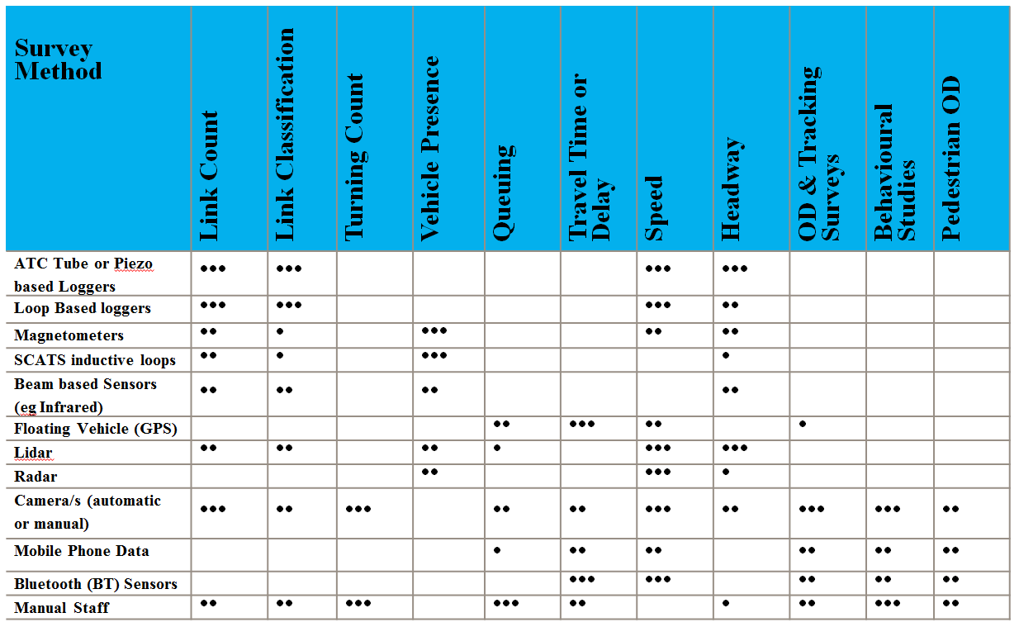
Key: • Minor Potential, •• Significant Potential with Limitations, ••• Appropriate for purpose
Table 1: Survey requirement (in blue) against survey methods (old and new), Benjamin, S (2013).

Austraffic believes that there is potential to continue to improve automated image recognition systems in the future. In the interim camera based systems should be compared with tried and tested methods e.g. manual counting and classification of the data across a range of light conditions, turning movements and traffic densities. The most positive aspect about camera based survey technologies is that the raw video files should be made available to allow the client to review the quality of the data provided. In comparison, there is no readily apparent methodology to validate BT technology and “remote” forms of data collection such as mobile phone based tracking. Whilst BT and remote forms of technology offer tremendous opportunity to collect mass data at a relatively low price this doesn’t necessarily mean that this is good value for money for any given survey. There is a need for focused validation of new technologies to understand their strengths and weaknesses and how they can be effectively compared to existing benchmark methods and technologies to allow clients to make informed decisions about the real value of using such data. In Victoria, we have seen large data sets of bulk data used un-validated as key inputs to major business cases. Given these circumstances Austraffic set out to validate the use of BT data.

REVIEW OF BLUETOOTH TECHNOLOGY
Austraffic began reviewing a range of BT Solutions two years ago. We reviewed a range of technologies, each for between 3 to 6 months on a range of standard test sites, which included local roads (suburban), urban arterial roads, rural arterial road, and metropolitan freeways. Validation of BT equipment has often been undertaken by driving a vehicle with multiple active BT devices passing a number of BT monitoring devices. Whilst this may provide some indication of the reliability or likelihood of a certain type of device being monitored, it does not assist in understanding how many devices are present in the vehicle stream as a whole. We sought to bench mark each system against a common set of measurements by validating BT device read rates to automatic tube counters (ATC) and video (count and number plate surveys); we compared tens of thousands of records during the course of the validation of the following:
- Read rate
- Repeatability

Read rate was considered in terms of number of MAC addresses per 100 vehicles identified once buses, pedestrian, cyclists and background devices were removed. We found that the read rate varied perhaps a little across different types of road and importantly could be unknowingly biased if great care is not taken in the setup of sensors which is discussed in further detail below. The key statistic which traffic engineers require is the number of vehicles that are equipped per 100 vehicles passing a sensor. This is not easy to determine without detailed vehicle-by-vehicle analysis given that BT detection is a “zone” not “point” based location detection (see Figure 1). With careful analysis, it is possible to infer the number of vehicles which are acting as probes at a particular point in time. This is an important element to understand IF the device relies on this information with factoring as part of Origin Destination Studies. It is not possible to accurately reference and compare read rates. Other studies have over time quoted read rates of between 15 and 40%. In Australia from testing of a range of devices, we found read rates on the same section of road but with differing devices between 15 and 35%. In additional, we were able to match another 10% to 15% using Wifi Macs with one particular device. We found that one of the devices we tested consistently yielded over 30% BT sample rate in a range of conditions.

Repeatability is an extremely important characteristic. It indicates the likelihood of MAC address collected at one point being collected again the next time the vehicle goes past a sensor. We have not found this figure quoted formally by many equipment manufacturers. From our extensive testing, we found repeatability to be as low as 50% for some devices (which also had low read rates) to over 90% in the case of the product we eventually selected. The manufacturer of the most repeatable product quote levels as high as 98% in slow moving traffic conditions.

We undertook a range of survey on freeways. Some of these were noted to be problematic (Benjamin, 2013) where we were relying on omnidirectional consideration of the Mac address target areas. Figure 1 below outlines and example of this problem, with vehicles outlined in red which are located on another freeway ramp unintentionally being monitored. This led to some unintended and significant biases in the final data produced from the BT survey in comparison to an extremely accurate camera based survey (97% sample). Ways of mitigating this form of survey bias are outlined in Strengths, Weaknesses section below. What is very different about BT technology to other forms of survey is that there is little to no easy way to identify the survey error outlined below without secondary forms of measurement.

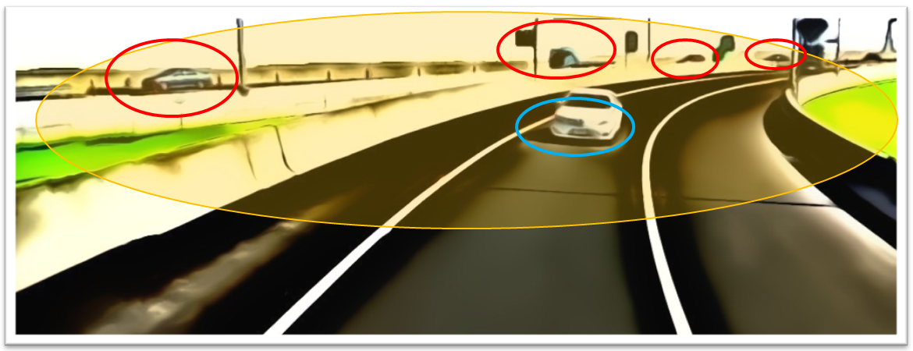
Figure 1: Target area (also for cameras) in blue, a large zone actually being captured in yellow and unwanted / unintended vehicles monitored in red.

PRACTICAL CONSIDERATIONS TO IMPLEMENT BLUETOOTH
As well as considering the quality of data provide by a given technology or methodology, it is important to consider the practical application of the technology these are outlined below.

DATA SURVEILLANCE AND PRIVACY ISSUES
Austraffic note that this is one of the most important and conversely poorly understood issues in the Australian Traffic Engineering / Transport Planning industry. There is a lot of confusion regarding these issues, and there has been very poor communication at a practical level regarding how legislation and guidelines could be interpreted. Some of the guidelines, in some Australian states, are about to be reviewed. Our present (though possibly incomplete) interpretation regarding how these issues could be considered is outlined below. Please note that you should always seek a legal interpretation when considering technology which could potentially infringe on one or more of these issues. It is incumbent on organisations using technologies which have the ability to track (such as ANPR and BT) to understand the implication of the legislation in particular as infringements carry heavy fines and custodial sentencing.

Privacy Legislation and guidelines relating to privacy generally relate to the capture of images relating to private activities OR to the association of individuals activities to an individual.

Surveillance Devices Acts relate to the ability to track an individual OR object, regardless of whether the individual can be immediately identified (e.g. matching a MAC address to a database containing MAC addresses and personal details).

Our current understanding of the implication of act and guidelines and acts in Australia have the following implications for automated forms of data collection which track an individual OR object (ie vehicle) using ANPR and BT are related to Surveillance Devices acts, however, there may be some organisations particularly government agencies with access to personal data that also need to be cognisant of Privacy acts and guidelines.

The use of BT and ANPR is technically prohibited in Western Australia, Victoria, South Australia and New South Wales under Surveillance Devices Acts. There is no Surveillance Devices Act in Queensland, as a result, there seems to be a practical interpretation that these devices can be used Queensland. In practice, there have been trials and installations made by exception in South Australia and New South Wales of either or both BT and ANPR. After targeted consultation Austraffic has recently completed an extensive BT trial for VicRoads in Victoria to monitor travel times of alternative routes during long term tunnel closures on the M1 corridor.

At a pragmatic level privacy and surveillance issues relating to ANPR and BT may be considered as a technical “non-issue”. Robust procedures and technical solutions are required to ensure the perceptions of privacy and surveillance concerns are dissipated. There are obvious ways for the data to be further anonymised this is, in addition to the fact that, the MAC address is never normally associated to an individual at any point during the purchase of the device. Community engagement with the issues has been poor. Austraffic have made representations to Austroads and the National Road and Transport Commission (NRTC) seeking greater clarity around the ongoing use of these devices, rather than limited approval of individual trials. At present, some authorities and some surveyors choose to ignore or are ignorant of existing legislation in a number of Australian states. Austraffic and some other contractors choose to comply with current State based legislation.

What is perhaps more concerning than BT survey privacy issues are the volumes of location data collected about individual movements in public and private space by mobile phone operators and handset, tablet, and satellite navigation device providers, perhaps unknowingly as a condition of use of a service or technology buried deep within terms and conditions rarely read by customers. These issues are only just beginning to be understood by users of these products and worthy of further open discussion within the community.

INSTALLATION, GROUND TRUTHING AND VALIDATION
BT technology solutions provided by some suppliers can be and is often relatively simple to set up. Key aspects that we considered important were:

- Potential to adjust sensor direction
- Weight and fixings of unit. Important to security, public safety and safety of installers
- Remote access to monitor unit performance and adjust key unit settings
- Power usage and flexible power options
- Data quality. Sample rate (capture rate) and repeatability as mentioned in the review of BT technology above, these measurements are poorly understood
- Data filtering and presentation. There a lack of understanding and transparency relating to data filtering.
- Survey monitoring and real time feedback during survey

It is interesting to see the different ways that BT solutions are deployed for survey usage. Some suppliers position the sensor at ground level due to the weight of the devices (particularly the batteries). Other manufacturer’s note that the height of the device is fixed at the road side is a vital factor affecting the potential to capture MAC Addresses. The potential sample rate needs to be considered in the context of the length of the link being surveyed and the proportion of through traffic to consider whether the level of matches you are collecting will be significant. Other devices are recommended to be installed at a height of between 3 and 5 metres above the ground. There is a careful balance to be struck in considering the potential level of capture versus OH&S issues involved in working from height. When working on freeways any disruption to traffic flow for installation and monitoring has significant implications on safety of workers and the traveling public. However, it is important to consider that an installation at height will result in a greater level of capture which can in turn result in the need for fewer units to be installed.

STRENGTHS AND WEAKNESSES AND MITIGATION
Every form of survey technology will have a range of strengths and weaknesses. These are summarised below for the device selected by Austraffic for ongoing use, which has significant flexibility:

Strengths:
- Ease of installation and collection of bulk data
- Ability to check sensor performance remotely in real-time
- High levels of repeatability of MAC address identification

Weaknesses:
- Lower level sample rate collected (approx. 30%) in comparison to other forms of survey
Mitigation: This is itself is not necessarily a weakness as long as there are high levels of repeatability and the sample rate is understood (compared to a secondary form of measurement)
- It is difficult to confirm vehicle type from a MAC address alone, there are some factors that can be discerned from the MAC address
Mitigation: Need for secondary sensors
- Difficult to check for survey bias (e.g. situation outlined in Figure 1) without secondary forms of measurement or directional antennae and complex filtering algorithms
Mitigation: Use of multiple and adjustable antennae
- Bias can be induced from a single vehicle carrying more than one BT device e.g. two people with two phones in a car, or more people and more devices on a bus or tram.
Mitigation: Filtering mechanisms which can recognise and remove multiple matches from a single vehicle
- Temporal errors: Wang et al (2011) undertook a detailed analysis of this phenomenon which is due to the fact that BT detection is based on zones. This review noted the error to be within 4 to 7% of camera based comparisons. This is still significant and needs to be considered when using the technology for travel time surveys.
Mitigation: Use of multiple sensors (and care in dealing with strength of reading will minimise their errors); however, these errors should be carefully considered if these devices need to be used.

With all of the above potential weaknesses, there may generally result in minimal impact on statistical significance and use for travel time purposes as long as there is a statistically valid sample of surveyed vehicles traveling end-to-end through the chosen survey area. However, when considered for Origin Destination Surveys, which are far more susceptible to survey bias, Wang et al (2011) noted that there is a need for improvements to filtering techniques, and the use of multiple sensors to try to reduce bias and survey errors.

CONCLUSIONS
This paper outlined a range of potential survey solutions for common survey requirements focusing on Bluetooth MAC Address based surveys for the Travel time and OD surveys. The technology offers the opportunity to monitor travel time and potentially undertake OD surveys (when partnered with a robust validation process) at relatively low cost in comparison to other survey methods in some circumstances, particularly when used over extended survey periods.

We have been reviewing a range of different BT systems over the last two years. We have noted a wide range of read rates and repeatability levels quoted and an even wider range of results in practice from the validation studies we have undertaken. In some Australia we note that capturing over 30 unique device MAC addresses per 100 vehicles from BT alone is possible in many road environments and that Wifi has the potential to substantially increase that capture rate. It is important to note that a high level of repeatability is vital. Without repeatability the capture rate can never be properly realised and there is the potential to introduce significant biases into all forms of survey.

Some obvious BT survey biases are caused by counting multiple devices in a single vehicle, predisposition to slower moving vehicles or potentially bicycles, tram or bus based devices, and with some less developed systems unknowingly targeting the wrong vehicle flows. All of these issues can be substantially mitigated with the use of multiple, directional antennae and robust, transparent, filtering processes. For OD surveys we note that the use of secondary forms of survey to confirm the sample rate is a necessity as is some form of secondary identification survey (e.g. using cameras to identify light versus heavy vehicles) so that any survey biases can be clearly understood and mitigated.

REFERENCES

Benjamin, S. (2013). “Real time and historic data in a blender”. AITPM National Conference, (July 2013) Traffic Engineering Stream, Perth

Porter, J. D., Kim, D. S., Park, S., Saeedi, A. and Magana, M. E. (2012). Wireless Data Collection System for Travel Time Estimation and Traffic Performance Evaluation.
Final Report SPR 737 OTREC-RR012-06.

Praveen Kumar, Ankush Mittal and Padam Kumar, Informatica Journal (2007) “Study of Robust and Intelligent Surveillance in Visible and Multi-modal Framework Number 31, Page 447-461

Wang, Yinhui, Malinovskiy, Yegor, Wu, Yai-Jan, Lee Un Kun, University of Washington, (2011) “Error Modeling and Analysis for Travel Time Data Obtained from Bluetooth Mac Address Matching”

ACKNOWLEDGEMENTS
The author recognises the support and input of Austraffic colleagues David Michell and John Reid. The author also wishes to thank the suppliers of all equipment loaned to Austraffic to allow us to undertake trials of their equipment.

