

Electric vehicle socialisation, in Christchurch
Martin Brown-Santirso M.Sc.
Senior Advisor Transport
Martin.brown-santirso@eeca.govt.nz

ABSTRACT

Electric vehicles (EVs) are an emerging technology that has the potential to dramatically change the way we use energy for transportation. EVs are four times more efficient than conventional vehicles (around 250Wh per km compared to around 1000Wh), and in countries with a large proportion of renewable electricity such as New Zealand they provide a significant and real opportunity to reduce carbon emissions.

However, while EVs are available for sale in New Zealand, uptake has remained low (under 90 as of December 2012). This is a result of high upfront costs, as well as perceptions (some warranted, some not) about the performance, utility, and risks of EVs. With this in mind, EECA and Mitsubishi partnered up to increase awareness and improve businesses’ understanding of EVs.

For this, EECA developed a project to place an EV with a number of the key agencies involved in the reconstruction of Christchurch to socialise the vehicle and influence potential users. It was perceived that the reconstruction efforts presented an opportunity to start future-proofing the city particularly around foreseen changes in transport technologies. The vehicle was placed with each agency for a period of three months and used as a pool vehicle to reach as many users as possible.

Results of the research indicate that the EV had a positive impact on users’ perception and general opinion of EVs. However, likelihood to consider EVs in the next purchase decreased.

Acknowledgements

EECA would like to thank Mitsubishi Motors New Zealand for contributing the use of the iMiev EV and their active participation in the project.

Also, we want to thank the participating agencies in Christchurch for their positive participation and support in hosting the EV and carrying out this research.
- Christchurch Earthquake Recovery Authority (CERA)
- Christchurch City Council (CCC)
- Environment Canterbury (EC)
- Orion

INTRODUCTION

Transport plays a key role in our economic development as a nation and in our day-to-day activities as individuals – yet many people don’t realise its impact on our energy sector.

Transport makes up 38% of total energy used in New Zealand, an energy-intensive activity reliant almost exclusively on petroleum products: last year, an estimated 57 billion litres (~200PJ) of oil products was used for transport (MBIE, 2013, p.18), mostly by cars and trucks.

Unsurprisingly, then, transport is the biggest energy-related source of greenhouse gas emissions in New Zealand (MBIE, 2013a, p.18). The 57 billion litres of oil attributed to transport last year resulted in greenhouse gas emissions of around 14 million tonnes of CO₂e (MBIE, 2013b, p.2), as well as emissions of particulate matter and nitrogen and sulphur oxides that are detrimental to health.

However, the high level of oil consumption and the key role transport plays in the economy raises issues that can pose significant risks for New Zealand and for the world.
- Supplying a growing demand for petroleum fuels with a resource that is ultimately finite
- Exposure to price volatility
- New Zealand’s dependency on foreign fuels
- Security of supply
- Air quality issues
- Increasing the risks from climate change

To mitigate these risks EECA has identified broad areas of action that reduce oil consumption and can help New Zealand to shift away from oil. Some of these include: improving the energy efficiency of vehicles, increasing the renewable energy share in transport, and promoting improved driver behaviour. Specific initiatives in areas underway through EECA include:

- The vehicle fuel economy labelling programme, which allows car buyers to compare the fuel efficiency of vehicles
- Training for heavy vehicle drivers to save fuel and improve safety
- Promoting efficient car tyres

Another solution is the emergence of electric vehicles (EVs). Using battery powered electric motors EVs do not rely on petroleum and produce no tailpipe emissions. Also EVs are 4 times more efficient than conventional vehicles and if the electricity is generated from renewable sources they provide enormous carbon saving potential.

However their uptake to date has been limited due to a number of factors. Chief among these are high prices, range limitations, and public perceptions about the technology readiness and suitability.

EV BACKGROUND IN NEW ZEALAND

EVs (or electric vehicles) refer to vehicles that are partly or wholly powered by an external source of electricity. In the context of this paper, EVs are cars with battery packs that are recharged from an electricity supply external to the vehicle and there are two key variants:
- Battery electric vehicles (BEV) - These are wholly electric
- Plug-in Hybrids (PHEV) - These have a small internal combustion engine as part of the system to extend the range.

The benefits of EVs to New Zealand

The combination of EV’s efficiency and New Zealand’s highly renewable electricity represents a very elegant means of 'greening’ New Zealand’s transport sector.

EVs are about four times more efficient than modern petrol powered cars. Few people realise that for every litre of petrol they put in their car, more than 80% is wasted as heat or transmissions losses – even after 100 years of development, petrol powered cars are only 18% efficient (Consumer Energy Centre, 2014). By comparison an EV only loses around 10% of the energy in the batteries when converting it into motion. Replacing a conventional vehicle with an EV will save around 2 tonnes of CO₂ per year.

Powering around 2 million vehicles would only require around 8% of electricity demand in 2039 (CAENZ, 2010). This is a small amount of energy compared to the oil figures above.

This means for every average petrol car replaced with an EV, we would see a carbon emissions reduction of around 2 tonnes per year, as well as a reduction in local air pollution, and economic benefits associated with a reduction in oil imports.

The suitability of EVs to New Zealanders

EVs are very well suited to New Zealand households.

Most New Zealanders drive an average of 39km per day (Ministry of Transport, 2008), well within the range of EVs currently available. PHEVs provide range security for those motorists concerned with travelling longer distances.

We have high garage ownership that enables convenient and safe off-street charging for most households. The 230 voltage in New Zealand enables convenient home overnight charging for most vehicles.

Recharging at residential electricity rates is equivalent to about 26 cents/litre petrol – adding up to fuel ‘savings’ around $2,000 per year for the average motorist.

The challenge for EVs in New Zealand

However, despite all these benefits, the market for EVs in New Zealand faces a number of barriers including (Spring, 2009; National Academy of Science, 2013):
- Perception/knowledge – Most new technologies have to endure a period of scepticism, especially when the new technology provides a like-for-like substitution. There are a number of perceptions around the utility, safety, complexity, maintenance, costs, etc.
- Infrastructure – In some countries there is need for extensive recharging infrastructure. In New Zealand with the high garage ownership and daily travel demand averaging 39km, EECA believes EVs can be recharged at home or work without an initial need for significant infrastructure.
- Range – The limited range of EVs limits their utility. EVs have a practical range of around 100km, enough for daily city travel, but not for long commutes, or holidays. Even in cases where an EV would be suitable (e.g. around town use) concern about running out of power (“range anxiety”) can put buyers off. The PHEV has been developed to overcome this, and advanced battery technologies are also expected in the market in the coming years to increase the current range limitation.
- Prices – the upfront cost of an EV remain considerably higher than similar conventional vehicles, about twice as much. This is particularly the case in New Zealand compared to overseas markets. Although prices have started to come down, the current prices make EVs uneconomic for most uses, especially at a household level.

With this in mind, EECA undertook the project with Mitsubishi to improve the perceptions and understanding of EVs.

THE PROJECT

In 2012, Mitsubishi and EECA signed an MOU to promote the deployment of EVs in New Zealand. Under this agreement Mitsubishi offered the use of an i-MiEV – Mitsubishi’s first fully electric EV available for commercial release. After exploring a number of options, EECA developed a ‘socialisation’ project for the i-MiEV to assess the effects of experiencing and driving an EV has on participating motorists’ perceptions of EVs.

The project lasted for one year, and was based in Christchurch. The reconstruction efforts provided an excellent opportunity to future proof the city and influence the perception of planners to promote the deployment of EVs. This was also of interest to Mitsubishi as the reconstruction effort following Japan’s 2011 earthquake.

For this reason the four organisations invited to participate were the principal agencies in the Christchurch reconstruction. The EV would stay with each for four months as part of their car pool.

The participating organisations were:
- Christchurch Earthquake Recovery Authority (CERA)
- Christchurch City Council (CCC)
- Environment Canterbury (EC)
- Orion

This gave organisations an opportunity to assess the vehicle’s suitability for their business and their operational needs, as well as fulfilling the project’s aim of socialising the vehicles and improving perceptions. The car was fitted with an eye-catching design to draw attention and generate discussion (see picture 1).

The i-MiEV is a small 4 seat hatchback, similar to a Suzuki Swift or Daihatsu Sirion. It is powered solely by a battery, which can be plugged into a 15 amp power socket. It takes about 8 hours to recharge from empty, and a fully charged vehicle runs for about 100 km. It has a 47 kW motor that provide full torque from zero revs. In other words, the car is quite zippy.

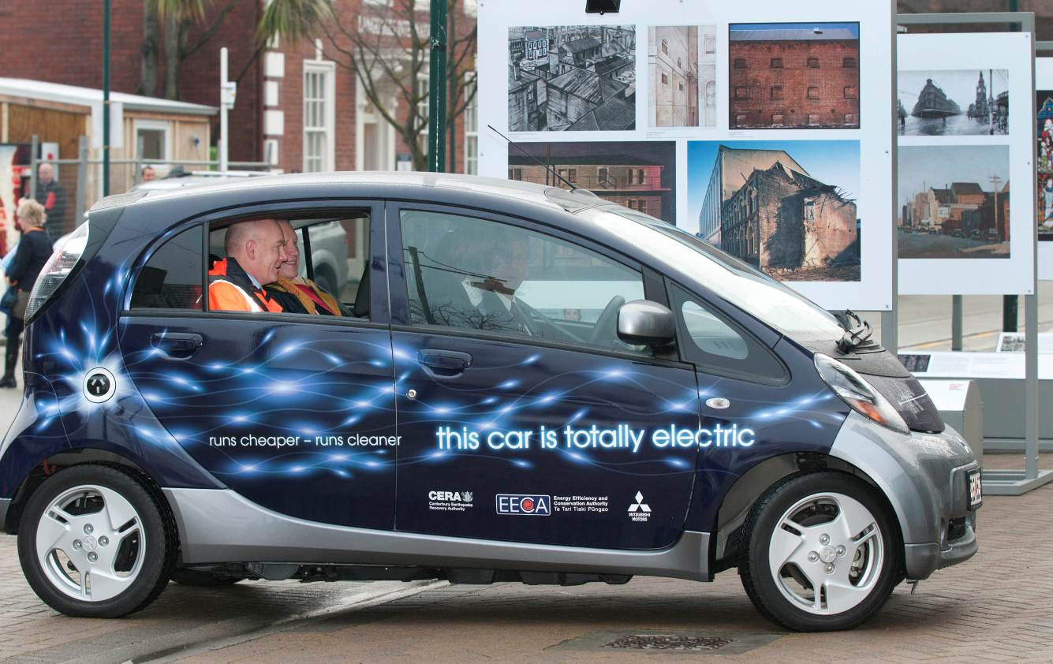

Picture 1 - iMiev test drive by Orion’s chief executive.

The research component of the project aimed to understand how having the vehicle in their fleet would affect users’ perceptions and understanding of EVs in terms of suitability, image, performance, safety, and economics.

The data collection consisted of surveys before and after the EV’s stay with each organisation. The surveys were administered via Survey Monkey and a link sent to all staff in each organisation through an internal communication. The key contacts within each organisation were responsible for administering the survey, and provide follow up. The questionnaires included questions on the awareness of how to recharge EVs, availability of EVs, and the general perception. The surveys were administered two weeks prior to the EV arriving to the organisation and then again as soon as it departed.

RESEARCH RESULTS

The EV was well received by the four organisations, and was used by over 120 unique drivers over the year. The general feedback from the project’s coordinators within each organisation was very positive, and they indicated a high level of interest by the users.

The surveys had around 200 respondents (including from staff that did not drive the vehicle) from the four organisations including members from senior management. The survey concentrated on the awareness and perception of the respondents about the EV in a range of areas:
- Awareness of the existence of EVs and their availability
- Awareness of charging options
- Perception and/or image
- Suitability for personal and organisational use
- Rating the experience of driving the vehicle.

The questionnaires also included questions about the respondents’ transport demand and the practical side of the trial within their organisations. Analysis for these questions is not part of this paper as the paper focuses on the general impact of the experience of driving the vehicle and the perception they have of the vehicle.

Awareness of existence and availability in New Zealand

The aim of these questions was to assess what proportion of the population of the study was aware of what EVs are, whether they are available, and where to obtain one.

The results indicate that the great majority of users were aware of the existence of EVs, if not necessarily their availability in New Zealand or where to get one. Less than one percent of the respondents indicated they were unaware of EVs.

The responses for the question on the availability of different types of EVs in their region provided a strong indication of choice awareness and availability. Figure 1 shows the responses and demonstrates a positive impact created by the vehicle stay within the organisation.

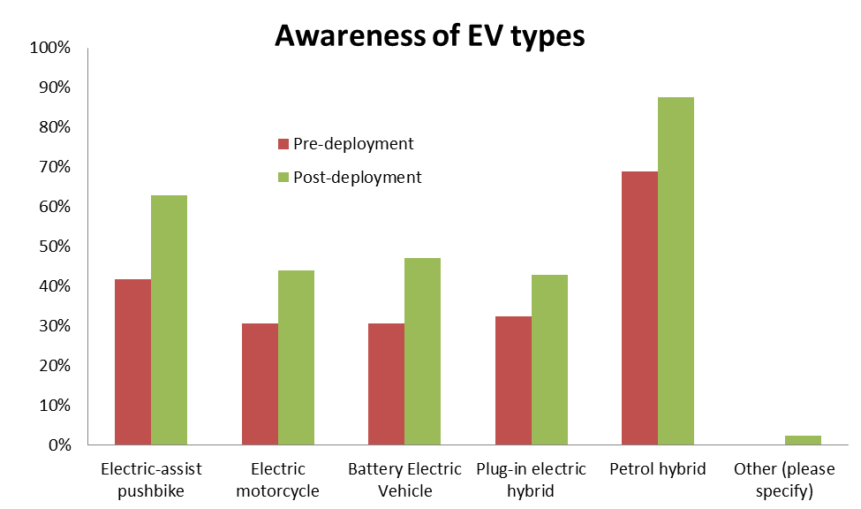

Figure 2 – Reponses to EV choice awareness.

It should be noted that the change will not be wholly due to the experience of the vehicle, but also due to material used in the promotion of the project to staff. This included organisational intranet notices, staff emails, and links to information.

The key implication in this question is that the increased awareness is likely to also increase the probability that users will consider this technology with their next purchase.

Awareness of charging options

This question asked users to volunteer the options available to them now for charging an EV.

The actual responses were varied, ranging from electrical socket to human power, but they can be broadly classified into the categories in Figure 2. The variation expressed is a good indication about the low level of information available about charging options. However, it is positive that the home charging option figures very high as EECA believes that this where the majority of EV charging will happen in the future. It is also consistent with recent EV charging behaviour research (The EV Project, 2013).

The post-deployment survey results showed an increased proportion of ‘don’t know’ responses, and a reduction of the other options. This indicates that while the vehicles were available for their use the project did not provide enough information in the use and operation of the vehicles over the period. This is an area of improvement that has been noted for future efforts.

Awareness of options is important as a market that is well informed about options and performance can better assess the costs and benefits of available choices which can benefit EVs once they become more cost effective.

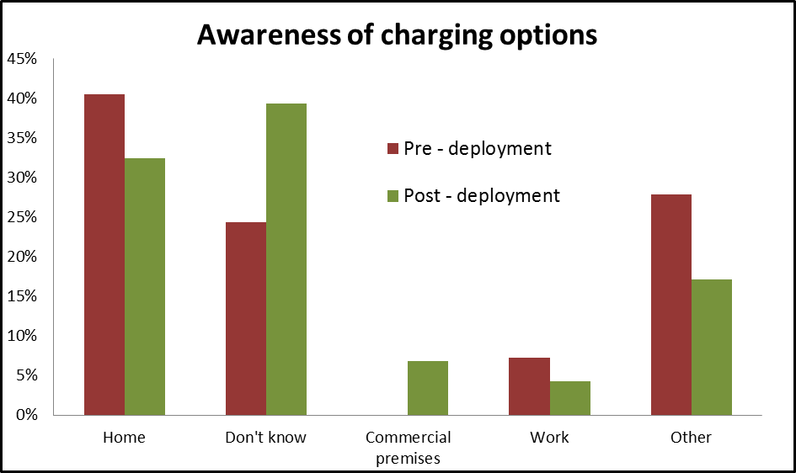

Figure 3 – Awareness of EV charging options.

Perception and/or image

This question asked respondents to provide the first three words that come to mind when thinking of EVs. The key thought is that if users have strongly positive words, it is more likely that they will consider this option when it comes time to purchase.

Again, there were a range of responses and these were classified into three categories:
- Positive word association with EVs, largely associated with:
  - Environmental credentials (e.g. green, clean air, sustainability, efficient)
  - Low running costs (e.g. economical, cost saving, cheap)
  - Image or suitability (e.g. modern, intuitive, cool, logical choice)
- Negative association with EVs
  - Current prices (e.g. expensive, overpriced, rip-off)
  - Performance limitations (e.g. range, power, ‘not there yet’)
  - Maintenance issues (e.g. battery life, replacement costs, maintenance costs)
  - Image (e.g. ugly, shopping basket, ‘housewife vehicle’)
  - Environmental perceptions ( e.g. green wash, increased electricity demand, battery disposal)
- Neutral associations with EVs, generally indicating a feature of the vehicle (e.g. quiet, electric vehicle, brand names related to EVs or hybrid vehicles)

The diversity of words and the use of similar features on both the positive and negative columns reflect top-of-head opinions which are often based on incomplete information (Spring, 2009). For example, concerns related to the disposal of batteries after automotive life are being largely addressed in advance, as modern lithium batteries are expected to have a second life at the end of the motoring life, and they are being designed to be largely recyclable (Popular Mechanics, 2010).

The deployment of the EV had a positive impact on the opinion of respondents: the number of positive associations increased by 9% while the negative associations decreased by 14% in the post-deployment survey (See figure 3)

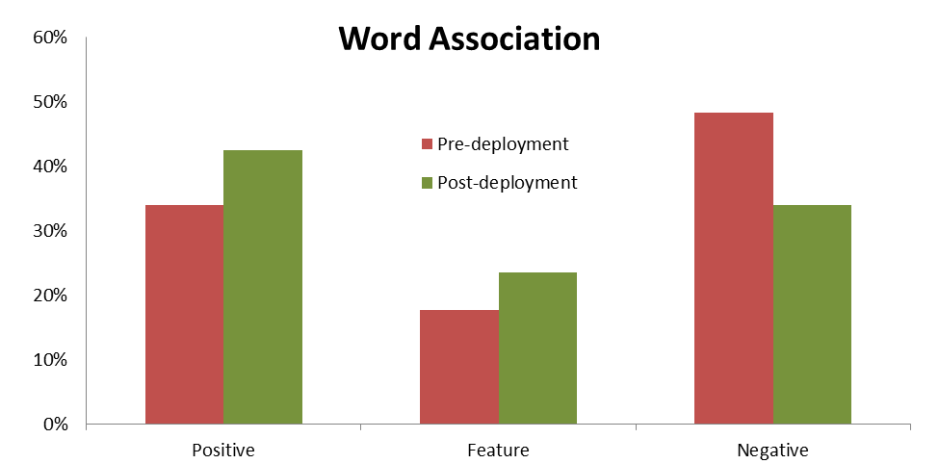

Figure 4 – Image of EV assessment using word association

Suitability for personal and organisational use

These questions aimed to get a general perspective from users on whether EVs, with their limitations, were suitable for the daily operation of their organisation or their personal use. The questionnaire asked that if the overall cost of EVs and conventional vehicles was comparable over the life of the vehicle would the respondent consider EVs in the next vehicle purchase. A similar question was posed regarding the inclusions of EVs in their organisation’s fleet.

The results showed a decrease in the number of individuals that were willing to consider EVs in their next purchase from 66% before the EVs deployment to 59% after (Figure 5).

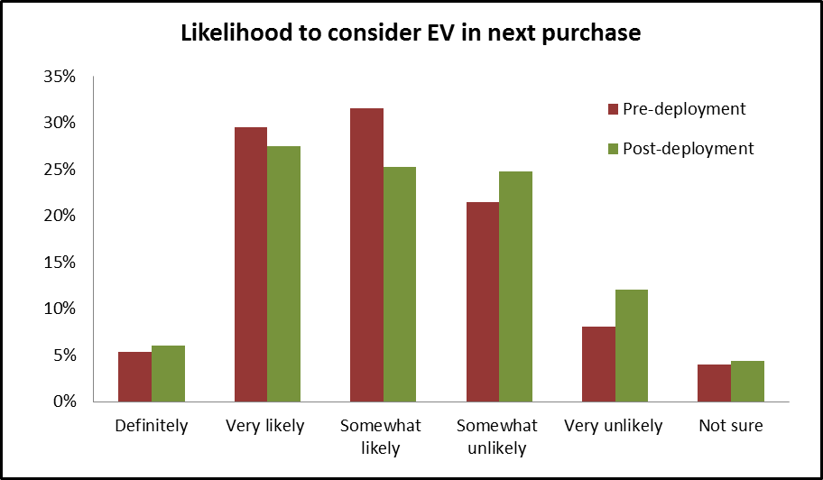

Figure 5 – Likelihood to consider the purchase of an EV by residential purchasers.

These results are not consistent with the rest of the survey. Potential reasons for the results include:
- Reluctance to replace their ‘main’ vehicle with one that has range limitations – see discussion below
- Statistical – a slight bias in the before or after sample can alter results.
- Uncertainty as residential buyers rarely by new vehicles so the considerations are different.

Respondents were invited to comment on their responses, and the comments were generally about the key drawbacks faced of the EV for their lifestyle. Some of the more common comments were around the range being too limited for family trips, lack of towing capacity, and the fact that residential purchasers rarely buy new vehicles. Some responses indicated users being happy with their current vehicles, or not yet fully trusting the new technology.

EECA considers that even with the existing range limitations, there is an opportunity in New Zealand, with its high level of car ownership, to replace one of a household’s cars with an EV. A family may choose to use an EV for frequent around-town use, and keep the larger petrol car for longer one-off trips.

Note that 59% of respondents would consider this technology when the prices reach parity. This implies that when EVs become more cost effective, there will be a ready market if there are enough options, especially vehicles that address the concerns expressed above.

When the same question is posed to provide a view from their organisation’s perspective (Figure 6), respondents were much more positive, with 80% agreeing that EVs should be included in their organisation’s fleet. The effect of the EV’s time in the organisation did not change the overall agreement levels, but it did increase the proportion of those that were in strong agreement.

From this it can be postulated that the main channel to market for EVs today will be through business fleets, and then flow on the residential fleets.

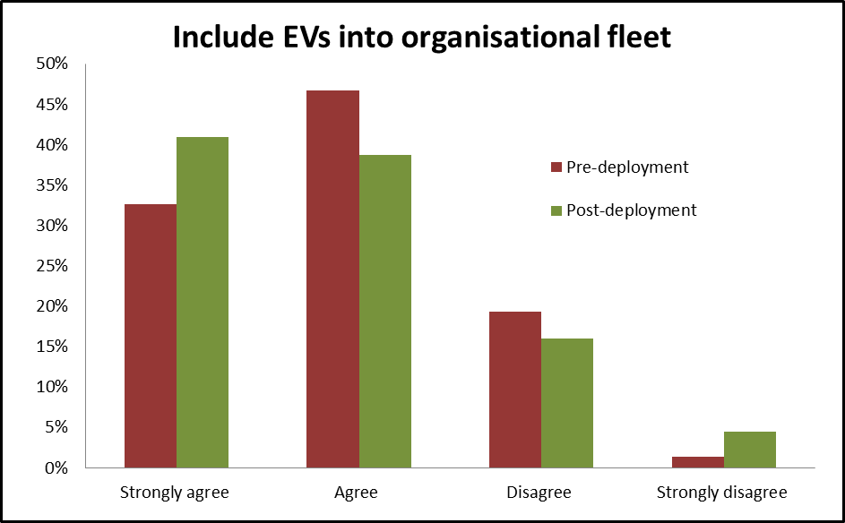

Figure 6 – Agreement to organisation including EVs into their fleet.

Experience of driving the EV

The responses to the driving experience were very positive starting with a question rating the experience from a disappointing 1 to and excellent 10.

75% of respondents rated the experience 8 or above indicating that the majority of users enjoyed the EV. Less than 9% of respondents provided a 5 or lower.

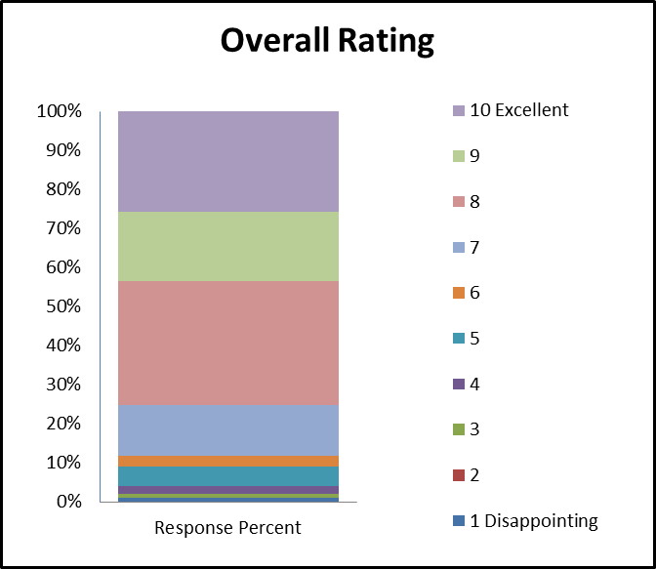

Figure 7 – Experience rating

EV features

Respondents were also asked to rate aspects of the EV from ‘disappointing’ 1 to a ‘meets all my needs’ 5. The lowest marked features for the iMiEV were Range, Image, and Safety. The low marks for range are understandable given the vehicles limited range, and the image relates to personal taste. However the safety perception maybe due the small size of the vehicle, is unwarranted as the iMiEV has a respectable 4-star ANCAP rating.

The highest ratings were for quietness, ease of parking, and suitability. The quietness and ease of use are expected, but the suitability rating is very encouraging as it indicates that drivers were satisfied with how the EV performed during their use.

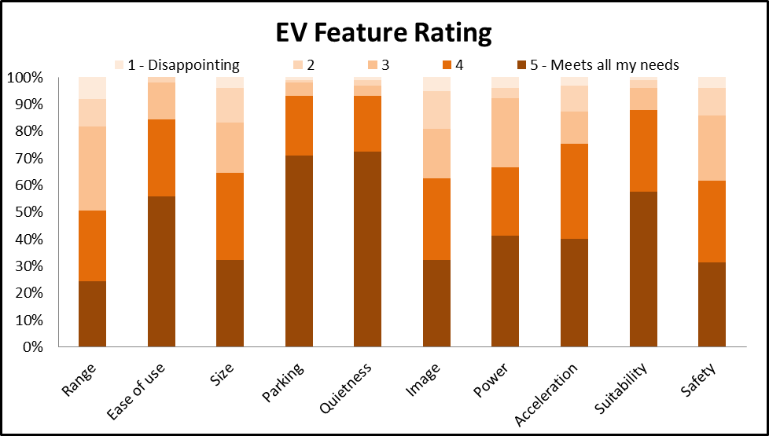

Figure 8 – Users rating of different aspects of the EV.

Respondents were also asked to consider their initial opinion of EVs and how that opinion changed through the experience of using the vehicle.

The results show that around 80% of respondents had an improved opinion of EVs after the experience, and half of them indicated their opinion had ‘gone way up’.

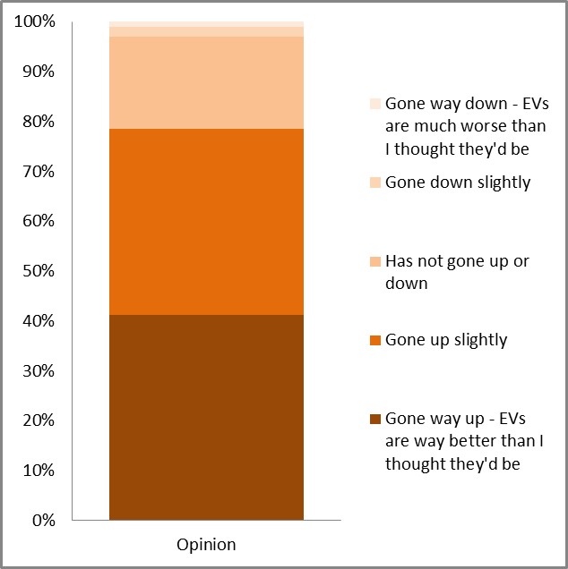

Figure 9 – Users general opinion of the EV.

DISCUSSION

In summary, the results of this socialisation project indicate that most people have a generally positive view of EVs. However it has identified several concerns about EVs, such as the range and the validity of environmental claims.

Therefore, providing opportunities for the market to have first-hand experience of the technology to improve the understanding of the advantages and limitations, and increase overall awareness is an important factor in increasing acceptance and deployment of EVs in New Zealand.

The results also show a general support for the development of EV technology as a response to greenhouse gas emissions; this was especially evident in the comments and responses to the word association question.

However, the project also identified a significant section of users that support EV development but do not believe the technology is ready. This is an important area of action for this project, as it aims is to demonstrate that EVs are ready for a large proportion of uses.

The questions on the likelihood of next purchase and on EV fit for the organisation highlighted that users believe that EVs have a place in the fleet. The much higher support for the organisation to make the purchase indicates that EVs should at least enter their purchasing decision-making processes as users think they are suitable. And this is one of the key avenues for EVs to diffuse to the wider fleet.

Of particular interest are the experiences of the respondents that drove the vehicles. The high rating provided for one of the smaller and simpler EVs in the market suggests that newer and larger EVs may do better and get over some of the barriers. For example, PHEVs like the upcoming Mitsubishi Outlander and Holden Volt are larger vehicles with a ‘back-up’ ICE engine to charge the vehicle should the battery run short, getting over the range (and some image) issues.

REFERENCES

Consumer Energy Centre of the California Energy Commission. (2014) Energy Losses in a Vehicle. Retrieved January 2014: http://www.consumerenergycenter.org/transportation/consumer_tips/vehicle_energy_losses.html

Centre for Advanced Engineering New Zealand (CAENZ) (2012). Electric Vehicles: Impacts on New Zealand’s Electricity System. Christchurch: Centre for Advanced Engineering New Zealand.

Ministry of Business, Innovation, and Employment (MBIE). (2013a). Energy in New Zealand 2013. Wellington: Ministry of Business, Innovation, and Employment.

Ministry of Business, Innovation, and Employment (MBIE) (2013b) Energy Greenhouse Gas Emissions. Retrieved December 2013: http://www.med.govt.nz/sectors-industries/energy/energy-modelling/publications/energy-greenhouse-gas-emissions/energy-greenhouse-gas-emissions.pdf

Ministry of Transport, 2008. New Zealand Household Travel Survey 2003-2007. Ministry of Transport. Retrieved January 2014: http://www.transport.govt.nz/research/travelsurvey/latestresults/

National Academy of Sciences, (2013). Overcoming Barriers to Electric Vehicle Deployment: Interim Report. National Academies Press. Retrieve from: http://www.nap.edu/catalog.php?record_id=18320

Popular Mechanics, (2010). 10 things you didn’t know about the Nissan Leaf. Retrieved from:
http://www.popularmechanics.com/cars/reviews/hybrid-electric/10-things-you-didnt-know-about-the-nissan-leaf

Spring, R. (2009). Canadians’ Perceptions of electric Vehicle Technology. Retrieved from: http://www.pollutionprobe.org/pdfs/perceptionsEVT.pdf

The EV Project (2013). Quarter 2 Report: The EV Project. Retrieve from: http://www.theevproject.com/cms-assets/documents/127233-901153.q2-2013-rpt.pdf

