Measuring Accessible Journeys

Bridget Burdett

BE(hons), MET, MIPENZ, CPEng

Senior Transportation Researcher

TDG, Hamilton

bridget.burdett@tdg.co.nz

Abstract
This paper summarises a pilot study measuring accessibility of journeys in Hamilton, New Zealand. It was undertaken by TDG on behalf of CCS Disability Action. Its method was to count pedestrians with mobility aids, and to compare these numbers with the proportion of mobility aids in the population. The project was funded by the Ministry of Social Development’s ‘Making a Difference’ fund.

Pedestrians were counted for a four hour period on a weekday at each of six count sites. A total of 9,525 pedestrians were counted across all sites, of whom 97 used a visible mobility aid. The proportion of mobility aid use by site varied from 0.1%, to 5.6% of all pedestrians. It was estimated from Statistics New Zealand data that approximately 3% of New Zealand’s population uses a mobility aid.
The study identified opportunities to use the counting tool to remove gaps in the delivery of accessible transportation, across all parts of the transportation system.

INTRODUCTION
This project is a pilot study measuring accessibility of journeys in Hamilton, New Zealand. It was undertaken by TDG on behalf of CCS Disability Action, with funding from the Ministry for Social Development’s ‘Think Differently’ campaign. Its method is to count pedestrians with mobility aids, and to compare these numbers with the proportion of mobility aids in the population. The project has three primary aims:
- Counting people: To count the number of people (pedestrians) at six locations around Hamilton, including the subset of that number who use visible mobility aids;
- Expected numbers: To estimate the proportion of mobility aid users in the population, and thereby identify relative accessibility of counted sites by the difference between the expected proportion of people with mobility aids, and the proportion observed at each site;
- A transferable method: To develop the project methods for use by local and national road controlling authorities and other organisations as a pedestrian network planning tool.
The project does not aim to count all people with disability, or with mobility impairment. It is intended as a step towards measurement of accessible journeys, by counting what is objectively countable. Through simplification of the definition of disability and the proxy of a visible mobility aid, it is intended that the methods used will be readily adoptable by road controlling authorities and other interested organisations, in providing an evidence base to support improvements in provision of accessible transportation systems.

OBJECTIVES
This project shares the wider objectives of the Ministry for Social Development’s Think Differently campaign, which are:
- to increase knowledge and understanding of disability;
- to increase the personal relevance of disability for all New Zealanders;
- to mobilise personal and community action for positive change; and
- to address the social environment that tolerates or accepts exclusion of disabled people.
The project brings transportation planning and engineering together with social and community objectives. Pedestrian counting is by no means new. It is more or less an established part of transportation network planning and is also used in many other fields including the commercial property and retail sector as an indicator of the use or attractiveness of areas and facilities. What this study aims to do is firstly, to promote more frequent and routine counting of pedestrians, just as on-road traffic is rigourously counted. Secondly, the study aims to equip those undertaking pedestrian counts for whatever reason with tools that enable them to dig deeper; to reveal more about the travel patterns of the entire community and some of the most vulnerable users of the transport system.
This project and its methods were developed in collaboration with representatives of the disability sector, and in particular, with CCS Disability Action. The rationale from the perspective of the disability sector is to demonstrate the value of access by counting people with disabilities in some measurable way, and to use this data to monitor the effectiveness of infrastructure investment. The process is intended to be a proactive method for transport planners and engineers to demonstrate provision of best-practice access. Ultimately, it could negate the requirement for people with disabilities to advocate for access in a reactive, case by case manner.

METHODS
The main research component of this project was in estimating the overall prevalence of mobility aid users in New Zealand, and applying this information to particular catchments. The study also involved developing a pedestrian survey template, including the proportion of pedestrians who use mobility aids.
Estimating prevalence of mobility aid use
It was estimated in New Zealand’s Household Disability Survey that 78,000 adults and 9,500 children had a mobility disability in 2006, and used some form of mobility equipment in relation to permanent disability. This represents approximately 2.0% of the total resident population, when including those aged under 15.
The following data (NZ Household Disability Survey: Disability and Formal Supports in New Zealand 2006) summarises different types of mobility aids used by adult New Zealanders with permanent disability. ‘Permanent disability’ requires that a person lives with a particular impairment for at least six months. The proportions noted in Table 1 are not summative; that is, a survey respondent could list as many mobility aids as they had access to. The mobility equipment highlighted in bold in Table 1 represents visible mobility aids selected for inclusion on the count sheets for this study.
Data for children is not provided to the extent shown in Table 1. There is no known data about the use of mobility aids for people with temporary disability, or for people who live in residential care facilities.

 | Age group (years) |  |  |  | Total
Type of mobility equipment | 15–64 |  | 65+
 | Number | Percent | Number | Percent | Number | Percent
Back or leg brace, splint, or support | 4,300 | 0 | 2,100 | 0 | 6,400 | 0
Orthopaedic footwear | 2,500 | 0 | 2,200 | 0 | 4,700 | 0
Artificial foot or leg | -- | -- | -- | -- | -- | --
Walking frame | 1,900 | 0 | 15,900 | 3 | 17,800 | 1
Walking stick | 13,400 | 1 | 45,000 | 10 | 58,400 | 2
Crutches | 6,200 | 0 | 6,200 | 1 | 12,400 | 0
Mobility scooter | -- | -- | 7,000 | 2 | 8,800 | 0
Manual wheelchair | 3,600 | 0 | 4,100 | 3 | 7,700 | 0
Motorised wheelchair | -- | -- | -- | -- | 2,900 | 0
Other equipment for moving about | -- | -- | 2,600 | 1 | 3,900 | 0
No equipment | 127,900 | 5 | 78,800 | 17 | 206,700 | 7
Any equipment | 24,000 | 1 | 54,200 | 12 | 78,300 | 3
Total mobility-disabled adults | 152,000 | 6 | 133,100 | 29 | 285,000 | 9
Table 1 Estimated proportion of adults using mobility equipment
Source: Table 5.22, NZ Household Disability Survey: Disability and Formal Supports in New Zealand 2006
In sum, it is estimated from Table 1, and by the data not included in this table that approximately 3% of the adult population use a visible mobility aid. The following people are excluded from the data in Table 1 but will nonetheless be represented in any count statistics:
- people with temporary disability, due primarily to injury or illness;
- people who use a mobility aid but do not identify as having a disability, and are therefore not included in the ;
- children aged under 15; and
- people with visible aids not represented in Table 1, specifically, guide dog or walking cane.
The data in Table 1 therefore underestimates the proportion of people in the population who use a mobility aid. In the absence of any other data to estimate a more accurate figure, 3% was adopted as an initial estimate of ‘expected’ proportion of visible mobility aid use, generally. It is expected that over time, continued research will improve this estimate or its reliability.
There are of course a number of people with mobility impairments who do not use visible mobility aids, who are therefore excluded by the estimate. In addition, some mobility aids are not necessarily visible, for example orthopaedic footwear and leg braces or splints. As stated in the introduction, this project is intended as a step towards measurement of accessible journeys, by counting what is objectively countable. Types of mobility and other impairments affecting peoples’ ability to travel independently include (but are not limited to), for example:
- non-visible mobility impairments, for example artificial limbs, pain affecting mobility, visual impairment;
- intellectual impairment including mental illness; and
- hearing and other non-visible sensory impairment.
The nature of a wide range of impairment and its effect on peoples’ use of the transportation system was explored by survey methods as part of this study.
With limited data around prevalence of disability in the population generally, and at particular locations, counting people with mobility aids will be a relative, and not absolute, measure of access. Its usefulness in the absence of more comprehensive, location-specific demographic data is to inform public and private stakeholders about which places are observed to be more accessible than others. More comprehensive statistics would improve the tool such that the gap between what is observed, and what is reasonably expected, can be more reliably ascertained.
Pedestrian survey template
The method developed to count pedestrians involves establishing a cordon, and manually counting every pedestrian who crosses that cordon in a predefined time period. For this pilot study, six sites were selected. At each site, a cordon was defined and pedestrians were counted for a four hour period, between 11:30am and 3:30pm on a weekday. This time period was chosen for counting convenience to suit volunteers and project staff. More work is required to refine time periods of most use for particular locations or to target particular population samples.
At the top of each count sheet, the date and time were noted, as well as the surveyor name, site name, weather, and wind conditions. A site map was included so that the precise location of the count could be marked. This helped counters to focus on the particular people to be counted. It also provided reference for any counts or monitoring that may happen in future, at the same location. Pedestrians were tallied, and the total number of pedestrians crossing the marked cordon for each hour was noted on a worksheet. As each count covered a four hour period, there were four worksheets completed per count site. In addition, all pedestrians with visible mobility aids were tallied on a table on the same worksheet, according to their mobility aid. A sample worksheet is shown as Figure 1 below.
There were two surveyors at each count site. Each pedestrian observed with a visible mobility aid was approached by one of the surveyors and asked whether they would be willing to answer some questions about their travel choices. These questions were intended to provide qualitative information about peoples’ travel choices, and any implications of their mobility impairment in their active participation in society. At the top of each count sheet, the date and time were noted, as well as the surveyor name, site name, weather, and wind conditions. Interview questions were developed in consultation with representatives of the disability sector. Questions were:
- How did you get here today?
- Why did you choose that method and route?
- Do you have any other mobility aids?
- Do you sometimes travel with a companion for mobility reasons?
These questions were selected to provide more background data to understand the nature of disability and its effects on mobility and accessibility. The last question (“Do you sometimes travel with a companion for mobility reasons?”) was included to potentially inform research into the wider implications of disability in society. It was intended to contribute to future discussion about the prevalence and importance of independent travel. The person’s reason for traveling was not included as a question, though this may be a useful addition for future surveys.

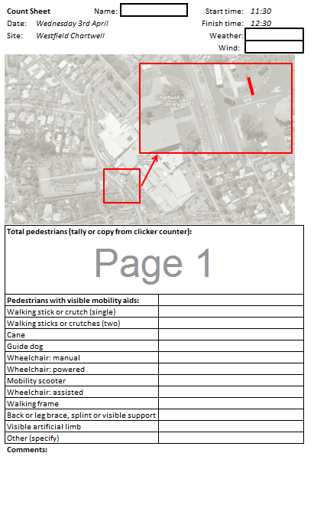
Figure 1 Pedestrian Survey Template

RESULTS
Each of the six count sites provided four hours of continuous data in April 2013. A total of 9,525 pedestrians were counted, of whom 97 used a visible mobility aid. The proportions of different mobility aids use is shown in Figure 2. The range of visible mobility aid use across all sites is shown in Figure 3.
The data in Figure 2 show that there was meaningful variation in both absolute numbers of pedestrians observed, and in the proportion of those pedestrians using mobility aids. The site with lowest proportion of people with mobility aids was the University of Waikato and the highest proportion was observed at Westfield Chartwell, a suburban shopping mall.
The results lead naturally to questions about what proportion of pedestrians with mobility aids might realistically be expected across a range of sites such as those surveyed. As it is known that older people are more likely to have a disability requiring use of a mobility aid, it is reasonable that places and times attracting a higher proportion of older people (for example, a suburban shopping mall in the middle of a weekday, or a hospital) might show high numbers of mobility aid users than a university, which attracts a much higher proportion of younger people.
Further analysis of statistics related to characteristics of trip generation and people living within the catchment of a particular facility would provide more insight as to the expected proportions of people with mobility aids that might be indicative of relative accessibility.
The data in Figure 3 show that a wide variety of mobility aids were counted across all six pilot sites. Of the twelve categories included on the count worksheet, two were not used (“Back or leg brace, splint or visible support” and “Visible artificial limb”).
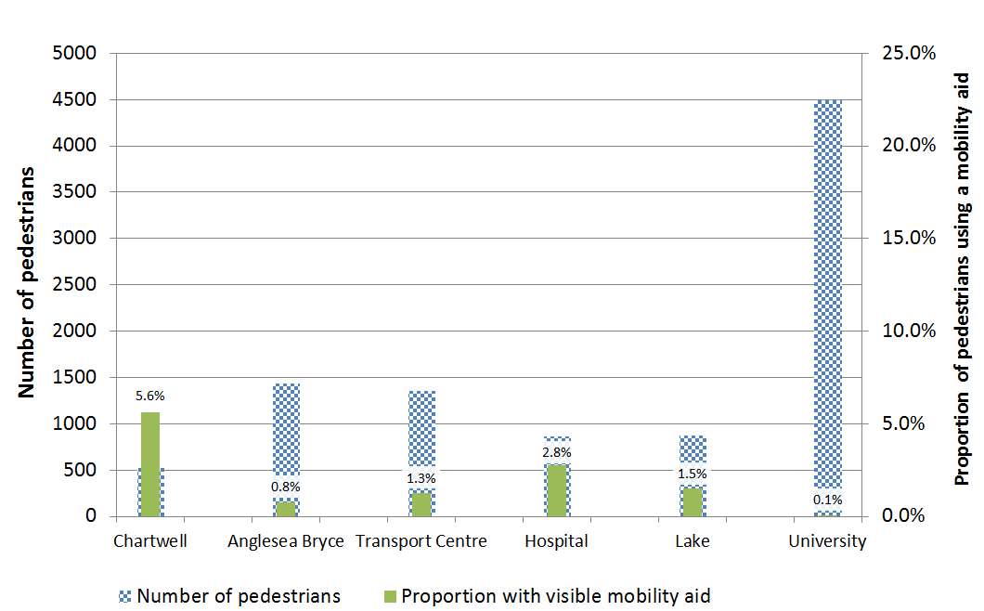
Figure 2 Proportions of mobility aid use by site
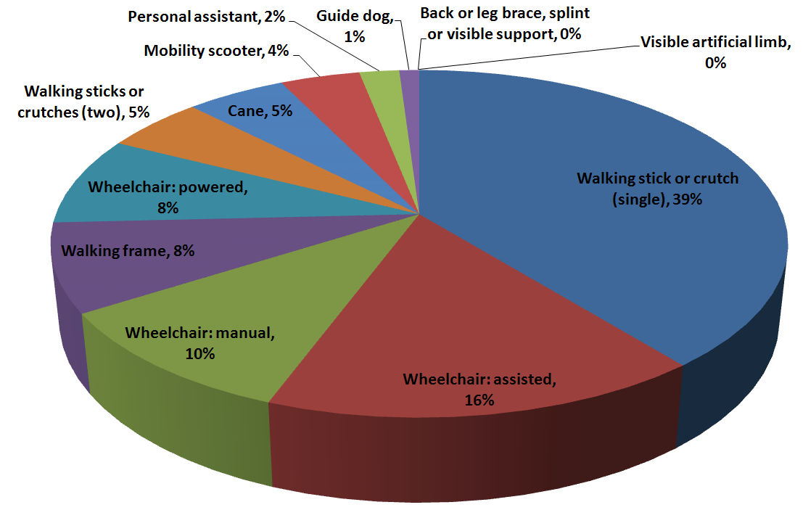
Figure 3 Overall proportions of mobility aids counted
Generally, the proportions of mobility aids seen are only loosely related to mobility aid usage data from Statistics New Zealand. A comparison of the pilot data with national statistics is shown in the table below. The Statistics New Zealand data does not sum to 100 because it allows for people using different mobility aids in different situations (for example, a walking stick at home and a walking frame or wheelchair when out shopping).
As noted earlier, people counted may not self-identify as having a disability (and indeed, several people questioned for the interview data explicitly claimed not to be ‘disabled’). Therefore the count data will always be drawn from a larger sample than that used to determine national statistics, which are based on a survey of adults who self-identify as having a permanent disability lasting six months or more.

 | Proportion Based on National Statistics | Proportion Counted in Pilot Project
Back or leg brace, splint, or support | 7% | 0%
Orthopaedic footwear | 5% | 0%
Artificial foot or leg | 0% | 0%
Walking frame | 19% | 8%
Walking stick | 63% | 39%
Crutches | 13% | 5%
Mobility scooter | 9% | 4%
Manual wheelchair | 8% | 27%
Motorised wheelchair | 3% | 8%
Other equipment for moving about | 4% | 8%
Sum | 133% | 100%
Table 2 Mobility aid types: National data and Count data
Table 2 shows that the most prevalent mobility aid for the pilot counts as well as nationally is a walking stick or crutch. People using a single walking stick or crutch may be more likely to be temporarily disabled, or to use such a device for comfort or security, as much as to aid mobility.

Interview Data
Of the 97 people counted with a visible mobility aid, 36 (37%) agreed to answer survey questions. Answers are summarised as follows:
Type of mobility aid:
- 15 Walking stick or crutch (single);
- 5 Wheelchair (assisted);
- 4 Wheelchair (manual);
- 2 Wheelchair (powered);
- 3 Walking frame;
- 3 Mobility scooter;
- 1 walking sticks or crutches (2);
- 1 guide dog;
- 1 cane;
- 1 other (moon boot).
How did you get here today?
- 14 private car (driver or passenger);
- 8 bus;
- 5 Walked, with powered mobility aid (power chair or mobility scooter);
- 6 Walked, with manual mobility aid (walking stick, frame or guide dog);
- 2 Taxi;
- 1 other (ambulance).
Why did you choose that method and route?
All responses were a mixture of ‘easy/convenient’. Some mentioned lack of choice (“I haven’t got a car/can’t drive/no alternatives”). Some mentioned cost as a reason for using or not using a particular mode (ie walking instead of using the bus, or using the bus instead of a taxi).
Do you have any other mobility aids?
- No: 24;
- Yes: 12.
Do you sometimes travel with a companion for mobility reasons?
- No: 21;
- Yes: 15.
As an exploratory, qualitative component of this research, the interview data exemplified the complexity of disability and transport choices. There was no obvious correlation, for example, between mobility aid type, and propensity to travel with or without a companion, or to use a particular mode. The type of mobility aid used was not predictive of peoples’ likelihood to travel with a companion.

DISCUSSION
Suitability of Tool
Overall, the pilot study was successful in demonstrating a useful means for counting pedestrians, including a subset using identifiable mobility aids. The cordon method to define which count location worked to clarify those pedestrians who were and who were not to be counted. While the particular numbers and proportions found in this pilot study are not assumed to be indicative of relative access in isolation, the method itself was found to be readily usable, reliable and repeatable.
As a method to collect qualitative data, the interview was relatively straightforward. Approximately 37% of pedestrians approached were willing to be interviewed. The questions used on the survey were useful in demonstrating the complexity of mobility impairment, and respondents found them straightforward to answer. The questionnaire worksheet format allowed for entry of more detail where this was offered. Several people, for example, appeared willing to elaborate on challenges they face in moving around their communities, more generally than the specific trip that the survey happened to intercept.
Tool Usability
Approximately twelve different people were trained on-site in the use of the worksheets for recording count data and interview responses. All surveyors reported that the worksheets were easy to use and that the process was straightforward. Analysis of approaches and results indicated that the methods were robust, in that every surveyor followed procedures in the same way. Results were not dependent on interpretation of the methods, which indicates that the method itself is robust.
Survey Bias and Data Limitations
By counting and interviewing pedestrians present at a particular place, the interview data in particular is biased towards those people who are motivated and able to travel. Disability is complex, and there is a wide range of factors influencing peoples’ propensity to travel, many of which are outside of the realm of transportation provision itself. The provision of quantitative data provides a picture of relative accessibility. The higher the proportion of pedestrians with mobility aids observed at a particular point, the higher the relative access of that place is, at least during the timeframe covered by the survey.
While data from interviews provides insight into why people do choose to travel, it does not help to determine why people do not travel to a particular place. The absence of mobility aid users, or comparisons between similar facilities or the same facility over time is perhaps more useful to begin to address issues of inaccessibility.
Site Selection and Time of Day Differences
For this pilot study, pedestrians were counted between 11:30am and 3:30pm on weekdays during school terms. Thus only a limited type of pedestrians could be observed. In terms of developing a counting methodology, this was not problematic for the pilot study. However, in order for results to be used to prioritise pedestrian network planning and investment decisions, a wider spectrum of timeframes and sites would provide more comprehensive data.

RECOMMENDATIONS
Development of Method: Counting
Given that the counting tool has been demonstrated to be robust and usable, it is recommended that the counting programme be extended to more sites, and a more comprehensive range of times and days. Use of the data would then be recommended to inform pedestrian and public transport planning and investment decisions.
The delivery of accessible and inclusive transportation systems does not rest solely with the road controlling authorities and the public sector. The tools could also be provided directly to organisations that have an interest in ensuring that their own facility is accessible. There is a connection between accessibility and commercial or organisational success. A university with an accessible campus attracts more students. A shopping mall that is easy to get to and move around attracts more customers.
The count method itself would benefit from investigations into automation of the process. An example of this would be video analysis, which would not require manual counting. Video would enable continuous recording at a count cordon, that could be either manually processed later, or portions of the processing could also be automatized.
It is therefore recommended that the count process be extended to more sites and across more varied times of the week and year, and that investigations into automation of the count process continue.
Data storage
It is recommended that a web-based data storage capacity be developed, to capture increasing volume of count data over time. If such a tool were developed to automate production of reports, its use would be incentivised and it would be therefore more likely that those using the tool provided their data to the wider pool.
Development of Method: Expected Proportions
There is currently only very limited data available about the presence and nature of disability in New Zealand. Census data is published based on national statistics, but this is not broken down demographically or geographically in any way, even on request. The reason for this is that the census data is currently only collected to provide a source population for the more in-depth Household Disability Survey. This survey has an official health-related definition of disability which cannot be self-assigned. Therefore to avoid confusion, self-assigned disability as provided by Census data is not released. The Household Disability Survey provides detail about the nature and prevalence of disability, but it is not in any way linked to respondents’ home addresses.
In order to estimate likely expected proportions of people with mobility aids at different count sites, methods must be developed to estimate these numbers.
Further research is recommended into the prevalence of mobility aid use, and its correlation with other factors (such as age, socio-economic deprivation, and employment status) such that more meaningful expected proportions can be determined to support planning based on the count data that this tool provides.
Informing Asset Management
As the database of pedestrian numbers and mobility aid proportions grows, it is recommended that it is used to inform asset management decisions. Examples of such use include prioritising of maintenance and capital works for new footpaths and road crossings, and prioritising infrastructure improvements for bus stops and interchanges. The tool could also be used to monitor effectiveness of transportation infrastructure investment by a before/after analysis of the proportion of pedestrians with mobility aids using a particular route, or accessing a particular destination.
It is recommended that measurement of accessible journeys informs prioritisation of infrastructure maintenance and capital works expenditure, through incorporating counting of pedestrians with mobility aids into regular pedestrian count programs, or initiation of a comprehensive series of counts.
Informing Transport Policy and Planning
Data about how pedestrians travel, and in particular, relative proportions of mobility aid use can help to inform the transportation industry at policy level. It is recommended that more sites are counted so that data can inform the following processes:
- Total Mobility policy and prioritising areas of greatest need;
- Public transport (bus and train) analysis, including strategic reviews of networks and planning for accessible design of vehicles and bus stops / train stations / interchanges;
- Network modelling and planning for future growth within existing areas and for future development, informed by count data in conjunction with demographic projections around age and disability in particular; and
- Guidance documents around provision of pedestrian infrastructure such as footpaths and road crossings, as well as tactile pavement indicators and other information systems.
Informing Social and Health Policy and Planning
At a higher level, the absence of accessible journeys affects peoples’ ability to participate in recreation, in employment, and in life, generally. It is recommended that the tool be further developed to analyse peoples’ access to transport, and the implications that this has on their lives. Specific areas for further research in terms of health and social policy include:
- The journey to work and how people with temporary or permanent disability use the transport system;
- The nature of inclusion: how education, recreation and public facilities welcome people with disabilities through transport provision, and in a wider sense; and
- Lessons learned: Analysis of sites with high mobility aid proportion, to analyse the features of those places that attract more people with mobility challenges.
Informing Commercial and Retail Policy and Planning
The tool has potential for public/private facilities to track their performance over time, and to measure their accessibility relative to other facilities in their market. The tool could be used to assess ease of access at different entries to a shopping mall, for example, or to different branches of a facility such as a public library or medical centre. The tool could also be used to monitor relative access at facilities in different towns and cities, around a country, or to compare relative access internationally.
Audits across a range of facilities (for example, branch libraries) could help to prioritise whether infrastructure is targeted towards a range of improvements to a single facility, or a series of changes across all facilities. Before and after counts of pedestrians using the facilities, combined with more qualitative interview data, could help to identify the nature of design that best supports universal access.
It is recommended that the tool be promoted for use by commercial and retail developers to inform policy, planning and design.

REFERENCES

STATISTICS NEW ZEALAND NZ Household Disability Survey: Disability and Formal Supports in New Zealand 2006
www.stats.govt.nz

