**TECHNICAL PAPER**

**WELLINGTON PUBLIC TRANSPORT FUTURE**

**Author & Presenter**: Andrew Foy, BPlan

Associate Director, AECOM

Andrew.Foy@AECOM.com

**ABSTRACT**

There has been a long history of studies looking at the nature and shape of the public transport network in Wellington. These range from the De Leuw Cather Transport Plan in 1963 to the Wellington Public Transport Spine Study completed in 2013. The public transport network has evolved over this time with heavy rail to the north and buses south of the CBD.

The 2013 study was developed to inform decisions on the future direction for public transport in Wellington. The study focussed on major improvements to public transport between the Wellington Rail Station and the regional hospital to provide a high quality, reliable and safe service. A wide variety of transport mode and alignment options were considered. This led to identification of the final options of Bus Priority, Bus Rapid Transit and Light Rail Transit travelling between the Wellington Rail Station and Kilbirnie in the east and the regional hospital in the south. Consultation is now underway to gather public feedback before further decisions are made.

This paper focusses upon the differences that have occurred over time in methodologies, assumptions, assessment techniques and the trends in the technology of moving of people and how these have influenced outcomes. In particular how the transport network considered by the Public Transport Spine Study has evolved from trams to trolley buses and what the future state could be.

# Introduction

In August 2011, AECOM was appointed by Greater Wellington Regional Council to undertake the Wellington Public Transport Spine Study (PTSS). This is a joint study led by Greater Wellington Regional Council in partnership with the New Zealand Transport Agency and Wellington City Council. There has been a long history of studies looking at the nature and shape of the public transport network in Wellington dating back to 1963.

The purpose of the PTSS is to assess the feasibility and the merits of a range of longer-term options for providing a high frequency and high quality public transport system between the Wellington Railway Station and the Wellington Regional Hospital. It will consider possible connections to the north and south-east, and will seek to support the urban intensification of this growth corridor.

Public transport has existed alongside development for many years and has changed and evolved, including the form, power source and justification for development. In considering the changes considered into the future I have restricted my consideration to the core study area of the PTSS.

# The Development of Public Transport in Wellington

Public transport in Wellington developed to support urban development and was for many the sole means of transport available. The first cars in New Zealand were imported into Wellington in 1898. In these early days not only were cars rare but they were also expensive and hence restricted to the wealthy (Pawson). In 2013 dollars a car cost between 40-100,000 dollars. In comparison to todays transport choices the car was not a viable alternative to public transport for most people.

**Tram Network**

Within the PTSS study area trams were the predominant mode of public transport prior to the 1940s. Initially trams were both steam (from August 1878) and horse powered. However due to the noise, pollution and heavy maintenance required, in 1882 steam was replaced 100% by horses. Trams began electrification during 1904 and operated as single units with some having additional capacity as they were double decked (WCL). In comparison the London underground began with steam powered engines and began electrification in 1903, Auckland has waited another 110 years for electrification. At its longest the tram network was 52 kilometres in length and evolved to provide a transport network enabling development in outlying areas as they grew.

With increasing costs of operation and maintenance there was no further extension to the tram network. The Mt Victoria Tunnel was completed in 1931 and although envisaged initially as a tram tunnel it was opened as a traffic tunnel. In the late1940s trams began to be replaced by [buses](http://en.wikipedia.org/wiki/Bus) and [trolleybuses](http://en.wikipedia.org/wiki/Trolleybus) as they were seen as more advanced and better suited to Wellington’s winding roads and steep gradients In 1964 the final tram route was replaced and now all public transport service south of the Wellington Rail Station is provided by diesel or electric trolley buses.

**Rail Network**

In the mid-1870s the first railway line from Wellington to Lower Hutt was constructed. This was followed by the construction of the Kapiti railway line from Wellington via Johnsonville in the early 1880s. A deviation to bypass Johnsonville was constructed in the mid-1930s and this became the North Island Main Trunk (NIMT). The NIMT was electrified to Paekakariki in 1940, followed by the electrification of the other Wellington lines in the 1940s and 1950s. In 2009 and 2010 the Wellington Regional Rail Programme saw the introduction of Matangi Electric Multiple Units and other regional infrastructure upgrades including extending the double tracking and electrification through to Waikanae.

# Previous Studies

There have been a range of studies that have identified possible changes to the transport environment based on assumptions on future development and the growth in travel demand. These are detailed below with the main finding related to public transport highlighted and the way in which the PTSS considered this outcome. Each of these studies has included assumptions on options, costs, growth in development and infrastructure. The PTSS being the latest of the studies includes components from each.

### 1963 - Comprehensive Transport Plan for Wellington

In 1963 American firm De Leuw Cather carried out a study into the long-range transportation needs of the Wellington Region on behalf of the City of Wellington. The resulting Comprehensive Transportation Plan focused on rail for public transport and recommended that **rail provision in the CBD should be re-examined after completion** of the Foothills Motorway. The motorway was completed in 1973 and today forms State Highway 1 providing road access to the CBD and suburbs to the south through the Terrace Tunnel (completed 1978).

The PTSS investigated the extension of rail through the CBD to Courtenay Place.

### 1993 - Study of Public Transport Options Johnsonville-Wellington CBD Corridor

In 1993, Wellington City Council and Greater Wellington Regional Council commissioned the *Study of Public Transport Options Johnsonville-Wellington CBD Corridor*. This study focuses on the rail corridor between Johnsonville and the Wellington CBD and identifies public transport options for the northern suburbs. The study considered improvements to the existing rail services, replacement of rail with on street buses, replacement of rail with a guided busway and **replacement of rail with light rail possibly extended into the CBD**. The study also considered other modes of transport such as monorails and trolley buses, however these were discounted. The results were used for public consultation prior to Greater Wellington Regional Council determining future policy for services in the Johnsonville – Wellington CBD corridor.

The PTSS further investigated the extension of LRT through to Johnsonville

### 1995 - Light Rail Feasibility Study

In 1995, Wellington City Council and Greater Wellington Regional Council commissioned the *Light Rail Transit Feasibility Study* which considered the initial feasibility of providing a light rail system on the suburban rail network and through the CBD. The study identified a number of benefits that Light Rail Transit (Light Rail Transit) could provide Wellington. The study also identified route options, planning, environmental, legislative ownership and funding issues and provided an assessment of the financial and economic viability of converting the existing network to Light Rail Transit. The study tested a range of options against the conversion of the Johnsonville rail line to Light Rail Transit with it terminating at Wellington Railway Station. All options compared were deemed worthwhile. Resolution of a number of issues was however required before a final choice could be made. These issues included funding, ownership, Resource Management Act implications and detailed community consultation. The study assumed that a **Light Rail Transit route through the CBD would be an extension of the existing Johnsonville Route**. Three route options through the CBD were identified with two alternate route sections. All three commenced at the west of the Railway Station and terminated in Courtenay Place.

The PTSS investigated the extension of LRT through the CBD to Johnsonville, Newtown and Kilbirnie.

### 2005 - North Wellington Public Transport Study

In 2005, Wellington City Council and Greater Wellington Regional Council commissioned the *North Wellington Public Transport Study*. The study identified options for future public transport in Wellington’s northern suburbs and considered four scenarios; improvements to the existing rail services, replacement of rail with on street buses, replacement of rail with a guided busway and replacement of rail with light rail possibly extended into the CBD. The scenarios were compared to a base case of replacing the English Electric Units with Ganz Mavag and minimum rail improvements. Of these scenarios, the **on street bus performed the best in terms of economic performance**. However due to expectations and associated risks the base case was recommended. This has now been implemented.

The PTSS included current plans for bus priorities to the north and continuation of existing rail services.

### 2008 - Ngauranga to Airport Study

In 2008 the N2A was commissioned by Transit New Zealand (now New Zealand Transport Agency), in conjunction with Wellington City Council and Greater Wellington Regional Council. This was a multi modal study including provision of public transport. Part of the vision set out in the plan is that **priority will be given to public transport and that public transport will provide a high quality, reliable and safe service along the Wellington growth spine** and proposed the Public Transport Spine.

The PTSS is undertaken in the context of the N2A Corridor Plan and takes account of the investigations carried out in developing that plan.

### 2009 - Bus Operational Review

In 2009 Greater Wellington Regional Council commissioned the *Central Area Bus Operational Review*. The review covered public transport on the Golden Mile between Wellington Railway Station and Kent and Cambridge Terraces. The focus was to improve the efficiency and reliability of bus operations through the Wellington central area. The review identified current issues and options for improving the efficiency and reliability of bus services through the Golden Mile. Key priorities were identified for the short, medium and long term and an indicative improvement programme was recommended. Issues identified included; poor legibility due to the split route, insufficient stop capacity, variability in bus occupancy and passenger loading inefficiencies. Measures identified to address these issues include; investigation of suburban hubs and relocation of road space in the long term, integrated ticketing and bus stop layout and design in the medium term and bus priority and schedule reviews in the short term. The review concluded that “**significant opportunity exists to enhance public transport operation on the Golden Mile through a mixture of infrastructure and operation intervention**s” (Opus, page 48).

The PTSS seeks to deliver on the opportunity to enhance public transport.

### 2011 - Wellington City Bus Review

In 2011/2012 the *Wellington Bus Review* identified operational inefficiencies of peak and off peak buses travelling through the CBD. It proposed **changes to the bus network operation to lower bus congestion**, reduce modal conflicts and improve reliability of journey time. This study is aimed at the short to medium term future.

These improvements are taken account of in the Wellington Public Transport Spine Modelling as part of the Reference Case.

# Historical Context

The findings of the PTSS can be considered in the context of historical trends, past decisions and the outcomes of previous studies that consider movement of people within the study area. Figure 1 graphically portrays a timeline of studies and changes to the transport environment against changes in population in the Wellington urban area and growth in cars in New Zealand. This shows that since 1963 when the Comprehensive Transport Plan for Wellington was completed, population has increased by approximately 50%. It also underlines the rapid growth in the uptake of cars, in 1945 there were more cars in New Zealand than people in the Wellington Urban area.

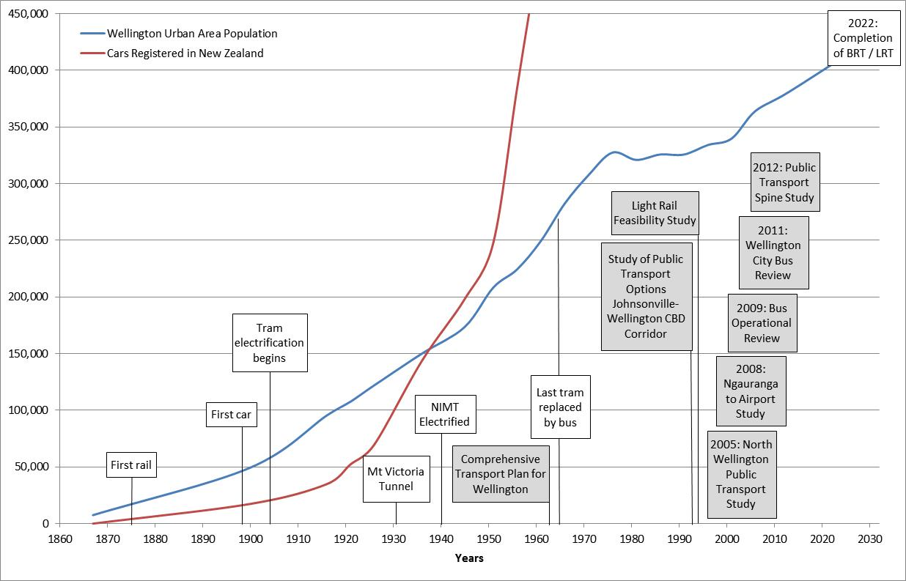

Figure 1: Population and Vehicle Registrations (source Statistics New Zealand)

# The Wellington Public Transport Spine Study

The PTSS is a long term planning study which investigated the feasibility of different options to achieve a public transport step change. This includes the benefits, costs, economics and policy levers associated with potential options for a high quality solution. Figure 2 displays the tram network and corridors investigated. The PTSS considered routes similar to the previous tram routes for extensions to the south with the exception of the use of the Mt Victoria Tunnel and a potential Coutt Street tunnel. Options to extend both Light Rail Transit and Rail through the CBD as suggested in earlier studies were also investigated. Whilst the core public transport spine was identified from the Wellington Railway Station to the Hospital, options to extend this to the north, south and east were also considered.

Options were assessed through a three stage sieving process, from a long list of options (88), which included different alignments and modes, the options were refined to eight and then three. The top three options taken forward to the final Short List assessment were:

* **Bus Priority.** An enhanced bus network with greater priority at intersections and along key corridors, but using existing vehicle types. Low cost option.
* **Bus Rapid Transit.** Dedicated bus lanes for new high capacity vehicles as well as other system improvements to enhance frequency and journey times. Medium cost option.
* **Light Rapid Transit.** Dedicated lanes and tracks for new light rail vehicles as well as interchanges to transfer from other modes. Medium to high cost option.

|  |  |
| --- | --- |
| Figure 2: Tram Network and Route Options Considered (source: Option Evaluation Report, 2013) |  |
| K:\_PROJECTS\WTTP GWRC 001 Wellington PT Spine Study (60222076)_GIS ONLY\4_PDF-JPG-Word\Summary_Report\Final\Routes\StudyArea.jpg |

Figure 2: Tram Network and Route Options Considered (source: Option Evaluation Report, 2013)

# The Wellington Public Transport Spine Study Assumptions

A set of assumptions were developed and agreed that fed into the option assessment and transport modelling. Transport modelling was carried out by Greater Wellington Regional Council using the Wellington Transport Strategy Model and Wellington Passenger Transport Model. Assumptions which are included in the model include landuse projections, improvements to the transport network, public transport modes and costs of travel.

**Future Development**

The scenario used for the study is based upon medium growth with land use intensification focussed along the growth spine. Population in the region is forecast to increase by 55,000 to reach 526,000 by 2041. Growth occurs in Wellington City (78% of growth) and Kapiti (22% of growth), the rest of the region remains relatively unchanged. Within Wellington City 32% of all growth occurs along the Spine with the majority occurring within the CBD. Regional employment is forecast to increase by 35,000 to reach 276,000 by 2041 with the majority of growth (70%) occurring in Wellington City and 52% of all growth along the Spine, mostly within the CBD (AECOM, 2013). This forecast distribution of growth suggests that the majority of future development will be focussed to the south of the Wellington Rail Station.

**Future Changes to Transport within the Region**

Future capital projects which are already committed, or are needed to maintain a minimum level of service over the evaluation period were included within the assessment. The major infrastructure assumptions related to future projects within the region are related to State Highway projects and in particular the Roads of National Significance (RoNS). The current New Zealand Transport Agency timing for projects was incorporated in all modelling.

Future changes to public transport included all programed bus priority improvements, integrated ticketing and changes in services in line with the Wellington City Bus Review.

**Mode Option Assumptions**

To understand the applicability of different public transport modes to Wellington an initial stage of the study was to conduct an international review .The purpose of the International Review was to learn from the implementation of passenger transport systems overseas and develop case studies as reference points for the study. The International Review then provided input into option evaluation, option design and operational costs of the options developed. Thirty five case studies were investigated covering Personalised Rapid Transit (PRT), Bus Rapid Transit (BRT), Light Rail Transit (LRT) and Mass Rapid Transit (MRT) across Europe, the Middle East, North America, South America, Asia, Australia and New Zealand (Auckland’s Northern Busway). Table 1 displays aspects of modes investigated (AECOM, 2012)., these were applied to the evaluation of options and applicability to Wellington.

|  | Personal Rapid Transit | Bus – Bus Rapid Transit | Light Rail Transit | Mass Rapid Transit |
| --- | --- | --- | --- | --- |
| Vehicle capacity  (standing + seating) | Low:  4 – 6 | Medium:  60 – 150 | Medium:  110 – 350 | High:  140 – 280 |
| Typical max passengers/hour | Low:  500 | Low-Medium:  1,000 – 36,000 | Medium:  3,500 – 20,000+ | High:  30,000 – 90,000 |
| Degree of segregation | Segregated | Non-segregated – Fully Segregated | Non-segregated – Fully Segregated | Exclusive right-of-way |
| Expenditure per km (NZ$) | $9 million –  $20 million | $0.5 million –  $75 million | $12 million –  $141 million | $105 million |
| Turning radii (m) | <10 | 7 – 13 | 10 – 25 | >250 |

Table 1: Modal comparison from international review

**Impacts of Assumptions**

The implications of future changes in population and the investment in highway projects can be assessed through changes in forecast travel. Between 2011 and 2021 there was an increase in trips by public transport. However, between 2021 and 2031 there was an overall decrease in the use of public transport during the morning peak period. Investigations revealed that this forecast decrease in trips was due to the construction of additional road capacity through local improvements and the RONS’s which reduced the time taken to travel to the CBD. An example is the travel from Kapiti and Upper Hutt to the CBD. Taking 55 minutes in 2011 and forecast to decrease by 6 minutes in 2031. There were small decreases (of 1 -2 minutes) in travel times from Miramar, Seatoun, the airport, and Kilbirnie. In comparison the travel time to the CBD by public transport was forecast to remain similar, increasing the attractiveness of driving compared to public transport (AECOM, 2013).

# Understanding Demand

To clarify, define and confirm the short list network which would best provide for the future demand for public transport a catchment analysis was used. This differed from modelling options to assess patronage and instead considered all trips by any mode. This examined the potential extensions to the study area that could best provide for forecast travel demand between origins and destinations. The analysis:

* Highlighted catchments with the potential to deliver increases in the use of public transport.
* Analysed the potential demand for extended through services from the north and south.
* Analysed potential corridors and routes to connect between the Wellington Rail Station and Kilbirnie.

Figure 3 displays the trips travelling to the CBD during the 2031 morning peak hour (extracted from the Wellington Transport Strategy Model) which are within 800 metres of a public transport service. This shows a similar demand from the north and south to the CBD. An important aspect to note is that while the demand appears equal the catchment for rail from the north is larger due to the provision of park and ride at rail stations (GWRC, 2013).

Comparing these figures back to the system capacities in Table 1 this analysis confirmed there was adequate demand to consider Bus Rapid Transit or Light Rail Transit servicing the south and southeast.

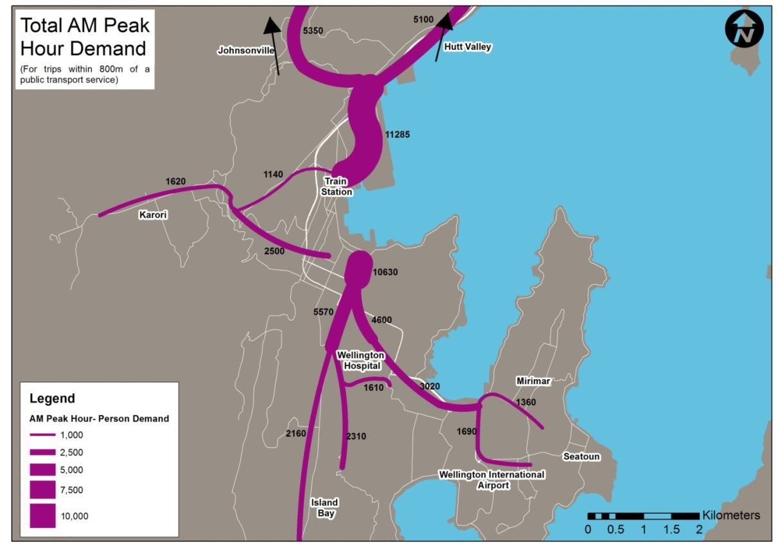

Figure 3: Analysis of Future Travel Demand (source: Modelling Report, 2013)

A wider review of forecast demand was also completed to understand and reconsider previous options. These included the benefits of extending the rail line through the Wellington CBD and whether there was significant demand for through trips through the CBD. The demand analysis considered both public transport trips and all trips by any mode. This allowed an understanding of demand between areas well supported by public transport and those that were not. This analysis revealed that:

* The majority (86%) of trips arriving at the periphery of the Wellington CBD from the north end their trip within the CBD. There is little demand for travel through the CBD to destinations beyond.
* For rail trips that end in the CBD, the majority complete their journey by foot, approximately 15% transfer onto bus.
* There is a high public transport mode share from the north (40 - 70 % from some origins). Providing a new public transport mode is likely to move these trips from rail to a new public transport mode rather than capture additional public transport mode share.

For travel demand from south of the Wellington CBD, it was concluded:

* There is a lower public transport mode share for trips to the CBD, so a good opportunity to capture additional public transport users.
* Extending a high capacity system to Newtown connects catchments to the CBD and the Regional Hospital.
* Extending a high capacity system to Kilbirnie (south east) would provide a direct, quick and frequent service to the CBD for passengers from the Miramar Peninsula and Kilbirnie, and remove the need for passengers to transfer between modes for a short length of their trip. It also offers the option of future services to the Regional Airport.

For these reasons, extending a high capacity system to the south-east was considered to have merit as it increased public transport mode share, and reduced overall travel time for public transport users.

# Confirming Corridors

The demand analysis confirmed extensions to the study area but did not confirm the corridors to be used. The analysis of corridors to serve the identified catchments included an assessment of options to travel between the west and the east of Mount Victoria. Each option was considered in the context of the street environment and desired level of service which included.

* The ability to provide an appropriate level of operation and service for chosen passenger transport modes
* Providing a direct and legible route to connect key origins and destinations
* Minimising the widening of corridors that will impact on properties.

**Hataitai bus tunnel**

This is the existing bus priority route through Mount Victoria, it is a single lane tunnel with traffic signals controlling the movement of buses. Access to the tunnel is through narrow residential and commercial streets with numerous driveways, 350 on street carparks and through 18 intersections. The limitation of a single lane tunnel which has limited capacity coupled with potential impacts of providing additional capacity through narrow streets means that this route is not considered appropriate for high capacity public transport. The use of the Hataitai bus tunnel has been maintained in the Bus Priority option only.

**Constable Street**

This existing bus corridor connects Kilbirnie to Newtown via Constable Street and Crawford Road. This route links Kilbirnie to the hospital and CBD through the passenger transport spine. However, the route is longer and therefore likely to provide a slower journey time to the CBD than alternative routes. Travelling through narrow residential and commercial streets with many driveways and intersections would likely compromise the level of priority that could be provided. To provide priority for public transport would require widening, removal of parking and would impact on properties the entire length of Constable Street. Crawford Road presents constraints as it is steep, built into the side of a hill and widening would require the removal of on street parking for houses with no onsite parking. The focus of the Constable Street corridor was confirmed as a local bus connection with improvements provided in the Bus Priority option only.

**Mount Victoria tunnels**

The New Zealand Transport Agency is planning for an additional tunnel (by 2022) and additional capacity on the approaches. The planned improvements provide an opportunity for the corridor to become a focus for public transport as was originally envisaged. Providing a corridor with few driveways, signal controlled intersections which will provide priority as well as a direct link to the CBD. This route connects to the public transport spine at the Basin Reserve. Forecasts suggest a relatively uncongested trip through the tunnels, for this reason buses travelling through the tunnels was considered acceptable, providing improved travel times without needing additional capacity.

For light rail an additional tunnel(s) was considered necessary, this has been the subject of intense debate. The advice received by the project team was that whilst the concept of Light Rail Transit travelling in a tunnel with general traffic is possible it is not best practice or recommended. There would be a number of additional systems required to address fire life safety and power issues through the tunnel as well as potential operational difficulties (AECOM,2013). Because of these potential difficulties the Light Rail Transit option provides for an additional tunnel.

**Final Corridors Selected**

The corridor analysis indicated that implementing potential options with a high degree of priority was constrained by the form of existing development and the way in which the corridors had developed. Figure 4 displays the identified corridors by mode chosen for the final assessment.

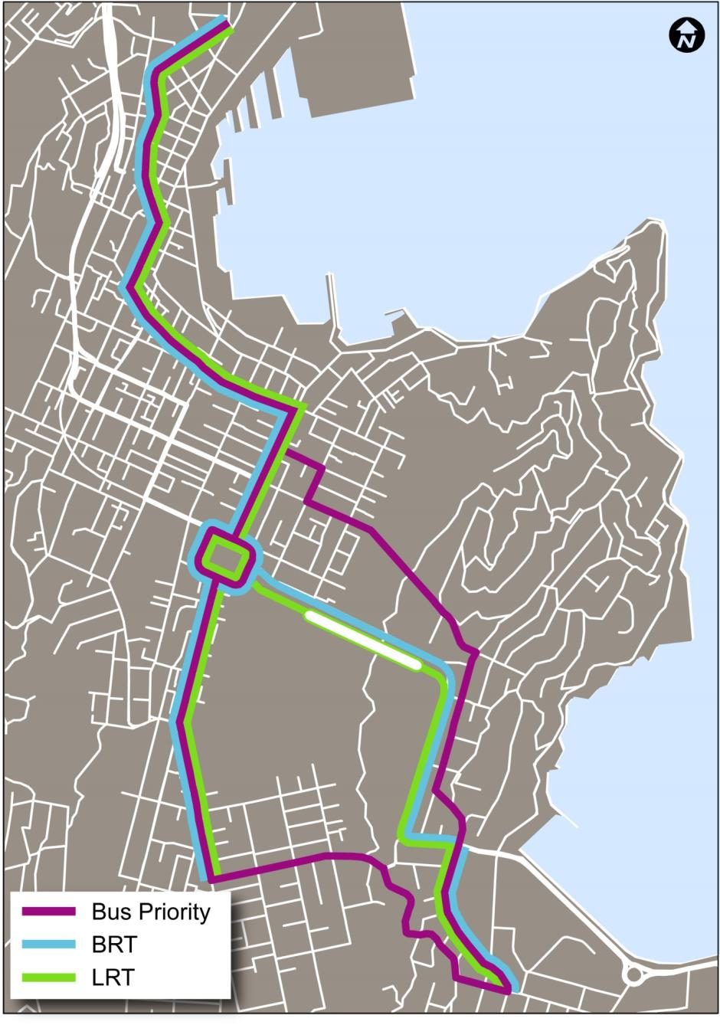

Figure 4: Final option corridors (source: Option Evaluation Report, 2013)

# Option Comparisons

Option components, cross sections and corridor widths for each of the options were defined and refined. This identified the impacts on existing and future development, any absolute constraints and provided the detail to develop option costs. The options were modelled by Greater Wellington Regional Council with the results providing future forecasts of changes in patronage. Table 2 provides a comparison of key measures for each option extracted from the Option Evaluation Report (AECOM, 2013).

|  |  |  |  |
| --- | --- | --- | --- |
|  | **Bus Priority** | **BRT** | **LRT** |
| Travel time savings along corridors to Wellington Railway Station (2031 Morning Peak) | | | |
| From Kilbirnie  From Newtown | 3 minutes  3 minutes | 11 minutes  6 minutes | 11 minutes  7 minutes |
| Changes in patronage (morning peak) | | | |
| South to the CBD (2031) | +3% in 2031 | +8% in 2031 | No increase |
| 2021 Regional  2031 Regional  2041 Regional | 35,800 (+1%)  34,300 (+1%)  35,500 (+1%) | 36,300 (+2%)  34,800 (+2%)  36,100 (+3%) | 35,800 (+1%)  34,300 (+1%)  35,600 (+1%) |
| Transfers | | | |
| At Newtown  At Kilbirnie | 280 (+75%)  60 (+20%) | 210 (+35%)  150 (+200%) | 1340 (+740%)  1020 (+1940%) |
| Cost (millions) and economic assessment | | | |
| Construction  PT annual operating cost | $59  $88 | $207  $83 | $938  $89 |
| Benefit cost ratio range | 0.57 to 0.67 | 0.87 to 1.55 | 0.05 to 0.10 |

Table 2: Option Comparison

Key points from this comparison are:

* The options have limited impact on regional patronage as the focus was on options serving the the south and southeast rather than a regional change.
* Bus Rapid Transit and Light Rail Transit enable faster travel times to access the CBD along the spine corridors due to the level of segregation from general traffic.
* Light Rail Transit requires passengers travelling beyond the spine to transfer at Newtown or Kilbirnie. The need to transfer lead to a lower patronage increase than Bus Rapid Transit where services travel beyond the spine.
* Costs for Light Rail Transit are almost five times higher than the next most expensive option. Mainly due to the high cost of fixed infrastructure, moving services and the requirement for an additional tunnel through Mount Victoria.

Bus Rapid Transit provides the highest benefit cost ratio with the highest increase in forecast patronage.

# Conclusion

The Wellington Public Transport Spine Study is the latest in a series of studies that have considered potential options to provide for growth in public transport and the future development in Wellington. Each of the preceding studies has recommended potential improvements to the transport system based on assumed options, costs, growth in development and infrastructure.

The earliest study referenced took place in 1963 and some of the recommendations from that study have since been completed. One of the major recommendations for public transport was to extend rail through the CBD. The PTSS assessed this option and found that it did not provide adequate benefits to justify further consideration.

Later studies considered light rail through the CBD and to the north, the PTSS considered these options. Catchment demand analysis and identifying the potential uptake of public transport confirmed that the focus of a high capacity public transport option should be to the south and southeast.

The assumption to include the Roads of National Significance network improvements in option testing has affected future travel patterns. This assumption led to a decrease in public transport patronage in the future as travel times by car to the CBD improved.

The initial development of a public transport system in Wellington was crucial to allow for the movement of people and to unlock the potential for development. Since the first tram began operation, the population of Wellington has increased from 50,000 and is forecast to grow to 526,000 by 2041. The public transport system has evolved from horse and steam driven trams to now include rail, buses and trolley buses. Based on the assumptions for the future adopted Bus Priority, Bus Rapid Transit and Light Rail Transit options were considered in detail. Comparison of these options shows that Bus Rapid Transit provides the highest increase in patronage and has the highest benefit cost ratio. Bus Priority which has the lowest cost is forecast with the same increase in patronage as Light Rail Transit.

Since the release of the study final reports in June 2013 there has been a period of public consultation followed by hearings. A draft report of the Wellington Public Transport Spine Options Hearings Subcommittee is available on the Greater Wellington Regional Council website. This draft report details the recommendations of the Subcommittee, key points include:

* The core spine corridor to be along the Golden Mile, Kent/Cambridge Terrace and branching to Newtown via Adelaide Road and Riddiford street and Kilbirnie via State Highway 1.
* Bus Rapid Transit is the preferred option for the spine.
* The need to plan for the development of the preferred option in a progressive manner to move from bus priorities to Bus Rapid Transit.
* The need to align residential and economic growth along the spine and at key nodes.
* Protecting potential future expansion to the airport.

**References**

Pawson, E. 'Cars and the motor industry - A motorised society', Te Ara - the Encyclopedia of New Zealand, updated 13-Jul-12. URL: http://ww.TeAra.govt.nz/en/cars-and-the-motor-industry/page-1

WCL (Wellington City Library), http://ww.wcl.govt.nz/heritage/trams.html, downloaded December 2012.

Opus International Consultants Limited, Central Area Bus Operational Review, Final Report, November 2009

Greater Wellington Regional Council (GWRC), PTSS Short List Evaluation -Modelling Report, June 2013

AECOM, International Review of Public Transport Systems, February 2012

AECOM, Option Evaluation Results, June 2013