THE IMPACT OF ADAPTIVE ROAD LIGHTING ON ROAD SAFETY

William Frith1 M Sc (Hons), M. Sc (Transport Engineering), BA, FCILT, AFACRS, MICADTS and Mike Jackett 2 BSc, M.Eng.Sci

1 Research Manager, Road Safety, Opus Research, Wellington (William.Frith@opus.co)

2 Jackett Consulting, Wellington (Jackett@paradise.net.nz)

**Abstract**

Adaptive road safety lighting is lighting which may be changed with changed circumstances. It may change with traffic flow, the weather, weekday/weekend, presence of vulnerable road users etc. It is clear from recent urban research benchmarking lighting levels to crash outcomes that in general any decrease in lighting levels can be expected to decrease safety and vice versa. Under a safe system, if lighting levels are reduced, the designer needs to ensure that other counter measures are taken, to reclaim the loss, either at the site of the reduction in safety, or arguably, elsewhere in the network. The designer also needs to use fine-tuning to maximize the safety gains from available lighting resources. A case study based on using urban arterials found that without increasing energy output an increase in crash savings of some 14 % could be achieved with a simple two step adaptive lighting scheme targeting lighting to risk. A smaller gain (11%) was achieved by targeting lighting levels to traffic volume. In conclusion, adaptive road lighting, used wisely within a safe system context allows fine-tuning of our lighting conditions so that safety and environment benefits can be simultaneously realised at a more optimal cost.

**Keywords**

Lighting, road safety, adaptive

**Introduction**

In New Zealand lighting required to ensure a reasonable level of personal security is known as Category P lighting and by design is less intense than that required to ensure road safety (Category V lighting). This paper is concerned with Category V lighting – lighting for road safety.

Adaptive lighting is lighting where the average luminance can be changed with changed circumstances during darkness. This is in contrast to “normal” lighting which is lighting which stays unchanged during the period of darkness. Normal lighting is designed to a chosen subcategory of lighting according to national or local codes of practice (CIE115, 2010). Adaptive lighting is appropriate where there is a need to vary the level of lighting at different times; for example off-peak, during better weather or worse weather[1], times when there are more or fewer crashes, when there are more vulnerable road users around or when there is more ambient light. Here a higher or lower level of lighting can be selected from the range of subcategories available in National Standards.

This paper looks at the safety of adaptive lighting generically, rather than from the viewpoint of any one technology. However, the technology is most suited to LED luminaires which may be easily dimmed or brightened. Examples of their flexibility are given in Collins, 2011. It is clear from the literature (e.g. Jackett and Frith, 2013) that in general any decrease in lighting levels can be expected to decrease safety and vice versa. Thus, under a safe system, if lighting levels are to be reduced, the designer needs to ensure that other countermeasures are taken, to reclaim the loss, either at the site of the reduction in safety, or elsewhere in the network.

Adaptive technology has great potential and has come at the same time as adaptive vehicle lighting technology (Berlitz, 2013). Adaptive vehicle lighting technology seeks to adapt the lighting of vehicles to the level of ambient lighting and also to the presence of other vehicles. These two technologies, which are both aimed at similar objectives, have developed almost totally separately.

Similarly, retro reflective road markings, surface mounted delineators and posts are other ways to assist in vehicle guidance at night. These technologies have also developed separately from the development of road lighting. Ideally, all these measures should be combined in a systems approach to provide optimal guidance for vehicles. In reality this type of approach is still a long way off with significant obstacles such as in situ inventories of vehicles, road lighting, marking and delineation infrastructure of very mixed ages and conditions.

The approaches used to make decisions on the use of adaptive lighting are not well developed internationally. They tend to be arbitrary, based on little hard evidence, and safety is not explicitly and seldom implicitly taken into account. Examples of approaches can be found in BSREC (Black Sea Regional Energy Centre) (2007). None of the approaches found internationally have provision for the direct inclusion of crash information in the choice of lighting level. New Zealand is fortunate that the choice of subcategory within the AS/NZS1158 road lighting standard allows for safety implicitly and also has flexibility to move to a higher as well as lower level of lighting as appropriate.

With adaptive lighting, changes in lighting levels tend to be made using traffic volume criteria. Crash rates per vehicle kilometre vary during the night reaching peaks between midnight and 3 am in New Zealand. The level of safety (measured by crashes per hour) relates not only to the traffic volume but also to the crash rate. Thus, it would appear more appropriate to use traffic volumes weighted by accident rate to identify high risk periods rather than just traffic volumes. This would result in a lower volume threshold for reducing lighting in places and at times with higher than usual accident rates and a higher volume threshold for places and times with lower than usual accident rates.

An illustrative case study was thus carried out using data from urban arterials on Auckland’s North Shore.

**Methodology**

Jackett and Frith (2013) described the dose response relationships between the level of road lighting and road safety for urban New Zealand lighting installations. This case study was carried out by combining those dose-response findings with temporal crash and traffic volume data. The volume data was on a “day of week” by “hour of day” basis and related to a selection of major urban roads within the former North Shore City. The former North Shore City is the only source of data in this format known to the authors. The crash data were Police reported crashes from the area of the new Auckland super city. The crash data were obtained from the NZTA’s Crash Analysis System (CAS) for Auckland Super City area for five years, 2007 - 2011 in a “day of week” by “hour of day” format for road type “Major Urban Roads”. The wider Auckland City data were chosen to maximise the sample size.

These data were used to estimate:

* Relative day/night crash risks;
* Potential savings from utilising a higher and lower lighting level; and,
* Comparative savings if targeting by crash distribution rather than traffic volume distribution.

The use of crash data from a wider area than the former North Shore City carries with it the implied assumption that the temporal pattern of crashes on that network is broadly similar to that on the former North Shore City network. A representative mix of shopping and commuter routes was included.

Figure 1 displays the results from determining from that crash data the time of day of crashes reported as “dark” and “light” by the Police. Using all of year data it was found that 6am and 6pm were effectively the cross over points where a majority of day crashes became a majority of night crashes and vice versa. Clearly this is a big approximation as darkness varies by month of year, but a single annual figure is desirable for the purposes of this estimate.

. 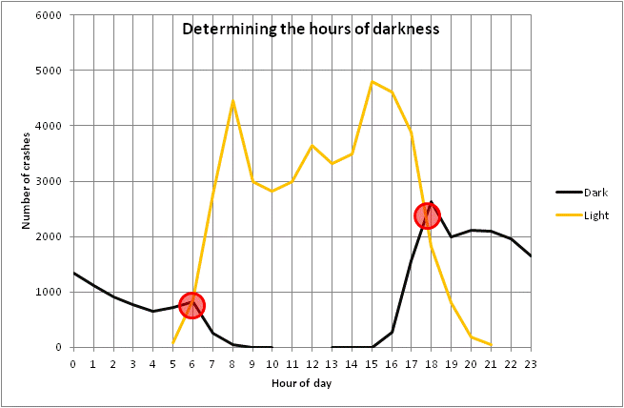

Figure 1: CAS “Light” and “Dark” crashes, Auckland showing the transition point at 6am and 6pm

**Results**

***Relative day/night crash risks***;

Table 1 combines crash and traffic volume data by day of week and hour of day to produce a normalised crash risk index per VKT[2]. The highest crash rates in the matrix in Table 1 are around 7 and 8 and occur in the early hours of Friday and Sunday morning. The early hours of Saturday morning are in the range 3 to 6.5. The cells in red identify the higher individual risk periods and the green cells the lower individual risk periods.



Table 1: Crash rate per VKT normalised such that the average during the day (6am - 6pm) is set to 1.0

Note: Red represents high crash rates and green represents low crash rates.

In terms of social cost[3], it is the cells with the highest total number of crashes that represent the periods of greatest potential benefit. Table 2, which has been normalised in a similar way to Table 1, displays the periods of the night with an above average number of crashes in red.

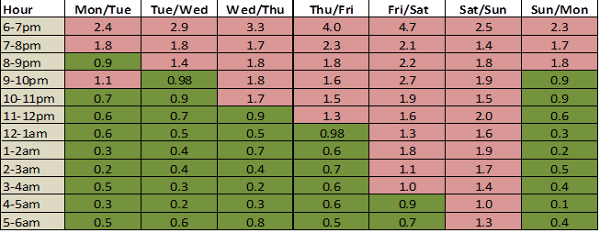

Table 2: Number of crashes per hour normalised such that the median cell is set to 1.0

Note: 50% of cells are marked red representing periods with high crash frequency and 50% marked green representing periods with low crash frequency.

***Varying lighting levels by crash levels***

Lighting for road safety purposes is classified into four sub categories. According to the joint Australia- New Zealand road lighting AS/NZ1158 V1 corresponds to an average luminance of 1.5 cd/m2, V2 to an average luminance of 1.0 cd/m2, V3 to an average luminance of 0.75 cd/m2 and V4 to an average luminance of 0.5 cd/m2 The 2013 Auckland Transport guidelines for street lighting [4] indicate that generally V1 is used on streets with daily volumes greater than 20000 vehicles, V2 for 15000 to 20000 and V3 for 5000 to 15000 and V4 3500 to 5000. Other Councils’ guidelines may vary from these.

If a lighting installation can be varied to deliver more light at the periods with high crash numbers and less light at the periods with low crash numbers, then safety can be maximised for a given total nightly lumen output. Four scenarios are examined below: Savings quoted are relative to having no lighting at all.

1. A single V4 level of lighting is provided throughout the night.
2. A single V3 level of lighting is provided throughout the night. This represents the norm for much State Highway lighting in NZ.
3. A V3 level is provided for 50% of the time and dimmed to V4 for the remainder. The high level is applied at the times with most crashes. This option lowers energy use while minimising the adverse effect on safety.
4. A V2 level is provided for 50% of the time and dimmed to V4 for the remainder. The high level is applied at the times with most crashes. This option uses the same energy as option 2 but achieves greater road safety savings.

Table 3 depicts the four scenarios.

|  |  |  |  |
| --- | --- | --- | --- |
| **Scenario** | **Percentage saving – high period** | **Percentage saving – dimmed period** | **Percentage saving overall** |
| 1. V4 level | 19.3% | Not dimmed | 19.3% |
| 2. V3 level | 27.6% | Not dimmed | 27.6% |
| 3. V3/V4 levels | 27.6% | 19.3% | 25.7% |
| 4. V2/V4 levels | 34.9% | 19.3% | 31.4% |

**Table 3: Predicted crash savings under four road lighting scenarios***.*

Note: The periods for higher lighting levels being determined by high crash numbers as highlighted in red in Table 2.

By comparing scenarios 2 and 4, which have the same energy input, it can be seen that better targeting of light levels will achieve a greater crash saving, from 27.6% to 31.4% of crashes saved, an increase in savings of some 14%.

If energy saving is a priority, then comparing scenarios 1, 2 and 3 shows that by dimming the lights at the times when there are fewer crashes reduces the negative impact of the lower light levels. With a targeted V3/V4 option, crash savings reduce from 27.6% to 25.7% compared to a much larger reduction from 27.6% to 19.3% if V3 lighting was reduced to V4 lighting for the whole night.

***Varying light levels by traffic volume***

Figure 2 and figure 3 show the hourly distribution of traffic volume on “major urban routes” compared to the distribution of crashes on the same type of road. For the night time section (6pm - 6am) there are some subtle differences, particularly for Friday, Saturday and Sunday morning. Note that these are the same periods identified earlier as having a high crash risk per vehicle kilometre of travel.

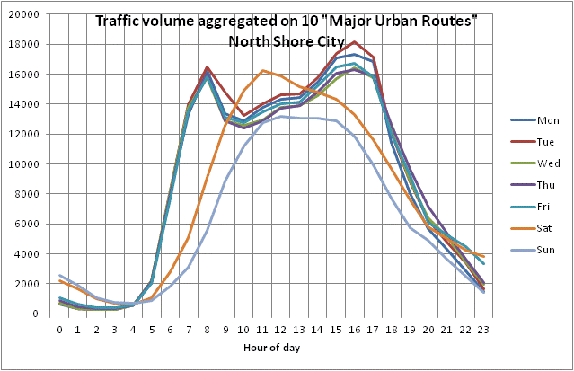

Figure 2: Traffic volume by time of day and day of week

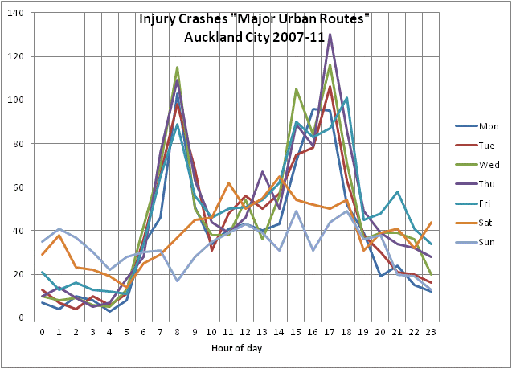

Figure 3: Injury crashes by time of day and day of week

If traffic volumes alone are used to select the periods when lights should be dimmed or brightened there is a risk that dimming may take place during some of the high crash frequency periods resulting in increased crashes. To determine the impact of this, the four lighting scenarios tested above were re-run using varying lighting levels chosen solely on the basis of traffic volume. This is depicted in Table 4.

|  |  |  |  |
| --- | --- | --- | --- |
| **Scenario** | **Percentage saving – high period** | **Percentage saving – dimmed period** | **Percentage saying overall** |
| 1. V4 level | 19.3% | Not dimmed | 19.3% |
| 2. V3 level | 27.6% | Not dimmed | 27.6% |
| 3. V3/V4 levels | 27.6% | 19.3% | 25.3% |
| 4. V2/V4 levels | 34.9% | 19.3% | 30.6% |

**Table 4: Predicted crash savings with four road lighting scenarios determined by traffic volume**

By comparing scenario 4 from table 3 with scenario 4 from table 4, it can be seen using crash information will achieve a greater crash saving from 30.6% to 31.4% of crashes saved, an increase in savings of some 2.6% over the use of traffic volume only.[5]

If the shape of the risk matrix is determined by the frequency of serious and fatal crashes rather than all injury crashes, then the risk matrix takes the form shown in Table 5. The overall shape is broadly similar to Table 2 but with more red cells evident in the early hours of Friday morning. This indicates that using a ***safe system approach*** the high risk period includes the small hours of Friday, Saturday and Sunday mornings.

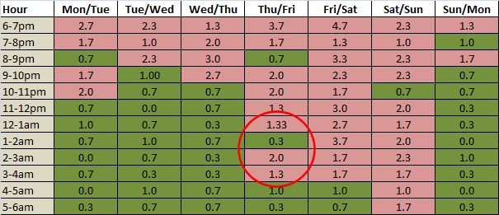

Table 5: Alternative matrix based on the frequency of fatal and serious crashes in each cell

Note: Red cells represent periods with high crash numbers (proposed high light level) and green the periods with low crash numbers (proposed low light level). The red ellipse indicates an area of change when only fatal and serious crashes are considered.

**Discussion**

Traffic volume works as a reasonable surrogate for crash frequency, except in some specific high risk times. In particular the traffic volume data fails to tell the true story at the weekend and approaching the weekend.

The case study found that without increasing energy output an increase in crash savings of some 14 % could be achieved with a simple two step adaptive lighting scheme (one level above, one level below normal) targeting light levels according to traffic crash data. A smaller figure (11%) is applicable if light levels are targeted according to traffic volume data.

The ready availability of detailed traffic volume data at most road lighting sites could provide a useful first step in selecting periods for high and low level lighting. This could then be supplemented by information on high risk times, using information similar to that in the crash frequency matrices used in the case study.

**Conclusions**

* Adaptive road lighting, used wisely within a safe system context, has the ability to fine tune our lighting conditions so that safety and environment benefits can be simultaneously realised at a more optimal cost.
* As a simple guide urban arterial networks lighting should be retained at higher levels during the dark periods from dusk Friday evening through to sunrise Sunday morning.
* As more sophisticated adaptive technology becomes available, weather related changes in lighting should be incorporated, giving greater light to those times when weather is bad.
* Options (which would not be mutually exclusive) for the future include the following:
  + A risk matrix to superimpose on the local traffic volume matrix;
  + A standard crash rate matrix to apply to different types of road no matter where they are in NZ and independent of traffic flow; and
  + Regionally generated crash rate indexes with or without volume data

**Acknowledgements**

This work was funded by the New Zealand Transport Agency (NZTA).

**References**

BSREC (Black Sea Regional Energy Centre) (2007) *Intelligent Road and Street Lighting in Europe* (E–Street). Sofia Bulgaria.

Berlitz, S. (2013) *Regulatory Impacts of Advanced Lighting Systems*, SAE International Government –Industry Meeting. Retrieved from: <http://www.sae.org/events/gim/presentations/2013/berlitz_stephan.pdf> (Viewed 5/6/2013).

Collins, A. (2011). *Intelligent street lighting Eden Park surrounds*. Paper Presented at the NZTA/NZIHT 12th Annual Conference 'Building and Maintaining Highways for the Future’: New Plymouth.

CIE115. (2010). *Recommendations for the lighting of roads for motor and pedestrian traffic*. Technical Report CIE 115, Second Edition Commission International d’Eclairage, Vienna, Austria.

Jackett, M. and Frith, W. (2013). *Quantifying the impact of road lighting on road safety — A New Zealand Study*. IATSS Research, 36, 139–145.

SWOV (2012) SWOV Fact sheet The influence of weather on road safety SWOV Institute for Road Safety Research, Leidschendam, the Netherlands

1. Bad weather is a genuine road safety hazard (SWOV (2012))
2. Note it is not possible or necessary to produce an absolute value of VKT so the data has been normalised such that the average day crash rate = 1.0. Thus an index figure of 5 would indicate a risk of five times the average day figure.
3. In New Zealand, the social cost of a road crash includes allowances for loss of life and life quality, loss of output due to temporary incapacitation, medical costs;’ legal costs and vehicle damage costs . For more detailed information see:<http://www.transport.govt.nz/assets/Uploads/Research/Documents/Social-Cost-of-Road-Crashes-and-Injuries-June-2013-update.pdf> ( Viewed 4 January, 2014)
4. <http://www.aucklandtransport.govt.nz/improving-transport/have-your-say/ATCOP/ATCOP_Section_19_Street_Lighting.pdf> Viewed $ January 2014
5. This figure is for illustrative purposes only. The approximate nature of the traffic volumes used would make the use of any statistical testing unwise.