Vehicle Activated Electronic Signs - 5 Years on

A Case Study

Robyn Gardener GDipRS, MTraf
Programme Manager: Speed & Signature Projects, ACC
robyn.gardener@acc.co.nz
(Co-author) Peter Kortegast BE(Civil)
Transportation Engineer, Opus International Consultants
peter.kortegast@opus.co.nz

Abstract:
This technical paper revisits a trial of electronic vehicle-activated permanent warning signs installed at sites in Tasman and Marlborough Districts during mid 2009, five years on from installation.
In Tasman, electronic bridge cycle warning signs designed to activate as cyclists ride over a sensor were installed for the first time in New Zealand at Appleby Bridge. In Marlborough, three high risk out-of-context curves were treated with vehicle-activated curve warning signs. The signage has been operational since May/June 2009.
At the time, it was hypothesised that the installation of the vehicle-activated signage would be associated with a reduction in crashes on the curves and an improvement in the comfort and safety of cyclists using the bridge. When the trial was reported to IPENZ in 2009, the signage had been operational for a short period and the positive early indications were met with some scepticism by some in the traditional engineering profession. At the time the authors proposed further monitoring of the sites and data collection be carried out to assess the effectiveness of this type of technology on driver behaviour and crash incidence.
Five years on, both authors have moved on in their careers and have taken the opportunity to step back and revisit the project, assess post-installation crash statistics, draw conclusions and share with industry colleagues the success, or otherwise, of these low-cost electronic interventions at high risk sites.

INTRODUCTION:
NZ Transport Agency (NZTA) Region 10 covers the top of the South Island and includes the Marlborough, Nelson and Tasman Districts. The opportunity arose to deploy electronic road safety signs in the area through a national safety funding initiative and funding was approved for a trial. A literature review was undertaken to assist with understanding of the use and expected behaviours of road users around the use of electronic signage. Research suggested that electronic signage had a role to play in addressing crashes related to speed and possibly fatigue and inattention by engaging the driver with a message.
Winnett and Wheeler (2002) had undertaken a large scale evaluation of vehicle activated signs for the UK Department for Transport. In that study they found that there was a statistically significant reduction in speeds of between 1 and 14mph associated with this type of sign. They also found a one-third reduction in crashes when compared with a baseline of predicted crashes over the time of the study without the signs in place. Winnett and Wheeler suggested that such signs have a greater effect than fixed signs and that there was no evidence of driver habituation to the signs, even over a period of three years.

Austroads (2008) suggested that, due to the lack of habituation of these types of signs, they may have a role to play as an anti-monotony measure. There is a tendency for fatigued drivers to lose track of their speed control on bends and these signs may incline a driver to heed the warning as the activation of the sign “engages” them.

As a result, the following types of electronic signs were proposed for installation when the opportunity arose to use electronic signage to assist with road safety: speed indication devices (SIDs); cycle activated cyclist warning signage, vehicle activated curve warning signs and time specific rural school warning signs, all of which would engage drivers at sites with particular safety issues.

This technical note will focus on two specific types of electronic signage deployed across the region - cycle activated cyclist warning signs installed at SH60, Appleby Bridge, Tasman District and vehicle activated curve warning signs installed at SH1, Dazzle Corner and Butter Factory Corner, and SH6, Pak Lims Corner, Marlborough District. Figure 1 shows examples of signs and Figure 2 shows sign locations.

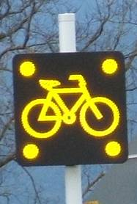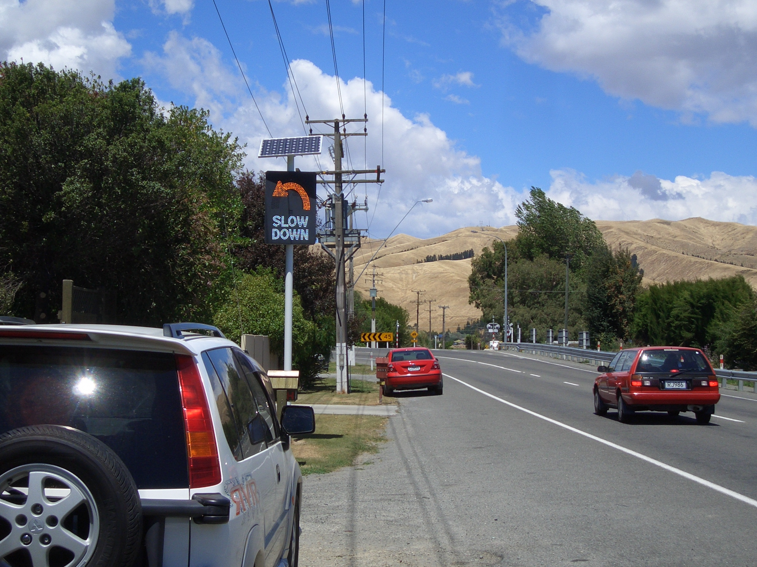
Figure 1: Cycle activated cyclist warning sign (left), vehicle activated curve warning sign (right)
Two case studies, SH60 – Appleby Bridge and SH1 – Butter Factory Corner, are used as the basis for the discussion.

Discussion:

Case Study 1: SH60 Appleby Bridge
Appleby Straight is a black spot section of SH60 located to the north of Nelson. Over the five year period, 2005 to 2009, there had been 4 fatal crashes involving vehicles, with a five year annual average crash social cost of $3 million (NZ Crash Analysis System, CAS). No cycle crashes occurred during this period. The section of highway had been identified as a Network Safety Co-ordination (NSC) site and had been a focus for crash reduction work in the region.

The Appleby State Highway Bridge is 230m long, 7.3m wide and carries over 12,000 vehicles per day. The bridge has concrete side rails with a 200mm non-mountable vertical kerb face. The approaches have lead-in w-section barriers for 100m and variable width shoulders between 1m to 2m.

The constrained space on the bridge does not reduce the average vehicle speed when a cyclist is in the lane, and the bridge has an 85th percentile speed of 85km/h regardless of whether or not a cyclist is present. This was determined by a floating car speed survey.
Table 1: Appleby Bridge Data
Annual Average Daily traffic (AADT): 12,000 veh/day | Cycle Volume: 140 cyclists/day
Heavy Vehicles (HCVs): 7% | Bridge Width: 7.3
Speed Limit : 85km/h | Posted Speed Limit: 100km/h

While there was no previous crash history related to cyclists using the narrow 7.3m wide Appleby Bridge situated just prior to the Appleby Straight, the regional cycle strategy identifies the Appleby Bridge as an impediment to peri-urban commuter and recreational cycling and the site was highlighted as the number one priority for State Highway improvements. There was strong interest from cyclists for safety improvements at the bridge.

A capital project was investigated involving retro-fitting clip-on bridge cycle lanes but the estimate of $1.4 - $2 million (NZ) made it impossible to economically justify the project so alternative safety improvements were investigated.

It was decided to proceed with cycle warning signs to alert both cyclists and vehicles to the cycle pinch point. Winnett and Wheeler (2002) suggested that conventional static permanent warning signage was less effective than electronic signage and there was no evidence of driver habituation, so real time warning signs, activated only when cyclists were using the bridge, were indentified as the best option.

There was an expectation that, if vehicle drivers were made aware of a cycle in the immediate vicinity as they were driving over the bridge, they would slow to a speed that allowed them to follow a cyclist on the bridge rather than crossing the centreline and passing whether or not there was a vehicle in the opposing lane.
Speed surveys, cycle counts and videos of driver behaviour were undertaken prior to any improvement work at this site.

SH60 Appleby Bridge
Cycle Sign
SH1 Dazzle Corner
Curve Warning Sign
SH6 Pak Lim’s Corner
Curve Warning Sign
SH1 Butter Factory Corner Curve Warning Sign
Figure 2: Electronic Sign Locations

Cycle Sign Design
Using the known technology of electronic flashing light signs attached to permanent warning signs with manual push button or light beam trigger systems as a starting point, a user activated system was investigated. A time-period activated electronic sign approach was used to develop the electronic cycle sign with corner flashing lights, similar to that used in New Zealand school zone signs, and approved and legalised for highway use.

The next challenge was developing a suitable detection system. Two options were considered, a signal detector loop and manual push button for the cyclist. It was thought unlikely that, due to the cycle volume at this site, a push button requiring cyclists to slow to activate would be an effective option. Initially, the use of standard signal detector induction loops placed on a green painted widened shoulder where cyclists would be directed to ride was proposed to activate the signs. The cost to install these loops, with seal widening, green paint and marking was in excess of $20,000 (NZ). A significant amount of signage was also required which, it was considered at the time, could distract other road users compromising safety.

An alternative detection system, the eco-counter, was selected. This could detect cyclists in the main vehicle stream. The system had an added advantage of being a continuous cycle counter. The loops had not been used to trigger an electronic sign before and required software to be designed to convert the count signal back to an electronic switch signal.

The final system development was site testing of time period for display, spacing of loop to sign position and selection of sign operation in both directions or in the direction of travel.

It was decided to space the loop 30m prior to the sign to allow approaching cyclists to cross the loop and see the sign activated before crossing the bridge, allowing them a level of confidence that the system is working. The system is currently only activated in the direction of travel.

Case Study 2: SH1 Butter Factory Corner
Butter Factory Corner is an intersection on State Highway 1 (SH1), located to the south of Blenheim in the suburb of Riverlands. The intersection is a 45km/h curve with a T-junction local road, Alabama Road, intersecting on the outside of the curve. The intersection is complicated by the close proximity of the national rail link and a number of residential houses, along with a primary school. There is no stacking distance for vehicles between the railway crossing and the intersection, and sight distances are substandard.

The site has an AADT of approximately 7000 on State Highway 1 and 2000 on Alabama Rd with 15.6% heavy vehicles. The intersection has had 15 reported crashes (NZTA CAS) in the 10 year period ending 2009 and, although to date all crashes have resulted in minor or non-injury, there is potential for a major event should a crash occur in conjunction with a passenger train. Crashes involve a range of causal factors, inattention, fatigue, too fast for corner, trucks too fast or insecure loading, swung wide on bend and failure to give way.

A crash reduction study recommended lowering the speed limit at the site from 80km/h to 70km/h and installing threshold signage. But lowering of the speed limit raised the issue of whether a lesser speed limit would be “credible” and meet the setting of speed limit rules. The crash issues related to the isolated speed at the corner and just a little further on from the site there are open rural paddocks and a perceived 100km/h environment.

The local community had long advocated for a solution to the problems at the site. Proposals included installing a roundabout, reconstruction at the site to ease the curve and install a right turn bay to address some of the crashes, and a proposal for a localised by-pass removing the curve and the intersecting junction.

All options, except reducing the speed limit, required large funding commitments. A project to purchase an adjacent property then ease the curve and install a right turn bay was in the NZTA programme awaiting funding. In the short term, the community still wanted a solution that would improve the intersection until such a time as the funding was available for the engineering project.

A short term solution was agreed with the community and installed. It included a mix of available tools:
- The speed limit was reduced from 80km/h to 70 km/h (February 2009).
- Threshold treatments installed (May 2009).
- Thriebeam guardrail was installed to protect houses where vehicles had previously ended up in front yards (May 2009).
- A shared footpath/cycle path was installed from the railway crossing near Riverlands School to a safe crossing point on State Highway as part of the school’s road safety programme (May 2009).
- Electronic speed advisory signs installed as a reminder for drivers as they passed through the open fields in the 70km/h zone (completed June 09).
- Electronic curve advisory signs installed at the approaches to the corner in both directions to warn motorists and truck drivers to slow down if they are approaching the corner at speeds faster than the curve advisory (completed June 09).

Sign Installation and Monitoring
Once the decision was made to install the electronic curve advisory signage at the site, it became obvious that sign positioning would be crucial to effectiveness – placed too far out from the curve, they would be giving the “slow down” message to all vehicles and placed too close to the corner, any driver travelling too fast would not have time to brake on the straight before entering the curve.

Prior to installation, tube counters were placed for a week to collect pre-installation approach speeds at the corner. It was planned to use this data to ascertain the distance required to decrease speed to the required posted advisory speed allowing for driver reaction times.

Problems arose when siting the signage as calculated distances were not in positions where the displays could be mounted, taking into account services both underground and overhead, all requiring clearances from the various utility companies. The next option was to place the signs further out from the calculated spot and increase the thresholds for activation of the sign. Several visits were made to the site and observations made of where most drivers were braking prior to the curve.

Activation of the displays is by speed-activated radar. Signs are set on three modes:
- No display – when vehicles approach at the curve advisory speed or less (northbound 55km/h, southbound 45km/h).
- Curve illuminated – when vehicles approach between the curve advisory and 10 km/h above (northbound >55km/h < 65km/h, southbound >45km/h < 55km/h).
- Curve illuminated and Slow Down message – when vehicles approach at 10km/h or more above the curve advisory (northbound >65km/h, southbound >55km/h).

Project Costs:
Case Study 1: SH60 Appleby Bridge
The SH 60 Appleby installation total project cost inclusive of professional fees was $55,000 (2009 dollars). This cost was made up of electronic signs and poles (2), power connection, surge protection/fuses (cost varies with distance to power source), detection loops (2), counter and signal controller and professional fees. A solar alternative is also available with additional costs per sign.

Case Study 2: SH1 Butter Factory Corner
The SH1 Butter Factory Corner curve warning signs installation total cost was $34,990 (2009 dollars). This cost was made up of electronic speed activated curve warning signs, solar power units, poles and sockets, data logging and GSM modem, technical installation and commissioning, additional on-site warranty, traffic management, rail supervision and site installation, and professional services.

Results:
Case Study 1: SH60 Appleby Bridge
There have been no cycle crashes at Appleby since installation of the signs in July 2009.

The signs themselves are mains powered and have had no significant maintenance issues over the four years with no major vandalism. Other similar installations which are solar powered have suffered theft of solar panels.

Opus is planning to undertake perception surveys of users and speed measurements in February 2014 prior to the conference and will report these results in our presentation.

Case Study: SH1 Butter Factory Corner
Butter Factory corner showed 9 crashes during the period 2004-2009 prior to the installation of the signage, resulting in 5 minor injuries and truck load losses of some not inconsiderable value. These crashes involved too fast entering the corner (3), loss of control under braking, accelerating or while turning (3), insecure or moving truck loads (3), as well as lack of attention to others on the road (6).

Early tube counts were undertaken before the installation of the signs at the points where the signs were to be installed. Counts were undertaken hourly over a 24 hour period. Approach speeds to the curve were measured with the 85th percentile speed varying from 64 – 73 km/h depending on the time of day. Tube counters installed again after the installation of speed activated warning signs indicated a speed reduction with 85th percentile speeds varying from 66 – 68 km/h. The corner approach speed reduced in range with top 85th percentile speeds dropping 5km/h on the approaches after the installation of the signs. From June 2009 to November 2013, when the planned infrastructure upgrade was completed, there had been 2 crashes at the site resulting in zero injuries. One crash involved a rear-ending at the rail crossing signals, the other involved an insecure load or truck trailer hitting another vehicle.

Observations undertaken at the three sites just after the installation of the signs showed vehicles activating the “slow down” message appeared to automatically brake when “engaged” by the sign. Five years on, observations undertaken during October 2013 at the Dazzle Corner site show drivers continue to exhibit the immediate braking behaviour when “engaged” by the activation of the “slow down” message. This aligns with Winnett and Wheeler’s research that “there is no evidence of driver habituation to the signs, even over a period of three years” (2002).

Anecdotally, drivers have reported being “awakened” by the curve warning sign flashing at the Dazzle Corner site and trucking companies actively report sign faults on both approaches to this corner to the roading authority office.

Early results from the electronic curve warning signs suggested that the signs were likely to be effective in slowing speeds and thus reducing crashes and injury severity. Five years on there has been a reduction in both crashes and injuries at all three sites where signage has been installed, with particular success being achieved at the Dazzle Corner site.

Table 2: Pre and Post Installation Crash/Injury Data at Three Trial Sites
Site | Pre Installation |  |  |  | Post Installation
Site | Crash Totals |  | Injury Severity |  | Crash Totals | Injury Severity
Site | - 10 years  01.01.1999 - 30.05.2009 | - 5 years  01.01.2004 -30.05.2009 | - 10 years  01.01.1999 - 30.05.2009 | - 5 years  01.01.2004 - 30.05.2009 | + 5 years (approx)  30.05.2009 - 30.11.2013 | + 5 years (approx)  30.05.2009 - 30.11.2013
SH1 Butter Factory Corner | 15 | 9 | 1 S, 5 M | 5 M | 2 | -
SH1 Dazzle Corner | 15 | 14 | 1 F, 2 S, 12 M | 1 F, 2 S, 11 M | 3 | 1 M
SH6 Pak Lims Corner | 9 | 5 | 1 F, 1 S, 2 M | 1 S, 1 M | 2 | 1 M

Conclusion:
The authors consider both of the trialled electronic signage options have demonstrated that they are effective tools to add to the road safety interventions tool box. The reduction in crashes and injuries at sites such as the three out-of-context curves, each awaiting transformational infrastructure upgrades when funding becomes available, suggests that the installation of vehicle activated signage which elicits a known type of response, such as braking in this case, is useful as an interim low-cost safety intervention.

While Winnett and Wheeler’s research suggests that there is no evidence of driver habituation to the signs, “even over a period of three years”, the authors consider that interventions such as these should be reserved for high-risk, high-profile sites where a message needs additional conspicuity and all other lower level incremental delineation options have been tried prior. The authors believe it is important that interventions which demonstrate such apparent success at identified high-risk sites are used sparingly. Additional research is required ascertain whether extensive driver exposure to this type of signage is detrimental to the apparently automated braking response that has been demonstrated at the out-of-context curve sites and the more modified “sharing the road” behaviours induced by the cycle activated signs.

The authors suggest there is value in giving further thought to providing more guidance for the use of LED signage as discussed in NZTA’s Traffic Control Devices Manual. Further development of MOTSAM Appendix A3 advisory speeds guidance and page 6-47 PW-35 Cyclists could include both these signs as possible best practice options for treating high risk sites. A staged hierarchical diagram of curve signage interventions is recommended with a case included for electronic curve warning signs reserved for the most high risk sites.

Acknowledgements
The authors wish to acknowledge the assistance of Jean-Francois Rheault of Eco-compteur, Philip Walton of Integrated Traffic Solutions, John Ashman of HMI Technologies and Neil Garnett of Opus International Consultants.

References

Austroads, 2008, Scoping study to assess road safety engineering measures to address fatigue, Internal Report, Austroads, Aust.

Winnett, MA & Wheeler, AH, 2002, Vehicle activated signs – a large scale evaluation, TRL report 548, Transportation Research Laboratories, Crowthorne, UK.

