THE DAMAGING EFFECT OF OVERWEIGHT VEHICLES

ON SOUTHLAND ROADS

Authors
John Laskewitz, BE (Civil), CPEng, IntPE(NZ), MIPENZ, member IPWEA NZ
Client Service Manager SDC & GDC, MWH, Invercargill, NZ
john.p.laskewitz@mwhglobal.com 03-211 0280

Ken Hudson, BE (Civil), CPEng, IntPE(NZ), MIPENZ
Principal Pavements Engineer, MWH, P O Box 9624, Wellington NZ
ken.c.hudson@nz.mwhglobal.com 04-381 5706

David Wanty, BE/ME (Civil), MSc (Transport Planning & Eng.) CPEng, MIPENZ, MITE
Principal Transportation Engineer, 48 McLintock Street, Wellington 6037, NZ
davidwanty@clear.net.nz 022-643 1065

To be presented by: Ken Hudson

ABSTRACT
This paper outlines analysis of axle group loads of overweight permit applications to Southland and Clutha District Councils and their damaging effect (compared to those for the relevant representative legal vehicle, applying the appropriate power for the equivalent standard axle (ESA)).

Fatigue cracking (ESA 5th power) and rutting (ESA 7th power) effects are assessed corresponding to carrying 1000 tonnes of the commodity loaded.

The investigation includes analysis of the NZ Transport Agency (NZTA) weigh-in-motion (WiM) 2012 data at each WiM site to derive representative loads for vehicles carrying about 50 tonnes, such as High Productivity Motor Vehicles (50MAX), and uses the TERNZ (2012) report figures which are based on all the WiM 2012 data (dominated by the Drury site) and RUC records (for the tare weight).

The findings of the analysis are presented in a series of graphs for different Truck and Trailer and B train vehicles and for different representative vehicles. Discussion is given on potential policy and the likely future raising of the legal weight limit from 44 to 50 tonnes.

Recommendations are given on extending the WiM network in the South Island to include more than the Waipara site, along with needs for further research.

INTRODUCTION

Southland and Clutha District Councils independently engaged MWH to undertake some initial investigation into the analysis of the damaging effect of overweight vehicles on their local roads.
The process began with the authors investigating the effect of the New Zealand Transport Agency (NZTA) introduction of HPMV permits, for a particular short section of road in Clutha District. The investigation included reviewing the reports on the associated NZTA website and creating an initial Excel tool based on the TERNZ (2012) report.

Following analysis of some of NZTA’s weigh-in-motion data available from their Traffic Monitoring System (TMS) refinement of the tool was instigated which was then put into use for assessment of a small number of permits issued by Clutha District Council (CDC) for the test case road in question. The cracking and rutting damage caused by the permitted vehicles (using ESA to the power of 5 and 7 respectively) was compared with that for a representative 44 tonne legal vehicle, taking into account the differing number of trips to transport 1000 tonnes of load.

The next stage involving developing this further and creating a spreadsheet database of the permits issued by Southland District Council (SDS), noting SDC has the largest extent of public roads of any Council in New Zealand.

High productivity motor vehicle (HPMV)

High Productivity Motor Vehicles (HPMV) were instigated by the New Zealand Government to improve the efficiency of transporting goods across the country as advocated by various organisations. Subsequently the New Zealand Transport Agency (NZTA) introduced a special class of HPMVs called 50MAX, which were to be limited to a gross vehicle mass of 50 tonnes and a minimum of 9 axles. The idea behind this was that the permitting of heavy vehicles complying with the 50MAX specifications should be made simple and easy, to improve freight efficiency.

ternz (2012) report

TERNZ (2012) examined NZTA’s Traffic Monitoring System (TMS) weigh-in-motion (WiM) data for 2012 to derive loading distribution patterns – refer also NZTA (2012). They also examined the Road User Charges (RUC) data to derive the tare weight of RUC vehicles.

Based on this data, the authors derived the typical load distributions for representative 44 tonne Truck and Trailer and B trains with 7, 8 and 9 axles, and their corresponding tare weights. The trailer loads were then adjusted slightly to ensure the total gross weight of the vehicle matched 44.0 tonnes.

From the TERNZ report it appeared that the addition of an extra tractor axle or extra trailer axle added a further approximately 1.0 tonnes. Also the tare weight from WiM data was about 0.50 tonnes heavier than that for RUC due to diesel, driver and equipment added (ignoring the larger difference for 7 axle Truck and Trailers which was considered to be a discrepancy). This was used to derive the tare weights for other large heavy vehicle (HV) types not in the TERNZ report.

A further useful finding of the TERNZ report was that they established a way to distinguish between 7 axle Truck and Trailers and 7 axle B trains (which are both classed as PAT vehicle type 751 in the WiM data). This would have been particularly useful in the past when most B trains were 7 axles, but B trains with 8 axles (and increasingly 9 axles) now predominate.

TERNZ stated that the critical threshold for the distance from the front axle to the mid-point of the second and third axles was 4.25 metres (the ‘second’ axle spacing is typically about 1.3 metres). Consequently we examined this threshold for records for the Drury site (which contributed to almost half of all the WiM records TERNZ examined), but for a smaller sample (1-5 February). Our finding was that a 4.50 metre threshold would be more appropriate, indicative of the idea that TERNZ had analysed the data in intervals of 0.25 metres (which seemed likely) and had quoted the lower instead of the upper threshold for the 4.25-4.50 m range.

We examined this further for the first axle spacing for 7 and 9 axle trucks (a more convenient parameter consistent with the NZTA vehicle classification scheme) and from the Drury WiM established an equivalent threshold of about 3.8 metres as evident from the Figure 1 below.

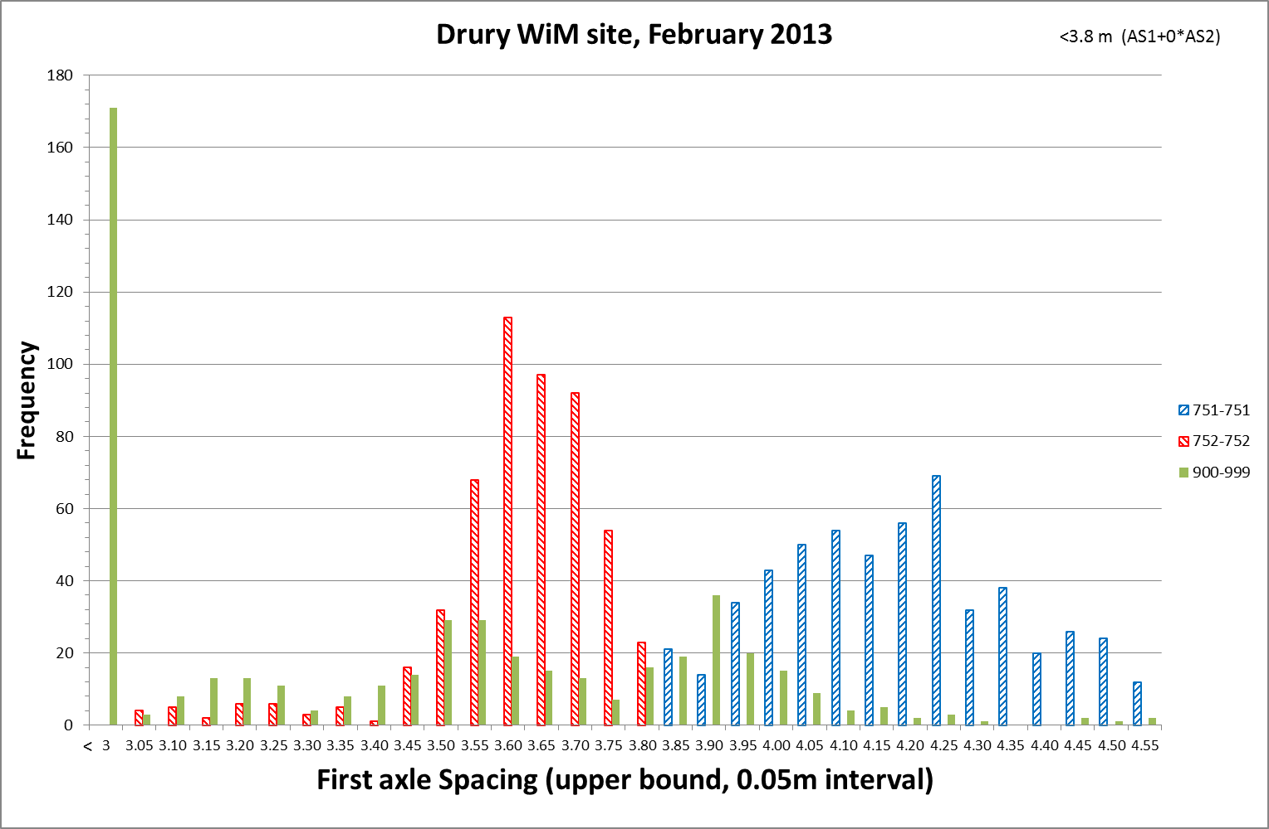
Figure 1: First axle spacing for 7 axle 1222 configurations and for 9 axle HVs.

growth in OVERLOADING

THE NZTA (2012) annual report gives a considerable amount of information from the six WiM sites for which the data are presently held in TMS.

Figure 2: Example of the growth in overloading from the NZTA 2012 weigh-in-motion report

While the annual NZTA WiM reports began in 2009 (with an increasing number of tables and graphs), an overloading index has been compiled since 2001 noting that there were fewer sites at that time and in 2012 the legal limits changed for some vehicle types.

Figure 2 above shows that trend for the three vehicle types most commonly recorded as overweight, which includes 8 axle truck and trailers, a very common heavy vehicle in Southland.

Based on a small sample at this stage, we derived from the Drury WiM data the representative load distribution of certain vehicle types with gross weight in the 49-51 tonnes range using our Excel spreadsheet tool. We also repeated this for our adjusted PAT type 751 vehicles (truck and trailer only) for those with gross weight in the 43 to 45 tonnes range. Note that the Excel tool analyses the exported WiM data for individual heavy vehicles (a standard TMS report) and derives the ESA (strictly SARm) values for the different powers.

HPMv 50max vehicles

Unfortunately the TERNZ report did not provide analysis of loading distributions for typical vehicles with a gross weight of around 50 tonnes.

Examination of the loading distributions in Figures 3 and 4 below, given in the NZTA annual weigh-in-motion reports (refer http://www.nzta.govt.nz/resources/weigh-in-motion/), reveal considerable change from year to year. For example for the common 8 axle truck and trailer, it appears that there was a substantial increase in overloading from 2009 to 2010 and from 2011 to 2012.

Figure 3: Example load distributions from the NZTA annual WiM reports: 8 axle T&T

Figure 4: Example load distribution charts from the NZTA annual WiM reports: all HVs

The changes in the load distributions could be due to real effects, the effect of the introduction of HPMV and 50MAX vehicles, a change in the calibration of the WiM hardware (such as the temperature correction), or a combination of the three; unfortunately there is no way of really knowing.

damaging effect

The NZTA reports are all based on the standard ESA using the fourth power rule (ESA₄) and assume that “steer axles are single tyred and all others are dual tyred”. The axle spacing threshold applied to distinguishing single axles from those in axle sets or groups is 2.10 metres, the same as for the NZTA and Austroads vehicle classification schemes whereas for the calculation of Vehicle Axle Index (VAI) in overweight permit applications it is 2.4 metres, and for HPMV is 2.0 metres (different spacing applied for determining if twin-steer – refer NZTA Factsheet 13g High Productivity Motor Vehicles).

While ESA₄ might be appropriate for empirical pavement design, this is not the case for mechanistic design where the 5th power is appropriate for fatigue cracking and the 7th power for rutting for chipseals on thin flexible pavements (and 12th power for cement bound layers). Specifically, the Austroads Pavements Design Guide (2004) states:
“The Damage Exponents 5 and 12 (for fatigue of asphalt and cemented material respectively) are derived from the fatigue relations for these materials… The Damage Exponent 7 (for rutting and loss of surface shape of bound pavements) is derived from the subgrade strain criterion…The Damage Exponent 4 (for overall damage to granular pavements with thin bituminous surfacing) is derived from field studies of pavement performance“.

The New Zealand Supplement to the Guide retains the exponent choice as does the Austroads Guide to Pavement Design Part 2 (2012). Empirical design is valid for standard highway loadings; HPMVs apply higher than standard axle loadings (i.e. outside the empirical design envelope), which suggests that empirical design is not appropriate and that it is prudent to use mechanistic design, particularly where the local roads suffer damage primarily from cracking and rutting.

From accelerated testing Arnold et al concluded that higher powers than Austroads may apply for weak pavements and lower powers for strong pavements. While Southland District does have some weak pavements, the usual Austroads powers have been used in this paper.

In addition NZTA acknowledges in their 2012 WiM report that “80-90% of Quad Axles are single tyred” and that “from observation, there is an increase in the utilisation of ‘super single’ type tyres in the SADT, TADT, TAST and TRDT groups, however, the impact or significance cannot be measured or derived from this [current WiM sites] technology”.

MWH have previously proposed to investigate this important issue for NZTA and to gather firm evidence, and we have undertaken our own analysis of the WiM data to gauge the effect of differing assumptions (0%, 20%, 40%, 60%, 80%, 100% super single tyres on trailers) regarding the percentage of ‘super singles’ on the ESA₄, ESA₅, ESA₇ and ESA₁₂ calculations – refer to Hudson and Wanty (2014).

Graphical outputs

The damaging effect on pavements for a number of permit applications are shown in the Figures 5 and 6 below for cracking and rutting, with the effect of some representative vehicles also shown. Due to the limited number of overweight permit applications for B trains, the graphs only relate to truck and trailers, the majority of which are 8 axle (T8, green triangles).

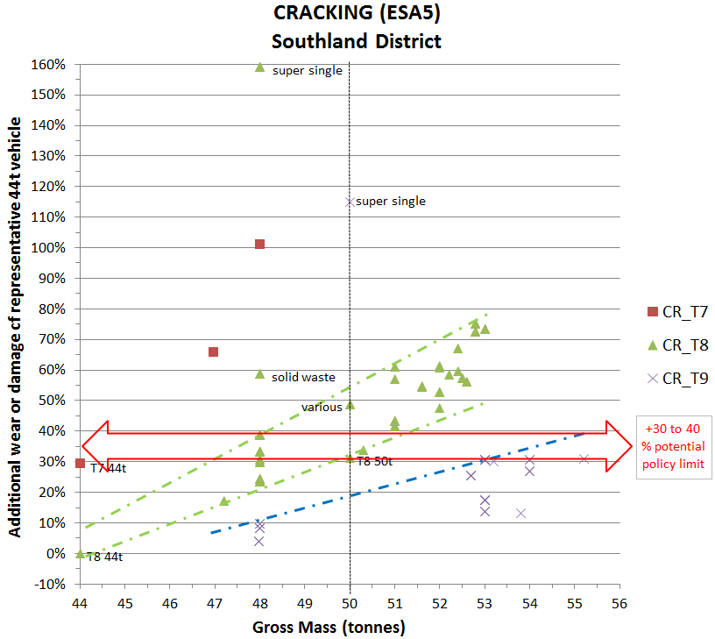
Figure 5: Graph showing effect on cracking for SDC permits
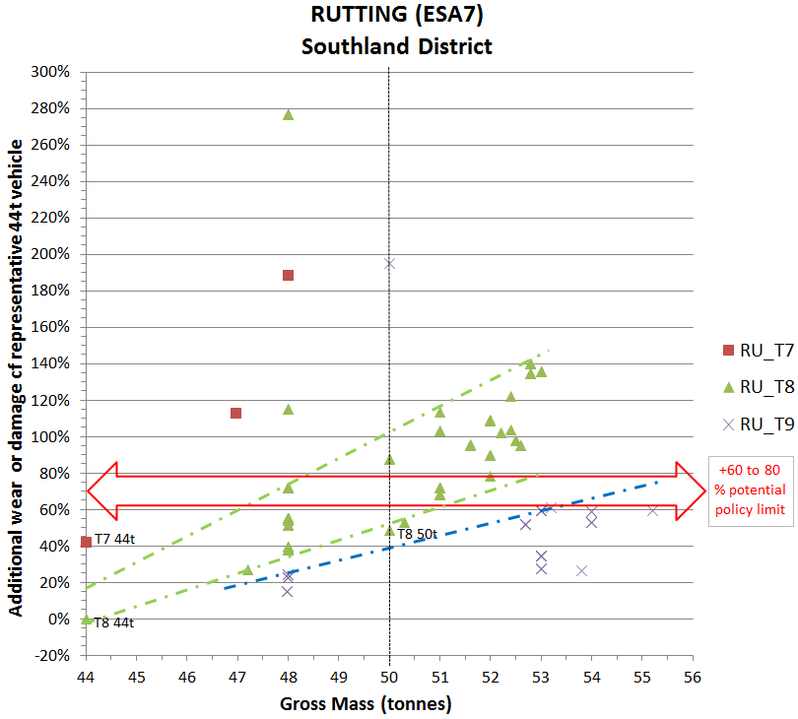
Figure 6: Graph showing effect on rutting for SDC permits

Examination of the graphs in Figures 5 and 6 above, shows that the additional wear or damage of the representative 8 axle 44 tonne truck and trailer vehicle relative to the representative 8 axle 44 tonne truck and trailer vehicle (T8 44t) is 0% as naturally expected.

The additional wear or damage of the representative 7 axle 44 tonne truck and trailer vehicle relative to the representative 8 axle 44 tonne truck and trailer vehicle is approximately 30% and 42% for cracking and rutting respectively, similar also to the additional wear or damage of the representative 8 axle 50 tonne truck and trailer vehicle relative to the representative 8 axle 44 tonne truck.

The graphs show the large adverse effect of trailers with large single tyred axles (super singles).

The graphs show the adverse effect of the two 7 axle truck and trailers (gross mass 47/48 tonnes).

Examination of the permit data for the 8 axle truck and trailers with gross mass less than or equal to 50 tonnes but with the calculated additional pavement wear for cracking exceeding 40% (for example the 48 tonne truck and trailer transporting solid waste), seems to indicate that these comprise trucks with greater than 7 tonnes on the drive axles; however the sample size is small and the possible linkage of this is conjecture at this stage. What the above graphs show however, is that for a given gross mass the loading distribution can influence the additional pavement wear for cracking in an approximate 20% range (25% to 30% range for rutting).

Note that different results are likely for B trains. For instance, from analysis of the same Drury WiM data, the additional wear or damage of the representative 7 axle 44 tonne B train relative to the representative 8 axle 44 tonne B train is about 64% and 105% for cracking and rutting respectively.

the effect of super singles

To date only a few permits have been requested in Southland for vehicles (actually the trailers) with large single tyres instead of the usual dual standard tyres. These have all been for tandem axle sets for which the Pavement Design Guide reference load is 90 and 135 kN for large single and dual standard tyres respectively.

Applying a tandem axle set load of 13,000 kg (127.5 kN) the respective ESA for large single and dual standard tyres are 4.0 and 0.80 for 4th power; 5.7 and 0.75 for 5th power and 11.5 and 0.67 for 7th power. This clearly shows the damaging effect of super singles with significant load imposed, noting Section 16.1 of the Austroads Pavement Research Group Report No. 18 (APRG (2002) states : “There has also been the ever-increasing upwards trend of higher axle/tyre loads, over-loading and the increased rutting effect of super single tyres (at least five times normal dual tyres)”.

It is also noted that for quad axles, there is no difference imposed in the (July 2013) RUC charge for single or dual tyred axles, even though the damaging effects are most likely significantly and substantial greater for super singles, and despite the aforementioned NZTA statement that 80-90 percent of quad axles are super singles.

POLICY CONSIDERATIONS

From analysis of the graphs a number of potential policies could be considered, which are now discussed, noting that at time of writing these are only postulated and have not been informally or formally adopted by SDC who are only just beginning initial discussions with NZTA on this matter.
A reminder also that the graphs are only for truck and trailer vehicles, since only a few of the permit applications currently loaded in the spreadsheet tool relate to B trains.

Clearly it would seem that the use of super singles is inappropriate for overweight vehicles so a policy could be introduced to that effect.

The permitting of 7 axle vehicles to carry more than the current legal limit of 44 tonnes also seems inappropriate; unless the damaging effect is computed as less than a certain level. Currently the proportion of 7 axle vehicles travelling on SDC roads is fairly low, constituting approximately 27% of all vehicles with 6 or more axles, of which the majority (63%) are 8 axle truck and trailers.

For the case of fatigue cracking (5th power) the damaging effect for 48 tonne applications (which is a common case, due it seems to the RUC charge thresholds) is in the range 20-40 percent greater than that for the representative 8 axle Truck and Trailer. For 50 tonnes the mid value might be about 40 to 45 percent, which also appears to correspond to the limit for 9 axle truck and trailers with up to around 60 tonnes (noting however that no overweight permits greater than 56 tonnes were in the applications analysed). One might think then that if an upper limit in the additional cracking effect is set at 40 percent, then above 50 tonnes all permitted truck and trailers require 9 (or more) axles. Note importantly that the NZTA require all 50MAX vehicles to have 9 or more axles.

A similar process could be worked though with regard to rutting effects. On the surface it seems that for the same gross weight the equivalent additional pavement wear for rutting is about twice that for cracking, e.g. for 50 tonnes about 80 to 90 percent more. However if that is considered an unacceptable rutting surcharge so to speak, then a different general policy would be required, based on whatever was considered to be the acceptable increase in the rutting effect.

Naturally the implementation of any policy and/or limit will be influenced by historical events. For example if there has been little change in the number of permit applications for many years, presumably continuance of the historical levels of maintenance could continue to suffice in keeping cracking and rutting and the pavement condition to acceptable levels.

For the past two decades there has been a beneficial trend in an increase in the number of axles for truck and trailers and for B trains so that, in many cases the amount of ESA and hence damage caused has reduced. If one considered that in the past the predominant heavy vehicle carrying 44 tonnes had 7 axles, then allowing overweight permits with the same damaging effects could be considered reasonable. As shown above, for truck and trailer vehicles this relates fairly well to the assessed damaging effect of 50MAX vehicles with 9 axles.

If the general legal limit was raised in the future from 44 tonnes to say 50 tonnes, as might be reasonably expected for state highways at least, then based on the above there could result in a further increase in the damage caused on local roads, assuming some operators who presently operate at the 44 tonne limit switch to the higher allowed weight limit (for which there would be no need to apply for a permit to legally do so) without an increase in the number of axles.

POTENTIAL EFFECTS ON SOUTHLAND DISTRICT COUNCIL NETWORK

As the bulk of the heavy truck and trailer traffic on the Southland District Council network is made up of 8 axle configurations (more than twice the proportion of 7 axle configurations) this sets the current level of consumption of the pavement asset.

Based on the previous sections and given the likely uptake of 50MAX and the current proportion of 7 axle and 8 axle 44 tonne legal mass vehicles, it would be reasonable to expect an increase in pavement damage across the SDC sealed network of the order of 20%. Currently there is an expectation that SDC pavements will achieve an average life of 60 years, based on the current rate of renewals. By increasing the rate of pavement damage (consumption) by 20%, this life would drop to 60/1.2 = 50 years.

SDC have 1950 km of sealed road. At 60 years life, an average of 32.5 km of pavement rehabilitation will be required long term at a cost of around $6.5 million per annum.

At 50 years life, an average of 39 km of pavement rehabilitation will be required long term at a cost of around $7.8 million per annum

While on a national scale an extra $1.3 million per annum is not huge, it is significant to a population base of fewer than 30,000 people who are facing an aging pavement network, increasing heavy traffic volumes, NZTA funding assistance uncertainty and no indication of any additional funding to compensate for this increase in pavement damage. This is especially concerning given that the RUC charges currently set do not appear to address the additional damage being done.

The above figures do not take account of the additional pavement damage that 50MAX vehicles would cause to Southland District’s 3,000 km of gravel roads and 1,060 bridges. It also does not take account of the additional damaging effects of any full HPMV permits that may also be issued.

This assumes super singles are not allowed and 7 axle units do not get HPMV permits. If either of these were permitted to any significant degree the above additional costs would increase substantially.

road user charges

The calculation of the July 2013 Road User Charges was added to the tool to calculate the RUC saving based on a per 1000 km distance for carrying the freight in an overweight permitted vehicle rather than in a gross mass 44 tonne vehicle.

Potentially this information could also be considered in making policy decisions. For example, it shows that there are savings in RUC for operating overweight permits even though the net effect of the overweight permitted vehicles (including 50MAX vehicles) is to cause more cracking and rutting damage to the roads on which they travel.

CHECKS and summary

The spreadsheet includes a number of checks automatically highlighted (via conditional formatting) and the user can input the column of the fields output in the summary worksheet (i.e. print-friendly).
The checks include discrepancy between the input VAI and that automatically calculated, noting that currently not all of the non-standard tyre sizes are contained within the lookup ranges.

In some cases the permit application is for axle set loads up to a certain limit provided that the gross weight does not exceed a specified level. In these cases the sum of the allowable axle loads can exceed the allowable gross weight in which case a check message is highlighted and the computed additional cracking and rutting damage percentages are not output in the graphs. For Southland District this situation appears to arise for carrying “general bulk” goods.

In addition some simple statistics by the commodity carried are output (in the lookup worksheet), noting that the commodity carried is not observed or discernible from any of the NZTA regular traffic monitoring surveys. Furthermore to our knowledge, there have been no special commodity surveys undertaken at any of the WiM sites (or NZTA/Police low speed enforcement weigh stations) for over 15 years.

CONCLUSION

MWH has developed for Southland District Council (and other councils in the south) an Excel tool which helps them to assess the damaging effect of overweight permit applications on their roads.

The tool is useful in developing evidence-based policy in this area, moderated by the type and location of overweight permit applications and on historical patterns and maintenance history.

It is concluded that the damaging effect of (permitted) truck and trailers with gross mass up to 50 tonnes (and 7 to 9 axles) is worse in terms of the wear and damage related to cracking and rutting than for 8 axle truck and trailers loaded up to the current legal gross limit of 44 tonnes (the common configuration on SDC roads). However it has been noted that the effect of 8 axle truck and trailers up to 50 tonnes gross weight is no worse compared to 7 axle truck and trailers loaded up to the current legal gross limit of 44 tonnes. The effect for 9 axle HPMV truck and trailers loaded up to 56 tonnes (or possibly more) is likewise no worse compared to 7 axle truck and trailers loaded up to the current legal gross limit of 44 tonnes.

It is concluded that allowing HPMV to have single tyred trailer axles is inappropriate, and likewise allowing overweight vehicles (greater than 44 tonnes gross weight), with only 7 axles, appears inappropriate due to most probably causing comparatively excessive pavement damage.

The analysis undertaken to date provides useful information on which to make evidence-based policy. It is hoped that policy matters can be updated and addressed more fully when presenting this paper.

RECommendationS

It is recommended that the NZTA and the Ministry of Transport ensure that RUC charges for large single tyred axles reflect the wear and damage they cause to pavements compared to dual tyred axles – in some cases this might requiring introducing an additional RUC vehicle type.

It is recommended that the NZTA should ensure that they monitor the impact of single tyred non-steer axles at their weigh-in-motion sites, which will require modification to be able to distinguish single from dual tyred axles at high speed.

It is recommended that the NZTA should investigate whether the commodity carried could be discerned to an acceptable degree / extent at their WiM (and telemetry) sites using video processing for example.

It is recommended that the NZTA extend their WiM sites to include more than a single site for the South Island, and to establish typical load distributions for larger heavy vehicles for local roads.

references
Hudson K. C. and Wanty D. K. (2014). The damaging effect of super single tyres on pavements, Draft poster paper for the 2014 IPENZ Transportation Group Conference, March 2014.

TERNZ (2012) Lower Bound HPMVs – Vehicle Configurations, November 2012

Arnold G, Steven B, Alabaster D, and Fussell A. 2005 “Effect on Pavement Wear of Increasing Mass Limits for Heavy Vehicles – Concluding Report”. Land Transport New Zealand Research Report 281. LTNZ. 2005.

acknowledgement and Disclaimer
The authors acknowledge MWH for their support and their permission (also given by Southland District Council) to produce and present this paper. The views expressed in this paper are the personal views of the authors and should not be taken to represent the views or policy of MWH, Councils, the NZTA or any related entity.

