40kph School Zones

Remote Integrated Sign Control & Monitoring

AUTHORS



Wayne King Mike Brearton Brett Abbott

REA, MCILT BCom BCom, BSc.

IPENZtg Member IPENZtg Member IPENZtg Member

Hutt City Council Digital Telemetry Ltd Digital Telemetry Ltd.

Lower Hutt Wellington Wellington

Wayne and Mike will jointly host the roundtable presentation.

- ABSTRACT

This presentation explains how Hutt City Council (HCC) introduced 40kph School Zone variable speed limits and devolved the remote monitoring to allow "hassle free" operation by the individual schools. Preliminary implementation of variable school zone speed limits under the sole direct daily control of the individual schools failed, due to intense housekeeping facing school offices at the critical 8:30 am period. In many cases the signs were not activated by the school staff due to no time being available. The presentation focuses upon the development of a remote sign control and monitoring service that controls the signs automatically and retains total flexibility for the individual schools to manage their own time setting. In addition to this the sign operation is constantly monitored for condition and provides interlocking. The interlock prevents a false display of 40kph in one direction and 50kph in the other should a single sign fail. The system has also proved helpful to Police to verify sign on or off disputes. A practical Live demonstration will be available during the presentation.

The Digital Telemetry Ltd Web Page offers a sample sign scheduler.

http://www.digital-telemetry.com/SampleSchoolSignScheduler.aspx

- INTRODUCTION

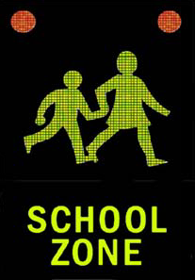
During 2009 Hutt City Council introduced a 40kph variable speed limit outside one of city’s primary schools. Randwick School on Randwick Road is on a major arterial route (>20,000 vpd) in the city’s network and the need for better management of the school pedestrian crossing was obvious. Even with Police presence, there were many reported incidents of vehicles driving past the School Patrol Lollypop STOP signs.
Initially active PW31 (Janet & John) signs were installed with the times of activation set according to the NZTA Guidelines and managed daily by the school staff. The effect upon traffic was excellent. However the mechanism to control the signs was ineffective for three reasons.
- Solar Power was unreliable during winter
- School Staff too busy to turn it on.
- Wireless transmission was poor and sign control was intermittent.
During 2010 the PW31 (Janet & John) signs were replaced with 40kph Variable Speed Limit signs and several other active school signs (40kph and J&J) were added outside other schools in the City using the same technology. Problems attributable to above 3 listed items continued, and solutions were sought.
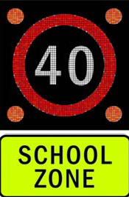
2.1 Solar Power
Solar power on paper seems a rather green and attractive proposal. However the on-going battery maintenance issues are costly and result in too much down time. It was concluded that when there is a legal requirement for a 40kph speed limit, sign reliability is paramount. It was therefore decided that Solar Power was not a practical alternative for legal speed signs.
HCC now specifies battery operation backed up with overnight charging from the Street Light circuits. This results in a higher initial install cost, with lower operational costs. Loading on the circuit is typically similar to one street light lantern. Electric supply companies have been cooperative with permitting the use.

2.2 School Too Busy

Chance discussions with one or two of our friendly schools (part of our School Travel Plan programme) revealed that during the morning pre-school tuition time (typically 8:15am to 8:45am) a normal school office is a “Hive of Intense Activity”. Probing revealed that it was common for schools to tell us that they simply forgot to turn on the signs in the rush!

2.3 Wireless Transmission Poor
In addition to the above issues it was discovered that in several areas the wireless remote control mechanism was simply not always up to the task. Interference was common when distances were long and industrial interference was also considered a contributory factor. The addition of signal amplifiers proved costly and only marginally effective.

- RESOLUTION

A solution to resolve all these three issues was identified and resolved with the help of a local innovative company, Digital Telemetry Ltd. The author(s) devised a remote web based access telemetry system that had the following key elements;
- Individual School access

Base plan of school days

Base plan of School/Sign times

Holiday and no-pupil days

Advance scheduled special On/Off function

Instant On Function
- Sign condition monitoring

Where the sign technology permits, the telemetry system should monitor the sign conditions status including battery condition.
- Sign interlocking

Provision to shut down all signs for the site if there is potential for a misleading display. For example, showing 40kph in one direction and nothing (implied 50kph) in the other direction.
- History recording

Maintain a log of all sign activity. Confirmation that the sign changes have been made by email to those that need or wish to know, usually the individual school, but may include others.
- Remote access for service

To allow remote access by the maintenance providers including Council staff.

Digital Telemetry were invited to implement the system, and use it to control existing sign installations. The joint solution is discussed below.
  - School Access
The easier it is for staff to manage the schedule, the more likely it is that the schedule will be right.
The web page general user interface (GUI) design focused on simplicity. The schedules are presented in terms the schools understand with simplicity and clarity being cardinal design parameters. At the start of each year, each school confirms their term dates (which can vary from school to school by a few days) and their regular on/off times. In most cases, it’s that easy.

A sample GUI is available from the Digital-Telemetry Web Page
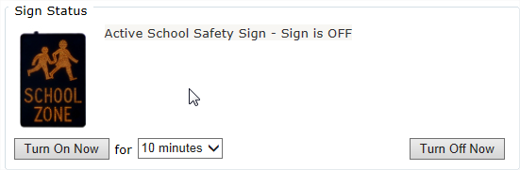
Handling exception situations isn’t much harder: if a non-standard activation is required for a school event, they can activate the Hot Key (“Turn On Now” button).

Figure 1: Hot Key - Instant ON Button
Schools do not need to worry about events common to everyone: daylight savings changes, national and regional holidays are all handled automatically from the base term plan.
Each school has their own login(s) to the web site, giving them access to their own school. Council staff and maintenance contractors also have access codes (logins), giving them access to all of the signs within their region. There are other advanced scheduling features available as well: e.g. teacher only days.
  - Sign Condition Monitoring

No sign is perfect: they are exposed to harsh weather conditions, and are frequent targets of vandalism. So increasing reliability needs to involve constant condition monitoring.
The sign controllers maintain regular communication with the central servers. If problems develop, we know immediately. Active monitoring means early detection of issues. Response times are reduced, and outages are often prevented because of the early warnings. Without monitoring, sign faults are usually reported by parents… how many days later?

  - Sign Interlocking
A key step in building reliability was to integrate the programmable sign controllers into each sign.
Activation of the signs is not reliant on external weak links, such as radio communications or human intervention. Each controller knows its schedule: if the power is on, the sign will activate precisely when it should.
Digital radio links are still involved and are important: just not for sign activation. The controllers maintain an open link with central servers, using standard cell phone (radio) modems. A regular stream of communication between the servers and each sign controller provides the monitoring that assures us the signs are healthy and working.
The web-site uses these links too: changes to schedules are sent to controllers this way. Or, a school may use the web site to explicitly send the controller an on/off request.
The most recent improvement to the system has been to include a system interlock to avoid conflicting displays where 40kph may be displayed in one direction with a potentially Illegal “No Display (50kph implied)” in the other directions. Should a fault be detected where only one display can actuate, the system automatically overrides keeping both signs off, and reports a fault condition.
  - History Recording
Accurate recording of activation times is an integral part of the monitoring process. The web site shows recent activity, though all activities are retained on the central servers indefinitely.
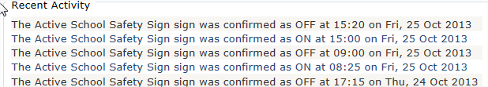

Figure 2: History Log
These activity logs have been used to support police prosecutions of traffic violations.
- SYSTEM DESIGN

Accurate and consistently correct activation times are a key factor in ensuring active school zone signs are achieving their maximum potential effect. This dictated the primary goal of the system design: precise and reliable sign activation. The key elements to providing that were:
- Web based, easy-to-use user interface to define schedules
- Integrated sign controllers
- Advanced and flexible scheduling capability
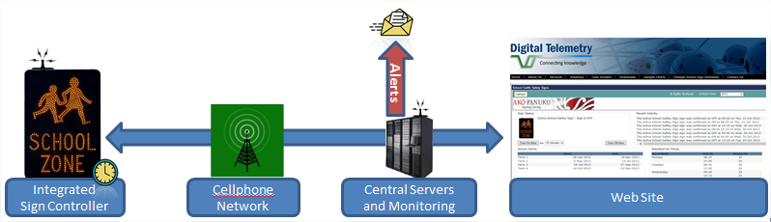
- Continuous monitoring

Figure 3: System Overview
  - Advanced Scheduling Capability
Scheduling school signs looks simple at first glance: NZTA rules give clear unambiguous guidelines that should be followed. It is the handling of exceptions that makes an advanced scheduler so important:
- Daylight savings time
- National and regional holidays
- Teacher only days
- Varying start/finish times for different days of the week
- Multiple schools with different start/finish times within the same controlled space complicates standard NZTA timing.

The Digital Telemetry sign controllers were designed to cope with any and all of these scenarios. Daylight savings time is handled automatically. National and regional holidays are also automatic, and require no intervention. Teacher only days can be added to the schedule on the web site in advance, requiring no intervention on the day.
  - Monitoring
Potential modes of failure are many and varied. The system was designed to provide constant condition monitoring wherever possible. Signs are polled at a 90 second rate as programmed ON/OFF times approach. This polling rate is reduced to 5 minute poll cycles outside critical sign times. The key to reliability is constant condition monitoring.
The sign controllers maintain constant communication with the central servers. If problems develop, we know immediately. Examples include:
If a sign doesn’t turn on (or off) when expected, monitoring support staff are informed within 90 seconds.
- If battery voltage drops below a threshold, alerts are raised so the issue can be investigated before it becomes a problem.
- If a sign reports a fault condition (may be sign dependent), the monitoring controller informs the central servers so an investigation alert can be raised.
- If a controller is out of contact for too long, investigation alerts are raised.
- Email notifications can be sent to schools each time a sign turns on/off. This added a level of assurance for schools that had lost faith in previous control mechanisms. We notice that now confidence has been restored, most schools opt-out of the notifications.

Active monitoring means early detection of issues. Response times are reduced, and outages are often prevented because of the early warnings. Without regular monitoring, sign faults are usually reported far too late, and service can be lost for some days.
  - Integrated Sign Controllers
All signs in the system contain a microcomputer with imbedded cellular modem. This means that activation of the signs is not reliant on external weak links, such as radio communications or human intervention. Each controller knows its schedule: if the battery’s reserve power is available, the sign will activate precisely when it should. Cellular digital links are still involved and are important, but not essential for normal activation. The controllers maintain an open link with central servers, using standard cell phone (radio) modems. A regular stream of communication between the servers and each sign controller provides the monitoring that assures us the signs are healthy and working. The website uses these links to update schedules or respond to instant Hot Key requests.

- NUTS & BOLTS HARDWARE

The signs are controlled using a Siemens designed microcomputer: the Cinterion TC65T. Siemens are industry leaders in electronics equipment, renowned for superb quality and reliability. The TC65 is essentially a microcomputer with an embedded cellular modem. It is used throughout the world in M2M (machine-to-machine) applications. Using Java, it can be programmed to provide a wide range of solutions. It supports several industrial interface options, making it a flexible component of those solutions. Low power requirements make it ideal for use beside solar powered equipment.
The embedded modem uses the standard GPRS network, supported by both Vodafone and 2degrees. Compatible equipment to support Telecom is due to be announced soon. The system devised is scalable and transportable to other applications.

- CONCLUSION (Result)

Eleven (11) schools in Lower Hutt are now using the system, with 4 more planned for this financial year. A further three councils have installed these controllers at 17 other schools.
Problems previously presented have reduced to Nil. All schools report total satisfaction with the control system. The first school to use our automated signs had previously been frustrated by manually controlled radio based technology, and had the following to say:
“We had to remember all the time to turn it on and off, and after school to set the timer for it to come on the next day before we went home. You couldn’t do that on a Friday, so had to come in early on Monday. If I got held up in traffic and didn’t get there in time it had to be set in ten-minute bursts.
Much better system now, doesn’t rely on somebody having to remember. Occasionally when people were busy it didn’t get turned on/off at the right time.”
The sentiment has been anecdotally reported from most schools using the system.
System monitoring costs are typically less than $1,000pa per school and are considered to be value for money through early fault recognition negating the need for site visits from technicians with bucket trucks.

- RECOMMENDATION

Based upon this experience the authors recommend that the NZTA reverse their preferred control methods contained in Traffic Note 37 Clause 5.1 to give preference to automatic remote control before manual control by school staff (on a day-by-day basis).
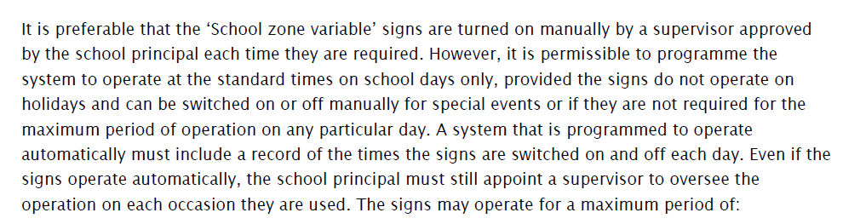
Figure 4: Extract from NZTA Traffic Note 37 Clause 5.2
Plus emphasise the need for interlocking with 40Kph regulatory signage.
Plus emphasise the potential un-reliability of solar power for Regulatory Signage.

ACKNOWLEDGEMENTS

Hutt City Council – for the opportunity to design and implement the system and prepare the paper.

Digital Telemetry Ltd. – for sharing the solution and assisting prepare and present the paper.

