IPENZ TRANSPORTATION GROUP CONFERENCE 2014

Champagne Tastes on a Beer Budget? Achieving Effective Place Making and Transport

Andy Lightowler (BSc (Hons), FCILT), Technical Director (Beca Ltd)

(andy.lightowler@beca.com)

Sam Corbett(BSc (Hons), FCILT), Principal Transport Planner (Auckland Transport)

(sam.corbett@aucklandtransport.govt.nz)

ABSTRACT

The Orakei Board (OLB), with the support of Auckland Council, prepared a Masterplan for the Tamaki Drive waterfront corridor in January 2013. The Masterplan contains ambitious plans to improve both the transport and place making function of Tamaki Drive and to transform the corridor into a boulevard of world class quality.

In response to the Masterplan, Auckland Transport commissioned the preparation of a Corridor Management Plan (CMP) for the Tamaki Drive, Ngapipi Road, Kepa Road and Kohimarama Road (TaNKK) corridor to consider the wider transport network implications of the CMP. The CMP was prepared in the context of the future land use environment anticipated through the Auckland Plan and Proposed Auckland Unitary Plan, and taking into account a number of current proposals to address safety issues and improve place making on the corridor.

A key challenge for the CMP was to identify proposals which were affordable, fundable and consentable, while simultaneously meeting the aspirations of the Masterplan. The paper highlights how these challenges were addressed and how the CMP was developed to ensure an effective transport system that is responsive to growth pressures, while also taking into account the uncertainty surrounding the future impact of climate change and sea level rise.

The CORRIDOR AND THE Key drivers for preparing a cmp

The TaNKK corridor (see Figure 1) is strongly defined by the topography, limiting transport connections and unique geographic setting. Tamaki Drive is bound along its entire length by the inner Waitemata Harbour. Access to the Auckland’s city centre is via a man-made causeway. At the western end of the corridor, the water of Hobson Bay and the volcanic feature of Orakei Basin and creek valley along the railway line further limit transport connections along Ngapipi Road. The alignment of Kepa Road traverses fairly steep gradients from Hobson Bay to reach Eastridge at the top of the ridge. The large land area of Whenua Rangatira further limits transport connections and active edges, while providing a passive recreation reserve and attraction.

The key drivers for preparing the CMP for the TaNKK corridor were:
- The need to integrate with the strategic growth direction outlined in the Auckland Plan (2012) and the Proposed Auckland Unitary Plan (2013)
- Endorsement of the Tamaki Drive Masterplan by the OLB in 2012
- The crash history of the Ngapipi Road / Tamaki Drive intersection (which is one of the worst of any intersection in Auckland)
- The proposed future bus network as outlined in the adopted Auckland Regional Public Transport (PT) Plan (RPTP) 2013 and the Auckland Cycle Network (ACN)
- Implementation of the Auckland Manukau Eastern Transport Initiative (AMETI)
- The emerging Harbour Edge Cycle Route Plan
- Integrating multiple projects and initiatives in the CMP area into a coordinated plan.

Figure 1 – The TaNKK Corridor
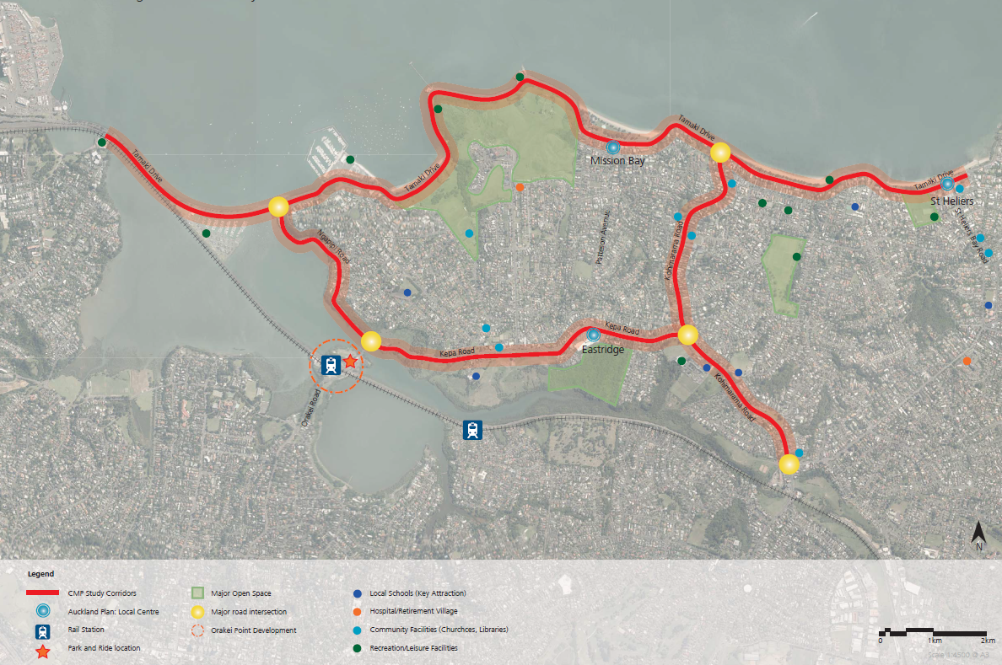

The Auckland Plan acknowledges the treasured environmental, recreational and amenity values of the coastal environment, particularly the magnificent setting which the Waitemata Harbour provides. It identifies three ‘Local Centres’ within the TaNKK corridor – Mission Bay, St Heliers and Eastridge (Kepa Road). The CMP anticipates only moderate growth in and around these centres, with future residential growth likely to be in the form of medium density terrace housing and low to medium-rise apartments. Future transport demand in the corridor will also be influenced by future development at Orakei Point and Bastion Point.

The Tamaki Drive Masterplan was developed by the OLB to provide a long-term vision for the future of Tamaki Drive. The Masterplan, titled ‘Tamaki Drive – A Place for People’, adopts a place-making approach with a focus on creating a more people-friendly environment. The Masterplan considers the different users, land uses and transport modes in the wider area and seeks to plan for the future of Tamaki Drive in an integrated manner. Key moves of the Masterplan include providing improved transport choices, more space for leisure and pedestrian-friendly connections to the water through a pedestrian boardwalk and promontories, protection of the unique coast and village character, plus a cycle path along Tamaki Drive (see Figure 2).

Figure 2 - Future Potential Cycle Path as Proposed in the Tamaki Drive Masterplan
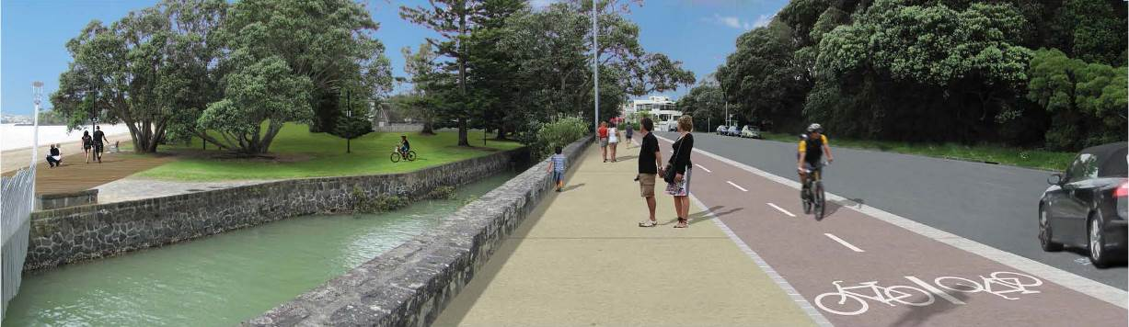
The future use of, and on-going growth along, Tamaki Drive will need to address the following key areas of focus:

- Maintaining and enhancing the ecological, cultural and landscape values of the waterfront
- The need to cater for events which seek to make best use of the recreation and destination values of the waterfront
- Balancing the potentially competing and conflicting needs of local commuters with the desires of visitors to enjoy the waterfront environment
- Land instability issues along Tamaki Drive
- Potential future implications as a result of climate change and sea-level rise.

The Auckland Integrated Transport Programme (ITP) 2012 - 2041 identifies Tamaki Drive as a secondary arterial roadway and maintains Ngapipi/Kepa/Kohimarama Road corridor as a primary arterial roadway. From a PT perspective, the Tamaki Drive segment of the corridor is designated for frequent services (minimum ten minute service headways seven days a week between 7am – 7pm by 2016), whereas Kohimarama Road and segments of Ngapipi Road and Kepa Road are designated for connector services (minimum 30 minute service headways seven days a week between 7am – 7pm by 2016).

The ITP also identifies Ngapipi Road/Kepa/Kohimarama Road as part of the regional freight network. The segment of Tamaki Drive to the west of Ngapipi Road is a designated route for over-dimensional vehicles. From the intersection of Tamaki Drive and Ngapipi Road, the over-dimensional route continues south on Ngapipi/Kepa/Kohimarama Road before connecting to St Johns Road and further south.

The Regional Land Transport Strategy (2010-40) identifies that the walking and cycling mode share should increase from 17% in 2009 to 35% in 2040, a doubling of the mode share for these modes. Tamaki Drive, Ngapipi Road, Kepa Road and Kohimarama Road are all part of the ACN. Specifically, Tamaki Drive is designated as a Cycle Metro facility, which is the highest level of cycle facility and refers to an off-street separated cycle facility, and therefore a key route in delivering the targeted increases in mode share for walking and cycling.

The Ngapipi/Kepa/Kohimarama Road segments of the study area are designated as a cycle connector facility as part of the ACN, which generally denotes the provision of on-street cycle facilities on these arterial roadways. The feasibility of the proposed Eastern Transport Corridor Cycleway project, part of the proposed Cycle Metro network, linking Glen Innes to Orakei via Meadowbank before crossing Hobson Bay to Tamaki Drive is currently being considered by Auckland Transport.

Auckland Transport has recently completed 17 high priority safety-related improvements along Tamaki Drive. These improvements include traffic calming and related safety treatments along Tamaki Drive to create a safer environment for all road users. In addition, Auckland Transport is planning to implement traffic signal control at the intersection of Tamaki Drive and Ngapipi Road, to improve safety for pedestrians and cyclists.

A summary of the current traffic flows and person trips by mode within the TaNKK CMP study area, particularly along Tamaki Drive is provided below.
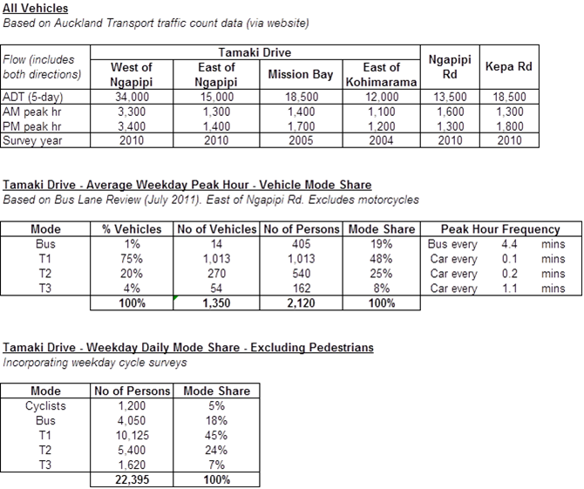

Corridor Management Plan Process

The CMP was prepared in accordance with Auckland Transport’s CMP Guideline and Simplified Procedure, following the broad process shown below.

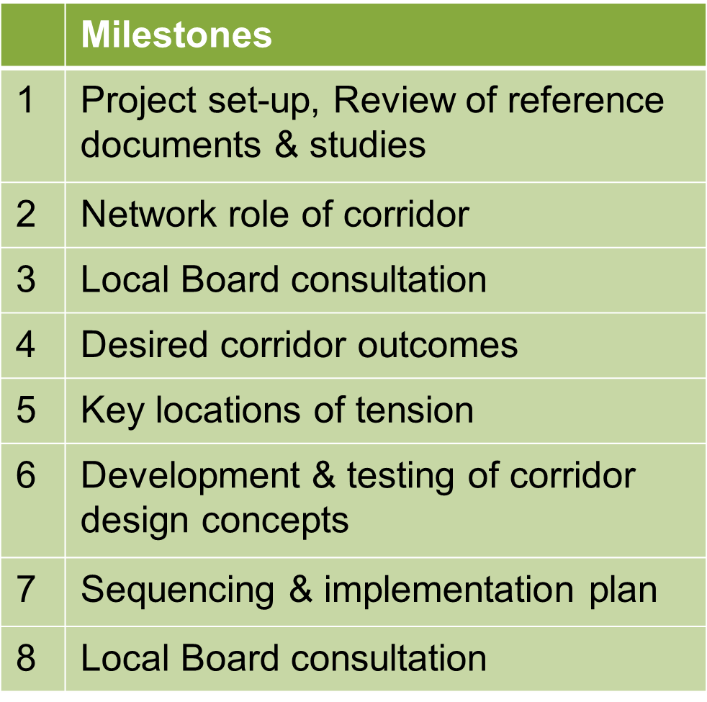

The development of the CMP involved collaboration with Auckland Transport, Auckland Council, the NZ Transport Agency, as well as consultation with the OLB and Ngati Whatua o Orakei. Individual meetings were held with the OLB and Ngati Whatua o Orakei to engage them early in the process.

Engagement with technical stakeholders was undertaken by way of three workshops. This engagement provided the opportunity for the Project team to work collaboratively to receive, consider and respond to feedback of technical stakeholders, particularly in relation to the various corridor options put forward. The key issues identified and responded to during stakeholder engagement are reflected in the CMP.

NETWORK ROLE OF CORRIDOR

An understanding of the network role of corridor was ascertained through feedback from the technical stakeholders and the OLB. In the first technical stakeholder workshop, stakeholders were asked to confirm the different sections of the corridor, based on the place/context typology and then assign the transport mode priorities to those sections, such that the transport role of each section could be identified. Figure 3 summarises the outcome of this process and shows the ten sections the corridor was divided into.
Figure 3 – Network Role of Corridor Summary
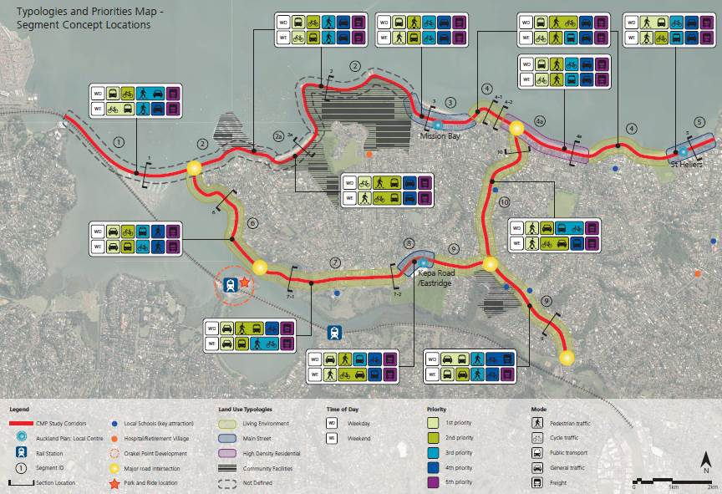

As the CMP development process progressed, the transport role of the corridor and the transport priorities were reviewed as the corridor concepts were developed to assess the alignment with the strategic direction philosophy. The initial mode priorities were therefore refined as the desired outcome for the corridor was balanced with the space available for all modes to safely operate within it.

Desired Corridor Outcomes and Key Locations of Tension

Following the identification of the network role of the corridor, the project team developed the desired corridor role and identified the related key ‘locations of tension’. This work included feedback from the technical stakeholders at the first and second technical stakeholder workshop.

The key locations of tension identified included:

- The need for car parking at certain locations on Tamaki Drive (such as the three Local Centres)
- The desire to prioritise cyclists, as well as pedestrians and high occupancy vehicles (HOVs) (including PT) on Tamaki Drive
- The need to provide for the current over-dimensional vehicle route and regional freight network along Tamaki Drive (west of Ngapipi Road), Ngapipi Road, Kepa Road and Kohimarama Road (southern section)
- The implication of widening the corridor on the environment.

The desired corridor role/outcomes was then defined based on the place/context typology and transport role, as well as relative mode priorities within each section.

The Project team and technical stakeholders confirmed the following strategic direction philosophy for the corridor:

- Maximise use of existing road corridor space
- Maintain lane capacity for general traffic
- Significantly improve cycle facilities
- Improved priority for HOVs (at targeted locations)
- Improve pedestrian connections to the Waterfront from Tamaki Drive
- Enhance the amenity of Tamaki Drive
- Enhance Tamaki Drive as a ‘destination’
- Provide adequate parking provision
- Provide opportunities to better treat storm water runoff to improve water quality and the overall ecological health of the surrounding environment.

A strategic direction concept was developed which sought to achieve the desired corridor outcomes and address the key points of tension.

Environmental considerations pointed towards minimising road corridor widening. Following feedback from Ngati Whatua o Orakei, the CMP provides opportunities to better treat storm water runoff to improve water quality and the overall ecological health of the surrounding environment.

Capacity for future growth in transport demand is proposed to be provided mainly by reallocating existing road space to encouraging greater use of other modes (active modes and high occupancy vehicles, including PT (HOVs)).

The option of extending the seawall, as outlined in the Tamaki Drive Design Manual (2009) and shown in Figure 4, was not advanced in the CMP because of the significant cost of this option compared to other options which can deliver the transport outcomes being sought. Furthermore, an extended seawall would potentially conflict with the direction set out in Policy 25 of the NZ Coastal Policy Statement, which seeks to discourage the use of hard protection structures.

Figure 4: Seawall Extension Option
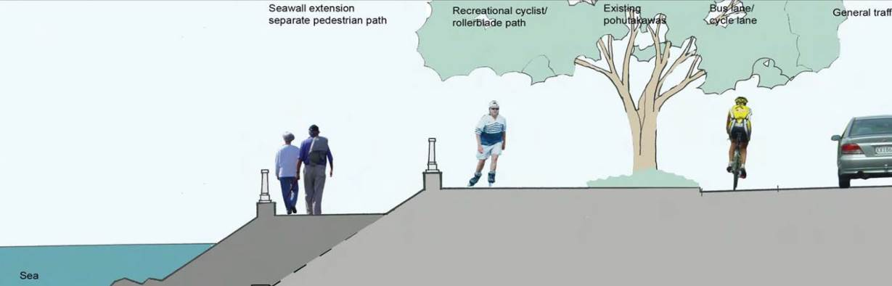

Nevertheless, whilst not forming part of the strategic direction, where relevant in the Tamaki Drive sections of the corridor, the CMP outlined the potential opportunities/benefits that may be achieved within the existing road corridor should seawall widening for a separate pedestrian boardwalk to be progressed at some time in the future.

In some cases, the strategic direction concept was not consistent with the modal priorities for that section, and the rationale for the strategic direction decision was therefore considered further. The strategic direction concepts for the corridor were then refined in response to technical stakeholder feedback, further consultation with the OLB and Ngati Whatua o Orakei, and comment received from Auckland Transport’s peer reviewer.

Strategic Direction Concepts

The overall strategic direction for the CMP is contained in Figure 5.

Lane Configuration

The corridor theme has two distinct focuses from a vehicle perspective. Along Tamaki Drive there is a ‘cycle focus’ and provision of HOV interventions to support a consistent level of service (i.e. the consistency / reliability) for the journey time, where necessary; and a ‘general vehicle’ focus is provided for along Ngapipi Road, Kepa Road, and Kohimarama Road.

The strategic direction for the corridor maintains the current lane provisions for general traffic within the Corridor, with the exception of the section of Tamaki Drive to the west of the Ngapipi Road intersection. With the exception of the west end of Tamaki Drive, this would maintain current general traffic lane capacity, but does not provide for further general traffic capacity, recognising that transport growth should be encouraged through other modes (active modes, and HOVs).

Along Tamaki Drive, east of the Ngapipi Road intersection, at least one general traffic lane in each direction is considered to be required given the current traffic demands and the reallocation of corridor space to provide for active modes and HOV interventions has generally been achieved through removal of medians and on-street parking, as well as the rationalisation of general traffic lane widths. The approach recognises the needs of active modes and HOV focus on Tamaki Drive.

The strategic direction maintains two general traffic lanes along Ngapipi Road, Kepa Road and Kohimarama Road. Along these roads, this recognises the primary arterial function of this part of the corridor and the need to provide for the over dimension vehicle route (11.5m wide by 6.5m high envelope) and the strategic freight network. It is noted that the over dimension vehicle envelope is not currently achieved on some sections of the Corridor (particularly Ngapipi Road), and the CMP does not seek to alter this situation.
Figure 5: TaNKK CMP – Overall Strategic Direction
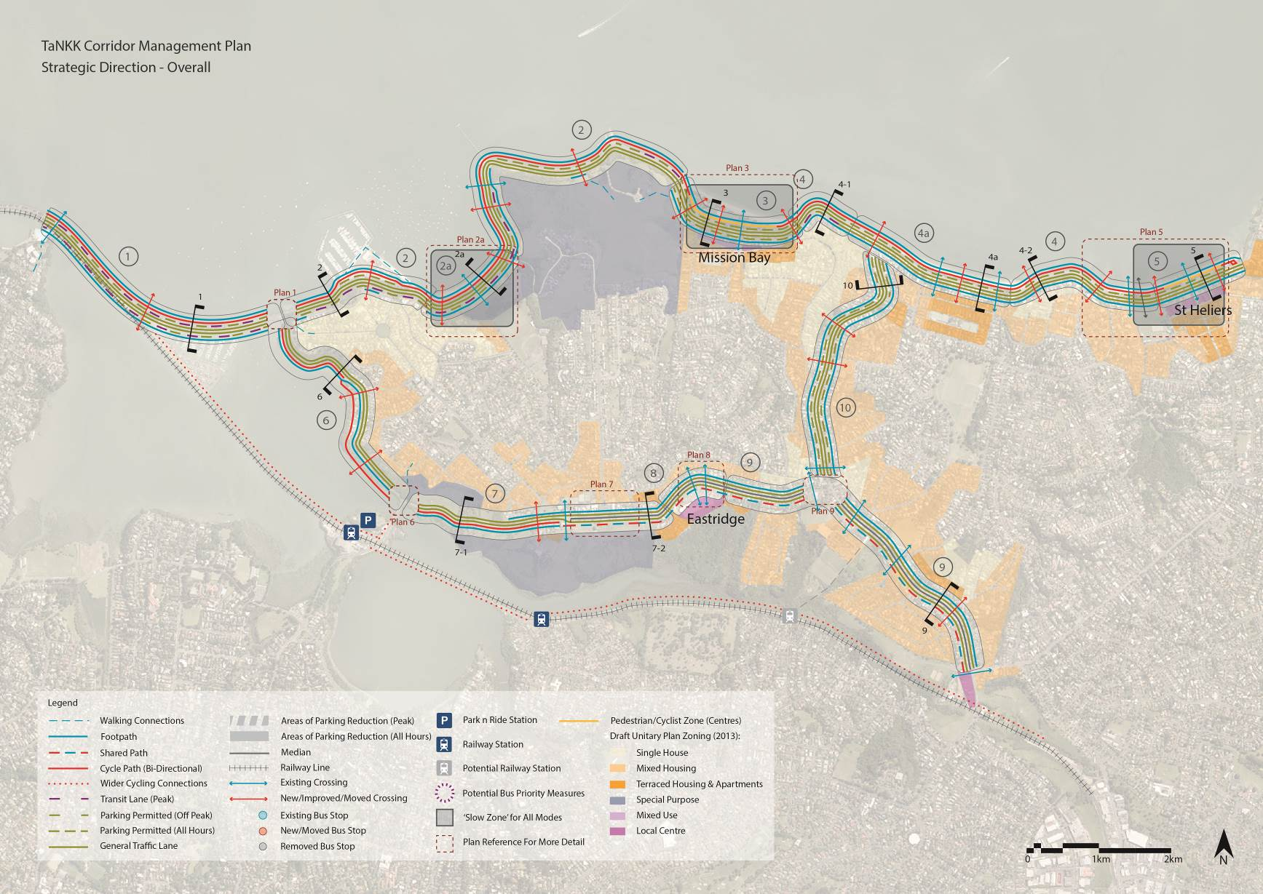

Cycling Facilities

Different types of cycle facilities have been provided for along the corridor to reflect the strategic direction for the provision of facilities to support different the types of cyclists and the relationship with the land use context (refer to Figure 6):

- A dedicated cycle path is provided along the majority of Tamaki Drive, modified in centres of Mission Bay and St Heliers, consistent with the direction of the ACN Cycle Metro, Tamaki Drive Masterplan and emerging Harbour Edge Cycle Route Plan (precedent images of these types of facilities are shown on Figures 7 and 8, as included in the Tamaki Drive Masterplan)
- Within the Mission Bay and St Heliers Local Centres, the strategic direction provides for a ‘pedestrian/cycle zone’ that provides the opportunity to configure these spaces to meet the evolving needs of the corridor over time responding to the future land use, transport and urban design context
- A variety of off-road interventions are identified along Ngapipi Road and Kepa Road; either shared, separated or segregated with pedestrians, to respond to the land use context, priorities and constraints of those Corridor sections
- Along Kohimarama Road cyclists will share the road space with general traffic.

The provision of the cycle path on the northern side of Tamaki Drive will reduce conflict with driveway access and intersections and the provision of new and upgraded crossing facilities at key locations on Tamaki Drive will enable convenient access to the cycle path.

The strategic direction is based on more confident cyclists continuing to utilise the road carriageway, where they will benefit from proposed HOV lanes facilities at key intersections and reductions in on-street parking. It is generally considered that a width of 3.2m would be satisfactory, where other cycle facilities are required, and 4.2 where they are not. The width to be adopted can be reviewed as designs are developed.

Separation or segregation of cycle path and footpath, as well as from general traffic, HOV and parking, can be considered through the further design process for this Project, as part of the Implementation Plan. It is recognised that there will be challenges in developing this facility, including the relationship of cyclists to adjacent pedestrian facilities, as well as the design of crossing points, and the relationships with adjacent car parking and bus stop facilities.

Irrespective of whether or not the Eastern Transport Corridor Cycleway project follows the Eastern rail line, it was agreed with stakeholders that there will be a demand for upgrading facilities along Ngapipi Road for pedestrians and cyclists to provide access to the Orakei rail station and between the Orakei Road intersection and Tamaki Drive.

Along Ngapipi Road and Kepa Road, it is considered necessary to provide for dedicated cycle provision to enable convenient local access to the Tamaki Drive cycle path and the Orakei rail station on Orakei Road. Along the southern section of Ngapipi Road, given the current corridor constraints, this cycle provision would be through a dedicated cycle path along the eastern side of Hobson Bay between Orakei Road and the Ngati Whatua o Orakei / Watercare land just north of Paratai Drive.

As part of this improved cycling infrastructure, cycle parking facilities would need to be upgraded. Cycle parking would need to be in local centres, for both commuter and short-term stays, such as through cycle corrals. Covered and secure cycle parking should be provided at the train stations and busier bus stops to encourage multi-modal journeys.

Figure 6: Strategic Direction – Cycling
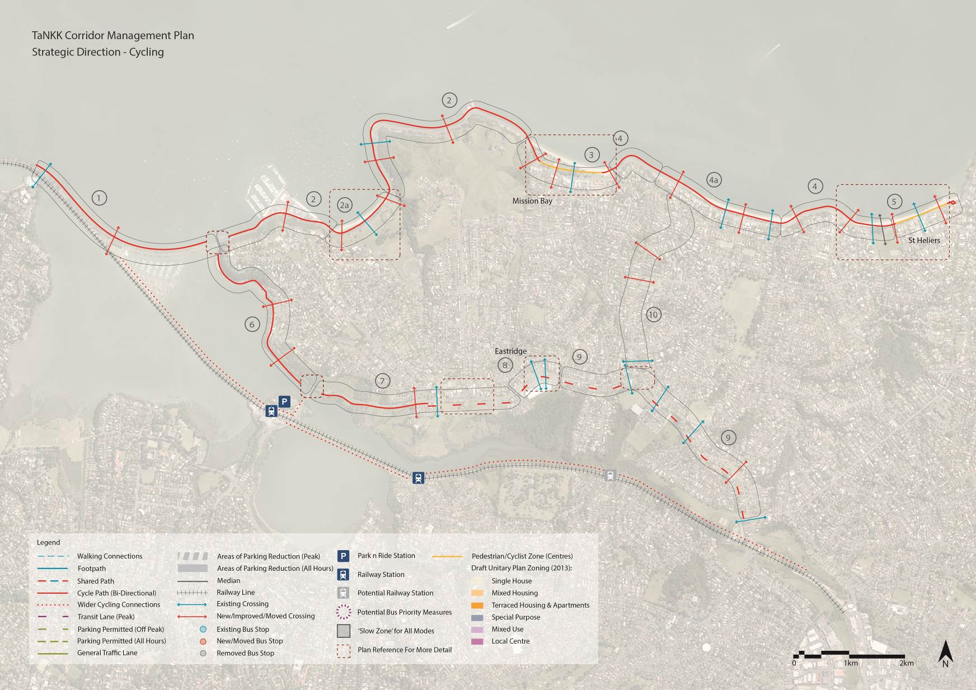
Figure 7: Precedent Image of Cycle Path (Majorca, Spain)
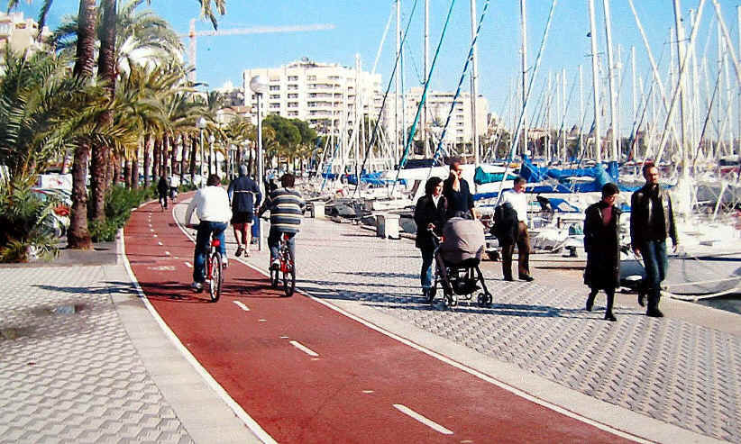

Figure 8: Precedent Image of Cycle Path (Nice, France)
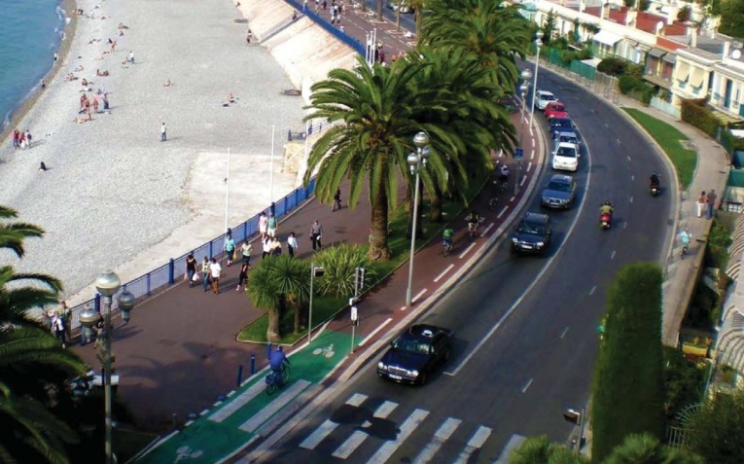

Public Transport / HOV Facilities

Provision has been made for HOVs (including PT) along Tamaki Drive through the identification of HOV lanes along certain sections, in order to enable a consistent level of service along the corridor, as illustrated on Figure 9.

This has focussed on the more heavily-trafficked sections of Tamaki Drive to the west of Kohimarama. This western section of Tamaki Drive (west of Kohimarama Road) currently has and is anticipated to continue to have higher traffic volumes than to the sections to the east of Kohimarama Road.

Greater emphasis is therefore placed on the need for interventions for PT along this section of the corridor, albeit it is considered that these can be focussed at key locations.
These key locations will supplement the current HOV lanes along Tamaki Drive and include the following interventions:

- Conversion of the current general traffic / parking lanes to the west of Ngapipi Road to HOV / parking lanes, as and when required
- HOV/ parking lanes on the eastbound and westbound approaches to Mission Bay.

The implementation of these facilities will depend on the assessment of the need for the intervention and will consider both future PT / HOV demand and maintaining a consistent level of service for buses. This will be assessed against the relevant Auckland Transport guidelines/criteria for the implementation of these facilities at that time. Over time, the strategic direction may result in these PT / HOV lanes being implemented over longer time periods (e.g. between 7am to 7pm), as opposed to at peak times only, and on six or seven days of the week, as opposed to on weekdays only, to maintain the level of service at the times of the day and days of the week when congestion occurs.

To facilitate bus stops at certain locations and protect corridor operation, there may be a need to allow for partially indented bus stops to enable continuity of appropriate pedestrian and cycle provisions.

Parking Facilities

The strategic direction concept (Figure 10) identifies the reduction of on-street parking in several locations on Tamaki Drive, along Kepa Road and on the east side of Kohimarama Road.

Reductions in on-street parking are likely to be required as part of the strategic direction in order to deliver the balanced corridor outcomes from a transport, land use and urban design perspective. However, it is recognised the potential removal of car parking, particularly on some sections of Tamaki Drive will have implications. As such, a parking strategy will need to be developed to support the strategic direction for the corridor. This will be pivotal to achieving many of the strategic direction initiatives.

Walking and Public Realm Facilities

Walking facilities along the TaNKK corridor have been improved and will provide continuous connectivity as illustrated on Figure 11, though the type of facility may vary.

In addition to the shared paths described above, footpath upgrades are proposed, particularly to serve bus stop locations on the corridor. This is complemented by upgraded and new pedestrian and cycle crossing facilities along the corridor.

A public realm upgrade referred to in the Tamaki Drive Masterplan and the Tamaki Drive Design Manual was the idea of promontories or ‘steps to the sea’ (as shown in Figures 12, as included in the Tamaki Drive Masterplan), where people have direct access to the water’s edge. While this is outside the scope of the CMP, the strategic direction has considered the future potential for these public realm upgrades, which will contribute to a consistent place-making theme along the corridor.

A wide footpath is considered vital in the Local Centres of Mission Bay and St Heliers to enable cafés and restaurants to have external seating which adds activity to these centres and contributes to place-making initiatives. Where parking is shown on Tamaki Drive outside these centres, the parking spaces could be alternated with a wider footpath to allow for public seating, ‘parklets’ or build outs for crossing facilities.

The Landing is a recreational activities area with associated retail (see Figure 13) on Tamaki Drive, located between the Ngapipi Road intersection and Okahu Bay. The Masterplan for The Landing has recently been approved by the OLB. The Masterplan includes provision of a pedestrian boardwalk within the site along the entire frontage with Tamaki Drive. This facility is consistent with the strategic direction concept proposed for the Tamaki Drive corridor, in providing a separate footpath that enables the bi-directional cycle path.

The provision of the footpath (boardwalk) within The Landing site means that the footpath along the northern side of Tamaki Drive no longer needs to be provided within the road corridor.
Figure 9: Strategic Direction – Public Transport
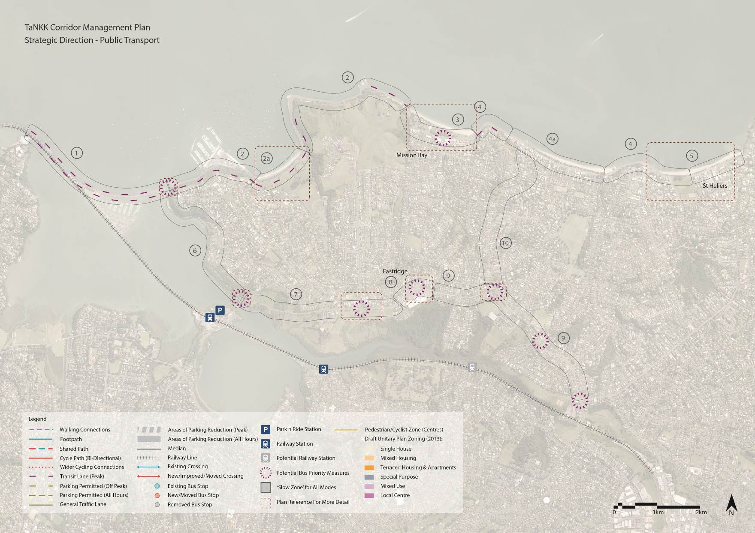
Figure 10: Strategic Direction – Parking
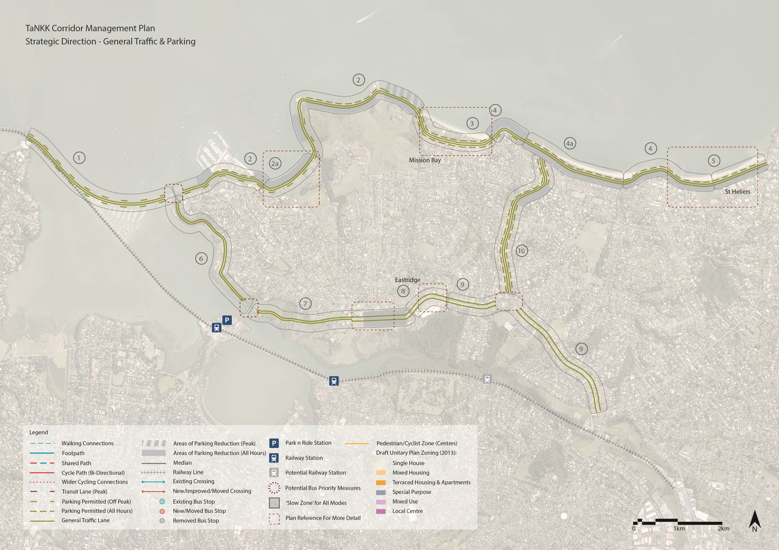
Figure 11: Strategic Direction – Pedestrians
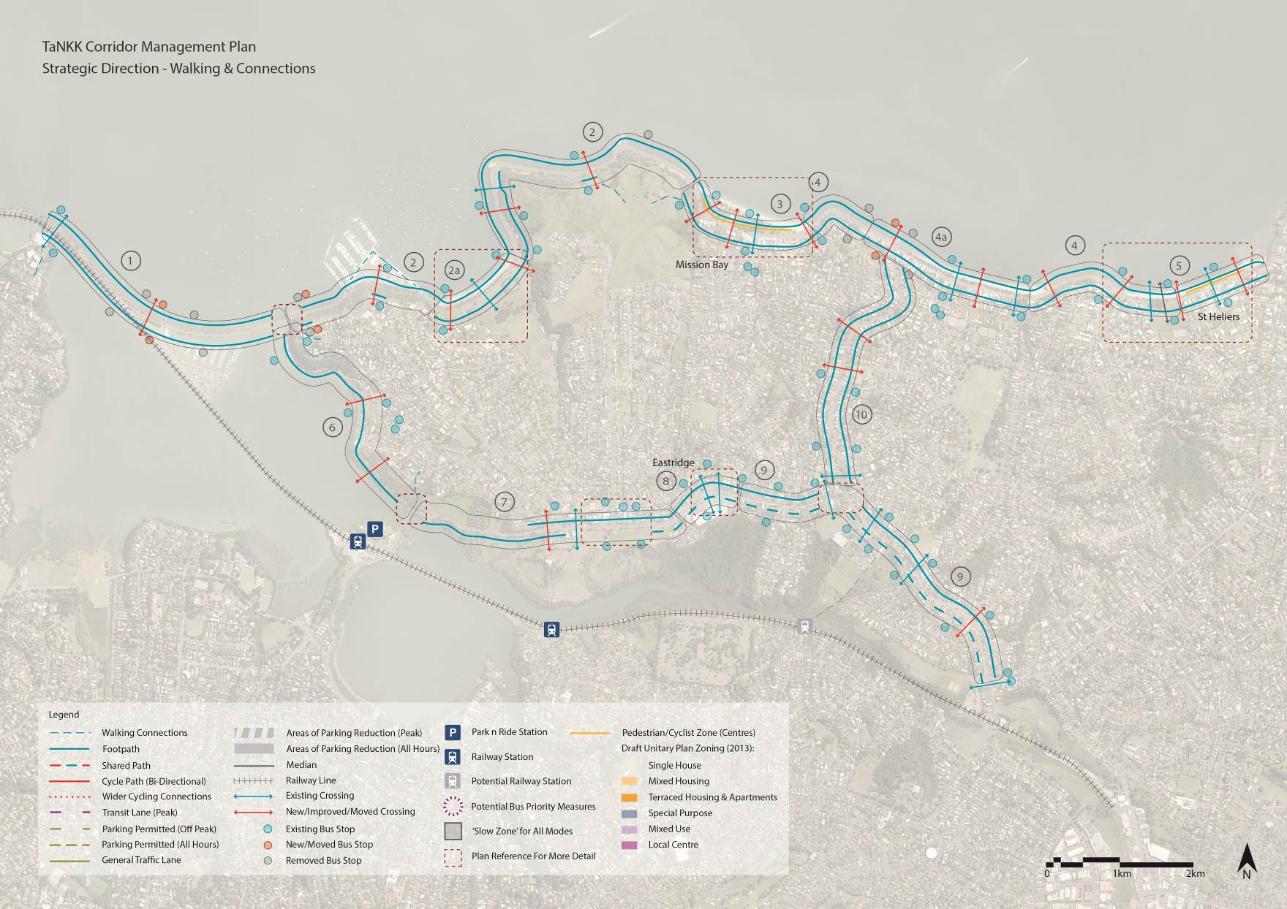
Figure 12: Potential Promontory and ‘Steps to the Sea’
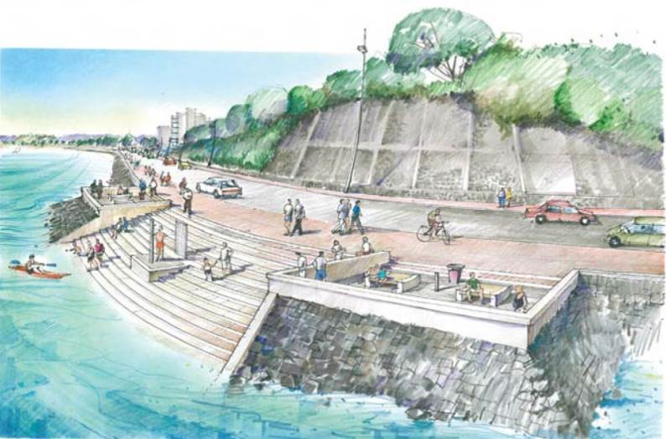

Figure 13: The Proposed Landing Masterplan
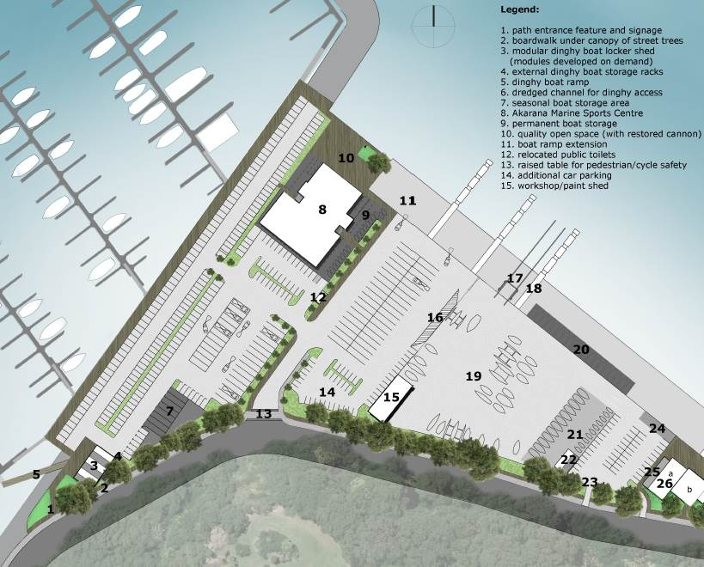

Traffic Implications of the CMP

Traffic modelling has been undertaken to consider the potential impacts of the AMETI project and the implications of the strategic direction for the Tamaki Drive section of the corridor in the context of the anticipated land use changes. The assessment of both the changes in traffic flows and travel times along the Tamaki Drive and Ngapipi / Kepa / Kohimarama sections of the corridor predicted that the more significant effects on the corridor related to the background traffic growth between 2026 and 2041. The modelling of both the AMETI project and the TaNKK CMP strategic direction predicts that these will generally not have a significant adverse impact on the operation of the road network.

CONCLUSIONS AND Lessons LeArnt

The CMP process has identified a package of proposals to make better use of existing road space. The study identified that, whilst there are benefits in providing some widening of the road corridor, for the majority of the corridor the desired corridor outcomes can be accommodated within the existing road width. These outcomes included enhanced facilities for pedestrians and cyclists, and enhancing the amenity of Tamaki Drive as a destination. Providing improved pedestrian and cycling facilities along Tamaki Drive will impact on-street parking availability and will therefore need to be well coordinated with a parking strategy for Tamaki Drive. With the exception of town centres, where parking is in high demand, reallocating on-street parking to create improved pedestrian and cycling facilities is considered to be an appropriate measure to optimise the corridor space allocation and promote the use of more sustainable transport modes.

In particular, the option of significantly extending the seawall was not recommended because of the significant cost of this option compared to other options which can deliver the transport outcomes being sought. Furthermore, an extended seawall would potentially conflict with the direction set out in the NZ Coastal Policy Statement, which seeks to discourage the use of hard protection structures.

Nevertheless the CMP does allow for a separate pedestrian boardwalk to be progressed at some time in the future if funding permits. The recommended strategic direction of the CMP will therefore help the OLB achieve its aspirations in a phased and cost effective way.

Traffic modelling has demonstrated that the proposed solution can accommodate future predicted traffic volumes satisfactorily.

A key lesson learnt from the CMP process is the need to focus on providing a strategic direction for future work and not to get bogged down in the specifics of what is proposed.

REFERENCES

Auckland Plan, AUCKLAND COUNCIL, (March 2012)

Proposed Auckland Unitary Plan, AUCKLAND COUNCIL, (September 2013)

Tamaki Drive Masterplan - ‘Tamaki Drive – A Place for People’ - ORAKEI LOCAL BOARD, (December 2012

Auckland Regional Public Transport (PT) Plan, AUCKLAND TRANSPORT, 2013

Auckland Cycle Network, AUCKLAND TRANSPORT (2013)

Harbour Edge Cycle Route Plan, AUCKLAND TRANSPORT (under development)

Auckland Integrated Transport Programme 2012 – 2041, AUCKLAND TRANSPORT (2012)

Regional Land Transport Strategy (2010-40), AUCKLAND TRANSPORT (2010)

Corridor Management Plan Guideline and Simplified Procedure, Version 2, AUCKLAND TRANSPORT (October 2012,)

Tamaki Drive Design Manual, AUCKLAND COUNCIL (2009)

NZ Coastal Policy Statement, DEPARTMENT OF CONSERVATION, (2010).

