HELPING DRIVERS TO MANAGE SAFETY

AT HIGH RISK RURAL INTERSECTIONS

Hamish Mackie, PhD, HFESNZ, Director, Mackie Research and Consulting Ltd. hamish@mackieresearch.co.nz

Ken Holst, NZCE, CTPM&C (UNSW), Senior Safety Engineer, NZ Transport Agency

Ken.holst@nzta.govt.nz

Colin Brodie, NZCE (Civil and Traffic), CTPM&C (UNSW), MIPENZ,

Chief Advisor, Safety, Highways and Network Operations, NZ Transport Agency

Colin.brodie@nzta.govt.nz

Fergus Tate, PhD, MSc, BE, NZCE, CPEng, MIPENZ ,

National Manager, Traffic and Safety, NZ Transport Agency

Fergus.tate@nzta.govt.nz

ABSTRACT
This study describes the development of NZ Transport Agency’s (NZTA) rural intersection active warning system (RIAWS) and outlines the outcomes from the first two RIAWS pilot sites at Himitangi (Manawatu) and Yaldhurst (Canterbury). The RIAWS trial is part of a wider programme by NZTA to address safety at high risk intersections. The evaluation measures reported here include system performance, motorist speed and driver perception. The RIAWS has the aim of reducing fatal and serious crashes at high risk intersections by reducing traffic speed when potential for a collision exists. Side road and right turn vehicles at the intersection trigger a variable speed limit of 70 km/h on the major road. Motorist behaviour and perceptions since the RIAWS have been operational have been positive. Modal traffic speeds at the intersections when the 70 km/h speed limit sign is activated range from 68-72 km/h compared with modal speeds of 81-96 km/h before RIAWS installation when potentially conflicting traffic is present. Based on driver feedback from Himitangi, the RIAWS has been positively received. The findings suggest that while motorists do naturally moderate their speed slightly through rural intersections in the presence of potentially conflicting vehicles, RIAWS is likely to cause more substantial speed reductions and significantly reduce the crash forces involved in collisions at high speed intersections and potentially reduce the likelihood of collisions.

- Introduction
Improving the safety of high risk intersections is a strategic priority under the government’s Safer Journeys Road Safety Strategy and the two action plans that have followed. The High Risk Intersection Guide outlines that intersection crashes accounted for 38% of all injury crashes on New Zealand roads between 2006 and 2010. The development, trial and implementation of a Rural Intersection Active Warning System (RIAWS) is part of this wider programme to address safety at high risk intersections.

In New Zealand, the RIAWS development began with a scoping study (Mackie 2010) to understand various intersection ITS based safety systems that have been developed overseas and the potential for the trial of such a system in New Zealand. The most compelling of the overseas examples was a system that has been trialled by the Swedish Road Administration (SRA) between 2003 and 2007. Variable speed limit (VSL) field trials were implemented at 19 locations in different parts of the country. Many of the installations were at intersections where the variable speed limit was triggered by the presence of a side road vehicle that may have the potential for a collision. At locations where a permanent 90 km/h speed limit existed, a variable 70 km/h speed limit was installed. At these sites, vehicle speeds reduced by 14 km/h on average, accepted gap time increased by 1-2 seconds and the system was perceived very positively by the motoring public (Lind 2009).

The initial NZ scoping report recommended that there is potential for RIAWS in New Zealand and that RIAWS may be a useful and cost-effective intersection countermeasure at high risk intersections. This is because RIAWS has the potential to reduce serious casualties at rural intersections by:
- Slowing motorists on major road intersection approaches and thus reducing crash likelihood (effectively increasing available stopping distance) and severity (less energy on impact)
- Increasing driver state awareness and therefore preparing motorists for a possible event (effectively reducing reaction time)
- Improving motorist gap judgement (accepting longer gaps) on minor road intersection approaches
The report also gave preliminary ideas for system design and evaluation metrics.

Given the potential for RIAWS to improve safety at rural intersections, a trial was planned and carried out. The purpose of this trial was to demonstrate the development of a RIAWS system in New Zealand and evaluate its effectiveness.

- Development of RIAWS
Once it was established that RIAWS has potential in New Zealand, a process of development was carried out. A structured method of obtaining expert opinion for the sign design was followed using a Delphi process, which involves an iterative improvement process via an expert group. This included key stakeholders and representatives from NZTA (National office as well as regional representation), NZ Police and Automobile Association. A further step to determine the RIAWS sign design included focus groups administered in Tauranga, Nelson, Christchurch, Auckland, Dunedin and Napier. In total 60 road safety experts participated with the smallest group being Tauranga (5) and the largest Auckland (10).

After considerable development and discussion, the sign formats for RIAWS were agreed (Figure 1). The speed limit option has been evaluated to date with the “Slow Down” format currently being trialled in Northland.

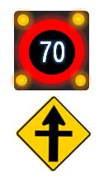
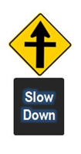

Active
Static

Static
Active

Figure 1. Signs developed for use as part of the RIAWS trial

A further small study was carried out to assist with the decision making process for setting the variable speed limit for the system (Mackie 2011). The purpose of this study was to examine the role of speed in rural crashes in general and then specifically examine the likely effects of various speeds on rural intersection crashes. Specifically, the objectives were to:
- Examine the role of speed in crash likelihood and severity
- Examine the relative influence of mean speed and speed distribution
- Examine various vehicle-activated speed limit options, (i.e. 60, 70, 80 km/h) and discuss the likely speed reduction that might be achieved at rural intersections, likely speed distribution for each, and hence the likely relative crash/severity outcomes
- Compare the likely effectiveness of speed reducing vs driver awareness focussed approaches.
Key to this analysis was the considerable evidence that vehicle speed magnitude is highly related to crash risk and severity (Nilsson 2004, OECD 2006, Fildes and Lee 1993, Wramborg 2005, Richards and Cuerden 2009), but the distribution of speed has also been shown to affect crash risk (Aarts and Van Schagen 2006, Archer et al. 2008 and Garber and Gadiraju 1989).

From the analysis it was determined that a variable speed limit of 60 km/h would be a ‘Safe System’ solution for the RIAWS. However, further discussion among the project team and wider reference group resolved that a 70 km/h variable speed limit may have overall better compliance by motorists. Based on this, a 70 km/h variable speed limit was chosen for RIAWS by the project reference group and project team.

- RIAWS trial site selection

Based on information from previous literature and subsequent operational considerations, a selection checklist (Error: Reference source not found) was developed for the initial RIAWS site selection process.

Table 1. RIAWS site selection criteria

- Use High Risk Intersection Guide identification procedures: Start with 3 Fatal or Serious crashes over 5 years, use 2 if other evidence present as per HRIG
- Evidence of crash codes compatible with objectives of RIAWS, i.e. turning or crossing vehicle vs vehicle crashes
- Preferably higher volume major road, with side road traffic volume lower, but not so low that exposure is minimal. Side road volume also not so high that sign will be activated most of the time
- Existing 100 Km/h major road speed limit
- Possibly intersection approach visibility issues (too little or too much)
- Relatively simple geometry (T or X), without complicating factors such as multiple lanes on through road (accepting that many intersections have acceleration lanes and right turn bays)
- No planned works in short to medium term. Longer-term may be OK as RIAWS may provide a good interim solution (e.g. before a rural roundabout)

Working through the list of highest risk intersections in New Zealand, many of those ranked at the top had imminent works planned for remediation (as would be expected), making them unsuitable for the RIAWS trial. Eventually two initial pilot sites (Figure 2) were identified and confirmed:

- Himitangi (Manawatu) – SH1/Highway 56/Himitangi Beach Rd
- Yaldhurst (Canterbury) – SH73/Buchanans Rd

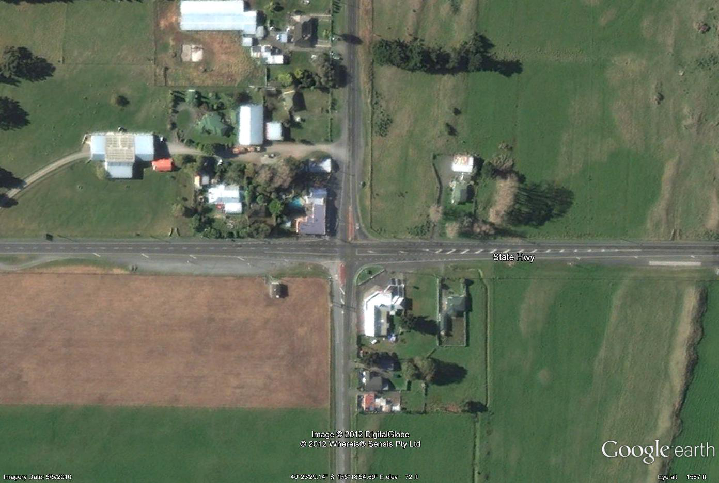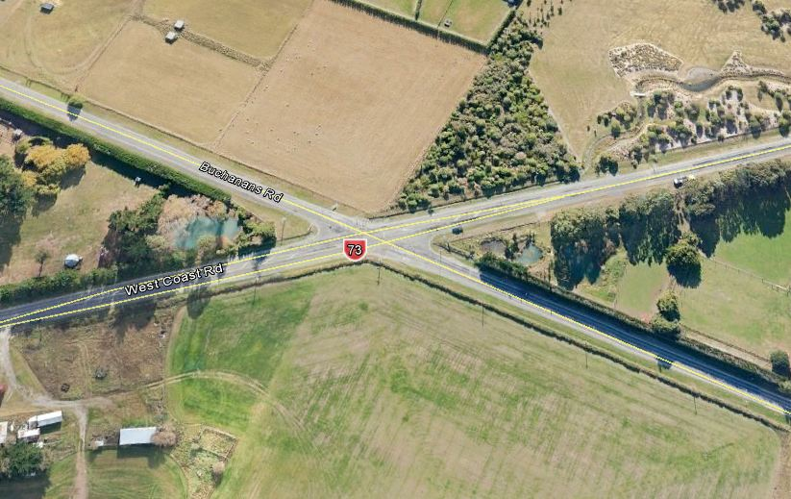

Figure 2. The general layout of the Himitangi and Yaldhurst pilot intersections

At Himitangi there have been three serious injury crashes between 2008-2012 with 88% (14) of all crashes over 10 years involving crossing or turning. At Yaldhurst there have been one fatal and two serious injury crashes between 2008-2012 with 79% (12) of all crashes over 10 years involving crossing or turning.

- RIAWS Development and Operational Performance

The RIAWS is designed to slow major road through traffic on approaches to an intersection when a potential collision risk exists. Variable speed limits signs on the approaches are triggered by the presence of side road and turning traffic.

The outcomes required for RIAWS and the system architecture that followed was developed by the project team, with detailed system design and installation completed by Armitage Group.

The RIAWS consists of the following elements (Figure 3 and Figure 4):

- Side-road radar sensors (high definition radar) to detect approaching side road traffic approximately 150m from the intersection and activate signs
- Side-road limit line sensors (cut loops) to detect waiting traffic and trigger the end of sign activation following a delay
- Right turn bay sensors 50-66m from limit line, to activate signs, plus limit line sensors to detect queuing traffic and terminate sign activation following a delay
- Variable speed limit signs approximately 150m from intersection
- A central control system box to manage the system and accommodate data collection equipment

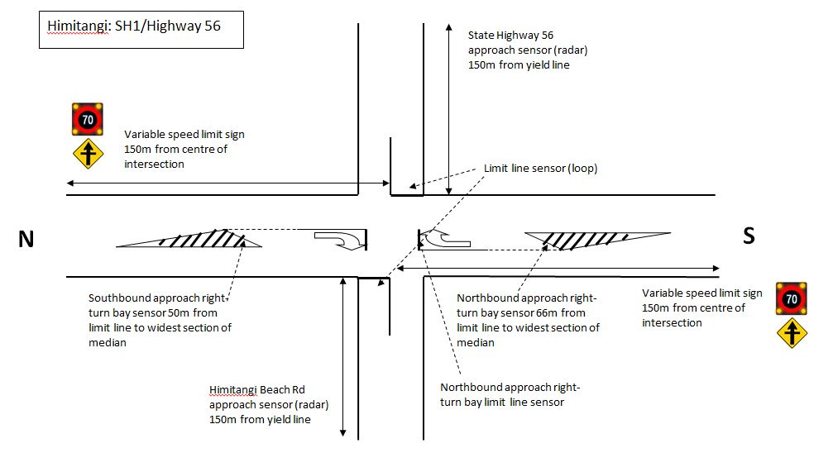
Figure 3. Schematic design of the RIAWS for Himitangi

Soon after the installation of RIAWS at Himitangi (December 2012) and Yaldhurst (May 2013), the system was checked to ensure the sign trigger and activation periods were reasonable. Minor adjustments were made to the system following this initial check.

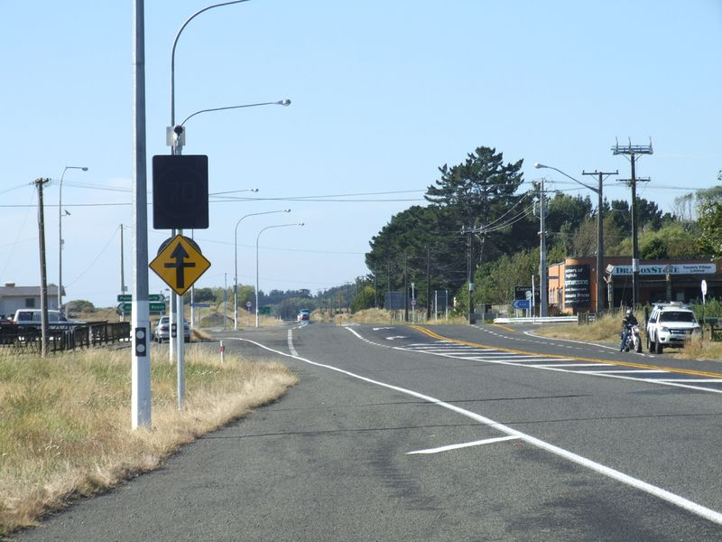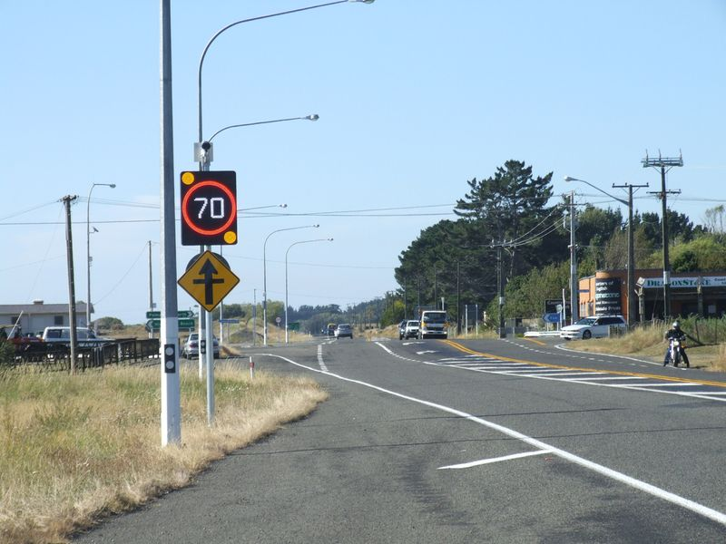

Figure 4. The RIAWS in operation at Himitangi with no conflict risk (left) and a potential conflict risk (right) with a side road vehicle present (circled).

- RIAWS evaluation method

Because it will take some time to determine the safety improvement benefits of RIAWS, surrogate safety measures have been developed to evaluate short to medium-term effectiveness. Therefore, the more immediate objectives of the RIAWS trial are to evaluate the feasibility and indicative safety benefits of RIAWS. This study evaluated the following outcomes:

  - RIAWS development and operational performance
  - Major road traffic speed through the intersection
  - Public perception and understanding of the system
Further work is underway to understand the motorist gap selection patterns following RIAWS installation.
To understand the operational performance of RIAWS, the project team attended a ‘launch’ of each system and observed it operating. Further, a regional engineer carried out a structured audit of various characteristics of the system shortly afterwards. The data collection system provided data from which an analysis of sign activation time could be carried out.

Speed was measured for each direction on the major road, both at the sign (using radar) and at the intersection (using inductive loops). A target of 14 days of data collection prior to, and following RIAWS commissioning, was set. In reality, eight days of data were collected before and after RIAWS commissioning at Himitangi and a ten days at Yaldhurst.

A public perceptions survey was carried out for Himitangi only, by capturing number plate information for vehicles passing through the intersection using automatic number plate recognition (ANPR) and then accessing vehicle owner address details through the motor vehicle registry (following NZTA approval). A paper survey was then mailed to vehicle owners, with an option of completing the survey online. The survey asked motorists a range of questions related to the meaning, conspicuity and legibility of the signs and any perceived hazards and suggested changes associated with the system.

- RIAWS evaluation outcomes

The proportion of time the variable speed limit signs spent on and off was measured and analysed, to check power demand and ensure that the system was not being overused or underused. An example of the sign activation patterns is shown in Figure 5, for Yaldhurst. At both Himitangi and Yaldhurst the sign was active for over 50% of the time for large parts of daylight hours, transitioning to minimal activation at night. The project team has concluded that this activation pattern is acceptable as it reflects the periods of demand and does not unduly slow through vehicles when there is no collision risk.
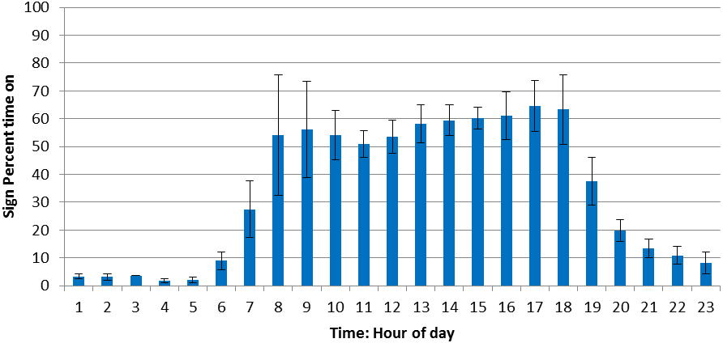
Figure 5. Average and standard deviation (error bars) percent time on for each hour of the day (for seven days) for the northbound direction at Yaldhurst.

  - Major road traffic speed through the intersection

The RIAWS has been effective in reducing traffic speed through the intersections. When the signs are activated by potentially conflicting traffic, mean and modal speeds are typically very close to the speed limit of 70 km/h (Figure 6 and Table 2). Statistically it is clear that the RIAWS system has positively reduced traffic speed at the intersections. For example, a t-test comparing the mean speed at the Yaldhurst intersection before and after RIAWS installation (with the sign activated in the post condition) returns the following results:

Degrees of freedom = 16393

t statistic = 64.9

p = < 0.001 (very close to zero)

Further, effects sizes (Cohen’s d statistic) for the intersection comparisons with the sign on were typically between 0.72 and 1.0 (Table 2), reinforcing a strong real effect in reduced mean speed.

However, statistical significance is less relevant here because it is very obvious that the system has positively affected mean speed. More importantly is whether RIAWS has had sufficient effect to improve road safety at high risk intersections. Prior to RIAWS, modal intersection speeds ranged between 81-96 km/h across the Himitangi and Yaldhurst sites. Following RIAWS, when the sign was active, modal intersection speeds ranged between 68-72 km/h.

It is also important to note that there is not a perfectly clear distinction between those motorists exposed to the 70 km/h speed limit, compared with those who were not. There will have been a proportion of motorists who passed the sign (approx. 150m from the intersection) assuming the speed limit is either 100 km/h if the sign was ‘off’, or 70 km/h if the sign was activated, but then before they reached the intersection speed loops the signs will have been either activated or turned off. For example, a motorist could pass the sign without it being activated and so the motorist will consider the speed limit to be 100 km/h. Meanwhile a side road or turning vehicle triggers the system and signs are activated. By the time the major road vehicle triggers the speed loops at the intersection, the data will be recorded as ‘sign on’ data, yet the motorist will have assumed the speed limit is still 100 km/h. So in reality, the ‘sign off’ traffic speed data is likely to be slightly lower than the actual speed of those motorists who were exposed to the sign being inactive. Likewise, the ‘sign on’ data is likely to be slightly higher than the actual speed of those motorists who were exposed to the sign being active. For this reason, it is recommended that the modal speeds provide the best indication of the change in motorist speed behaviour before and after the installation of the RIAWS system.

In Table 2, ‘sign off’ and ‘sign on’ sub-conditions exist for the pre-RIAWS condition. At Yaldhurst, before the electronic signs were made operational, it was possible to categorise the pre-RIAWS speed data in the same way as the post-RIAWS speed data, using the sign triggers to determine whether the sign would be on or not, without them actually being illuminated. This allows motorist speed behaviour, when potential conflict situations exist, to be differentiated from motorist speed when there are no potentially conflicting vehicles and allows a direct comparison with the RIAWS ‘sign on’ and ‘sign off’ data.

The data shows that even without the RIAWS, traffic speed through the intersections were slightly slower when potentially conflicting vehicles were present. However, the RIAWS has caused traffic speed to reduce even further, with modal speeds during RIAWS sign activation being 68-72 km/h across each direction and both sites.

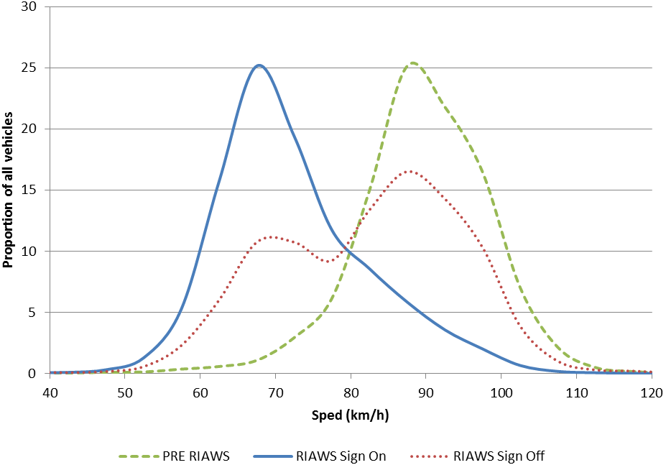

Figure 6. Example of speed profile changes at Himitangi in the northbound direction before and after RIAWS Installation.

Table 2. Speed data for Yaldhurst pre and post RIAWS installation.

SH 73 Northbound Intersection
 |  | Vehicle  Count | Mean  Speed (km/h) | Standard  Deviation | 85th %  speed | Effect Size  (Cohen’s d) | Modal speed
Pre | sign off | 10971 | 88 | 9 | 98 | - | 90
Pre | sign ‘on’ | 16410 | 84 | 12 | 94 | - | 81
Post | sign off | 12448 | 83 | 13 | 95 | 0.50 | 81
Post | sign on | 16394 | 76 | 11 | 86 | 0.72 | 72
SH 73 Northbound Radar
 |  | Vehicle Count | Mean Speed (km/h) | Standard Deviation | 85th % speed | Effect Size  (Cohen’s d) | Modal  speed
Pre | sign off | 14936 | 92 | 12 | 103 | - | 94
Pre | sign ‘on’ | 17998 | 91 | 10 | 102 | - | 92
Post | sign off | 16143 | 88 | 12 | 102 | 0.31 | 87
Post | sign on | 19208 | 82 | 10 | 92 | 0.90 | 81
SH73 Southbound Intersection
 |  | Vehicle Count | Mean Speed (km/h) | Standard Deviation | 85th %  speed | Effect Size  (Cohen’s d) | Modal  Speed
Pre | sign off | 11227 | 90 | 9 | 99 | - | 95
Pre | sign ‘on’ | 14858 | 88 | 10 | 98 | - | 90
Post | sign off | 11469 | 85 | 12 | 98 | 0.47 | 81
Post | sign on | 16435 | 77 | 10 | 88 | 1.01 | 71
SH73 Southbound Radar
 |  | Vehicle Count | Mean Speed (km/h) | Standard Deviation | 85th % speed | Effect Size  (Cohen’s d) | Modal  Speed
Pre | sign off | Not available | Not available | Not available | Not available | - | NA
Pre | sign ‘on’ | Not available | Not available | Not available | Not available | - | NA
Post | sign off | 13956 | 90 | 12 | 102 | 0.12 | 89
Post | sign on | 16611 | 82 | 10 | 93 | 1.77 | 82

  - Public perception and understanding of the system
In total 307 survey responses were collected (297 posted paper surveys and 10 online) representing a 31% response rate. Overall, based on the driver feedback, the RIAWS has been positively received. There have been a minority of negative comments regarding the system however it is important to distinguish between drivers’ opinions of the system as opposed to their actual behaviour, which generally appears to be positive to date. Nevertheless, some of the feedback can be used to further improve the RIAWS at future sites. The majority of respondents correctly understood the key message from the RIAWS at Himitangi, although a minority did not understand the regulatory nature of the signs or why they were being instructed to slow down by the signs. More conspicuous signage indicating the up-coming intersection, and possibly the potential for conflict, could be considered.

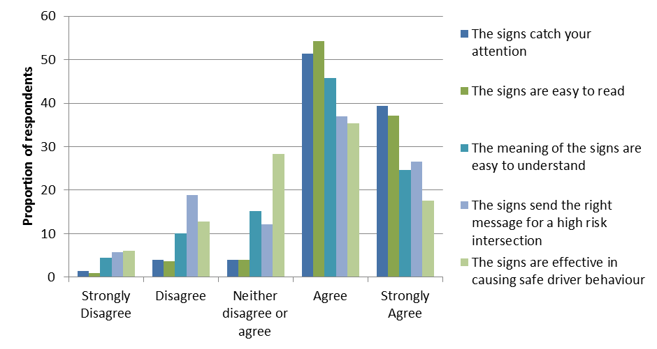
Figure 7. Survey response to question: “For the signs shown in the picture, and from the perspective of a motorist driving through this intersection, please circle the number that most closely matches your level of agreement with each statement”

- Discussion
From the data it is clear that generally, motorists slow down slightly at rural intersections when the potential for a collision exists, although this was clearer at Yaldhurst than at Himitangi. However, it appears that most motorists do not adjust their speed sufficiently to mitigate the effects of a potential collision situation, no doubt trading off safety with convenience, or perhaps being unaware of the consequences of an intersection collision at 80-100 km/h. The relatively high level of compliance with RIAWS suggests that the system is highly credible to most motorists and the variable speed limit of 70 km/h simply represents an extension of reasonable precautionary behaviour at rural intersections. It could be said that RIAWS helps motorists by extending their existing precautionary behaviour, in line with current evidence of the survivability of crash situations at various speeds.

Applying the analysis that was carried out earlier (Mackie, 2011), it could be interpreted that the RIAWS is likely to significantly reduce the crash forces involved in collisions at the intersection and potentially reduce the likelihood of collisions. Applying the RIAWS speed outcomes to the risk of KSI curve for side impacts (adapted from Richards and Cuerden 2009), it is clear that in theory the RIAWS system should have substantial effects on intersection safety (Figure 8). But only the crash behaviour of the intersections over time (minimum five years) will determine if this eventuates in reality.

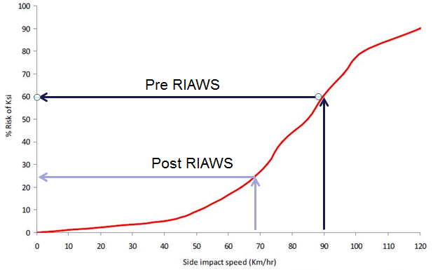
Figure 8. Estimated improvements to risk of death or serious injury following RIAWS installation

Following the application of the selection criteria outlined earlier, four more RIAWS sites have been chosen, are currently in operation and are being evaluated at:

- SH1/Kennington Rd, Invercargill
- SH3/SH54, Newbury (near Palmerston North)
- SH1/SH10, Pakaraka, Northland
- SH10/SH11, Puketona, Northland

At Puketona, the “Slow Down” sign version is being evaluated. After approximately six months it will be swapped with the 70 km/h sign at Pakaraka so that the relatively effectiveness of the two sign options can be evaluated.

Further analyses of motorist gap selection at Himitangi (using video collected at the intersection) and evaluation of the further four trial sites will help to confirm the merits of RIAWS (or otherwise). The further use of RIAWS as ‘business as usual’ around the country will then need to be considered by NZTA. There are a number of considerations for the wider use of RIAWS in New Zealand including cost, the nature of the problems present at specific intersections and the potential programming of physical infrastructure such as a rural roundabout.

There may be a case for using RIAWS when a high risk intersection warrants transformational remediation such as a rural roundabout, but funding does not allow this to happen for a number of years. In such situations RIAWS may provide a useful and relatively cost effective interim countermeasure until transformational works are implemented. At other intersections, the High Risk Intersection Guide identification process might identify that an intersection ranks relatively high in terms of road safety risk but it doesn’t quite meet the threshold for transformational works. In such a situation, RIAWS might also provide a useful road safety solution.

- Conclusion

A RIAWS has been developed and evaluated in New Zealand. The findings to date suggest that the RIAWS performs well and has the potential to significantly reduce fatal and serious casualties at rural high risk intersections by extending drivers’ natural intersection risk management strategies. Longer-term evaluation of the pilot sites and further trial sites will help to confirm the efficacy of RIAWS in New Zealand.

REFERENCES

AARTS, L., and VAN SCHAGEN, I. (2006). Driving speed and the risk of road crashes; a review. Accident Analysis and Prevention, 38(2), p215–224.

ARCHER, J., FOTHERINGHAM, N., SYMMONS, M. & CORBEN, B. (2008). The Impact of lowered speed limits in urban/metropolitan areas. Monash University Accident Research Centre Rpt No. 276, Australia.

CHARLTON, S. (2003). Restricting intersection visibility to reduce approach speeds. Accident Analysis and Prevention, 35(5), p817-23.

CHARLTON, S. and BAAS, P. (2006). Assessment of hazard warning signs used on New Zealand roads. Wellington: Land Transport NZ Research Report 288.

FILDES, B.N. & LEE, S.J. (1993). The speed review: Road environment, behaviour, speed limits, enforcement and crashes. Report CR127. Federal Office of Road Safety. Canberra, Australia.

GARBER, N.J., GADIRAJU, R., 1989. Factors affecting speed variance and its influence on accidents. 1989-01-01 1213. Transportation Research Record, Washington D.C., USA

LIND, G. (2009). Estimation of safety benefits of VSL at intersections and on weather-controlled links. 27th International Baltic Road Conference, p10, Riga, Latvia.

MACKIE, H.W. (2010). Rural Intersection Warning Systems: Review of information and recommendations Stage 1 Report. A report prepared for NZ Transport Agency by TERNZ Ltd.

MACKIE, H.W. (2011). The effects of speed on rural intersection crashes. A report prepared for the NZ Transport Agency by TERNZ Ltd.

NILSSON, G. (2004). Traffic safety dimensions and the Power Model to describe the effect of speed on safety. Bulletin 221. Lund Institute of Technology, Lund, Sweden.

OECD/ECMT, (2006). Speed management. Paris. OECD Publishing.

RICHARDS, D. and CUERDEN, R. (2009). The relationship between speed and car driver injury severity, Department for Transport, UK.

TATE, F. (2003). Jaws: The Safety Impacts, PhD Thesis, Leeds: University of Leeds Institute for Transport studies.

WRAMBORG, P. (2005). A New Approach to a Safe and Sustainable Road Structure and Street Design for Urban Areas. Paper presented at Road Safety on Four Continents Conference, Warsaw Poland.

YAMANAKA, H. and MITANI, T. (2005). Vehicle behavioural safety assessment for unsignalised small intersections to evaluate collision avoidance system. Journal of the Eastern Asia Society for Transportation Studies, 6, p2667–2675.

Acknowledgement

This work was funded by the NZ Transport Agency.

