IPENZ TRANSPORTATION GROUP CONFERENCE 2014

iWay: Delivering Mode Shift in the 21st Century

Authors:

Judith Makinson BEng (Hons), MSc, CPEng, MIPENZ, CEng, MICE

Principal Transportation Engineer

Traffic Design Group Ltd

Email: Judith.Makinson@tdg.co.nz

Owen Mata

iWay Team Leader

Hastings District Council

Email: Owenm@hdc.govt.nz

Presenters:

Judith Makinson, Owen Mata

IPENZ TRANSPORTATION GROUP CONFERENCE 2014

iWay: Delivering Mode Shift in the 21st Century

- INTRODUCTION

This paper provides an overview of the Hastings District Council’s (HDC) experience in delivering mode shift in the 21st century through their iWay project. The paper summarises measures taken by HDC to achieve mode shift to walking and cycling, the general methodology adopted for monitoring and evaluating whether mode shift is occurring and whether the project targets are being reached. It sets out key issues learned about how to achieve mode shift, but why it happens.

This paper is not intended to be a research paper, but presents a summary of findings from a ‘real world’; monitoring programme. As such, full details on survey and modelling methodologies used during the course of the study have not been included but can be provided on request.
- THE iWAY PROJECT

‘iWay’ is the branding name chosen by HDC for the strategies, interventions and community initiatives to support and promote active mode transport choices in Hastings. The iWay project is partly funded by the award received from New Zealand Transport Agency (NZTA) in 2010 to support Hastings’ aspiration to become a New Zealand ‘Model Community for Walking and Cycling’.

The funding received from NZTA for the iWay project was originally divided over a three year period. At the end of the first three years, additional funding was provided by NZTA to develop the project further. NZTA stated that the funding was awarded to Hastings for some key reasons, including the HDC’s long standing commitment to walking and cycling, strong leadership from the mayor and elected members, and the support and enthusiasm of council officers.

HDC saw the model communities initiative not just as a transportation related project, but as an opportunity to improve the quality of life for everyone in the Hastings area – especially future generations. The original HDC proposal to NZTA stated:
“It is our vision to see people walking, cycling, and importantly, talking, meeting and greeting each other rather than being isolated in their cars – this vision has real potential to generate real community spirit, along with tangible socio-economic and environmental outcomes”

To achieve the overall objective of seeing 20% of local short journeys taken by foot or by bike by the year 2020, HDC has undertaken a program of both physical works and a range of information and education programs to promote walking and cycling as easy, cheap and fun. The physical works were based around a connected network of cycle routes integrated with land use and trip purpose on the basis of establishing a hierarchy of routes.

This hierarchy is defined at four levels as shown in Figure 1 overleaf:

Arterial routes to link Hastings’ principal communities through main centres of population, employment and education. These are high quality facilities that seek, in the first instance, to follow routes that are on quiet roads with slow moving traffic or consist of dedicated off-road facilities. These are combined walking and cycling routes.

Collector routes to connect schools, community facilities, major attractions and residential areas to the arterial network. These form the majority of the marked cycle network in terms of length and consist mainly of a re-allocation of road space.

Low volume local roads not already designated an arterial or collector, providing the finer grained permeability and connectivity across the whole network. The focus on these roads and will be designing spaces for the community, based on best urban design and place based planning principles as set out in HDC’s best practice design guide (creating more liveable urban spaces).
Transformation of local roads will be delivered over time in conjunction with HDC’s urban road renewal programme.
Connectivity for pedestrians, focussing on the connectivity of the footpath network, particularly across busy roads, along identified vulnerable user routes and around intersections and key community facilities. This work included accessibility audits of footpaths with key facilities (e.g. old people homes, schools, kindergartens etc) and population groups, such as Age Concern, Disability Reference Group etc.

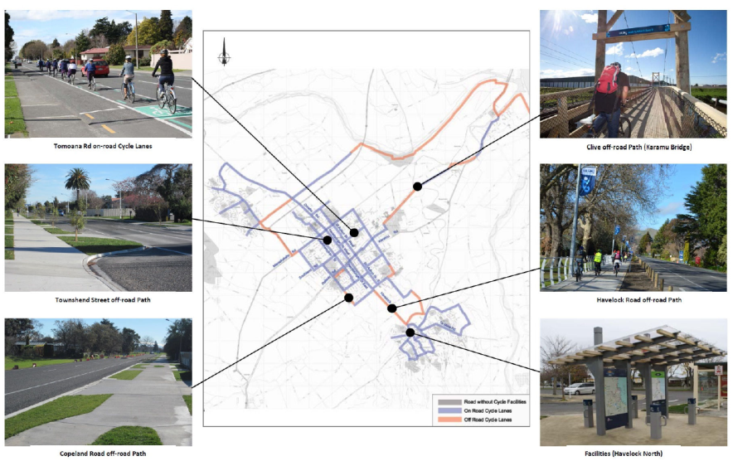
Figure 1: iWay Route Plan and Examples of Infrastructure

In addition to the program of infrastructure work, a campaign of “soft measures” was also launched – a strategy of community engagement activities which would complement the construction work. Central to this was cultural change in the local area – a change in how the Hastings community viewed walking and cycling. Four key strands were identified:
- Walking and cycling to work
- Walking and cycling to school
- Walking and cycling to shops
- Walking and cycling for fun

Through a full programme of events, marketing and working with local schools and businesses, Hastings aimed to “normalise” walking and cycling for each of these groups. The aim was to make alternative modes of transport as “normal” and as easy as taking the car, using best practice approaches taken from around the world.

2.0 MONITORING AND EVALUTAION OF iWAY
2.1 Purpose of Monitoring and Evaluation (M&E)
The key aim of the M&E study has been to not only identify whether mode shift is occurring, but also to obtain an understanding of why. This is a complex question and understanding of the interrelationship between education, marketing, infrastructure and mode shift is necessary to ensure that financially and physically sustainable mode change to walking and cycling can be achieved.
2.2 Key Performance Indicators (KPIs)
Three levels of KPI have been used in this this study. The primary KPIs of identifying 8% mode shift year on year to walking and cycling, improving road safety for pedestrians and cyclists (particularly in the child category) and improving road safety perception by at least 50% are the ‘must haves’ of the project to be able to deem iWay as being successful. These are supported by a second tier of KPIs that represent the ‘want to haves’. These include public awareness of iWay, increasing levels of weekly physical activity, reducing vehicle speeds on roads with cycle facilities, and increased bus patronage on ‘The Express’ services. These two levels of KPI focus on hard data and look at overall trends of travel behaviour change.
The final level of KPIs is the one that focuses on the ‘who’ and ‘why’ of iWay. The points considered here are who is walking and cycling and why, what people think about walking and cycling as modes of transport, whether increasing walking and cycling activity is changing road safety and traffic behaviour, if the change in walking and cycling behaviour has affected bus patronage and how effective the physical infrastructure iWay has provided is in achieving mode shift. Identification of progress against these goals depends on interpretation of combinations of the data obtained rather than straightforward reporting of observations.
2.3 Timeline
The process derived for undertaking the M&E of the iWay project includes a number of key steps. The Scoping Report (June 2011) confirmed the methodology for the M&E process and identifying the data sets to be used throughout. This was followed by a Baseline Report (September 2011) identifying pre-iWay walking and cycling behaviour using existing data sets only. It provided a baseline for comparison of effects arising from the scheme in future years. This Baseline Report covers the period of 1st July 2009 to 30th June 2010 and was written retrospectively. The final stages of the M&E project have been the Annual Reports which analyse the change in travel characteristics and progress against the KPIs for a consecutive three year period following the Baseline Report and the introduction of iWay infrastructure and initiatives.
2.4 Methodology
An innovative four-tiered approach to the M&E study has been adopted, providing an opportunity to cross-validate outcomes from different data sources. These tiers are:
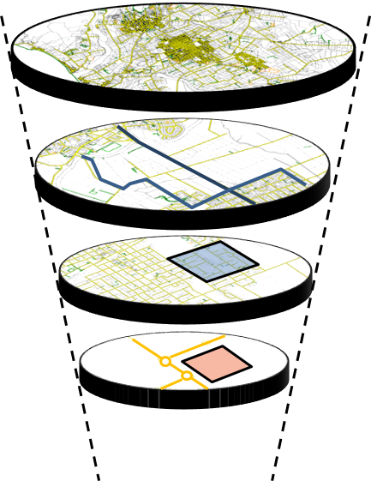 | Global Tier: assessment of primarily existing empirical data defined areas of Hastings including the inner CBD area and the whole of the urban area of the District.  Key Link Tier: using both empirical and interview survey information to assess not only network performance but also people’s attitudes to walking and cycling.  Community Tier: using mostly interview survey data to understand people’s attitudes to walking and cycling at key community locations such as schools, post shops, hospitals and supermarkets.  Organisational Tier: Through evolution of the iWay project, the focus of the organisational tier has changed and will be linked to the HDC schools travel initiative, ‘MoveIt’.

2.5 Data Collection
There are a number of existing data sets that have been used to identify baseline (pre-iWay) travel characteristics within different elements of the study area, and also allow for the comparative year on year assessments during the implementation stages of iWay. These include National Census 2006 and 2013, National Household Travel Survey (HTS), NZTA Crash Analysis System (CAS), HDC Automatic Traffic Count (ATC) programme HDC annual cycle count programme and Hawkes Bay Regional Council (HBRC) bus patronage data.
Having these constant and consistent sources of information is a key strength of the study allows for direct comparison year on year. In addition to these existing data sources, a series of bespoke surveys have also been carried out year on year across the M&E period using consistent survey methodologies:

Manual cyclist and pedestrian surveys have been undertaken at the inner CBD cordon, outer cordon, at a number of interview survey locations and off-road cycle arterials. These weekday morning and evening peak hour counts have been classified by general age and gender in response to growing HDC interest in who is taking up active travel options.
Intercept interview surveys have been carried out, starting in Year 1, to capture travel behaviour and attitude information whilst people are involved in travel activity. This is a key difference between iWay and other similar studies that tend to rely more on after the fact surveys or travel diaries. This approach reduces sources of bias linked to after-the-fact reporting and also includes car and public transport users during a walk leg of their overall trip The Year 1 and Year 2 interview survey samples have been between 500 and 600 strong from within a total population of around 66,000. This gives a sample size of around 0.7% - 0.9% and is similar to the sample sizes used during the UK’s Cycling City and Towns project. https://www.gov.uk/government/publications/evaluation-of-the-cycling-city-and-towns-programme-interim-report
The ATC programme has been improved to provide constant cordon and screenline locations. Additional installations have also been made alongside manual pedestrian and cycle count locations to give a basis for comparison of approximate mode share (walk/cycle/vehicle numbers only).

3.0 WHAT HAS iWAY ACHIEVED?

3.1 Mode Shift
An assessment of the annual automatic cycle count (ACC) programme data in Chart 1 shows strong levels of growth but also significant variation in cycle volumes across the core network. The sites included in the assessment are those on the iWay arterial cycle route network and also those adjacent to iWay interview survey locations. Only sites with three consecutive years of data have been included to give a clear indication of the level of change from Baseline to Year 2.
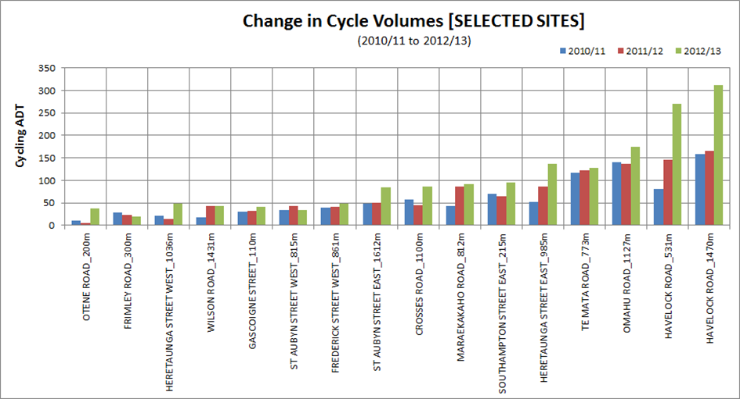
Chart 1: HDC Annual Cycle Count Data Observed Cyclists
When we look at where the change has occurred and where iWay has installed physical infrastructure, we see that:
- Havelock Road off road arterial installed in Year 1 (2010/11) has seen a doubling in cyclist numbers;
- Southampton St East on road cycle lanes installed at the end of Year 2 (2011/12) have seen a 31% increase in cycle traffic;
- Otene Road off-road path forming part of the Clive arterial, installed at the end of Year 2 (2011/12) also saw a substantial increase on a route which was previously little used.
- Omahu Road on road cycle lanes (part of the Flaxmere arterial) were installed in Year 1 (2010/11) and have seen a 20% increase in cycle traffic volumes.
This suggests that getting infrastructure in the right place makes a difference to cycle volumes and that there has been mode shift on certain routes.
Reponses gained during the interview surveys suggest that at the overall community tier, cycling mode share has increased from 7% to 12% with walking mode share increasing from 31% to 45%. Similarly, at the organisational/school tier, overall cycling mode share has increased from 5% to 10% and walking mode share from 31% to 62%. Mode shift is not necessarily consistent within each community and at each school but the overall outcome is suggesting an increase in walking and cycling behaviours.
At a global level, the target of achieving a year on year increase in both walking and cycling mode share of 8% has yet to be met conclusively as there are considerable variation in walking and cycling activity observed within the data sets.
Although the HTS has limitations, it was identified as the best available annual source of data at the global (‘all Hastings’) level. Consideration of the annual HTS walking and cycling mode share results and the 5-year rolling averages for these travel modes gives conflicting outcomes. There is also variation between the HTS data and that obtained from the ACC (Chart 1) and manual pedestrian and cycle count surveys. The HTS has a small sample based on random household selection from within 12 meshblocks within Hastings. These meshblocks are sampled year on year until all households have been approached before new meshblocks are selected. This means that the HTS focuses on a particular trip origin area for a number of years, before moving to a new area whereas the ACC and manual counts capture activity at a cordon level i.e. anybody travelling into or out of Hastings. This captures a greater variety of trip origin locations leading to a wider representation of travel behaviour.
The Scoping Report (2010) highlighted very clearly that it is essential to ensure that data collection is geared to the level of change that is being sought. It also highlighted that small changes can be hard to find and that if inappropriate data sets are considered, the change being sought can be missed. The iWay experience has confirmed this: if only HTS data was used, the mode shift that is showing up at the lower levels would not have been identified and the project would have been classed as a fail. Identifying and using appropriate datasets is therefore crucial to a meaningful M&E study . This is illustrated in Chart 2 which shows the different cycle mode share result from the variety of data sources used. This assessment is a simple mathematical average only with no weighting factors to allow for different sample sizes being applied. What it shows is the value in using a tiered approach to M&E to ensure that KPIs or target achievements are not overlooked due to sample size or data collection issues.
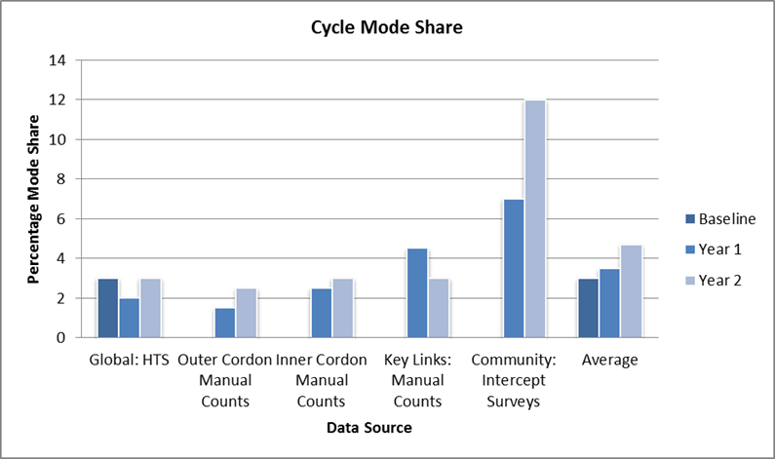
Chart 2: Cycle Mode Share Outcomes from Different Data Sets
3.2 Mode Stability
Mode stability, or how active people are year on year, assists in understanding whether mode change is occurring and whether it is occurring due to existing pedestrians and cyclists becoming more active or whether there are more people walking and cycling. From the interview surveys, Chart 3 suggests that both of these are occurring with the number of people being totally inactive decreasing from 18% to 10% and the number of people walking or cycling daily increasing from 39% to 56%.
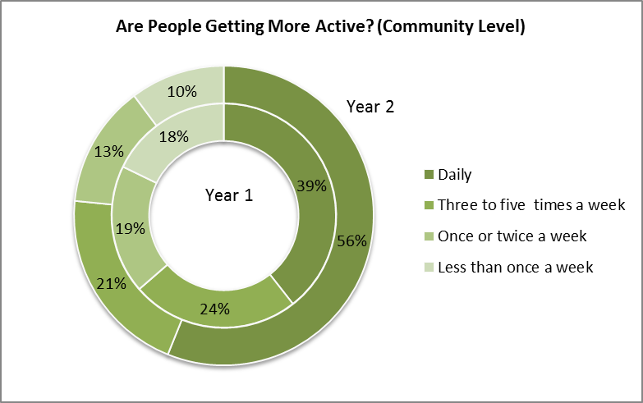

Chart 3: Community Activity Levels
3.3 Mode Awareness
Part of the M&E study has been identifying people’s awareness and understanding of iWay. Around 63% of interview survey respondents had an understanding of iWay, with there being a strong focus on cycling within the responses gained. This is an increase compared to Year 1 when iWay brand awareness was around 56%. This outcome suggests that on-going marketing is important part of sustaining on-going mode shift; people need to know what is being done and what is available before they can make a decision as to whether they should change their travel habits.
Demographic data collected during the surveys shows that men are more likely to be more active than women and activity frequency also declines with age. Understanding who is walking and cycling allows for better targeting of information and awareness raising. This is particularly well illustrated by Chart 4 which shows the mode split obtained from the interview survey responses at the various schools included in the iWay M&E study.
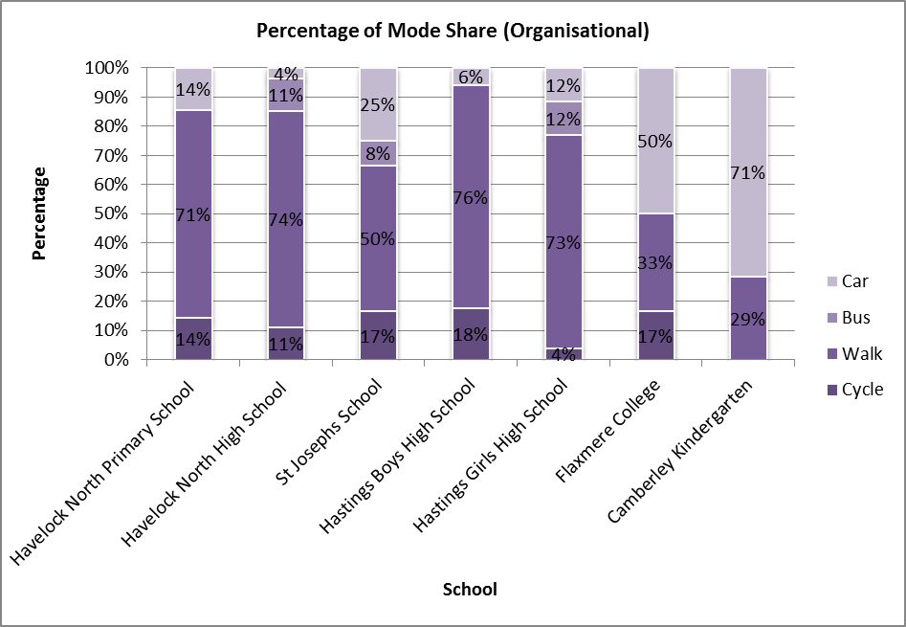
Chart 4: Mode Share at Education Facilities
When looking at Camberley Kindergarten, the target audience for education or marketing around walking and cycling clearly needs to be aimed at parents/caregivers as they are the decision makers when it comes to travel choice and are currently travelling predominantly by car. At Hastings Girls High School, cycle use is very low, suggesting that teenaged girls need more encouragement and support to get them cycling than boys of the same age group.
3.3 Travel Mode Choice
A key component of the M&E study is to identify whether people are walking and cycling due to lack of access to a car or are they walking and cycling as a definite decision to do so. Based on the interview survey responses, Charts 5 and 6 show mode availability for pedestrians and cyclists at the key link and community tiers. If we consider this in conjunction with the mode stability charts at the link and community tier level (Charts 7 and 8), these two pieces of information suggest that mode shift is occurring as a choice rather than out of necessity i.e. more people are walking and cycling and more people have access to other modes for those trips.
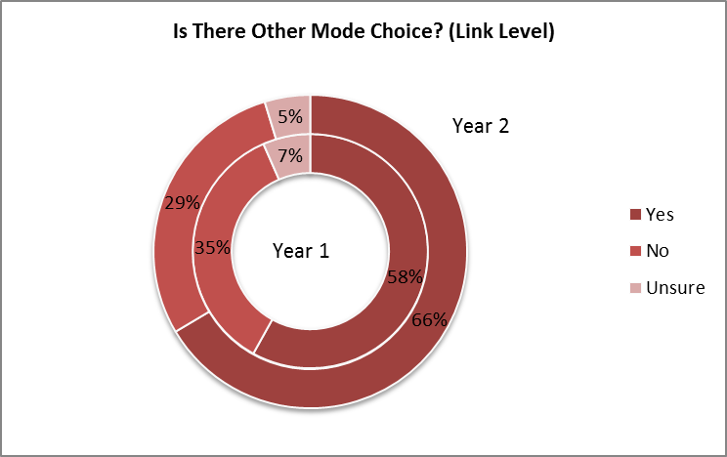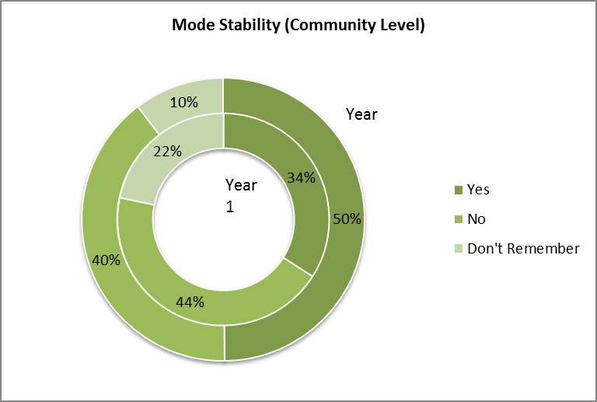
Chart 5: Key Link Mode Availability Chart 6: Community Mode Availability
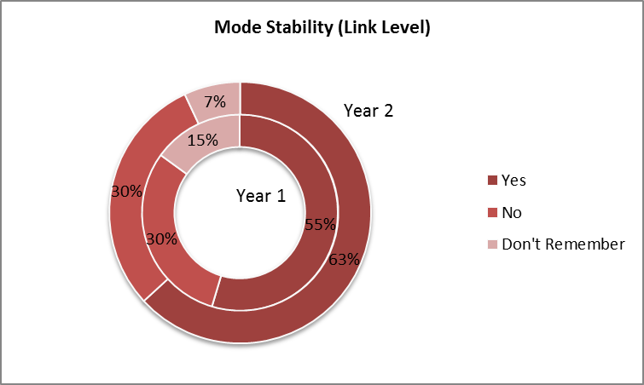
Chart 7: Key Link Mode Stability Chart 8: Community Mode Stability

3.4 Cycle Kilometres Travelled (CKT) and Vehicle Kilometres Travelled (VKT)
VKT can be used as a proxy to identify general traffic characteristics and hence infer overall activity levels. VKT has been calculated from traffic volumes recorded in the ATC data applied to generic classes of roads within the Hastings District Urban Area using the Hastings Area Transport (HAT) model network. Chart 9 shows that VKT is remaining relatively stable over the study period with there being a 2% decrease from Baseline to Year 2 in the morning peak hour and a 5% increase in the evening peak hour. These changes relate to around a 4,000 km/year and 15,000 km/year respectively across a network length of 582 km. Assessment of the ATC data shows that there has been a 3.6% reduction in Average Annual Daily Traffic (AADT) volumes. Combing this with the changes in modelled VKT suggests that fewer but longer car trips are being made.
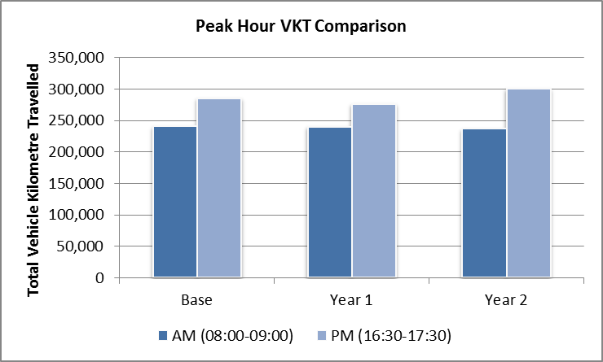
Chart 9: Hastings District Urban Area VKT Comparison
CKT can be assessed using the same methodology as VKT by using the cycling element of the HAT model and the manual count data at set locations. The outcome of this assessment is shown in Chart 10.
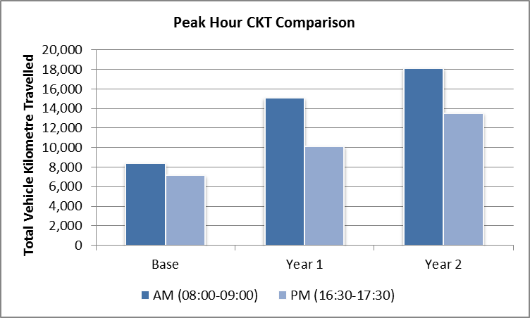
Chart 10: Hastings District Urban Area CKT Comparison
This shows there has been a year on year increases in modelled CKT from Baseline to Year 2 in both the morning and evening peak hours. These increases are 116% and 89% respectively and relate to around 6,000 km/year to 9,000 km/year across a network length of 582 km. In real terms, this means that for every km of road network, some 11 – 16 more cycle trips are being made in Year 2 peak hours than in the Baseline. It is reasonable to conclude from this and the ACC data in Chart 1 that a combination of mode shift and increased cycle trip length has occurred.

3.5 Road Safety
If increased walking and cycling is to be encouraged, it is essential to ensure that they are not only safe modes of travel but that they are perceived as being the same.
The numbers of crashes occurring on the Hastings road network has reduced year on year from the Baseline to Year 2 which suggests improvement in the overall road safety record. The Year 2 cycle crash rate has reduced to 113 crashes/million cycle km from 372 crashes/million cycle km in the Baseline. This is a reduction of 229%. The overall vehicle accident rate has also decreased noticeably year on year from 206 crashes/million vehicle km to 114 crashes/million vehicle km. Crash rates have been calculated using observed crash numbers from CAS and the modelled values of VKT and CKT. In relation to pedestrians and cyclists, the overall number of crashes has decreased from Year 1 to Year 2 and is now lower than the Baseline values. This has been coupled with an increase in the distance cycled leading to a reducing cycle crash rate as shown below in Chart 11.
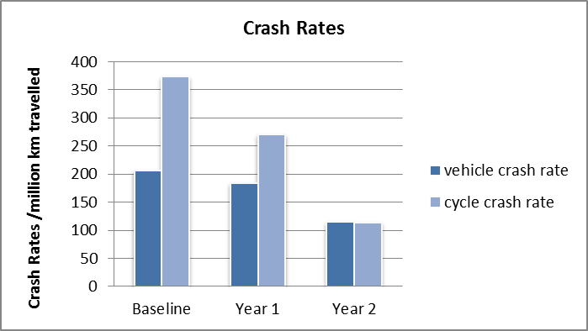
Chart 11: Global Tier Crash Rate Comparison
Chart 11 indicates that the reduction in crash rates for cyclists may be outstripping that for vehicles and that the cycle crash rate may have reduced to be in line with the vehicle crash rate. A longer time period is required to be certain of these results.
4.0 CULTURAL CHANGE
This paper has so far identified the extent of iWay, the activities and infrastructure it supports and the level of travel behaviour change it is achieving i.e. the ‘who’ and the ‘how’. The key to ongoing mode shift is to understand the ‘why’ people have changed. Just as important is the question of why haven’t they, and the aspects of local culture which might discourage this change.
4.1 Existing Local Culture
Hastings is typical of many provincial NZ towns in that a strong driving culture exists, including a tendency to take the car for even the shortest of trips. When the project began, cycling was most often seen a sporting activity rather than as a utility means of transport. Cycling was also dominated by older males – Hawkes Bay has one of the largest road cyclist clubs in the country, and the majority of the members are middle aged men. This meant that conversations around cycling often centred on motorist’s conflicts with such cyclists in rural areas, leading to questions about their right to be on the road at all.
In addition, decades of local under investment in walking and cycling by councils meant that often new roading projects did not consider the needs of walkers or cyclists properly. The needs of vehicles were prioritised in many cases.
As a result, the quality of provision for walkers and cyclists was often poor, and these two groups did not feel encouraged. To cycle through Hastings for an experienced cyclist often felt like a battle, and a new cyclist could easily have such a bad experience that the experiment would not be repeated. To exacerbate the situation, car drivers did not expect to encounter cyclists and did not take them into account properly. Walking and cycling – especially for children – were thought to be unsafe.
For iWay to reach its objectives, the project team decided that a significant cultural shift would be necessary. Infrastructure provision alone would not be enough: the project needed to change the way the area thought about walkers and cyclists – both from a public perspective and a council perspective.
4.3 Why People Are Not Walking and Cycling
Some 40% of the interview survey respondents stated distance or time as the key barrier to walking or cycling, with around 23% stating the need for a car for either work or trip chaining purposes as why they didn’t walk or cycle. This equates to around two thirds of the interviewees and is generally consistent with the results from the first year’s survey. The remaining reasons given generally related to lack of supporting trip end facilities, driver behaviour and road safety, lack of infrastructure, lack of knowledge or skills and lack of physical ability or will.
These answers reveal some key messages that promoters of sustainable travel need to understand:
- Time is valuable to a lot of people. To get these people to walk or cycle, the actual time taken for new travel behaviours has to compare favourably to their current patterns. This may mean looking at not just door to door travel to work time but time spent at the gym, exercising in the morning or evening etc. It is also worth noting that where people are simply not motivated to walk or cycle, “lack of time” can be given as a default reason for not doing so since it is a more socially acceptable reason than simply being lazy.
- People need information and help. Showing people how and where they can walk and cycle safely and getting them started are essential. This is where running walking and cycling events and promotions can succeed. A recent example of iWay doing this is the ‘Tripswitch Week’ where people were encouraged to switch a usual car trip for a walk or cycle trip. One feedback comment that amply demonstrates the need or support and information is:
… I usually take the car and was a bit scared to ride to work in the Hastings traffic. I figured that there would be [fewer] cars on the road on Tripswitch Week. I was apprehensive cycling in and around roundabouts and traffic lights …. I did get off my bike each day at the Stortford Lodge roundabout and crossed the road as a pedestrian, to be SAFE. I do ride along iWays once or twice a month in the weekend with a friend. Was never going to cycle to work, but thanks to Tripswitch it has not been that bad at all. And I will continue to bike to work (weather permitting). …
4.2 Branding and Brand Awareness
HDC decided that a strong walking and cycling “brand” would help to bring together all the different infrastructure and community engagement strands of the programme, and also be an advantage in pushing through cultural change, such as driver behaviour. The iWay team also believed that many public body active transportation campaigns are seen as “preachy”, environmental and overly proscriptive, and that the project would benefit from the perception of iWay as positive and independent.
Through the course of the project, the iWay name has been the subject of much publicity both locally and nationally – mostly planned (and positive) but not always, for example when looking to replace parking spaces with cycle lanes, or building pathways on land where nearby residents have encroached. The importance of a high level of brand awareness was reflected in the project target, which was that at least 50% of local people should be aware of the iWay project. Chart 12 shows that 63% of local people are aware of the programme compared with 56% in Year 1. In addition 74% of people recognised the Share the Road campaign. The interview surveys have also shown very few negative comments received in relation to iWay (less than 1%) with most people who expressed an opinion about iWay being in favour of the project.
Chart 12: iWay Brand Awareness
Using the iWay brand, the project is now in a strong position to communicate future projects, drive forward culture change and to further develop public consultation approaches.
4.3 Perception of Safety
The increase in actual safety for pedestrians and cyclists has already been discussed above: it is also important in influencing the decision to change transport mode that people’s perception of safety is positive.
In parallel with actual safety, how safe people feel walking and cycling around Hastings is improving with the average safety perception increasing to 7.9 on a scale of 1 (very unsafe) to 10 (very safe) in Year 2 from a baseline value of 7.1 in Year. This equates to 77% of people overall feeling safe and is a 16% increase from Year 1). There has also been a considerable increase in the number of people feeling very safe in Year 2 which is a markedly positive result. These results are shown in Chart 13.

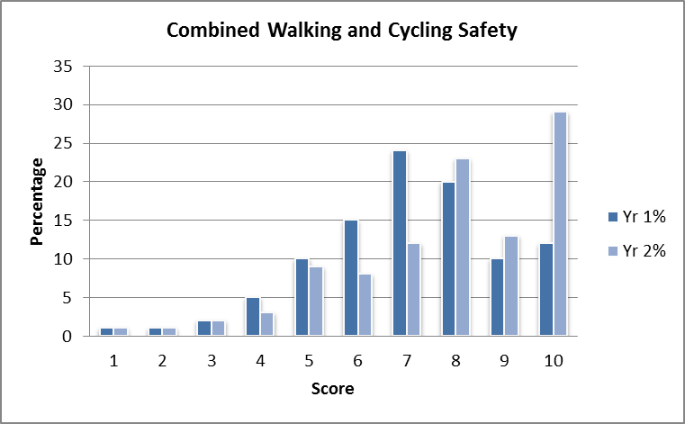
Chart 13: Safety Perception
In Year 2, the question was extended to ask why people feel safe. The majority of people gave very generalised positive and negative answers (e.g. “Hastings is safer than London”, “I’m scared of dogs’) but those who provided answers relating to iWay commented on good pedestrian and cycling facility design as being a key factor.
Some links have increased cycling and walking activity and decreasing crash numbers whilst others have decreasing cycling and walking mode share but increasing crash numbers. It should be noted that some links have very low crash numbers and that identification of trends specific to these location is not realistic. An example of this is Maraekakaho Road which has only 0 or 1 reported cycle or pedestrian crashes per year over the past five years.
4.4 Leadership
Before considering further what behaviour changes iWay has created, it is important to recognise that iWay has only been implemented after a certain behaviour change occurred. Like many local authorities internationally, HDC had a cycling strategy in place and good intentions on delivering it. However, the financial and political will to deliver on this strategy was not always as strong as it might have been.
The Hastings mayor has admitted that in previous years HDC had paid “lip service” to its own walking and cycling strategy. The award of the model community funding from NZTA made HDC aware that an opportunity existed to finally implement this strategy – including elements that had been discussed for many years. Importantly, the mayor and deputy mayor saw this as an important chance to improve quality of life locally, and showed a willingness to lead the community towards this objective. This leadership was important when the project faced public criticism, and allowed progress to continue being made.
Changing that behaviour was therefore the key to unlocking the iWay success. Without a high level buy in by Councillors, the ability of HDC staff to promote and deliver iWay would have been seriously compromised.
Also important has been leadership from HDC officers. Many council programmes now complement the iWay initiative: for example, the ongoing programme of road renewals from year to year seeks to implement many of the principles of the project. Wider, shared use footpaths and narrower carriageways to limit speed are now a feature of many local road renewal projects and the needs of both pedestrians and cyclists are now considered more carefully. The planning of the future CBD also now recognises the importance of creating a pedestrian friendly town centre. The philosophy of the iWay project now has a strong place in Council business.
4.2 Driver Behaviour
In terms of whether driver behaviour has changed as a result of iWay, the ‘Share the Road’ campaign was slightly less well known and understood compared to iWay. Consideration of vehicle speeds on links with cycle facilities also shows some varied results. Of those included within the study, those with on-road cycle lanes generally saw lower vehicle speeds than pre-iWay. On roads with off-road cycleways, vehicle speeds had increased on average. The information obtained is not conclusive but given that vehicle speeds have generally increased within the Hastings District Urban Area, these results suggest that on-road cycle lanes make drivers more aware of cyclists and there may be a side friction effect of them being in place. The overall speed increase in roads with parallel off-road cycleways was higher than the general trend. This suggest that two things may be occurring; that there are fewer vehicles on those routes as a result of mode change with a subsequent release of capacity; that drivers are not expecting to see cyclists on the road and speed up accordingly.
4.4 Infrastructure
The M&E study (and particularly the interview survey element) has shown that pedestrian and cyclist route choice is generally made based on directness or speed of route.. Most interviewees didn’t think that their route choice was affected by the level of infrastructure provision. However, if that point is considered from the infrastructure provider’s perspective, it underlines the importance of ensuring the walking and cycling infrastructure is provided on the most direct routes possible. To put the time cost of diversion into perspective, for a car travelling at 50kph, every 100m diversion adds 7s to journey time. For cyclists travelling at 18kph the extra time is 20s and for pedestrians travelling at 5kph the extra time is 1minute 12s. Individually, these changes may not be much but cumulatively, they can be expected to affect the relative attractiveness of the different modes of transport.
In terms of what infrastructure was popular with pedestrians and cyclists, Chart 14 shows that both on and off road cycle lanes were considered important as was the provision of good routes across intersections for pedestrians. Interestingly, cycle stop boxes at traffic signals were not considered to be effective, with road narrowing at roundabouts to encourage cars to wait behind rather than alongside cyclists only slightly more so.
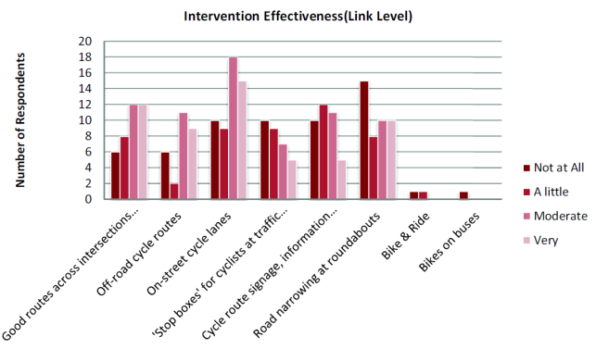

Chart 14: Interview Survey Responses on Infrastructure Effectiveness

5.0 CONCLUSIONS

The first thing that has to happen for mode shift to occur is for there to be high level political support and buy in. Without this willingness to make it happen, then projects such as iWay are unlikely to succeed as they need sustained effort from enthusiastic people to make them work.

In terms of what iWay has achieved:

• The previous decline in walking and cycling rates has been reversed, and walking and cycling mode share is generally increasing, with there being some noticeable increases in the volumes of cyclists observed on some roads after iWay infrastructure has been constructed (Chart 1 and Section 3.1). This demonstrates the importance of getting the right infrastructure in the right place.

• The overall distance travelled by cyclists appears to have increased with there being a likely drop in the cycle crash rate. This has been accompanied by a reducing vehicle crash rate and a general decrease in the actual numbers of crashes involving cyclists and pedestrians. All of the preceding is modelled, not actual data, so I guess, and thus can only be tentative results. People’s perception of road safety has also improved.

• How people view walking and cycling has changed, with more people undertaking these activities more often, people feeling much safer about doing them and people actively choosing to walk and cycle rather than traveling by these modes for a lack of alternative.

These outcomes suggest that making people aware of the available infrastructure and the on-going active marketing of events and publicity encourages more people to try walking and cycling in the first instance. Once they have tried walking and cycling, having good infrastructure in place means more people are confident in their ability to walk and cycle safely and on a regular basis. For those who already walk and cycle, the infrastructure makes the activity more enjoyable and they are happier to do it more often.

The challenges going forward will be to continue to achieve mode shift year on year, particularly once the ‘easy wins’ have been achieved and it is the hard core drivers that are left.

In terms of the M&E study and how it has been carried out, our experience has shown that:
- No data collection or survey methodology is perfect but maintaining consistency ensures that errors are also consistent within year on year comparisons of data.
- Using a tiered assessment approach allows cross validation between data sets and gives a more robust outcome.
- iWay M&E is a great ‘one off’ but isn’t feasible year on year where there are budget constraints. One outcome of the project this year will be to create best practice guide that looks at typical data availability and how it can be used ‘as is’ or augmented to create ‘best value’ datasets.

6.0 REFERENCES

Reports
BARGH,A. (2011) Hastings iWay Project - Monitoring and Evaluation Study Scoping Report
LI, V. (2011),HDC iWay Baseline Report
LI, V. and MAKINSON, J (2012) HDC iWay Year 1 Report
MAKINSON, J (2013) HDC iWay Monitoring and Evaluation Year 2 Technical Report
REDFERN, R (2011) Evaluation of the Cycling City and Towns Programme Interim Report

