**MEASURING TRANSPORT RESILENCE IN MANAWATU**

**Muhammad Imran*, Chrstine Cheyne* and John Harold\***

* Resource and Environmental Planning programme, Massey University, [m.imran@massey.ac.nz](mailto:m.imran@massey.ac.nz), [c.m.cheyne@massey.ac.nz](mailto:c.m.cheyne@massey.ac.nz), [johnharold@gmail.com](mailto:johnharold@gmail.com)

***Abstract:*** *The National Infrastructure Plan identifies resilience as a guiding principle for economic development. The aim of this paper is to present a Resilience Indicator Framework (RIF) for measuring transport resilience. The methodology comprises a cross-disciplinary literature review focused on the concept of resilience in transport infrastructure, current approaches to the measurement of transport resilience and resilience in related literatures (e.g. supply chain logistics; community resilience, etc.), and the development of a Resilience Indicator Framework (RIF) that illuminates six dimensions of transport resilience: engineering; services; ecological; social; economic; and institutional. Through desk-top research and key informant interviews, quantitative and qualitative data on economic, social and ecological dimensions of resilience are gathered to apply the framework in a case study of transport infrastructure in the Manawatu-Whanganui region. The case is selected because of its geographic location (recognising Palmerston North’s importance as a distribution centre and the region’s critical linkages to other regions north, south, east and west). Most importantly, it has experienced threats to transport resilience from damage to critical infrastructure (e.g. flooding as experienced in 2004; the Manawatu Gorge closure in 2011-2012). Draft guidelines are proposed for transport planners to assist with measurement of resilience in transport infrastructure*

**1. INTRODUCTION**

Resilience is becoming a significant consideration in planning New Zealand’s transport networks and infrastructure, demonstrated by the government’s transport goal to create “…an effective, efficient, safe, secure, accessible and resilient transport system that supports the growth of our country’s economy…” (Ministry of Transport, 2011b, p. 6). However, it is important to note that this apparent emphasis on resilience is situated within the context of an overriding policy agenda of enhancing New Zealand’s transport networks to achieve economic growth (Ministry of Transport, 2011a). The Manawatu-Whanganui Regional Land Transport Strategy 2010-2040 prioritises transport resilience in the region by setting a 2040 vision of “[a] safe, sustainable and resilient transport system that supports economic development and lifestyle choices, with strong connections to national corridors” (Horizons Regional Council, 2010, p. 35). This emphasis on resilience in the Manawatu-Whanganui region is, in part, driven by concerns about predicted shocks to the region’s transport networks due to the effects of climate change (such as expected increases in flooding and landslips) and increases in the price of oil (Horizons Regional Council, 2010).

There have been several notable transport disruptions in the Manawatu-Whanganui region recently. This includes widespread disruptions to roads as a result of a significant flood in 2004 (Kumaran, 2004), the lengthy closure of the State Highway 3 Manawatu Gorge road in 2011-2012 following a large landslip (Forbes, 2011) and landslips have recently damaged the rail line in the region (Duff, 2010; Ellingham, 2013). These disruptions are particularly problematic given the increasing economic importance of the logistics and supply chain sector for the region’s economy (Palmerston North City Council, 2010). But it must be noted that the government’s transport policy agenda is primarily concerned with the state of the national economy, rather than particular regions (Ministry of Transport, 2011a). At this scale of analysis resilience concerns within a particular region may take on a lesser significance unless they are affecting nationally significant transport routes or inhibiting New Zealand’s overall economic growth. Nevertheless, such events highlight the vulnerability of transport networks and draw attention to methods of assessing their resilience. In order to develop better transport networks which can cope with external shocks, such as natural hazards, methods of assessing resilience should be developed to better inform planning and investment decisions. The purpose of this research is to review literature on transport resilience and make a qualitative measurement of resilience of the road and rail infrastructure in the Manawatu. It addresses the question, how resilient is the road and rail infrastructure in the Manawatu? This paper will firstly examine the academic literature on transport infrastructure resilience and its measurement, before outlining the method, data and results of the Manawatu case study.

**2. RESILIENCE IN THE TRANSPORT SECTOR – LITERATURE REVIEW**

There are two major interpretations of the concept of resilience. The first, engineering resilience, is concerned with the time required for a system to return to its original state of equilibrium following a disturbance. The other, ecological resilience, refers to the degree of disturbance a system can absorb before being forced to move from its previous state of equilibrium to a new one (Davoudi, 2012; Reggiani, 2012). However, Bruneau *et al.* (2003) have combined these interpretations and state that a resilient system should be less likely to fail, should have fewer social and economic consequences if a failure occurs and should be able to be restored rapidly.

Assessing the resilience of transport infrastructure is a growing area of interest to researchers in the planning and engineering fields. This is understandable as transport network disruptions can have significant social and economic impacts. These range from relatively minor impacts such as disrupting household and business activities to severe impacts such as inhibiting the movement of emergency services (Jenelius, 2009; Jenelius and Mattsson, 2012). There are significant direct costs involved in recovering from transport disruptions, and the indirect costs caused by an inability to respond or a slow recovery can have considerable long-term economic impacts (Office of the Auditor-General, 2013). New Zealand’s transport networks currently face challenges as a result of ageing transport infrastructure, funding shortfalls and the threat of natural hazards (Office of the Auditor-General, 2013).

Some work has been carried out in New Zealand to assess and improve the resilience of transport networks. ‘Lifelines’ projects and groups have been established in most regions to identify and assess natural hazards which could affect infrastructure systems. However, a 2008 survey of coordinators of these groups found that in many regions there was a perception that very little funding had been put towards improving the resilience of the road network (Gordon and Matheson, 2008a, p. 70). Specifically, among local authorities there was a “very low level of funding for specific works to mitigate or improve the transport network’s resilience to natural hazards” (Gordon and Matheson, 2008b, p. 22) There was also a need for a “systematic resilience based framework” to help asset managers better understand resilience, identify weaknesses and plan accordingly (Gordon and Matheson, 2008a, p. 73).

Measuring resilience

There have been some efforts to develop methods of assessing the resilience of transport infrastructure, but there is no widely accepted method at present. Chang and Chamberlin (2004) point to a need for assessments of the resilience of key lifeline infrastructure to be carried out in a multifaceted way. However, because of the multifaceted nature of resilience, it is difficult to develop “quantifiable, succinct, and meaningful” assessment tools (Chang and Shinozuka, 2004, p. 741). Bruneau et al. (2003), in the context of community resilience to earthquake hazards, argue that resilience has four key properties: robustness, redundancy, resourcefulness, and rapidity. Robustness refers to the strength of the system, or its elements, to cope with shocks without losing functionality or failing. Redundancy refers to the availability of alternate means of providing key services when there is a disruption. Resourcefulness refers to the ability to identify and prioritise problems and put resources towards problems. Lastly, rapidity refers to the capacity to respond to disruptions and resolve issues quickly. Bruneau et al. (2003) expand on this concept by identifying four key dimensions of resilience: technical, organizational, social, and economic. Technical dimensions refer to the capability of infrastructure or entire networks to perform to the desired standard during a hazard event. Organizational dimensions relate to the capacity of institutions to improve the four properties of resilience identified above. The social and economic dimensions refer to the capacity to reduce social harm and economic losses respectively.

Quantitative methods of assessing the resilience of transport networks and infrastructure have been developed by some researchers. Serulle (2010) argues that most methods of assessing resilience are qualitative and there is a need for more quantitative methods. Serulle’s (2010) work examines a potential transport disruption using a range of metrics such as the average delay and reduction in network speed delays and costs to transport users. Similar work has been carried out by Freckleton et al. (2012).

Despite the evident challenges and complexity of measuring the resilience of transport infrastructure, measurement methods have significant potential to inform proactive planning and investment decisions (Freckleton *et al.*, 2012). McDaniels et al. (2008) argue that resilience can be enhanced by both risk mitigation activities undertaken before a shock and response activities following the event, as shown in Figure 1 below.

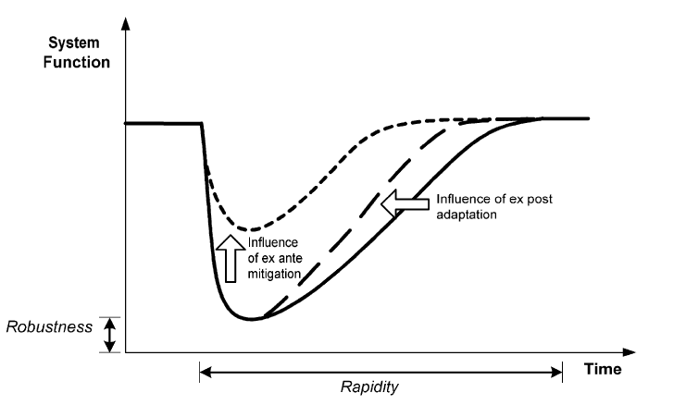

Figure 1: Influence of ex ante and ex post decisions on dimensions of resilience (McDaniels *et al.*, 2008, p. 312).

In summary, the literature suggests transport infrastructure resilience assessment methodologies should take into account multiple factors including the spatial layout of the transport network and availability of suitable alternate routes, the ability of key links to withstand natural hazard events, the likely time required to restore functionality to the network, the likely impact on traffic flows and the social, economic and environmental consequences of disruptions. Resilience assessment tools can be used to both assess baseline resilience and identify ways of improving resilience (Pettit *et al.*, 2013).

3. METHODOLOGY

This research drew on secondary data sources and four in-depth key informant interviews. The interviewees include a Board member of Destination Manawatu (a Regional Tourism Organisation), a senior staff member of Tararua District Council and the NZTA’s Central Region office, and the Dannevirke Area Committee Chairman of the St John Ambulance. The aim was to elicit information about the social, economic and environmental aspects of transport sector resilience in the Manawatu. The participants have considerable knowledge relating to the planning of the road network and/or its economic and social significance. They also had knowledge of the impacts and/or management of the Manawatu Gorge closure in 2011-2012. State Highway 3 between Ashhurt and Woodville passes through the Manawatu Gorge and carried approximately 6870 vehicles per day in 2010 (New Zealand Transport Agency, 2013a). The gorge closure featured prominently in the interviews as it gave this project significant impetus and provided a case study of a significant transport disruption and subsequent recovery. Economic data was also provided by Palmerston North City Council.

The second phase of this research will involve interviews with a representative of a freight company, Kiwirail and staff from all councils in the region. These interviews will be supplemented with the road crash statistics and traffic flow data during the Manawatu Gorge closure.

4. RESULTS

Data is organised into five categories: economic, social, environmental, institutional and vulnerability impacts of the Manawatu’s road and rail network.

1. Economic impacts

Transport disruptions such as the State Highway 3 Manawatu Gorge closure can have significant economic impacts. However, the data paints a nuanced picture. Data provided by Palmerston North City Council’s Economic Policy Advisor (Figure 2) indicates that domestic visitor spending in Palmerston North City and Manawatu District remained relatively buoyant throughout the Manawatu Gorge closure. However, there appears to have been a slowing in spending in Tararua District, on the eastern side of the gorge. A more robust analysis of the data would be required before any firm conclusions could be made. The Tararua District Council Manager Strategy and District Development said Woodville retailers were particularly affected by a reduction in traffic moving through the town, though this was compounded at times by other factors.

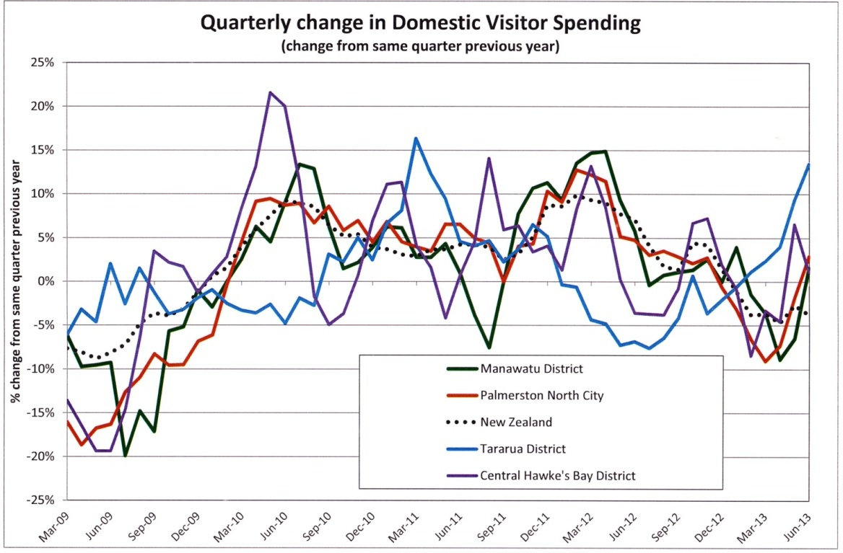

Figure 2: Quarterly change in domestic visitor spending March 2009 to June 2013 in selected areas of New Zealand. Source: Palmerston North City Council Economic Policy Advisor, August 5, 2013.

NZTA (2011b) traffic flow data shows that the State Highway 3 Manawatu Gorge road is an important and well-utilised link between the Manawatu and eastern areas (Figure 3). The data also shows that the State Highway 3 Manawatu Gorge route is, in terms of traffic flow and utilisation by heavy vehicles, of comparable significance to the other state highways to the south and north of Palmerston North. It is classed as a regional strategic route (New Zealand Transport Agency, n.d.), a classification which indicates it has social and economic significance to the region and links regionally significant locations and provides connections to adjacent regions (New Zealand Transport Agency, 2011a).

Figure 3: Average daily traffic flow (both directions) at selected monitoring sites in the Manawatu, 2006-2010. Source: NZTA (2011)

During the interviews, the Destination Manawatu Board Member expressed concern that the gorge closure may have dissuaded freight businesses who were considering moving operations to the Manawatu:

I think it created a question mark for industries that are potentially looking at the Manawatu as a central place for doing distribution, in that suddenly, the east-west connection appeared vulnerable. It’s always been vulnerable, but I think the scale of this highlighted the potential risks and that the solutions appeared to be having a backup that’s climbing over the hills and that’s almost accepted as an acceptable alternative. So I think it’s quite damaging. One of the things that I believe is that the strategic strength of the Manawatu and its economy is its central location and if central location is to be exploited the economy here is dependent upon good transport linkages. It becomes more important than for any other part of the country in my view*.*

1. Social impacts

The main focus of data collection on social impacts has been the impact on access to health services. The interview with the St John Dannevirke Area Committee Chairman primarily explored the impacts of the 2011-2012 gorge closure on the Dannevirke St John health shuttle service. The chairman said most of the service’s clients, including many requiring chemotherapy and dialysis, are transported to medical appointments in Palmerston North. The gorge closure had several impacts on the service, including increased overall costs due to wear and tear on vehicles and increased fuel use:

I would say it [the cost] would be about 10 percent more… it costs us now about $35,000 a year… to run it and with the depreciation on that it would go up to about $60,000 I would say. So you put another 10 to 15 percent on top of that for going over the gorge.

It also affected clients:

…it was harder on our clients… the going over the Saddle [Road], so lots of times we went round through the Pahiatua Track, but that’s not really much better y’know. And also … it took a lot longer getting over there. And so therefore we had to start off a lot earlier in the morning and so people were sitting in the buses longer and therefore they were a bit more grumpier, y’know. And winding up over there if you got behind a truck or something like that… and you just imagine after a procedure in the hospital and all you want to do is get home and then you have to sit in a blinkin’ van and wind up all over those hills.

The closure also placed additional demands on volunteers, which led to rosters having to be changed. Despite the additional cost and time needed to operate the service as a result of the closure, the service did not request or receive any additional funding or support from central government or local authorities and additional costs were met via donations.

1. Environmental impacts

Transport disruptions often have environmental impacts. In the case of the Manawatu Gorge closure, the alternate routes are considerably longer, suggesting that overall vehicle emissions and fuel consumption would increase if overall traffic flows on this transport corridor remained stable. Past experience when State Highway 3 through the Manawatu Gorge was closed to cars for 75 days following the 2004 floods suggests that overall traffic flows in this corridor do not drop significantly when disruptions occur (Horizons Regional Council, 2004; New Zealand Transport Agency, 2009). It is therefore likely that 2011-2012 closure would also have not resulted in a significant reduction in vehicles using the corridor and that there was likely to have been an increase in vehicle emissions and fuel consumption, though it could not be precisely quantified.

Increased soil erosion presented another potentially significant adverse environmental effect of the Manawatu Gorge landslip and subsequent rehabilitation works. However, the NZTA claims that appropriate measures were in place to minimise the impact. For example, NZTA has published a detailed draft guide for contractors on soil erosion control to assist them in meeting their environmental obligations. The NZTA Senior Network Manager argued that the works could have positive impacts in the long-term:

It perhaps may give us an opportunity rather than a detrimental effect because we’ve got that big scar up there. We did design it to take on vegetation, so it’s not going to look like that forever. The thing is, it will just take time.

1. Vulnerability impacts

The key informant interviews also explored the vulnerable sections of the regional transport network, including the Manawatu Gorge and other areas. The NZTA Senior Network Manager said the agency was involved in the region’s civil defence group, which enabled collaboration with local authorities and utility providers to identify vulnerabilities. The Whirokino Trestle and State Highway 56 near Opiki had been identified as vulnerable areas. The latter is flooded on a relatively frequent basis, but there are alternative routes available, while work is underway to assess the feasibility of replacing the former (MWH, 2013). Despite on-going efforts, the Manawatu Gorge is likely to continue to pose challenges, he indicated:

I think there will probably a lot more sort of the rock catchment netting type works. We may not be able to prevent the big 100 day closure but we might be able to prevent the 1 or 2 day type closures.

A comprehensive upgrade of the Manawatu Gorge route to reduce the probability of closure would also carry a significant cost. Research commissioned by the NZTA considered a range of options, such as realignment of the road, or constructing a tunnel or bridges, however these options were costly, ranging from $120 million to $1.8 billion, and were not deemed to be cost effective (MWH, 2012).

NZTA’s methodology for assessing land transport projects incorporates consideration of resilience to some extent with resilience considered as part of the ‘strategic fit’ assessment, which is designed to test how projects align with the strategic direction of transport investment (New Zealand Transport Agency, 2013b). However, resilience is only one of a number of factors, and many are based on economic considerations (New Zealand Transport Agency, 2013b). This indicates that detailed economic analysis of the benefits and costs of proposed resilience enhancing projects should be pursued in order to establish their merits in a manner which fits within the current framework.

The Tararua District Manager Strategy and District Development said that the 2004 floods had tested the district’s transport network, including the closure of 70 roads, which had identified flood-prone sections of road. Subsequently, the council has been incorporating flood mitigation measures into road upgrades and renewals, which has improved performance during smaller-scale events:

We’re in quite a good state to be honest and that was demonstrated by more recent flash flood events where we’ve coped really quite well. There are rivers that will always go above the road in particular circumstances so that’s an acknowledged state. And so there are places where we have to be quite careful about public safety with signage and … road closure. So it will happen, so it’s just the recovery and the damage to the road network afterwards.

1. Institutional impacts

Events such as the 2011-2012 Manawatu Gorge closure also draw attention to the institutions responsible for managing the transport network, how well they work together and what they learn from such events. In the case of the gorge closure, State Highway 3, managed by the NZTA, was blocked and the main alternative route was the Saddle Road, a local road (Figure 4).

The Tararua District Council is responsible for managing the eastern portion of the Saddle Road. According to the Tararua District Council participant, the council’s relationship with the NZTA was strengthened by the event:

We found the way it worked in terms of us providing control back to NZTA for that temporary time as effective for their management of the complete crisis. And the changeover back, it was dealt with very fairly. So… it was unusual but it … showed that we were partners and we recognise that NZTA had [a] major interest to make sure that the state highway continued to function, or the network continued to function

This productive relationship has continued after the event, he said:

Recently [the NZTA] agreed to give our engineering services in Woodville the job to professionally oversee the Saddle [road upgrade] project. So that’s them returning the favour essentially to allow us the opportunity to make a difference now that it’s gone from a crisis to a more stable state.

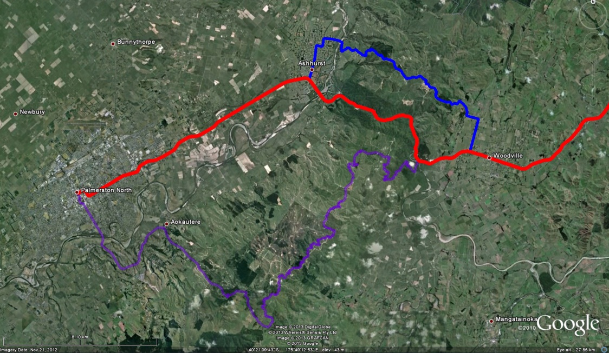

Manawatu Gorge

Figure 4: Map showing the State Highway 3 route east from Palmerston North through the Manawatu Gorge in red, the Saddle Road route in blue, and the Pahiatua Track route in purple. Image: Google Earth (n.d.).

The NZTA Senior Network Manager comments indicated that the agency’s relationship with Tararua District Council may have influenced its planning for other vulnerable parts of the road network:

I think the lessons learned is probably working with our local authority people and tell them where our risk is … like if [a state highway] closed down we’ll need to use your local road for a longer period of time. Because at the moment if it’s like a day closure they’re happy… but if it’s longer than 2, 3 [or] 4 days you can actually see the damage on their road. That’s when they’ll start saying well hang on a moment, we’ll need a bit of help here. So it’s just identifying these bits of road, working with the council and get a memorandum of understanding so that if this happens then we’ll take over and so forth.

He said that other institutions had responded promptly while the slip was cleared and the road remediated which meant the long duration of the closure was attributed to the magnitude of the landslip.

I thought we fast-tracked everything. Everyone came to the party. Even getting the resource consent was a quicker process. There really isn’t any issues (sic).

… if you’re in a normal project to build a new bridge would take anywhere from 3 to 10 years because of all the processes that we have to go through. But this one we built a 60 metre long bride and a 100 metre long retaining wall in less than 4 months.

However, the Destination Manawatu Board Member believed the Gorge closure had shown that local authorities across the central North Island needed to advocate more strongly to central government:

Well one of the learnings for me, was that it reinforced for me that the region, and I’m talking about not just the Manawatu, but also the Hawke’s Bay [and] New Plymouth, are not well organized in terms of articulating the strength of the issue and the solutions that should be addressed.

In summary, the data shows that disruptions to Manawatu’s transport infrastructure, such as the Manawatu Gorge closure in 2011-2012 and 2004 floods, have had a range of impacts. The region’s transport infrastructure plays an important role in its economic development, especially considering the increasing significance of the freight and logistics sector. Transport infrastructure is also important in meeting social needs, particularly for those in the adjoining Tararua District. Transport disruptions such as the Manawatu Gorge closure can also have environmental consequences, such as increased emissions and fuel consumption. Particular sections of the Manawatu transport network have been identified as vulnerable.

5. DISCUSSION

The data presented in the previous chapter has shown some of the impacts that disruptions to Manawatu’s transport network can have. Attention will now be turned to measuring the resilience of the region’s transport infrastructure. This will be done by considering each one of Bruneau et al.’s (2003) properties of resilience, discussed earlier.

1. Robustness

This measure of resilience considers the physical strength of infrastructure, or its ability to withstand adverse events. This research has identified that some key sections of Manawatu’s road and rail transport network lack physical strength and integrity. As discussed in the previous section, the Manawatu Gorge is likely to remain vulnerable to landslides in the future due to its underlying geology and not being cost effective to make them more resilient. This may be an on-going concern for freight companies. The Whirokino Trestle is another key part of the region’s transport network which is currently vulnerable, although a replacement is being considered (MWH, 2013). Whilst there are vulnerabilities in some of the Manawatu’s road and rail infrastructure, it must be acknowledged that some work has been carried out to make many of these areas more resilient. The 2004 floods posed a stern challenge to the region’s transport infrastructure and, subsequently, work has been carried out to strengthen weak areas of the network. Some infrastructure failed, such as the Saddle Road bridge over the Pohangina River, near Ashhurst, and was subsequently replaced (Galloway, 2006), improving robustness as a by-product. The Saddle Road was also upgraded during the Manawatu Gorge closure, with a further $4.5 million upgrade planned (NZTA, 2013b), improving this alternate route to the Manawatu Gorge.

1. Redundancy

Redundancy, in the context of transport infrastructure, refers to the availability of multiple/alternative routes and modes. Redundancy is an issue in some areas of the Manawatu road and rail network. The road network connecting Manawatu with southern and northern areas has a reasonable degree of redundancy, as there are several state highways available, along with local roads connecting them or supplementing them. This means there are often alternate routes available in a reasonably close proximity, should a disruption occur. There is less redundancy in the corridor connecting Manawatu with eastern areas. The only major route is the State Highway 3 Manawatu Gorge road, with the two alternate routes, the Saddle Road and Pahiatua Track, not well-suited to carrying high traffic flows or heavy vehicles because they are local roads. This lack of redundancy may be a result of the more difficult terrain in the eastern Manawatu, compared to other parts of the region. The rail network as a whole lacks redundancy, as trains travelling between Hawke’s Bay and the Manawatu have to be diverted to Wellington when the Manawatu Gorge is closed (Duff, 2010).

1. Resourcefulness

Resourcefulness refers to institutions’ ability to identify and prioritise problems and put resources into addressing them. Local authorities and the NZTA have clearly had to face significant challenges in the region, such as the 2004 floods and Manawatu Gorge closure, but they have demonstrated a relatively high degree of resourcefulness. The Tararua District Council has learned from the 2004 floods and is improving its local road network. The Tararua District Council and NZTA also demonstrated they could work together in managing the Saddle Road during the Manawatu Gorge closure, with the agency stepping in to manage the local road as a result of the pressure on the council’s resources. This appears to have established a better relationship between the two parties and provided the NZTA with insights into effectively managing local roads during a state highway disruption. However, further case studies of the management of other events as well as proactive planning would be useful to determine whether these processes are generally collaborative and well integrated. The Dannevirke Health Shuttle Service also demonstrated resourcefulness by maintaining their level of service to clients despite the obstacles caused by the Manawatu Gorge closure.

1. Rapidity

Rapidity refers to the speed at which full functionality is restored to a network which has been damaged. The Manawatu Gorge 2011-2012 closure was certainly a lengthy disruption which became a significant concern for road users. However, this appears to be a reflection of the practical difficulties and magnitude of this particular task. A more detailed assessment informed by engineering experts would be needed to make an informed conclusion on whether all such disruptions are due to challenging terrain, resources or other factors.

This paper considers the resilience of Manawatu’s road and rail network in the context of Bruneau et al.’s (2003) four key properties of resilience and has shown areas of strength and weakness. Some key transport infrastructure is lacking in terms of robustness, though work has been done and is set to be done in the future to address these deficiencies. Despite this, the Manawatu Gorge is likely to remain vulnerable unless significant works are carried out. This is compounded by a lack of redundancy in the eastern Manawatu road network. The rail network is also lacking in terms of redundancy in general. The institutions responsible for the road network appear to demonstrate a reasonable level of resourcefulness in terms of responding to disruptions and learning from them. Rapidity is harder to evaluate, as factors such as terrain and event magnitude draw out the recovery time from adverse events.

6. CONCLUSION

Manawatu’s transport network has been affected by several disruptions recently, with economic, social and environmental consequences. This has highlighted the need for tools for measuring the resilience of transport infrastructure to assist decision-makers in determining priorities for investment. There is not an established method of measuring resilience, however a qualitative assessment has been possible using Bruneau et al.’s (2003) properties of resilience. This research has identified that some of the region’s transport infrastructure lacks robustness, while there is a lack of redundancy in the eastern portion of the road network and the rail network as a whole. However, the authorities responsible for road infrastructure in the region appear to be resourceful. Rapidity was a concern during the 2011-2012 Manawatu Gorge closure; however, this may be due to the difficult nature of the terrain.

Resilience measurement techniques have much to offer planners, engineers and others involved in the provision of transport infrastructure. This research has examined transport infrastructure and networks to identify vulnerabilities and prioritise future improvements. This is particularly important given the social and economic importance of transport networks and the threats posed by natural hazards and other sources of disruption to transport network functioning. Anticipated future challenges, such as the expected effects of climate change and rising oil prices, also underline the importance of robust resilience assessment measurement of transport infrastructure.

**Acknowledgement**

The authors would like to acknowledge constructive comments of anonymous referees, which have been very helpful in revising this paper. We would like to thank the Massey University Research Fund (MURF) 2013 that enabled us to hire a research assistant for this project.

**REFERENCES**

BRUNEAU, M., CHANG, S. E., EGUCHI, R. T., LEE, G. C., O'ROURKE, T. D., REINHORN, A. M., SHINOZUKA, M., TIERNEY, K., WALLACE, W. A. & VON WINTERFELDT, D. 2003. A framework to quantitatively assess and enhance the seismic resilience of communities. *Earthquake Spectra,* 19**,** 733-752.

CHANG, S. E. & CHAMBERLIN, C. 2004. *Assessing the role of lifeline systems in community disaster resilience*. Buffalo, New York: Multidisciplinary Centre for Earthquake Engineering Research (MCEER).

CHANG, S. E. & SHINOZUKA, M. 2004. Measuring Improvements in the Disaster Resilience of Communities. *Earthquake Spectra,* 20**,** 739-755. [Accessed 2013/04/14].

DAVOUDI, S. 2012. Resilience: A bridging concept or a dead end? *Planning Theory & Practice,* 13**,** 299-307.

DUFF, M. 2010. Drivers keen to snap slip. *Manawatu Standard*, September 27. Available: <http://www.stuff.co.nz/manawatu-standard/news/4171002/Drivers-keen-to-snap-slip>.

ELLINGHAM, J. 2013. Railway line nears end of slip repairs. *Manawatu Standard*, August 19. Available: <http://www.stuff.co.nz/manawatu-standard/news/9059333/Railway-line-nears-end-of-slip-repairs>.

FORBES, M. 2011. Manawatu Gorge closure costs about $62,000 a day. *The Dominion Post*, September 22. Available: <http://www.stuff.co.nz/dominion-post/news/5664229/Manawatu-Gorge-closure-costs-about-62-000-a-day>.

FRECKLETON, D., HEASLIP, K., LOUISELL, W. & COLLURA, J. 2012. Evaluation of transportation network resiliency with consideration for disaster magnitude. *91st annual meeting of the Transportation Research Board.* Washington, DC.

GOOGLE EARTH n.d. Google Earth version 5.2.1.1588 [cartographic software].

GORDON, M. & MATHESON, S. 2008a. *Engineering lifelines and transport - should New Zealand be doing it better? Part one. Phase 1: Situation scan. Phase 2: New Zealand risk exposure. New Zealand Transport Agency Research Report 355A*. Wellington, New Zealand: New Zealand Transport Agency.

GORDON, M. & MATHESON, S. 2008b. *Engineering lifelines and transport − should New Zealand be doing it better? Part two. Phases 3 and 4: Gap analysis and solution development. NZ Transport Agency Research Report 355B*. Wellington, New Zealand: New Zealand Transport Agency.

HORIZONS REGIONAL COUNCIL. 2004. *Storm: Civil emergency storm and flood report*.

HORIZONS REGIONAL COUNCIL. 2010. *Regional land transport strategy 2010 to 2040*. Palmerston North, New Zealand: Author.

JENELIUS, E. 2009. Network structure and travel patterns: explaining the geographical disparities of road network vulnerability. *Journal of Transport Geography,* 17**,** 234-244. Available: DOI <http://dx.doi.org/10.1016/j.jtrangeo.2008.06.002>.

JENELIUS, E. & MATTSSON, L.-G. 2012. Road network vulnerability analysis of area-covering disruptions: A grid-based approach with case study. *Transportation Research Part A: Policy and Practice,* 46**,** 746-760. Available: DOI <http://dx.doi.org/10.1016/j.tra.2012.02.003>.

KUMARAN, C. 2004. The floods of February 2004. *Impact.* March 2004 ed.

MCDANIELS, T., CHANG, S., COLE, D., MIKAWOZ, J. & LONGSTAFF, H. 2008. Fostering resilience to extreme events within infrastructure systems: Characterizing decision contexts for mitigation and adaptation. *Global Environmental Change,* 18**,** 310-318.

MINISTRY OF TRANSPORT. 2011a. *Connecting New Zealand: A summary of the government's policy direction for transport*. Wellington, New Zealand: Author.

MINISTRY OF TRANSPORT. 2011b. *Government policy statement on land transport funding 2012/12-2021/22*. Wellington, New Zealand: Author.

MWH. 2012. *PSW 198 – SH3 Manawatu Gorge aternative route assessment final report*. Wellington, New Zealand: Author.

MWH. 2013. *Otaki to north of levin PFRs. Report No. 9: Whirokino Trestle project feasibility report*.

NEW ZEALAND TRANSPORT AGENCY. 2009. *State Highway traffic data booklet 2004-2008*.

NEW ZEALAND TRANSPORT AGENCY. 2011a. *State highway classification Q&As*. Available: <http://www.nzta.govt.nz/consultation/classification-system/docs/q-and-a.pdf>.

NEW ZEALAND TRANSPORT AGENCY. 2011b. *State highway traffic data booklet 2006 - 2010*. Wellington, New Zealand: Author.

NEW ZEALAND TRANSPORT AGENCY. 2013a. *State highway traffic data booklet 2008 - 2012*. Wellington, New Zealand: Author.

NEW ZEALAND TRANSPORT AGENCY. 2013b. *Strategic fit for new and improved infrastructure for state highways*. Available: <http://www.pikb.co.nz/assessment-framework/strategic-fit-2/strategic-fit-for-new-and-improved-infrastructure-for-state-highways/>.

NEW ZEALAND TRANSPORT AGENCY. n.d. *Table of state highways in each category*. Available: <http://www.nzta.govt.nz/planning/process/doc/criteria-and-thresholds.pdf>.

OFFICE OF THE AUDITOR-GENERAL. 2013. *Transport sector: Results of the 2011/12 audits*. Wellington, New Zealand: Author.

PALMERSTON NORTH CITY COUNCIL. 2010. *Manawatu region sector profiles 2010: Logistics and supply chain*. Palmerston North, New Zealand: Author.

PETTIT, T. J., CROXTON, K. L. & FIKSEL, J. 2013. Ensuring Supply Chain Resilience: Development and Implementation of an Assessment Tool. *Journal of Business Logistics,* 34**,** 46-76. Available: DOI 10.1111/jbl.12009.

REGGIANI, A. 2012. Network resilience for transport security: Some methodological considerations. *Transport Policy*. Available: DOI <http://dx.doi.org/10.1016/j.tranpol.2012.09.007>.

SERULLE, N. U. 2010. *Transportation network resiliency: A fuzzy systems approach.* (Master of science thesis), Utah State University.