City rail link – unlocking auckland’s travel future

Author/Presenter: Daniel Newcombe, MEngSt (Transportation), BPlan, MNZPI
Corridor & Centre Plans leader, Auckland Transport
daniel.newcombe@aucklandtransport.govt.nz

17th November 2013

Abstract
The City Rail Link (CRL) is the key project in an integrated transport programme to keep Auckland moving as the city grows by a projected 700,000-plus people during the next 30 years. The underground rail line linking Britomart and the existing western line near Mt Eden Station via the city centre will unlock the region's rail network and allow a train up to every five minutes from most Auckland stations.
This complex, city-shaping project represents a game-changer for transport in Auckland, requiring innovative and unique solutions. This paper will cover the latest developments of the CRL project, as well as explaining key engineering components and how the project provides the foundation for a step-change in public transport for Auckland in years to come.
INTRODUCTION
The City Rail Link (CRL) project requires the construction of a 3.4km rail tunnel through the heart of Auckland to link Britomart Station to the existing Western Line. The purpose of the CRL is to convert Britomart into a through station and add three new underground stations (Aotea precinct, Karangahape Rd and Newton precinct), which will allow for more frequent rail services as well as more destination options. Figure 1 below outlines the proposed route and stations.

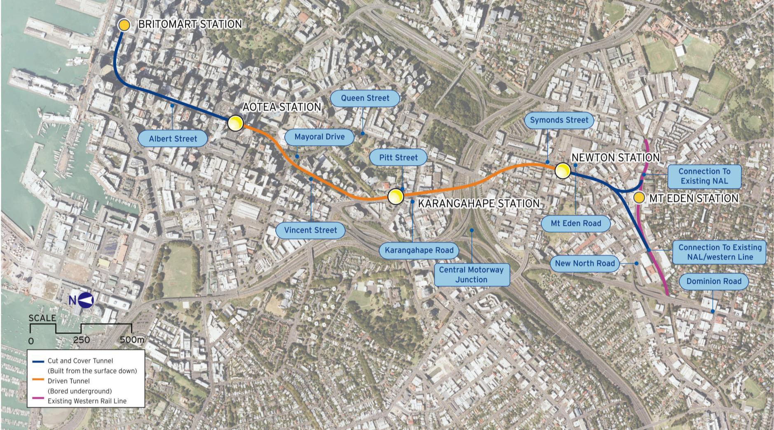
Aotea Station
K Rd Station
Newton Station
Figure 1 - City Rail Link route and station locations within city centre

As a terminus station, Britomart is currently only able to turn around 20 trains per hour, which acts as a bottleneck for the wider rail network, limiting the frequency of services that can be offered. The increased level of service resulting from CRL is predicted to attract more customers to the rail network, with more people choosing rail as a faster, more reliable and convenient mode of transport around the region.

The preferred alignment has been identified and a statutory planning process is underway to secure the route. Auckland Transport (AT) continues to progress work required in preparation for the CRL detailed business case, including evaluating potential procurement options. This paper provides an overview of the CRL project, covering strategy, design and finances.

Strategic overview
As Auckland’s population grows, so does the demand for transport options to move people around the region. Unlocking public transport and decongesting Auckland’s roads are important components in achieving the Council’s vision of Auckland being the world’s most liveable city.

The CRL is identified as one of three priority transport projects within the Council’s Auckland Plan, along with the Auckland-Manukau Eastern Transport Initiative (AMETI) and the Additional Waitemata Harbour Crossing (AWHC). The CRL builds on previous public transport investment, including the opening of Britomart and rail electrification, and extends and improves a rapid transport option which is unaffected by traffic congestion. Improved accessibility is a key to Auckland’s economic growth, which in turn makes a significant contribution to that of New Zealand. The CRL will future-proof for transport demands for an Auckland that is predicted to be home to two thirds of New Zealand’s growth over the next three decades, with a population exceeding two million. The scale of the region’s projected population growth is clearly demonstrated in Table 1 below, which shows that Auckland’s growth to 2041 will be more than the size of any other NZ city.

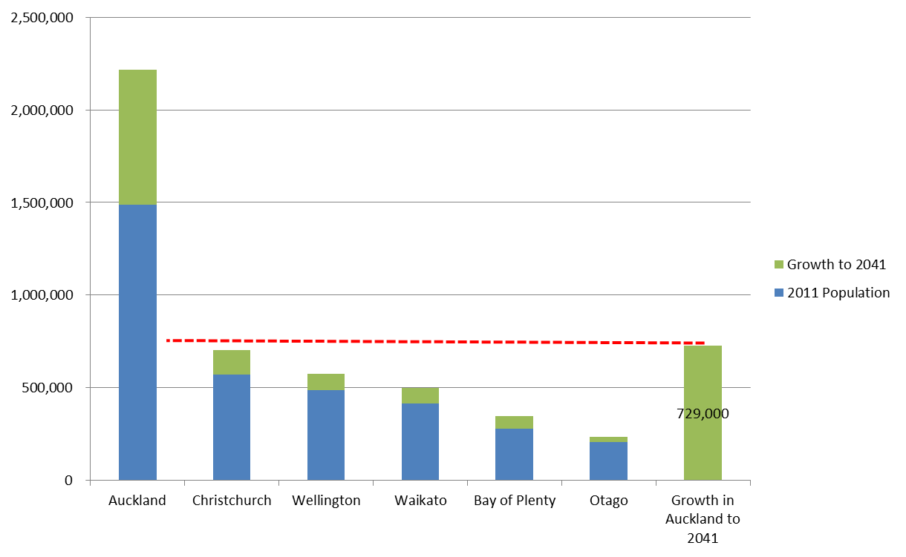
Table 1 - Auckland region's population growth to 2041 (Source – ITP, 2012)

Population growth brings a range of other pressures. For instance, city centre student numbers are projected to grow by 30% to around 72,000 and will generate additional trips on top of those generated by growth in jobs in the city centre. The table below shows the scale of growth expected over the next three decades, in the region and city centre.

 | Population |  |  | Employment
 | 2011 | 2021 | 2041 | 2011 | 2021 | 2041
Auckland | 1,486,000 | 1,722,100 | 2,160,700 | 682,495 | 783,168 | 957,659
City centre | 39,465 | 73,449 | 77,487 | 90,936 (2006) | 117,970 | 146,167
Table 2 - Population and employment growth projections (Source – CCFAS, 2012)

Auckland accounts for 34% of jobs in NZ and most are in metropolitan Auckland. Transport is critical in shaping urban form and leading economic development, and the City Centre Future Access Strategy found that cities with efficient transport systems tend to have higher productivity than more dispersed places. Improved travel times for workers can therefore be expected to give greater employment opportunities. Significant economic gains can particularly be made from transport investment that improves access into areas of high employment density.

The growth in population and employment, particularly in the city centre, will bring a significant growth in travel, and the expected volume and mode share for regional AM peak trips is shown below in Table 3. The city centre stands out not just for the significant growth, but also the large proportion of travel by public transport and active modes (The model used for the mode projections assumes that the CRL is in place).

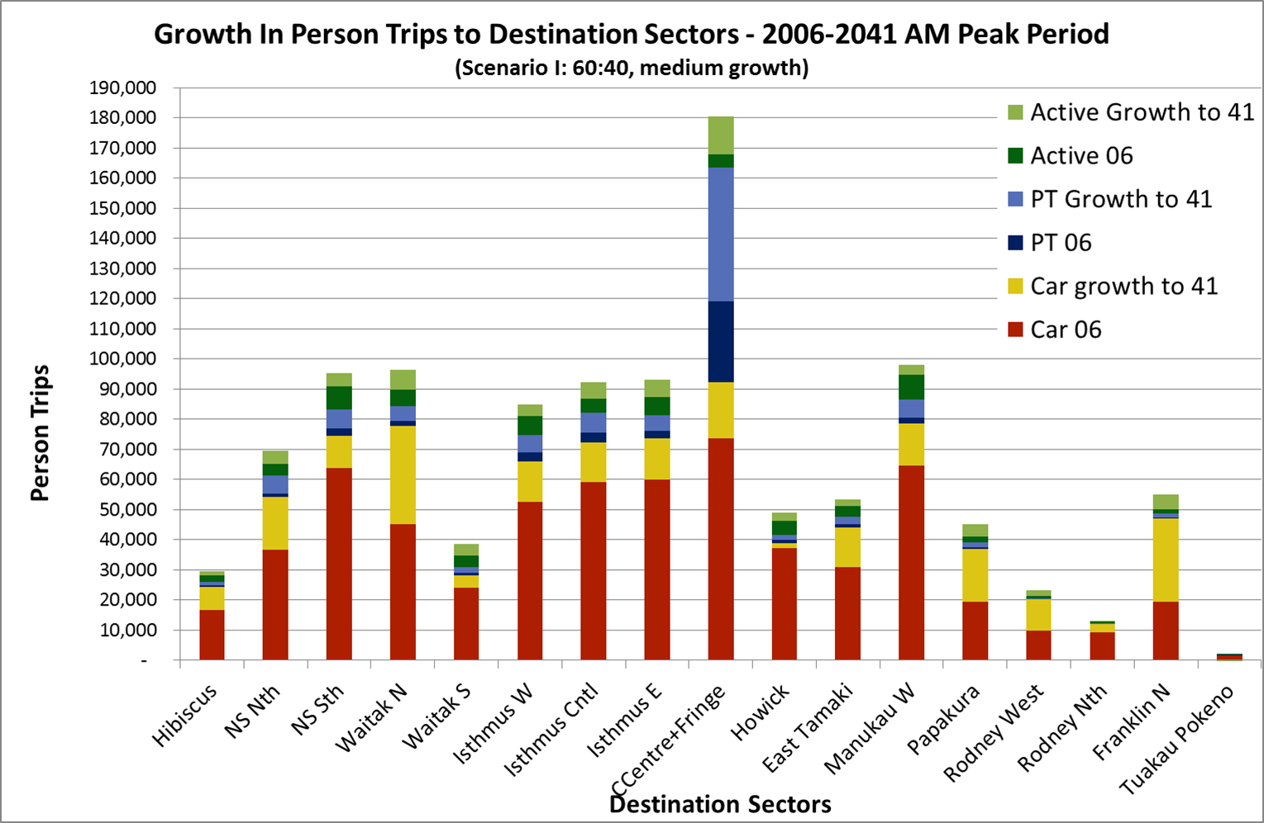
Table 3 - Growth in person trips to destination sectors (2006-2041 AM peak period) (Source – ITP, 2012)

BENEFITS
Although the prime benefit of the CRL will be increased rail frequency, capacity, and quality across the whole passenger rail network (and provide for the expected growth in travel demand described above), the CRL also has other benefits. These include providing for economic growth, improved rail resilience and reliability, reduced travel times for both public transport and road users, and a less congested road network for freight, travellers who cannot use public transport or vehicles passing through Auckland.

The CRL will also allow for a more efficient and effective bus network (feeder buses to rail stations rather than long distance bus trips) and will be a city shaping project, assisting intensification in the city centre (leading to employment and productivity growth, specialisation, etc.) and along rail corridors.

The CRL will help address congestion in the city centre road network and reduce the number of buses that would otherwise be needed to provide for travel to/from the city centre, which, if left unaddressed, will limit the growth of the city centre and Auckland (see City Centre Future Access Strategy section below).

Since the opening of Britomart in 2003, annual rail patronage has grown from 2.5m to around 10m trips (a quadrupling of patronage), showing a strong latent passenger demand is released once infrastructure is provided (the ‘build it and they will come’ factor). Historically, business cases for public transport investment in NZ have underestimated resulting patronage changes. There are strong positive correlations in overseas examples between electrification, service/station improvements and patronage, with Perth being a recent example.

PROJECT OVERVIEW
The CRL requires the construction of a 3.4 kilometre rail tunnel under Auckland’s city centre, to link Britomart to the existing Western rail line. The route passes under Albert, Vincent and Pitt Streets, under the Central Motorway Junction and connects with the Western rail line in the vicinity of Mt Eden Station. The CRL includes three new underground stations to be located at the Aotea precinct, Karangahape Rd and Newton precinct, as shown below, and becomes part of the network of currently 42 rail stations.

The function of the CRL is not a loop with trains running in circles to service solely the city centre, but a network expansion initiative that adds three further stations to the existing heavy rail suburban network. Although the final train operating plans are not yet set, passenger trains could, for instance, be able to be through-routed from the Western to the Southern line (see Figure 2), without the need to reverse out of the constrained Britomart bottleneck. Freight trains will not be permitted to pass through the tunnels due to safety reasons.

Upon completion, virtually the entire city centre (including Auckland University) will be within 10 minutes’ walk of a train station (including the imminent Parnell Station, due to open in 2015).

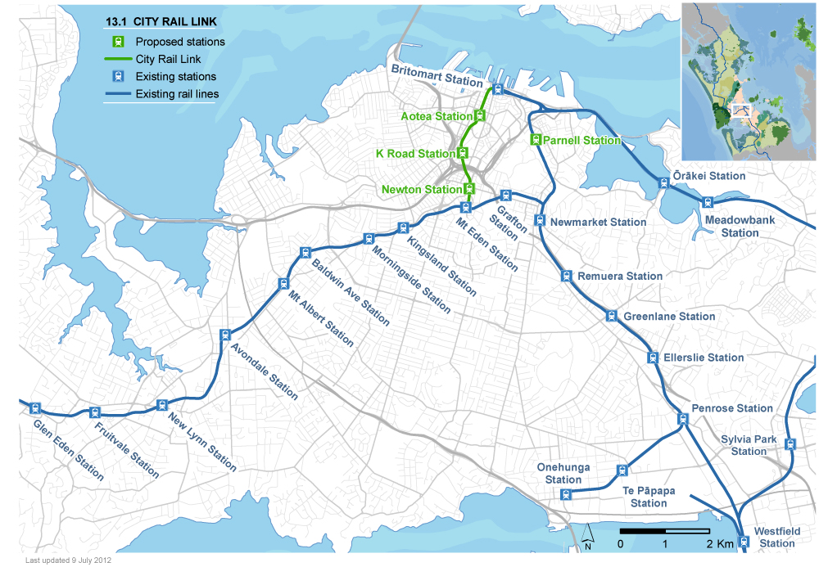
Figure 2 - City Rail Link route within regional rail network

The removal of the Britomart bottleneck will expand the rail network and create the capacity to increase service levels to Auckland’s growing outer suburbs in the west, south and east, as well as the growing CBD. It is expected that the post-CRL network will allow for trains up to every five minutes at peak for most stations. The CRL will also allow for quicker travel and improved access to more of the city centre, with the three new stations. Table 4 below provides an indication of the travel time savings that can be expected from various locations in the network to the CRL stations.

Travel Times to City Rail Link Stations (indicative)
From | To Intended Location | Travel by Train/Bus (minutes) |  |  | % Improvement in Travel Times
From | To Intended Location | Before CRL | After CRL | Reduction in Travel Time | % Improvement in Travel Times
New Lynn | Aotea Station | 51 | 23 | 28 | 55%
Morningside | Aotea Station | 39 | 14 | 25 | 64%
Onehunga | K’ Road Station | 47 | 27 | 20 | 43%
Manukau Centre | K’ Road Station | 61 | 42 | 19 | 31%
Newmarket | Aotea Station | 27 | 10 | 17 | 63%
Panmure | Newton Station | 40 | 27 | 13 | 33%
Table 4 - Travel times to CRL stations (Source - CBD Rail Link Study – Options Evaluation Report)

The CRL will have an important role in the city’s economic development, as it will help facilitate new commercial and residential development, and access to employment and educational opportunities, not just for the city centre, but for all communities on, close to, and with access to, the rail network. For example, Manukau and New Lynn metropolitan centres are expected to become more attractive as places to live and work because of the improved rail access to the city centre and across the network. Auckland Council sees the CRL as a key enabler of increasing employment in the city centre and metropolitan centres adjacent to the rail network.

On the transport network, travellers that spend the longest time on the network have the highest potential to contribute to congestion. Providing longer-distance travellers with an alternative, more reliable, option to private vehicles has the potential to present the greatest improvement to road congestion. Decongested roads available for commercial trips/freight are key if Auckland, and New Zealand as a whole, is to meet its targets of increasing exports and growing the economy.

There is significant development potential around the new CRL stations. The Council’s City Centre Masterplan (CCMP) has figures of 340,000m² of development potential around Aotea Station, 126,000m² around Karangahape Rd Station and 1,070,000m² around Newton Station (these figures were based on previous District Plan entitlements and are likely significantly increased under the new Unitary Plan, which encourages city centre intensification).

As part of the emerging business case for the CRL, there have also been investigations into assessing how the announcement of the CRL has already changed the development economics around stations on the Western Line (which gains the biggest travel time savings to the city centre from CRL), with the announcement of CRL triggering land value increases that make more intensive residential typologies more economical to develop, especially at Morningside and Newton stations. This also applies to a lesser extent further out on the Western Line (where the Unitary Plan also allows a level of intensification that would allow these typologies to occur more easily).

CRL HISTORY
The concept of the CRL has been around since the 1920’s. However, investment in a CRL-type project was only occasionally and briefly considered and by the early 2000s the Auckland commuter rail network was rundown and poorly used. The seeds for the CRL were sown with the construction of Britomart Transport Centre in 2003, which had its foundations future proofed for a subsequent rail extension.

In early 2006, Auckland Regional Transport Authority (ARTA) produced the Rail Development Plan (RDP) as the business case for electrification of Auckland’s rail network. This foresaw electrification as a key enabler of further patronage growth but noted that addressing the constraint of Britomart being a “dead end” station would be a critical enabler of further network development above and beyond what was already planned for at the time.

In 2007, Central Government approved the Auckland Electrification Project. Key deciding factors were: lower lifecycle costs (as Electric Multiple Units - EMUs - are cheaper to maintain with fewer moving parts and last much longer than Diesel Multiple Units - DMUs), reduced noise and vibration in urban areas, faster acceleration and deceleration, and that electrification enabled future construction of an underground rail tunnel in the city centre.

In 2008, the then Minister of Finance, Hon Dr Michael Cullen, wrote to the Chair of the New Zealand Railways Corporation stating that it “was in the long term public interest to secure and protect the CBD tunnel route even though construction may not take place for many years” and advising that it was “appropriate for ONTRACK to assist in the protection of the CBD tunnel route by acting to protect the route at the earliest appropriate opportunity.”

In 2009, ARTA and KiwiRail (previously ONTRACK) commenced an investigation to designate a route for the CRL. This work considered a large number of potential route options, taking into account key considerations such as station locations in relation to passenger catchments; rail geometry, including the need to climb at sustained grades of 3.5%; the requirement to pass under the Central Motorway Junction; and to maximise the use of already designated road corridors. Other considerations included travel times, construction costs and constructability.

Options directly serving Auckland University, Auckland Hospital and any connection with Wynyard Quarter were considered and eliminated due to technical and constructability issues, as well as the negative impact of increased route distance on construction costs and travel times. Any connection at Wynyard Quarter will be considered as part of the Additional Waitemata Harbour Crossing (AWHC) project, or separate initiatives. As noted earlier, Auckland University will be within a ten minute walking catchment of the planned CRL stations, as well as the upcoming Parnell station.

A preferred option, which is the current alignment, was identified in early 2010. It was favoured due to a relatively short and direct route minimising travel times; station locations aimed at maximising patronage; best use of existing road corridors and its sufficiently long length providing the ability to deal with the steep grades needed to connect Britomart to the Western Line. The preferred option was approved by ARTA and Kiwirail, and endorsed by the Auckland Regional Council, Auckland City Council, and the Auckland Regional Transport Committee. AT is now the delivery agent for the CRL, as a Council Controlled Organisation (CCO) of Auckland Council.

CONSTRUCTION
The CRL has a targeted date to become operational in 2021. Figure 3 below shows a simplified long section of the CRL route. Due to the topography of the city centre, the CRL will attain a maximum grade of 3.5% between flat stations (3.5% being the steepest grade trains can typically traverse). Roughly 90% of the CRL will be underground in tunnels, currently expected to be constructed using a mix of cut-and-cover and tunnel boring machine (TBM) techniques. The cut-and-cover section is expected to be the most suitable method along the northern portion of Albert St, where a combination of underground services, difficult soils and the shallow depth of the tunnel means a TBM is unlikely to be viable(The Mt Eden end will also have some cut-and-cover). Although it has been suggested that the current SH20 Waterview TBM be used for this project, the CRL tunnel diameter is significantly smaller, so re-use is not possible, and the TBM is a one-use machine. The NZ Transport Agency (NZTA) has arranged to sell back the TBM to the supplier, following completion of the project.

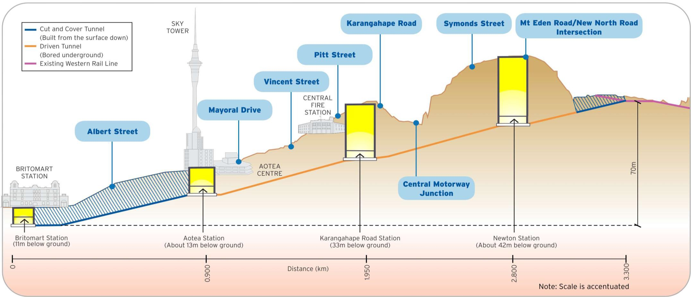
Figure 3 - Simplified long section of the CRL route

At Britomart, platforms 1 and 5 were future-proofed to enable tracks to be extended through the foundations of the former Chief Post Office. Platforms 2, 3 and 4 remain available for terminating services or special services. Where the CRL alignment connects to the existing Western rail line (at Mt Eden station) a large construction area of 3.5ha will be required, in order to accommodate equipment associated with the TBM and to allow for the complex grade separation of the tracks.

Figure 4 below shows a simplified illustration of the proposed Aotea station. Each of the three new stations will be constructed at significant depths (Newton station will be 42m underground, Aotea 13m and K Rd 33m) and a range of design and construction methodologies are being considered.

The stations are also being designed with the intention to integrate the station precincts into the surrounding areas, to contribute to the character and vitality of the city centre, and to maximise the potential catchment for users. The CRL stations are expected to be catalysts for development, shaping the city and improving transport choices for Aucklanders. Station design considerations include access points and the incorporation of station entrances within or adjoining intensive commercial or residential developments.
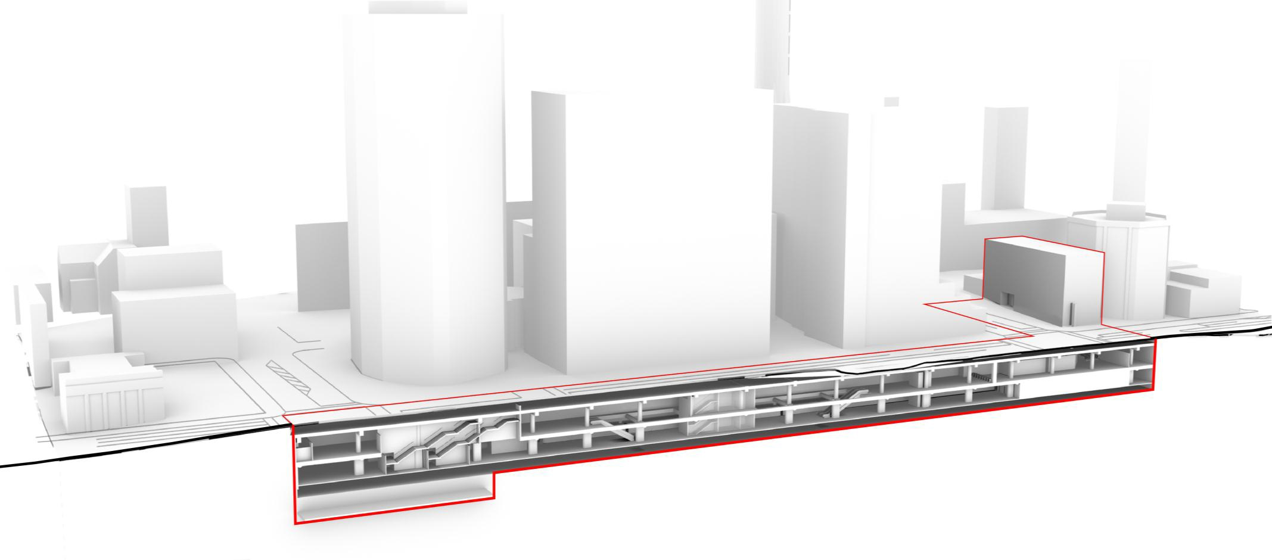
Figure 4 - Simplified illustration of the proposed Aotea station

Due to the large range of underground services within or passing across Albert St, it is expected that roadworks will be required in and around the cut-and-cover and station sections of CRL route for several years. A robust temporary traffic management system will be required in such a complex and congested location as the city centre.
AT intends to have several key public transport projects in place ahead of CRL construction and also defer some proposed projects which affect traffic capacity until after CRL completion.

SUPPORTING ELEMENTS
The operation of the CRL tunnel relies upon the electrification of the rail fleet, which is underway and will be in place by mid-2015. As service frequencies increase, pressures on existing rail infrastructure (e.g. Quay Park and Newmarket junctions) and level crossings will become more of an issue, possibly requiring further network upgrading. The completion of CRL (or rather, the removal of the Britomart bottleneck) allows for future expansion of rail to the North Shore or Auckland Airport, if those projects proceed.

Bus routes (both within and outside of the city centre) will be updated once the CRL is in place, so that the two public transport modes can be fully integrated - with buses acting as feeders to the rail network. Station precinct design will need to facilitate interchanges from one mode to another.

In addition to constructing the CRL, a series of other initiatives and policies will be implemented as additional levers that will influence public transport usage. The parking strategy for the city centre will seek to limit the number of long-stay commuter car parks, encouraging commuters to shift to public transport for their travel. This will be supported by the Unitary Plan, which will expand the areas within which maximum parking provisions will apply. Providing ‘park and ride’ facilities in outer parts of the Auckland region connected to frequent rapid transport services will help provide an alternative to city centre commuter parking.

AT inherited a complex fare and ticketing system, which discourages connections between services, and contains a number of inefficiencies - particularly in relation to the relatively high use of cash fares. The Auckland Integrated Fare System (AIFS) Project, at this stage due for implementation in early 2014, is addressing many of these shortcomings. AIFS will:
- Significantly reduce the number of fare products
- Allow the use of a single ticket across different operators and modes
- Reduce the financial penalty that is currently incurred for transfers
As a second stage, an integrated zonal fare system with no penalties for transfers between services will be implemented. This is planned for 2014/2015.

CITY CENTRE FUTURE ACCESS STRATEGY
In 2011, the Minister of Transport requested a robust multi-modal evaluation of the need for improved access to the city centre and the best multi-modal solution to provide that access, before consideration of a business case for the CRL. In early 2012, Sinclair Knight Mertz was appointed by AT to undertake this work in collaboration with Auckland Council and Central Government. The response, the City Centre Future Access Study (CCFAS), was released in December 2012.

Deficiency analysis undertaken as part of CCFAS found that the city centre will face significant access issues across all entry points from as early as 2021 due to continuing growth in trip numbers as a result of projected population and employment growth. This analysis indicated that without substantial transport investment, by 2021 most of the bus network will be at capacity or over-capacity, average car speeds in the city centre during the morning peak will more half from 16 km/h to just over 7 km/h and the rail network will have reached the maximum number of services possible.

This deficiency analysis also showed without substantial improvements, by 2041 the bus network will be significantly over capacity, car journey times in the city centre will increase significantly with average car speeds dropping to 5 km/h during the morning peak, and further capacity issues will occur on the rail network.

The CCFAS sets out a thorough analysis of alternatives and identifies the optimal mix of public transport modes to meet future demand. The study took a long list of 46 options and developed a package for three short list “headline” public transport options:
- Underground Rail (CRL)
- Surface Bus
- Underground Bus.

Analysis showed that a public transport programme combining the CRL and surface bus options (which became the ‘Integrated’ option) will best meet city centre access needs in a sustainable manner. This option included the CRL and incremental bus network improvements.

As shown in Table 5 below, the Integrated option is the option that provides the most public transport capacity and therefore is expected to address access into the city centre for the next 30 years, from the south, east and west as well as the central and southern isthmus.

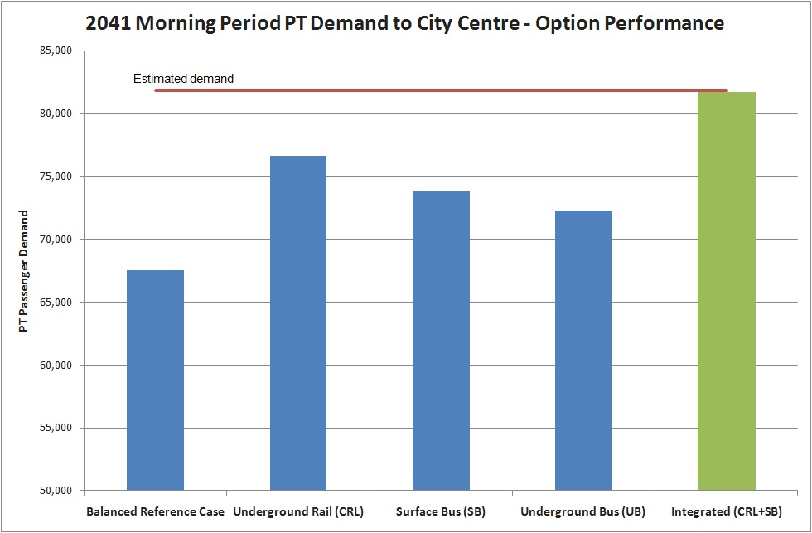
Table 5 - 2041 AM Peak Public Transport demand to city centre - option performance

CITY RAIL LINK FINANCES
The CRL has an estimated capital cost of $2.86 billion when fully inflated from 2012 to the year of spend. As all costs have been allocated and inflated to year of spend, the total estimated cost of the CRL is not expected to change year on year. Table 6 below shows a breakdown of the estimated capital costs set out in the Council’s Long Term Plan (LTP).

Costs | LTP ($m in 2012 dollars inflated to year of spend)
Expected Construction Cost | 2,324
Additional Trains | 336
Other network optimisation | 140
Sub Total (excluding land) | 2,800
Gross land purchase | 245
Estimate land sales | 183
Net Land (initial estimate) | 62
Total | 2,862
Table 6 - Estimated capital costs of the CRL
Only costs directly attributable to the CRL are considered in the estimate. Detail as to what comprises ‘other network optimisation’ costs will continue to be evaluated by the CRL project team. The LTP indicates that the CRL will be funded 20% from rates and development contributions, 30% from ‘alternative funding’ and 50% from Central Government. However, funding continues to be an unresolved issue and Auckland Council sought recommendations from an independent ‘Consensus Building Group’ (CBG) on a preferred mixture of funding tools that would deliver the funding to implement the transport projects required in support of the Auckland Plan. The CBG recommended consideration of increased rates, fuel taxes, tolls for new roads, fare increases and road pricing. However it is not yet clear which mix of funding tools will be used to help fund the CRL.
It is worth noting that since 2006, Auckland and Central Government have invested $1.6 billion in Auckland’s rail infrastructure - Auckland Electrification Project ($500m); DART ($600m) and EMU procurement ($500m). There has also been extensive Auckland investment in rail stations (with NZTA funding assistance).

In June 2013, the Prime Minister announced that the Government broadly agrees with the conclusion from CCFAS that the forecast growth in demand for access to the city centre would best be met with a combination of CRL and substantial access upgrades for buses. The Government committed to a joint business plan for CRL with Auckland Council in 2017 and providing its share of funding for a construction start in 2020. The Government was also prepared to consider an earlier start date if Auckland city centre’s CBD and rail patronage growth hit particular target thresholds.

NEXT STEPS FOR THE CITY RAIL LINK
The Notice of Requirement (NoR) to protect the land required to build and operate the CRL was lodged with Auckland Council by AT (as the requiring authority) in August 2012 and notified in January 2013. At the time of writing the hearing in front of independent commissioners was underway. It is expected that the commissioners will make a recommendation to AT before the end of 2013, and the next steps will be for any appeals to be lodged with the Environment Court and resource consents to be subsequently applied for, based on a reference design currently being prepared. A property acquisition programme for surface properties required for the CRL is on-going.

CONCLUSION
The CRL is the key project in an integrated transport programme to keep Auckland moving as the city grows during the next 30 years. The project will unlock the region's rail network and allow a train up to every five minutes from most Auckland stations. This complex project represents a game-changer for transport in Auckland, requiring innovative and unique solutions. Over the next few months and years, AT will be taking the next critical steps in planning, constructing and operating this important city-shaping project.

REFERENCES
Auckland Council (2012). Auckland Plan, Auckland, NZ
Auckland Council (2012). City Centre Masterplan, Auckland, NZ
Auckland Regional Transport Authority (2009) Auckland CBD Rail Link Study – Options Evaluation Report, Auckland, NZ
Auckland Transport (2012). City Centre Future Access Study, Auckland, NZ
Auckland Transport (2012). Integrated Transport Programme, Auckland, NZ
Auckland Transport (2013). Regional Public Transport Plan, Auckland, NZ
Consensus Building Group (2013), Funding Auckland’s Transport Future – Final Report – Alternative Funding for Transport, Auckland, NZ

