HOW UNSAFE DOES THE ROAD LOOK – MEASURING PERCEIVED RISK
Dr Shane Turner, National Specialist – Road Safety
PhD, Civil Engineering, University of Canterbury
BE (Hons), Civil Engineering, University of Auckland
MWH New Zealand Ltd, 6 Hazeldean Road, Hazeldean Business Park, Christchurch
E-Mail: shane.a.turner@mwhglobal.com
Jerry Khoo, Senior Transport Engineer
BE (Hons), Civil Engineering, University of Auckland
Beca Ltd, 21 Pitt Street, Auckland 1141
E-Mail: jerry.khoo@beca.com
Hayden Trumper, Transport Engineer
BE (Hons), MET (Transportation)
Beca Ltd, 410 Colombo Street, Sydenham, Christchurch
E-Mail: hayden.trumper@beca.com

ABSTRACT
Road safety professionals have a relatively good understanding of the 'objective' crash reduction benefits of the majority of 'generic' safety improvement measures, but generally a lower level understanding of perceived risk. Perceived risk is important as drivers behavour is linked to how safe they think a specific section of road is. Road safety can be compromised when the perceived risk is a lot lower than the objective crash risk. We want drivers to have clear messages of where the road is safe and where it is less safe, so they drive more carefully in less safe situations. This research compares the perceived risk specified by drivers for various road links (from surveys) with the objective risk as specified by KiwiRAP. Drivers were asked to rate perceived risk using three different surveys methods. In the first method, an on-line web-survey, over 500 drivers were asked to rate the risk of various sites from photos. A smaller sample of drivers were then asked to rate road links from video files and photos of several road links in Waikato and Canterbury. In the final survey participants did a driver-over along a route in Canterbury and were asked to rate the risk of various sections along the route. Participants were also asked to rank the benefit of a possible series of counter-measures along a surveyed route. The surveys showed that drivers rated curves as having a high perceived risk, while road-side hazards typically had a lower level of perceived risk.

ACKNOWLEDGEMENTS

The research team would like to thank the Automobile Association for funding this research and in particular Simon Douglas, the project manager. We also acknowledge the contribution made by Bridget Burdett and the TARs research group, led by Sam Charlton, in developing the study methodology.

INTRODUCTION
Driver perception of crash risk has been found to have an impact on whether crashes occur at a site or along a stretch of road. While two sites may have the same level of objective risk, the site that looks less safe to drivers (higher perceived or subjective risk) often has a lower number of crashes than the one that looks safe (lower perceived or subjective risk).
A key role of traffic safety professionals is to ensure that the driving public are made aware of the risk they face on various sections of the road network so that they can behave in a manner required to safely negotiate the risk. This is generally achieved by applying safety countermeasures with visual cues such as delineation (e.g. raised reflective markers, edge-lines, chevrons and edge marker posts), signage and hazard markers.
While there is considerable research on the impact of safety countermeasures on objective risks (or the actual number of crashes), there is limited research, especially in New Zealand, on perceived or subjective crash risk. The purpose of this research is to better understand where the objective (directly measurable) road safety risk matches drivers’ subjective (indirectly measurable) risk, and its effects on driver behaviour. A better understanding of the drivers’ subjective risk will allow safety professionals to communicate more effectively the risk associated with specific roads to the drivers that use them.
The project aims to clarify in a New Zealand context:
- where objective (directly measurable) risk matches drivers’ subjective (indirectly measurable) risk: i.e. the road is self-explaining in terms of risk;
- where objective risk is greater than drivers’ subjective risk: the environment is not as safe as perceived by drivers;
- what perceptual cues are used by drivers to measure their subjective level of risk.
By identifying the factors contributing to correlation between objective and subjective risk, the research points towards areas of further investigation and trials in terms of ways to use cues in the road environment, to align objective risk afforded by the road, with drivers’ subjective risk perceptions.
In relation to the aims of this research, the four primary questions investigated in this research are:
- What level of risk is experienced by drivers on hazardous New Zealand roads?
- What road features do drivers use to judge driving risk?
- Which hazardous road situations are under-recognised by New Zealand drivers?
- What countermeasures can be used to convey a more accurate perception of risk?
This research was undertaken in collaboration with TARS at Waikato University, who have also undertaken a research study on this topic for the AA.

MEASURING OBJECTIVE (ACTUAL) RISKS
The objective risks of various sections of the New Zealand state highway network have been assessed using KiwiRAP (New Zealand Road Assessment Programme). This risk measurement is based on both the historical crash data reported, as well as on the level of safety features ‘built-in’ to the road (and roadside).

SURVEY METHOD 1: WEB SURVEY
A web survey was selected to obtain a cross-section of the subjective risks perceived by New Zealand drivers. The web survey that was undertaken had an alternative forced-choice design, in which participants were ‘forced’ to rank two/three images by their levels of perceived risks.
As the focus of the study was on understanding the relative perceived risks of various road features by drivers, the photographs selected (see Figure 1 for an example) for use in the survey comprised of differing road features such as:
- Median barrier
- Road markings
- Intersections
- Presence of signs
- Curves (and grade of road)
- Objects at the road-side
- Road-side ditch
- Wide median

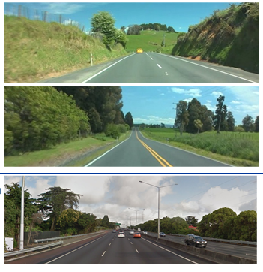
Figure 1 – Web Survey – Ranking of Perceived Risk Photos
The questions developed for the web survey included questions related to demographics (age and gender) and driving experience (type of driving licence, driving distance) in addition to perception of relative safety risk (the images). This online survey was launched and distributed to the New Zealand Automobile Association members on the 4th April 2013, and ran until the 30th April 2013. A total of 559 respondents were collected during this period, which was higher than the 100 participants initially targeted.
Based on the web survey results and analysis, the conclusions that can be drawn are:
- Curves ranked as higher risk (even with barriers) than straight with other roadside hazards (such as power poles).
- Undivided carriageway (with no power poles) ranked as higher risk than a divided carriageway with wide median and wire rope barrier.
- No significant difference in perceived risk between a curve with or without roadside barrier.
- Presence of side road (even with wide centreline) consistently ranked as higher risk compared to presence of road-side furniture (i.e. power poles, barriers, warning signs)
- Presence of barriers on straight ranked as lower risk.
- Perceived risks do not match with objective risks (see Figure 2), with no correlation evident. This is likely to be a result of the objective risk taking into account features, such as road-side objects that seem to have little influence on driver’s perceived risk. Further work is planned to break down the kiwiRAP Road Protection Score (RPS) into its various components to see whether a better fit is possible.
- Generally very little difference in the responses between different age groups and gender, although there is some evidence that the Under 35 participants have under-recognised the risks of the non-obvious roadside hazards on a straight road, such as roadside ditch and narrow/limited shoulder width.

The above findings are based on a forced-choice decision for the survey participants, and the results would probably suggest participants’ perceived risk in a conscious state.

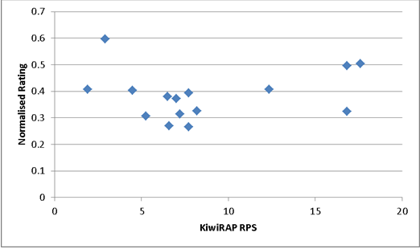
Figure 2 – Relationship between Perceived Risk and Objective Risk (RPS)
(note the subjective rating data has been normalised as scoring was for two images in some cases and three images in others)

SURVEY METHOD 2: VIDEO SURVEY
In-person interviews, using videos of several sections of state highways were carried out to assess subjective risk perception. A total of six participants viewed the video sections and answered a series of questions. The participants were also asked to assess the level of risks on counter-measures, which were digitally inserted into photographs.
The road section videos were selected to provide a range of objective and subjective risk elements and ranged between 2km and 5km such that the sections are relatively homogeneous throughout each of the segment selected. The segments of these videos were:
- SH1 between south of Taupiri to north of Ngaruawahia – RP 519 / 8.0-13
- SH1 between Tahuna Rd Interchange to end of divided carriageway - RP 502 / 8 – 9.8
- SH1 from end of divided carriageway to north of Huntly - RP 502 / 9.8 – 13.2
- SH75 (Christchurch to Akaroa route), selected 15km split over 4 sections
shows the perceived risk (average of six participants) and objective risk (from KiwiRAP) of the seven road sections (including 4 sections on SH75). A lower KiwiRAP RPS indicates a safer road. For perceived risk a higher value (up to 10) is safer. In column 3 and 6 the ranking has been provided in brackets

Table 1: In-person Video Survey Results Summary
Section | Perceived Safe Speed (km/h) | Average Safety Rating (10 being safest) / Overall Safety Ranking (1 being safest) | Noted Safe Features | Noted Unsafe Features | KiwiRAP RPS / Overall Safety Ranking (1 being safest)
SH1 between south of Taupiri to north of Ngaruawahia | Mean: 95  Std Dev: 6.1 | 7.8 (=2) | - Passing lane  - Straight road  - Wide shoulder  - Well sign posted  - Flat terrain | - Intersection / side road | 11.0 (=6)
SH1 between Tahuna Rd Interchange to end of divided carriageway | Mean: 103  Std Dev: 9.4 | 8.5 (1) | - Median / wire rope barrier  - Lamp posts (well lit at night)  - Relatively straight section  - Well sign posted  - Dual carriageway (ease to pass) | - Merging | 2.6 (1)
SH1 from end of divided carriageway to north of Huntly | Mean: 89  Std Dev: 8.4 | 7.3 (4) | - No passing lines  - Wide shoulder  - Well sign posted | - Intersection / side road  - Roadside activities (shops) | 9.6 (3)
SH75 RP 35 / 0.0 - | Mean: 74  Std Dev:6.4 | 6.4 (7) | - Well sign posted  - Good visibility | - Lots of curves  - Narrow / limited shoulders | 9.4 (2)
SH75 RP 35 / - 5.3 | Mean: 84  Std Dev: 3.5 | 6.7 (=5) | - Well sign posted  - Good visibility | - Narrow / limited shoulders  - Limited overtaking opportunities | 10.6 (5)
SH75 RP 24 / 0.0 - | Mean: 95  Std Dev: 14.7 | 7.8 (=2) | - Well sign posted  - Good visibility  - Relatively straight section | - Intersection / side road  - Sharp corners | 11.0 (=6)
SH75 RP 24 / - 5.17 | Mean: 77  Std Dev: 8.5 | 6.7 (=5) | - Well sign posted  - Relatively straight section | - Narrow / limited shoulders  - Sharp corners | 9.8 (4)

The following findings can be drawn from the results above:
- Unsafe features mentioned mainly consist of the road geometry (i.e. curves / sharp corners), narrow road width (including shoulders) and presence of side roads.
- Figure 3 does show there is somea relationship between perceived risks and the objective risk (RPS), but the two are generally in opposition to each other, with perceive risk decreasing as objective risk increases. The exception is the section of SH1 between Tahuna Road interchange and end of divided carriageway, which is quite a lot safer than the other routes. The main outlier is the first section of SH1 (south of Taupiri) which has a lower perceived risk but a quite high objective risk. The relatively higher traffic volume, lack of a median barrier and presence of road-side hazards are the likely reasons for the high objective risk.
- Perceived safety features consist of signage and good road geometry (i.e. straight and open section)
- There is little mention of roadside hazards, such as roadside ditch, power/light poles and banks, which is taken into account and measured in KiwiRAP RPS. This indicates that over a longer distance (compared to a precise location survey carried out in the web survey), the participants have not recalled or noted these to be of significant concern.
- There is a some relationship between objective safety and the perceived safe speed (Figure 4). Other than the section of SH 1 south of the Tahuna Road interchange (see Table 1), the drivers specified higher perceived safe speeds for sections with higher objective risk. This result is of concern and needs further investigation, as we would expect the reverse of this.

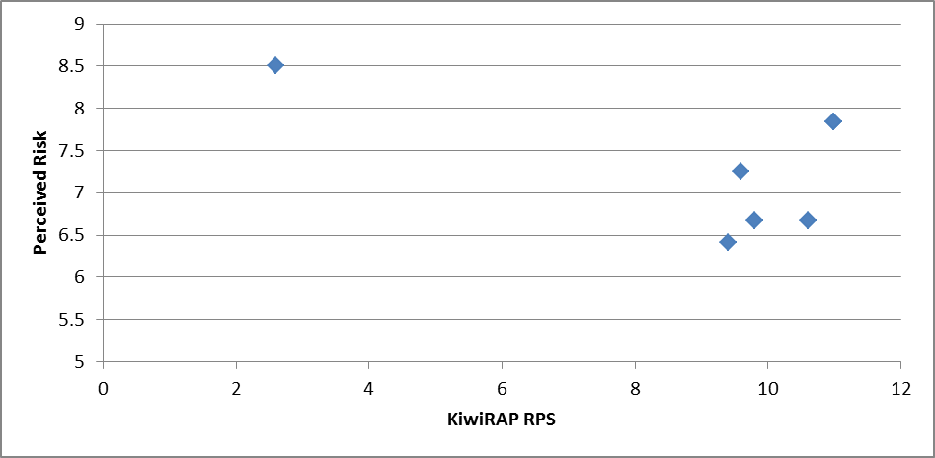
Increasing risk
Increasing risk
Figure 3: Perceived risk vs Objective risk (KiwiRAP RPS)

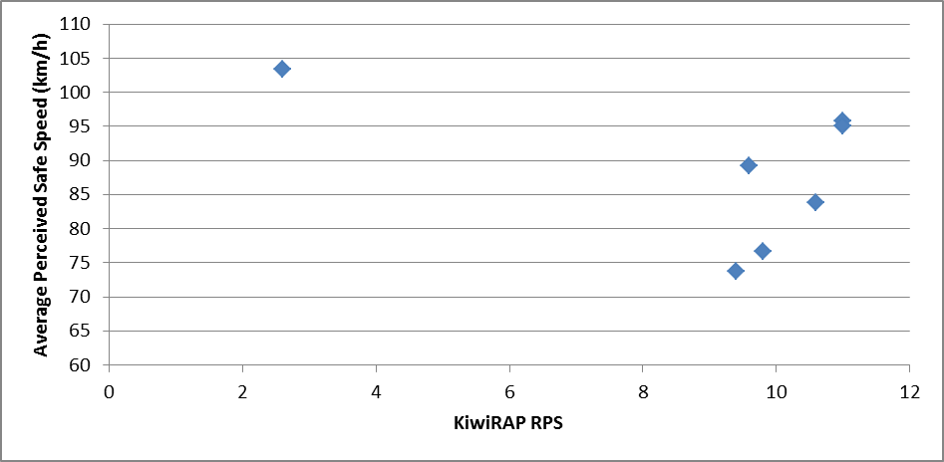
Figure 4: Perceived safe speed vs Objective risk (RPS)

A series of pictures were then digitally manipulated and participants were then asked to rate the level of perceived risks (out of 10, with 10 being safest). Figure 5 shows an example of the different road features/ countermeasures used in the survey. The researcher who interviewed the participants noted that all participants intuitively tried to seek the differences between the images, and the researcher constantly reminded the participants that the purpose of the survey was to understand their perceived risks to avoid the participants being primed to provide the answers that were deemed as ‘correct’ answer.
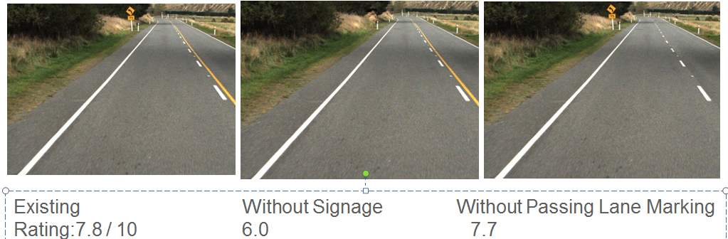
Figure 5 – Example of photos showing different Road layouts
Based on this countermeasures survey, the following conclusions can be drawn:
- The presence of curve advisory speed and signage was perceived to be safer. This finding is consistent with the findings from the in-person video survey where participants identified curve advisory speed and chevron signs to be the safe features.
- Median separation (such as wire rope in this case) was perceived as the safest countermeasure, followed by high crash rate sign, wide shoulder and wide centreline.
- Wide centreline was perceived to be less safe compared to the existing scenario without normal painted lane lines. This could be attributed to confusion attributed to unfamiliarity of the markings, as reported in the Wide Centreline Trial Report (Burdett, 2012), where drivers reported being uncertain as to what the road marking were indicating.

SURVEY METHOD 3: DRIVE-OVER SURVEY
A sample of six drivers was selected to drive-over one of the 20km routes used in the video surveys (Method 2), accompanied by a researcher. The route selected for the drive-over was State Highway 75 (RP14/1.2 – RP35/7.5), approximately between Tai Tapu and Pranui Beach Road intersection (on the link between Christchurch and Akaroa). This route was used in previous risk evaluation research (by Tate & Turner, 2007).
In this survey, each driver was asked to firstly drive through the entire length in both directions. Each driver was then asked to drive through each study section (in both directions) and was stopped at a safe location to rate their perceived risk (on a scale of 1 to 10) and what they perceived to be a safe speed for that section. The actual speed the driver was also recorded using GPS equipment. Table 2 shows the results (with site rankings in brackets).
Table 2: Drive-over Survey Results Summary (Average of all Participants)
Section | KiwiRAP RPS / Ranking (1st being safest) | Average Rated Safe Speed (km/h) | Average Driven Speed (km/h) | Average Rated Safety (10 being safest) / Ranking (1st being safest)
1 | 6.4 (=1) | 97 | 87 | 8.3 (1)
2 | 9.2 (6) | 91 | 82 | 7.2 (7)
3 | 8.5 (4) | 88 | 80 | 7.5 (6)
4 | 11.0 (8) | 96 | 88 | 7.8 (3)
5 | 6.4 (=1) | 95 | 84 | 8.1 (2)
6 | 6.6 ( 3) | 91 | 83 | 7.7 (4)
7 | 9.7 (7) | 88 | 82 | 6.9 (8)
8 | 8.7 (5) | 96 | 87 | 7.6 (5)

From this drive-over survey, the following conclusions can be drawn:
- Average driven speed for each section is between 8km/h and 10km/h lower than the perceived safe speed.
- The correlation between the perceived risk and objective risks (RPS) was fairly high for the SH75 sections (see Figure 6), with one notable outlier (Section 4).
- There is correlation between the drivers’ average driven speed and perceived risk, with the lowest average speeds (82km/h) occurring on the highest perceived risk sections (Sections 2 and 7), and higher speeds driven where there is a lower perceived risk (Sections 1 and 4).
- From this survey, the features generally perceived to be safe were:
  - Sight distance / visibility
  - Raised pavement markers
  - Signage and curve advisory speeds
  - Straight / gentle curve sections
- The features generally perceived to be unsafe by the participants for this survey were:
  - Lack of no-overtaking lines
  - Narrow road section, including around some tight curves
  - Roadside objects (i.e. rockface) not protected
  - Series of (out of context) curves
  - Roadside drains / ditch
  - Side road vehicles entering

The inbound and outbound speeds for this drive-over survey were compared to the speeds from the drive-over surveys carried out in an earlier research study by Turner and Tate (2009). The Turner and Tate (2009) research carrying out more survey runs along SH75. The speed data was combined to produce a better estimate of the average driven speed of each section (from 18 drivers in total, including multiple runs). Figure 7 shows a box plot of the actual speeds from each section compared against the KiwiRAP RPS (objective risk). Firstly it shows there was quite a large variation in speeds, which supports the need to obtain additional speed data. There also appears to be very little correlation between objective risk and driven speed. This may be due to some of the objective risk factors, notably road-side hazards, which are include in the RPS, not impacting on driver’s perception of safety or their choice of speed.

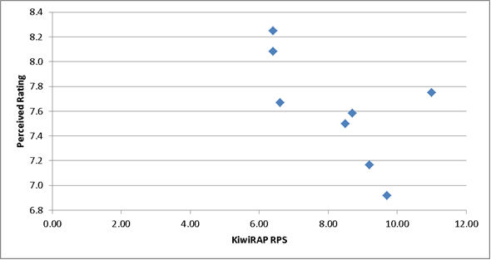

Figure 6: Perceived risk vs Objective risk (KiwiRAP RPS)
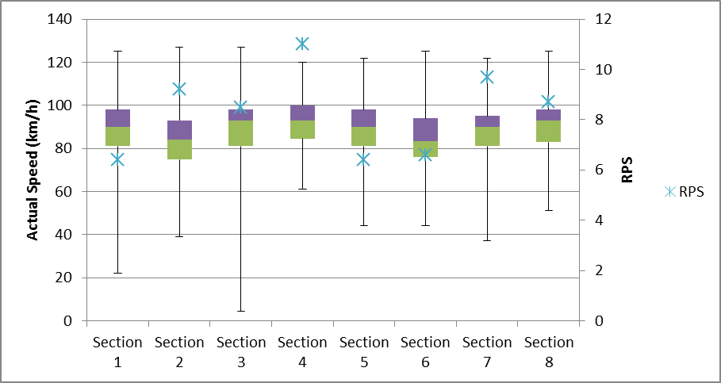
Figure 7: Actual Speed Data (Combined with Turner and Tate, 2009) and RPS

PERCEPTUAL COUNTERMEASURES META-ANALYSIS
The metadata collated from the three surveys, namely the web, in-person video and drive-over surveys, were collectively analysed in combination with observations derived from the Wide Centreline Report (Burdett, 2012) and Transverse Lines Marking Report (Martindale and Urlich, 2010). This dataset, comprised of these five metadata fields, provided information specific to Risk Countermeasures as was the focus of this analysis.
In the analysis of this metadata the following primary aspects were considered in deriving the underlying patterns and themes from which the analysis findings are outlined:
    - Survey Participant demographics
    - Test image content including;
      - Geometric road network layout
      - Signage
      - Road markings
      - Roadside (and on road) features
    - Subjective ratings
    - Subjective opinions and comments
    - Actual speeds (In-person drive over survey)
    - Objective risk ratings
    - External report findings
Subjective ratings, opinions and comments from participants were compared against one other and also against the features of a given image or road section. A number of common themes were identified as flowing through the metadata and those have been identified and expanded on as findings below.
The web-based survey, with 559 respondents, provided a diverse range of metadata where themes common throughout the analysis provide a reasonable level of confidence with analysis findings. In the case of both the video and in-person surveys the limited sample set (6 participants for each) displayed the influence of subjectiveness in respondent risk ratings. This limitation resulted in inconclusive data spread and a low level of confidence in the findings, except when this data was supplemented with risk ratings from the web-based survey or other research.
Analysis of this metadata can also becomes clouded when you consider a respondents subjective rating to a still image of say an un-signposted (30km/h) corner in the road network. When un-signposted the objective risk is high due to the possibility of a driver failing to negotiate it safely, while data would indicate that the subjective opinion would tend to rate this un-signposted corner as carrying a medium-high subjective risk, as a still image does not portray the intensity of the corner out of sight distance. When the same corner is considered with a posted curve advisory speed sign and chevrons; the objective risk calculation would consider this corner to now carry a lower objective risk rating where as a respondents subjective opinion will tend to be either the same or higher than the un-signposted image now that they are aware the corner is in fact a 30km/h corner. Thus, in some sense the subjective evaluation by the respondent requires consideration of the corner in its entirety rather than a single image on entry. In reality of course, a driver would read the 30km/h sign, slow down to negotiate the corner and then retrospectively subjectively rate the corner as having a lower subjective risk than if reality had given them an un-signposted 30km/h corner to negotiate. Therefore a direct comparison and analysis of still image based against video or in-person surveying cannot in essence provide a similar flow of data.
From this research, the following countermeasures were analysed on their use to convey more accurate perception of risk include:
Curve speed advisory signs and chevrons – Analysis of the data set indicated that drivers perceived a reduced safety margin through the positioning of curve speed advisory signs. Where curve speed signs were present in trial images, data showed that sample drivers considered these sections of road to be 16% safer than without these advisory signs installed. Data from the drive over study indicated that corners which were not signposted with recommended curve speeds carried a much higher objective risk than was subjectively perceived by the driver prior to entering the corner. (CONFIDENCE LEVEL: HIGH)
High crash rate signs – Analysis of the data set indicated that the presence of high crash rate signs effectively conveyed to drivers that safety margins for that stretch of road were reduced. These signs aided in aligning the perceived (subjective) risk judgement and the actual (objective) risk of a section of road. (CONFIDENCE LEVEL: HIGH)
No overtaking yellow lines – Analysis of this sample data set indicated that the presence of no overtaking road markings resulted in a reduction in perceived (subjective) risk. This finding contradicts any suggestion that as safety margins decrease, due to the reasons for a no overtaking section e.g. corner and/or rise, so should there be a resultant increase in the driver’s perceived (subjective) risk. It could be considered that the actual (objective) risk introduced by the road layout is over shadowed by the reduced possibility of collision due to opposing traffic crossing the centreline. (CONFIDENCE LEVEL: LOW)
Median barriers – The data set analysis indicated that where median barriers were installed the perceived (subjective) risk was reduced as a result of the additional protection provided against collisions with oncoming traffic. (CONFIDENCE LEVEL: MEDIUM)
Wide centreline – Although not conclusive, a small sample in the digital image manipulation comparison test indicated a minor increase in perceived (subjective) risk when a wide centreline was compared against the standard white dotted line. This may indicate a level of driver confusion due to the unfamiliarity of the markings, as reported in the Wide Centreline Trial Report (Burdett, 2012), where drivers reported being uncertain as to what the road marking was indicating, although the tested image had a side road, found to be perceived as high risk in this research, which may influence the risk perception. (CONFIDENCE LEVEL: LOW)
Slow down advisory signs (electronic) – Analysis of the data set indicated that electronic ‘Slow Down’ advisory signs were an effective method of conveying the actual (objective) risk and aligning it with the subjective risk judgement. (CONFIDENCE LEVEL: MEDIUM)
Low light countermeasures - While not specifically measured in this set of surveys participants acknowledged that the presence of reflective edge markers and road lighting aided in providing an increased accuracy of objective risk for low light driving e.g. during hours of darkness (CONFIDENCE LEVEL: LOW)
FINAL REMARKS/SUMMARY
Based on the experimental methods carried out in this research, the details of research findings have been summarised below to answer the four primary questions investigated in this research.
What level of risk is experienced by drivers on hazardous New Zealand roads?
From all the three surveys undertaken in this research, there is not a strong relationship between drivers perception of risk and the actual level of hazard on New Zealand roads as measured by the KiwiRAP RPS). The level of risks experienced by drivers on hazardous roads varies significantly from site to site, with drivers perceiving some roads to be safer than their actual risk and vice versa.
What road features do drivers use to judge driving risk?
From this research, the road features that drivers use to judge driving risk (perceived risk) could broadly be summarised as follows:
- Road geometry. From this research, it has been found that horizontal curves / sharp corners were perceived as higher risk (even with barriers) than straight with other roadside hazards (such as power poles).
- Signage. Presence of signage such as curve advisory signs / chevrons, high crash rate signs, slow down speed signs, were perceived to convey a message of reduced safety margins for the road.
- Intersection / presence of side road. Presence of side road (even with wide centreline) was found to consistently perceived as higher risk compared to presence of road-side furniture (i.e. power poles, barriers, warning signs).

Which hazardous road situations are under-recognised by New Zealand drivers?
This research has found that the risks for some road situations are under-recognised by New Zealand drivers. The features that are under-recognised are:
- Roadside hazards. From the experimental surveys carried out, there is little to suggest that drivers perceive the risks of roadside hazards.
- No overtaking yellow lines. While the research has found that drivers perceived the more open sight distance from straight road to be of lower risks compared to curves, the presence of no overtaking yellow lines indicated a reduction in perceived (subjective) risk.
What countermeasures can be used to convey a more accurate perception of risk?
From the meta-analysis carried out, it has been found that certain countermeasures provide a more accurate perception of risks. These include:
- Signage – Presence of signage such as curve advisory signs / chevrons, high crash rate signs, slow down speed signs, were perceived to convey reduced safety margins for the road. Analysis indicated that drivers perceived a reduced safety margin through the positioning of curve speed advisory signs.
- Road markings – There is some evidence that drivers rely on road markings as one of the cues for risk perception. Analysis of datasets indicated that road markings such as no overtaking lines have an effect on risk perception. Although not conclusive, a small sample in the digital image manipulation comparison test indicated a minor increase in perceived (subjective) risk when a wide centreline was compared against the standard lane lines. Based on this research, there is anecdotal evidence that other road markings, such as transverse line markings could also be effective perceptual countermeasures to indicate reduced safety margins.

REFERENCES
Burdett, B (2012), NZTA Wide Centreline Trial, Technical Paper, IPENZ Transportation Conference, Rotorua, New Zealand
Martindale, A., and Ulrich, C. (2010). Effectiveness of Transverse Road Markings on Reducing Vehicle Speeds. NZ Transport Agency Research Report 432. Wellington, New Zealand: NZ Transport Agency.
Turner, S. and Tate, F. (2009). Relationship between road geometry, observed accident, speed and rural accidents. NZ Transport Agency Research Report 371. Wellington, New Zealand: NZ Transport Agency.

