BEYOND NETWORK CAPACITY AND EFFICIENCY INDICATORS

Author and Presenter:
Jared White, Senior Transportation Engineer
Abley Transportation Consultants
BE(Hons), GIPENZ
jared.white@abley.com

Co-author:
Paul Durdin, Director
Abley Transportation Consultants
BE(Hons), CPEng, MIPENZ
paul.durdin@abley.com

ABSTRACT

Resource consent applications are assessed by testing compliance against Rules set out in a District Plan. This provides Councils with varying degrees of discretion to consider the external environmental effects of the application.

Although most statutory documents explicitly identify the need to integrate land use and transport, often the focus of transport assessments to support consent applications tends to be on network capacity and efficiency issues. Other transport indicators such as road safety, accessibility, environmental sustainability, resilience or travel choice seem to carry less weight in the overall assessment.

This note looks into new assessment techniques and indicators for a range of transport matters that improve consideration of a number of environmental variables, including road safety performance by mapping risk along corridors and at intersections. This enables Councils to understand in a ‘level of service’ sense, how specific elements in their entire network are performing. Further examples include calculating the vehicle kilometres travelled to approximate environmental variables and highlighting how accessibility analysis can promote the multi-modal potential of a development.

The note will be of interest to transport professionals that produce or assess transport assessments

INTRODUCTION
The activity status of any resource or subdivision consent application is informed by its compliance with Rules set out in a District Plan. For transport, most District Plans provide Councils with varying degrees of discretion to consider the environmental effects of an application beyond its immediate site.
Although the objectives and policies of transport strategies and plans, including District Plans, almost always explicitly identify the need to integrate land use and transport, often the focus of some transport assessments tend to be on network capacity and efficiency issues. Indicators such as measures of vehicle congestion and increased journey times are common whereas while other transport indicators such as road safety, accessibility, environmental sustainability, resilience or travel choice are assessed they seem to carry less weight in the overall assessment.
The focus on network capacity and efficiency issues could be driven by knowledge-gaps when assessing these other transport indicators. Within the Resource Management Act (RMA) context the use of well-known indicators is likely to be magnified where there is a desire for clear thresholds as to the quantification of effects and the acceptability of those effects.

BACKGROUND
Transport Assessments have long been prepared for transport strategies, scheme assessments and development proposals to assess transport related effects. Between 2007 and 2010 a New Zealand Transport Agency (NZTA) research report 422 (Abley, et al 2010) was developed to establish Integrated Transport Assessment (ITA) guidelines. This report highlights that guidelines were developed “to improve transportation assessment practices in New Zealand” and that “it is generally acknowledged that the assessment of transportation effects in New Zealand is undertaken with variable results and quality”.
The assessment of transport effects is a key part of good land use and transport planning and the guidelines developed have been done so to ensure these aspects are assessed in an integrated manner. The following sections of this technical note look at key areas of transport assessments that could play a more important role than they currently do.

ROAD SAFETY

Current Assessment Methodologies
The traditional approach to road safety in New Zealand has been to focus efforts on reducing crash occurrence at sites with the greatest number of observed crashes. This reactive approach to road safety has often been the subject of criticism by the general public. “Do we have to wait until someone dies or is seriously injured before this gets fixed?” has been a much too commonly heard phrase. The Government has sought to redress this through their support of proactive and risk-based industry initiatives through the Safer Journeys programme guides such as the ‘High-Risk Rural Roads Guide’ and the ‘High-Risk Intersections Guide’ have now been produced.
A Road Assessment Programme has been adopted by NZTA on the high speed State Highway network known as KiwiRAP. Crash risks that are based on historical crash data and Star Ratings based on engineering features of a road have been mapped as part of KiwiRAP. The risk metrics mapped as part of KiwiRAP, are:
• Collective Risk, which is based on the average annual number of fatal and serious crashes occurring per kilometre of State Highway.
• Personal Risk, which is based on the average annual fatal and serious injury crashes occurring per 100 million vehicle kilometres travelled.
Mapping these metrics and star ratings allows practitioners to focus their attention to sections of the State Highway network where the greatest collective and personal risks of fatal or serious crashes may occur. This recent approach to road safety is a vast improvement on traditional ‘seek and treat’ methods but the analysis has concentrated on the rural or high speed networks whereas a considerable amount of vehicle travel in New Zealand is on urban road networks. Methods to assess urban networks are being developed that target the highest risks.

A New Way Forward?
In August 2012, NZTA established a new technical committee to develop the risk assessment process for roads in urban areas and the Urban KiwiRAP model. The new committee consisted of representatives from the NZTA, Auckland Transport, the Tauranga, Christchurch and Dunedin City Councils as well as the consulting industry. Each of the local authorities represented on the committee have participated in a trial to develop and test risk assessment processes for urban corridors on their networks.
The risk assessment model was formed of two components with the first being for intersections as defined by the High-Risk Intersections Guide since the guide is applicable in rural and urban environments. The second component is a corridor assessment, where a brand new process needed to be derived.
KiwiRAP uses a fatal and serious crash approach whereas the High Risk Intersections guide uses an estimated Death and Serious injury (DSi) casualty equivalents approach. Given that fatal and serious crashes tend to be more rare and random events in urban environments than in higher speed rural networks the decision was made to adopt the estimated DSi casualty equivalents approach.
The next task was to develop a standard method for defining a corridor that could be applied across any road controlling authority’s transport network. The agreed process for defining a corridor was based on the hierarchical classification of the road and the intersecting road. The Collective Risk of a corridor is calculated in two parts; an intersection component and a mid-block component. The intersection component of the corridor Collective Risk is calculated by summing the DSi casualty equivalents of all intersections along the corridor. The mid-block component of the corridor Collective Risk is calculated by summing the DSi casualty equivalents of all mid-block sections along the corridor.
The overall Corridor Collective Risk is calculated by adding together the Collective Risk values of the corridor’s intersections and mid-block sections and dividing by the total corridor length in kilometres. Dividing by corridor length enables direct comparisons to be made between corridors. Personal Risk for corridors is an exposure based metric that is determined by taking the Corridor Collective Risk in combination with the traffic flow. Specific exemptions are applied to Medium-High and High personal risk categories to ensure only those corridors with three or more injury crashes can be defined as High, and two injury crashes as Medium-High.
Due to the spatial nature of crash data and the road network the transport data sets have been brought together in a geospatial environment to calculate the risk profiles. Using Geographical Information Systems (GIS) makes calculating the risk profile of all corridors in a town, city or region highly cost-effective and time-efficient compared to the manual equivalent; in particular a large urban network where a manual method would simply be uneconomic and inefficient.
After calculating the estimated DSi casualty equivalents per km along corridors, risk threshold categories were developed by reviewing and analysing the distribution of Collective Risk values across the contributing network areas. The objective of the threshold was to achieve the iRAP vision of targeting the highest risk 10% of roads based on collective risk (McInerney, 2012) where typically 50% of crashes occur. An iterative approach was taken to develop the Urban KiwiRAP Corridor Collective Risk thresholds to attempt to classify 10% of the highest risk roads based on estimated DSi casualty equivalents per kilometre as either medium-high or high and then the number of actual injury crashes on those roads can be compared to the iRAP target of 50%. The agreed Corridor Collective Risk categories are shown in Table 1.
Table 1: Corridor Collective Risk categories
Risk Category | Corridor Collective Risk Thresholds  (estimated DSi casualty equivalents per km)
Low | <0.1
Low Medium | 0.1 - <0.5
Medium | 0.5 - <1.0
Medium High | 1.0 - <2.0
High | ≥2.0

Application to New Zealand Cities
The Urban KiwiRAP risk mapping results for the four contributing Council city areas show highly encouraging results. Table 2 shows that over all four cities, 8.3% of the networks by length are classified as high-risk i.e has a Collective Risk profile of Medium-High or High as defined in the High Risk Guides series such as the High Risk Intersection Guide (New Zealand Transport Agency 2013). These high risk corridors account for 63.1% of all injury crashes, which significantly exceeds the iRAP target.
Table 2: corridor collective risk statistics
City | High-Risk Network by Length | Proportion of Injury Crashes
Auckland | 9.0% | 58.8%
Tauranga | 5.4% | 31.0%
Christchurch | 10.6% | 72.6%
Dunedin | 3.5% | 53.2%
Average | 8.3% | 63.1%
The results in Table 2 show that Tauranga does not achieve the iRAP target as just 31% of the injury crashes occur on the high risk lengths of the road network meaning the lower risk roads have proportionally too many crashes. The Tauranga network is small relative to the other three and many of the high traffic volume carrying routes are designed to a very high standard, such as expressways.
An example of the corridor risk mapping outputs that have been produced for Auckland is shown in Figure 1.
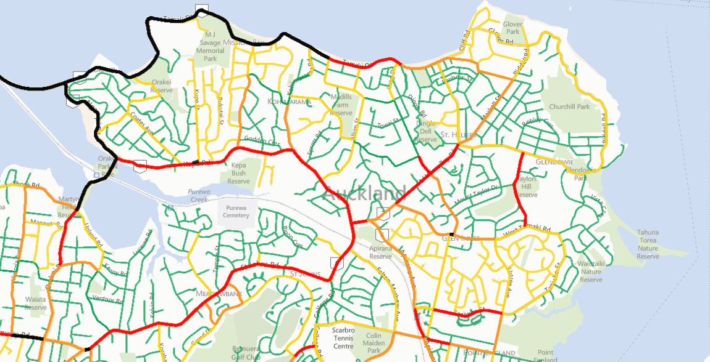
RISK KEY
Low
Low Medium
Medium
Medium High
High
Figure 1: Example Corridor Risk Maps - Auckland
The map in Figure 1 has a similar appearance to the diagrams that are produced to assess traffic volumes and the related effects on road capacity. This new method can help Councils to understand the safety performance of all roads in their network by mapping risk along corridors and at intersections. While roads carrying greater amounts of traffic may be more represented in the medium-high and high risk categories, collective corridor risk mapping can identify which corridors are at the greatest risk. This is putting safety on an equal footing with network efficiency indicators because Councils will be able to understand in a ‘level of service’ sense, how specific elements in their network are performing.
By understanding crash risks in a spatial manner Councils can be better placed to assess the additional demands that developments may have on the network safety performance. Should a development be proposed on a High Risk corridor then this could be a trigger to channel a proportion any developer contributions towards future safety upgrades of that corridor. It is yet to be seen how this information will be available but the format of the results and the environment it is prepared in lends well to them being uploaded to interactive websites. With the risk analysis process run it would be a simple task for Council staff to provide information on risk categories of corridors so that they could be considered in an ITA. Furthermore if the results are available on a website than transport professionals may be able to gain direct access to them.

TRAVEL DISTANCE
The assessment of travel distance (or Vehicle kilometres travelled (VKT)) related aspects of developments is not necessarily undertaken in the incorrect manner, it is just an assessment tool that tends to be used very infrequently, especially in the RMA field. The most common area where it is used is with transport models alongside scheme assessments and strategic road option testing. Larger developments that make use of transport models in assessing traffic distribution and assignment can also infer a network wide travel distance assessment.
Every new development will generate new traffic on the road network in the vicinity of the site and depending on wider changes to traffic patterns there may be additional VKT. Often there are many trips to developments that are already travelling on the network with vehicle driving past the site (passby trip) or diverting (diverted trip) from a trip nearby the site or from a similar destination in a different location. The diverted trips may occur because the development provides a closer/more convenient alternative activity for some drivers and therefore the distance of the trip may decrease.
If a development or new land zoning brings about a significant shift in traffic then the amount of VKT on the road network may have the potential to reduce. This highlights that good land use planning could reduce the length of vehicle trips on the network which in turn reduces the impact of a number of variables such as fuel use and air quality. If the development involves a significant amount of heavy vehicle movements then any reduction in VKT could be highlighted as a potential reduction in pavement deterioration.
ACCESSIBILITY
Earlier this year the national methodology for measuring transport accessibility (Abley, Halden, 2013) was published by the NZTA. Accessibility is a new area of study in New Zealand assessing community enablement through the transport network to a number of opportunities including employment, health and education. Various local and regional authorities are beginning to develop understandable indicators related to accessibility that will guide sound integrated land use and transport planning decisions. These can include walking distances to bus stops or the number of employment opportunities within a certain travelling time from a household (by transport mode) and developments can be assessed on how these indicators might improve as a result or are supportive of the indicators.
As an example, if a development site was located on a high capacity corridor with efficient vehicular access then the chances are it could be assessed as not adversely affecting the capacity or efficiency of the road network. However the location may not be suitable for supporting non-vehicular based trips. On the other hand if a site is assessed to place strain on network capacity, but it is well accessible to all modes of transport, then augments could be put forward in an ITA that the site may fit in with indicators. An accessibility analysis could be used to strengthen the case for a development in particular for larger plan change applications.
Accessibility analysis enables many modes of transport to be assessed so it can highlight areas where car dependence will prevail and where investment in active and public transport could improve network efficiency through mode shift without providing more capacity for private vehicles. What accessibility analysis can be used for is to demonstrate how development could complement the existing urban form and proposed residential growth which in turn can reduce car use.

conclusions
This technical note has briefly looked into three transport indicators that are not directly related to network capacity and efficiency to see if they can play a greater role in integrated transport assessments.
Recent improvements in the analysis of road safety are proactive and risk based but are mainly confined to the high speed state highway roads. Just this year a process for Urban KiwiRAP has been developed and with risks along corridors mapped it is now much clearer to determine the most at-risk parts of urban road networks. This process could provide value in understanding the impacts of developments in the most at-risk areas.
There are other headline indicators such as VKT which directly relate to a number of variables such as fuel use and air quality. If VKT is considered when planning land use or developments, and it is shown to reduce, then this can also reduce road network costs. Accessibility analysis can assist planning by locating land uses in optimised locations to minimise car use and identifying existing barriers to accessibility by non-car modes as well as highlighting how well development does in this sense.
Good land use planning has a significant role to play when managing motorised travel. Overall there are now a greater number of indicators providing a better understanding of land use and transport integration other than simply congestion and efficiency. Together these newer indicators are providing decision makers with better information to holistically assess developments alongside network capacity and efficiency.

REFERENCES
Abley, S, P Durdin, M Douglass (2010) Integrated transport assessment guidelines. NZ Transport Agency research report 422
McInerney, R, iRAP: A world free of high risk roads
http://www.roadsafetyfund.org/Documents/Policy_Forum_2012/Rob_McInerney.pdf
New Zealand Transport Agency (2013) High Risk Intersection Guide
Abley, S and D Halden (2013) The New Zealand accessibility analysis methodology. NZ Transport Agency research report 512

