New Emissions Analysis Techniques

AUTHOR & PRESENTER
Bevan Wilmshurst
Principal Transport Planner, TDG
BSc. BMus.
IPENZ Transport Group Member
IPENZ Modelling User Group Committee Member
bevan.wilmshurst@tdg.co.nz

Bevan has over 13 years’ experience as a transport planner in New Zealand and the UK. He has particular expertise in specialist transport modelling and analysis techniques, and this experience includes a number of years working as training and support manager for an international software development and transport planning consultancy.

ABSTRACT
Traditional methods for evaluating vehicle emissions commonly involve analysis of average vehicle speeds. For example, the techniques in the Economic Evaluation Manual for calculating Vehicle Operating Costs. These procedures use known relations between emissions, other factors (gradient, heavy vehicle etc.), and the average vehicle speed.

This approach is generally considered suitable for a wide area emissions inventory, a broad calculation of the change in vehicle operating costs for a larger road scheme, and other similar analyses.

It does not take account of vehicle acceleration.

Some modern network optimisation schemes don’t necessarily target an improvement in overall average speed, but looks to smooth traffic flow, improve reliability, and reduce stop-start conditions. For example, Motorway Speed Management systems. Is an average speed approach still relevant for schemes of this nature?

New techniques for emissions analysis have emerged overseas, referred to as “Instantaneous Emissions Models” (IEM). For example, Transport Scotland’s AIRE (Analysis of Instantaneous Road Emissions) tool.

An IEM model considers a 3rd aspect in the relationship between vehicle dynamics and emissions – acceleration. The process is similar to that used in traditional average speed methods; on a second-by-second basis emissions are estimated based on a vehicle’s current speed, acceleration, and characteristics.

INTRODUCTION
Estimating emissions from transport vehicles is an area of increasing importance in many parts of the world.

There are several different approaches to estimating fuel use and tailpipe vehicle emissions. Traditional methods commonly involve analysis of average speeds, and use of relationships between emissions and average speed (and a small range of other factors). New techniques in use overseas include vehicle acceleration in the evaluation of emissions, along with rich datasets of disaggregated vehicle and network environment information.

The objective of this paper is to discuss the differences between traditional vehicle emissions analysis approaches and new techniques. This will consider specific examples where there may be limitations to certain analysis methods and the potential of newer approaches to transport appraisals in New Zealand.

The focus of this paper is on specific techniques used in emission analysis relating to transport schemes, notably comparisons of Scheme A vs. Scheme B or Scheme A vs. Do Minimum. The author is not an expert on issues such as dispersion modelling, climate change and wider environmental assessment. Although some cursory information and references are provided, the paper does not include any in-depth review of the accuracy of, or comparisons between, on-street observations and emissions modelling approaches. Some information on these issues is included in the reference papers.

BACKGROUND
Economic Analysis
Transport planners are commonly exposed to vehicle emissions analysis in conducting economic appraisal of road schemes. This is overt in calculations of tailpipe pollutants (e.g. carbon dioxide, carbon monoxide, oxides of nitrogen, hydrocarbons and particulate matter) and is also carried out as part of Vehicle Operation Cost (VOC) calculations. A major component of VOCs is fuel use; around 30% of the base VOC component, according to Table A5.0(a) Economic Evaluation Manual (EEM) (NZTA, 2013), which is calculated via a vehicle emission analysis process.

Global and Local Air Quality Assessment
As noted above, the author is not an expert in dispersion modelling, climate change, and other environmental assessment. The following broad concepts are worth noting with respect to the analysis of transport schemes and to provide background to this paper;

- Vehicle tailpipe emissions techniques (as described in this paper) will not currently accurately estimate on-street emission levels due to environmental variables (wind, valleys, buildings etc.).

- Dispersion models may be used for this purpose.

- Estimation of absolute emission levels tends to be more of a global issue dealt with macroscopically rather than being a focus for smaller-scale transport schemes. The EEM (NZTA, 2013) stated “Mitigation of air pollution: The focus is now turning towards improved vehicle emissions standards for new vehicles and vehicle screening”.

The key aspect of the analysis described in this paper is that it’s comparative, i.e. Scheme A vs. Scheme B and Scheme A vs. Do Minimum, rather than quantitatively measuring absolute emission values. In many parts of the world, the focus on local (e.g. city pollution levels) and global (e.g. climate change issues) air quality issues has increased the emphasis on the evaluation of emissions in relation to transport schemes. An example as reported in the Sydney Morning Herald of the WestConnex transportation scheme “greatly improving air quality” on a local route. In another local example, the Environment Court declined the resource consent application for a new arterial in Nelson noting “air quality in the Washington / Victory community was a principal reason”.

TRADITIONAL EMISSIONS ANALYSIS
Average Speed Models
The traditional approach to emissions analysis is to use known relationships between vehicle emissions, average travel speed and a small number of factors such as fuel, gradient, and vehicle type (light, heavy etc.). As described above, fuel use is a major component of VOCs and is calculated via a vehicle emission analysis process. Figure 1 below shows a VOC calculation figure from the EEM (NZTA, 2013) which provides an example of the common shape/form of an emissions/average speed relationship.
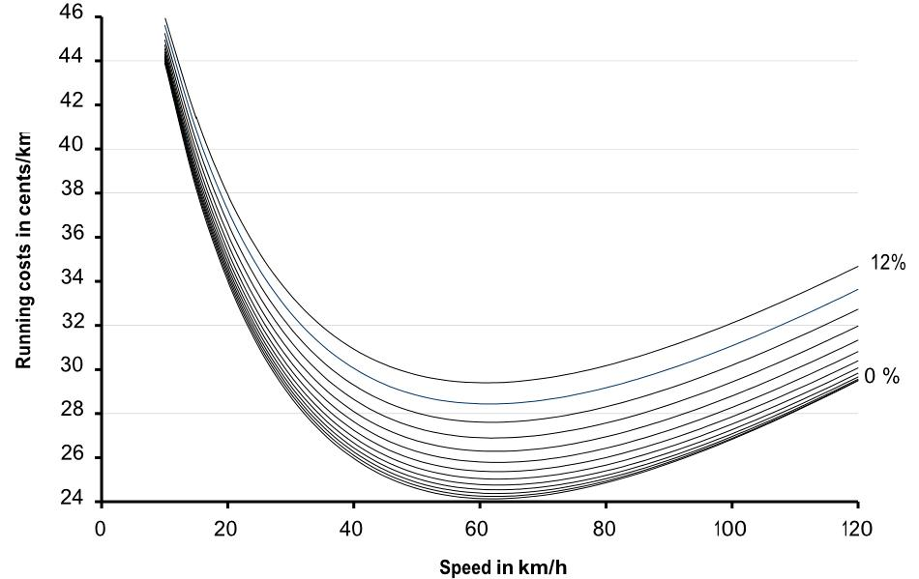
Figure 1: EEM A5.7 Table A5.1 Passenger Car VOC by speed and gradient

This traditional approach can be described as an “average speed model’ and the relationship between particular emissions and average speed usually takes the form of an inverted curve as shown in Figure 1 above. EEM appendix A9.3 (NZTA, 2013) is an example of this approach, providing average speed based formulae for calculating CO, NOx, PM10 and VOC vehicle emissions for Light and Heavy vehicles.

Transport Models Outputs and Emissions Calculations
To carry out calculations for a specific road scheme, or an area-wide emissions inventory, outputs from transport models are commonly used. Any form of traffic model can be applied when using the traditional average speed approach; e.g. model forms such as strategic, deterministic, macroscopic, microsimulation etc. These models provide link and/or origin-destination traffic flows, average speeds, and vehicle composition information (percentage of light, heavy etc. vehicles). Fuel use and emission data is calculated via simple look-up tables, graphs, or equations from these model outputs.

Limitations of the Average Speed Approach
The average speed approach has been widely used and historically has been a convenient mechanism for emission analysis. The averaging approach will generally smooth out potential variations in speeds, for example;

- Variations in the speeds of individual vehicles, e.g. on a particular link, trip, and across the period of analysis

- Variations in collective speed and acceleration within links, trips, and the analysis period

- Effects of changing network conditions, e.g. varying gradients, within sections and across trips

As noted, for local transport schemes the focus of emissions analysis is commonly comparative. The issues described above may be of little consequence globally, or in quantifying emissions levels across a region, but they are recognised overseas as being increasingly important as congestion increases, the nature of transport projects changes, and awareness of air quality issues grows.

Congestion and the nature of the transport scheme are of particular interest. Emerging transport schemes and more traditional roading projects in highly congested environments may not target a direct and significant reduction in average trip speed. Rather, the focus may be on smoothing traffic flow, reducing stop-start conditions, protecting the network from flow-breakdown, and improving reliability.

The limitations of the average speed approach, notably with respect to the nature of the project, have been recognised in UK published guidelines, and the Department for Transport states (DMRB, 2007);

The most widely used approximations for estimating road traffic emissions are based on two
parameters only: the type of vehicle and its average speed. In many cases, this is the only practical approach as data for a more complex evaluation are not available. However, in determining the methodology to use for a particular application, some attention should be given to the exact nature of the project and its likely consequences on vehicle emissions. In some cases, such as projects which result in variations in driving patterns but do not greatly affect average speed, a more detailed emission model may be required. It may be necessary to use an ‘instantaneous’ emission model, in which emissions are related to vehicle operation (usually via a vehicle speed-time profile) on a second-by-second basis.

NEW EMISSIONS ANALYSIS TECHNIQUES
Instantaneous Emissions Models
Instantaneous Emissions Models (IEM) have been in existence for a number of years. For example the MODEM model, which is now considered out-of-date, was developed by the European Commission’s DRIVE programme in the early 1990s as reported (Boulter P G, McCrae I S, and Barlow T J, 2007). An IEM model considers a third aspect in the relationship between vehicle dynamics and emissions; acceleration. A similar process is used to the average speed approach; on a second-by-second basis (instantaneous) lookup the vehicle’s speed and acceleration is used to estimate the emissions output.

An example of the three dimensional aspect of IEM emissions predictions is shown in Figure 2 (Shaw, 2011). This demonstrates how CO2 emission is dependent on speed and the product of speed and acceleration.

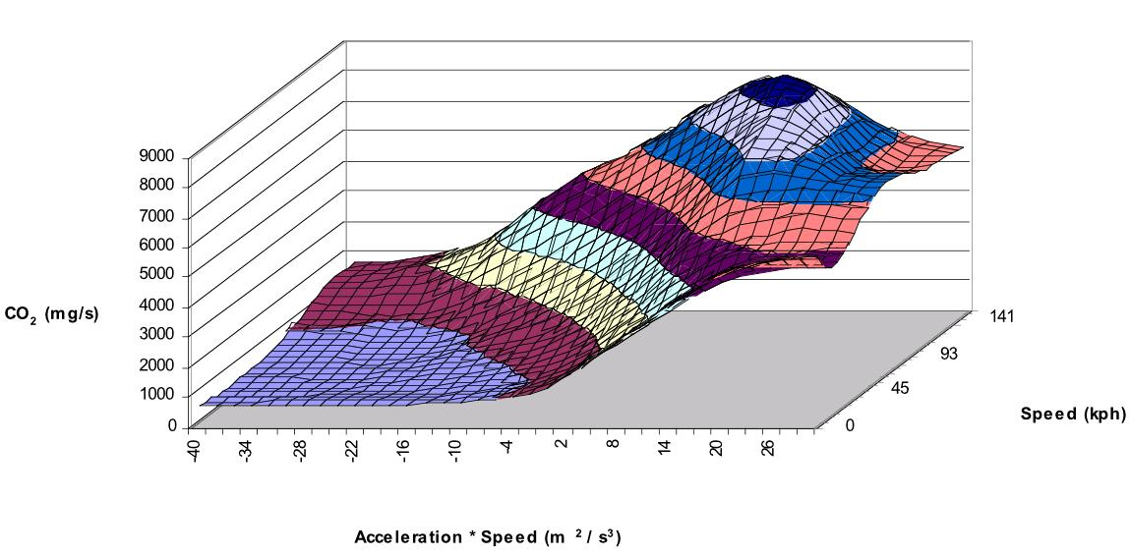
Figure 2: MODEM Based CO2 Emissions Surface Plot – EURO I Medium Petrol Car

Advances in Transport Models
The average speed emissions analysis is particularly convenient for traditional macroscopic-style (‘equilibrium’ or ‘deterministic’) transport models. These models readily provide average link and trip statistics (e.g. speeds). Further development and application of instantaneous emissions modelling has been possible due to newer transport modelling techniques, specifically microsimulation models. As has been reported (Barlow T J, Boulter R P G, and McCrae I S, 2007), a potential solution to growing the application of IEMs is the use of microsimulation model to generate the required emission model inputs.

Microsimulation models have been commercially available for 15 to 20 years. They are referred to as ‘microsimulation’ due to the analytical detail that they are based on, and the modelling of individual units (in transport models vehicles, and in some cases people), not due to any restriction on limitation of the size of study area or style of network that can be modelled.

Microsimulation models replicate individual vehicles trips through the transport system, plus their interactions with the network environment and other vehicles. Vehicle’s, with notional ‘drivers’, evaluate their speed, distance from the vehicle in front, gap acceptance, lane choice etc. commonly on a sub-second basis often referred to as the time-step. This provides a rich range of outputs – to the level of tracking the individual vehicles trips through the network at each time-step (e.g. every 0.5 seconds).

Instantaneous Emissions Models use these outputs from microsimulation models (vehicle type and fleet data, current acceleration, current speed, gradient etc.) to calculate and collate emission values.

Transport Scotland AIRE
Analysis of Instantaneous Road Emissions (AIRE) is an example of an instantaneous emissions calculation process developed by Transport Scotland and currently actively employed in the analysis of road schemes in Scotland.

As stated on the AIRE website, the AIRE module uses detailed IEM factors derived by TRL using the Passenger car and Heavy duty Emissions Model (PHEM) developed by the Technical University of Graz (internet, Transport Scotland). The PHEM emissions model contains a significantly rich and detailed data, including for example disaggregation of information by vehicle load and gradient.

As noted previously, the intention of this paper is not to provide commentary or investigation into the detailed relative predictive accuracy, or the accuracy of on-street predictions of various emissions modelling methods. Information on the development of the PHEM-based Instantaneous Emissions module can be found in Shaw (2011), and commentary of the verification of the AIRE calculations and comparisons with vehicle trace data are described is included in the AIRE user guide (Transport Scotland, 2011). Shaw (2011), includes detail on a comparison of microsimulation model speed and acceleration profiles across two study areas (urban and motorway) with observed drive cycle data.

APPLICATION OF IEMS
Nature of the Transport Scheme
There are a range of quite diverse factors and issues in considering the merits or otherwise of the Average Speed approach to emissions analysis compared with an IEM, such as examples already noted - global air quality issues, dispersion modelling and on-street emission estimation accuracy, through to local vehicle fleet composition considerations.

For transport planners and network operators, the nature of the transport scheme is perhaps the most important aspect when considering approaches to emissions analysis. This includes aspects such as the study area environment and operation, the form of the scheme, and notably what the scheme issue(s) the scheme is aimed at treating/addressing. The importance of this consideration is highlighted in the above reference (DMRB, 2007); “some attention should be given to the exact nature of the project and its likely consequences on vehicle emissions”.

If the transport scheme targets changes in the acceleration profile of trips through the study area, for example by reducing stop-start conditions, then average speed analysis approaches are unlikely to predict an appropriate relative difference between the ‘reference’ (e.g. Do Minimum) and ‘with scheme’ scenarios. This is particularly relevant for schemes which perhaps do not directly target or offer a reduction in vehicle kilometres travelled and/or an increase in average speeds, but aim to address other considerations, such as the management and optimisation traffic flow, protection from flow-breakdown, progression of trips through the system, system recovery, and trip/network reliability.

Consideration may also be needed in what may be considered relatively straightforward scenarios, depending on how the approximation to average speed affects the particular analysis (e.g. emissions and/or VOC and economic calculations). For example, within an 80-100kph study area an at-grade roundabout suffering from moderate levels of congestion may produce average speeds through immediate roundabout vicinity study area of 40-50kph (i.e. decelerating from 100kph, queuing for a period of time, accelerating back to 100kph), equivalent to peak hour intersection Level of Service E to F. Grade separation of the intersection with the objective of maintaining ‘free-flow’ speeds may aim to produce average speeds of 80-100kph. A trip-based average speed application may produce a dis-benefit in Vehicle Operation Costs for the scheme; Figure 1 shows passenger car VOCs increasing from 25-26 cents/km to 26-27 cents/km. In reality the fuel use (and hence VOC) from decelerating from a higher speed to around 10kph and accelerating back is likely to be higher than if maintaining a free-flow speed, producing a scheme benefit. This would be evident in the application of an IEM; for example, application of AIRE in a scenario similar to this shows reductions in total carbon of around 25% across one peak period.

Johnsonville Town Centre Example
Various transport projects and road improvements investigations have been conducted in Johnsonville Town Centre in recent times. A microsimulation model of the town centre study area has been utilised to assess the performance of the network under varying traffic demand and network layout scenarios for a number of years.

Johnsonville Road runs northbound from SH1, through a signalised cross-road with Broderick Street, past the Johnsonville mall and shopping area, terminating at a roundabout with Moorefield Road. Along the stretch of Johnsonville Road between Broderick Street and Moorefield Road are two signalised pedestrian crossings which are regularly used due to the retail activity in this area. As part of roading improvement option studies within the Town Centre, linking and synchronisation of the signalised pedestrian crossings with the Broderick Road signals was investigated using the microsimulation model. The study area and model network are shown in Figure 3 below.

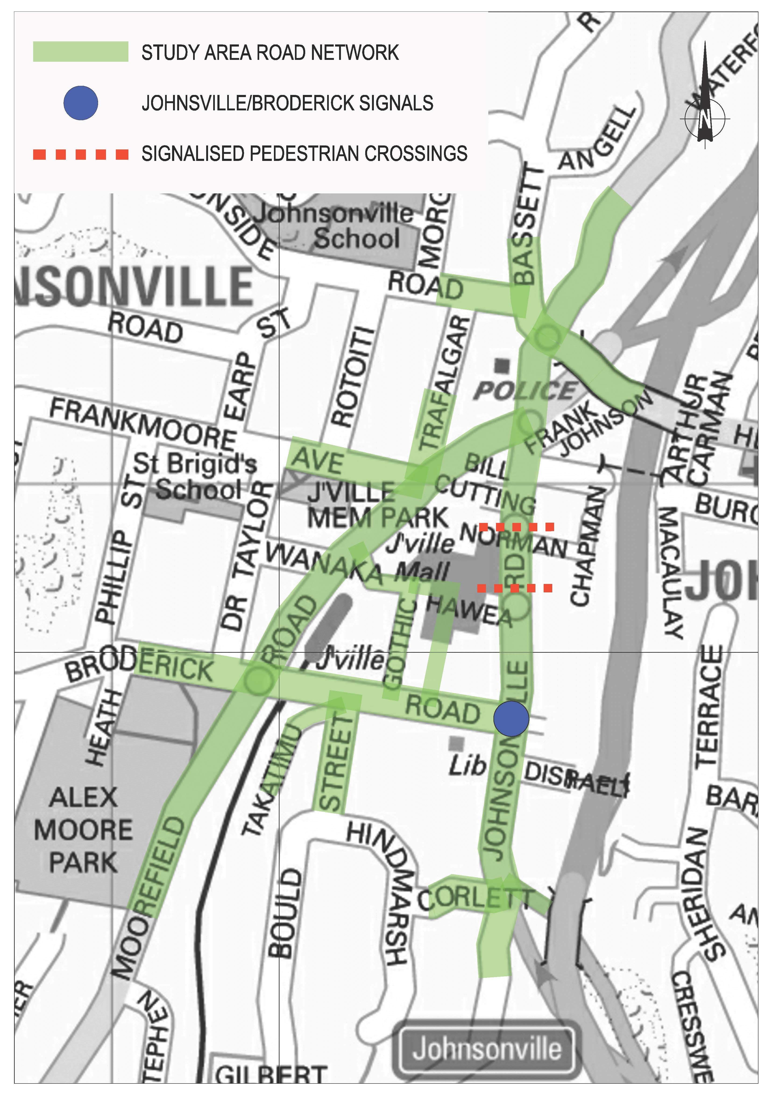
Figure 3: Johnsonville Town Centre Study Area

At the time of the assessment, this relatively subtle change to the operation of the network was shown to provide some benefits, particularly for traffic travelling along the length of Johnsonville Road but also modest network-wide benefits. Although the performance of isolated intersections and signalised crossings remains relatively unaffected, network savings accrue due to a higher proportion of trips being unimpeded along the Johnsonville Road corridor and reduced stop-start conditions.

This particular investigation has been used to examine the network-wide average link speed benefits and how these translate into emissions savings using an average speed and IEM method. The results presented below show a comparison between the ‘Base’ scenario (representation of the then existing on-street environment) and the scenario where the pedestrian crossings are synchronised with the Broderick signals. Figure 4 shows the average network link speeds for the Base and Scheme scenarios.

Figure 4: Comparison of PM Peak Average Network Link Speeds

Figure 5 below shows the emissions savings (percentage benefits for Base vs. Scheme) calculated using the EEM average speed light and heavy vehicle emissions formulae and Transport Scotland’s AIRE module using the same modelled runs and output data.

Figure 5: Average Speed and IEM PM Peak Emissions Savings

Figure 4 demonstrates average link speed savings of around 1.0 to 2.0kph, 4 to 10%.

Figure 5 demonstrates that the EEM average speed formulae this translates into a similar extent of emissions benefits of PM10 (2 to 8%) and NOx (2 to 6%) relative to average speed reductions.

For Carbon, savings are higher and similar benefits are predicted by both the average speed and IEM methods.

Using the AIRE IEM method, emissions savings are greater for PM10 and notably greater for NOx.

This demonstrates the potential greater impact reductions in stop-start conditions can have where an IEM model is used to calculate emission outputs compared to emissions changes using the average speed approach.

ISSUES AND CONSIDERATIONS
Modern Transport Schemes
As described above in relation to the nature of transport schemes, IEMs are particularly relevant for transport schemes which do not necessarily target or produce improvements in average speed or reductions in vehicle kms travelled, but focus on other forms of improvement – managing traffic speed and flow, protection from flow-breakdown, improving reliability and recovery etc.

These types of projects may be considered as more ‘modern’ transport schemes. A good example are Managed Motorway techniques. The fuller-scale motorway management system, as employed on UK motorways, includes dynamic speed management (Variable Mandatory Speed Limits, VMSL) which involves monitoring the conditions of the motorway system in real-time and enforcing a speed management strategy across sections of motorway corridor. This system, along with other components such as ramp metering techniques like those employed on NZ motorways, look to achieve several notable improvements to network performance;

- Reduce stop-start traffic conditions and improve traffic flow
- Protect network bottlenecks from traffic demand flow and manage flow-breakdown

Schemes of this form are often considered as ‘optimising’ the existing transport network asset. Optimisation schemes such as Managed Motorway techniques which aim to smooth traffic flow, reducing stop-start conditions, may offer local air quality benefits due to the change in acceleration profile of vehicle trips through the network. The extent of these emission savings could only be investigated through the application of an Instantaneous Emissions Model.

Microsimulation Models and Data Processing
Some rhetoric exists in the transportation industry, particularly in Australasia, on the approaches to and application of microsimulation traffic models to network-wide analysis and some elements of this are discussed by Wood (2012). This paper will not explore these issues in detail, but notes the form and scale of the networks possible as demonstrated by Shaw (2011); this paper outlines the application of a CBD microsimulation model for Glasgow City Centre (population area of over 0.5 million) and a strategic microsimulation motorway network (covering around 15sqkm) to emissions testing.

The application of an IEM such as AIRE does not necessarily require the collection of any additional or specific transport data, simply a microsimulation model is required for the particular study area. Nor does the microsimulation model necessarily require any specific or detailed traffic data in support of its development and/or any level calibration/validation over-and-above standard requirements; it is sufficient that the microsimulation model (as with any form of transport model) is suitable for measuring the impact of the scheme in question.

In the author’s experience, currently it would seem unlikely to develop a microsimulation model specifically for the purpose of conducting an instantaneous emissions analysis exercise. It is more likely that a microsimulation model would be developed to investigate ‘standard’ scheme outcomes such as travel time savings, and emissions analysis would form a component of this wider assessment. This would be particularly relevant in the case of modern transport optimisation techniques (as described above), where it is likely that a microsimulation modelling approach would offer the most robust approach to measuring all aspects of potential scheme benefits and emissions would form one component of this analysis.

As described in the section “Advances in Transport Models” the application of some IEMs requires detailed outputs from the microsimulation. This can lead to very large datasets of electronic files and subsequent potentially lengthy post-processing of this data to produce the emissions outputs. This aspect of IEMs needs to be recognised, but is relatively easily managed with current computing technology and power.

CONCLUSIONS

There are two broad approaches to analysing vehicle emissions; Average Speed and Instantaneous Emissions models.

Average speed techniques have been used traditionally and can be used with any form of traffic model. An average speed approach will smooth over potentially important variations in vehicles speeds and changes in the acceleration profile of trips through a network.

Instantaneous Emissions models can be used with microsimulation traffic models and include vehicle acceleration as an additional dimension in the analysis process. These models, for example Transport Scotland’s AIRE module, are employed overseas in the analysis of transport schemes.

Where the transport scheme in question affects stop-start conditions and does not change average link or trip speeds to the same magnitude, there are limitations to the Average Speed approach and benefits in employing an Instantaneous Emissions model.

REFERENCES

Manual
NZTA (2013). Economic Evaluation Manual, New Zealand Transport Agency, NZ.

Department for Transport, Design Manual for Roads and Bridges Volume 11, Section 3 Environmental Assessment, Environmental Assessment Techniques, May 2007, Highways Agency, UK

Transport Scotland (2011). AIRE Analysis of Instantaneous Road Emissions User Guidance, Transport Scotland, UK.

Project Report
BARLOW T J, BOULTER P G, and McCRAE I S, UK Highways Agency, An evaluation of instantaneous emissions models, August 2007, Transport Research Laboratory (TRL)
BOULTER P G, McCRAE I S, and BARLOW T J, UK Highways Agency, A review of instantaneous emissions models, August 2007, Transport Research Laboratory (TRL)

Conference Paper
SHAW, C. (2011). Scottish Transport Applications & Research, The Detailed Modelling of Vehicle Greenhouse Gas Emissions, 12 May 2011, paper 5, Transport Scotland (prepared by SIAS Limited).

O’BRIEN, J. et al (2012). JCT Traffic Signal Symposium, An approach to modelling road networks for air quality management, 20-21 September 2012, best paper, Newcastle University / Durham City Council.

TATE, J (2012). European Research on Mobile Emission Sources 2012 Plenary, Advances in vehicle emissions remote sensing and modelling in the UK, paper 5, University of Leeds.

Journal
WOOD, S (2012). Traffic Engineering and Control, Traffic Microsimulation – dispelling the myths, SIAS Ltd.

Internet
Nelson Public Library, Nelson City Council, Arterial Traffic Study, Evaluation of Best Arterial Route Options, Appendix H
http://www.nelsonpubliclibraries.co.nz/assets/Our-council/Downloads/ATS-appendix-h-stage-3-report.pdf

Transport Scotland, Analysis of Instantaneous Road Emissions (AIRE)
http://www.transportscotland.gov.uk/aire

The Sydney Morning Herald, WestConnex the solution to many of Sydney’s ills
http://www.smh.com.au/comment/westconnex-the-solution-to-many-of-sydneys-ills-20131110-2x9s4.html

Wikipedia, Atmospheric Dispersion Modeling
http://en.wikipedia.org/wiki/Atmospheric_dispersion_modeling

Wikipedia, Managed motorways in the United Kingdom
http://en.wikipedia.org/wiki/Managed_motorways_in_the_United_Kingdom

ACKNOWLEDGEMENTS

Donovan van Kekem, Air Quality Scientist, URS

