EFFECT OF REJUVENATION ON PERFORMANCE PROPERTIES OF RECYCLED ASPHALT PAVEMENT

Authors:
Kerry King - Presenter
BE (Hons), IPENZ
Transportation Engineer,
Jacobs
Kerry.King@jacobs.com

Glynn Holleran
MSc (Materials Science)
National Binders Advisor,
Fulton Hogan
Glynn.Holleran@fultonhogan.com

Irina Holleran
ME (Civil Engineering)
PhD Student and Technical Services Manager,
University of Auckland
Irina.Holleran@fultonhogan.com

Dr Theuns Henning
PhD (Civil Engineering), MIPENZ
Director Transportation Research Centre,
University of Auckland
t.henning@auckland.ac.nz

ABSTRACT

As the cost and demand for bitumen and aggregate resources increases, it is vital to implement more sustainable practices in pavement construction. Recycled asphalt pavement (RAP) technology involves the use of recycled asphalt in the construction of new pavement surfaces which presents significant economic and environmental savings. In order to facilitate the further development of RAP technology, mix performance issues attributed to the use of high quantities of RAP need to be addressed. This study investigated the use of RAP and the effect of binder rejuvenation on mechanical performance properties of hot-mix asphalt (HMA) mixes, with the aim of establishing RAP pavements as a standard practice in the pavement industry.

Test specimens were prepared from five 30% RAP mixes including one control mix and four mixes that contained different rejuvenation agents. Test specimens were subjected to overlay, dynamic modulus and wheel tracking tests. Rejuvenation resulted in notable improvements to cracking resistance and a decrease in dynamic modulus. It was observed that rejuvenation slightly decreased deformation resistance when compared to the control. The results obtained from the present research provide an understanding of the effect of rejuvenation on the performance of asphalt surfacing mixes containing large quantities of RAP.

INTRODUCTION

Recycled asphalt pavement (RAP) material is generated from milling the surface layer of existing HMA pavements when rehabilitation works are required. Although the properties of RAP differ to those of virgin HMA, the material can be used to replace a proportion of virgin aggregate and binder to produce recycled asphalt pavements for surfacing applications. By recycling existing materials, RAP technology presents a more sustainable alternative to conventional HMA pavements by reducing the demand for quality binder and aggregate. This provides many advantages to the paving industry in the form of significant economic and environmental savings as a result of preserving resources.

RAP material does not have fixed physical characteristics and the properties will vary with the RAP source and with time. To overcome this variability, road agencies have put usage limits and measures in place to maintain the quality and consistency of asphalt mixes containing RAP. It can be seen in Table 1 that between Australia and New Zealand, half of the road agencies currently allow the use of 15% RAP or more in dense-graded asphalt surfacing mixes. However, a number of states currently do not have structures in place to allow for the use of RAP. RAP has been utilised in pavement construction in New Zealand for a number of years, however, the allowable percentage of RAP material in a recycled mix is currently limited to 15% (NZ Transport Agency, 2014). The economic and environmental benefits of RAP use can be further increased if higher quantities are used in surfacing mixes, but the use of higher proportions of RAP in mixes requires approval from the NZ Transport Agency subject to demonstrating adequate mix performance. A more extensive mix design procedure is required for high RAP mixes as there are concerns that high recycled material contents significantly reduce the performance of asphalt pavements. The reduction in level of performance would lead to higher pavement maintenance and rehabilitation costs, thus disproving high recycled mixes as a financially viable pavement surfacing alternative. A lack of understanding of the effect of rejuvenation on pavement performance is acting as a barrier to using higher RAP contents in HMA mixes, creating a need for clear mix design guidelines and material characterisation as well as detailed manufacturing and construction practices. Demonstrating a high level of pavement performance through the use of rejuvenation agents is required in order to encourage the use of high quantities of RAP and establish this as a standard practice in Australia and New Zealand.

Table 1 Current RAP limit specifications for dense-graded asphalt surfacing mixes (Austroads, 2015)
Country | Jurisdiction | Limit | Allowance
Australia | Northern Territory | No specifications are currently in place for the use of RAP | New specifications will allow for RAP use in the future
Australia | Queensland | Use of RAP is not allowed | -
Australia | New South Wales | Up to 15% RAP is allowed provided the RAP source meets specification criteria | Can be increased to 20% subject to further performance testing
Australia | Victoria | Up to 20%, depending on traffic volume | Limit can be increased to 30% subject to further testing
Australia | South Australia | Use of RAP is not allowed | -
Australia | Western Australia | Use of RAP is not allowed | -
New Zealand | New Zealand | Up to 15% is allowed in all mixes | Can be increased to > 30% subject to demonstrating performance, suitable manufacturing plant and quality control

Numerous studies have focused on binder rejuvenation as a more sustainable and economic technique used to extend the service life of recycled asphalt pavement surfacing layers. Rejuvenators are used in asphalt recycling applications to improve properties fundamental to the long-term performance of recycled asphalt mixes, thus encouraging greater proportions of RAP to be used in practice. Rejuvenation agents are typically waste oil products used to reconstitute the chemical composition of aged binder by restoring the fractions lost during construction and over the service life of the pavement. In an asphalt plant, the rejuvenation agent is added to the virgin aggregate, virgin binder and RAP material and the uniform dispersal of rejuvenation agent throughout the entire mixture can be achieved through mechanical mixing. The mechanism in which the rejuvenation restores the properties of the binder is specific to the chemical composition and type of rejuvenation agent. In general, the rejuvenation agent forms a layer surrounding the bitumen-coated aggregate and begins to diffuse into the outer layer. The rejuvenator penetrates into the aged binder layer, decreasing the viscosity of the inner layer and increasing the viscosity of the outer layer until equilibrium is reached.

PROBLEM STATEMENT

Asphalt becomes aged during manufacturing and construction as well as over the service life of the pavement. However, the asphalt still retains considerable value and can be milled for reuse. Bitumen ageing is a mechanism that has a significant effect on the properties of asphalt material and is one of the main factors causing pavements to deteriorate. Ageing causes an increase in the stiffness of the binder present in RAP and when combined with virgin materials, can result in an HMA mix that may be stiffer overall. Studies have found that higher proportions of RAP considerably increase the stiffness, or dynamic modulus, of the resulting mixture in comparison to mixtures containing only virgin materials or low percentages of RAP (Li et al., 2008). The increase in mix stiffness contributed by the RAP material has been found to increase the resistance of a mix to permanent deformation, resulting in decreased pavement rutting depths (Mogawer et al., 2011).

Although the increased stiffness can be beneficial, the aged binder can have an adverse effect on the reflective cracking resistance of RAP pavements, especially in pavements where high quantities of RAP are used. Reflection cracking is initiated by existing defects such as cracks or joints in the pavement layers below the surface. The cracks propagate through the overlay and form a cracking pattern on the surface of the pavement. This is common in resealing or when using overlay treatments on pavements as this form of maintenance does not change the properties of the binder which is the main cause of cracking. When reflective cracks propagate through the HMA overlay, this allows for the infiltration of water into the lower structural layers of the pavement, leading to rapid deterioration of the pavement in the form of other mechanisms such as permanent deformation. Thin, dense-graded HMA pavement surfaces have a limited ability to resist reflection cracking, thus careful consideration must be given to this potential failure mechanism in mix design, manufacturing and construction.

The addition of rejuvenation agents to RAP mixes has been found to significantly improve cracking resistance performance in comparison to mixes containing only recycled material and no rejuvenator (Tran et al., 2012). Studies have found that deformation resistance parameters decreased as a result of binder rejuvenation, but rutting values were still below specified limits (Shen et al., 2007). However, rejuvenation agents have not been widely used in HMA mixes containing high quantities of RAP due to the lack of understanding of the effect of rejuvenators on performance properties. For the purposes of this study, binder rejuvenation is used to control the properties of the RAP material by altering the binder chemistry in order to enhance and optimise mechanical properties.

OBJECTIVES

The underlying aim of the presented research was to encourage the use of higher quantities of RAP as a standard practice for the paving industry in New Zealand. The objective of the study was to characterise the performance of rejuvenated HMA mixes containing high proportions of RAP in terms of their cracking and permanent deformation resistance. HMA specimens were prepared and tested in the laboratory and the results obtained from performance testing were compared to published studies to validate the findings.
SCOPE OF RESEARCH

Mix design methodology

Performance testing was conducted on five HMA mixtures, where one mix contained no rejuvenation agent (control), and the other four mixes contained one of four different rejuvenation agents. The mixes consisted of:

- HMA with 30% RAP and no rejuvenation agent (control);
- HMA with 30% RAP and fatty acid oil derivative asphalt additive;
- HMA with 30% RAP and modified alkylamido-polyamine additive;
- HMA with 30% RAP and polyol ester performance additive; and
- HMA with 30% RAP and naphthenic/hydrocarbon oil regeneration additive.

All of the five mixes contained PGT64 grade binder and all RAP material was obtained from one source which had been stockpiled. This is important as the properties of RAP material can significantly differ between sources and this would have a large influence on the results obtained from performance testing. The mix design process was in accordance with the specifications for dense-graded asphalt materials outlined in NZTA SP/SM10:2014 (NZ Transport Agency, 2014). All mixtures were prepared in accordance with the test method set out in the standard AS 2891.2.1-1995 (Standards Australia, 1995a) and AS 2891.2.2-1995 (Standards Australia, 1995b). Manufacturer’s recommendations were used to determine the dosage of rejuvenation agent that was required and the method in which each rejuvenator was added to the mix.

Laboratory performance testing methodology

The present research builds on an previous study conducted by Holleran et al. (2013) in which the asphalt mixture performance tester (AMPT) was used to characterise recycled HMA overlay mixes and compare their properties. Three performance tests were conducted including overlay testing, dynamic modulus testing and wheel tracking. These three tests were selected to form a testing methodology as one performance test alone does not provide enough information to determine whether a mix will perform well in terms of permanent deformation and reflective cracking. The optimisation of one particular performance characteristic may have an adverse effect on another, thus three simple performance tests were used to provide a comprehensive evaluation of the performance properties of rejuvenated HMA mixes. The three tests were carried out in accordance with established standard test methods and are summarised in Table 2 below.

Table 2 Standard test methods used
Performance test | Standard test method
Overlay test | TxDOT Designation Tex-248-F Test Procedure for Overlay Test (Texas Department of Transportation, 2014)
Dynamic modulus test | AASHTO Designation TP 79-13 Standard Method of Test for Determining the Dynamic Modulus and Flow Number for Asphalt Mixtures Using the Asphalt Mixture Performance Tester (American Association of State Highway and Transportation Officials, 2013b)
Wheel tracking test | AG:PT/T231 Deformation resistance of asphalt mixtures by the wheel tracking test (Austroads, 2006)

The purpose of the overlay test was to measure the susceptibility of HMA mixtures to reflective cracking and to compare the cracking resistance of rejuvenated HMA mixtures to that of the control mixture. This is primarily used to rank mixes based on the potential cracking resistance demonstrated by the mixes that were investigated. Overlay testing aims to remove the interference of real-world effects which allows the binder and aggregate matrix to be tested in isolation. Due to this, the test is highly dependent on test specimen preparation and the RAP source used. The test was carried out in accordance with TxDOT designation Tex-248-F (Texas Department of Transportation, 2014) using the AMPT machine. Test specimens with a length of 150 mm, height of 38 mm and width of 75 mm as shown in Figure 1, were cut from moulded samples with a diameter of 150 mm and a height of 115 mm. Six specimens of each mix type were tested and the air void tolerance for each specimen was 7 ± 1%. The overlay test was carried out at 25°C in a temperature controlled chamber. The overlay testing apparatus consisted of two steel plates with a joint in between and the test specimen was attached to the plates using a two part epoxy. One plate was fixed while the other moved in the vertical direction to open the joint to a maximum displacement of 0.063 cm. Once the plate reached the maximum displacement, it then returned to its original position. This process occurred over 10 seconds and was considered as one cycle. The load required to move the plates to the specified displacement was recorded for each cycle. The test automatically terminated when the load required to slide the plate to the maximum displacement had decreased by 93% of the first recorded load measurement, or when 1000 cycles had been completed. The number of cycles reached by each sample was recorded by the AMPT software and the results of the four rejuvenated mixtures were compared to the control mix.

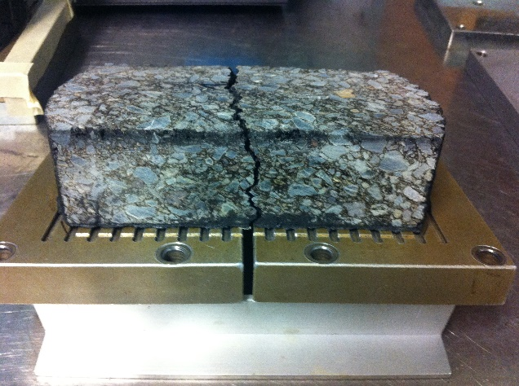
150 mm
38 mm
Steel plate
75 mm
Joint
Figure 1 Overlay test specimen showing crack propagation
The dynamic modulus, E*, is a material property that is used to characterise the viscoelastic behaviour and stiffness of HMA mixtures. For testing, specimens were cut, cored and prepared in accordance with AASHTO Designation PP 60-09 (Texas Department of Transportation, 2014). Six test specimens were prepared from each mix type for dynamic modulus testing. Specimens were cored from compacted mould samples with a diameter of 150 mm and height of 175mm. The final cylindrical test specimen was required to have a diameter of 100 mm and height of 150 mm with an air void tolerance of 7 ± 0.5%. The testing was carried out using the AMPT machine shown in Figure 2 in accordance with the test method set out in AASHTO Designation 79-13 (American Association of State Highway and Transportation Officials, 2013). The test specimens were subjected to sinusoidal compressive loading at temperatures of 4°C, 20°C and 40°C and frequencies of 10 Hz, 1.0 Hz and 0.1 Hz for each temperature. The applied stress and resulting strains were measured and recorded by the AMPT software to calculate the dynamic modulus of all six samples and the results of three samples were reported. The reported results from testing were used to develop dynamic modulus master curves.

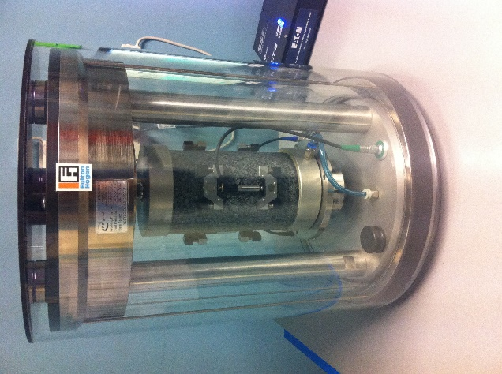
Figure 2 Dynamic modulus set-up using the AMPT
The wheel tracking test is used to test the permanent deformation or rutting performance of asphalt mixtures to give an indication of how the mix will perform in the field when subjected to repeated traffic loading. The test was conducted according to the standard test method set out in AG:PT/T231 (Austroads, 2006). Two slab specimens for each mix type were required for testing and each slab was 300 mm in width, 300 mm in length and 50 mm in height. The slab was fixed to a table and the table oscillated beneath a wheel loaded with 700 N to simulate a tyre moving over the specimen. A vertical displacement measuring device measured and recorded the rut depth of the surface of the slab during the test and each slab was wheel tracked to 20,000 wheel passes. The wheel tracking test was conducted in a temperature controlled cabinet at a constant temperature of 60°C. This temperature was maintained throughout the test.

RESULTS

Overlay test results

Overlay testing was conducted on six test specimens for each mix type. The number of cycles reached was used to evaluate the susceptibility of each mix to reflective cracking and determine if the process of binder rejuvenation had an effect on performance. A greater number of loading cycles reached during the overlay test indicated an increased level of resistance to reflective cracking (Zhou and Scullion, 2005, Mogawer et al., 2011). Table 3 and Figure 3 show the results of the overlay test. The average number of cycles reached by the control samples containing no rejuvenation agent was 369 cycles which was considerably lower than for the rejuvenated samples. Analysis of the data showed that there were statistically significant differences between the control mix and the mixes containing the multipurpose asphalt additive, polyol ester performance additive and naphthenic oil rejuvenation agents. In contrast, there were no statistical differences between the number of cycles reached by the control mix and the mix rejuvenated using the fatty acid asphalt additive. The variances for the number of loading cycles reached were calculated and were all well below the limit of 30% variance specified by the test method set out in TxDOT Tex-248-F (Texas Department of Transportation, 2014). This indicated that the results obtained from overlay testing were statistically satisfactory.

Table 3 Overlay test results
Mix type | Initial tensile load (kN) | Cycles reached | Coefficient of variance (%)
Control | 2.22 | 369 | 6.4
Fatty acid asphalt additive | 1.89 | 501 | 9.5
Modified akylamido-polyamine additive | 1.84 | 694 | 10.0
Polyol ester performance additive | 1.89 | 887 | 11.5
Naphthenic oil regeneration additive | 2.05 | 685 | 10.3

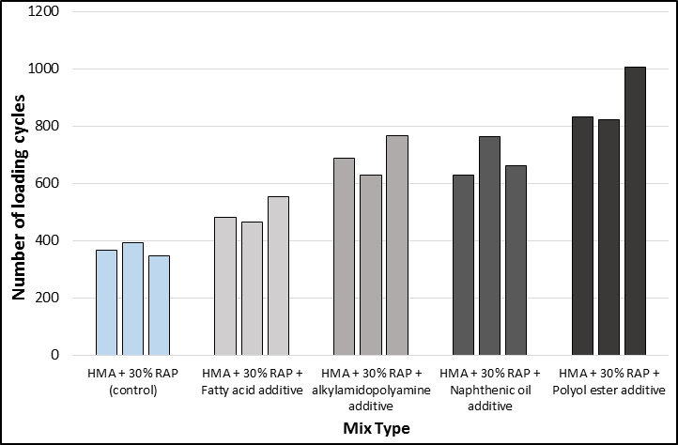
Figure 3 Loading cycles reached during overlay test
The average initial tensile load for the control mix specimens was 2.22 kN which was higher than the initial tensile load for the rejuvenated mixes which ranged between 1.84 kN to 2.05 kN. The average reduction in tensile load of the overlay test specimens is shown in Figure 4. It was observed that the trend in load reduction of the rejuvenated mixes is similar to that of the rejuvenated mixes, with a steep reduction in tensile load within approximately 100 loading cycles. The results obtained from overlay testing clearly show that the addition of rejuvenation agents can significantly improve the reflective cracking resistance of HMA mixes containing 30% RAP when compared to control mixes with no rejuvenation agent. This improvement in performance can be attributed to the process of binder rejuvenation which restores the properties of the aged binder present in the RAP material by rebalancing its chemical composition. The decrease in overall mix stiffness of the rejuvenated mixtures resulted in a decreased susceptibility to reflective cracking. This finding was validated by results obtained from published studies which found that rejuvenation improved the reflective cracking performance parameters of recycled asphalt mixtures (Tran et al., 2012).

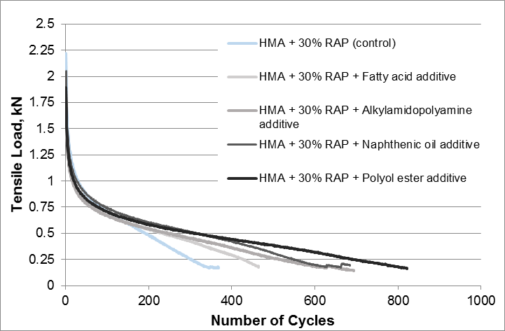
Figure 4 Reduction in tensile load during overlay testing
Previously published studies have found that HMA surfacing mixes containing low quantities of RAP material (10% - 15%), have a similar cracking resistance to virgin HMA mixes (McDaniel and Anderson, 2001). In contrast, higher proportions of RAP such as 30%, may have adverse effects on cracking susceptibility therefore a more comprehensive mix design procedure is required. The use of rejuvenation agents can improve cracking performance properties of mixes with high quantities of RAP and realise more significant economic and material savings. A lack of understanding of the effect of rejuvenation on performance properties and inadequate performance of high recycled HMA mix has limited the use of RAP in high quantities within the paving industry (Austroads, 2013). The results obtained from the presented study provide a valuable understanding of the effect of binder rejuvenation on mix performance and encourage the widespread use of high proportions of RAP in surfacing mixes.

Dynamic modulus test results

The rejuvenated mix demonstrating the most significant improvement to cracking resistance was subjected to further testing to evaluate the effect of binder rejuvenation on the dynamic modulus of the mix. The results of the dynamic modulus testing are shown in Figure 5 which shows the average dynamic modulus for the control and the polyol ester performance additive rejuvenated mixes at the three test temperatures.

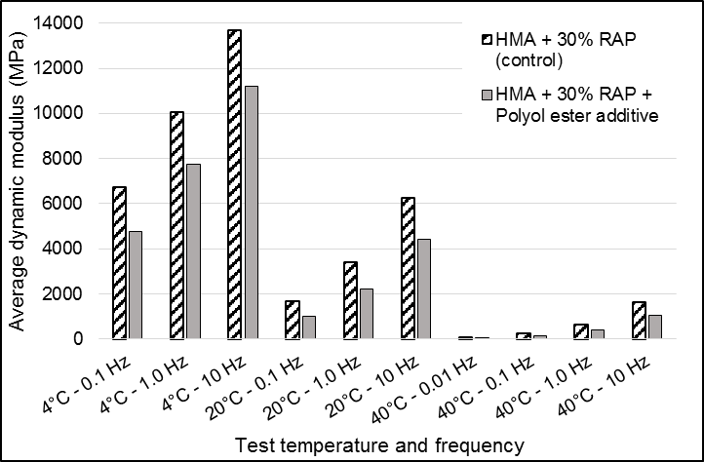
Figure 5 Comparison of average dynamic modulus
At the lowest test temperature of 4°C, there was a statistically significant difference between the average dynamic modulus values of the control mix and the rejuvenated mix for all three frequencies. The difference between the average dynamic modulus values for the control and rejuvenated mixes were statistically significant for the test carried out at 20°C for the 10 Hz and 1 Hz frequencies. At the highest test temperature of 40°C however, the only difference between the average dynamic modulus of the two mixes that was statistically significant was for the values obtained at the highest test frequency of 10 Hz. For the frequencies including 1.0 Hz, 0.1 Hz and 0.01 Hz, the differences between the average dynamic modulus of the control and rejuvenated mix were statistically insignificant. Overall, it was observed that the control mix containing no rejuvenation agent has the highest average dynamic modulus of the two mixes at the three test temperatures. The lower dynamic modulus values of the rejuvenated mix in comparison to the control mix suggest that the addition of the rejuvenation agent decreased the stiffness of the mix. These results also indicate that the high stiffness values obtained for the control mix can be attributed to the presence of aged binder present in the RAP material. All coefficients of variation for the obtained results were within the acceptable range specified by the dynamic modulus standard method of test, therefore the test results were statistically satisfactory (American Association of State Highway and Transportation Officials, 2013).

The dynamic modulus master curves for the control and rejuvenated mixes are shown in Figure 6. The rejuvenated mix had a lower dynamic modulus than the control mix at lower frequencies and this indicates that rejuvenation has an effect on the stiffness behaviour of the HMA mix. At higher frequencies (>100,000 Hz) there was no notable difference between the dynamic modulus of the two mixes. The results observed from the presented study are in agreement with published studies which also found that the dynamic modulus values of rejuvenated HMA mixes were lower than that of control mixes that did not contain any rejuvenation agents (Tran et al., 2012).

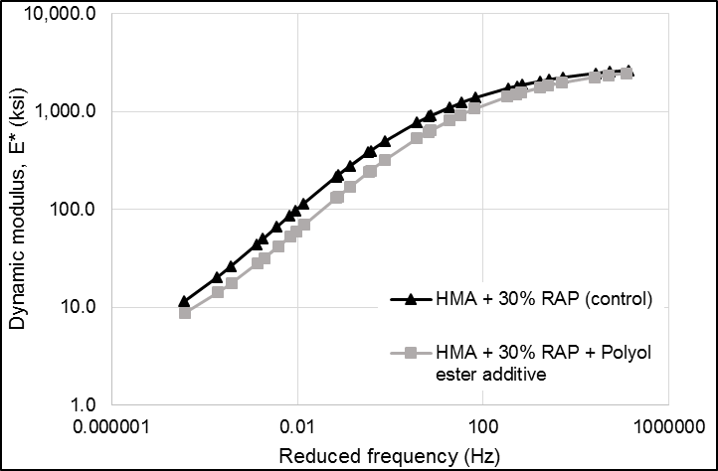

Figure 6 Dynamic modulus master curves
Wheel tracking test results

The rejuvenated mix demonstrating the most significant improvement in cracking resistance as a result of binder rejuvenation was then tested for resistance to permanent deformation by conducting the wheel tracking test. Based on the results obtained from the dynamic modulus testing, the polyol ester performance additive rejuvenator softened the binder present in the RAP material and reduced the stiffness of the overall mix. The wheel tracking test was performed on two rejuvenated slabs and two control slabs to ensure that rejuvenation did not have an adverse effect on the mix deformation properties. During and at the completion of the test, the rutting depth caused by the repeated passing of a loaded wheel of each slab was measured by a vertical displacement device. The results were then used to compare their deformation properties.

The trends in the rut depth of test slabs are shown in Figure 7. The trend in the rutting development was similar for all four slabs with a sudden increase in rut depth at the beginning of the wheel tracking test, followed by a gradual increase in rutting occurring with the increase in number of wheel passes. Table 4 shows the results of the wheel tracking test with the two control slabs having final rut depths of 2.59 mm and 2.82 mm and the two rejuvenated slabs having rut depths of 3.37 mm and 3.42 mm. After 20,000 passes had elapsed, the final rut depths experienced by the four slabs were well below the 6 mm rut depth limit specified in Draft NZTA M/10:2014. This is the maximum allowable rut depth requirement for the design of asphaltic mixes able to withstand heavy and very heavy traffic loading (NZ Transport Agency, 2014). This indicates that the deformation resistance results for the tested slabs, particularly the rejuvenated mix slabs, were satisfactory.

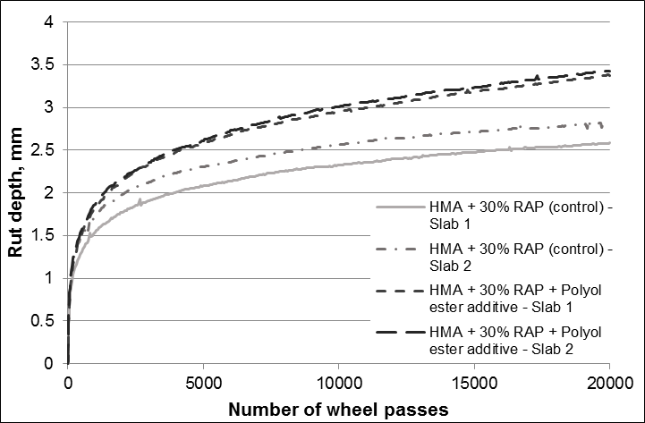
Figure 7 Rut depth development with increasing wheel passes during wheel tracking test
Table 4 Final rut depth results from wheel tracking test
Mix type | Rut depth (mm)
HMA + 30% RAP (control) – slab 1 | 2.59
HMA + 30% RAP (control) – slab 2 | 2.82
HMA + 30% RAP + Polyol ester additive – slab 1 | 3.37
HMA + 30% RAP + Polyol ester additive – slab 2 | 3.42

The rutting results show that there was a notable variation in deformation characteristics between the control and the rejuvenated slabs. The larger rutting depths observed in the rejuvenated slabs could be attributed to rejuvenation and its effect on the stiffness of the mix, resulting in an increased susceptibility to deformation. In general, published studies have shown that the addition of RAP material to HMA mixtures is indicative of increased resistance to permanent deformation which results in lower rut depths (Bonaquist et al., 2003 , McDaniel et al., 2000). The results from the present research align with previously published studies which found the incorporation of rejuvenators to mixtures containing high proportions of RAP to reduce rutting resistance (Mogawer et al., 2013).

Overall, the results from the overlay testing, dynamic modulus testing and wheel tracking provide a comprehensive understanding of the effect of binder rejuvenation on the mechanical performance of HMA mixes containing 30% RAP. Although small quantities are regularly used in New Zealand for asphalt surfacing mixes, the use of larger quantities of RAP in practice is not as common and requires a more extensive mix design procedure to ensure adequate performance. This is not required for HMA mixes containing small quantities of RAP (10% - 15%), as the performance properties are not adversely affected. However, when larger quantities of RAP are used, the economic and material savings can be further increased. Although the use of high quantities of RAP may have adverse effects on mix performance, it has been found that rejuvenation agents can improve cracking resistance of RAP mixes without significantly compromising deformation properties.

DISCUSSION AND CONCLUSIONS

This study was carried out in order to investigate the effects the addition of various rejuvenation agents has on the performance of HMA mixes containing high proportions of RAP. The test methodology addressed the effect of rejuvenation on reflective cracking resistance, mix stiffness and resistance to deformation by conducting dynamic modulus tests, overlay tests and wheel tracking tests on laboratory prepared HMA specimens.

It was observed from the overlay testing that the addition of rejuvenation agents, particularly the polyol ester performance additive rejuvenation agent, significantly improved the cracking resistance of HMA mixes containing 30% recycled material. There was a statistically significant difference between the control and all rejuvenated mixes except for the mix rejuvenated using the fatty acid oil derivative. The addition of the polyol ester rejuvenation agent also decreased the dynamic modulus, or stiffness, of the mix when compared to the control and this only had a limited effect on the deformation properties of the rejuvenated mix. When considering the effect of rejuvenation on the deformation resistance of the mix, it was observed that the rutting depths of the rejuvenated HMA slabs were slightly greater than that of the control slabs. However, the rutting depths for both mixes were well below the acceptable limit for the standard test.

A recommendation that has eventuated from this research is a need for further investigation into the long-term effect of binder rejuvenation on pavement performance. The results obtained in the laboratory from overlay testing and dynamic modulus testing have been shown to have a strong correlation with long-term observations from previous field studies (Zhou et al., 2007), however, previous research has indicated that the rejuvenation process continues to have an effect on the binder properties over a long period of time (Karlsson, 2000, Zaumanis et al., 2014b). The performance of an asphalt pavement is dependent on environmental and loading conditions to a large degree, therefore to fully investigate the effects of binder rejuvenation on pavement performance, full-scale pavement sections need to be set up in the field. From this, the effect of rejuvenation on pavement properties can be monitored over time in an Australia or New Zealand context.

A ‘life-cycle’ approach should be taken to assess the commercial viability of using rejuvenation agents to facilitate the use of higher percentages of RAP material in asphalt mixes. This form of analysis can be applied to compare the cost and environmental impact of conventional HMA construction to the cost of recycled HMA construction over the entire life time of the pavement. Previous studies have assessed the material related costs of producing rejuvenated, recycled HMA and how the cost is affected by increasing the RAP content of the mix. As shown in Figure 8, the general trend that was observed from the analysis was that as the RAP content increases, the rejuvenation cost also increases, relative to the total production cost. However, at RAP proportions of 30%, the large majority of the total cost is contributed by the price of the virgin aggregate and binder (Zaumanis et al., 2014a). The environmental and material savings from reusing greater proportions of RAP will need to be balanced against the cost of the use of rejuvenation additives. This will need to include direct savings from reducing the demand on virgin binder and aggregate as well as the non-tangible environmental benefits. These savings need to be quantified in order to account for the expenses associated with additional RAP processing, laboratory and field testing, modifications to asphalt plant equipment and the cost of the rejuvenation agent. Although this may be a significant investment, it may prove advantageous to the New Zealand and Australia paving industry if the results from a full-scale field trial demonstrate adequate performance of rejuvenated mixes.

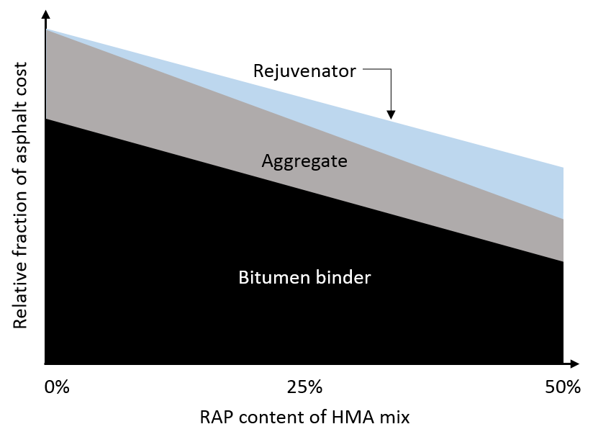
Figure 8 Simplified material related costs for recycled HMA mixes (adapted from Zaumanis et al. (2014a))
The findings of the presented study provide a valuable understanding of the performance of high recycled HMA mixes and in particular, the effect of different rejuvenation agents on their performance parameters. Performance testing has validated the effect of rejuvenation and allowed for the prediction of pavement performance in the long term. The results of the study also confirm what is fundamentally understood regarding the effect of rejuvenators on the performance properties of RAP mixes. These findings can be used to support the use of higher quantities of RAP for HMA pavement surfacing applications by validating the mechanical performance of rejuvenated mixes.

ACKNOWLEDGEMENTS

The financial provided for this research by the ARRB Group Ltd through the University Research Support Grant Scheme is gratefully acknowledged. The authors would like to acknowledge the Fulton Hogan Auckland Technical Division Research & Development Laboratory and the Fulton Hogan Auckland Laboratory for their contributions to the study.

REFERENCES

AMERICAN ASSOCIATION OF STATE HIGHWAY AND TRANSPORTATION OFFICIALS 2013. AASHTO Designation: PP 79-13 Standard Method of Test for Determining the Dynamic Modulus and Flow Number for Asphalt Mixtures Using the Asphalt Mixture Performance Tester (AMPT). Washington D.C., United States of America: American Association of State Highway and Transportation Officials.
AUSTROADS 2006. AG:PT/T231 - Deformation Resistance of Asphalt Mixtures by the Wheel Tracking Test.
AUSTROADS 2013. Maximising the Re-use of Reclaimed Asphalt Pavement: Binder Blend Characterisation. Sydney, Australia.
AUSTROADS 2015. Maximising the Re-use of Reclaimed Asphalt Pavement - Outcomes of Year Two: RAP Mix Design. Sydney, Australia.
BONAQUIST, R. F., CHRISTENSEN, D. W. & STUMP, W. 2003 NCHRP 513 Simple Performance Tester for Superpave Mix Design: First-Article Development and Evaluation. Washington D.C., United States of America.
HOLLERAN, G., HOLLERAN, I. & JAYALATH, C. 2013. Overlay Testing and Surface Mixes. AAPA 15th International Conference. Brisbane, Australia.
KARLSSON, R. 2000. Laboratory Studies of Bitumen Rejuvenator Diffusion Using FTIR-ATR. Royal Institute of Technology.
LI, X., MARASTEANU, M. O., WILLIAMS, C. & CLYNE, T. R. 2008. Effect of Reclaimed Asphalt Pavement (Proportion and Type) and Binder Grade on Asphalt Mixtures. Transportation Research Record: Journal of the Transportation Research Board, 2051, 90-97.
MCDANIEL, R. & ANDERSON, R. M. 2001. NCHRP 452 Recommended Use of Reclaimed Asphalt Pavement in the Superpave Mix Design Method: Technician's Manual. Washington D.C., United States of America.
MCDANIEL, R., SOLEYMANI, H., ANDERSON, R. M., TURNER, P. & PETERSON, R. 2000. Recommended Use of Reclaimed Asphalt Pavement in the Superpave Mix Design Method.
MOGAWER, W. S., AUSTERMAN, A. J., BONAQUIST, R. & ROUSSEL, M. 2011. Performance Characteristics of Thin-Lift Overlay Mixtures High Reclaimed Asphalt Pavement Content, Recycled Asphalt Shingles, and Warm-Mix Asphalt Technology. Transportation Research Record: Journal of the Transportation Research Board, 2208, 17-25.
MOGAWER, W. S., BOOSHEHRIAN, A., VAHIDI, S. & AUSTERMAN, A. J. 2013. Evaluating the effect of rejuvenators on the degree of blending and performance of high RAP, RAS, and RAP/RAS mixtures. Road Materials and Pavement Design, 14, 193–213.
NZ TRANSPORT AGENCY 2014. Draft Specification for Dense Graded and Stone Mastic Asphalts. Wellington, New Zealand: New Zealand.
SHEN, J., AMIRKHANIAN, S. & TANG, B. 2007. Effects of rejuvenator on performance-based properties of rejuvenated asphalt binder and mixtures. Construction and Building Materials, 21, 958–964.
STANDARDS AUSTRALIA 1995a. AS 2891.2.1-1995 Sample preparation – Mixing, quartering and conditioning of asphalt in the laboratory. Sydney, Australia: Standards Australia Limited.
STANDARDS AUSTRALIA 1995b. AS 2891.2.2 -1995 Sample preparation - Compaction of asphalt test specimens using a gyratory compactor. Sydney, Australia: Standards Australia Limited.
TEXAS DEPARTMENT OF TRANSPORTATION 2014. TxDOT Designation: Tex-248-F Test Procedure for Overlay Test Texas, United States of America: Texas Department of Transportation.
TRAN, N. H., TAYLOR, A. & WILLIS, R. 2012. Effect of Rejuvenator on Performance Properties of HMA Mixtures with High RAP and RAS Contents. Auburn, Alabama: Auburn University.
ZAUMANIS, M., MALLICK, R. B. & FRANK, R. 2014a. 100% recycled hot mix asphalt: A review and analysis. Resources, Conservation and Recycling, 92, 230-245.
ZAUMANIS, M., MALLICK, R. B. & FRANK, R. 2014b. Determining optimum rejuvenator dose for asphalt recycling based on Superpave performance grade specifications. Construction and Building Materials, 69, 159–166.
ZHOU, F., HU, S., CHEN, D. & SCULLION, T. 2007. Overlay Tester Simple Performance Test for Fatigue Cracking. Transportation Research Record: Journal of the Transportation Research Board, 2001, 1–8.
ZHOU, F. & SCULLION, T. 2005. Overlay Tester: A Rapid Performance Related Crack Resistance Test. Austin, Texas: Texas Transportation Institute.

