**Modelling disrupted networks: A review of the modelling simulators**

Dana Abudayyeh

PhD Candidate, University of Canterbury, New Zealand

Dana.abudayyeh@pg.canterbury.ac.nz

**Abstract**

Different traffic representation levels are used to model traffic; macro-, micro-, meso-scopic, and hybrid models. These models are used by various computer packages to simulate degradations of a road network and estimate the economic impacts (e.g. increased costs for freight and travellers). Simulation models are based on the user equilibrium principle which states that “the journey times on all the routes actually used are equal, and less than those which would be experienced by a single vehicle on any unused route”. This principle, also known as Wardrop’s first principle, is used differently in different types of models. For instance, in microscopic simulation models, optimal paths are recalculated periodically and vehicles re-assigned to new optimal paths, to take account of route changes after a trip has begun in case of blockage to reduce delay. In the absence of disruption or congestion, no re-assignment will occur. This regular “updating” is more appropriate for studying short-term capacity reductions. In contrast, mesoscopic models do not allow for re-assignment of traffic after a trip has commenced. This probably results in inaccurate estimates of delays. However, some mesoscopic packages have what is called the time slices facility (quasi-dynamic) as in SATURN package. This facility can be used to simulate short-term closures with less computational effort and running time than microscopic models (full dynamic models).

While the reviewed studies discussed and combined mesoscopic and microscopic models, no studies have been found that discuss the circumstances in which each type of model is most appropriate for modelling different types of traffic disruption (i.e. short-term and long-term disruptions), one question remains: what are the factors and the circumstances which indicate that one should select one model rather than the other? This paper gives a better understanding of the relative merits of each model to simulate disrupted road networks.

1. **Background**

Different traffic representation levels are used to model traffic; macro-, micro-, meso- scopic, and hybrid models. Macroscopic models, deal with the relationships of flow, speed, and density. These type of models accept a coarse level of input data (i.e. aggregate variables), such as; link configuration (i.e. number of lanes, intersection form etc). In macroscopic models, a four-step model (trip generation, trip distribution, mode choice, and route assignment) is utilised to predict the volume of demand and travel patterns (i.e. origin-destination (O-D), mode choice and route choice). Data may be aggregated at zonal level or at household level, rather than predicting the individual behaviour of each vehicle in the system. On the other hand, microscopic models deal with the movements of individual vehicles by using a car-following model (for predicting braking and accelerating behaviour of drivers of all following vehicles), a lane-changing model (for predicting the ability to manoeuvre), a gap- acceptance model (for predicting gap acceptance decisions at intersections) and a route-choice model (i.e. describes how drivers choose which path to take from their origin to destination and how they react to traffic information along the way). All four types of model allow for variations in driver characteristics (e.g. how aggressive they are and how familiar they are with the network). Microscopic traffic flow models require, in addition to the parameters required by macroscopic models, fine-detailed information about vehicle and driver behaviour performance parameters, and road geometry and layout.

Mesoscopic models fill the gap between macroscopic and microscopic, and their properties are a mixture of the properties of both microscopic and macroscopic models (Hadi et al., 2007). As in microscopic models, the mesoscopic models’ unit of traffic flow is the individual vehicle; however, the movements of vehicles are modelled by utilizing macroscopic models, as discussed later.

Macro-, meso-, and micro-scopic modelling approaches are used within various computer packages to simulate degradations of a road network performance and subsequently estimate the economic impacts (e.g. increased costs for freight and travellers). Barceló (2010) defined the term “simulation” as “an alternative to analytical models consisting of a technique that imitates on a computer the operation of a real-world system as it evolves over time”. Thus, traffic simulation models are able to emulate the movement of vehicles in the traffic flow. It should be noted that the term is used more frequently with microscopic and mesoscopic modelling, as in macroscopic models (i.e. strategic models) a larger scale is used and there is no need to simulate individual vehicles. In what follows, more detail about simulation programmes will be provided.

Simulation models, as with virtually all models for predicting traffic flows on networks, are based on the user equilibrium principle. According to Barceló (2010) “the concept of user equilibrium assumes that travellers try to minimize their individual travel times, that is, travellers choose the routes that they perceive to be the shortest under the prevailing conditions”. This is consistent with Wardrop’s first principle (1952) that “the journey times on all the routes actually used are equal, and less than those which would be experienced by a single vehicle on any unused route”. Wardrop’s first principle is used differently in different types of models. For instance, in microscopic simulation models, optimal paths are recalculated periodically and vehicles re-assigned to new optimal paths, to take account of route changes after a trip has begun in case of blockage to reduce delay. In the absence of disruption or congestion, no re-assignment will occur. This regular “updating” is more appropriate for studying short-term capacity reductions (Berdica et al., 2003a). In contrast, mesoscopic models do not allow for re-assignment of traffic after a trip has commenced. This probably results in inaccurate estimates of delays as will be discussed later in this paper. After a blockage and congestion occurs, traffic generally diverts around the blockage to reduce delay, so if a model does not allow for such diversion, it might over-estimate the impact of the blockage, making it unsuitable for assessing the impact of short-term congestion reductions. However, some packages have what is called the quasi-dynamic facility as in SATURN package. This facility can be used to simulate short-term closures with less computational effort and running time than microscopic models (full dynamic models). This paper gives an in depth review of different traffic models and simulators in case of a network disruption.

1. **Macro-, meso-, and micro-scopic models**

In this section macro-, micro-, meso-scopic, and hybrid models are described.

### **Macroscopic Models**

Macroscopic models of traffic flow, also known as strategic models, are based on the traffic flow theory describing the relationship between, volume, speed, and density. These models attempt to classify the average behaviour of a link instead of the behaviour of a specific vehicle. Typically, macroscopic models are based on a four- step model, involving trip generation, trip distribution, mode split, and trip assignment.

Macroscopic model applications usually have fewer parameters to calibrate and are less sensitive to small changes in network coding, which means the model running time is shorter than microscopic models. However, they are limited to the cases where the interaction of vehicles is not crucial to the results of the simulation (Burghout and Wahlstedt, 2007).

### **Microscopic Models**

In microscopic models, the interactions of individual vehicles are represented by vehicle acceleration and deceleration, lane changing behaviour and gap acceptance. They produce space-time trajectories of vehicles as they move through the network (FHWA, 2004).

There are a number of concerns related to applying microsimulation models, summarised by Akçelik (2007) and Zhang et al. (2010) as follows:

* The large amount of detail needed when modelling a road network.
* The slowness of input data preparation, and running time for large scale applications.
* The large effort needed to calibrate the model with a large amount of parameters.

As a result, this makes developing microscopic models for large networks very challenging, especially if there is a very large number of vehicles in a network, when it may not be possible for the software to keep track of every vehicle.

In the presence of Intelligent Transportation Systems (ITS) applications (e.g. ramp controls, or adaptive traffic signal control systems), it has been noticed (Barceló et al., 2005; Burghout and Wahlstedt, 2007) that microscopic simulation models are suited to modelling both vehicle interactions and drivers’ reactions, when exposed to such applications at the high level of detailed required. The possibility of modelling route choice in microsimulation models is important when evaluating ITS systems that help drivers decide their routes via en-route messages.

### **Mesoscopic Models**

Mesoscopic models simulate individual vehicles, but describe their interactions based on macroscopic relationships. For example, they can simulate the routing of individual vehicles equipped with in-vehicle, real-time travel information systems. The travel times are determined from the simulated average speeds on the network links and nodes. The average speeds are, in turn, calculated from a speed-flow relationship (FHWA, 2004). Mesoscopic models deal with platoon dispersion and queuing, in which the vehicle departure profile, arrival pattern, and the average travel time in the link are estimated.

Mesoscopic models have shown some weakness related to accurate modelling of adaptive signal control as both the positions of vehicles and the behaviour of driver are approximated (Burghout, 2004).

### **Hybrid Models**

Some studies have involved approaches that try to develop links between macro-, meso-, and micro-scopic models. Those approaches can be classified into two main categories:

* Micro- with macro-scopic models.

For instance, Helbing et al. (2002) proposed a simple algorithm (deriving macroscopic traffic models from given microscopic car-following models) to combine micro- and macro-scopic models to carry out simultaneous micro- and macro-scopic simulations of freeway sections. More models were developed using this approach (e.g. Bourrel and Lesort, 2003; and Magne et al., 2000).

* Micro- with meso-scopic models.

A hybrid meso-micro model (Mezzo) has been proposed by Burghout (2004). The main advantage of the Mezzo model is the ability to model large networks with increased accuracy, plus a reduced data requirement and easier calibration (see also Horowitz, 2003; Casas et al., 2011).

Since mesoscopic is between macroscopic and microscopic, this makes it more reasonable to use a hybrid micro- meso model, but it should be kept in mind that vehicles in mesoscopic models and vehicles in microscopic models are not treated the same.

Figure (1), shows a method for classifying model-types, duration of degradation and extent of degradation. However, the boundaries between the levels of detail, the levels of duration, and the extent of degradation have not been defined previously.

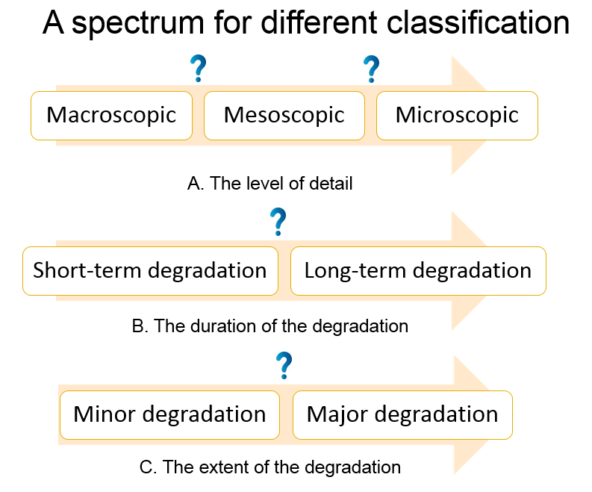

Figure 1: A method for different classifications

## **Simulation Packages**

Various traffic simulation packages have been used to simulate traffic at the macro-, meso-, and micro-scopic scale, for different duration events. The most widely used packages are: Paramics (Parallel microscopic simulation), AIMSUN (Advanced Interactive Microscopic Simulator for Urban and nonurban Networks), VISSIM (Verkehr in Stadten Simulation), CORSIM (CORridor SIMulation), SATURN (Simulation and Assignment of Traffic to Urban Road Network), TRANSIM (TRansportation ANalysis SIMulation System), Cube, Emme, TRACKS, and Transyte (Traffic Network and Isolated Intersection Study Tool).

The literature does not provide a clear cut result on which traffic simulation program gives the best results; this may be due to the fact that the performance of the software depends on the situation. Moreover, the literature review showed disagreement over the classification of traffic modelling software into the three different levels of detail (macro-, meso-, and micro-scopic). Different classifications were given to the same programme, based on different perspectives. For example; TRANSIMS was termed microscopic by some (Cheng and Wang, 2013; Hobeika and Paradkar, 2004; Zhang et al., 2010), while it was reported that TRANSIMS was developed as a replacement for the four-step travel demand model (Rilett, 2001). Furthermore, SATURN was classified as microscopic modelling software (Ratrout and Rahman, 2009), as macroscopic modelling software (Andjic, 2000), and as mesoscopic modelling software (Berdica et al., 2003b).

More details about SATURN, Paramics, and AIMSUN will be discussed in the following paragraphs, as these three packages are the most commonly used to simulate traffic.

* 1. **SATURN**

SATURN was developed at the Institute for Transport Studies, University of Leeds (Van Vliet, 2014). Two distinct forms of input data are required by SATURN; an O-D trip matrix representing zone to zone trip demands for the period of interest, and a network description (e.g. junction type, lane structure, saturation flows). Both the trip matrix and network data are input to a “route-choice” model, which allocates trips to routes, using an equilibrium approach.

SATURN provides two levels of detail; a “simulation” network, which is used to describe a traffic management scheme where the impacts are crucial and large, and a “buffer” network, which is used where the traffic impact management scheme is less critical. The buffer network, which is normally surrounding the simulation network, is coded in less detail.

SATURN assigns travel demands between discrete geographical areas (zones) to most likely routes, and then simulates travel times on roads and through intersections. The complete model is based on an iterative loop between the assignment and simulation phases. Thus, the simulation determines flow-delay curves based on a given set of turning movements and feeds them to the assignment. The assignment in turn uses these curves to determine route choice and updated turning movements. These iterations continue until the turning movements reach reasonably stable values (Ortúzar and Willumsen, 2011).

One feature of interest in SATURN is what is called “Time-Slicing”, with the traffic conditions at the end of a time-slice being the starting conditions for the subsequent time slice. If a network is modelled from 8:00am-10:00am, small intervals (say 10 minutes) could be used to calculate the average flow rate. This interval is user-set. By using this feature, short-term degradation might be simulated by using SATURN, since the traffic condition for short intervals can be captured. It should be noted that the duration of the interval is directly related to the simulation running time. For instance, for a two hour simulation interval, using a 1-minute time slice will need more running time than a 10 minutes time slice, as SATURN will develop 120 scenarios versus only 12, respectively.

* 1. **Paramics**

Paramics simulates each individual vehicle for its entire trip through the network. The movement of individual vehicles is governed by interacting models representing vehicle following, gap acceptance, lane changing behaviour and route choice. The interacting models are applied at the same time to simulate the traffic condition. Every time a vehicle moves onto a new link the programme re-evaluates its route choice and determines its next two turns, preferring options offering the minimum delay. Thus a Paramics model is not a traditional network equilibrium model, but a dynamic model (SIAS, 2010).

The input data in Paramics includes the physical layout of the road network represented by nodes and links and other details describing the geometry. Traffic demand is represented by a matrix of origin/ destination movements. Both static (i.e. remaining constant throughout the simulation) and dynamic (i.e. updated at each time step of the simulation) sets of parameters for each driver are presented. Static Parameters include vehicle type, “driver aggression” (used for determining the critical gap for lane changing, etc.) and “awareness” (to distinguished between drivers who are familiar or unfamiliar with the road network) parameters. These parameters are important to better estimate the travel time. Dynamic parameters include vehicle position and travel time.

To build a Paramics model, both network data (i.e. lanes, junctions, timings, etc.) and trip matrices (for driver/vehicle) are used as input data. During the simulation vehicles are released from the origin and make their own way towards the destination. Paramics applies the vehicle following, lane-changing, gap-acceptance and route-choice models, and keeps updating the vehicle position, speed and acceleration, and driver experience (e.g. time stopped and elapsed journey time). The complete model is based on an iterative loop between the assignment and simulation phases (Laird and Nicholson, 2000). It should be noted that Paramics generates traffic randomly. Hence, if 60 vehicles move from an origin to a destination in an hour, the time between vehicles departing the origin varies randomly, with a mean of one minute. It is necessary to do multiple runs (6-10, say), to get reasonable estimates of the total travel time or total delay.

* 1. **AIMSUN**

AIMSUN can simulate mesoscopic, microscopic and hybrid models. This dynamic model has been developed at the Universitat Politecnica de Catalunya in Barcelona in the mid of 1980s. It is marketed by TSS-Transport Simulation Systems in Spain (www.aimsun.com). AIMSUN has a user friendly interface (Application Programming Interface) as well as the ability to use Python to code complicated traffic scenarios. As other microscopic simulation models, AIMSUN models the movement of individual vehicles in the road networks. This model is becoming popular for simulating ITS (i.e. dynamic route guidance systems, incident management systems, and ramp metering).

The input data in Aimsun includes a variety of options related to the geometry, driver, and vehicle characteristics. The position and speed of each vehicle keeps updating through the simulation. Traffic demand is represented in two ways either using a matrix of origin-destination movements or what is called traffic states in which the turn of the traffic flow proportions at every node of the network can be defined. To build a model, network coding (i.e. lanes, sections, connections, etc.), demand (for driver/vehicle), along with the type of control are used as input data. It is necessary to do multiple runs (15-20, say), to get reasonable estimates of the total travel time or total delay.

1. **Applications**

Three models, being Paramics, SATURN, and TRACKS models (represent micro-, meso-, and macro-scopic models respectively) have been developed for the area around the University of Canterbury, Christchurch, New Zealand. It should be noted that the aim of developing these models was to simulate traffic demand and flow in general, without focusing on traffic disruptions. These applications are summarised as follows:

* Cameron (1996) used SATURN to model different flow conditions, and the results were analysed and compared against observed traffic flow behaviour at a four signalised and two roundabout controlled intersections. The results showed that the morning and afternoon link flows compare favourably with the model, except that there is a wide variation in link flows at the roundabouts and signalised intersections.
* Laird and Nicholson (2000) developed a microscopic simulation model using Paramics software, the model calibration showed two kinds of error; that associated with the modelled flow (e.g. simplifications made in the route choice model or network description), and that associated with the observed flow (e.g. manual traffic count). The model demonstrated a good level of fit to screenline and link flows throughout the model area. Moreover, link flows met accepted calibration criteria, with the calibration for key route links being slightly better compared than for non-key route links.
* Andjic (2000) has developed a TRACKS model, modified the Cameron SATURN model and compared them. The two model flows were also been compared the link flows in normal condition from Paramics. It was concluded that TRACKS and SATURN can complement each other, as TRACKS can be used to identify parts of a network that require traffic management schemes to be applied, and SATURN can be used to evaluate such schemes in detail. This is consistent with the classification of models as macro-, micro-, or meso-scopic, with TRACKS being a macro-scopic model. The calibration check showed good agreement between the modelled and observed traffic flows data for both the AM and PM networks.

Two other studies have involved applying macro-, meso-, and micro-scopic simulation models for assessing the impact of short incident events. Firstly, Berdica et al. (2003) investigated the implications of model choice in detail. Three computer programs (TRACKS, SATURN, and Paramics) were used to simulate traffic on the road network around the University, for the same traffic demand.

Complete closures of 10, 20, 30 and 40 minutes were simulated for one link, with the mid-point of each closure scenario being 8:30 am. The average time spent travelled on the road network for different closure durations as estimated using Paramics can be seen in Figure (2).

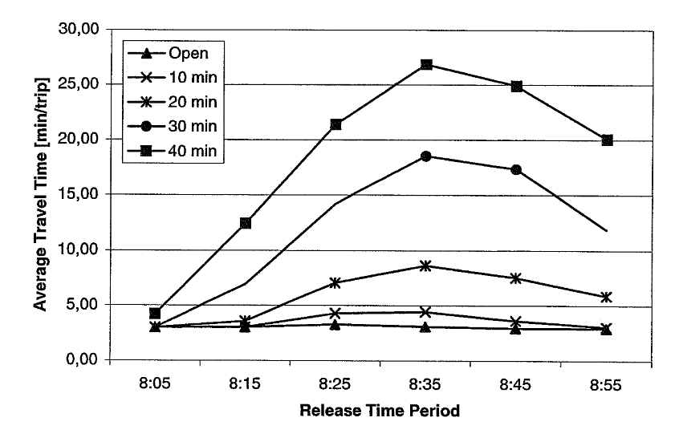

Figure 2: Average travel time for different closure durations using Paramics

Source: Berdica et al. (2003)

It is interesting to notice the average travel time between closure intervals. If the mid-point of the closure is taken as a base to compare, it is clear that the difference in average travel time between the 20 minute and 30 minute closures is almost twice the difference between the 10 minute and 20 minute closure intervals. One might therefore expect a larger difference between the 30 minute and 40 minute closures, but this seems not to be the case (the difference decreased). This could be due to the size of the simulated network not being large enough to model all the re-routing of drivers when the period of closure is long. This research will seek to find an explanation for this unexpected result.

Moreover, the results of the study showed that Paramics is more sensitive to disturbances and disturbances duration. Travel times obtained using TRACKS increased only a little as closure duration increased as can be seen in Figure (3). For the first 10 minutes of closure, the travel time is increased by 18% in Paramics compared to a 1% increase in TRACKS, while SATURN did not predict a noticeable increase for a closure up to 30 minutes long. This may indicate that the time-slicing feature in SATURN was not used, while the upward trend in TRACKS indicated that time-slicing was used. It appears that, microsimulation is able to better simulate short-term disturbances in the road transportation system.

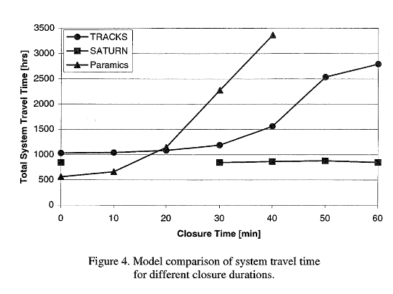

Figure 3: Model comparison of system travel time for different closure durations

Source: Berdica et al. (2003)

It is worth noting that the size of the network should depend upon the level and duration of the degradation and the subsequent spatial distribution of re-routed traffic. For a partial, short-term degradation, a small sized network will give good simulation results, as not many drivers will divert far from their route to avoid congestion. However, in the case of complete, long-term degradation, more drivers will divert far from their route, to avoid congestion and decrease the travel time, and the new path could be outside the boundaries of the simulated network, which will mean inaccurate estimates of the effect of the degradation.

Recently, another study conducted by Wilmshurst et al. (2015) applied CUBE, SATURN, and Paramics model which represent macro-, meso-, and micro-scopic models respectively, to estimate the impact of a blockage on the road network northern Christchurch. The modelled network covered the Northwood, Belfast and Kaiapoi areas (i.e. the northern corridor into and out of Christchurch). The studied area is well covered by a Bluetooth (BT) journey time data system and NZ Transport Agency (NZTA) permanent traffic count sites. BT data was investigated for both directions of travel. The NZTA traffic count data was used to determine the volumes in key locations and factor up the BT volume sample. The study concluded that the microscopic model represented by Paramics is able to give a more robust estimate of the actual impacts compared with other traditional “strategic” models (i.e. CUBE). However, there was no mention of using the time-slicing feature in this study.

It should be noted that two main concerns should be considered when collecting data using BT detector. The first one is that BT data is not able to provide accurate estimates of traffic flows due to the multiple signals or no signals from a vehicle, thus BT data should be compared to traffic volume counts collected via another method (Nelson, 2010). The second point is the ability to work effectively under a long-term disruption, when the demand might exceed the capacity and may affect the BT detectors accuracy (e.g. the signal speed and time).

Koorey et al. (2014) investigated the ability of using ITS (adaptive signal control and VMS) to detect the respond to traffic accidents and the most appropriate traffic management strategies to apply when such incidents are detected. The study concluded that incident management plans are most effective when there are sufficient vehicles present to benefit from any plan implemented, there is at least one obvious diversion route, and there is sufficient spare capacity to enable diversion routes to work better than the original routes. The study developed a template which can be applied to testing potential scenarios for a particular network being managed for identifying the most significant risks to a network.

**5. Conclusions and future research**

This paper presented a review of the literature for different types of models which are used to simulate road traffic networks. While the reviewed studies discussed and combined mesoscopic and microscopic models, no studies have been found that discuss the circumstances in which each type of model is most appropriate for modelling different types of traffic disruption (i.e. short-term and long-term disruptions), one question remains: what are the factors and the circumstances which indicate that one should select one model rather than the other? In addition, the boundaries between the levels of detail, the levels of duration, and the extent of degradation are arbitrary and not clearly defined. A better understanding of the relative merits of each model in different situations is needed for accurate simulation of road networks.

**References**

Akçelik, R., 2007. Microsimulation and Analytical Models for Traffic Engineering.

Andjic, Z., 2000. University of Canterbury Traffic Study: Development of SATURN and TRACKS Models (Master of engineering thesis). Department of Civil and Natural Resources Engineering, University of Canterbury, Christchurch, New Zealand.

Barceló, J. (Ed.), 2010. Fundamentals of Traffic Simulation, International Series in Operations Research & Management Science. Springer New York, New York, NY.

Barceló, J., Codina, E., Casas, J., Ferrer, J.L., García, D., 2005. Microscopic traffic simulation: A tool for the design, analysis and evaluation of intelligent transport systems. J. Intell. Robot. Syst. 41, 173–203.

Berdica, K., Andjic, Z., Nicholson, A.J., 2003a. Simulating Road Traffic Interruptions- Does it Matter What Model We Use? Presented at the Network Reliability of Transport. Proceedings of the 1st International Symposium on Transportation Network Reliability (INSTR), Kyoto, Japan.

Berdica, K., Andjic, Z., Nicholson, A.J., 2003b. Simulating Road Traffic Interruptions- Does it Matter What Model We Use? Presented at the Network Reliability of Transport. Proceedings of the 1st International Symposium on Transportation Network Reliability (INSTR), Kyoto, Japan.

Bourrel, E., Lesort, J.-B., 2003. Mixing Microscopic and Macroscopic Representations of Traffic Flow: Hybrid Model Based on Lighthill-Whitham-Richards Theory. Transp. Res. Rec. J. Transp. Res. Board 1852, 193–200.

Burghout, W., 2004. Hybrid microscopic -mesoscopic traffic simulation (Doctoral Dissertation, Royal Institute of Technology). Stockholm, Sweden.

Burghout, W., Wahlstedt, J., 2007. Hybrid Traffic Simulation with Adaptive Signal Control. Transp. Res. Rec. J. Transp. Res. Board 1999, 191–197.

Cameron, L., 1996. A Traffic Model for The University of Canterbury and its Environs (Masters thesis, Department of Civil and Natural Resources Engineering, University of Canterbury). University of Canterbury, Christchurch, New Zealand.

Casas, J., Perarnau, J., Torday, A., 2011. The need to combine different traffic modelling levels for effectively tackling large-scale projects adding a hybrid meso/micro approach. Procedia - Soc. Behav. Sci., The State of the Art in the European Quantitative Oriented Transportation and Logistics Research – 14th Euro Working Group on Transportation & 26th Mini Euro Conference & 1st European Scientific Conference on Air Transport 20, 251–262.

Cheng, L.-C., Wang, H., 2013. Modeling User Equilibrium in Microscopic Transportation Simulation. J. Transp. Res. Forum JTRF 52, 85–102.

FHWA, 2004. Traffic Analysis Toolbox Volume III: Guidelines for Applying Traffic Microsimulation Modeling Software (No. FHWA-HRT-04-040). Federal Highway Administration.

Hadi, M., Sinha, P., Wang, A., 2007. Modeling Reductions in Freeway Capacity due to Incidents in Microscopic Simulation Models. Transp. Res. Rec. J. Transp. Res. Board 1999, 62–68.

Hall, M., Van Vliet, D., Willumsen, L.G., 1980. SATURN - A Simulation-Assignment Model for the Evaluation of Traffic Management Schemes - TEC : Traffic Research Hub. Traffic Eng. Control 21, 168–176.

Helbing, D., Hennecke, A., Shvetsov, V., Treiber, M., 2002. Micro- and Macro-simulation of Freeway Traffic. Math. Comput. Model. 35, 517–547.

Hobeika, A.G., Paradkar, R., 2004. Comparative Analysis of Household Activity Matching Approaches in Transportation Analysis and Simulation System. J. Transp. Eng. 130, 706–715.

Horowitz, R., 2003. Development of Integrated Meso/Microscale Traffic Simulation Software for Testing Fault Detection and Handling Algorithms in AHS: Final Report. Calif. Partn. Adv. Transit Highw. PATH.

Koorey, G., McMillan, S., Nicholson, A., 2014. The Effectiveness of Incident Management on Network Reliability-Stage 2. NZ Transport Agency research report LTR-118 (unpublished).

Laird, J., Nicholson, A., 2000. Application of Microsimulation Traffic Modelling to a New Zealand Road Network. University of Canterbury, Christchurch, New Zealand.

Magne, L., Rabut, S., Gabard, J.F., 2000. Towards a Hybrid Macro-micro Traffic Flow Simulation Model. INFORMS Salt Lake City.

Nelson, D., 2010. Blu Fax Applictions July 15 2010.

Ortúzar, J. de D., Willumsen, L.G., 2011. Modelling Transport, 4th Edition. ed. Wiley, England.

Ratrout, N., Rahman, S., 2009. A comparative Analysis of Currently Used Microscopic and Macroscopic Traffic Simulation Software. Arab. J. Sci. Eng. 34 (1B), 121–133.

Rilett, L., 2001. Transportation Planning and TRANSIMS Microsimulation Model: Preparing for the Transition. Transp. Res. Rec. J. Transp. Res. Board 1777, 84–92.

SIAS, 2010. S-Paramics 2010 reference manual. Edinburgh.

Van Vliet, D., 2014. SATURN Manual- Version 11.3. ATKINS.

Wardrop, J.G., 1952. Some theoretical aspects of road traffic research. Proc. Inst. Civ. Eng. 1, 325–362.

Wilmshurst, B., Wallir, I., Kirby, P., 2015. Demonstrating the benefit of network operations activities. Wellington, New Zealand.

TSS-Transp. Simul. Syst., www.aimsun.com

Zhang, H., Cai, H., Oh, J.-S., Yang, C.Y.D., 2010. Development of a Microscopic Traffic Simulation Model Using TRANSIMS: A Case Study in the Southeast Michigan Area. American Society of Civil Engineers, pp. 3552–3563.

**Acknowledgments**

I would like to thank my senior supervisor Professor Alan Nicholson for the patient guidance, encouragement and advice he has provided to write this paper.