COMMUNITY STREET REVIEWS

Joanna Gascoigne

B Resource Studies

Senior Researcher, TDG

Bridget Burdett

BE(hons), MET, CMEngNZ

Principal Researcher, TDG

Abstract:
Pedestrian safety and access are important issues for the professional transport profession. However, walking is a complex mode to plan for, because people move around in a wide variety of ways. Furthermore, reported pedestrian crashes are relatively rare, so there are not often clusters that can be used to prioritise improvements to footpaths and road crossings. Road Controlling Authorities may struggle to know where to prioritise investment in walking.
Recently we have worked with Auckland Transport to involve Community in audits of footpaths and road crossings, with the aim of prioritising improvements for local pedestrian networks. We have adapted the Community Street Review process into a simplified tool. The main changes we have developed are first, to include background demographic information in reporting (such as age structure of the community of interest); and customisable worksheets for a walking audit with local people on the streets and road crossings of interest. The process has been made more relevant and flexible so that it is easier for Road Controlling Authorities and local people to work together on pedestrian access and safety. The outcome is more evidence-based decision making, where local people can feel a sense of ownership and contribution.
The conference presentation will summarise the main inputs into our revised Community Street Review process, and the outputs that Road Controlling Authorities can use to help them prioritise investment.

INTRODUCTION
Background
The Community Street Review (CSR) process was introduced over ten years ago into New Zealand (Abley, 2006), and developed since that time as a tool to measure walkability through engagement with people who are familiar with local footpaths and road crossings (NZ Transport Agency, 2011).
Since the CSR was developed and guidance produced, TDG has worked with Auckland Transport to refine the approach such that it is more simple, flexible and adaptable than its original form. The main changes from original guidance to the process summarised here are that the process is less prescriptive, particularly in terms of advance planning; the worksheets that local people complete are shorter; and the entire process is more flexible, allowing for participants to provide overarching views on sections of footpath and road crossings without walking their length entirely.
Auckland Transport’s mandate for using CSRs to inform investment priorities comes from its Regional Land Transport Plan (Auckland Transport, 2015), which identified that “Aucklanders want current funding to be reallocated more favourably towards public transport, walking and cycling” (p10). Furthermore, one of Auckland Transport’s strategic themes is to “Transform and elevate customer focus and experience”. Combined, the CSR was identified by Auckland Transport as a way to involve customers in prioritising more investment in walking.

What is a Community Street Review?
Community Street Reviews (CSR) are a form of community consultation involving members of the local community walking a predetermined pedestrian network. CSRs are intentionally subjective, and they rely on the input of local people who walk sections of footpaths on a daily or regular basis. Participants are asked to rate each section of footpath as well as road crossings based on a set of questions. The criteria aim to evaluate the footpath condition (for example, trip hazards, gradient, crossfall) and road crossings (for example, convenience, safety, time delays). Participants are encouraged to give their honest opinion on all aspects of the footpath and road crossings including accessibility, safety, convenience and enjoyment.
Where are CSRs undertaken?
CSRs can be undertaken anywhere but are generally focussed in areas where there is a pedestrian presence such as a main street or town centre; or neighbourhood connections to and from community facilities (such as a school) or to transport hubs such as train or bus stations. In some cases, CSRs can be undertaken on streets that currently do not have a high pedestrian count. The survey is then used to identify why pedestrians don’t walk a section of road which can provide information on how this could be improved to encourage pedestrian use.
When is the best time to complete a CSR?
CSRs can be undertaken on sections of footpath that may have been identified by the local Territorial Local Authority or Community Board for an upgrade, or have been identified for review. Ideally, CSRs are undertaken before any proposed works have been approved or that are under construction.
Who can participate in a CSR?
A group of 6-10 local people per review is recommended. Each review can take up to 1-2 hours. It is beneficial that the participants are local people who either live, work or spend time in the community. It is also desirable to have a diverse group ranging in ages, ethnicities, backgrounds and abilities.
Participants can be anyone who have a vested interest in improving the pedestrian experience. They range from parents with young children in prams, working professionals, retired people, to community leaders such as councillors and local board members. It is helpful to include people with visual or mobility impairments, to capture the broadest range of experiences.
Why do we do CSRs?
Engaging with the local community is inherently valuable in determining what is best practice. Locals often understand the functionality of their local street aimed at providing the best outcome for a project. User-centred design is increasingly seen as a powerful approach to designing new and retrofit systems that are best suited to the needs of real people who are not ‘experts’ in designing the ‘product’ (in this case, the footpath) that they are intended to use (Haklay & Tobon, 2003).

What are the benefits of a CSR?
For the project:
- Local people have unique insights into how people travel through the community, where they cross the road or take short-cuts, which routes they use at day time, and night time. They know where people shelter in wet weather and where they go on hot summer days.
- Local people can provide information on where people go and congregate and what kinds of infrequent events that happen that might take over the street.
- Local people provide an understanding of why people do, or do not, choose to walk.
- The community are more likely to support a project (and a government organisation) when they have been involved. It can also improve peoples’ understanding of the complexities of transport planning and improve peoples’ attitudes about their choices and behaviour as road users.
For the community:
CSRs give the community a voice whereby engagement can empower and involve them in a process they are not usually involved in. This can effectively create a better relationship between the community and local government. It can give local people the opportunity to provide input into transport engineering decisions where they can see real change providing them with a sense of ownership in their community. With this comes pride of place and respect for their surroundings.
For the professional:
Working with the community can help professionals become more human-centred. They can learn about the barriers faced by the community and how that impacts their lives. They can gain a better understanding of the values and culture of different communities and how this may impact on street design and use.

COMMUNITY STREET REVIEWS: HOW DO THEY WORK?
Local people are invited to participate through any available local contact person or group, such as a local social media group, local business association, school, church group or library. There are many ways to contact likely participants, best customised to a local community through initial contact with people who understand how the community works. In some communities the local church or school may be the best initial contact, while others may have strong social media networks.
It is useful to include people with a range of physical and cognitive abilities on the CSR if possible. Local and regional advocacy groups such as CCS Disability Action, the Blind Foundation and the Stroke Foundation may have local contacts willing to participate. Other groups such as Plunket and Age Concern may also be useful sources of participants.
Participants are asked to meet at a designated location where a specific survey route has been determined. Each participant is provided with survey sheets whereby they are requested to provide participant information. This personal information is used to understand the participant’s knowledge and use of the area and their own personal needs and limits (e.g. mobility, vision).
Participants are then asked to walk a section of footpath or road crossing and complete a survey sheet for each section (Sections and road crossings numbered along the route as shown in Figure 1). Footpath sections are typically 100m – 300m long, although the length is completely flexible depending on the time allocated to the walk, and the complexity of the route. For example, some long, uniform sections of footpath can be included, as well as shorter sections where the environment changes between residential berm and commercial shop fronts. Typically a change in the nature of the footpath would dictate the start and end of each section.
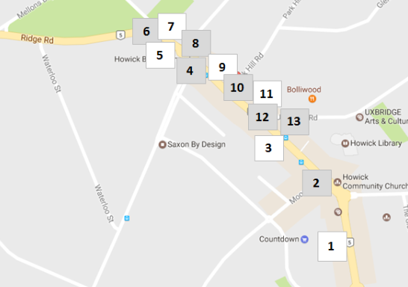
Figure 1 Typical CSR route map showing section (white) and road crossing (grey) numbers
Generally, participants walk as one large group with a group leader guiding participants. The Group Leader is not intended to influence participants’ responses but is available to answer questions and encourage discussion amongst participants.
For each path length or road crossing, participants are asked a series of 6-7 questions where they rate each section ranging between Very Good and Very Bad. Figure 2 and Figure 3 show examples of survey sheets. The sheets are customisable, so that if there are particular questions of interest for the project team or Council, these can be added. For example, in some places it may be useful to ask about the presence of street furniture, or particular obstructions such as rubbish left for collection, or about how participants might feel about walking through the section at night or in wet weather.
The questions shown in Figures 2 and 3 depart from those in the original Guidelines (NZ Transport Agency, 2011) in that they are customisable for local settings; and there are fewer boxes for participants to complete after each section of footpath or road crossing. These simplifications make the process easier for local authorities to adapt to their community of interest, and easier and less time-consuming for participants to complete.
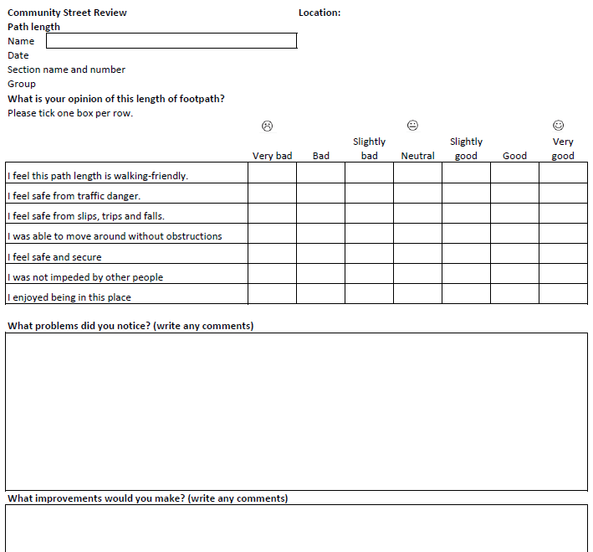
Figure 2: Community Street Review - Path Length Survey Sheet

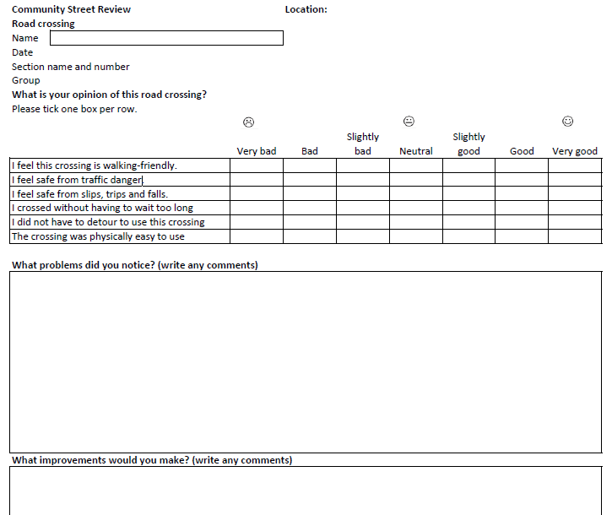
Figure 3: Community Street Review - Road Crossing Survey Sheet
Summary Responses
When a Territorial Local Authority (TLA) would like some local perspectives on footpaths and road crossings outside of the routes identified for a CSR, participants can provide their views on a separate one-page worksheet, created to suit the priorities of the project. The form and questions for this ‘Route review’ worksheet are completely flexible, but may include for example “What are the worst places to cross this road?”; or “What are the worst sections of footpath on this route?”, so that responses can be mapped for discussion about investment priorities. An example of a Route review sheet is not provided here because they are intended to be bespoke (that is, not copied from guidance).

Evaluating Findings
The review process can provide physical evidence of the challenges local people face on daily basis. Simple challenges might include crossing a busy road to get from a bus stop to their place of work or home, or walking along a busy footpath cluttered with street furniture. Figure 4 to Figure 7 show examples of the daily challenges pedestrians may face. Once the problems are identified, it gives TLAs the tools to implement solutions that cater for local needs.

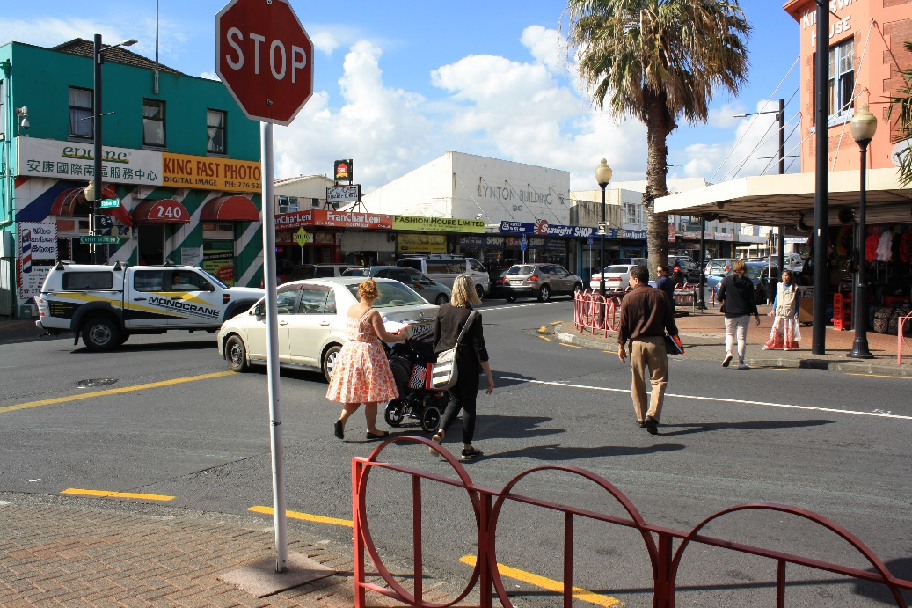
Figure 4: Balancing Traffic Volumes with Town Centre Connectivity
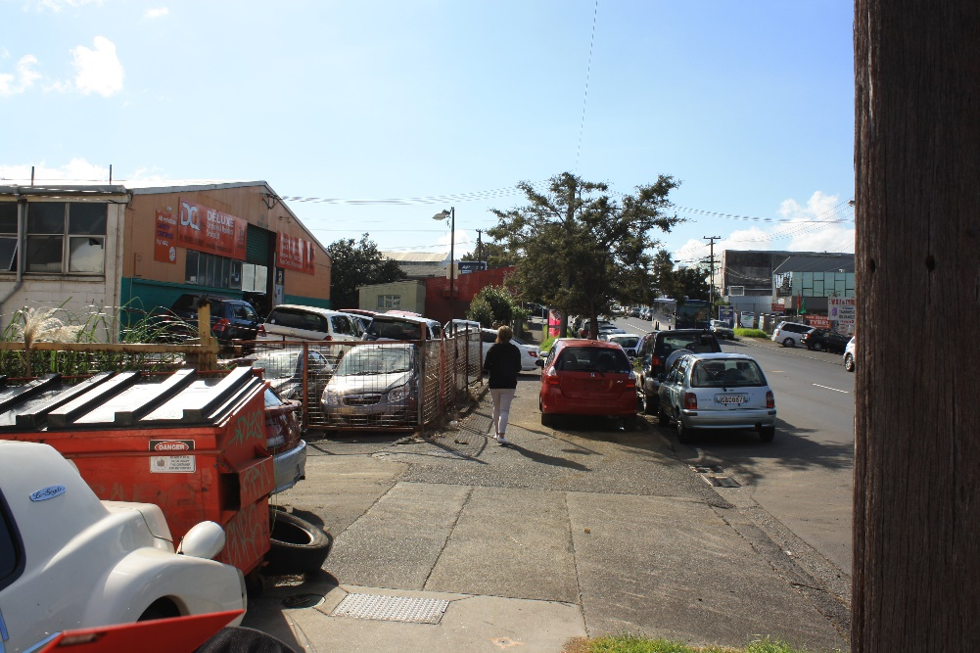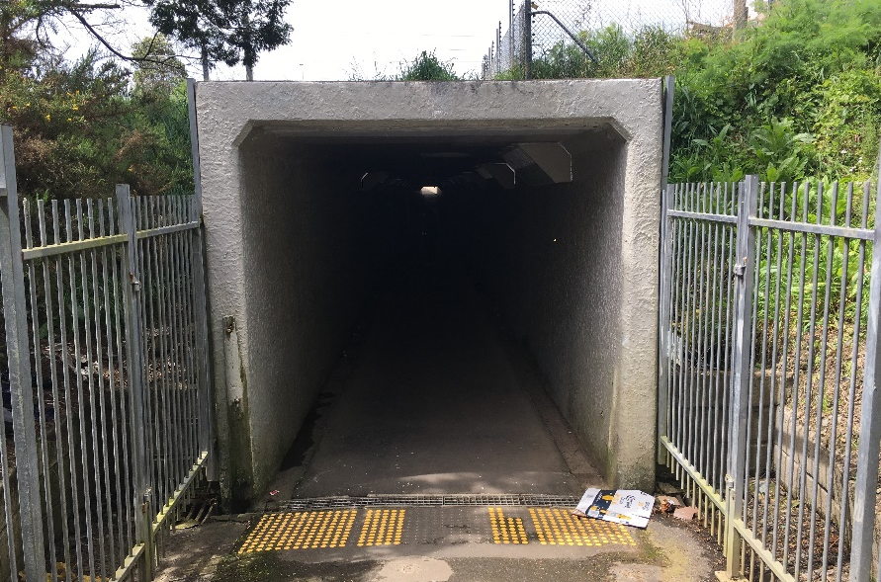
Figure 5: Understanding the importance of personal safety and pedestrian connectivity by creating a desirable walking environment.
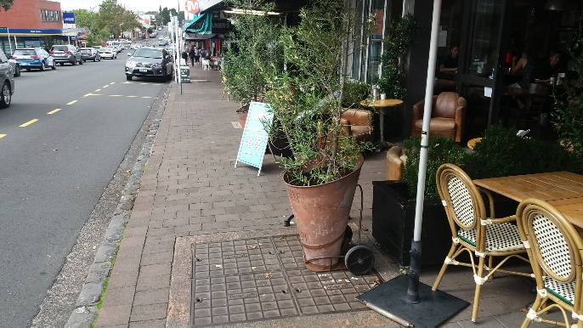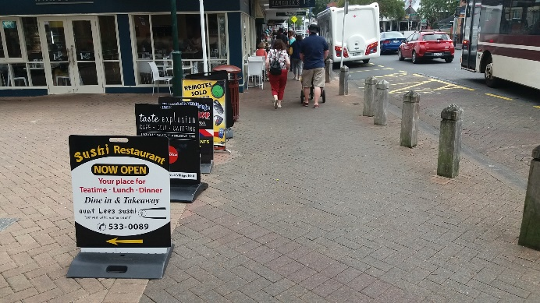
Figure 6: Encroachment of Street Furniture
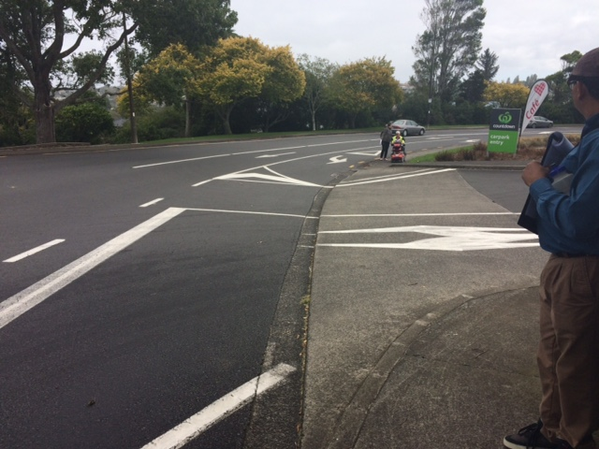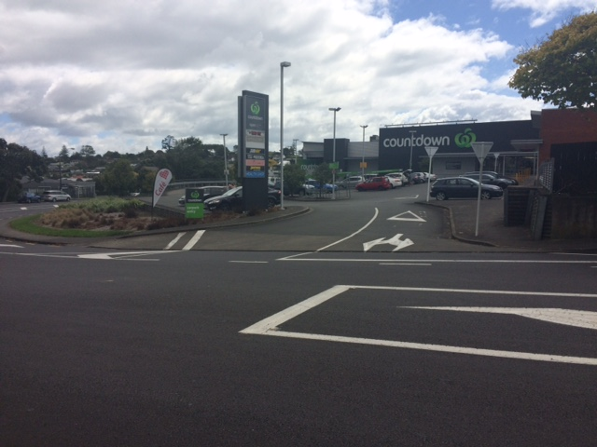
Figure 7: Supermarket Vehicle Crossing - Conflict between Pedestrians and Inbound Priority Give Way

Response variation: An example

In a recent CSR undertaken by TDG for Auckland Transport, a student in his twenties walked a section of footpath and rated it highly. The student felt safe from danger and comfortable with the footpath section.

An elderly lady walked the same section of footpath and rated it poorly. The elderly lady identified three cracks in the footpath where the footpath had become uneven and raised in parts creating potential trip hazards. She responded, “I need to be careful about where I am walking these days. If I take a fall by tripping on one of these cracks, I can cause some serious harm to myself”.

The variety of responses highlights that whilst there is a risk that the young student could also trip on these cracks in the footpath, the risk of serious injury is likely to be lower for the student compared to the elderly lady. There is inherent value in recruiting a range of local people to participate in any CSR.

What are some common themes?
Each survey varies in terms of needs and wants however some overarching themes from the surveys are listed in Table 1:

Summary of participant priorities | Possible solutions
Wider footpaths | Restricting fixed street furniture and monitoring mobile street furniture.
Less traffic | Diversion of traffic.
Slower traffic | Installing traffic calming
Prioritise alternative modes of transport. | Reducing traffic lanes, installing cycle lanes, widening footpaths, accessible bus stops.
Better visibility | Removal or reduction of street furniture or parking.
More priority for people over motor vehicles. | Installation of raised crossings.
Smoother/even surfaces | Footpath resurfacing and flush kerbs

Table 1: Overarching Themes from Community Street Reviews

Ranking Maps
Once the survey has been completed, each answer is given a score between 1-7 based on the participants responses ranging from Very Bad (1), Bad, Slightly Bad, Neutral, Slightly Good, Good and Very Good (7). The results are then mapped to provide an indication of where participants have identified footpaths or crossings that are enjoyable, where they feel safe, and those that need improvement.

Figure 8 and Figure 9 are an example of ranking maps used to evaluate and prioritise each section. Figure 8 shows the section in yellow has a lower score whereas sections in blue have ranked higher. These maps give a clear indication of path lengths and road crossings that should be prioritised for assessment.

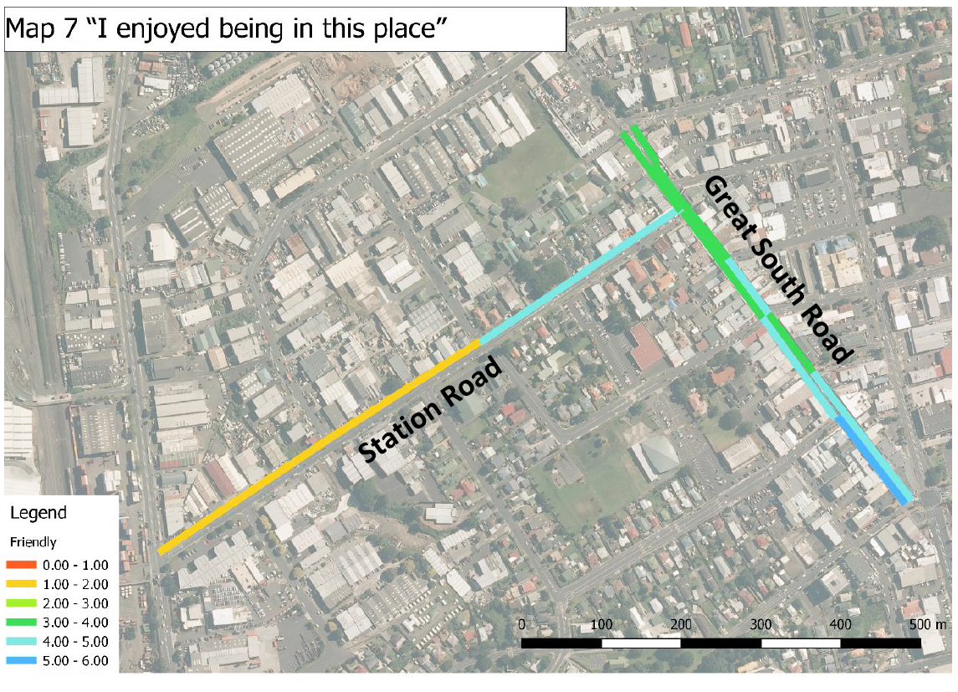
Figure 8: Path Length Evaluations
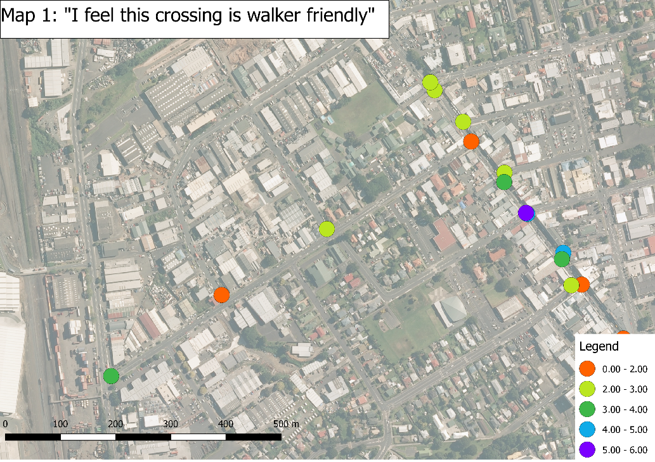
Figure 9: Road Crossings Evaluations

Discussion: What is the broader purpose of a Community Street Review?
The CSR aims to engage with the local community and community stakeholders. It is an opportunity for local people to have their say about their local neighbourhood and how it could be improved. The CSR also provides the TLA with local knowledge about an area which may influence decisions to upgrade, redesign or relocate to improve the street design.

CSRs aim to identify issues experienced by participants on a day to day basis. They are not relying on NZTA’s Crash Analysis System (CAS) to advise the TLA where a problem might be but asking the question to someone who has local knowledge on issues that may otherwise fly under the radar such as the number of near misses at a road crossing.

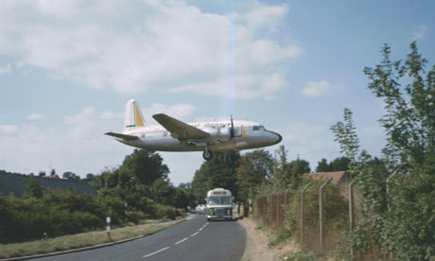
Figure 10: Near misses often fly under the radar until someone gets injured (Photo source: Ken Elliott/Air-Britain)
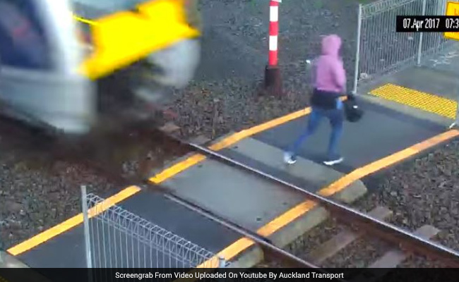
Figure 11: Near miss - Woman ignores alarm bells and signals at rail crossing to cross the tracks (Source: Auckland Transport)
A street review can give the local community an opportunity to identify sections of footpath or road crossings that they consider dangerous. This does not necessarily mean that there have been any serious injuries or fatalities but possibly near misses or sections where pedestrians feel unsafe. Community Street Reviews are an opportunity to look through the eyes of those less mobile, or live with a visual or physical impairment. It is an opportunity to listen where local people share their experiences and give first principles feedback. Do pedestrians feel relaxed, safe, and secure? OR do they feel anxious, nervous, or threatened?

What is the outcome?
TLA’s can use the information communicated through the Community Street Review process to improve pedestrian routes so they become more user friendly and therefore encouraging more people to choose walking as a convenient and healthy mode of transport.
The outcomes of the CSR give the TLAs an opportunity to focus on the needs of the community based on what will improve their experience walking down the street.
The installation of a road crossing in an unsafe location or inconvenient location (off route) can be the difference between the crossing fulfilling its purpose, or being labelled as a wasted investment. The CSR gives first-hand insights into whether a section of footpath or crossing is functional and practical. The review also offers a platform for the community to provide feedback on how a footpath or crossing could be improved.

Broader considerations for reporting CSR outcomes
It is important to understand the underlying demographics of an area being surveyed so that the specific needs of the community can be met. Does the area being surveyed have an ageing population with a higher probability of mobility scooters, wheelchair users or use of walking aids. Is the area being surveyed have a younger population with a lot of young families.
Responses are often diverse depending on age of participants and their specific needs. This identifies the importance to invite a wide range of people to participate in the CSR but also gives the TLA an good understanding of the needs of that specific community.

CONCLUSION
CSRs have potential to provide valuable insights into peoples’ walking experiences on their own streets. The findings can be used to prioritise investment effectively. The process is also a useful engagement tool for transport professionals, improving their understanding of how transport infrastructure affects peoples’ daily lives. The process can be adapted by TLAs to provide a customised, cost-effective tool to deliver best-practice for walking.

REFERENCES
ABLEY. S. (2006) Measuring Walkability, IPENZ Transportation Group, Queenstown.

HAKLAY, M. and TOBON, C. (2003). Usability evaluation and PPGIS: towards a user-centred design approach. International Journal of Geographical Information Science, 17(6), pp.577-592.

NZ TRANSPORT AGENCY (2011) Predicting Walkability NZ Transport Agency Research Report 452, Wellington, New Zealand

