**Waterview Tunnel: Assessing the Early Impacts**

**Andy Hooper1*, Chamika De Costa2, Hoda Rezaie3, Ranjan Pant4, Soroush Rashidi5, Taylor Carnell6**

1. Auckland Motorway Alliance, New Zealand,andy.hooper@ama.nzta.govt.nz, +6427 211 5978
2. Auckland Motorway Alliance, New Zealand
3. Auckland Motorway Alliance, New Zealand
4. New Zealand Transport Agency, New Zealand
5. Auckland Motorway Alliance, New Zealand
6. Auckland Motorway Alliance, New Zealand

**ABSTRACT**

The Waterview Tunnel (WVT) is the most significant increase in regional road connectivity since the opening of the Auckland Harbour Bridge in 1959. The WVT links together two of Auckland’s five motorway corridors and opens up alternative routes for existing motorway journeys, as well as attracting significant traffic from the arterial network.

In the days and weeks following the opening of WVT, a period of instability in congestion patterns was expected as users became used to the new network. Daily reporting on the overall performance of the motorway system was required for two purposes: a) to inform traffic management and traveller information operations and guide actions to dampen any instability; and b) to inform senior executives in the New Zealand Transport Agency who needed to engage with politicians and media in the days following the opening of this controversial project.

To meet these requirements whilst addressing the problems associated with the range of available data sources, formats and quality, the Auckland Motorway Alliance (AMA) developed a hybrid system that combines real-time traffic data sources with an online first order macroscopic simulation model of the entire motorway system. The approach combines the strengths of both real-time Big Data sources and macroscopic simulation modelling, whilst simultaneously minimizing the weaknesses of each. Five key network performance metrics were defined to summarise motorway network performance.

Early results indicate that in the first three months following the opening of WVT a redistribution of traffic demand between motorway corridors has occurred leading to an equivalent of 8,000 to 10,000 hours of travel time savings due to congestion relief on the motorway system each day, with the distribution of network delay being more equitable and less variable. Improved network resilience has been observed following major incidents. The approach presented will be further utilised to carry out the project Post Implementation Review.

**Introduction**

Auckland, New Zealand’s most populous city with 1.6 million residents, is located at the narrowest neck of the country, flanked by harbours on both sides. These bodies of water effectively separate the city into five distinct urban areas: the central isthmus (including the main CBD), surrounded by; the North Shore; Manukau to the south; Waitakere to the west, and the Eastern suburbs (as indicated in Figure 1). Each of these areas contains both significant housing and employment, with the largest concentration of employment in the main CBD located just south of the Auckland Harbour Bridge.

Auckland’s urban motorway system consists of five interconnected, bi-directional motorway corridors, three of which extend radially from the CBD. The total directional length of the motorway network within the urban area is over 280km and motorway links are the only road connections of any significant capacity to span the main bodies of water and connect the separate land masses (and in several cases the only connections of any type). The motorway system carries in excess of 1.1 million vehicle-trips per day, some five times that carried by the public transport system. Auckland is currently experiencing record population growth of around 70,000 people per year (4%) with around 45,000 additional cars on the road each year.

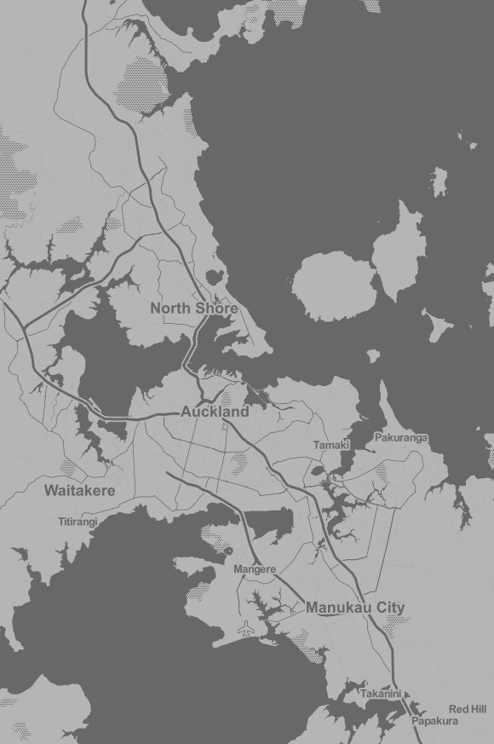

**CBD**

**Auckland Harbour Bridge**



**Waterview Tunnel**

Figure 1 – Auckland’s geography, indicating the significance of the motorway network to regional connectivity

Due to Auckland’s positon on a narrow ribbon of land, its motorway system functions as both: a national strategic link for journeys between Auckland and the rest of the country (and north-south journeys passing through Auckland); and the main commuter and freight links within the Auckland region. The average trip length on the Auckland motorway system is between 12 and 13 kilometres and trips passing through Auckland with origins and destinations in neighbouring regions to the north and south account for only 1-2% of all trips.

The motorway system experiences significant peak period congestion on a daily basis (with peaks extending to 3 to 4 hours) and a lack of realistic alternative non-motorway routes or modal choices for many journeys means that even relatively minor incidents can seriously impact the operation of the regions’ entire transport system.

**Network significance of the new Waterview Tunnel link**

The Waterview Tunnel (WVT) is a new link that connects State Highway 20 (Southwestern motorway) to State Highway 16 (Northwestern motorway). Opened in July 2017 the WVT forms the critical link in the Western Ring Route (WRR), an alternative route connecting the Auckland region both internally and to other regions by connecting State Highway 1 at the northern and southern ends of Auckland via State Highways 20, 16 and 18.

The WVT link also significantly improves accessibility within the Auckland urban area between several areas of the city separated by water, especially Waitakere to the west and Manukau to the south, as well as providing greatly improved road connection between the CBD and airport. In addition the new link provides an attractive alternative route between the southwestern extremity of the isthmus area and the CBD on the northern edge of the isthmus. This is attracting a significant number of vehicle trips to the motorway system that previously exclusively used arterial routes to access the CBD. Furthermore, the WVT link provides a number of alternative, full motorway routes between all four main areas of the region, providing a level of route choice not experienced previously by Auckland motorway users.

**Short term volatility of traffic patterns and congestion**

The fundamental step-change the WVT link represents to regional road connectivity is the most significant since the opening of the Auckland Harbour Bridge (AHB) in 1959.The shock the opening of the AHB imposed on traffic patterns is well-known in Auckland folk-lore (Figure 2 below indicates traffic on the AHB on its opening day)

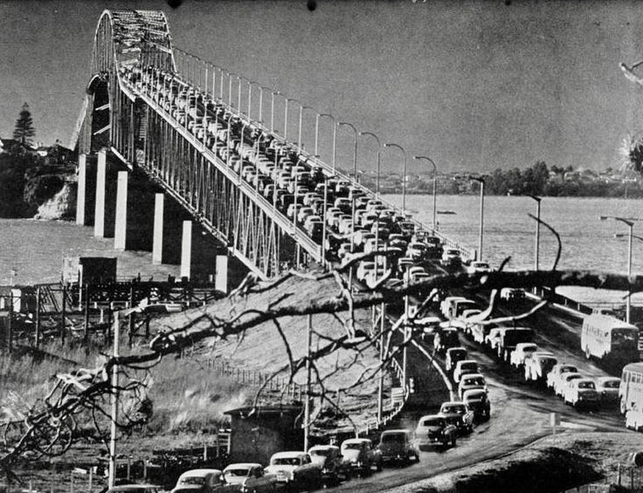Strategic assignment modelling using the Auckland Regional Transport model undertaken as part of the WRR investigation and design indicated the expected long term routing patterns under normal (non-incident) operating conditions, once the operation of the network settled. However, over a short timescale of up to several weeks following the opening of WVT, usage and demand patterns were expected to be in flux as travellers: used the tunnel for the first time; modified their route choices out of ‘novelty value’ of using the tunnel; and systematically explored new routing possibilities that may improve their daily travel experience.

Operational modelling of the post-WVT motorway network undertaken by the Auckland Motorway Alliance (AMA)[1] using a purpose built first order macro simulation model of the entire motorway system[2] indicated relatively small changes in the pattern of demands loading the new motorway network could lead to large changes in the congestion patterns. As a result, from an operational standpoint the opening of WVT was viewed as a ‘shock’ to the operation of the motorway system, and a period of operational instability or volatility was anticipated once the WVT opened.

Figure 2 – Traffic on the Auckland Harbour Bridge on opening day, 1959

This paper provides both an overview of the early impacts of the WVT on the Auckland motorway system and a description of the novel data analysis and reporting system that was purpose built to deliver rapid performance reporting capability.

**Short term network performance reporting**

A full comprehensive evaluation of the impact of the WVT on the Auckland transport system will be carried out 6-12 months after opening. However a need was identified to provide daily network performance reports during the period of anticipated operational instability immediately following the opening of the WVT. These reports were needed to service two distinct audience groups:

1. Operations staff at the Auckland Transport Operations Centre (ATOC)
2. Senior Leadership at the New Zealand Transport Agency (NZTA) and Ministry of Transport.

Whilst a WRR Concept of Operations, Operational Plans and Standard Operating Procedures had been drawn up for the WRR to assist ATOC staff, these focused on the new ‘business as usual’ operations expected after the settling in period. A more reactive approach was required in the first few weeks following opening to allow operations staff to make daily changes to both traffic management systems (the network-wide Ramp Metering System (RMS) and the regions’ traffic signal system which operates on SCATS) to dampen any swings in demand patterns and traveller information provision (via VMS, broadcast and social media).

The Senior Leadership at the New Zealand Transport Agency (NZTA) and Ministry of Transport (MoT) required up-to-date information on the overall operation of the motorways (and wider transport system) to engage with politicians and the media. Congestion, the transport system and the strain associated with Auckland’s growth are hotly debated in both mainstream and social media, and debate about the improvement or otherwise following the opening of WVT was anticipated to occur immediately, irrespective of any comprehensive impact evaluation due months later. Strongly held differing views existed prior to WVT opening as to whether the WRR, and the WVT in particular, are long overdue upgrades to a motorway system that was never completed; or misplaced investment that would have been better directed to improving the regions’ underdeveloped public transport system[3].

The expected redistribution of motorway congestion patterns along with a number of ubiquitous sources of widely available real-time traffic and travel time meant there would be a lot of potential for interested groups to cherry pick evidence to support widely divergent views about the operation of the transport system in the days following the opening of the WVT. Therefore a need for robust and objective assessment of the motorway system as a whole was identified, that both accounted for redistribution of congestion patterns and how variable those patterns were day-to-day until the system settled.

**Data Sources and Data Fusion Tools**

Auckland’s motorway system is highly instrumented in terms of traffic detection, to support existing operational systems, such as the coordinated ramp metering system (RMS) as well as legacy systems. This consists primarily of point sensors: thousands of loop detectors, a small number of radar/infrared sensors and more recently around 70 Bluetooth detectors. In addition probe-based GPS data sourced from commercial providers is now being used to provide comprehensive travel time data.

In order to meet the rapid reporting requirements, whilst effectively handling, cleaning and analysing the vast amount of data available, the AMA developed the Motorway Analysis and Reporting System (MARS). This is a hybrid system that combines real-time traffic data sources with an online first order macroscopic simulation model of the entire motorway system that has been reported on previously (Hooper et al. 2016). This approach synergistically combines the strengths of both real-time Big Data sources and macroscopic simulation modelling, whilst simultaneously minimizing the weaknesses of each in what can be thought of as a “production line” for improving data. Figure 3 provides a diagrammatic overview of the system. MARS handles around 3 million lines of input data per day and its principal benefits for daily reporting network level performance of the motorway system during the shock of the WVT opening period can be summarised as follows:

1. Traffic flows are internally consistent giving a correct picture of the traffic state for every 300m section of the motorway network in terms of speed, volume and density, rather than just where detectors are located (i.e. it in-fills gaps between detectors in accordance with the fundamental traffic flow equation and the law of conservation of vehicles, overcoming inconsistent flows that are often seen at adjacent detector sites).
2. The system is resilient to both systematic detector error and multiple isolated detector failures with minimal degradation of quality (due to its ability to in-fill indicated above).
3. The system is able to filter both systematic error and much of the noise (random error) associated with the real-time data sources providing a significantly smoothed output data (it in effect acts like a large signal processor).

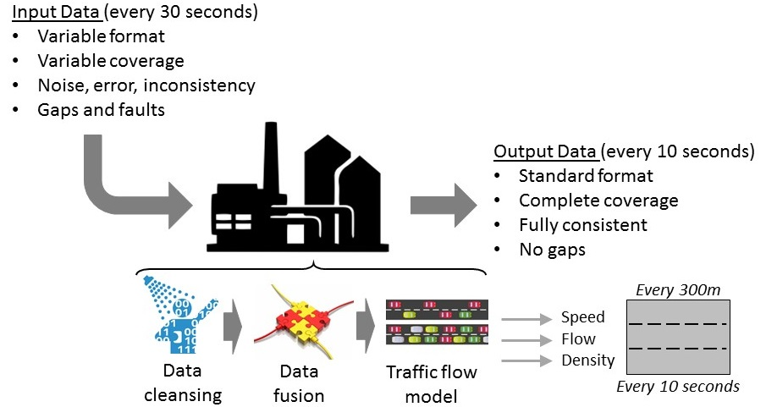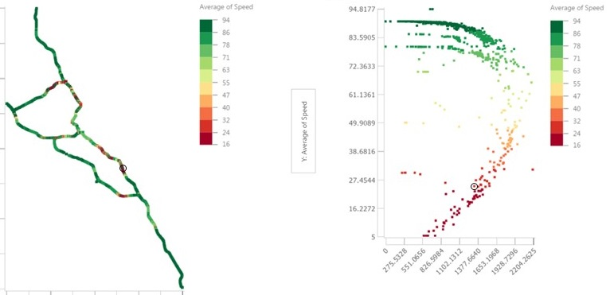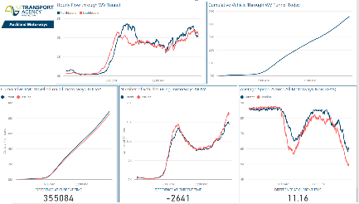

*1100*

*Cells*

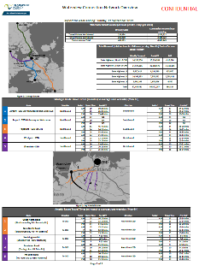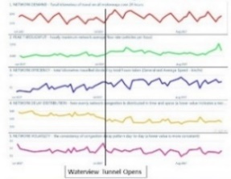

*Live Dashboards*

*Daily Metrics & Reports*

*Data “Production Line”*

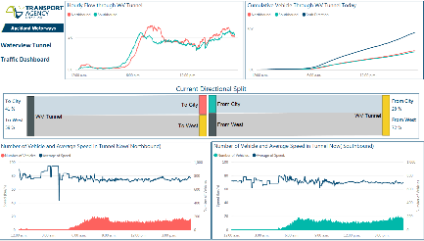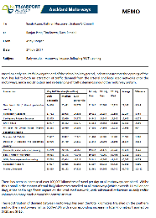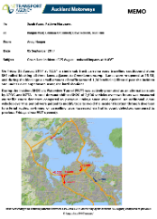

*Weekly reports & ad-hoc analyses*

*Detailed results for 1100 cells every 10 seconds*

*Detailed Outputs*

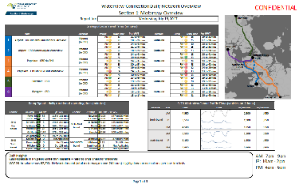

Figure 3 - Motorway Analysis and Reporting System (MARS) overview

Testing has shown high levels of accuracy of system outputs against:

* The official traffic counting stations at 50 dispersed locations around the motorway system (these are separate to the more numerous RMS loop detectors, do not provide real-time data into the analysis system, and are positioned and calibrated to provide highly accurate traffic counts).
* Corridor travel times from independent commercial probe data-based sources (Google, TomTom).

**Early Results**

Note that the results presented here provide an early informal indication of the impacts of WVT on the motorway network. Baseline values from June 2017 before WVT opened have been used for convenience and to provide comparison over as short a period as possible to limit seasonal and growth effects, with Post-WVT results from August and September being presented. The formal Post Implementation Review that is being undertaken for the government’s Gateway Review process will include work to select the most appropriate baselines and periods for post-WVT results.

Five summary network metrics were designed to provide an overview of the short term impacts of the Waterview tunnel on the performance of the entire motorway system through daily tracking (see Table 1). These impacts and their key implications are the “headline impacts” suitable for senior management and board level reporting. The impacts are summarised in Figure 4 and indicate an improvement on all measures since the opening of WVT.

|  |  |
| --- | --- |
| ***Measure*** | ***Description*** |
| 1. NETWORK DEMAND | *The total kilometres travelled on the entire motorway network by all vehicles over a 24 hour period. Provides a measure of the overall load on the system.* |
| 2.NETWORK CAPACITY | *The maximum recorded network kilometres travelled in one hour.* ***Higher is better.*** |
| 3.NETWORK EFFICIENCY | *Quantifies the overall magnitude of delay around the motorway network and across the day without consideration of the distribution of delay.* ***Higher is better.*** |
| 4.NETWORK DELAY DISTRIBUTION | *Quantifies how concentrated delay is around the motorway network and across the day without consideration of the overall magnitude of delay.* ***Lower is better.*** |
| 5.NETWORK VOLATILITY | *Quantifies how variable the pattern of delay is around the motorway network and across the day, without consideration of either the concentration or the overall magnitude of delay.* ***Lower is better.*** |

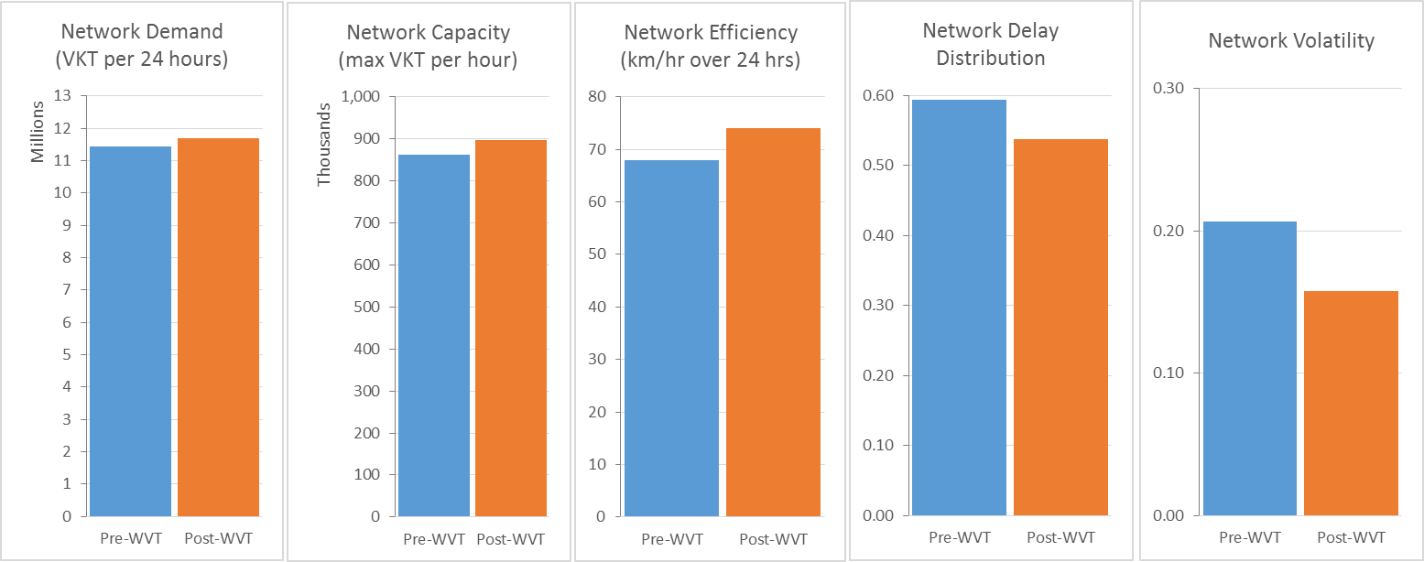Table 1 – Motorway network performance summary metrics

Figure 4- Changes in network performance following opening of WVT (last two weeks of normal demand before WVT opened and first two weeks of normal demand after WVT opened, after school and university holidays finished mid-July)

## Key Result 1: Re-distribution of Traffic Demands

There has been an increase of over 290,000 kilometres of travel per day on all motorways combined.  Whilst this is both small in the context of total daily kilometres travelled on all motorways (which exceeds 11.5 million per day), and is to some degree expected (due to the increase in motorway network length of 30 lane-km associated with WVT), it has had a significant impact on the local road network, with substantial reductions in daily traffic volumes recorded on many arterial roads around the central Auckland isthmus.

Redistribution of demand between motorways has seen the total kilometres travelled on the southern and northern motorways fall by 6-7% with a corresponding increase in total kilometres travelled on SH20 and SH16 (see Table 2 and Figure 5).

|  |  |  |  |  |
| --- | --- | --- | --- | --- |
| **Corridor** | *Pre-WVT Total km per day (average for Jun-2017 Mon-Fri*)* | *Post-WVT Total km per day (average for Aug & Sep 2017, Mon-Fri)* | *difference* | *% difference* |
|
| **SH1 southern** | 3,824,917 | 3,590,157 | -234,761 | -6.1% |
| **SH1 northern** | 2,243,310 | 2,093,594 | -149,716 | -6.7% |
| **SH16** | 1,590,431 | 1,730,600 | 140,170 | 8.8% |
| **SH20 (excl WVT)** | 1,537,661 | 1,718,066 | 180,405 | 11.7% |
| **SH18** | 545,755 | 530,458 | -15,297 | -2.8% |
| *\*excluding Fri 02 Jun and Mon 05 Jun due to Public Holiday* | | | | |

*Table 2 - Redistribution of traffic demands following WVT opening*

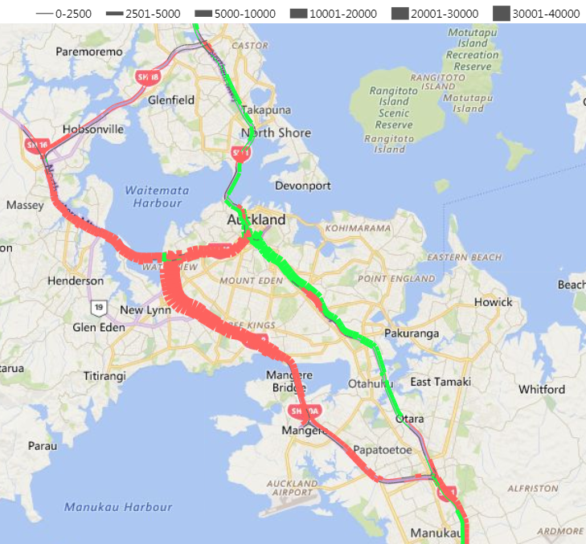

Figure 5 - Changes in daily motorway traffic volumes following the opening of WVT

**Key Result 2: Improved Efficiency of the Motorway Network Asset**

The redistribution of motorway demands has led to more efficient operation of the motorway system overall, as reflected in the daily Network Efficiency metric values (see Table 3). This is resulting in congestion relief equivalent to between 8,500 and 10,000 less hours of total travel time per day on the motorways alone[4], as summarised in Table 2 (note: this does not account for reduction in overall travel time across the arterial network due to reductions in traffic volumes attracted to use the new WVT link).

|  |  |  |  |  |  |  |
| --- | --- | --- | --- | --- | --- | --- |
|  | *Post-WVT averages for*  *Aug & Sep 2017, Mon-Fri, 24hrs* | | | *Pre-WVT average for Jun-17, Mon-Fri*, 24hrs* | *equivalent non-WVT total hours (24hrs)* | *congestion relief (hours)* |
| *Total km* | *Total Hours* | *GAS\*\** | *GAS\*\** |
| ***a*** | ***b*** | ***c =a÷b*** | ***d*** | ***e =a÷d*** | ***f =b-e*** |
| **SH1 southern** | 3,590,157 | 47,105 | 76.2 | 67.0 | 53,569 | -6,465 |
| **SH1 northern** | 2,093,594 | 28,402 | 73.7 | 67.3 | 31,094 | -2,692 |
| **SH16** | 1,730,600 | 27,317 | 63.4 | 61.8 | 27,985 | -667 |
| **SH20 (excl WVT)** | 1,718,066 | 21,908 | 78.4 | 79.5 | 21,622 | 286 |
| **SH18** | 530,458 | 8,507 | 62.4 | 61.5 | 8,629 | -122 |
| *\*excluding Fri 02 Jun and Mon 05 Jun due to Public Holiday* | | | | | **Total** | **-9,660** |
| *\*\*GAS = Generalised Average Speed* | | | | |

Table 3 – Average daily travel time savings across the motorway system since WVT opened

## Key Result 3: Improved Reliability and Resilience of the Network

Contrary to expectations, after the first day following opening of the tunnel the Network Volatility measure settled almost immediately to a level below the pre-WVT baseline which has so far been maintained through the return to normal demands following the end of school and university holidays. This indicates a higher consistency of congestion pattern in time and space day-to-day than before the tunnel opened.

The reason for this unexpected (but welcome) early result of improved reliability of the motorway system with the addition of the WVT links, may be due to the SH20-SH16-SH18 route being a viable alternative to SH1 for a number of trips of typical length. As well as a more efficient use of the network asset, it appears the redistribution of demand also allows the motorway system to more effectively absorb minor shocks, such as breakdowns and crashes during busy periods. The easy availability of real-time traveller information from a range of sources may be assisting this by driving small marginal shifts of demand at peak times in response to minor shocks which is smoothing out some of day-to-day variability in congestion that was common prior to WVT opening.

Whilst there have not been many major incidents on the motorway network since WVT opened, the few that have occurred indicate the network has significantly improved in resilience (where resilience in this context is defined as the ability to absorb, adapt to, and/or rapidly recover from a potentially disruptive event).

This is illustrated by the most potentially disruptive incident that has occurred since WVT opened. On Friday August 25 at 12:55pm a truck rolled on SH1 at Green Lane interchange on the southern motorway, blocking all three lanes adjacent to Greenlane onramp. All lanes were re-opened at 13:58, and during the blockage a small amount of traffic (around 1,300 vehicles) filtered past the incident site under Police supervision using the hard shoulder.



Figure 6 - – Observed changes to demand patterns due to 25 Aug incident compared to previous Fridays since WVT opened

During the incident SH20 via Waterview Tunnel (WVT) was actively promoted as an alternative route by ATOC and NZTA via VMS, radio and social media. A total demand shift to SH20 of 2,600 vehicles over two hours was measured via traffic count detectors compared to previous Fridays since WVT opened. An additional 2,600 vehicles over this period were judged to modify trips to avoid the incident location through diversion to arterial routes, re-timing or cancelling trips (assessed via traffic count detectors compared to previous Fridays since WVT opened).

Using the AMA’s purpose-built Rapid Scenario Testing Tool[5] the net impact of the incident on the motorway network was estimated to be around 2,000 hours additional hours of delay over 24 hours (1.5%) with a recovery time of 1.5hrs. The impact was largely confined to SH1 with only minor secondary delay impacts on SH20 due to diverted demand.

The relatively modest impact of such a severe incident at a critical location is considered to be due to three main factors:

1. The rapid time in which the incident was cleared and all lanes re-opened (just over 1 hour)
2. The redistribution of motorway network demands since WVT opened, resulting in a 6%-7% reduction in demand day-to-day on the southern motorway.
3. The additional redistribution of demand away from the southern motorway to SH20 as a result of promotion of SH20 via WVT as an alternative route as part of the incident response.

To assess the contribution of the new WVT link to reduced impact and recovery time on SH1 two versions of the incident were assessed using the Rapid Scenario Testing Tool. One version of the incident replicated the demand patterns that actually occurred; the second replicated the same incident for pre-WVT network and demand patterns including:

* No background demand reduction of 6%-7% on the southern motorway
* No diversion of 2,600 vehicles to WVT and SH20.

In both cases demand reduction of 2,600 vehicles was applied to account for the observed diversion to arterial routes, re-timing or cancelling trips.

The results of the assessments are summarised in Table 4 below and indicated that the addition of the WVT link reduced the overall delays incurred on the motorway network by around 11,000 hours.

|  |  |  |  |  |  |  |  |  |
| --- | --- | --- | --- | --- | --- | --- | --- | --- |
|  | *Source* | *Description* | *a* | *b* | *c (a÷b)* | *d* | *e (a÷d)* | *f (b-e)* |
| Total network kilometres  (24 hrs) | Total network hours  (24 hrs) | GAS* | Base model GAS | Equivalent non-incident total hours | Additional hours of delay due to incident |
| (1) | Offline System | Equivalent incident without Waterview Tunnel (SH1 impacts) | 11,446,112 | 182,094 | 62.9 | 68.1 | 168,078 | 14,016 |
| (2) | Offline System | Replication of incident as occurred (SH1 impacts) | 11,568,877 | 171,975 | 67.3 | 68.1 | 169,881 | 2,094 |
| (3) | Real-time system | Adjustment for increased delays observed on SH20 SB due to diverted demand (1pm - 10pm) | - | - | - | - | - | 833 |
| *\*GAS = Generalised Average Speed* | | | | | **Overall impact: (1)-(2)-(3)** | | | **11,089** |

Table 4 - Estimate of incident delay avoided through availability of WVT as an alternative route

The congestion heatmaps in Figure 7 illustrate the increase in congestion that would have been experienced on SH1 had WVT not been open at the time the incident occurred (the direction of travel is from left to right and heatmaps cover the northern motorway from Silverdale to the southern motorway at Drury via Auckland Harbour Bridge and CMJ).

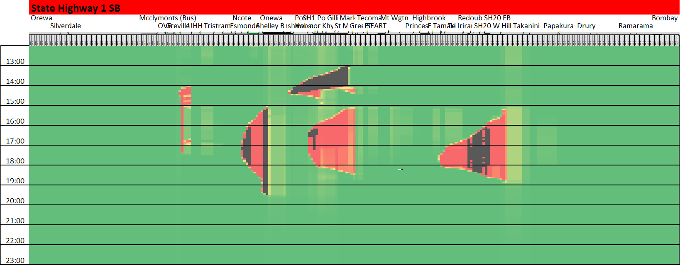

*Incident as occurred*

Lanes blocked at Green Lane

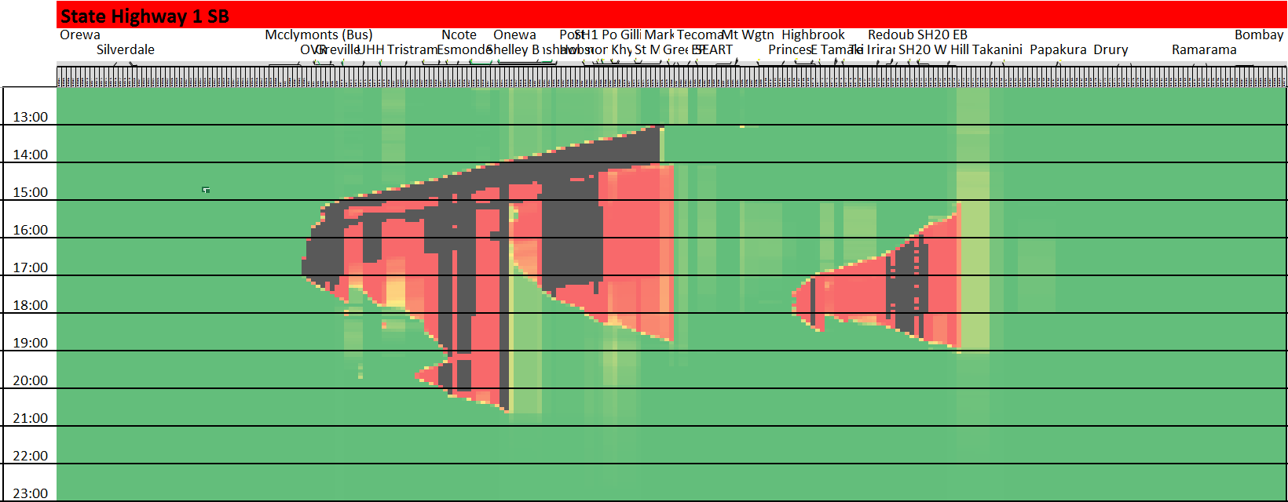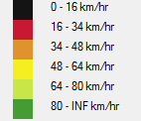

Lanes blocked at Green Lane



*Equivalent incident without Waterview Tunnel*

Direction of travel

Time of day

Direction of travel

Time of day

Figure 7 - Comparative Congestion heatmaps for incident with (top) and without (bottom) WVT

These heatmaps illustrate that overall recovery of the network would have been significantly worse had WVT not been available (both due to the more efficient distribution of demand across the motorway system generally, as well as the active diversion of demand to WVT/SH20 following the incident).

Overall recovery of the network occurs by 2.45pm in the replication of the actual incident (which aligns with observed data). However in the no-WVT scenario fully recovery doesn’t occur until around 8.30pm, nearly 6 hours later. This is due to the timing and location of the incident relative to normal PM congestion patterns. Without WVT the network is unlikely to have recovered prior to the onset of the PM peak, which would have then been exacerbated by the backlog of traffic on SH1 that hadn’t cleared.

The results of this assessment provides an early demonstration of the improved resilience of the motorway system that the connectivity of the WVT provides.

If this outcome persists in the longer term it will be an especially welcome result as two of the primary objectives of the WVT articulated during planning hearings were improved trip reliability and improved network resilience (New Zealand Transport Agency, 2010)

**CONCLUSIONS and recommendations**

In order to effectively manage the settling-in period following the opening of the strategic Waterview Tunnel link, there was a need to provide a rapid analysis and reporting system that would capture impacts across the entire of Auckland’s motorway system. The MARS system was developed to make the most of: available real-time data sources; traffic flow theory; and innovative system level metrics that summarise the performance of the motorway system as a whole.

Results from the MARS system in the first three months following the opening of WVT indicated the following main impacts on the motorway system:

* Around 290,000 additional kilometres of travel is occurring on the motorways system each day. In addition, a re-distribution of demand has occurred away from the southern and northern motorways to the north western and southwestern motorways.
* This is resulting in a more efficient use of the motorway network asset through congestion relief equivalent to between 8,500 and 10,000 less hours of total travel time per day on the motorways.
* Experience so far indicates that the addition of the WVT link has improved the resilience of the motorway system to shocks such as major incidents through providing a number of alternative routes around the motorway system.

The current version of MARS represents a step forward in network performance reporting. The AMA see the progress so far as the first step towards a number of decision support tools that could provide significant enhancement to network optimisation and network performance improvement activities as illustrated in Figure 8.

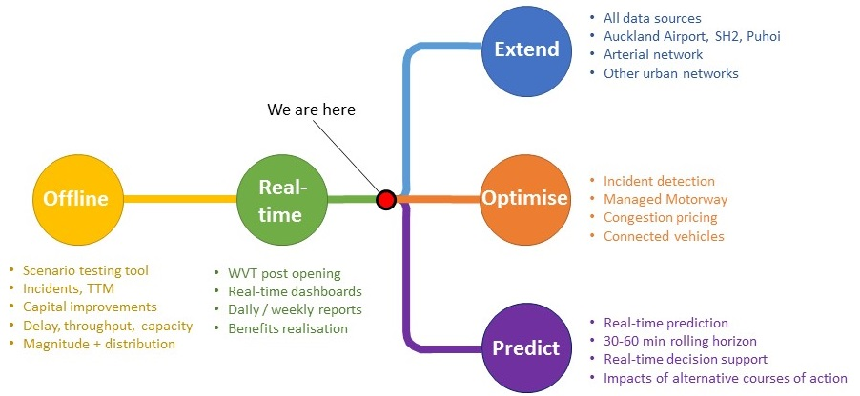

Figure 8 – MARS potential development pathways

Three main development paths are recommended:

1. Extend the capability and coverage of the MARS as a network performance measurement system, to include arterial networks and ultimately all transport modes.
2. Update the offline model fully to post-WVT conditions, and enhance the functionality and calibration to provide a detailed network optimisation support tool.
3. Develop additional modules to allow real-time prediction of short term future traffic conditions (by combining the two functions of offline prediction and real-time update).

**REFERENCES**

Bando, M., Hasebe, K., Nakayama, A., Shibata, A. and Sugiyama, Y., (1995). Dynamical model of traffic congestion and numerical simulation. *Physical review E*, *51*(2), p.1035.

Daganzo, C., (1994). The Cell Transmission Model: A dynamic representation of highway traffic consistent with the hydrodynamic theory, *Transportation Research Part B, (28)* 269–287.

Geroliminins, N and Daganzo, C., F., (2008). Existence of Urban-scale Macroscopic Fundamental Diagrams: Some Experimental Findings, *Transportation Research Part B (42)* 759 - 770.

Hooper, A., Yau, K., De Costa, C., Pant, R., (2016). A platform for real-time operational decision support using a Cell Transmission Model, *23rd ITS World Congress, Melbourne, Australia,* 10–14 October 2016.

New Zealand Transport Agency, (2010). Western Ring Route – Waterview Connection, Assessment of Transport Effects (Report G18), <http://www.nzta.govt.nz/assets/projects/completing-wrr/docs/docs-enquiry/application/g18-assessment-of-transport-effects-report.pdf>

1. *The AMA is an Alliance of the NZ Transport Agency (as the client) and five contractors and consultants working collaboratively to deliver term maintenance and operation services for the Auckland motorway network.*
2. *This is the AMA’s Offline Rapid Scenario Testing Tool, built using the Cell Transmission Model (Daganzo, 1994).*
3. *For a summary of this debate refer to http://www.shapeauckland.co.nz/media/1182/section-113-alternative-transport-funding-informationa4.pdf*
4. *This assessment covers Monday – Friday only, with a baseline of June 2017 (Mondays – Fridays; excluding Friday 2 June and Monday 5 June, as this Monday was a Public Holiday).*
5. *The Offline Rapid Scenario Testing Tool was used for this assessment rather than the Real-Time Motorway Analysis and Reporting System. Traffic demands and congestion patterns are highly variable on Fridays and insufficient non-school holiday Fridays had occurred at the time since the opening of Waterview to establish a clear baseline to evaluate incident day results from the real-time system against.*