**ARE STEEP DOWNHILL ON-RAMP MERGES SAFE?**

1. Stuart McDougall (presenter)

MEng.St.(Transportation Engineering), Post Grad. Cert. Management

Fellow of the Institution of Highway Engineers

Principal Planner at Resolve Group Ltd

[Stuart.McDougall@Resolvegroup.co.nz](mailto:Stuart.McDougall@Resolvegroup.co.nz)

1. Karen Fehl

BE Civil (Hons)

CMEngNZ

Service Line Leader – Transport Solutions at Resolve Group Ltd

[Karen.Fehl@resolvegroup.co.nz](mailto:Karen.Fehl@resolvegroup.co.nz)

**ABSTRACT**

Preparation for the opening of the Waterview Tunnel in Auckland in 2017 included considerable planning for the anticipated impacts to the network. Predictions for additional congestion downstream of the tunnel led to plans for localised widening and conversion of an existing on-ramp at Hillsborough Rd from a lane gain to a merge.

The proposed on-ramp change raised some concerns as the on ramp is situated on a relatively steep downhill gradient (approx. 5.3%). Experience at other ramp merges has led NZ Transport Agency traffic engineers to believe that merges where there are steep downhill gradients often lead to flow break down on the main carriageway lanes when the motorway is at or near capacity, with associated safety consequences.

This paper reports on the investigation to examine the relationship between flow breakdown, safety, crash rates and gradient at on-ramps generally and at Hillsborough Road on-ramp specifically. It covers an international literature review, observation evidence and crash data trends to draw some conclusions about the relative safety of steep onramp merges for the main carriageway users on motorways. It also considers reasons for flow breakdown at steep on-ramp merges but does not conclude any definitive relationship between the various physical and operational features investigated.

**INTRODUCTION**

This paper considers the relationship between flow breakdowns on the main carriageway lanes and gradient at on-ramps, based on a study carried out by Resolve Group Ltd for the NZ Transport Agency on the Hillsborough southbound on-ramp at State Highway 20 (SH20) in early 2017.

It considers some of the possible reasons for increased flow breakdown on steep negative gradient motorways adjacent to on-ramps, as this was understood to be a concern of the Transport Agency in the event that the lane gain at Hillsborough Rd southbound on-ramp was changed to a merge.

Minor safety incidents such as rear end crashes frequently impact more on the network through increased congestion and delay than they do through injury or damage. For this reason, minor crashes and other driver behaviour influencing network efficiency was also considered.

**BACKGROUND**

As part of planning for the wider network impacts of opening of the Waterview Tunnel, a series of downstream improvements was proposed to mitigate the impacts of the predicted lack of future capacity and the potential bottleneck on SH20 south of Hillsborough Rd.

The 2015 5 day AADT for the southbound motorway at Hillsborough Rd Interchange is approximately 32,000, while bottleneck modelling undertaken by AMA for likely demand scenarios suggested 40,000 – 42,700 vehicles over an 18hr period at the same location once Waterview Tunnel opened.

One proposal to address the predicted bottleneck was to extend a third lane on SH20 southbound from Waterview Tunnel to Hillsborough Interchange. This would involve the Hillsborough Rd on-ramp being converted from a lane gain to a merge. Since this on-ramp is on a steep downhill gradient (approximately 5.3%), there were concerns raised by the NZ Transport Agency regarding the relationship between downhill gradient on–ramps merging onto motorways and flow breakdown which could potentially impact on safety. It was thought that the impact could be more severe on motorways at or near to capacity.

**Issues**

The NZ Transport Agency had concerns about adopting the proposed capacity management strategy at the SH20 Hillsborough on-ramp due to the following reasons:

* Speed management on the steep on-ramp and adjacent main carriageway lanes;
* Loss of control on merging, leading to a potential crash black spot;
* Weaving /merging crashes; and
* Flow breakdown.

Figures 1 and 2 below show the location of SH20, Hillsborough Rd Interchange and adjacent interchanges

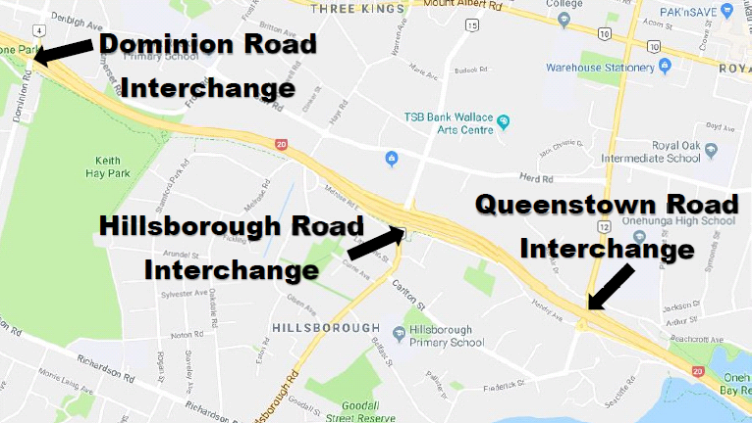

***Figure 1: SH20 – Location of Dominion Rd, Hillsborough Rd and Queenstown Rd Interchanges (Source: GoogleMaps)***

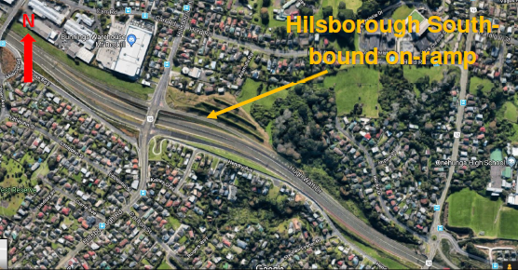

***Figure 2: Location and layout of Hillsborough Interchange (Source: Google Earth)***

Figure 3 below shows the current lane layout and options for proposed future layouts at the Hillsborough Interchange and the adjacent Queenstown Rd and Neilson St Interchanges. The implications of changing a lane gain to an on-ramp merge at Hillsborough Interchange led to this study.

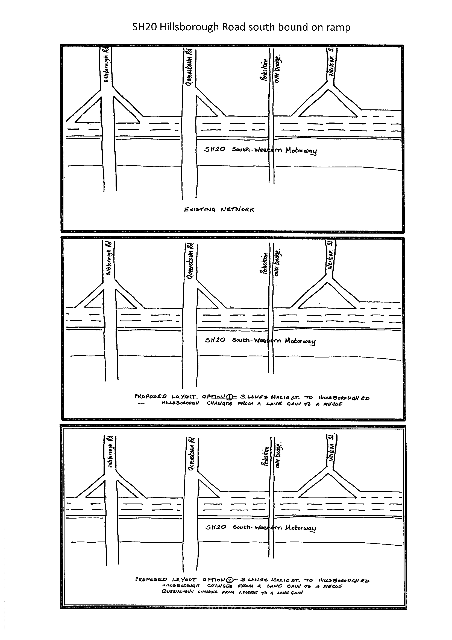

***Figure 3: Hillsborough Rd On-ramp Existing and Future Layout Options (Source: Resolve Group)***

**LITERATURE REVIEW**

As part of the study into steep on-ramp merges, a review of design standards and relevant academic papers was undertaken.

**Academic Papers**

The literature review has shown that attempts to model the interaction of the merging traffic streams and flow breakdown have not considered ‘negative gradient’ as a variable factor. Although there was no literature explaining why negative gradient has not been modelled, it is possibly because the modelling of the merging and weaving traffic is complex and therefore the number of variables would have been kept to a minimum. When the gradient of motorway access ramps is discussed in academic papers it often relates to positive gradient and the issues with slower moving HCVs merging onto the motorway.

From the literature research of published papers, we have concluded that the potential issues related to negative gradient merges have not been studied previously in peer reviewed academic papers.

**Design Manuals and Guidelines**

A review of design manuals and guidelines from Australia, United Kingdom and the United States of America was undertaken. The main concern addressed in the design documents is that vehicles on an on-ramp are able to match the speed of vehicles on the motorway so that joining vehicles can merge at the least inconvenience to vehicles already on the motorway. There is no directive about what negative grades are suitable for on-ramps or the adjacent main carriageway lanes.

Austroads (2015)1 considers the relationship between road speed and the gradient of the merging lane to give guidance on the required minimum length of the merge. Correction factors are given to shorten the length of the merge lane as merging vehicles will reach the speed of the vehicles on the motorway sooner on a downhill grade. The United Kingdom’s Design Manual for Roads and Bridges (2006)2, while not stipulating correction figures for downhill, advises on uphill gradient ramp length by considering large goods vehicles and the severity of the gradient.

In the United States of America, the Highway Capacity Manual (2010)3 also uses the percentage of trucks and buses, length and steepness of the downhill gradient as a basis for design.

None of the guidance considers in detail how merges should be designed on downhill grades beyond a minimal approach, which states the amount by which acceleration lanes can be shorter (as vehicles reach a similar speed as the live lanes of the motorway more quickly on downhill grades). Further, none of the design manuals suggest that downhill grades cause flow breakdown or could lead to safety issues.

**Finding turbulence caused by merging traffic**

Although not relating to the grade of the carriageway or ramp, the Highway Capacity Manual (2010) advises the following when considering flow rates immediately upstream of a ramp:

“Longer acceleration and deceleration lanes lessen turbulence as ramp vehicles enter or leave the freeway. This leads to lower densities and higher speeds in the ramp influence area. When the ramp has a higher FFS (Free Flow Speed), vehicles can enter and leave the freeway at higher speeds, and approaching freeway vehicles tend to move left (right in NZ) to avoid the possibility of high speed turbulence. This produces greater pre-segregation and smoother flow across all freeway lanes.”

This advice appears to differ from observed merging traffic through cameras at Traffic Operations Centres. Experienced Transport Agency traffic operations engineers in Auckland have noticed that longer acceleration lanes onto Auckland’s motorway network often cause more turbulence in traffic flows than merges on shorter on-ramps regardless of ramp grade, when the motorway is near capacity. It is noted that generally Auckland Motorway on-ramps are at grade or downhill at the point where merging occurs (with a small number of exceptions). It is acknowledged that this observation is not made as a result of a formal documented study, but as part of day-to-day operational experience and observation.

**ANALYSIS**

An analysis of a small sample of downhill on-ramps was undertaken using crash reduction study data, comparing physical features and traffic volumes to see whether any correlation exists between the features of steep ramp merges and higher than average crash rates on merging. Observations were also undertaken at Auckland Transport Operations Centre (ATOC) to understand merging activities. It should be noted that neither the crash data study or the operational observations were detailed formal studies, but they used existing data and information to clarify whether the anecdotal concerns with steep on-ramp merges were supported by observable trends on the Auckland motorway network.

**Observations of merging traffic**

Observations of merging traffic were carried out at ATOC for on-ramps with similar characteristics as Hillsborough Road on-ramp with a merge. Both Upper Harbour Highway and Wellington Street on-ramps are steep downhill merges onto an often-congested motorway. The locations of each interchange are shown in the figures below.

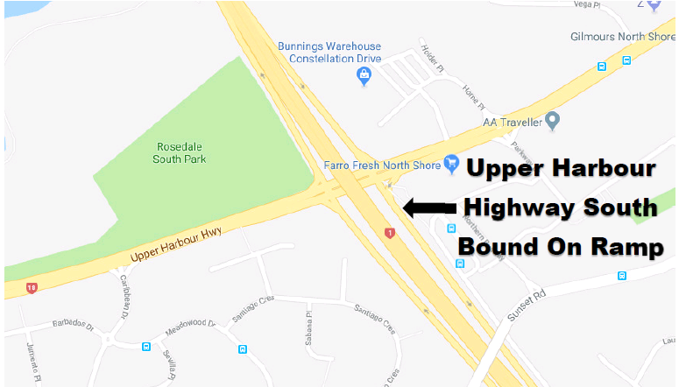

***Figure 4: Location of Upper Harbour Highway on-ramp***

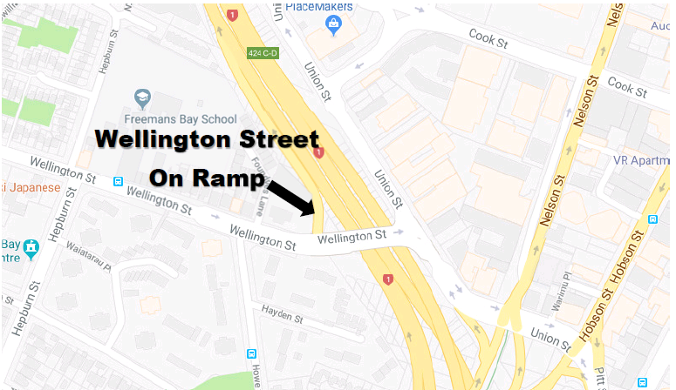

***Figure 5: Location of Wellington Street on-ramp***

Overall ATOC observed that longer merge distances tend to contribute more to inefficient merge scenarios than shorter merges. Short merges force drivers to merge at a consistent location, leading to less variability about the merge and presumably, more predictability for the traffic in the mainline lane receiving the merging traffic.

Further observations about the operation of these ramp merges include:

* On the Upper Harbour Highway southbound on-ramp, the full length of the ramp is seldom used during the peak when mainline traffic speeds are low (approx. 25-35kph), but used more frequently in the shoulder (end) of the peak. The merge length of approximately 250m at Upper Harbour Highway is slightly longer than suggested by the UK standard (230m for a motorway merge when the ramp and main carriageway lanes are at capacity). It appears to be adequate during and at the end of the morning peak. From observations at this interchange, merge length did not appear to be critical to efficient merging.
* Wellington St merging off-peak was straightforward. At most times of the day this interchange is heavily metred, via ramp signals, so merge problems would not be anticipated. Further, due to the extent of the metering, this on-ramp is not as relevant for comparison as other ramps in the region.
* The grade of on-ramp merge did not appear to have a negative influence on merge operation in either location.

**Comparison of On-ramp Characteristics**

The study investigated whether there was any correlation between the crash rates at motorway on-ramp merges and the geometric layout or the traffic volumes at the on-ramps. In the absence of relevant international studies or documentation, and recognising the unique nature of the NZ motorway system and drivers, a desktop study on similar ramps arrangements was undertaken.

A selection of on-ramps from Auckland and one from Wellington, with similar characteristics, were compared as set out below in Table 1.

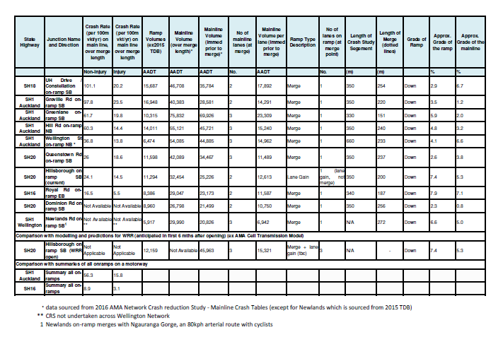

***Table 1: Comparison of steep on-ramp merge lanes (ordered by non-injury crash rate, largest to smallest) (Data source: Crash Reduction Study, Auckland Motorway Alliance, 2016)***

The criteria and characteristics compared are described below:

Criteria and Methodology

1. Ramp Traffic Volumes: AADT figures for the on-ramps were obtained from the NZTA Traffic Data Book 2015.
2. Mainline Traffic Volumes: AADTs on the main line for both the section where merging occurs (across the on-ramp merging area) and immediately upstream of the merge were obtained from the 2016 Auckland Motorway Alliance (AMA) Network Crash Reduction Study (CRS) (Mainline Crash Tables). The volume per lane was calculated from the immediate upstream volume divided by the number of mainline lanes. This methodology assumes an even density of traffic per lane which although not likely, allows relative volumes for comparison between two and three lane motorways.
3. Ramp Type: Whether a merge or a lane gain.
4. Relevant Crash Data: On the mainline section through the ramp merge area, this is the injury or non-injury crash rate in crashes per 100million vehicle kilometres travelled per year. This uses the crash data between 2011 and 2015 (inclusive) to provide a comparable crash rate. Crashes on the mainline only are considered in the AMA Crash Reduction Study, as the majority of motorway crashes on the Auckland network are rear end, non-injury crashes associated with flow breakdown, and merging effects. This was sourced from the CRS. Summary data for all on-ramps across the state highway section was also included as a comparison.
5. Length of Merge: Measured by the length of the 200mm continuity white line on the merge. This was scaled off digital maps and is in metres.
6. No of Lanes: Ramp lanes and mainline lanes at each location.
7. Length of Crash Study Segment: This is the length of the segment used for the crash rate, sourced from the 2016 Crash Reduction Study.
8. The Gradient of the Ramp: This was measured from <http://en-nz.topographic-map.com/places/Auckland-2791052/>. Measured as a percentage.
9. Gradient of the Mainline: This was measured from <http://en-nz.topographic-map.com/places/Auckland-2791052/> ; and by measuring from the interchange over bridge or under bridge or from the continuity lines, to the end of the merge (200mm continuity line). Measured as a percentage.

It is noted that while the data and methodology used in numbers 8 and 9 above provides an indication of relative gradient percentage, the source data used required extrapolation and the figures in the table should be treated as indicative figures for comparison only.

Site Selection

The ramps in the Table 1 above were chosen because they have similar characteristics to the Hillsborough Road onramp south bound. Namely, the locations are downhill main line motorways adjacent to downhill on-ramps, the main difference being that they are merges as opposed to a lane gain. It would be reasonable to expect the ramps below would have similar safety characteristics if Hillsborough Road on-ramp was changed to a merge.

It should be noted that while the Newlands south-bound on-ramp in Wellington is most similar to the likely future Hillsborough on-ramp in some respects (steep grade, single lane on-ramp merging with 3-lane mainline section), it is not a motorway, and has a posted speed limit of 80kph (with effective enforcement due to a downstream speed camera site) and the route allows for cyclists. Further, the crash analysis data available for the Auckland network is not available for the Newlands on-ramp.

Discussions with NZTA Network Management and Safety Team members in Wellington confirms that there are no perceived or evidence-based operational or safety issues with the Newlands on-ramp based on the characteristics of the ramp and merge arrangement. In fact, downstream conditions at the intersections at the bottom of Ngauranga Gorge, as the gradients flatten out are more significant operationally and are believed to have far greater impact than the on-ramp merge.

Discussion of Findings

The comparison undertaken over ten sites does not indicate any definitive relationship between the steepness of an on-ramp and the crash rate across all sample sites, or between any of the other site characteristics. This may be due to the small sample size used for the analysis, but is also likely to reflect the complex nature of ramp merging and its impacts on the wider network.

It can be seen from Table 1 that Greville Rd and Upper Harbour on-ramps have the highest non-injury crash rates. While the Upper Harbour Highway on-ramp is one of the steeper on-ramps, Greville Rd is relatively flat. Neither have especially high mainline lane volumes, although their on-ramp volumes are relatively high. On the other hand, Royal Rd has one of the lowest crash rates, but it is the steepest ramp.

The Greville Rd on-ramp feeds traffic from the suburbs of Browns Bay, Rothesay Bay, Murrays Bay, Pinehill, Rosedale to the east and Albany Lucas Heights, Coatesville, Dairy Flat, to the west. It also provides access to Massey University and the large Westfield Albany shopping mall. This on-ramp is consistently busy throughout the day. The traffic volume at this on-ramp is more likely to contribute to its crash rate than the geometry.

Green Lane has the highest on-ramp AADT but the shortest on-ramp merge length and only a moderate crash rate compared with the others in the sample. This may be due to the high traffic volumes resulting in the mainline carriageway often being at or over capacity with a reduced average speed providing more time to signal and manoeuvre safely This section of SH1 has some of the highest volumes of traffic in New Zealand. The traffic movement through this part of Auckland is large and continuous across the working week and the weekends. However, SH1 at Greenlane is one of the flattest grades..

It is interesting to note that both the steepest and the flattest ramps feature the higher crash rates. Royal Road and Upper Harbour are steep, but Royal Rd has the lowest crash rate and Upper Harbour has the highest non-injury and second highest injury crash rates. This would lend support to the conclusion that there is not a definitive relationship between steepness of the ramp and crash rate.

The crash rates summarised across all SH16 on-ramps and all SH1 crash rates are also shown in the table in order to establish whether the sample ramps have crash rates higher than the summary (average) results. It can be seen from the figures that as a group, the crash rates are all higher than the SH16 average, but are spread above and below the SH1 average. Again, the sample size of this study is not sufficient to draw definitive conclusions, but it would appear that the downhill ramps do not represent significantly higher crash rates than the averages across multiple on-ramps.

Considering different criteria, the following trends are noted:

|  |  |
| --- | --- |
| Criteria reviewed | On ramp description |
| On-ramp: Highest AADT | SH1 S/B Greville Rd |
| On-ramp: Highest adjacent mainline AADT | SH1 S/B Greenlane |
| On-ramp: Highest crash rate (injury) on adjacent mainline | SH1 S/B Greville |
| Highest crash rate (non-injury) on adjacent mainline | Constellation |
| On-ramp: Shortest length of merge | SH1 S/B Greenlane |
| On-ramp: Steepest adjacent grade of mainline | SH16 E/B Royal Road |

***Table 2: High-Level Observations from Comparison of on-ramp merges***

**Hypothesis: Flow breakdown on steep negative gradient**

During the study, an alternative potential reason was considered for increased flow breakdown on steep negative gradient motorways adjacent to on-ramps, which considers driver behaviour. This was understood to be a concern of the Transport Agency in the event that the lane gain at Hillsborough southbound on-ramp was changed to a merge.

Drivers on congested, but relatively fast-moving motorways need to balance the need for a safe braking distance between their vehicle and the vehicle in front, against the need to not create such a large a gap that it will encourage drivers in neighbouring lanes to enter the gap and by doing so reduce the available safe braking distance between vehicles. Consequently, drivers tend to drive as close to the car in front as they believe it is safe to do so, for any given speed and road condition. As the motorway becomes more congested the safe distance between vehicles tends to reduce, however the speed may not reduce to the same degree, so drivers are forced to accept a greater degree of risk.

The Highway Capacity Manual (2010) comments “Any disruption of the traffic stream, such as vehicles entering from a ramp or a vehicle changing lanes, can establish a disruption wave that propagates throughout the upstream traffic flow. At capacity, the traffic stream has no ability to dissipate even the most minor disruption, and any incident can be expected to produce a serious breakdown with extensive queuing. Manoeuvrability within the traffic stream is extremely limited, and the level of physical and psychological comfort afforded the driver is poor”.

As motorists on the motorway approach an on-ramp, drivers in lane 1 (the inside lane nearest to the edge of the motorway) tend to scan the ramp for vehicles and judge whether the vehicles on the ramp will impede movement when they join the live lanes. If a driver believes that the vehicles on the ramp will affect their movement, the driver is required to make a decision to either:

* Accelerate so that their vehicle will be in front of the vehicles on the ramp before they reach the live lane.
* Decelerate to allow vehicles on the ramp to gain entry into the motorway in front of the driver’s vehicle.
* Change lane, in which case the driver will need to either accelerate or decelerate depending on the gap to be accepted.
* Keep at a constant speed and assume that vehicles on the ramp will adjust their speeds to avoid collisions.

If the driver on the motorway chooses to decelerate, on a positive grade or at grade motorway this can be achieved by easing up on the accelerator, however doing so on a negative longitudinal grade may not slow the vehicle down sufficiently and it may be necessary to brake to reduce speed.

When motorways in the ‘shoulder peak’ (immediately before or after peak period) and are heavily congested but still flowing at a moderate speed, the gap between vehicles tends to be at its acceptable minimum. Drivers need to concentrate on the brake lights of the vehicle in front of their vehicle, as in these conditions there is minimal reaction time and an increased risk of rear end crashing into the vehicle in front.

If the driver in front brakes to create a gap as described above, the driver of the following must immediately brake as well and potentially brake harder as the following driver has no knowledge of what caused the braking in the first place. The braking and of showing brake lights, in turn causes a shockwave of flow breakdown upstream of the merging traffic. The increase in the number of vehicles braking on negative gradients as opposed to other gradients may be relatively small, but this may generate more flow breakdown.

Consequently, this theory suggests that traffic joining negative longitudinal grade motorways will generate more braking or showing of brake lights, which in turn will generate more flow breakdowns than traffic joining level or positive grade motorways, and it is this phenomenon that traffic engineers have observed.

A greater number of crashes or a lower average speed on motorways with negative longitudinal grades adjacent to merging traffic could be considered evidence to support this theory. However, it may be a correlational relationship as opposed to causal and therefore would be difficult to prove definitively. Although it would be difficult to prove the theory, it appears to be logical and therefore it would be reasonable to consider how to reduce the amount of braking on negative gradient motorways adjacent to on-ramps.

**CURRENT STATUS**

Figure 6 shows the view looking down the southbound lanes towards the point of merge with the on-ramp.

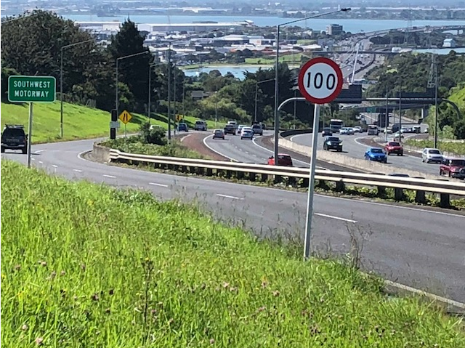

***Figure 6: SH20 looking south-east towards point of merge with southbound on-ramp***

Since the study was undertaken in mid-2017, the Waterview Tunnel has opened and a number of impacts on the wider Auckland motorway and arterial networks have been observed. The project has delivered three south-east bound lanes on SH20 from the southern end of the Waterview Tunnel linking into the Hillsborough Rd Interchange where the third lane is dropped as an exit-only lane at the southbound off-ramp and added again as a lane gain at the southbound on-ramp.

As mentioned earlier in this report, the Transport Agency considered taking the three southbound lanes past the off-ramp and converting the on-ramp to a merge. Although the work described in this report has not conclusively shown any link between crash rates and steep on-ramp merging, the proposal would have implications at the Queenstown Rd Bridge, which would need widening. It would also contribute to complex weaving and an increased arrival rate at the heavily congested Neilson St off-ramp. The current layout downstream of Hillsborough Rd is shown in Figure 3. The additional widening to 3 lanes through Hillsborough Rd Interchange has not been undertaken at this time.

The communications team for the Waterview project advise that they have had only a small amount of interest expressed (through queries from members of the public) about the layout of the Hillsborough Rd Interchange. This is despite a general overall high level of interest in the Waterview project and in particular the reasons behind network layout decisions.

Publicity information prepared to respond to questions about why SH20 drops a third lane at Hillsborough Rd notes that:

* The Transport Agency looked at several factors when deciding on the configuration of the road network at this location
* The Hillsborough Road interchange services a large catchment area from Titirangi to the West to Three Kings Royal Oak to the east. As such there is a very high on ramp flow at peak periods and for this reason there has historically been a lane gain to the motorway.
* Specific to this site the on ramp is on a steep downhill section. When an on-ramp merges into the motorway on a sharp incline the merge area performs poorly and the total number of vehicles able to move through the interchange drops.
* The Agency did look into adding a third lane, plus a lane gain from the Hillsborough Interchange, however it was found that opening more lanes would require the Queenstown Road bridge to be rebuilt because it is too narrow at this point.
* In addition, an extra lane would have increased the arrival rate to the Neilson Street off ramp in the AM peak which may have created a queue onto the motorway.
* The Agency will continue to monitor the transport network in this area and identify ways to improve it.

**CONCLUSIONS**

The study concludes that there is no definitive relationship between flow breakdown, safety, crash rates and gradient (either main carriageway or on-ramp) generally. Further, in Auckland there appear to be few specific operational problems with steep on-ramp merging compared to merging on flatter on-ramps. Further in-depth research would be required to fully understand these relationships and it is noted that studies of this nature do not appear to have been completed to date either in New Zealand or overseas.

There is relatively little available advice or recommendations from academic publications on this phenomenon. Based on the lack of information, the review concludes that the issue of steep downhill merges has not been considered sufficiently substantial to study in detail.

There is no specific mention of the relevance of downhill grades in design manuals except the ability to shorten the on-ramp.

As a result of the lack of evidence, it is concluded that good design of on-ramp merge areas is essential to optimise safe operation of on-ramp merges, including on steep downhill sections. This factor could be more important than the grade of the downhill ramp.

**RECOMMENDATIONS**

The study has identified no definitive correlation between steep downhill grades on-ramp merges, high traffic volumes and crash rates. International design guidelines and academic research is relatively silent about the subject, dealing only with the more general topic of merging efficiencies and geometric design conditions for merging.

It is recommended that if the lane gain is to be converted to a merge at Hillsborough southbound on-ramp, then the design of the merge (including the merge layout, length, markings) is critical to optimise the operational safety and efficiency. The design should influence consistent speeds across the main carriageway lanes and the ramp at the point of the merge as far as possible. The downstream capacity of any new road alignment should also be carefully examined.

The New Zealand Transport Agency will continue to monitor the demand and performance of SH20 in the vicinity of the Hillsborough Rd Interchange. The Agency recognizes the need to proceed with any further network changes in this area with caution, taking account of the conflicting demands of different transport users, and the difficulty in predicting the performance outcomes of any changes at this location and across the wider network.

**REFERENCES**

1. Austroads Guide to Road Design (2015, Part 4C)
2. Design Manual for Roads and Bridges (2006, Vol. 6, Sec. 2, Pt. 1)
3. Highway Capacity Manual (2010, Chap. 13)

**ACKNOWLEDGEMENTS**

The authors acknowledge the input of NZ Transport Agency, Auckland Motorway Alliance and Aurecon in the development of this paper and the project.