London in 2040: Planning Crossrail 2

AUTHOR AND PRESENTER:
Peter Moth
Transport Planning Professional (TPP), MCIHT
Senior Transport Planner, Transport Planning, Jacobs
Peter.Moth@jacobs.com

ABSTRACT
London's public transport network is expected to be at capacity in the 2020s. Crossrail 2 is a proposed north-south railway being planned in London, as a further 1.5 million people are expected to live to the UK capital by 2040 - equivalent to adding a city with a population the size of Auckland. A project over 40 years in the making, Crossrail 2 is planning to submit a formal application for consent in 2020, with the possibility of construction starting as early as 2023. This paper will draw out some of the planning issues facing the project and present them in a manner that is relevant to New Zealand, exploring the history of the project, the current proposals and where London could be by the time the project could open in the 2030s.
The paper is split into three sections:
- Introduction to some of the challenges facing London and a comparison with those in Auckland;
- Then: the first section will focus on the history of the Crossrail 2 project and its significance to London, lessons learned from the recent rail projects in London, earlier public consultations (and feedback), influence of politics, routes considered and ever-changing objectives;
- Now: the second section will explore the current scheme proposals, as the project prepares for a formal consent application, engaging with affected stakeholders, considering how to make the scheme better and more affordable to taxpayers; and
- Tomorrow: this section will explore a future London with and without Crossrail 2, and will explore some of the challenges facing the project, including rolling stock design, impact on a transport system that moves five million people per day and the project's role in supporting London's housing & employment requirements.
The paper will conclude by summarising the key areas of relevance to planning major infrastructure in other urban conurbations.

INTRODUCTION
Some of London’s future transport challenges are similar to those of other major world cities. Large population growth is likely to mean that many cities around the world will experience major crowding issues in the next 10-15 years. As way of comparison, Table 1 below provides a brief comparison between London and Auckland, two cities that dominate their country’s economy. The two are very different in many respects, both socially and physically, but both cities are growing at unprecedented rates, and, extrapolating this growth forward, the existing public transport network in both cities will be at capacity unless substantial capacity is added.

Table 1: Comparison of London and Auckland
 | London | Auckland
Population (as % of country) | 8.6m (12%) | 1.5m (32%)
Percentage of national GDP produced in city | 22% | 36.6%
Current population growth / week | 1,750 | 1,000
Transport demand forecast to exceed capacity | 2025 | 2030-2040
Major transport interventions under construction | Crossrail (2018) | City Rail Link (2023)
PT trips per person per year | 200 | 52
Housing requirement | 400,000 over ten years | 34,000 over 10 years

Auckland generates a greater proportion of national GDP than London does, reflecting the higher proportion of the population who live and work there. In terms of public transport trips per person, per year, it can be seen from Table 1 above, that despite recent improvements, Auckland performs relatively poorly. London achieves roughly four times as many PT trips per capita per year. Other cities of similar size, such as Vancouver, Ottawa and Calgary all achieve three times the level of PT trips per capita seen in Auckland.

Population growth in both cities is forecast to be substantial. In London, a further 1.5m people are expected by 2040, whilst in Auckland, a million more people are forecast by 2046. In percentage terms, Auckland’s growth (around 50-60%) is much greater than London’s. Major heavy rail investment in both cities is underway to support population growth and densification; Crossrail is due to open in London in late 2018 and Auckland’s City Rail link will allow substantially greater capacity into and through the CBD when it opens in 2023. London is now setting up the next major rail infrastructure project, known as Crossrail 2.

The context for Crossrail 2

London’s population is growing rapidly, at a rate equivalent to adding two Tube trains full of people every week – in rough terms that represents growth of approximately 2,000 people every eight days, equating to 91,250 people a year (London Reconnections, 2014). In January 2015, following 15 years of strong population growth, London passed its pre-war record of 8.6m people – London is now more populated than it has ever been in its past. As Figure 1 indicates, the Greater London Authority (GLA) has forecast three growth scenarios in 2050, labelled as low, medium and high. Even in the most conservative case, the population could grow by nearly a million, compared to 2015. Whichever scenario comes to light, London has a substantial housing shortage, and needs to build 400,000 additional homes in the next ten years (ten times more than Auckland).

Figure 1: Historic and 2050 forecasts for the population of London

The London Infrastructure Plan 2050 (GLA, 2014) suggests that, under a central scenario, the population could rise to 11.3 million (31% growth compared to 2015) by 2050, grounded on the economic strength of its highly productive internationally competitive centre.

Rail-based modes currently accommodate 80 per cent of the 1.2 million trips to Central London in an average weekday morning peak period. The network of rail lines needed to concentrate and then disperse such a volume of people is vast and is duplicated in only a small handful of cities in the world (TfL, 2015-1).

The mainline railways serving Central London bring passengers from large distances and do not generally penetrate the heart of the city but form a loose ring around the edge of the current Central Activities Zone (CAZ), where the Victorian engineers chose to site their railway termini. As a result, half of people entering Central London in the weekday morning peak by national rail, transfer onto either a London Underground (LU) or Docklands Light Railway (DLR) service, placing huge pressure on the transport network. By contrast, almost all passengers arriving at Britomart (in Auckland) walk to their onward destination, due partly to the lack of onward links available, and also due to the size of Auckland’s CBD, being much smaller than London.

Committed projects such as Crossrail and Thameslink have sought to overcome these historic constraints by connecting the national rail lines through the centre of London, relieving key termini bottlenecks and crowding on onward Tube lines. They will create new direct links to the heart of London and across the city, as illustrated in Figure 2, below. This releases capacity at the mainline termini which is then available to support high density office development in these locations, taking advantage of the exceptional connectivity these locations offer.

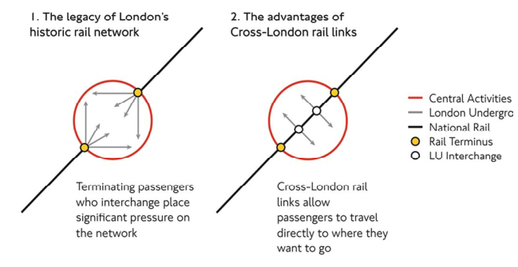

Figure 2: The effect of cross-London rail links reducing pressure around London’s termini

As well as Crossrail and Thameslink, London is investing heavily in transport infrastructure, with several LU lines set to be upgraded by 2025, to such a point that very little if any additional capacity can be added beyond this. In all, public transport capacity is expected to increase by 30% by 2025. Despite the fact that population is due to increase by roughly the same amount, demand for public transport is expected to grow by 60% over the same period and is expected to outstrip supply by the mid-2020s (TfL, 2015-1).

Figure 3, below, illustrates forecast levels of crowding on the underground network in 2031. It can be seen that a number of lines exceed four passengers standing per square metre (ppsm) . Particular problems are forecast on the Northern line (north of Tooting Broadway), the Victoria line, the Jubilee line, the Central line and the Piccadilly line (south of Finsbury Park).

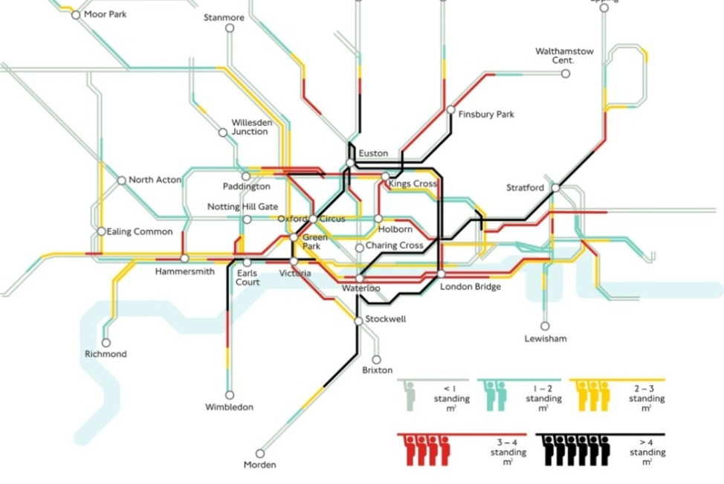

Figure 3: Forecast crowding levels on the Tube network in 2031, AM peak (07:00-10:00)

Agglomeration benefits are substantial in London due to the scale and density of employment it accommodates in its central core and the quality of its transport networks. The scenario in Auckland is similar, where Houghton, 2017, found that the ability for exchange in the CBD is increasingly recognised as fundamental to the urban economy in the 21st century. London’s success benefits the UK as a whole but this cannot be taken for granted, given future conditions forecast on the public transport network. Without supportive policies, population and employment growth could be choked off. The likely outcome, based on historical trends, is not stability but decline and falling living standards (Crossrail 2, 2016).

Congestion on the underground network is one of a number of problems facing London in the next 10-15 years. Other problems include a London wide housing shortage and lack of access by public transport to some of London’s key regeneration centres. In order to combat these problems, a set of goals and objectives have been identified; these are listed in Appendix A.

A number of solutions to address these objectives have been explored by Transport for London in recent years. Of all the solutions explored (see Table 2 below), a new high frequency, cross London heavy rail system appears to address the problem most successfully.

Table 2: Comparison of high level options considered to address London’s objectives
 | Option(s) considered | Summary
Non-transport infrastructure solutions | Behaviour change, reducing need to travel, uptake in technology | Demand for travel has increased despite improvements in technology. Fails to meet housing demands and ignores agglomeration effect
Non-transport infrastructure solutions | Constrain demand using new fares policy | Using fares to constrain demand offers at most a marginal benefit; doesn’t accommodate significant growth in population
Transport infrastructure  solutions | Enhance capacity of existing PT network | Only marginal improvements in capacity are possible beyond committed schemes. Fails to meet objectives 2i and 3ii (see Appendix A)
Transport infrastructure  solutions | Significantly increase road capacity | Highway improvements cannot facilitate the growth of London’s central activity zone to the level of density required to meet population
Transport infrastructure  solutions | Addition of new rail capacity | The creation of a new SW to NE rail corridor is best able to meet London’s housing and transport objectives

Summary

In order to relieve forecast crowding conditions on the transport network, and to help meet London’s housing shortage, additional public transport capacity is needed. If population forecasts are to be believed, many more people will be travelling to Central London in the future, adding further pressure to the transport network. Projects that add radial public transport capacity to Central London will best meet London’s objectives; they will help secure the benefits of a successful Central London economy by allowing more workers to access jobs there.

THEN: HISTORY OF CROSSRAIL 2

The origins of Crossrail 2 go back to the London Rail Study in 1974 (Hebbert, 2013). The Terms of Reference of the study were “to review arrangements for passenger travel by rail, wholly or mainly within Greater London, and on cross-boundary services carrying passengers mainly to and from work in central London”. The study was effectively an assessment of London’s future public transport needs. It is worth noting that in 1973:
- there were fewer than 650m annual LU journeys (today this figure is 1.34bn);
- Greater London’s population was 7.4bn and falling (today this is 8.6bn and rising); and
- the most crowded lines were the Bakerloo and Central lines

The recommended schemes in the study have largely been completed, as demonstrated below:
- Fleet line – now Jubilee line (opened in 1999)
- British Rail through-running scheme – now ‘Thameslink’ (due to open in full in 2018)
- RingRail – now London Overground orbital route (complete in 2012)
- River Line – now DLR (complete in 2012)

However, there is one outstanding project. The London Transport (LT) Chelsea-Hackney line – a new underground line that would:
- relieve the Central line;
- provide a link to City and West End from Hackney;
- improve termini distribution at Victoria and Waterloo; and
- cost £190m

The 1974 Report recommendation was to safeguard a potential alignment, but with low priority, from Wimbledon to Epping, via the existing District and Central lines, with a new tunnel in central London, serving Waterloo and Victoria stations.

A further report in 1989 also highlighted the need for additional rail capacity, citing ‘Severe strains on London’s transport system’, ‘heavy congestion at peak times’ and ‘Overcrowding on the Underground and British Rail services’. The 1989 Report proposed a major upgrade programme to the existing network, and two new lines:
- ‘British Rail-gauge’ Crossrail line between Paddington and Liverpool Street; and
- LU-gauge line connecting Wimbledon and Hainault, otherwise known as the LT Chelsea-Hackney line (cost £1.3bn), as per the 1974 report

The line was first formally safeguarded by the UK Government (Department of Transport) two years later in 1991, with Waterloo now removed from the plans. The proposals included an alignment from southwest to northeast London, via a new tunnel in Central London. See Figure 4.

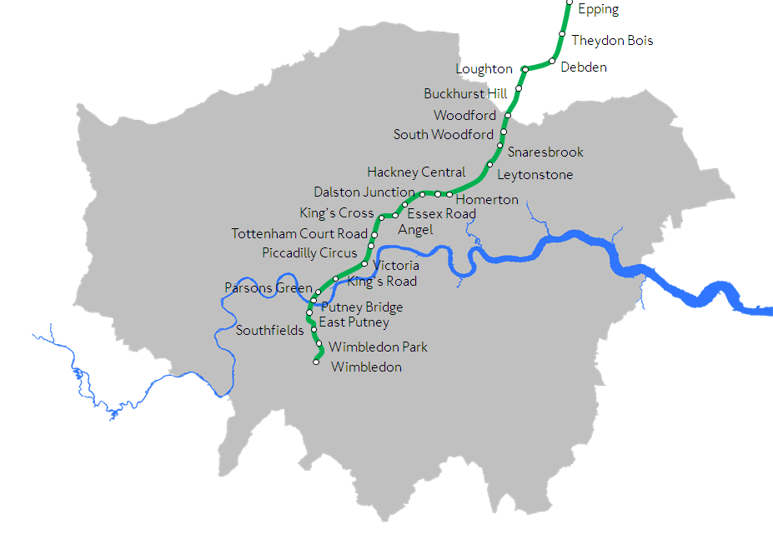

Figure 4: The safeguarded route from 1991 - 2015

Transport modelling at the time continued to demonstrate that options from Wimbledon to Hackney are best at reducing overcrowding on the network. However, the focus of attention for further investment was turning to a new east-west railway known as Crossrail (for which an application for planning consent was submitted in 2005) to help resolve congestion on an east-west axis.

Further optioneering 2010-2011

Following a period of population growth, London’s new Mayor, Ken Livingstone, called for a full review of the Chelsea-Hackney line route options in 2007, noting the considerable benefits of serving Clapham Junction and south thereof, which would require a considerable re-evaluation of the proposed route. In 2009, following a review of over 100 options (see Appendix B for details), the Secretary of State for Transport, Lord Adonis, requested a full review to understand whether the safeguarded alignment was still valid, given changing population and transport trends. Transport for London (TfL) completed a thorough option assessment process, using various tools, including strategic transport models, population / employment forecasts and economic appraisal.

Following the review, several major alterations to the route were suggested (details can be found in Appendix C), to meet changing transport, population and employment trends. Two shortlisted options were recommended for further development, for the purposes of developing the project further, which was formally renamed to Crossrail 2 in 2012. These are discussed below.

Option 1: High frequency, Central London metro

A self-contained metro system, capable of running 40 trains per hour (tph), per direction. The key characteristics of this option include:
- 120m long trains and platforms with 5.5m diameter tunnels;
- Ultra-high frequency: trains up to every 90 seconds;
- Fully automatic operation;
- Readily extendable onto the national rail network (in future), if required;
- Proven technology: based on Line 14 of the Paris Metro, with entirely automated operation providing a very high frequency service, and
- Estimated cost £10-15bn

Option 2: Regional metro option

A regional scheme, allowing trains to run from the national rail system underneath London, much like Crossrail. Because of the capacity constraints on the existing railway network, this option is constrained to a maximum frequency of 30tph. The key characteristics of this option include:
- 200 – 250m long trains and platforms, with 7.5m diameter tunnels;
- High frequency: driver operated trains up to every 120 seconds;
- Addresses key NR capacity gaps, especially on South West Main Line;
- Serves key London growth areas, offering potential to meet London’s housing needs;
- Serves more of London and beyond;
- Based on the concept of RER lines in Paris, and
- Estimated cost £20-30bn

2013 & 2014 Public consultations

With two options identified, attention turned to developing these options and, in particular, obtaining feedback from the public. A public consultation held in 2013 focused on people’s views on the two shortlisted options. More than 95% of 14,000 respondents either supported or strongly supported the regional option, substantially more than those supporting the metro option.

Together with the wider support from across the industry, a decision was taken to progress the regional option (Option 2) as the preferred option. Despite its large additional cost, a regional scheme would provide large benefits to the national rail network, as well as to Central London. As a result, the UK’s railway infrastructure provider, Network Rail, became a huge supporter of the regional scheme. Further design development took place throughout 2013 and 2014, ahead of a second consultation, which would focus on specific sections of the route, where decisions had yet to be taken. In summer 2014, TfL consulted on three key areas:
- An extension of the route from Alexandra Palace to New Southgate;
- Options for a station (or not) in Chelsea, and
- Route alignments and stations in the Hackney area.

Following this consultation, decisions were taken to extend the route to New Southgate (to allow Crossrail 2 trains to use the existing depot on the East Coast Main Line), retain a station at King’s Road Chelsea, and to safeguard a future extension to Hackney. The route safeguarding was formally refreshed (for the first time since 1991, significant changes were made to the scheme) in early 2015, to fully reflect the regional scheme, and 2014 consultation findings.

2015 Consultation

Following this refresh of safeguarding, detailed option appraisal was undertaken on a site-by-site level. This resulted in the identification of preferred station layouts and operational worksites, both of which were subject to a detailed public consultation in late 2015. For the first time, the public were asked to comment on proposals for Crossrail 2 that involved details regarding the impact on residential, commercial and other land, as well as impacts on the existing transport network during construction. The response, whilst generally positive, highlighted key areas on the route that would present challenges to delivery. In particular, public views on the proposals for Wimbledon, King’s Road and several ventilation shafts were far from supportive.

National Infrastructure Commission (NIC) review

In October 2015, the newly formed NIC reported recommendations on the Crossrail 2 project (NIC, 2016). The report concluded (among other things) that:
- Crossrail 2 should be viewed as an investment of national significance, because of its impact beyond Greater London and its importance in relieving nationally important rail termini and interchange stations;
- Crossrail 2 should be taken forward as a priority with the aim of opening in 2033;
- the scheme is required not only for the transport benefits it brings, but also the fact that its implementation is essential in order to meet London’s housing needs, and
- costs need to be saved from the project in order for Crossrail 2 to be affordable.

NOW: CURRENT SCHEME PROPOSALS

Crossrail 2 is being jointly delivered by Transport for London and Network Rail. Broadly speaking, TfL are responsible for the development of the underground elements of the scheme, and Network Rail the above ground sections. Key decisions are still to be taken in three key areas:
- Whether to serve Tooting Broadway or Balham in south London;
- Whether to serve Wood Green instead of Turnpike Lane and Alexandra Palace, and
- Whether or not to serve King’s Road

Following the NIC recommendations, the project is gearing up to an application for consent in 2020, with a view to scheme opening in 2033. The current scheme alignment is indicated below, in Figure 5. Note the number of branches in the south west corridor; Crossrail’s core 2-minute frequency quickly reduces to a 15-minute frequency on its four southwestern branches.

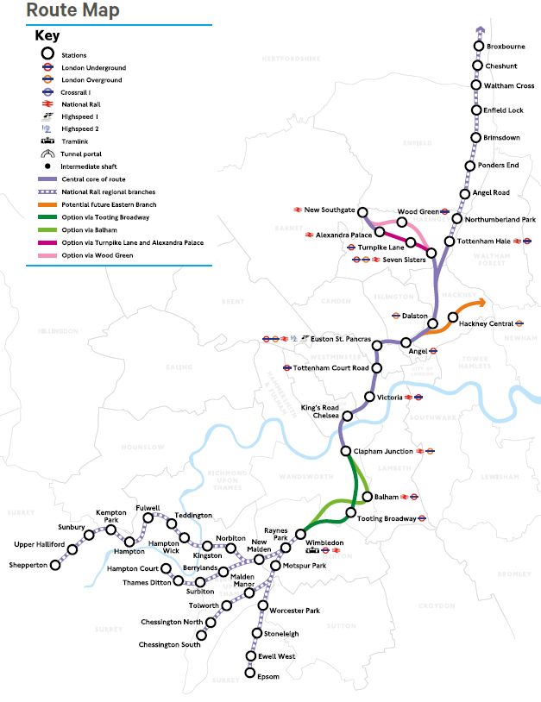

Figure 5: The current Crossrail 2 proposals

Current stage of development: 2018-2020

Further consultation is needed on the project in order to help guide key decisions. This consultation will focus not just on route selection but also on specific proposals at all worksites. It will also, for the first time, discuss proposals for sections above ground, those being developed by Network Rail, allowing the scheme safeguarding to be extended to cover all 47 stations on the route.

Crossrail 2 is currently developing detailed proposals ahead of a formal submission for consent in 2020. If successful, it could be granted consent through a Parliamentary bill by 2023. The current scheme cost estimate is around £30-35bn, a cost that is not currently committed. Despite these high costs, the benefit: cost ratio of the project was recently assessed as being greater than 2:1 (TfL, 2015-2). Due to the large quantity of public money potentially involved, efforts are underway to investigate how the cost of the project could either be reduced, or spread over a longer period. This work has explored options looking at phasing the project over several bespoke stages. Until a funding strategy is secure, there will always be a danger that the scheme is not developed further.

Focussed engagement at various points on the route has allowed the scheme to be developed in close liaison with key affected stakeholders, including landowners, London Boroughs and resident groups. Where this engagement has taken place, scheme layouts are broadly supported and the chances of opposition to the scheme are reduced. However, the opportunity has not been taken consistently along the route to discuss emerging proposals with all key stakeholders; no equivalent of the Investment Logic Mapping process exists in the UK (Brown, 2016), leading to an ad-hoc approach to liaising with stakeholders. Stakeholders are typically presented with a preferred option only, rather than a range of options to comment on. This will likely lead to difficult discussions at consultation and increase the likelihood of petitions being submitted to Parliament. More generally, however, Crossrail 2 continues to be widely supported. At a recent industry event a survey was undertaken asking “Which major infrastructure project should be prioritised in 2018?” Crossrail 2 topped the poll with 33% of votes, ahead of both Heathrow’s third runway and new housing.

TOMORROW: LONDON’S FUTURE WITH AND WITHOUT CROSSRAIL 2

As discussed in the introduction, London’s population is set to continue to grow, putting ever more pressure onto London’s transport network, particularly at rail termini. By 2025, additional public transport capacity will be required. Of all interventions considered, Crossrail 2 would be most effective at relieving these crowding issues (Crossrail 2, 2017), allowing London to fulfil its economic potential. The timeline in Figure 6 below indicates forecast crowding at various points in the future, if no more capacity is added beyond 2025.

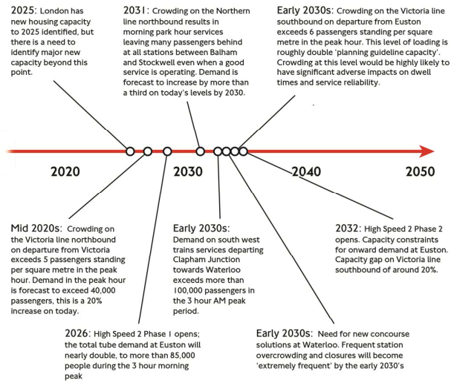

Figure 6: Future crowding between 2020 and 2050 in London, without Crossrail 2

Benefits of Crossrail 2

Crossrail 2 will provide many benefits to London and the UK. The two key benefits can be summarised as improved accessibility and reduced crowding. Taking the first of these, Crossrail 2 will serve many areas, particularly in north London, that currently experience low public transport frequency, slow journey times and poor access to rail and everyday amenities. Table 3, below, indicates the number of jobs accessible within 45 minutes, both with and without Crossrail 2. It can be seen that Crossrail 2 will make huge differences to some areas, for example, allowing Brimsdown access to four times as many jobs and Ponders End to twice as many jobs. This will help unlock housing potential at these sites, going a long way towards meeting London’s housing target, as a major byproduct of improved accessibility.

Table 3: Future accessibility at several points in London, with and without Crossrail 2

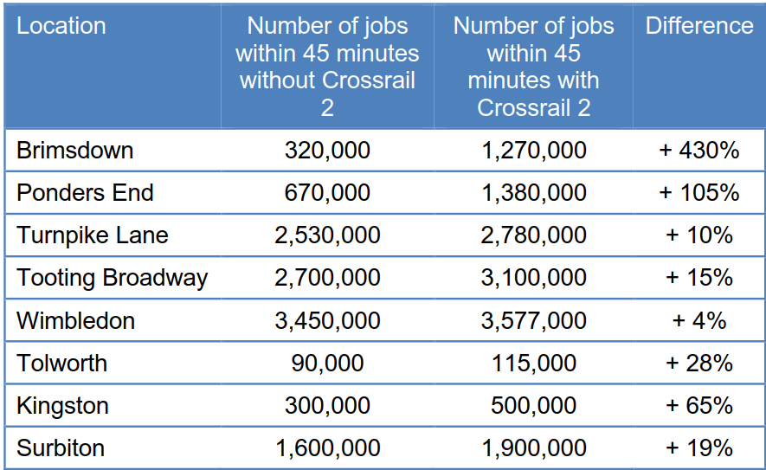

All told, Crossrail 2 will provide an additional 270,000 passengers journeys during the morning peak period. On a more local level, Crossrail 2 will deliver step-free access at all 47 stations on the route, allowing substantially improved physical access to the public transport system in London. Access to hospitals, schools and other day-to-day facilites will be greatly boosted by the new, easier and quicker journeys made possible as a result of the scheme.

On the second point, that of crowding relief, Crossrail 2 will not fully resolve all crowding issues in Central London, but it will go further towards reducing congestion in Central London than any alternative considered bt TfL. As Figure 7, below, indicates, Crossrail 2 will provide crowding relief to all nine London Underground lines, to a greater or lesser extent. The largest relief is expected on the Northern and Victoria lines, with reductions of around 20-30% forecast, as a direct consequence of Crossrail 2.

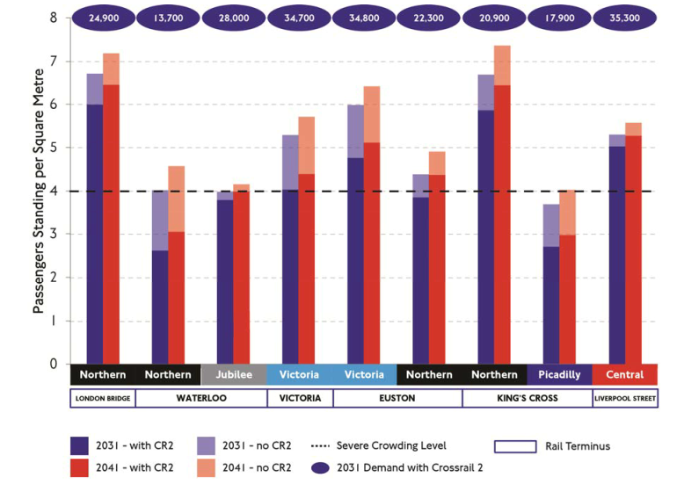

Figure 7: Future crowding on London Underground lines, with and without Crossrail 2

The analysis undertaken by TfL, 2015, has suggested that the Crossrail 2 scheme would substantially relieve crowding and congestion at key national rail stations, including Waterloo and Liverpool Street. By allowing suburban trains to run into Crossrail 2 tunnels through central London, substantial capacity is freed up, allowing more services to operate on the existing network, serving central London’s growing employment market (i.e. the effect illustrated in Figure 2).

Challenges

Building and operating Crossrail 2 will not be without its challenges. Aside from cost, one of the major obstacles to overcome will be the construction of the new railway whilst keeping the rest of London operational. Major interfaces with the existing network are expected at various key sites, and it is likely that mainline railways will be subject to substantial disruption. The works associated with Crossrail 2 involve widening existing railway corridors, constructing interchanges within existing London Underground stations and the temporary closure of major highway routes.

As noted above, the currrent scheme proposal includes four branches in the southwestern corridor, reducing service from a 2-minute frequency in the core to a 15-minute frequency. As noted by Walker, 2012, sufficient service frequency is absolutely key to achieving successful transit. There is a risk that, at a 15-minute frequency, some branch services are on the very outer edge of anything considered ‘rapid transit’. Whilst destinations on these branches consider themselves as very much on the Crossrail 2 scheme, they may be disappointed at the level of service offered.

A key operational technical challenge crucial to overcome in order to running a reliable 2-minute frequency is achieving sufficiently short dwell times. As noted by Walker, 2012, high frequency metro systems become intensely sensitve to dwell times at stations. Key variables affecting dwell include rolling stock design, train length, platform width and system operations. It is currently assumed that Class 345 vehicles will be used, which allow for three double doors (per side) on each of the nine carriages, making a total of 27 doors per train (RTM, 2016). This compares to the 12 doors available on Auckland’s AM class EMUs. In order to meet the 30tph peak frequency on Crossrail 2, 45 second dwell times will be required at central London stations, during which time upto 1,500 people will board / alight each service.

CONCLUSIONS AND RECOMMENDATIONS

It is clear from the investigations into Crossrail 2 that a strong case for another cross-London railway exists. It is the only scheme considered by TfL that reduces crowding on many of the London Underground lines to manageable levels, and the improved access provided by Crossrail 2 will allow up to 200,000 new homes to be built along the corridor, going a long way towards meeting London’s future housing needs. After more than 40 years of planning, a change of name and over 200 route options, the industry is beginning to settle on a preferred scheme.

There are, however, several key issues to resolve in order to deliver Crossrail 2; many of these are issues that face all cities planning major transport infrastructure around the world.

Firstly, the scheme needs support from those most affected by it. The construction of Crossrail 2 is likely to directly affect many more residents in Greater London and neighbouring authorities than any other recent infrastructure project. It is clear from consultation responses in 2015 that not all Londoners support the current proposals, and more must be done to engage with affected communities, in order to secure buy-in in advance of a formal consent application. Failure to do this will lead to an unmanageable number of petitions at the Select Committee stage of any Parliamentary bill, leading to long delays or even cancellation of the project. The scheme would have benefitted from obtaining formal stakeholder buy in to localised problems and objectives in the form of an Investment Logic Mapping process, or similar, as used in New Zealand.

Second, impacts on existing networks must be minimised during construction. Impacts at stations such as Wimbledon will be large in scale, and could lead to many long term closures of the existing railway. Where possible, these closures should coincide with planned upgrades to the network. Innovative lessons are being learned from Crossrail as to how to minimise freight movements on the road network, and minimise disruption to households. Opportunities exist to make better use of the railway network to shift material in and out of worksites. There is a need to explore innovative engineering solutions in order to minimise construction duration.

Thirdly, a funding strategy needs to be agreed. Several suggestions have been put forward (NIC, 2016). An independent report produced by PricewaterhouseCoopers (PwC, 2014) set out a number of options exploring how Crossrail 2 could be funded. It shows that over half of the costs of the scheme could be met by London using existing funding mechanisms. An agreed funding plan is ideally needed before a bill is submitted to Parliament (NIC, 2016).

It is not possible for Crossrail 2 to solve all of London’s transport problems, and nor should it seek to do so. For example, in order to minimise journey times to central London, the most direct route should be taken. However, to also relieve congestion on the Northern line, Crossrail 2 should be diverted to serve Tooting Broadway or Balham, involving a deviation of 2-3km. As suggested by Walker, 2012, adding a deviation to an otherwise straight route can defeat the line’s key purpose. There is also a risk that Crossrail 2 tries to serve too many branches in southwest London, compromising service frequency.

Finally, Crossrail 2 needs to fit within a coherent, clear strategy for the industry as a whole. Upgrades to several stations along the route are planned regardless of Crossrail 2, and if these are not fully coordinated, improvements will be delivered in silos, leading to frustrated passengers, long periods of disruption during construction and missed opportunities to take once-in-a-generation decisions to upgrade the network. In addition, Crossrail 2 needs to be fully integrated with land-use policy; in order for Crossrail 2 to facilitate the required number of homes along the route it will be essential that plans are integrated with station proposals from an early stage, otherwise opportunities will be missed, or infrastructure will be delivered at far greater cost and disruption.

If these significant challenges can be overcome, Crossrail 2 will help realise London’s full economic potential, by adding 10% to London’s public transport capacity and creating hundreds of thousands of new jobs and homes. The east-west Crossrail project is of a similar scale and is close to completion, on time and to budget, suggesting that such enormous infrastructure projects can be delivered in dense urban environments. However, forecasts suggest that some parts of this new line will be at capacity as early as 2025. London must move quickly to deliver the next transformational growth project.

Lessons for other major cities?
This paper has highlighted some of the social, economic and fiscal challenges associated with planning major transport infrastructure in confined urban environments; challenges that are applicable in all major conurbations, where residents, commerce and infrastructure competes for the same space. London’s experience has suggested that the following issues may be applicable for other cities looking to plan major rail infrastructure:
- Social: engage the most affected stakeholders as early in the planning process as possible, and involve them in decision making processes. Failure to do so will lead to planning in silo, delays, opposition and possibly even cancellation of projects;
- Economic: in order to secure the long term economic prosperity of major cities, it is essential that transport capacity is planned to meet population and employment growth. However, the construction of such projects needs to be carefully managed so as not to temporarily stifle the very economic growth the project is aiming to secure;
- Fiscal: establish a funding strategy for projects as soon as a preferred option is identified, in order to avoid delays through the consenting process, and
- Duration: Major projects take time to plan. Crossrail 2 is a project over 40 years in gestation, and it has had to respond to changing demographic and social trends. Had formal safeguarding not been secured in 1991, it may no longer be possible to deliver the scheme. In order to protect long term projects, ensure route protection is secured.
REFERENCES

Auckland Transport (2015) Integrated transport -investing in Auckland’s Future. Viewed 01/12/2017
https://at.govt.nz/media/939917/City-Rail-Link-Light-Rail-governing-body.pdf
Brown (2016) A guide to the benefits of Investment Logic Mapping. Viewed 11/02/2018
http://aspireeurope.com/documents/A%20guide%20to%20the%20benefits%20of%20Investment%20Logic%20Mapping%20v1.0.pdf
Crossrail 2 (2017) History. viewed 30/112017
http://crossrail2.co.uk/discover/history/
Crossrail 2 (2016) Delivering Growth in London and the South East. Viewed 30/11/2017
http://crossrail2.co.uk/wp-content/uploads/2016/10/Growth-Commission-Report.pdf
Hebbett (2013) London Crossrail - mega-infrastructure as keyhole surgery. viewed 08/12/2017
http://www.omegacentre.bartlett.ucl.ac.uk/wp-content/uploads/2014/12/OMEGA-Seminars-2013-01-30-Michael-Hebbert.pdf
Heath (2013) London has never been this important to the UK economy. Viewed 08/12/2017
http://www.cityam.com/article/london-has-never-been-important-uk-economy
Houghton (2017) A value of the urban realm toolkit for Auckland?. Viewed 08/02/2018
http://www.knowledgeauckland.org.nz/assets/publications/Value-of-the-urban-realm-toolkit-for-Auckland-Boffa-Miskell-2017-part-1.pdf
GLA (2014) London Infrastructure 2050. Viewed 03/12/2017
https://www.london.gov.uk/what-we-do/business-and-economy/better-infrastructure/london-infrastructure-plan-2050
London Reconnections (2014) How Quickly Will Crossrail’s New Trains Fill Up?, Viewed 28/11/2017
http://www.londonreconnections.com/2014/happens-crossrail-full-part-1-problem/
Lowrie (2016) Population Growth in 2016. Viewed 29/11/2017
https://www.greaterauckland.org.nz/2016/10/31/population-growth-in-2016/

Lowrie (2017). Auckland PT Performance Comparison 2017. Viewed 27/11/2017
https://www.greaterauckland.org.nz/2017/03/13/auckland-pt-performance-comparison-2017/
National Infrastructure Commission (2016) Transport for a World City. Viewed 26/11/2017
https://www.gov.uk/government/uploads/system/uploads/attachment_data/file/506633/Transport_for_a_world_city_-_100316.pdf
PwC (2014) Crossrail 2 funding and financing study. Viewed 03/12/2017
http://crossrail2.co.uk/wp-content/uploads/2016/10/crossrail-2-funding-and-financing-study.pdf
Rail Transportation Magazine (2016) There has never been a ‘better designed’ train, Viewed 03/12/2017
http://www.railtechnologymagazine.com/Rail-News/there-has-never-been-a-better-designed-train-than-crossrail-lu-boss-says
Ross, 2015 Talking Auckland. Viewed 01/12/2017
https://voakl.net/2016/03/09/auckland-makes-up-65-of-gdp-growth-regions-lag/
TfL (2015 -1). Crossrail 2: regional and national benefits. Viewed 01/12/2017
https://consultations.tfl.gov.uk/crossrail2/october2015/user_uploads/g8.pdf
TfL (2015 -2) Crossrail 2 NIC evidence submission. Viewed 01/12/2017
http://crossrail2.co.uk/wp-content/uploads/2016/10/Crossrail-2-NIC-evidence-submission.pdf
TfL (2016). Travel in London - report 9. Viewed 03/12/2017
http://content.tfl.gov.uk/travel-in-london-report-9.pdf
WALKER, J (eds.) (2012). Human Transit, Island Press, London, pg 48, 96, 102-103

Appendix A: Strategic goals and objectives for London

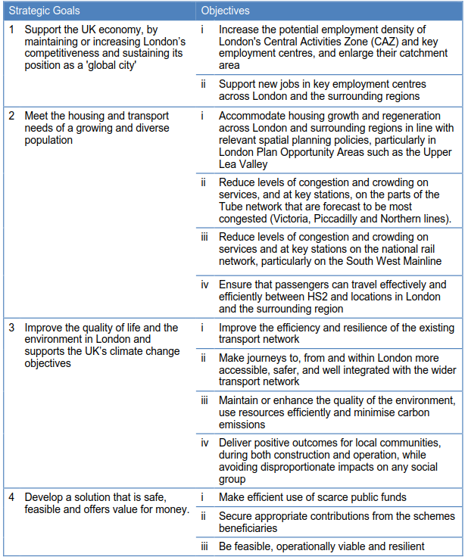

Appendix B: Summary of option assessment process undertaken between 2010-2011

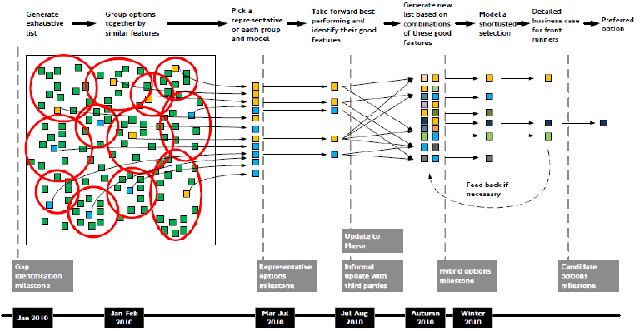

Appendix C: Findings from 2010-11 review of Crossrail 2 route options

- Alignments serving Finsbury Park reduce crowding on Victoria and Piccadilly lines, but add no new connectivity;
- Alignments via Seven Sisters & Tottenham Hale not only reduce crowding on the Victoria and Piccadilly lines, but also deliver major connectivity benefits to Hackney, Haringey, Enfield and beyond;
- Alignments that take over the Central line to Epping provide some limited crowding relief but do not relieve the Victoria or Piccadilly lines;
- An alignment via Stratford and Barking could provide connectivity and capacity benefits but would require very extensive additional tunnelling at great cost;
- Alignments via the West End performed best, along routes similar to safeguarding;
- Alignments via the City were not as effective at reducing crowding as those via the West End and did little to support London’s leisure economy, as well as being unable to serve the newly proposed High Speed (HS2) terminal at Euston;
- Alignments that provide interchange with the Northern line in south London appear to offer considerable potential to relieve what is currently the most crowding section of the Tube network;
- Alignments that serve Clapham Junction appear critical to unlock crowding relief at Waterloo and Victoria and on the Victoria line;
- Alignments that take over the District line branch to Wimbledon deliver only limited crowding relief as they do very little to address crowding on the South West Mainline (SWML), and none to the Victoria line south of Victoria, and
- Alignments to Sutton and Croydon deliver fewer benefits than routes using the SWML

Heath, 2013
Ross, 2015
Lowrie, 2016
Auckland Transport, 2015
TfL, 2016
Lowrie, 2017
https://www.london.gov.uk/what-we-do/planning/london-plan/current-london-plan/london-plan-chapter-3/london%E2%80%99s-housing
https://www.beehive.govt.nz/release/govt-build-34000-new-houses-auckland
An average Tube train in London carries around 850 people when fully loaded
The underground network alone is over 400km in length
Average commuting distance on rail into London is 50-60km
These upgrades will either add capacity through enhanced signalling or will involve the purchase of new rolling stock
Four passengers standing per square metre (ppsm) is the maximum crowding level that TfL plan for
The process of agglomeration is a phenomenon whereby the clustering of people and businesses generate higher productivity
Former name of Transport for London
Safeguarding is a formal process, undertaken by the Department for Transport (DfT), to protect land required for major new infrastructure projects from future development
Now Department for Transport
Now known formally as the Elizabeth Line, due to open in late 2018
NR’s London and South East RUS (2011)? identifies SWML as one of the most congested in the SE England in need of additional paths into Waterloo
Réseau Express Régional lines run from suburbs, through the city and continue on to suburbs on the opposite side of the city
The NIC were formed by the Conservative government in 2015.They provide the government with impartial, expert advice on major long-term infrastructure challenges.
CBI Infrastructure 2017 event 23/11/2017
Ponders End will benefit from the largest rail service frequency uplift on the Crossrail 2 route. Currently there are two peak hour services to Central London. With Crossrail 2 this will jump sevenfold to fifteen trains per hour.
Crossrail could facilitate as many as 200,000 of the 1,500,000 homes needed in London by 2050
Class 345 rolling stock is being used on the Crossrail project
Assuming a 6 car set
for example, HS2 is expected at Euston by 2026 along with capacity improvements at Clapham Junction & Victoria
An example of this can be seen at Old Oak Common in west London, where opportunities to provide TOD above the recently constructed Crossrail depot there were not taken, leading to a more expensive and fragmented solution

