EFFICIENCY IMPROVEMENTS AND NETWORK OPERATING PLAN

Ranjan Pant
(BSc Hon, MSc Eng., PhD)
New Zealand Transport Agency
Lev 11, HSBC Bld, 1 Queen Street, Auckland
New Zealand
Phone: +64 9 928 8796
Email: Ranjan.pant@nzta.govt.nz

ABSTRACT
NZ Transport Agency’s primary function is to deliver effective transport solutions for a thriving New Zealand. The measure of an effective transport system is to provide access and move people and freight safely and efficiently. Mobility demands in major cities in New Zealand are growing at a faster rate than expected; traffic flow rates are increasing significantly and peak periods are becoming longer and longer.

Making the optimum use of the existing infrastructure to maximise operational benefit through minor capital and operational improvements is an effective means of continuous improvement, particularly during the development of major infrastructure projects, some of which can take as long as 10 years from conception to delivery.

NZ Transport Agency is working together with Local Authorities to achieve the most from existing infrastructure. For this purpose, it is necessary to understand and agree network priorities; specifically by mode, time of day and corridor and/or intersection. For this purpose, Network Operating Plans (NOPs) for urban areas are either developing or have been developed. The core principles of those NOPs are based on the safe and efficient movement of “people and goods” and “linking the strategic plan with operational planning”.

Such a collaborative approach is necessary in this area to address appropriately the deficiencies in the system keeping in the mind that the transport system and human behaviour are changing rapidly. Major capital improvements follow more onerous business case processes, with subsequently longer time for delivery. In contrast minor capital and operational improvements, which are up to $1 Million in cost, follow a more agile delivery process, and maximise operational benefits of the existing system quickly. Development and prioritisation of the minor efficiency work nationally will provide the best possible performance outcomes for the transport system and also address customer expectations.

KEYWORDS
Efficiency improvement, network operating plan, optimisation

INTRODUCTION

NZ Transport Agency (NZTA)’s vision is “great journeys to keep New Zealand moving”. The aspiration is to become an internationally competitive, prosperous economy that all Kiwis can benefit from and participate in. Each and every sector should work together and find better ways to achieve this goal.

NZTA’s primary function is to deliver effective transport solutions for a thriving New Zealand. The measure of an effective transport system is to provide access and move people and freight safely and efficiently. Mobility demands in major cities like Auckland, Wellington and Christchurch are growing at a faster rate than expected; traffic flow rates are increasing significantly and peak periods are becoming longer and longer. Based on Auckland figures, every week there are 819 additional new residents, 344 new homes, 405 new jobs created, and a new street is provided in every two weeks, 670 vehicle imported via the port every day and vehicle kilometre travelled increases by 5.7% from 2016 to 2017.

City centres are the most frequented origins and destinations, generating a high number of passenger trips. Some of the bigger cities in New Zealand do not generate sufficient passenger numbers for use of public transport to provide significant relief to the road network. Due to low population density and other factors such as costs, landscaping, large expenditure on public transport services and infrastructure is sometimes not justified. A broad range of transport system optimisation initiatives is required for larger cities like Auckland, Wellington and Christchurch as well as in faster growing small cities like Hamilton, Tauranga, Dunedin and Queenstown. In the past, no comprehensive analysis and works have been carried out to investigate how the behaviour of the road users can be changed so as to achieve better transport system. Many people have a preconceived belief that some transport modes like public transport will not meet their requirements such as travel to their destinations, connectivity, journey time, costs, frequency of service, comfort, safety etc. This demonstrates there is a lot of work required to achieve the vision of NZTA and Local Authorities to give effect to the Government Policy Statement (GPS).

History of the Transport System
To a great extent nineteenth-century urban life moved at the pace of horse-drawn transportation and walking. It was more like a sustainable transport system and also considered a slow “mobility” era, but it had some dark sides. The evidence of the horse was everywhere—in the piles of manure that littered the streets attracting swarms of flies and creating stench, in the iron rings and hitching posts sunk into the pavements for fastening horses’ reins, and in the numerous livery stables that gave off a mingled smell of horse urine and manure, harness oil and hay. On a typical day in 1885 an engineer, Francis V. Greene, making a study of urban traffic conditions, counted 7,811 horse-drawn vehicles, many with teams of two or more horses, passing the busy corner of Broadway and Pine Street in New York.

Development of horse-less vehicles from the late 1800s was the main breakthrough in the mobility sector. Exponential increases in the production of motor vehicles have addressed most human expectations of better mobility. Cars were seen as a major problem solver for mobility as well as for so called environmental issues for some of the most populated cities at that time. Since then, the motor-vehicle oriented system has never looked back and has filled the whole earth with motor-vehicles for our mobility. The motor vehicle became a major part of human life. People can travel one place to another easily and efficiently. More and more vehicles on the road mean more and more conflicting movements and road capacities could not cope with the increasing number of vehicles. People started facing congestion and delay. As congestion is also considered as a sign of economic development and successful city, cities became victims of their own success. The old views on motor vehicles have now changed from an environmentally friendly system to “problem system”, because cities are suffering once again from both congestion and environmental problems caused by motor vehicles. The quality of mobility and transport systems are once again threatened. Lots of new technologies are now tested in mobility improvement area to achieve a better transport system. In reality it is very important to understand the effects on mobility with large numbers of motor vehicles, and it is necessary to recognise the relationship between technology, transport system and human behaviour.

TRANSPORT SYSTEM CYCLE

It is very important to understand the transport strategy before designing the transport system. Normally NZTA and Local Authorities have jointly developed the transport strategy. Designing a transport system is to understand the transport strategy and develop a process to implement the strategy into reality. A transport system cycle is the process from strategy to the implementation and also providing a feedback loop to strategy. Therefore there is a basic relationship between different phases of transport from strategy to feedback loops. This is a very complicated process if the whole system is considered but it can be subdivided in to several influential areas to make it user friendly.

There are several steps starting from strategy to the feedback loop in a transport system. Every system needs a strategy; similarly the transport sector needs a robust strategy. The transport strategy needs to describe the outcome expectations of whole transport system. This needs to be done at the whole network level and also needs to align with the Government Policy Statement (GPS). The figure below shows the transport system cycle.

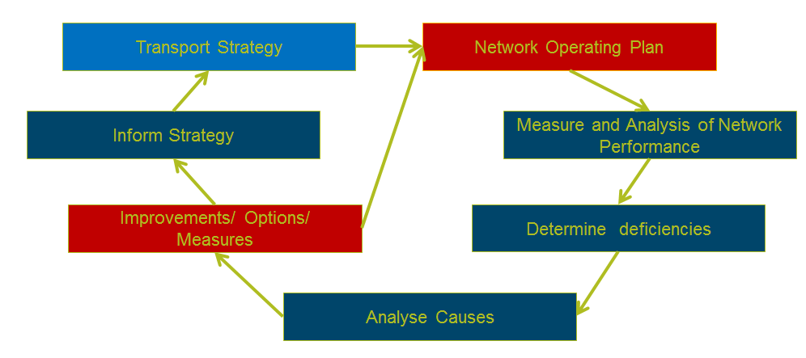

Figure 1 – Transport System Cycle

Every transport system needs to develop its transport strategy based on its transport vision. The Vision usually results from high level thinking /outcomes for the transport system. Transport Strategy should interpret this thinking in stages and robust outcomes. Strategy should cover what the transport system future outcomes look like. This should cover wider level expectations, both for people and goods movement, and place functions.

A network operating plan basically covers how the network should be operating to achieve the strategy. As the transport system is changing at a fast rate, the operating plan needs to address the very short, short and medium term as well as long-term aspirational goals. There can be more than one network operating plan, in which some parts and functions are relatively constant over the time as some other parts may be very dynamic, to address the ongoing changes in the transport system.

The success of the network operation is generally measured by the performance outcomes of the transport system. This compares the existing transport system with the expected transport system performance outcomes. The difference is the gaps in the system which need to be addressed and is an on-going process.

The deficiency in the transport system is the difference between the expected and the existing performance outcomes of the transport system. It gives information around how far the transport system is operating form its expected outcomes. As the transport system has various dependencies and dimensions, it is important to understand the key factors which have direct impact with the performance outcomes.

The main part of improving the transport system is to understand the causes of the problems. This requires careful analysis of the transport system. Data and analysis of data can help to understand the existing problems, it is necessary to robustly work through this analysis including human factors and perceptions and the rapidly changing technology areas. This is critical when improvements need to be made to the transport system.

Improvements to the transport system mean undertaking some physical and non-physical works to improve the performance outcomes of the transport system. Problems in the transport system can have more than one solution. These solutions generally have different attributes. This includes cost, time, complexity, future aspect etc. Combining one or more of these factors can influence the outcomes of the solutions. The solution can only address major or some parts of the problems. The solution can be driven by the trade-offs of multiple outcomes during option evaluation phase. Transport systems now cover a wide range of objectives than just moving from A to B, they have influence components like modes, place, people, goods and technology etc. Strategy plays a vital role in understanding what the main outcome expectations of the transport system are. If the strategy is to increase movement of people by public transport say by 10% in 5 years then solution should be driven by same principles. Achieving the outcomes of the strategy is the main objective of improving the transport system, in this case the percentage of increase in public transport patronage within 5 years.

It is important to check / inform the strategy level with what the transport system is really delivering. Having aspirational expectations is not a bad idea, but practicality and reality needs to be considered in the transport system. A feedback loop to strategy is very important to refine and or manage the expectations of the transport strategy.

NETWORK OPERATING PLAN (NOP)

Mobility is an important attribute that impacts on the living conditions in urban areas. Mobility demands of major cities and towns in New Zealand are increasing faster than expected in recent years. The level of congestion is affected by growth in mobility demand. Infrastructure development is in place or planned to address some of this anticipated increased travel demand. Deployment of new major infrastructure is always associated with significant impacts and implications and has limitations such as costs, environmental impacts etc. The best use of the existing infrastructure is one of the most important tools to partially relieve congestion with limited adverse consequences. To deliver the most out of the existing infrastructure, it is necessary to understand and agree how the transport system should be prioritised by place, mode, and time of day and by corridor or intersection. The NOP is a key document, which deals with these key issues and describes the understandings and expected outcomes shared by all stakeholders and partners.

According to the Auckland Network Operation Plan “A Network Operating Plan (NOP) is a guiding document and also an agreed plan to operate the transport system to achieve a set of agreed objectives (performance outcomes) including efficiency that takes into account mode, network, time of day and location”. It consists of multi-dimensional dependencies and thinking, and should be considered in complex situations. It is important to have a robust process to deal with the operation of transport system.

There are generally two aspects of NOPs:

- Static part
- Dynamic part.

The static part of network operating plan deals with the aspects of transport system which are not likely to vary much over the short to medium term future i.e. more or less constant over the time. These are mainly the process itself and the framework, such as vision, strategy, principles, methodology and expected outcomes for the transport system.

Transport vision and strategy and other guiding documents like the regional arterial road plan, cycle network, strategic freight network, public transport network, town centres and activity centres, walking and cycling strategy/network, one network road classification etc. are considered to develop the static part of the NOP.

The dynamic part of the network operating plan deals with the priorities, movements, location and function at the micro level of transport system. Based on criteria and requirements defined in the static part of operating plan, the dynamic part defines and delivers the operating part of the transport system. This is an important part of the transport system cycle as this influences the transport system performance outcomes. Making trade-offs based on the criteria mentioned in static part and stakeholder engagement is another important part in this stage. As this would influence the elements of transport system, it is necessary to ensure customer expectations are captured and addressed. It is recommended to identify the key stakeholders and partners as early as possible and to have more than one workshop and wider communications to make it successful. Several iteration processes are necessary to refine the operating plan. This is supported by the further four steps of the transport system cycle namely: measuring performance of transport system, determining the deficiency, analysing the causes and improvement/options.

In general several information and data sources like loop detectors, cameras, blue tooth, public transport data, walking and cycling info., tomtom, google, RAMM, surveys etc. are used to calculate the performance outcomes of the transport network. These sources are used to evaluate the benefit realisation of any measures.

The Network Operating Plan software tool “ SmartRoad” is used to understand the network deficiencies. “SamrtRoad” tool is initially developed by VicRoads to develop the Network Operating Plan for Melbourne. This tool has been refined by ARRB and tuned to fit the New Zealand environment. The tool uses the following factors for each mode to evaluate the performance outcomes of the transport network:

- Volume
- Occupancy
- User Experience Level of Service
- Mode Priority Factors (based on road user hierarchy in strategy)
- Relative Growth Factor
- Base user class value in $

The following figure is the outcome of Auckland Network Operation Plan showing the mode priority in central Auckland.

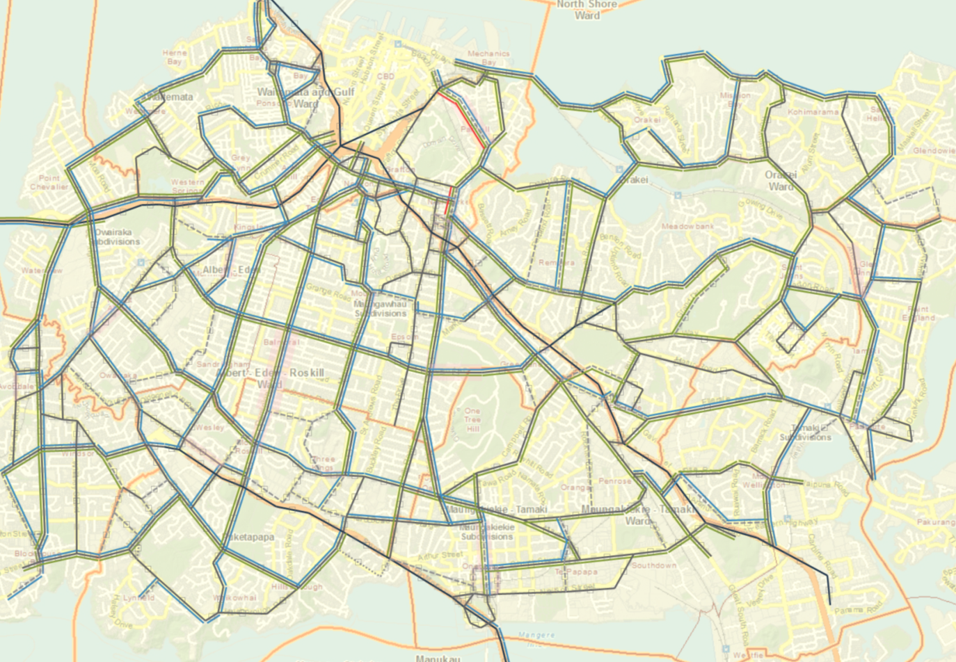
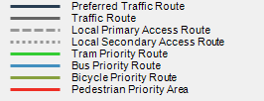

Figure 1 – Central Auckland NOP

A dynamic process is needed that is flexible and capable of addressing change in the transport system and change in the performance outcomes and expectations over time.

Currently, aspects of the transport system are changing faster than expected, especially technologies and human behaviour, making the whole transport system more complicated. It is hard to predict how, when and the intensity of the changing technology environment and human behaviour. These can have large impacts on the transport system. It is important to continuously gather intelligence about a changing market and to address upcoming new possible expectations in the transport system strategy. These will impact both the static and dynamic parts of the network operating plan. It will be necessary to revisit the static NOP every three years to make sure principles, methodology, expected outcomes etc. are still valid.

Customer and Collaboration approach
The collaborative “One System” approach improves the integration of network operations and development, and supports the strategic outcomes. One System also aligns with most of the local and central governmental approaches and customer focus outcomes. It provides the best model for integrating transport decisions with land use development and for balancing movement and place.

At the network-wide level, individual NOPs respond to the demands, priorities and future development of each mode (strategic and arterial roads, public transport, freight, cycling and walking, parking) over 10 years. These demands and priorities for the different networks and places are integrated and balanced, based on the strategic directions.
EFFICINECY IMPROVEMENTS

NZTA and local authorities work jointly to understand deficiencies and improve priority definitions. Major capital improvements follow the more onerous business case processes, with subsequently longer times for delivery and typically deliver new major infrastructure. In contrast minor capital or operational improvements, which are less than $1 million, follow a more agile delivery process, and maximise operational benefit of the existing asset quickly. NZTA works together with Local Authorities to develop and prioritise the minor efficiency work nationally through the NOP.

Efficiency improvement of the transport network can be achieved by managing the effects of congestion and unplanned events on the network through capacity management techniques and demand management techniques utilising a wide range of infrastructure, traffic management and technology and other interventions. In the efficiency improvement area there is a focus on multimode transport capacity management. This leads to the investment in infrastructure, system, capability, technology etc. to improve the performance outcomes of the transport system to achieve the strategic objectives. This deals with projects which are under $1M and can be implemented easily and will have higher benefit with low risk. This is called the Low Cost Low Risk programme. NZTA is actively investing in this area to address customer expectations.

Efficiency Improvement Analysis
A simple and easy evaluation criterion has been developed to understand the overall efficiency benefit of the system with minor improvements. This enables us to understand the “go/no-go” of the project as well as saving time and money in the process.

The evaluation process normalises every mode’s efficiency benefits into a simple and single term. With minor efficiency improvements whole benefits are calculated using person based benefits. This gives us the value of the system benefit in terms of the customer. All modal benefits are weighted by person and calculated as person hour benefits. This helps us to understand the effectiveness of the project. The evaluation process covers all transport modes, time of day and effectiveness.

Four major analyses are undertaken to evaluate the benefit.
- Improvement of reliability
- Person hours saved per person
- Person hours saved per hour
- Person hours saved over 10 years per dollar invested.

Reliability improvement is important from a customer prospective to ensure better journey time predictability. This will improve customer confidence in the transport system, and allow influencing of travel behaviour. This assists the customer to plan their time better. This is not only the mathematical value of a certain mode but includes the reliability at the person level. This assists in communicating the improvement in the transport system to the customer. This is considered a key part of system performance.

Person hours saved per person is an important factor for big cities with many people moving around the cities. This generally deals with what differences have been made for the average customer. The values of all sorts of movements are normalised to person hours. This provides us the overall system efficiency improvement. This covers where the improvement is made to address the overall expectations of the customer. In some aspects, one mode might be slightly disadvantaged due to some improvements in the system but there may be large benefits in overall system efficiency. This analysis gives an understanding of the effectiveness of the improvement in the transport system.

Person hours saved per person is very important for town centres and small cities, where many major and minor movements conflict and results in an inefficient transport system. This evaluation criterion deals with some movements, which may be suffering from large deficiencies in the system. This is a important measure when improvements in very congested cities,and relatively less congested cities, are compared. This will address the customer frustration and help to smooth the transport system performance outcomes.

The person hours saved over 10 years per dollar invested measure is effectiveness as well as a value for money analysis. This indirectly helps to analyse the benefit cost ratio of an improvement. This also links to general investment policy.

Hapai Online Tool
To make the whole process easy and efficient, an online tool “Hapai” has been developed. Hapai is a simple online tool which is used to gather information around minor improvements. This is accessible to both NZTA internal staff and external consultants and contractors who are working in the Minor Improvement Programme development.

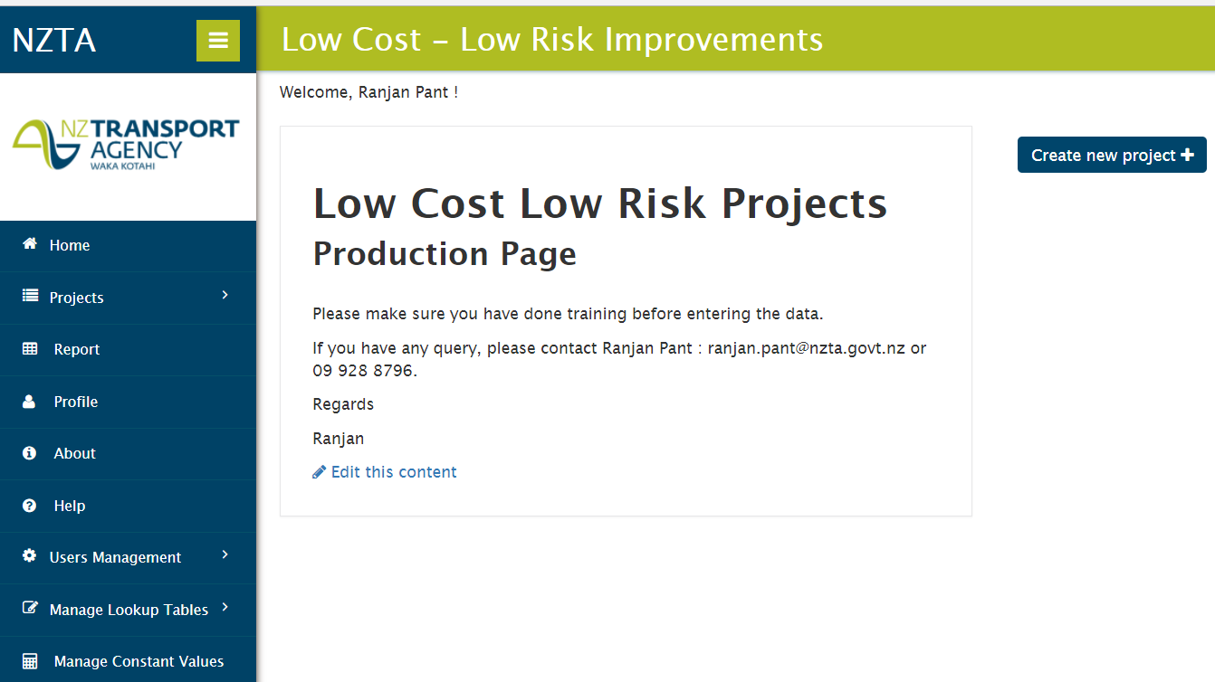

Figure 2 – Hapai online Tool

The tool is capable of assisting us in understanding nationwide initiatives around transport system improvements using minor improvement projects. This tool has other numerous capabilities including GIS information on the project. This enables us to display outcomes of all programmes on a map. This is able to provide information concerning intervention level information of the project on the map. This tool help us to avoid handling a huge complicated excel spreadsheet. This tool is also capable to capture and prioritise the existing and the future projects nationally. This is useful information for the future programme planning during the delivery process. Currently this tool is used for efficiency projects nationally and it is anticipated this will be used for safety and resilience projects by end of 2018.

Benefit of Process and Outcomes
The main benefit of the NOP process and improvement options lies in improving engagement and understanding between engineers, planners and stakeholders, right from setting strategy through to understanding the impacts of projects. The process provides significant value when assessing options for projects where there is no clear best option. The assessment can succinctly show whether the impacts on each mode are positive or negative and it can show this location by location, or across a wider network area. The process also helps to ensure that projects and operations focus on the movement of people and goods rather than just vehicles, helping to maximise the efficient use of the transport system.

For the road network
The NOP and minor improvements initiatives are achieving better informed decisions about a number of aspects of the network including:

- allocating public transport priority
- allocating road space to competing transport modes
- improving traffic flow at highly congested intersections
- controlling access to and from the arterial network
- planning for growth areas
- planning for the development of activity areas.

For the strategic planning and operational level
The process will answer the challenges posed by the complex problem of congestion management including:
- reducing travel demand
- encouraging more efficient and sustainable travel
- providing better information, and management of existing infrastructure
- managing the trade-offs between modes
- understanding the function of new infrastructure to support economic growth

CONCLUSION

Moving towards better transport systems is demanded by all transport system users. It is important for all to understand the whole transport system cycle and its long-term goal. Although the future of the transport system is dependent on technology development and human behaviour, it is still important to deliver effective transport solutions for a thriving New Zealand. There is no doubt a continuous and consistent process, intelligent planning, transport system analysis and customer focused improvements are the major considerations of the evolving transport system.

A collaborative approach has been undertaken by both NZTA and local authorities to interpret the transport vision and strategy into an operating plan through Network Operating Plan. This is considered as a vital step in understanding the gaps between the expected outcomes and the current situations in the transport network.

This has given the opportunities to address appropriately the deficiencies in the transport system. As major capital improvements take longer time for delivery, minor capital and operational improvements, which are up to $1 Million, has been adopted to maximise operational benefit of the existing system quickly. Development and prioritisation of the minor efficiency work nationally has provided the best possible performance outcomes for transport system and addresses customer expectations.

REFERENCES

Auckland Network Operation Plan (2015), NZ Transport Agency / Auckland Transport
Joel A Tarr (1971) Urban pollution -Many long years ago; American Heritage Magazine
Monthly Performance Report (2017), NZ Transport Agency
Pant, Dr R (2017). Future Technology and ideal Mobility, Approved paper ITS World Congress 2017
The Statistics Portal, Statista (2017): Statistics and facts about global e-commerce
UPS Online Shopping Study (2015) Empowered Consumers Changing the Future of Retail

