MEDIAN BARRIERS: DIVIDING FACT FROM FICTION

Carl O’Neil BE (Hons) MEngNZ

Senior Transportation Engineer, Abley Ltd.

carl.oneil@abley.com

Fabian Marsh BE, GCEng (Presenter)

Lead Advisor Safety, NZ Transport Agency

fabian.marsh@nzta.govt.nz

ABSTRACT

The installation of median barriers on New Zealand roads has resulted in marked decreases in the number of fatal and serious injury crashes. These results underpin signals from the NZ Government Policy Statement on Land Transport for greater investment in median barriers across the road network. To help support this investment, the NZ Transport Agency has commissioned an evaluation of crash data from all State Highways in New Zealand to further quantify the performance of median barrier installations in terms of DSI reduction.
Key points of investigation include the difference in safety performance between motorways and single-lane carriageway median barrier installations and how death and serious injury rates on median barrier corridors have changed over the period of 2013 through 2017 when the New Zealand road toll increased.
INTRODUCTION
Safer Journeys, New Zealand’s Road Safety Strategy 2010-20, has a vision to provide a safe road system increasingly free of death and serious injury (Ministry of Transport, 2010). The strategy adopts the Safe System approach to road safety focused on creating safe roads, safe speeds, safe vehicles and safe road use.
To help achieve the Safer Journey’s overarching goals, the Safer Journeys Action Plan 2016-2020 contains an Action to “Ensure roads and roadsides support safer travel”. As part of this Action, a number of sub-actions are specified, including “fewer deaths on urban arterials, head on and intersection crashes, vulnerable road users, and crashes on the open road”.
For every 100km of undivided rural State Highway in New Zealand, 7.6 people are killed or seriously injured every year, of which 2.5 are from head-on crashes. Median barriers have already been proven both in New Zealand and extensively overseas to effectively eliminate head-on crashes, and substantially reduce overall DSIs. New Zealand has embraced the use of median barriers on motorways and expressways but has yet to roll-out median barriers on other high-speed corridors in large quantities.

The NZ Transport Agency is committed to applying the Safe System approach to reduce serious road trauma and is tasked under the national road safety strategy to improve the safety of high-risk rural roads. To help provide further supporting evidence for the effectiveness of median barriers, the NZ Transport Agency (NZTA) commissioned Abley Limited (Abley) to examine the safety performance of median barrier installations on different road types and the performance of median barrier installations on narrower roads with retrofitted median barrier.

METHODOLOGY
Corridors were generalised into the following categories to help enable comparisons between different median divided road types and cross-sections.

Rural Motorway/Expressway
This category encompasses roads with at least two lanes in either direction, a continuous median barrier, a speed limit of 100km/h or greater, no at-grade intersections or accessways, and a modern, high-quality geometric alignment and design.
Examples of corridors included in this category are the Tauranga Eastern Motorway (SH2), the Waikato Expressway, and the Auckland Northern Motorway north of Albany.
Two motorways (namely the Belfast to Kaiapoi motorway north of Christchurch and some sections of the Waikato Expressway) were included in this category, despite having no median barrier, as the two directions of travel are separated by a wide grass strip.

Median divided Motorway/Expressway within urban environment (Urban Motorway/Expressway)
This category encompasses roads with at least two lanes in either direction, a continuous median barrier, 80km/h or greater speed limit, no at-grade intersections or accessways. The key attributes which differentiate ‘Urban Motorway/Expressway’ from ‘Rural Motorway/Expressway’ is congestion during peak hours and a high incidence of lane changes. Note that this definition differs from what is typically classified as an urban road (i.e. roads less than or equal to 70km/h).
This type of motorway is generally found close to major metropolitan centres and may be constrained by the built environment, have a higher density of onramps/offramps and have tight geometric alignment. Examples of this type of motorway include metropolitan sections of the Auckland and Wellington motorway systems.
Median divided Motorway/Expressway within urban environment with At-Grade Intersections (2+2 Median Divided Road)
This category encompasses roads with at least two lanes in either direction, a near-continuous median barrier (which may have some small gaps) and a speed limit of 80km/h or greater. Some at-grade intersections and accessways may be present, but they will generally be spaced at 1km or more and be controlled by signals or a roundabout. Note that this definition differs from what is typically classified as an urban road (i.e. roads less than or equal to 70km/h).
The only corridors included in this category are:
- The Hutt Valley Expressway (SH2) from Melling Link to Fergusson Drive, and
- SH20A near Auckland Airport.

Note that both of these corridors have high volumes, 80km/h speed limits, several congested signalised intersections along each route and are prone to congestion during peak hours
Narrower Roads with Retrofitted Median Barrier (Other Median Divided Road)
This category encompasses roads which generally have 1 or 2 lanes in either direction, a continuous median barrier and a speed limit of 80km/h or greater. Accessways and priority-controlled intersections may be present. Roads which fit into this category generally have had median barrier retrofitted to an existing corridor and have narrow cross-sections.
The corridors included in this category are:
- SH1 from Rangiriri to Longswamp (known as Rangiriri Highway),
- SH1 from Pukerua Bay to Paekakariki (known as Centennial Highway),
- SH58 from Old Haywards Road to Hilltop (known as the Haywards Hill Highway), and
- SH6 (Whakatu Drive) from Richmond to Nelson.

Undivided High-Volume Road (Undivided >6,000vpd)
This category encompasses undivided roads with more than 6,000 vpd and a speed limit of 80km/h or greater. Priority-controlled intersections and private accessways are present on these corridors. This corridor category constitutes undivided corridors which are good candidates for median barrier upgrades. Note that 6,000 vpd was chosen as the cut-off traffic volume since roads with more than 6,000 vpd tend to have more head-on crashes than run-off-road crashes.

Analysis Periods
Crash periods have been removed manually for corridors where construction of a median barrier (or other construction) was taking place, since temporary traffic management can interfere with normal crash patterns. Crash periods were only considered in full calendar year intervals since this information is readily available. For example, a corridor which was under construction between December 2013 and January 2016 would be ignored for all calendar years between 2013 and 2016 (four years).
Only corridors which have had median barrier in place for at least two years have been used for analysis. This cut off value has been used to ensure that enough time has passed for new crash patterns to emerge. Crash periods were only considered in full calendar year intervals. For example, a corridor which had median barrier installed during 2015, and opened in February 2016 would not be analysed as it does not have two full years of crash data available (2017 calendar year only). A corridor which had median barrier installed during 2014/15 and opened in November 2015 would be analysed as it has two full years of data (2016 and 2017 calendar years). For this reason, corridors such as the Christchurch Western Corridor have not been included.
Limitations
VKT figures are based on 2017 traffic volume figures for all years. Crash rates per VKT will be skewed lower for most corridors in years prior to 2017, since most corridors have had traffic volume growth in the past 5 to 10 years.
A second limitation is the short network length in the ‘2+2 Median Divided Road’ and ‘Other Median Divided Road ’ categories.

RESULTS AND DISCUSSION
Crash performance by median barrier typology
Figure 1 shows DSI per km (i.e. Collective Risk) for each of the five categories described in the previous section between 2013 to 2017. The results show that ‘Urban Motorway/Expressway’ and ‘2+2 Median Divided Road’ performed worst in terms of Collective Risk, followed by ‘Undivided High Volume Road’. ‘Rural Motorway/Expressway’ and ‘Other Median Divided Road’.
‘Urban Motorway/Expressway’ and ‘2+2 Median Divided Road’ generally have a greater crash density than other roads because they tend to have high volumes, congestion and have less desirable physical attributes (such as undesirable geometric alignment and heavily trafficked at-grade intersections).
Figure 1. DSI per km (2013-17) by Corridor Type

Figure 2 shows DSI per 100 Million Vehicle Kilometres Travelled (MVKT) for each of the five categories described in the previous section between 2013 and 2017. The results show that corridors classified as ‘Other Median Divided Road’ performed similarly to ‘Rural Motorway/Expressway’. ‘Urban Motorway/Expressway’ performed slightly worse than both ‘Other Median Divided Road’ and ‘Rural Motorway/Expressway’. ‘2+2 Median Divided Road’ (made up almost exclusively of SH2 in the Hutt Valley) was the poorest performing median corridor typology. ‘Undivided High-Volume Roads’ performed poorer than all median barrier types.
Keeping in mind the limitations of the analysis, the results show that median barriers consistently have better crash performance than undivided roads, even on ‘2+2 Median Divided Roads’ where direct property access and at-grade intersections are permitted. Another key observation is that very good levels of safety performance can be achieved by installing median barrier on existing roads, without the need for an expensive expressway upgrade.

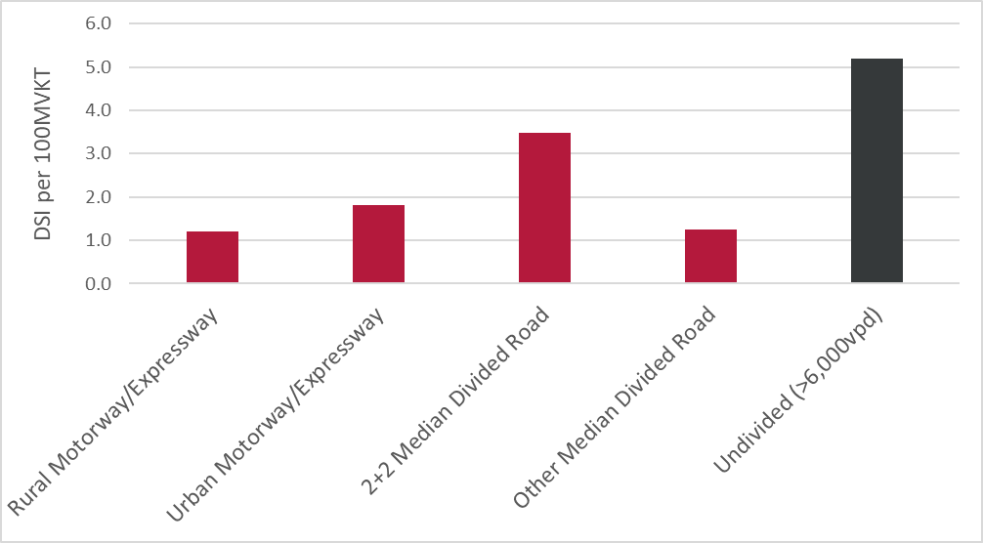
Figure 2 DSI per 100 Million Vehicle Kilometres Travelled (VKT) for all New Zealand corridors (2013-17)

Figure 3 shows DSI (excluding intersection crashes) per 100 MVKT for each of the five categories described in the previous section between 2013 and 2017. The results show that removing intersection crash types has a small or negligible effect on most of the median barrier categories with the exception of corridors classified as ‘2+2 Median Divided Road’. With intersection crashes removed, these corridors have an almost identical crash performance (in terms of DSI per 100 MVKT) to ‘Urban Motorway/Expressway. These results demonstrate that median barriers are still effective at midblock locations on corridors where direct property access and at-grade intersections are permitted, such as SH2 through Hutt Valley.

Vadeby (2015) found that Swedish median divided highways had between 1.0 and 1.5 DSI per MVKT and undivided rural roads had between 3.2 and 4.8 DSI per MVKT (intersection crashes not included). While acknowledging that the sampling method used to select corridors for analysis in this paper is slightly different to that used by Vadeby (2015), the results are very comparable to the findings in this paper.

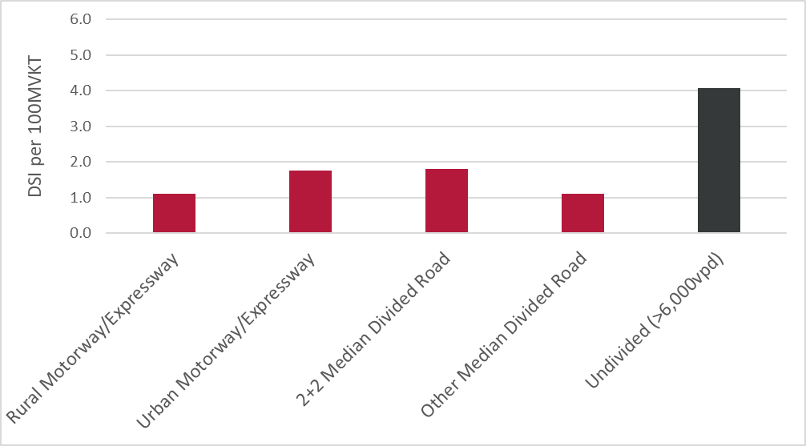
Figure 3 DSI (excluding intersection crashes) per 100 Million Vehicle Kilometres Travelled (VKT) for all New Zealand corridors (2013-17)

Crash reductions achieved on Narrower Roads with Retrofitted Median Barrier (Other Median Divided Road)
The crash history for three of the four corridors within the ‘Other Median Divided Road’ category was studied in greater detail. Figure 4 shows the location of these three corridors. SH6 from Richmond to Nelson (Whakatu Drive) was not studied since it is not a retrofitted median barrier installation.
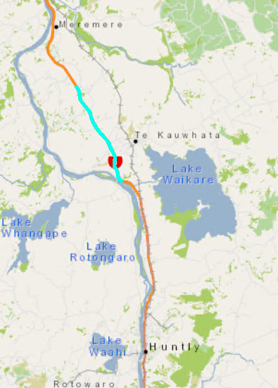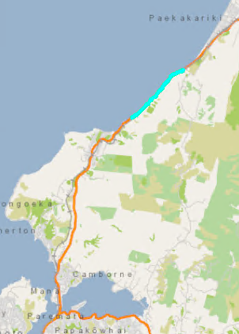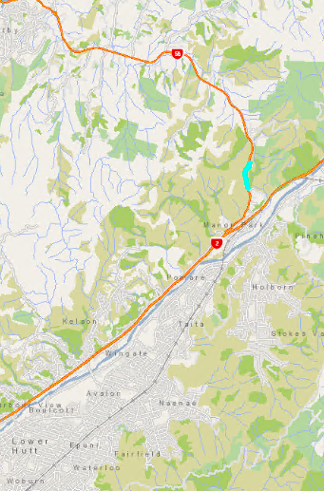
Figure 4. Locations (from left) of Rangiriri Highway, Centennial Highway and Haywards Hill Highway
Figure 5 to Figure 6. show the number of fatal and serious crashes recorded on Rangiriri Highway, Centennial Highway and Haywards Hill Highway respectively before and after median barrier was installed.
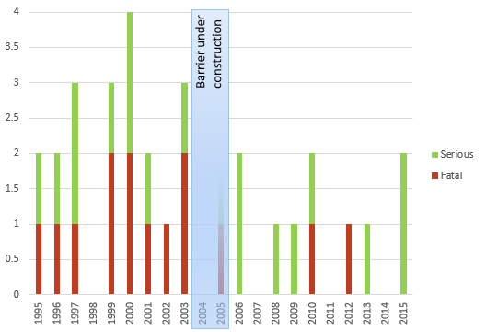
Figure 5. Rangiriri Highway Fatal and Serious Crash History (1995-2015)
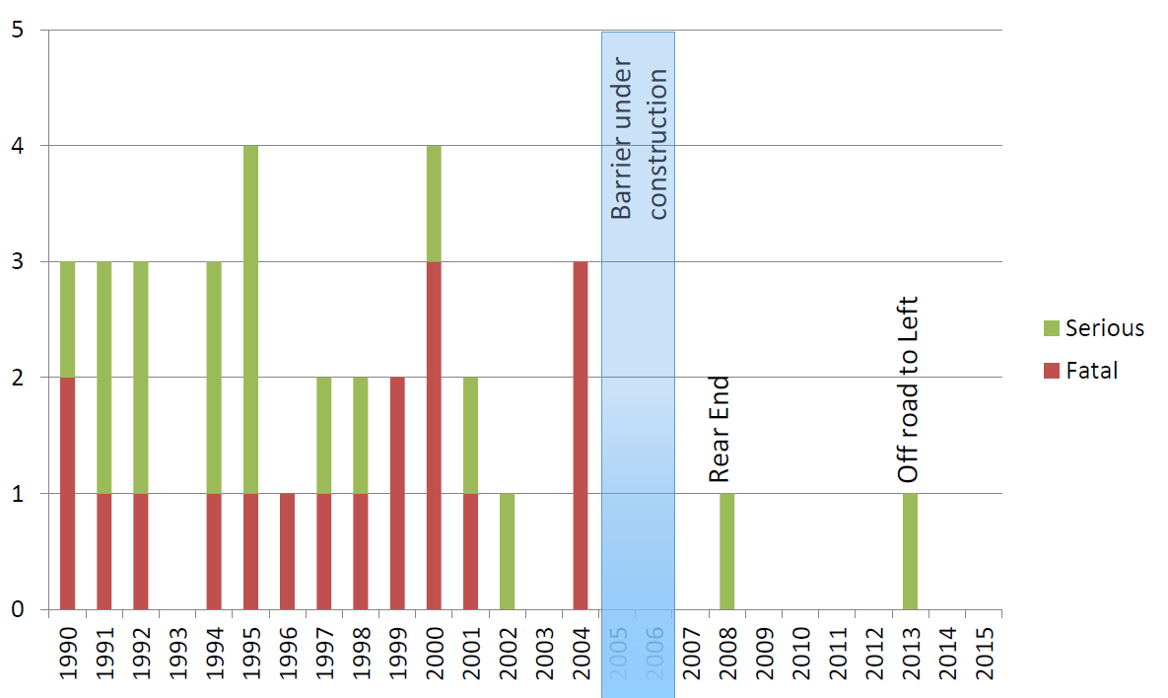
Figure 6. Centennial Highway Fatal and Serious Crash History (1990-2015)
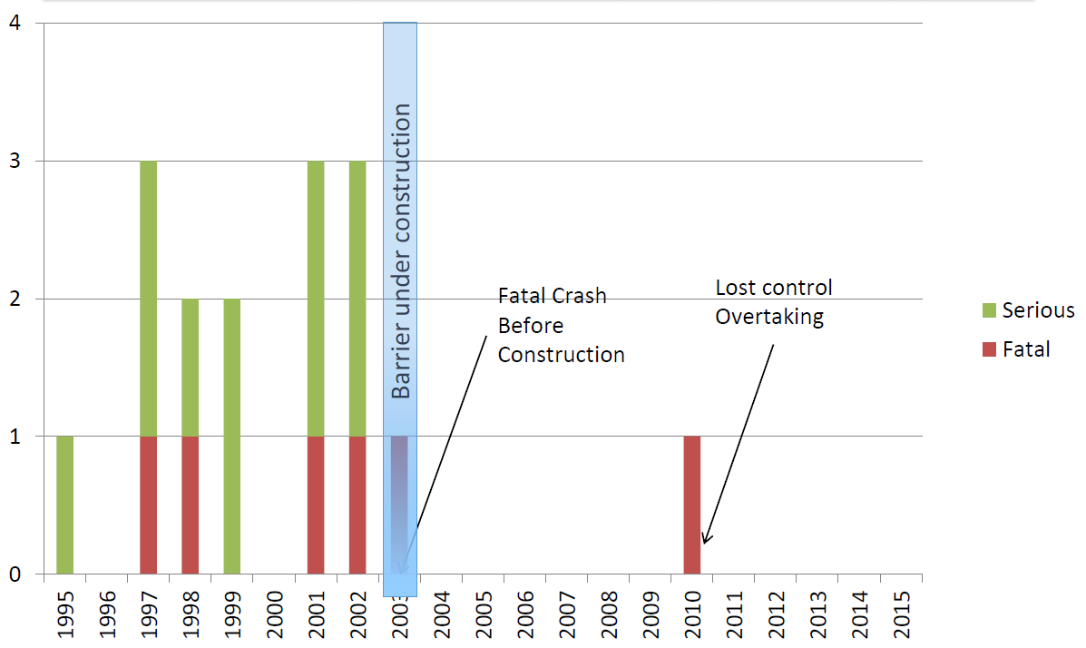Figure7. Haywards Hill Highway Fatal and Serious Crash History (1995-2015)

The number of fatal and serious crashes recorded on Rangiriri Highway decreased from approximately 2 per year (1995-2003) to 1 per year (2006-2015), constituting a 50% decrease in fatal and serious crashes. The number of fatal and serious injuries decreased from 4.2 per year (1995-2003) to 1.0 per year (2006-2015), constituting a 76% reduction in fatal and serious injuries.
The number of fatal and serious crashes recorded on Centennial Highway decreased from approximately 2.2 per year (1990-2004) to 0.2 per year (2007-2015), constituting a 90% decrease in fatal and serious crashes. The number of fatal and serious injuries decreased from 3.9 per year (1990-2004) to 0.2 per year (2007-2015), constituting a 95% reduction in fatal and serious injuries.
The number of fatal and serious crashes recorded on Haywards Hill Highway decreased from approximately 1.8 per year (1995-2002) to 0.1 per year (2004-2015), constituting a 95% decrease in fatal and serious crashes.
The results show a marked decrease in fatal and serious injury rates following median barrier installation on all three corridors. Despite having a number of uncontrolled intersections and accessways present, a very high reduction in deaths and serious injuries was still achieved on the Rangiriri Highway. On Centennial Highway and Haywards Hill Highway (where no intersections, and very few accessways are present), death and serious injury crashes were almost eliminated.
CONCLUSIONS
The results presented in this paper have shown that corridors with median barriers installed:
a) consistently have better safety performance (in terms of DSIs per VKT) than high-volume undivided roads,
b) substantially reduce DSIs on corridors where direct property access and at-grade intersections are permitted,
c) substantially reduce DSIs on corridors where barriers are retrofitted on narrow cross-sections, and
d) can almost eliminate DSIs when combined with grade-separated intersections and removing direct property access.
Overall, the results suggest that the safety benefits of transformative rural roads upgrades are primarily derived from the presence of median barriers rather than other improvements (such as widening) which are introduced with expressway upgrades. These results provide further evidence of the effectiveness of median barriers to provide permanent, long-term safety improvements on corridors with High Collective Risk.

REFERENCES
Ministry of Transport. (2010). Safer journeys New Zealand’s road safety strategy 2010-2020 viewed November 2018,
<https://www.saferjourneys.govt.nz/assets/Safer-journeys-files/SaferJourneyStrategy.pdf>
NZ Transport Agency (2011). High Risk Rural Roads Guide, viewed August 2018,
< https://www.nzta.govt.nz/assets/resources/high-risk-rural-roads-guide/docs/high-risk-rural-roads-guide.pdf>
Vadeby (2015). Traffic safety effects of narrow 2+1 roads with median barrier in Sweden, viewed January 2019, <https://www.vti.se/en/publications/publication/traffic-safety-effects-of-narrow-21-roads-with-med_920845>

Intersection crash types include Movement Codes ‘FB’, ‘GD’, ‘HA’, ‘HO’, ‘JA’, ‘KA’, ‘KB’, ‘KC’, ‘LB’, ‘MA’, ‘MB’, ‘MC’, ‘MD’, ‘MG’ and ‘MO’ as defined in the Guide for the interpretation of coded crash reports from the crash analysis system (CAS) (https://www.nzta.govt.nz/assets/resources/guide-to-coded-crash-reports/docs/guide-to-coded-crash-reports.pdf)

