CHANGING BEHAVIOUR:

PERSONALISED JOURNEY PLANNING

Jill Stoker: BA(Hons), MUrbPlan

Senior Travel Demand Planner, Auckland Transport

Jill.Stoker@AT.govt.nz

ABSTRACT
Origin-based (or residential) Personalised Journey Planning (PJP) projects have proven to be an effective means of changing individual travel behaviour away from driving alone to more sustainable modes of travel. Engaging with individual residents within a defined geographic area, then providing them with personalised journey information and incentives to trial different modes has delivered some excellent results, with high levels of behaviour change. PJP locations are often selected to support the uptake of new or improved public transport services, or new physical infrastructure such as transit lanes or cycleways. The paper will give an overview of the PJP approach that Auckland Transport has employed, setting out the methodology and the results that recent PJPs have delivered, including Benefit Cost Ratios. As well as reducing single occupancy vehicle (SOV) trips, PJP projects have health benefits associated with public transport and active modes. The paper will also provide an overview of current PJP projects and ‘where to next’ for these types of initiatives.

CHANGING BEHAVIOUR:

PERSONALISED JOURNEY PLANNING

INTRODUCTION

Auckland Transport has undertaken several Personalised Journey Planning (PJP) projects in the past four years in different locations across Auckland. While relatively small in scale, they are proving to be a cost-effective means of achieving travel behaviour change in a localised area.

For the purposes of this paper, a PJP project is one that targets a geographic residential area and provides journey planning advice to residents who drive alone, and who are willing to trial a more sustainable mode of travel. By focusing on a geographic area, PJPs concentrate on reducing the number of single occupancy vehicle trips from a similar origin (origin-based journey planning), rather than journeys to the same location (as with say workplace journey planning) which are destination-based.

AUCKLAND TRANSPORT’S APPROACH

The goal of a PJP is to shift individual travel behaviour from driving alone in the morning peak to using a more sustainable mode – walking, cycling, public transport or carpooling – reducing the number of single occupancy vehicle (SOV) trips and thus contributing to congestion reduction.

Most recent PJPs have required a minimum of 400 ‘sign-ups’, 250 committed participants and 200 evaluations. The travel behaviour change goal is 30%. In general, recent PJP projects have met these requirements.

Choosing a PJP area

Auckland Transport has taken several different approaches to choosing a PJP area. For some PJPs, the criteria were to support and leverage off the implementation of new infrastructure and public transport (PT) services. These criteria were the main impetus for the Birkenhead PJP in 2014, and the Manukau and Pah Roads PJP in 2017. See Figure 1 for recent PJP locations.

A study undertaken for Auckland Transport in 2015 looked at human factors that might result in a propensity to use public transport, and then used the 2013 census data to establish a PJP ranking by census area unit. This ranking was taken into consideration for choosing most PJP areas in 2016 and 2017 but with varying results. As Auckland’s population is growing rapidly and the make-up of suburbs is changing, combined with marked changes to Auckland’s transport system in the last 5 years (including new and more frequent services, a new bus network, upgraded buses and trains, priority lanes for PT) it is likely that the study’s recommendations are now out of date. Data from the most recent census is not yet available.

Other factors are also a consideration – localised congestion was a factor in the selection of Hauraki-Belmont (2016).

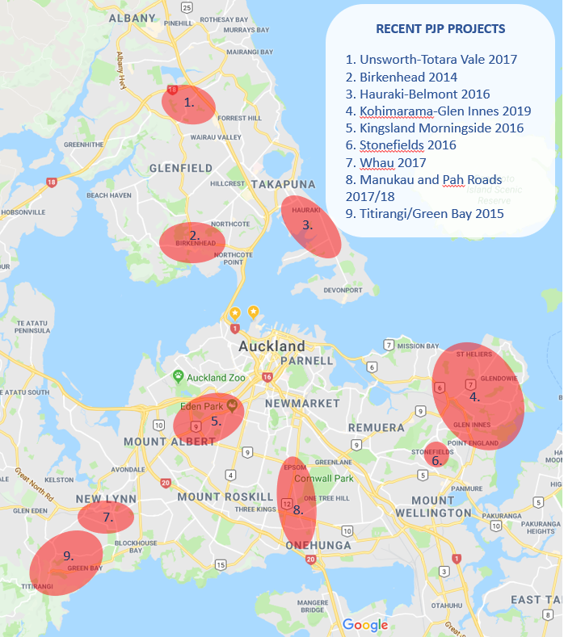

Figure 1. Recent PJP project locations.

Basic PJP methodology

The basic methodology that Auckland Transport has used in its PJP projects is:
- Raise awareness of the project in the community
- Door-knocking and participant recruitment (via a survey)
- Journey plans provided / participants commit to project
- Committed participants receive incentives and trial new mode for at least 4 weeks
- Post-trial evaluation of travel behaviour

Timeframes

The above methodology takes around 12 weeks to complete, plus reporting. Mode trials are usually timed to avoid December, January and school holiday periods if possible.

Providing advice

Auckland Transport develops an information flyer (see Figures 2 and 3) for each PJP area that often includes an accessibility map, showing PT routes, cycling routes and indicating walk and cycle times. These flyers, that also suggest ways to reduce car trips, are left with the resident at the door-knocking stage.

Each recruit receives a Personal Journey plan for their preferred mode, based on the information provided in the door-step survey. A follow-up phone call invites the recruit to commit to the project and trial their intended mode over a 4 to 6 week period.

Incentivising change

To encourage participants to trial alternative modes, Auckland Transport offers an incentive to each participant. Public Transport always has the biggest uptake, and PT participants are provided with an AT HOP card loaded with 14-days’ free bus and train travel. Other participants receive incentives such as backpack covers and puncture repair kits for cycling, and reusable coffee cups for carpoolers. While the incentives appear to be of differing value, the 14-days free travel off-sets part of the direct cost of the PT fare for the trial period, whereas there are often no direct costs associated with a change to walking, cycling or carpooling.

Evaluation of participants behaviour change in two recent PJP projects has shown that participants who did not receive incentives were less likely to change their travel behaviour than those that did.

RECENT PJP PROJECTS

Kingsland-Morningside 2016

Although indicated as likely to be a successful PJP area (a high propensity for public transport uptake) in the 2015 study, recruitment of participants was difficult: the high number of apartments in the area meant that survey staff could not engage readily with the residents, and 45% of households that were contacted were already using sustainable modes. Despite a low level of recruitment per number of residents (225 recruits from 3351 households), there was a high level of behaviour change amongst participants.

Most committed participants opted to trial public transport (over 80%), with 13% trialling cycling. Of the participants completing the evaluation, 47% had changed their travel behaviour, reducing drive-alone trips by 177 per week. Evaluation of HOP card data shows that many PJP public transport participants continue to use public transport (see Outcomes section, Table 2).

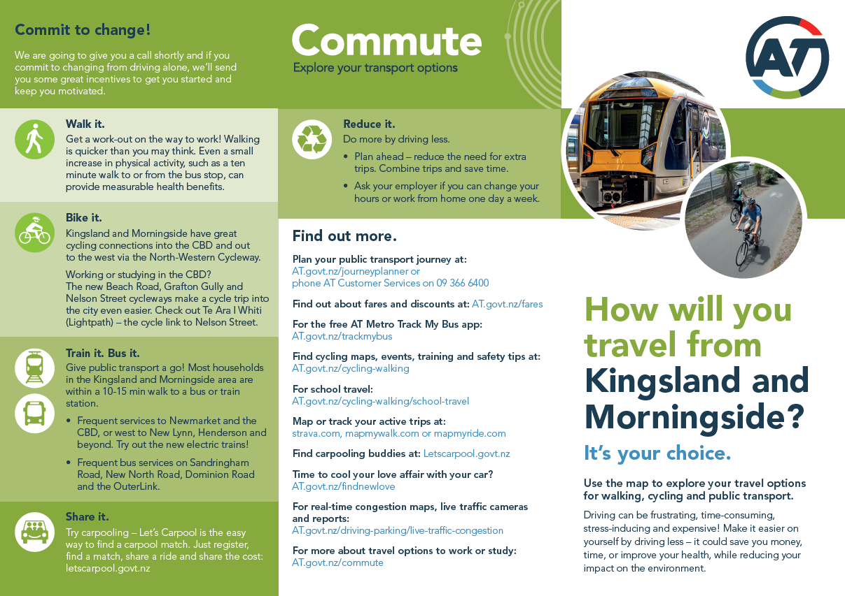

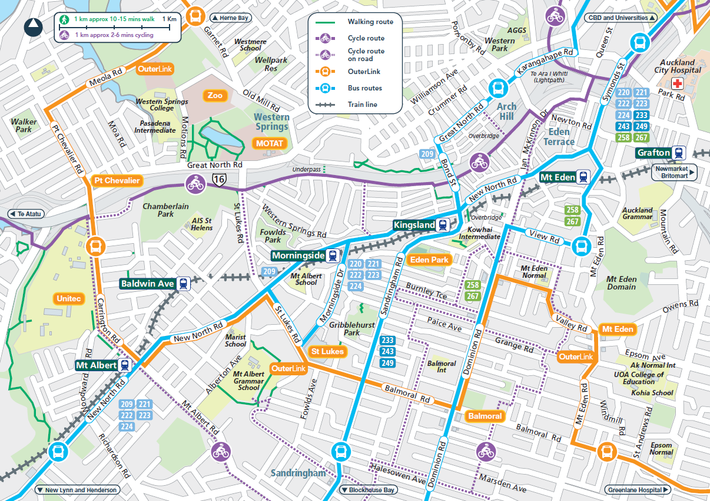

Figure 2. Kingsland Morningside PJP tri-fold brochure

Whau Local Board area – combined Home Energy/Transport project 2017

A home energy project sponsored by Auckland Council and the Whau Local Board – with the aims of reducing residential energy consumption, reducing carbon and saving money for residents – provided an opportunity for Auckland Transport to collaborate and add a transport component. As both projects (Home Energy and PJP) use a similar methodology (door-knocking, survey, provide advice, participants trial a new behaviour, evaluation) it made sense to trial this joint approach and reduce costs. This PJP ran as a trial with a target of 200 sign-ups (215 achieved).

This trial PJP was successful, despite being undertaken in autumn/ early winter. While the participant base was small, 49% of the 149 participants evaluated changed their travel behaviour (equating to 34% of the 215 original sign-ups). The collaboration was also positive for Auckland Council and the local board, with the reduction in car trips reducing annual carbon emissions by an estimated 38,603 kg-CO₂ over and above the estimated 26,464 kg-CO₂ reduction for the Home Energy component.

Manukau and Pah Roads PJP 2017-18

Auckland Transport implemented over 4 km of Transit (T3) lanes on Manukau and Pah Roads in July 2016, providing peak time priority lanes for buses, car-poolers (3 or more people), service vehicles, motorcyclists and cyclists. Travel times by bus along the transit lanes decreased by an average 50% during peak times. From mid-August 2016, Auckland Transport implemented Simpler Fares on all bus and train services. This zoned fare approach provided savings on most trips not using cash.

A PJP in this area provided an opportunity to build on the success of the T3 lanes and Simpler Fares. Door-knocking concentrated on areas within easy walking distance of bus stops, and the Onehunga train station, but also promoted the carpooling option.

While participant numbers were comparable to other projects, fewer participants than usual opted to trial public transport, with more opting to carpool or cycle. This appears to reflect the benefits of the T3 lanes: cyclists, and vehicles with 3 or more people, as well as buses, can use the T3 lanes. Unusually, 25% of participants asked not to receive an incentive, but still committed to the project. This project reduced morning peak drive-alone trips by over 400 per week. Despite the lower number of incentives for public transport, public transport replaced well over 50% of the drive-alone trips. This project resulted in 36% behaviour change.

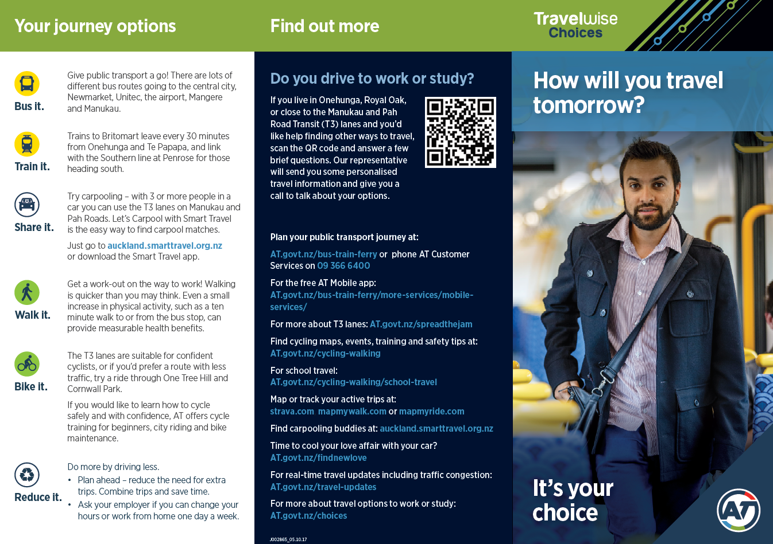

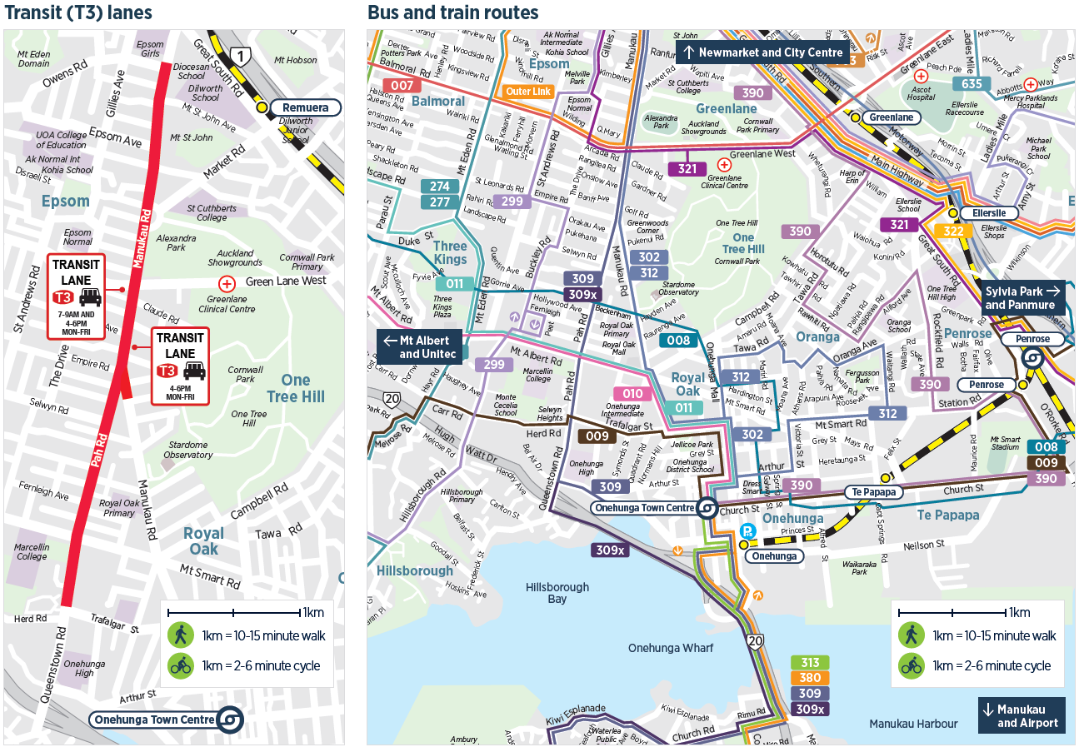

Figure 3. Manukau-Pah Roads PJP tri-fold brochure

Other recent projects

- Hauraki-Belmont (North Shore) 2016
- Unsworth Heights-Totaravale (North Shore) 2017
- Stonefields (Mount Wellington) 2016

OUTCOMES

As well as reducing SOV trips in the morning peak and achieving travel behaviour change, PJPs also contribute to better health outcomes by increasing physical activity – whether it is through walking or cycling, or adding a walk to the bus stop each day. In addition, PJPs contribute to reducing CO₂ and improving air quality.

Calculating a Benefit Cost Ratio

For three recent PJP projects, a Benefit Cost Ratio (BCR) has been calculated using guidance from NZTA’s Economic Evaluation Manual. It is based on project costs and results, rather than NZTA’s planning templates. See an example in Figure 1 below. Note the following:
- Walking distance to PT is averaged at 100m
- Incentive costs are not included as AT accounts for these elsewhere
- Only the morning trip is recorded
- There are no costs in subsequent years
- A conservative 3-year time frame has been adopted

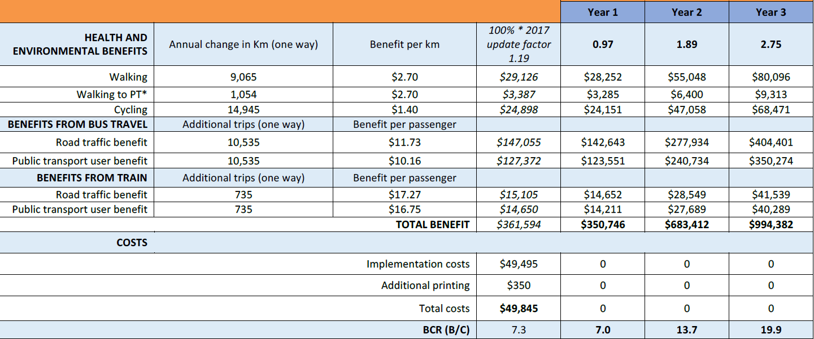

Table 1. Example PJP Benefit Cost Ratio calculation.

The three recent PJP projects all have excellent BCRs, with ranges of 6.6 to 9.9 in Year 1, and from 18.8 to 25.2 in Year 3.

Ongoing behaviour change

While additional follow-up surveys have not been undertaken for Auckland Transport PJPs, a three or six month evaluation is planned for the 2019 Kohimarama-Glen Innes PJP (see Current Projects below).

However, AT HOP card data shows that HOP cards issued to PJP participants do have on-going use. Participants needed to top up their cards for continued use once the free trial period ended. Overall, 42% of the 749 cards issued to PJP participants were topped-up at least once, showing a high level of behaviour change. Over 31% of cards issued for the Birkenhead and Titirangi PJPs in 2014 and 2015 respectively are still being used (1 Aug 2017 – 1 Nov 2018), with almost all cards being topped up in that period. The more recent PJPs show even higher levels with 45 – 58 % of cards used and 31 – 40% topped up. See Table 2 below.

 |  | All use |  | Recent use 1 Aug 2017 - 1 Nov 2018
PJP | Cards issued | % topped up | Number topped up | % topped up | Number topped up | % used | Number used
Birkenhead | 151 | 37% | 56 | 26% | 40 | 33% | 50
Hauraki | 132 | 48% | 63 | 36% | 48 | 45% | 60
Kingsland | 105 | 46% | 48 | 32% | 34 | 48% | 50
Manukau-Pah | 73 | 38% | 28 | 38% | 28 | 58% | 42
Unsworth | 123 | 40% | 49 | 31% | 38 | 50% | 62
Whau | 68 | 44% | 30 | 40% | 27 | 47% | 32
Titirangi | 97 | 41% | 40 | 28% | 27 | 29% | 28
 | 749 | 42% | 314 | 32% | 242 | 43% | 324

Table 2. AT HOP card use by PJP project.

Participant feedback

Auckland Transport’s PJPs have an extremely high level of customer satisfaction, with projects reporting satisfaction levels of over 90%. Participants have appreciated the one-on-one approach and the mode trial incentives.

Participant quotes:
- “I am selling my car as a result and will use PT full time with monthly passes”
- “I had already started to bike and the scheme was encouraging”
- “It’s an excellent idea and feel it’s made me more conscious about driving my car”
- “I’ve given up my car park at work”
- “I love taking the ferry – the whole family got involved in the project”

It is clear from the feedback that PJPs have a wider impact than on the participants alone: participants discuss the project with others, and family, friends and work colleagues notice changed behaviour.

CURRENT PROJECTS

The conference presentation will include an update on the following two projects.

Kohimarama Glen Innes 2019

This project is currently in the procurement stage and will start at the end of January 2019. The target area was to support the Downtown project – a suite of road, public space and ferry terminal improvements that will include the narrowing of Quay Street to one lane in each direction. There is therefore a need to reduce SOV travel on that route while maintaining city centre access for employees, visitors, residents, shoppers and students. This is a slightly larger project, which could provide a model for future support of other major projects.

New Movers 2018-19

The New Movers project is a collaboration with AT Metro, and while it is a departure from the methodology described in this paper, it still targets residents who currently drive and offers them the chance to trial a more sustainable mode. Auckland residents who have recently shifted house receive a flyer inviting them to complete a quick survey on their travel habits: those that drive and are willing to change receive a journey plan and an incentive appropriate to their preferred mode. This project only went live in early October, but some initial results will be available for presentation.

CONCLUSIONS

Auckland Transport’s PJP projects are an effective way of achieving travel behaviour change, albeit on a relatively small scale. Area choice for PJPs need to be considered carefully, but PJPs appear to be well-suited to supporting new infrastructure or services. Measurable results from the projects include a decrease in SOV trips, a decrease in vehicle kilometres travelled, a decrease in CO₂ emissions based on the reduction of vehicle trips, and a travel behaviour shift toward more sustainable modes. The small scale and high BCR for PJP projects provide an opportunity for replication across multiple areas, as well as opportunities for collaboration with other behaviour change projects.

