TRANSPORTATION 2020 CONFERENCE

CYCLEWAY TACTILE PAVERS, WHAT IS BEST practice?

**This paper has been peer reviewed**

**Author:**

Matt Allan, Transportation Engineer,

Abley Transportation Consultants Ltd

BEng(Hons)

[matt.allan@abley.com](mailto:matt.allan@abley.com)

Abstract

Tactile Ground Surface Indicators (tactile pavers) are used to give clear directional and warning messages to blind and vision-impaired people, as well as increasing their safety while crossing roads and throughout their entire walking journey. Tactile pavers are applied to shared walking and cycling infrastructure to differentiate cycle facilities from pedestrian facilities. Tactile pavers also warn and direct visually impaired pedestrians away from cyclists and other hazards to create a safer pedestrian environment. However, they can often be applied poorly by both designers and contractors leading to unclear and unsafe design outcomes for the visually impaired.

A brief literature review was undertaken to understand the design and planning guidelines for tactile implementation. To further understand the issues facing blind and low vision pedestrians in shared environments, a representative from Blind and Low Vision New Zealand was then interviewed. Additionally, a representative from the NZ Transport Agency was contacted to discuss existing issues with the suite of standards and guidelines that designers use when designing tactile applications. Finally, a design engineer with experience applying tactile pavers in the field was interviewed to gain a greater understanding of the issues facing practitioners when applying tactile pavers around cycleways and shared paths.

It was found that the design and implementation of tactile pavers for cycleways and shared paths presented interesting challenges to designers and contractors. These challenges often arise when pedestrian infrastructure is not designed as a priority, with road space allocated to vehicular traffic first, then to other modes. This often results in complex pedestrian crossing points as a result of combining pedestrian and cyclist movements onto shared crossing environments.

To assist designers and contractors in providing for visually impaired pedestrians, the following actions should be considered:

* Updating RTS 14 to provide further implementation examples for tactile pavers at shared crossings, and transition zones between the road environment and shared paths;
* Integrate the design elements of RTS 14 into the Austroads Guide to Road Design Part 6A; and
* Further research into user perceptions of shared path environments and cycleway infrastructure should be conducted. Practitioner training where designs are evaluated by vision-impaired people could also be beneficial.

It was also identified that there is a gap in industry knowledge when quantifying or confirming safety issues with cyclists and pedestrians in a shared environment. With an increasing focus on active modes and accessibility, it is recommended that further research is conducted into pedestrian and cyclist safety on shared paths.

Introduction

In New Zealand and across the world, Tactile Ground Surface Indicators (tactile pavers) are applied in buildings and roading environments to give clear directional and warning messages to blind and vision-impaired people, as well as increasing their safety while crossing roads and throughout their entire walking journey. Tactile pavers are applied to shared walking and cycling infrastructure to differentiate cycle facilities from pedestrian facilities. Tactile pavers are also used to warn and direct visually impaired pedestrians away from cyclists and other hazards to create a safer pedestrian environment. However, they can often be applied poorly by both designers and contractors leading to unclear and unsafe design outcomes for the visually impaired. Recently a variety of societal changes have influenced a change of travel behaviour from private vehicle usage to micro-mobility and active modes, including recent government policy statements on transport, emergence of e-bikes & other vehicles, demographic change and New Zealand’s commitments to zero carbon. Now, with New Zealand towns and cities increasing their investment in cycle infrastructure, there is an increased need for tactile pavers for both shared path and protected cycleways.

But what goes where? How do you design for complex path geometries? What are the issues facing blind and low vision pedestrians? This think-piece paper aims to investigate the challenges facing visually impaired pedestrians and the practitioners designing cycleway tactile pavers, with the hope of providing a clearer understanding of the challenges faced when applying tactile pavers and a goal of providing equitable outcomes for all users of our transport infrastructure.

Background

In August 2014, the New Zealand government announced the $100 million Urban Cycleways Fund (UCF), which paved the way for an increased investment in cycling of $333 million in the Urban Cycleways Programme (UCP). With this came significant investment in cycling infrastructure in New Zealand’s main urban centres. In combination with infrastructure investment, central and local governments have enacted new policies that encourage and emphasise the importance of micro-mobility and active modes in New Zealand’s transport system. Micro-mobility and active modes are quickly becoming popular transport options in NZ when coupled with factors such as increasing road demand, demographic change and commitments to a zero carbon future.

As a result, segregated cycleways and shared paths that provide for cyclists, micro mobility and pedestrians are now becoming common throughout New Zealand, providing increased amenity for all users with the aim of supporting sustainable and active modes of transport. However, these new forms of infrastructure provide a unique design challenge when considering how blind and visually impaired people interact with increased conflict points and changing pedestrian environments.

In New Zealand, the leading causes of blindness and low vision are age-related macular degeneration (AMD), diabetic retinopathy, glaucoma and cataracts, with AMD being the most common cause. Although a significant proportion of New Zealanders are diagnosed with AMD, not all cause blindness and low vision, as these conditions are generally progressive (Blind & Low Vision NZ, 2019). A report commissioned by Vision 2020 New Zealand estimated that the number of people aged 40 or over with vision loss will rise to almost 174,000 by 2020, with those who are blind rising to 18,302 (Taylor & Mapp, 2010). It was also predicted that in 2009, the total financial cost of vision loss (excluding the loss of wellbeing) in 2020 would be $400 million NZD.

With projected increases in the blind and low-vision population in New Zealand, and with the increased investment in cycling as a mode of transport, it is becoming increasingly important to design transport infrastructure that is accessible and equitable for blind and low-vision pedestrians.

Design Standards and guidelines review

The provision of a high-quality and equitable transport system for all users is an objective that can be addressed by a range of practitioners, including urban planners, urban designers and architects. Collaboration and consultation between practitioners will further enable the realisation of this objective, as transport design elements are only one of the many aspects that influences this objective.

For transport engineers designing cycling infrastructure in New Zealand and Australia, there are multiple design standards that outline requirements and design considerations for when designing cycling infrastructure and shared paths. Some examples of relevant tactile paver, cycle and shared path design standards include:

* ASNZS 1428.4.1 (2009) Design for access and mobility – Tactile ground surface indicators.
* NZTA RTS 14 (2015) - NZTA RTS 14 (2015) – Guidelines for facilities for blind and vision impaired pedestrians; and
* Austroads Guide to Road Design Part 6A – Paths for Walking and Cycling;

These standards cover the application of cycleway tactile pavers to varying detail and are further explored below.

ASNZS 1428.4.1 (2009) Design for access and mobility – Tactile ground surface indicators:

AS/NZS 1428. 4.1:(2009) Design for Access and Mobility Part 4: Tactile Ground Surface Indicators (TGSI) was released in November 2009. This standard sets out the requirements for the design and application of tactile indicators for new building work, to ensure safe and dignified mobility of people who are blind or vision impaired (Australian/New Zealand Standard, 2009). In New Zealand, this standard complements NZS4121 which applies primarily in buildings and related areas. Compliance with this standard is a legal requirement in the Building Act (2004). However, in roading environments, specifically for kerb crossings, compliance with this standard is not a requirement under the Building Act, and the details in the standard are purely advisory.

The standard covers both the design of the tactile pavers themselves, and their application at crossing points, with comprehensive examples provided for different crossing situations. The standard does not reference cycle infrastructure or tactile applications for shared paths and shared crossings. The standard references the Pedestrian Network Guidance and RTS 14 for best practice on design for visually impaired users of roads, footpaths and traffic signals.

NZTA RTS 14 (2015) – Guidelines for facilities for blind and vision impaired pedestrians

NZTA RTS 14 (2015) aims to provide best practice for the design and installation principles for pedestrian facilities that assist people who are blind or have low vision (New Zealand Transport Agency, 2015). There are two tactile types that are used in the road environment in New Zealand, these are:

* Warning indicators – a textured surface feature consisting of truncated domes built into or applied to walking surfaces to warn people who are blind or have low vision of a nearby hazard.
* Directional indicators - a textured surface feature consisting of directional grooves built into or bars applied to walking surfaces to give directional orientation to people who are blind or have low vision.

The application and design of these indicators are covered extensively in RTS 14, with multiple application examples for pedestrian crossing points, public transport access points and significant public facilities. Cycling infrastructure, including shared paths, are briefly covered under section 5.9 of RTS 14, with only shared crossing facilities covered in detail. The main guidelines outlined in RTS 14 when designing shared crossing facilities are:

* The provision of paint marking to indicate that pedestrians are to use one side of the shared crossing;
* Installing warning indicators across the entire width of the shared crossing, including the area allocated for cyclists; and
* Tactile paver layouts should lead pedestrians naturally to the side with the pedestrian push button, using directional tactile pavers where other cues are insufficient.

Figure 1. Shared Signalised Crossing Standard Detail (RTS 14)

An example of a shared crossing facility from RTS 14 is shown in Figure 1.

Austroads Guide to Road Design Part 6A – Paths for Walking and Cycling

The Austroads Guide to Road Design Part 6A (2017) covers the geometric design of pedestrian and cycling paths and the design of associated facilities (Austroads, 2017). The guide covers pedestrian paths, bicycle paths, shared paths and separated paths. Regarding the design for visually impaired users, the guide suggests general tactile treatments in some sections but does not provide details on how these might be applied.

Interviews

To further understand the issues facing blind and low vision pedestrians in shared environments, three different stakeholders were interviewed:

* A representative from Blind and Low Vision New Zealand was interviewed to understand the issues facing visually impaired pedestrians
* A representative from the NZTA was interviewed to explore potential design aspects that could be included in future standards
* A representative from a local consultant with experience in implementing tactile pavers for shared paths and cycleways was asked to identify issues facing practitioners in applying tactile pavers around cycleways.

Carina Duke, Practice Advisor– Blind and Low Vision New Zealand

Carina Duke is a Practice Advisor at Blind and Low Vision New Zealand and is often consulted for advice on tactile implementation and other design features for pedestrian footpath and shared paths. This consultation is often prompted by designers and contractors and has ensured positive outcomes for vision impaired pedestrians across New Zealand. In this interview with Carina, the following challenges were raised (Duke, 2019):

* Shared paths are not supported from a blind and low vision perspective. They can be a safe outcome for cyclists but can detract from pedestrian safety. The reduction in perceived safety and amenity can dissuade vision impaired people from walking as a mode of transport. If shared paths continue to be used, keeping them simple should be the priority in a shared environment.
* There are issues with shared crossings in which separated crossings are not designed for vision impaired pedestrians that must move out of the way of another path user. There is no guarantee that they return to the pedestrian side of the shared crossing. Shared crossings should be designed to allow for pedestrians crossing on the cyclist side, while guiding pedestrians to the desired sides.
* Directional tactile pavers should be applied on slip lanes to stop visually impaired users from using these lanes. These should be used in combination with warning tactile pavers at the road boundary to indicate a kerb cut down.
* Adding rumble strips (or similar warning devices) at the entrance to shared paths should be investigated to slow cyclists and alert visually impaired pedestrians that they are entering a shared space.
* Further research is required to understand pedestrian safety on shared paths.

Tim Hughes, *Principal Safety Engineer -* New Zealand Transport Agency

Tim Hughes is a Principal Safety Engineer specialising in active modes at the NZ Transport Agency. Tim Hughes is one of the main authors of RTS 14 and is considered an expert in design for visually impaired pedestrians. Tim provided the following commentary in relation to tactile provision for cycle infrastructure (Hughes, 2019):

* There is no need for another type of tactile marking. There is a current issue about the separation between footpath and roadway where there is no kerb. In RTS 14 the Auckland tactile treatment is referenced for indicating the traffic free pedestrian space within shared zones, where drivers are required to yield to pedestrians. However, recent examples have removed kerbs when the space is not intended to be shared and drivers have right of way. This is poor practice, and a tactile treatment will not be sufficient.
* It would be possible to optimise the design of warning tiles so they are more detectable underfoot while retaining their benefits of the existing design for wheelchair manoeuvring and bicycle stability. However, this is unlikely to happen as there is a huge investment in moulds for the current designs. There would be more merit in redesigning the direction tactile pavers – narrower raised strips and closer spacing. This would enhance detectability for blind and low-vision users and remove ankle rotation when only one side of foot is on raised strip, as well as reducing wheel bounce when crossing the tiles.
* It is becoming increasingly apparent that shared paths are only acceptable at low user volumes, and with adequate space. Pedestrians and cyclists are moving at different speeds. The mix creates problems for both groups. Speed control is a significant issue - rumble strips may not be the solution to speed control – vertical deflection such as gutter crossings and drainage channels seem to be most effective.

Mitchell Cocking, *Senior Civil Engineer –* Aurecon

Mitchell Cocking is a Senior Civil Engineer at Aurecon. He is a senior team member in the ‘Velos’ team for the major cycleway implementation in Christchurch. He was involved in the design and construction of the Rapanui (Shag Rock), Uni-Cycle and Heathcote Expressway routes. Mitchell raised the following issues that arose during these Christchurch cycleway projects (Cocking, 2019).

* The examples in RTS 14 are perfect-world scenarios and do not account for site constraints, for example large kerb radii.
* Installation is also an issue with many contractors not installing them as per guidance and in line with the plans. However, it is difficult to expect them to do it right when some layouts are difficult to install and are often just shown as a small detail on the plans.
* A better understanding of how tactile pavers are used by vision impaired users would assist in guiding the best practice. There are many examples around Christchurch and it would be beneficial to get some insight from the users about what works and what doesn’t.

Existing implementation ISSUES

With the increased provision of cycle facilities across New Zealand in recent years, there are now multiple examples of the application of tactile pavers. Current practice is to apply tactile pavers at crossing points to comply with RTS 14 and then have the proposed tactile applications reviewed by a representative from the Blind & Low Vision NZ. This practice has resulted in positive applications of tactile pavers in some instances. However, as consultation with Blind & Low Vision NZ is not mandatory, there are also many examples of poor application of tactile pavers.

Transitions between shared paths to sharrow-marked road environments

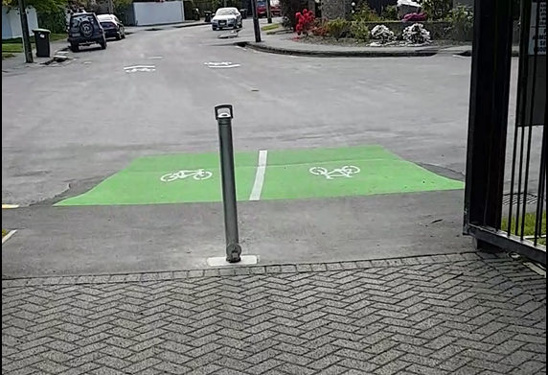One of the main areas where design for vision impaired users is poorly implemented is the interface between a road environment and a shared path. This includes the interface between shared paths and sharrow-marked road environments.

As shown in Figure 2, no tactile treatment has been provided at the transition from shared path to the carriageway. In this instance, the provision of directional tactile pavers would be sufficient to direct visually impaired users away from the active road environment. Visually impaired users can then detect the kerb and the berm edge with their cane to orientate themselves. However, there are other issues associated with this layout, including the positioning of the bollard and the speed environment change from the roadway to a shared path. These issues reduce the amenity of both able-bodied pedestrians and visually impaired pedestrians.

Figure 2. Riccarton Bush Shared Path (Cocking, 2019 )

Slip lanes to and from shared paths

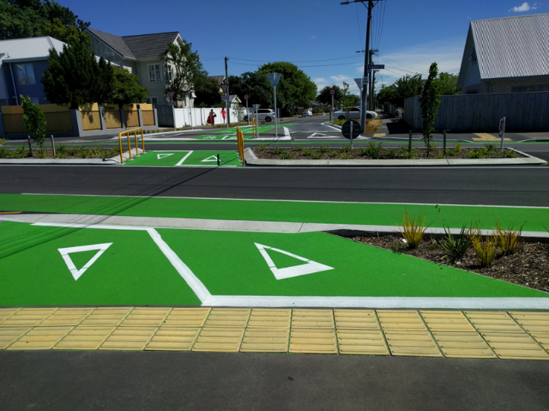Another area in which tactile treatments are poorly applied is at the interface between slip lanes and shared paths. As the kerb cutdowns have the same or similar characteristics as pedestrian crossing points, they require directional tactile treatments, sometimes in combination with warning tactile indicators further towards the road in the slip lane.

An example of a directional tactile treatment for a shared path slip lane is shown in Figure 3. The application of the tactile treatment is correct in that it directs pedestrians away from the slip lane and road in environment. However, an issue with this orientation is the angle that cyclists approach the directional pavers. It has been identified as a potential hazard for cyclists as bicycle wheels lose traction when they approach directional tactile pavers at oblique angles.

Figure 3. Directional tactile treatment across slip lanes (Cocking, 2019)

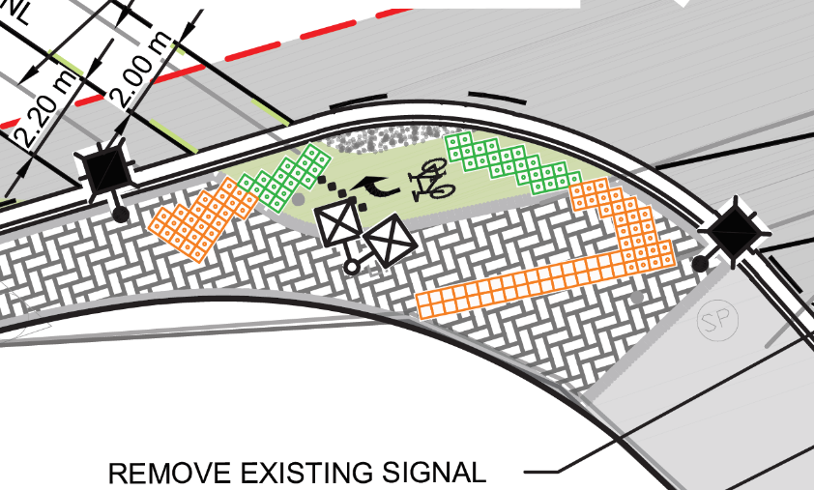Large Radii and angled kerbs

A challenge often faced by design experts is the implementation of directional and warning tactile pavers at crossing points that have large radii angled kerbs. This is a particular issue on shared crossing points that provide for both pedestrians and cyclists.

An example of a tactile implementation for a large kerb radius is shown in Figure 4. This design implementation is not best practice for visually impaired users as it does not efficiently direct visually impaired users to crossing points, nor does it segregate them from cycle crossing points. Fortunately, large curve radii are becoming less popular as tighter curve radii are used as a way of controlling entry and exit speeds from intersections, so this issue is becoming less frequent.

Figure 4. Tactile implementation for a kerb with a large radius (Cocking, 2019)

Discussion

From the interviews conducted and the tactile implementation examples that were examined, three significant problem areas were identified. These are:

* Issues with tactile implementations at shared spaces and shared paths, and the issues facing visually impaired pedestrians using this space;
* The existing standards and the example tactile applications for shared paths and crossings are perfect-world scenarios that do not account for many site constraints; and
* There is a wider issue that has been identified suggesting concerns with pedestrian safety on shared paths.

It is clear that the design and implementation of tactile pavers for cycleways and shared paths presents interesting challenges to designers and contractors alike. Carina Duke from Blind and Low Vision New Zealand outlined some examples of when tactile implementations are often done poorly, the most common being at shared path intersections with slip lanes merging cyclists with pedestrians at an intersection. These issues can often be resolved through consultation with Blind and Low Vision New Zealand, however, Carina suggested that these are largely a result of wanting to combine pedestrians and cyclists, and that these design issues should be considered further.

The challenges associated with conflicting users in shared environments can often arise when pedestrian infrastructure is not designed as a priority, with road space allocated to vehicular traffic first, then to other modes. This generally results in complex pedestrian crossing points, and combining pedestrian and cyclist movements onto shared crossing environments. There appear to be fewer issues with tactile implementation on segregated cycleways as no examples were raised in any of the interviews conducted. This is likely because segregated cycleways do not affect pedestrians at crossing points as they are controlled separately via signalised intersections, it is only when pedestrians and cyclists are combined that these issues arise.

Mitchell Cocking from Aurecon argues that the existing suite of standards used by designers for tactile implementations are largely perfect world scenarios and do not account for common and site-specific constraints. The main issues identified and discussed in the previous section were large kerb radii, transitions between shared paths to sharrow-marked road environments and slip lanes to and from shared paths. The issues associated with the design of tactile implementation on shared paths for visually impaired pedestrians is unlikely to be fully covered by any one standard. However, if the provision of shared paths and shared crossing facilities is to continue, the New Zealand standards and guidance that are used to provide for visually impaired users should be updated to include clearer shared path guidance. This will ensure a consistent best-practise approach to the design of shared path facilities that provides for visually impaired pedestrians.

Now, with many real-world examples of shared paths and shared intersections, any update to the current suite of standards and guidance should consider what works and does not work with existing implementations. A valuable resource in determining this would be blind and low-vision users who could provide their own perception of different tactile arrangements.

The comments raised by Tim Hughes were predominantly focused on the form of function of the two tactile treatments that are used in New Zealand. However, it was identified that there are existing issues with shared paths that have higher user volumes and space constraints. These problems appear to be exacerbated by the speed difference between the user groups on the shared path. Additionally, Carina Duke stated that Blind and Low Vision New Zealand does not support shared path and shared space environments, due to the perceived safety issues related to the difference in users’ speeds. Carina believed that these issues could result in a loss of safety and amenity for blind and low vision users and dissuade vision impaired people from walking as a mode of transport.

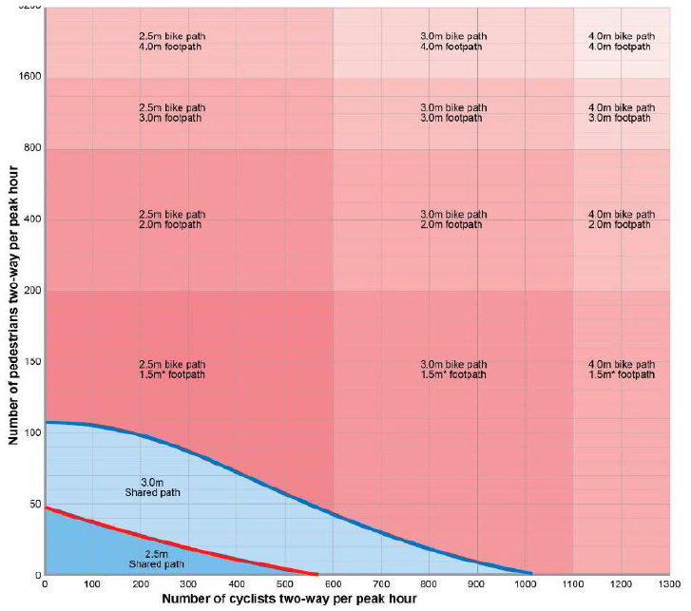Currently, there is a gap in industry knowledge when quantifying or confirming safety issues with cyclists and pedestrians in a shared environment. With an increasing focus on active modes and accessibility, further research into pedestrian and cyclist safety on shared paths should be conducted.

Figure . Path widths for a 50/50 directional split (Austroads, 2017)

We do know that shared paths should only be applied when there are low pedestrian volumes and low cyclist volumes. The ‘Austroads paths for walking and cycling guide’ provides preferred widths for shared paths, pedestrian footpaths and bike paths for different volumes of pedestrians and cyclists (Figure 5).

For higher pedestrian volumes or higher cyclist volumes, designers should look to reallocate road space to cyclists while preserving pedestrian amenity, rather than combining the two vulnerable user groups. Segregating cyclists from not only vehicles but also as this would provide the best safety outcome for all parties, though doing so most often requires challenging conversations and increased project costs.

Recommendations and Next Steps

To provide an equitable and practical road environment for all road users, we must be proactive in the design and planning of shared paths and other cycle facilities. In terms of providing for visually impaired users, the current best practice approach is complying with RTS 14 and consulting with Blind and Low Vision New Zealand . However, there is a knowledge gap in the industry on designing shared environments for visually impaired users. To assist designers and contractors in providing for visually impaired pedestrians, the following actions should be considered:

* Updating RTS 14 to provide further implementation examples for tactile pavers at shared crossings, and transition zones between the road environment and shared paths;
* Integrate the design elements of RTS 14 into the Austroads Guide to Road Design Part 6A; and
* Further research into user perceptions of shared path environments and cycleway infrastructure should be conducted. Practitioner training where designs are evaluated by vision-impaired people could also be beneficial.

Furthermore, it was acknowledged by Blind and Low Vision New Zealand that the provision of shared paths rarely provides an equitable safety outcome for pedestrians. Further research should be conducted into the perceived and real safety issues with shared paths. Until such time, shared paths should be discouraged in high-volume pedestrian or high-volume cyclist areas and engineers and designers should look to reallocate road space to provide for segregated cycle facilities, ensuring an equitable outcome for all road users.

References

Australian/New Zealand Standard, 2009. *Design for access and mobility,* Sydney : SAI Global Limited.

Austroads, 2017. *Guide to Road Design Part 6A: Paths for Walking and Cycling,* Sydney : Austroads.

Blind & Low Vision NZ, 2019. *Staticstic and Research.* [Online]   
Available at: https://blindlowvision.org.nz/information/statistic-and-research/  
[Accessed 20 October 2019].

Cocking, M., 2019 . *Figure 2. Riccarton Bush Shared Path,* Christchurch: s.n.

Cocking, M., 2019. *Figure 3. Directional tactile treatment across slip lanes ,* Christchurch: s.n.

Cocking, M., 2019. *Figure 4. Tactile implementation for a kerb with a large radius,* Christchurch: s.n.

Cocking, M., 2019. *Senior Civil Engineer* [Interview] (29 September 2019).

Duke, C., 2019. *Practice Advisor* [Interview] (14 October 2019).

Hughes, T., 2019. *Principal Safety Engineer* [Interview] (21 October 2019).

New Zealand Transport Agency, 2015. *RTS 14 – Guidelines for facilities for blind and vision impaired pedestrians,* Wellington: New Zealand Transport Agency.

Taylor, P. & Mapp, K., 2010. *Clear Focus — The economic impact of vision loss in New Zealand in 2009,* Canberra: Access Economics.

ACKNOWLEDGMENTS

Carina Duke, *Practice Advisor* - New Zealand Blind Foundation:

Tim Hughes, *Principal Safety Engineer -* New Zealand Transport Agency

Mitchell Cocking, *Senior Civil Engineer –* Aurecon