**RESILIENCE BASED DESIGN OF TRANSPORTATION SYSTEMS**

**This paper has been peer reviewed.**

Pathmanathan **Brabhaharan**

B Sc Engineering (Honours), M Sc Engineering (Foundation Engineering), M B A, CPEng

Fellow - Engineering NZ

Member - NZ Society for Earthquake Engineering, NZ Geotechnical Society, SESOC, NZ Society for Risk Management, IPWEA.

Technical Director

WSP New Zealand Limited

[brabha@wsp.com](mailto:brabha@wsp.com)

**RESILIENCE BASED DESIGN OF TRANSPORTATION SYSTEMS**

**ABSTRACT**

Transportation systems are key lifelines for our society to provide access for socio economic functionality. Given New Zealand’s location, it has high seismicity, rugged terrain and a harsh and variable climate. Climate change is resulting in more frequent severe weather events and potentially higher sea levels and associated storm surge. Access for communities becomes increasingly vulnerable to these hazard events and is critical for communities to survive and recover during and after such events. It is also important that we cater for gradual changes such as sea level rise associated with climate change. The resilience of our transportation systems is critically important for society.

It therefore makes sense that we have a resilience focus in the planning, conceptualisation, development and design of transportation infrastructure, as well as management of our transport operations. Resilience is the inherent robustness to continue to provide service, or the ability to recover quickly to provide functionality for the community. Focus on resilience is therefore critical in the development and design of transport systems.

A resilience-based design approach is proposed as one of the key fundamental pillars in the development of transport infrastructure systems to cater for natural and anthropogenic hazards including climate change. Such a design approach will involve characterising the resilience importance and functionality required given the context of the proposed transport infrastructure in a local, regional and perhaps national context. It will then require an early focus on resilience to ensure that the required functionality can be achieved by appropriate scoping and routing. Finally, design would have a focus on achieving the two, key metrics of resilience – ie availability - degree of access, and outage - time for recovery.

This paper sets out a novel resilience-based design approach, where the focus of design is to achieve a desirable level of resilience, appropriate to context. A focus on resilience will also enable an appropriate level of investment in the management of resilience risks to our transportation system and avoid over investment where a lesser level of resilience is acceptable and under-investment where a higher level of resilience is critical.

**INTRODUCTION**

Natural hazards have a significant impact on our transportation systems because of our rugged terrain shaped by our tectonic environment, associated seismicity and our vulnerable location in the South Pacific where we are exposed to severe climatic conditions and tsunami. Such impacts and their frequency are being exacerbated by climate change.

Our design standards have been shaped by those developed in more stable environments, and in past 75 years by concerns over life safety in earthquake events, particularly after the 1931 Napier earthquake. As a result, a lot of our standards and codes focus on life safety. In countries such as New Zealand with developed earthquake design standards, collapse of buildings and associated loss of life in earthquakes has been limited by design practice, except in few instances. For network infrastructure such as transportation, loss of life may not often be a direct consequence of natural hazards. Performance is important for response and recovery. Ability to respond and recover quickly may contribute to life safety, but also the social well-being and economic recovery.

In New Zealand, there has been an increased focus on lifelines, such as roads, rail, water, electricity, gas, wastewater, ports and fuel since the Wellington engineering lifelines study (Centre for Advanced Engineering, 1991). This and other lifelines studies that followed for our cities and districts highlighted the vulnerabilities in our lifelines systems, and the need for action to ensure that they perform better. However, a systematic approach to address these remained elusive.

Research into strategic management of resilience risks in the early 2000s led to the development of metrics for resilience (Brabhaharan, 2006), and a spatial approach to considering transportation networks holistically. This led to a focus on performance in the design of lifeline infrastructure. Given our increased understanding of the importance of resilience, there is a need to focus on design for resilience. The objective of this paper is to set out a novel *resilience-based design* approach, where the focus of the design is to achieve a desirable level of resilience in a range of natural hazards from storms, volcanic eruption, tsunami and earthquakes.

**OBSERVATIONS FROM PAST EVENTS**

**Learning from Past Events**

Past natural hazard events provide a good opportunity to learn and understand the resilience implications and needs for transportation networks. Such earthquakes have provided a valuable opportunity to understand the resilience implications, as well as test and calibrate resilience studies carried out. Such opportunities were provided by the 2009 Wenchuan earthquake in China (Yu et al, 2009), the 2016 Kumamoto earthquake in Japan (Chiaro et al, 2017) and the 2016 Kaikōura earthquake in New Zealand (Mason and Brabhaharan, 2019):

**2016 Kaikōura Earthquake**

The 14 November 2016 magnitude 7.8 Kaikōura earthquake in the upper South Island of New Zealand provided a valuable opportunity to understand the resilience of our transport network, and the implications for response and recovery. The earthquake caused failures along the transportation corridor between Picton and Christchurch, and showed that:

* State Highway 1S and the main South Island truck railway line were closed by the earthquake, particularly between Ward and Cheviot;
* Road access was restored quickly in places where there were small to moderate size failures, with limited repair and disruption costs;
* It took over a year to restore limited access where closed by large landslides, see Figure 1.
* The restoration of limited access by clearing and stabilizing large landslides involved very large costs and the disruption of a nationally significant transport corridor.

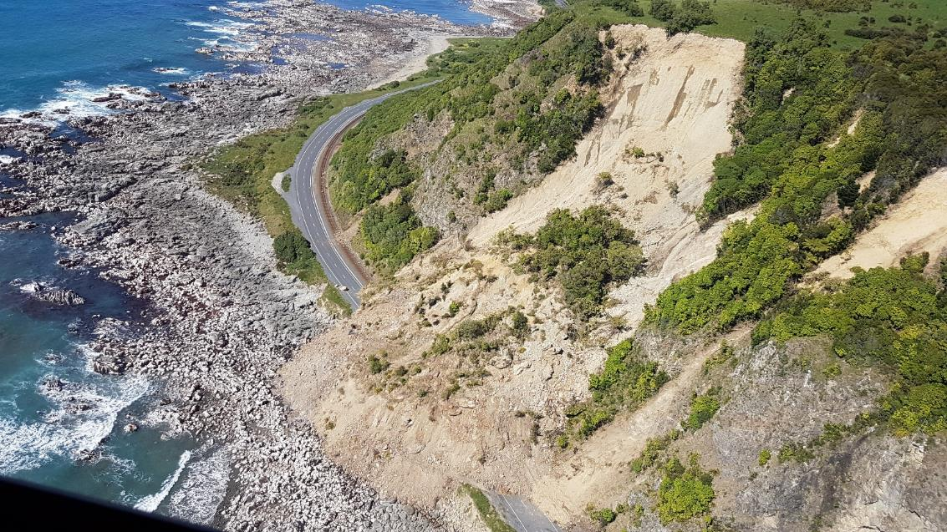

Figure 1. State highway and rail closed by large landslides in the 2016 Kaikoura earthquake, New Zealand.

Not only was the network affected by damage due to the earthquake, but also storm events following the earthquake, where the earthquake-displaced or loosened hillsides were affected by landslides and debris flows from relatively modest storm events and caused further disruption to the transportation access and recovery efforts.

This highlights the need for considering the resilience of transportation networks, as well as other infrastructure, so that more resilient infrastructure can be developed over time.

**2019 Storm Event**

Storm events regularly cause extensive damage and cot of transportation routes. For example, the March 2019 storm closed the state highway between Greymouth and Franz Joseph causing collapse of the bridge across the Waiho River and many landslides, see Figure 2.

Figure 2. State highway closed by bridge collapse and landslides in the March 2019 storm, New Zealand.

**PERFORMANCE BASED DESIGN IN TRANSPORTATION**

Since the early 1990s, there has been increasing recognition among geotechnical engineering practitioners of the need for performance-based design. New Zealand research into the earthquake performance of retaining walls during the 1970s culminated in the publication of a summary of that research in the Road Research Unit Bulletin 84 (Wood and Elms, 1990). This report proposed methods of design for retaining walls, classified as flexible, stiff or rigid, and included assessment of the displacement of retaining walls based on Newmark’s sliding block model. Together with European statistical analyses of the earthquake displacement of slopes based on a collection of past earthquake records and the Newmark sliding block approach (Ambraseys and Menu, 1988), this provided a means of assessing earthquake displacement with some level of statistical confidence.

Publication of this research in the Road Research Unit Bulletin and the increased use of reinforced soil and soil nailed walls, which were well suited to design allowing displacement, led to a performance-based design approach being adopted in the transportation sector. These developments, together with the increased focus on lifelines, provided the opportunity for geotechnical designers to design retaining walls to desired levels of maximum displacement performance rather than a design based on achieving a factor of safety.

The development of a strategy for Wellington City Council, to assess and prioritise mitigation to enhance the performance of the city’s road network (Brabhaharan, 2004), led to the implementation of a long-term programme to strengthen vulnerable sections of road – slopes, retaining walls, tunnels and bridges. Appreciating the importance of performance of the roads, rather than achieving a factor of safety, Brabhaharan and Saul (2005) adopted a performance-based design approach in the strengthening of retaining walls and slopes, with limited displacement to an acceptable level, see Table 1.

Limited displacement was accepted on the basis that the road will still allow emergency vehicles to pass, albeit slowly, and the cracking from displacement could be quickly remedied by using fill or bitumen to allow full access. Anchors for soldier pile walls were designed to be ductile to allow limited smaller displacements of the walls by using anchor bars with post-yield ductile behaviour.

Table 1. Performance Criteria for Ngaio Gorge Road Strengthening

|  |  |  |  |
| --- | --- | --- | --- |
| Performance Level | Performance | Return Period | Peak Ground Acceleration |
| Design level  (NZ Bridge Manual) | No more than 150 mm wall displacement, with minor damage with cracking of road. | 670 years | 0.35g |
| Contingency Level  (M7.5 Wellington Fault) | No more than 450 mm wall displacement, leading to some repairable damage and extensive deformation of road acceptable, provided it is able to remain open to traffic. | - | 0.47g |

This performance-based design approach was also adopted since the mid-1990s in many new transportation projects, such as the Wellington Inner-City Bypass (Brabhaharan, 2007) as well as for the assessment of existing assets such the Terrace Tunnel approach walls (O’Reily and Brabhaharan, 2006), see Figure 3.

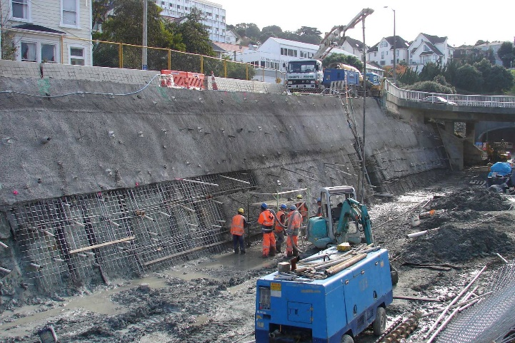

Figure 3. Soil nailed walls at Wellington inner-city bypass (left), Terrace tunnel approach walls (right)

**WHAT IS RESILIENCE?**

The need for a more systematic approach to manage risks led to research into strategies for the management of the risks to transportation networks from natural hazards in the period 2001-2006. The concept of resilience for road networks was developed, together with metrics to measure resilience (Brabhaharan, 2004).

From the perspective of transportation networks (as well as other lifeline infrastructure), *resilience* can be defined as the ability to recover quickly to restore the level of service after an event. A conceptual illustration of this is presented in Figure 4. Resilience for transportation routes can be characterised by the metrics of availability state (representing the reduced level of service) and outage state (representing the time required to restore service).

Network-wide resilience studies since this research highlight that transportation networks are highly vulnerable to natural hazards. Associated studies into the importance of transportation routes and criticality of resilience interventions have led to our understanding that depending on the resilience context within the transportation system, the resilience expectations can be significantly different for each route. This will apply both to existing transportation infrastructure as well as new infrastructure.

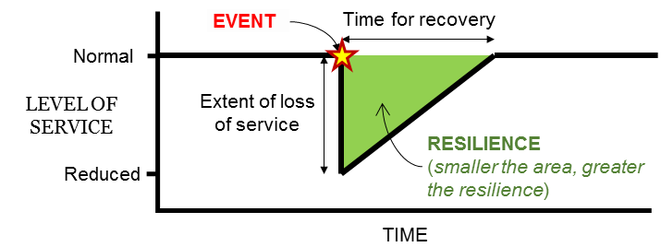

Figure 4. Concept of Resilience for transportation routes

Transportation systems with very little redundancy will require a greater level of robustness (for example in Wellington) compared to networks where there is abundant redundancy (for example in Christchurch). This raises the question as to whether we should be using resilience as a basis for our design, as well as asset management of transportation infrastructure.

**TRANSPORTATION RESILIENCE STUDIES**

Research into the systematic management of the resilience risk to transportation networks also developed a spatial approach to assess the resilience of transport systems at a network-wide level (Brabhaharan, 2004). This led to network wide resilience studies for several individual road networks in the Wellington region as well as elsewhere. While earlier studies focussed on earthquake resilience, subsequent studies (Hutt City, 2005 and Western Bay of Plenty, 2006, Taranaki, 2016) also included consideration of storm events and in the case of Western Bay of Plenty, volcanic events.

In the Wellington Region, individual resilience risk studies were carried out by Opus for the road networks in Upper Hutt, Wellington, Lower Hutt, Porirua and the state highway network over a period of some 12 years (1999 – 2011). These studies culminated in a region-wide integration of network resilience assessments in the Wellington Region through collaboration between the NZ Transport Agency, the 5 local authorities of Upper Hutt, Hutt City, Wellington City, Porirua City and Kapiti Coast District, and Opus (Mason and Brabhaharan, 2013). This led to an integrated understanding of the combined transport network and highlighted the associated critical vulnerabilities as shown in Figure 5. In 2016, the Wellington region’s resilience studies were extended to include storm resilience across the region (excluding the Wairarapa) and the impact of building damage and collapse on transport access in the inner-city areas of Wellington city (Opus, 2017).

Transportation access between districts in the region and access into and out of the Wellington region is likely to be closed for a long period of several months in the event of a large earthquake in the region, jeopardizing response and recovery after the event. This study highlighted the critical importance of transport resilience to the survival and functionality of society. Given the terrain, seismicity and climatic conditions, many of our regional transportation networks lack redundancy in transport corridors and hence such criticality is not uncommon.

This understanding of the resilience in the Wellington region was critical to the conception and design of new infrastructure for resilience and to enhance the overall resilience of transportation in the region as discussed in the next section.

Such an understanding of the resilience context is an important feature of being able to design for an appropriate level of resilience.

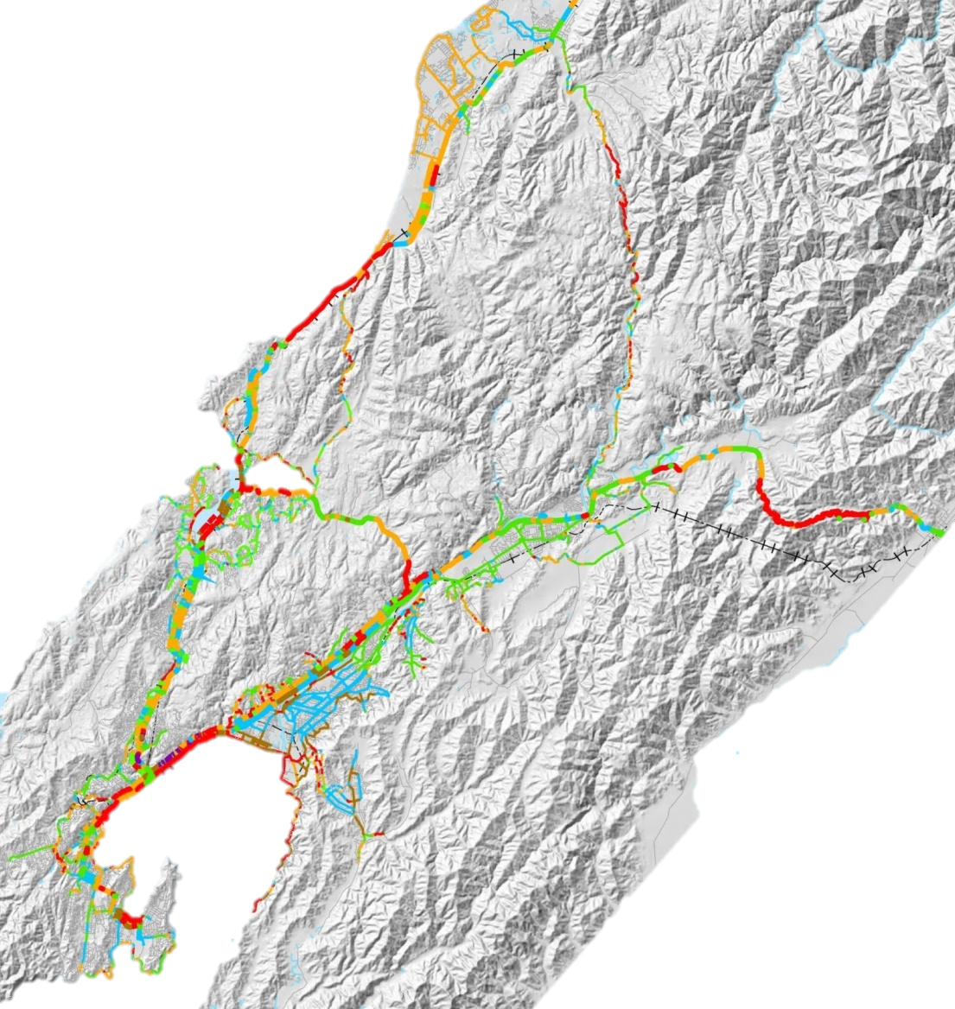

1 - Full

2 - Poor

3 - Single Lane

4 - Difficult

5 - Closed

**Availability State**

Figure 5. Resilience of Wellington road transport network in a local large earthquake event.

**DESIGNING INFRASTRUTURE FOR RESILIENCE**

**Transmission Gully Expressway Case Study**

Given the poor resilience of the existing routes, there is a critical need for resilience in the transport network in Wellington. An early focus on resilience was therefore adopted during the development of an alternate Transmission Gully route north of Wellington in 2007-2008. The conceptual design that was developed showed that an early focus on resilience can help achieve greater resilience of transport infrastructure, in this case, at no additional cost (Brabhaharan, 2009).

In this case, the resilience focus during conceptual design included challenging and modifying the route alignment and road form, so that the inevitable crossing of a major active earthquake fault (the Ohariu Fault) was on earth embankments rather than the viaducts previously proposed. While both embankments and viaducts would be damaged by rupture of the fault, an embankment can be quickly restored by earthmoving machinery, reducing the outage time to within a few days, compared to a viaduct, which would take many months to years to restore.

The quicker recovery possible after an earthquake with an embankment form, as well as modifications made to cut slopes to accept small failures but avoid large landslides, meant a much greater resilience could be achieved for the route.

This case study illustrates how a focus on the twin metrics of resilience – functionality and time for recovery – helped achieve a more resilient design solution for the expressway developed in 2007-2008. In contrast, traditional design would have led to a simple selection of a route based on earthworks cut-fill balance and design for a factor of safety, with little consideration to resilience.

In this case, the changes also resulted in much lower costs due to the change from viaducts to embankments, and acceptance of damage where access can be quickly restored. Such significant enhancements in resilience at no additional cost would be difficult to achieve, unless there was a focus on design for resilience from early stages of projects. This shows that achievement of significant improvements in resilience does not necessarily have to cost more if there was an early focus on resilience. There is a need to maintain this focus on resilience throughout the project development and construction, or else benefits gained could be eroded through procurement and detailed design stages.

**State Highway 2 Muldoon’s Corner Realignment**

Another example of design for resilience is the upgrade of the Muldoon’s Corner realignment of SH2 in the Rimutaka Hill Range in 2010-2012, see Figure 6. In this case, the highway was in rugged terrain, and the original design required large cut slopes, bridges and sidling fill embankments. An early review of the design enabled changes to be made to the alignment to avoid sidling fill embankments which are prone to failure and instead use of full embankments and where necessary reinforced soil embankments (Brabhaharan and Stewart, 2015). The bridges were also eliminated because bridges close to high slopes and cuttings are vulnerable to failure due to landsliding, as observed in the 2008 Wenchuan earthquake in China (Yu et al, 2009), and would take long to reinstate.

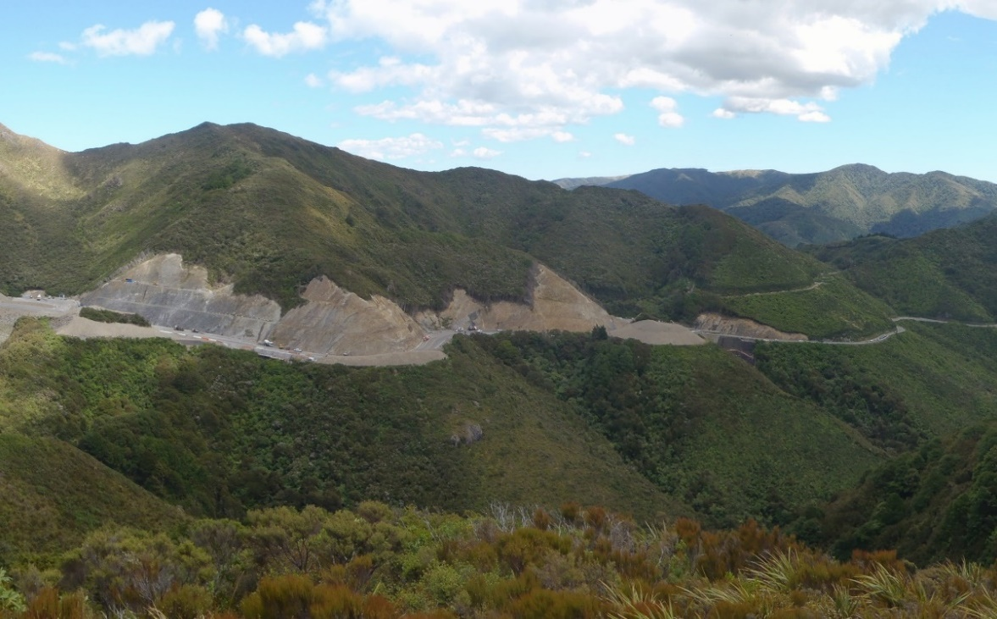

Figure 6. Design for Resilience of State Highway 2 Muldoon’s Corner realignment, Wellington.

The cut slopes were also formed through rock, considering the defects in the rock and their orientations determined through acoustic televiewer surveys in boreholes as well as traditional mapping of rock exposures. This enabled the design of rock cuttings to accept small wedge type failures that can be cleared quickly or contained by rock fall barriers but avoid large landslides by adopting suitable cut slope angles. Along one section, the rock slopes were anchored with high capacity rock anchors to enhance stability, particularly in storm and earthquake events.

This approach to design considering resilience, resulted in greater resilience, but also acceptable costs of construction, which were lower because of the elimination of bridges.

**Asset Management and Repair of Failures**

Frequent storm events and less frequent earthquakes lead to damage and failure of transportation routes and various periods of closures. The sections that fail are then repaired and restored using a variety of techniques, often with no consideration of the resilience of the transportation system. This leads to high expenditure in some cases where a resilience-based approach could lead to solutions at a lower (whole of life) cost, and in some other cases where some additional expenditure could lead to much greater resilience in future events.

A holistic consideration of the resilience of the routes will help us to progressively enhance the resilience of our transportation system. This requires a good understanding of the resilience of our transportation systems.

**Wellington City Road Network Strengthening Programme**

Principles of resilience considering loss of access and the outage period has been adopted in the strategy for enhancing the resilience of roads in Wellington City. Vulnerable retaining walls and steep under-slopes that have the potential to remove the road platform in a natural hazard event such as an earthquake or large storm, and which will take many weeks to months to restore, have been prioritised for strengthening to enhance resilience.

Low to moderate height uphill slopes are susceptible to failure and could close the road, but access could be restored quickly by earthmoving machinery, and hence have a lower priority for strengthening, and are planned to be managed by emergency response planning.

**Seismic Design of High Cut Slopes Research**

Access is critical for societies to survive and remain functional after natural hazard events such as earthquakes. This is a challenge given our rugged terrain, active tectonic environment and severe weather events. Transportation projects to form or improve roads in tectonically deformed fractured rocks, volcanic soils and our young geology mean that steep natural slopes and cut slopes formed along transportation corridors perform poorly in hazard events such as earthquakes. Flatter slopes and stabilisation measures would incur significant costs.

There was very little research or guidance for the seismic design of cut slopes either in New Zealand or globally. Research into the seismic design and performance of cut slopes was carried out by Opus with funding from the New Zealand Transport Agency during 2014-2016 (Brabhaharan et al, 2018). This led to guidance for seismic design of cut slopes using a resilience-based design approach, for the first time.

Further research into the performance of earthworks and slopes in the 2016 Kaikōura earthquake is currently underway with funding from the Ministry of Business Innovation and Employment, under the Endeavour research programme. This research is expected to provide further recommendations and guidance.

**Resilience based Design of Cut Slopes**

Achieving resilience requires a focus on reducing the two metrics of resilience:

* Loss or reduction in service or functionality
* Time for recovery.

The focus of current design methods is often on achieving margins of safety rather than service and functionality or time for recovery. A holistic approach would help achieve greater resilience at a more modest and affordable cost.

For example, the design of cut slopes then requires:

* accepting failures (such as small to moderate size wedges) in an earthquake, where road access is unlikely to be fully restricted (continued limited availability), and can be quickly restored by cleaning up the debris (limited outage time)(as illustrated from the Kaikōura earthquake example); and
* avoiding large failures that are likely to close the highway (poor availability) and take a long time to restore access (long outage time).

The guidance proposes a Resilience Importance Category as an input to the design process (Gkeli and Brabhaharan, 2019). Although the resilience-based design guidance has been developed for road cuttings, it can also be used for the wider transportation networks and other infrastructure.

The New Zealand Bridge Manual requirements only go part way for the design of bridges, where it specifies certain performance requirements for different earthquake events, and some characterisation of the relative importance of state highway routes.

**Resilience based Design for Transportation**

**Principles of Resilience based Design**

The principle of resilience-based design is to design to provide continued or quick return to functionality of the transportation system at an optimum cost. The resilience-based design approach for infrastructure can be illustrated conceptually using the diagram in Figure 7.

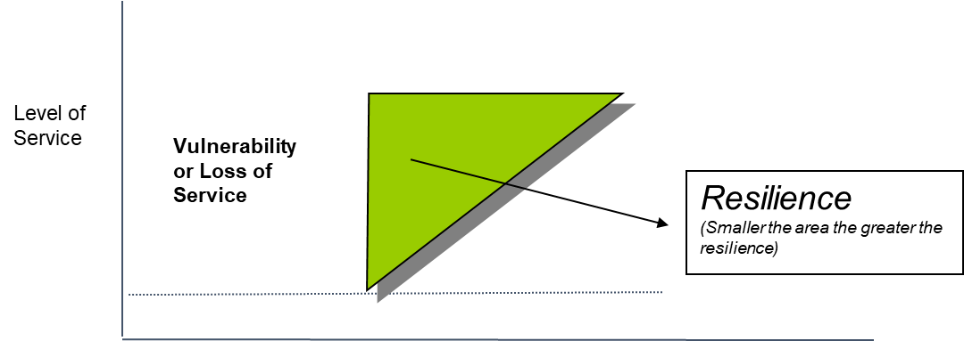

Time for Recovery

Figure 7. Enhancing Resilience through reduced reduction in functionality and time for recovery

Adopting a resilience-based design approach could help enhance resilience by limiting the reduction in service or functionality in an event, and also by adopting a design that enables functionality to be restored quickly (blue triangle compared to the green triangle). This approach would help achieve a desired post-earthquake return to functionality at an optimum cost.

**Key Principles of the Resilience based Design Approach**

Key principles of a resilience-based design approach would require:

1. Understanding the resilience needs or expectations of different infrastructure and their components, depending on criticality and exposure. This includes understanding any inter-dependence between infrastructure networks.
2. Design that provides the necessary level of functionality and time for recovery, depending on the identified criticality and resilience expectations.
3. Focus on the features of resilience-based design as outlined below.

The principles of resilience-based design considering loss of access and the outage period have intuitively been adopted in the strategy for enhancing the resilience of roads in Wellington City discussed above.

**Resilience Context and Expectations**

A key feature of resilience-based design is understanding the resilience needs of each transportation link or other piece of infrastructure, in the context of the regional transportation system. This will depend on the criticality of resilience for the route, based on the importance of the route and its vulnerability. The criticality of the route will depend on communities served, importance for lifeline utility restoration access, critical facilities dependent on the route, availability of alternative routes etc. For example, a section of the route may have very little or no redundancy (eg Transmission Gully expressway example above), while another route may have abundant redundancy of access such as in Christchurch city.

**Design for Functionality and Quick Recovery**

A second feature is for the design to focus on functionality and time for recovery rather than an arbitrary margin of safety such as factor of safety. An optimum design would allow some limited “failure” or reduction of functionality, provided that functionality can be restored quickly. This could be for example some limited deformation or displacement of embankments, small to moderate size wedge failures from cut slopes that can be retained by protection measures or quickly cleared, or bridge damage that would still allow limited access and is quickly repairable.

**Features of Resilience based Design**

Features of resilience-based design can be applied to a broad range of our transportation systems as well as the wider built environment, more than just transport corridors discussed in the above case studies. Figure 8 shows the key features of a resilience – based design.

Figure 8. Features of Resilience-based Design

Improved design guidance (such as in the Bridge Manual) by incorporating a resilience-based design approach through consideration of the resilience context, resilience importance category and design of resilience would help promote improved resilient design of transport facilities.

Resilience-based design following the key features and associated principles would help achieve a transportation system that would provide a desired level of resilience.

Resilience based design of a system will focus on the following principles, as illustrated in Figure 8:

1. Difficult – costly – time consuming to repair components . . . minimize damage (eg. bridges providing access, trunk utilities sharing transport corridor)
2. Easily - quickly repairable parts . . . accept limited repairable damage (eg distributor roads)
3. Low impact on community functionality – low cost . . . accept damage (eg low importance roads where communities will still have some level of access)
4. Systems and components are flexible and ductile (eg non-brittle retaining walls and embankments that can displace)
5. Infrastructure can perform in a ductile manner albeit with greater damage and is able to be restored in events somewhat greater than the design level.

Resilience also needs to be cognisant of the needs of society in different levels of events, for example:

* In high frequency but lower impact events such as a storm, continued socio-economic functionality is important for society, and transportation systems need to be able to function to the fullest extent possible with quick restoration of functionality with capacity within say hours.
* In a lower frequency, and higher impact events such as a major earthquake (eg Christchurch February 2011), the socio-economy will be less functional, and access for emergency response will be critical, followed by quick restoration of functionality in the days to weeks to allow recovery of infrastructure and socio-economic functionality.

These different dimensions of the functionality needed by society need to be taken into consideration in resilience-based designs.

**CONCLUSIONS**

Design of lifeline infrastructure for earthquakes has evolved from a purely margin of safety-based design, to a performance-based design, and the now proposed resilience-based design over the past 25 years. Resilience based design will help focus our attention to both functionality and time for recovery and facilitate the achievement of enhanced resilience for our infrastructure in a cost-effective manner.

Our focus needs to be on achieving continued functionality of society albeit at limited levels and quick recovery after natural hazards such as storms and earthquakes. There is a need to embed resilience-based design in our practice, and providing guidance is critical if we are to achieve resilience that is essential for the society and economy to recover and function, especially after natural hazard events.

I think a resilience-based design approach is critical to enable us to work towards a more resilient transportation system in New Zealand, and for a more resilient society. It is important that we embrace this and put in place measures to implement this in practice. This would require embedding this in our policies, standards, guidance and procurement processes. It is also important to back this up with funding by government so the resilience of our transportation systems can be better understood and provide the basis for improvements in resilience.

**REFERENCES**

Ambraseys, NN and Menu, JM (1988). Earthquake-Induced Ground Displacements. Earthquake Engineering and Structural Dynamics. Vol 16 985 – 1066.

Brabhaharan, P (2004). Systematic Management of the Risks to Transportation Networks from Natural Hazards. 2nd International Symposium on Transportation Network Reliability, Christchurch, New Zealand, 20-24 August 2004.

Brabhaharan, P (2006). “Enhanced Earthquake Design Standards for Foundations and Retaining Walls for Highway Structures”. Proceedings of the New Zealand Geotechnical Society2006 Symposium on Earthquakes and Urban Development, Nelson.

Brabhaharan, P (2007). Performance-based Earthquake Design and Construction of the Wellington Inner City Bypass, Wellington. NZ Society for Earthquake Engineering Annual Conference. 30 March - 1 April 2007. Palmerston North.

Brabhaharan, P (2009). “Performance focused Conceptual Design to enhance Route Security, Transmission Gully Highway, Wellington”. NZ Society for Earthquake Engineering Annual Conference. 3-5 April 2009. Christchurch.

Brabhaharan, P & Saul, GJ (2005). “Performance based earthquake risk mitigation of retaining walls at Ngaio Gorge, Wellington”. Planning & Engineering for Performance in Earthquakes. NZ Soc for Earthquake Engineering. Annual Conference 2005. Wairakei.

Brabhaharan, P, Mason, D and Gkeli, E (2018). Seismic design and performance of high cut slopes. NZ Transport Agency research report 613. July 2018.

Brabhaharan, P and Stewart, DL (2015). Rock Engineering of Cut Slopes to provide Resilience, Muldoon’s Corner Realignment, Rimutaka Hill Road, Wellington. 2015 ANZ Conference Wellington.

Centre for Advanced Engineering, 1991, “Wellington engineering lifelines study”. Wellington. 1991.

Chiaro, G, Alexander, G, Brabhaharan, P, Massey, C, Koseki, J, Yamada, S and Aoyagi, Y (2017). Report on Geotechnical and Geological aspects of the 2016 Kumamoto Earthquakes. Bulletin of the NZ Society for Earthquake Engineering.

Gkeli, E., Brabhaharan, P. (2019). Enhancing the resilience of transportation infrastructure: Resilience and performance-based design approach for high cut slopes and retaining walls. Proc. 2nd Intl Conf on Natural Hazards & Infrastructure, Chania, Greece. 9 p.

Mason, D and Brabhaharan, P (2013). “Resilience of transportation lifelines in the greater Wellington area”. Proc 19th New Zealand Geotechnical Society Symposium, Queenstown, November 2013.

Mason, D, Brabhaharan, P. (2019). Resilience of transport corridors in the 2016 Kaikōura earthquake, to inform recovery and future slope design and landslide hazard management. Proc. 2nd International Conference. Natural Hazards & Infrastructure, Greece.

O’Riley, F and Brabhaharan, P (2006). “Seismic Performance of the Terrace Tunnel Approach Walls, Wellington”. Remembering Napier 1931 – Building on 75 Years of Earthquake Engineering in New Zealand. NZ Society for Earthquake Engineering. Napier.

OPUS (2017). “Wellington Region Transportation Networks’ Resilience to Earthquake and Storm Events”. Report prepared by Brabhaharan, P and Callosa-Tarr, J for the NZ Transport Agency and Greater Wellington Regional Council.

Wood, J and Elms, D (1990). “Earthquake design of retaining walls”. Road Research Unit Bulletin 84. National Roads Board.

Yu, J, Yong, P, Reid, S, Brabhaharan, P and. Meng, P (2009). The Ms 8.0 Wenchuan Earthquake of 12 May 2008 Reconnaissance Report. NZSEE Bulletin. Vol. 43. Issue 1.