**TRANSPORTATION 2020 CONFERENCE**

**THINK PIECE PAPER**

**(This paper has been peer reviewed)**

**Redefining Liveability in Cycling Heaven**

**Emily Cambridge, Senior Landscape Architect**

BLA (Hons), Lincoln University, NZILA Registered

Beca Ltd, 267 High Street, Christchurch

E-Mail: [emily.cambridge@beca.com](mailto:emily.cambridge@beca.com%20)

**ABSTRACT**

I recently returned home to Christchurch after studying a summer school course, ‘Planning a Cycling City’ at the University of Amsterdam. I had never experienced the happiness that cycling brought me while I was in Amsterdam. I not only learnt about what contributes to a successful cycling city, but also experienced first-hand the incredible Dutch cycling culture, and how it contributes to the overall liveability of Dutch cities and the happiness of their people.

This paper expresses how I experienced the happiness of being immersed in the liveable city of Amsterdam from the vantage point of a bicycle. I reflect on how my experiences of integrated transport planning, reprioritised street space and interactions with others. I use my new knowledge and experiences to demonstrate how we can improve the liveability of our cities here in New Zealand.

Before my trip the Netherlands, I had a narrow understanding of liveability, as a culmination of factors that add up to a community’s quality of life. Living and cycling around Amsterdam however, along with the course literature has helped me expand my understanding of what liveability and a happy city really feels like.

**INTRODUCTION**

I felt an incredible sense of loneliness as I climbed back on my bike in New Zealand, after returning from Amsterdam. As I descended the hill and rode my usual route to work, I realised I was missing some vital ingredients that underpinned the happiness I experienced during my trip. The helmet on my head had ended the feeling of wind through my hair. The streets were empty of people, and the only other presence were the car drivers wrapped inside their warm steel shells. There was no interaction with anyone, no dancing, no negotiations, no informal rules or cues to read. This paper discusses how these types of spontaneous interactions fostered so much happiness while cycling in Amsterdam. As I got back on the bike in New Zealand after 3 weeks in Amsterdam I was amazed at the contrast I experienced. As I rode to work, I reflected on my learnings from the course and tried to answer the endless questions rolling around inside my head.

***So… what makes the Dutch some of the happiest people in the world?***

The UN World Happiness report (2019) has ranked the Netherlands in the top 5 happiest countries in the world. Various factors are assessed when determining the happiness of a country. Unsurprisingly the Netherlands scored highly in the areas of social cohesion, life expectancy and freedom of choice. Although these factors are not explicitly bicycle related, the bicycle can be attributed to all three. For example, in the Netherlands freedom of choice is most evident in the transportation network. There are several attractive options available for moving around the country including cycling, walking, buses, metro trams and trains. For a quarter of trips made in the Netherlands people choose the bicycle. It is on the humble, low cost Dutch bike that people do their shopping, go to work, socialise with friends, explore boundaries, learn and develop. While cycling in Amsterdam I had constant interactions with strangers at every intersection. This gave me a sense of social inclusion every time I got on the bike. For me, freedom of choice was the ability to cycle wherever I wanted to safely, without fear of getting stranded on a busy road in a sea of vehicles. These happiness factors are all the things I dream about for my own city.

***How can New Zealand progress towards this level of happiness for our cities and communities?***

The Canterbury Wellbeing Index was developed by the Canterbury Earthquake Recovery Authority (CERA) with the support of multiple agencies, to track the progress of social recovery in greater Christchurch post the 2011 earthquakes. The proportion of Wellbeing Survey respondents feeling ‘a sense of community’ (agree or strongly agree) has trended downwards to below 50 per cent as of April 2016. (Canterbury Wellbeing Index 2016 Summary).

Through my experience of cycling and dancing in Amsterdam’s lively streets, I felt an incredible sense of community and this came from virtually not even speaking to another person. On a bicycle you are constantly negotiating space, integrating movement with other cyclists and pedestrians, and this often feels a lot like dancing. Waiting next to someone at the traffic lights, making brief eye contact and even acknowledging another cyclists body language sparked this feeling. Through encouraging more people onto bikes, we will get more people out of their isolated cars and interacting with each other on our streets. This will be powerful in enhancing a sense of social cohesion and community in our cities. Interactions are discussed later in this paper.

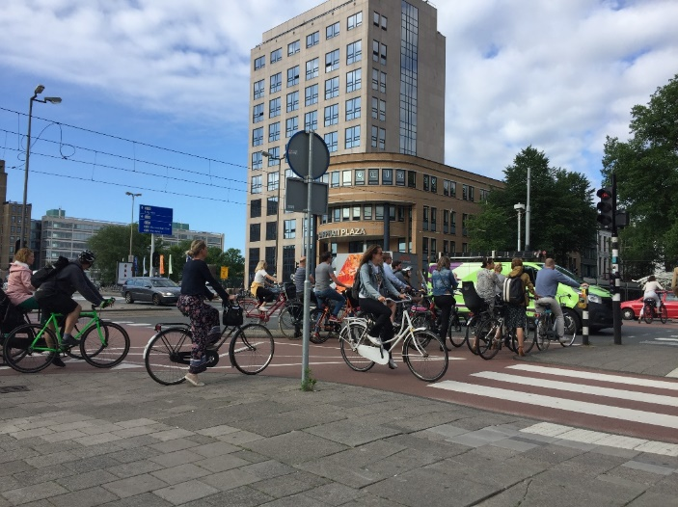

Figure 1 Dancing fietsers in the flow of negotiations on Weesperstraat

***Land use planning and transport choice***

Land use planning provides a macro view for the future development of a city. It is also an important factor in creating a liveable city. As I cycled around the streets in Amsterdam, I experienced a variety of urban and rural environments that I felt were scaled ‘just right.’ The buildings are modest in size, street corridors provide spaces which focus on people and there are amenities on every corner, including shops and local parklets. These key features are the result of good land use planning. They have also helped shape my newly defined meaning of the liveable city, by emphasising the importance of planning future land use. Land use planning is not only the zoning of land use – it defines connectivity, accessibility to amenities and should promote transport choice. In New Zealand, 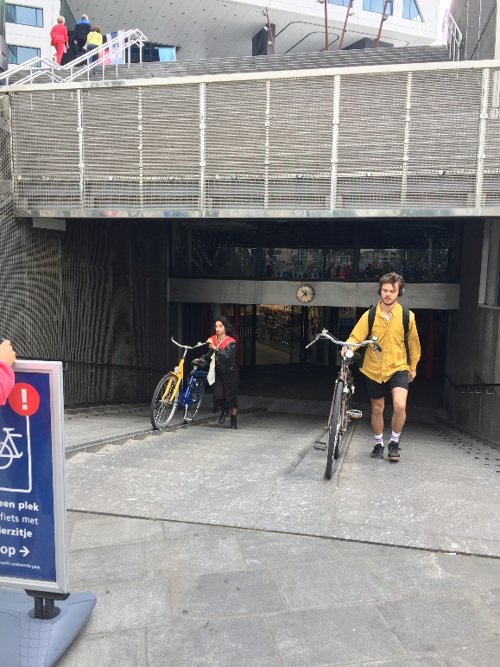urban sprawl has only created longer distances between our homes, local amenities and key destinations. It has promoted a culture of car dependency. The kiwi expectation is that you should be able to drive and park right outside your desired destination. According to Van Acker et al. (2010) travel behaviour is indeed the outcome of spatial, social and individual opportunities and constraints.

In order to change the kiwi ‘car’ culture and realise a true level of liveability for our cities, alternative accessibility options should be prioritised and effective. Lucas introduced us to the bike-train-bike model which is an efficient and flexible combination of transport modes. In the Netherlands I got to experience first-hand why the bike-train-bike system is the backbone to accessibility across the country.

As I cycled through the back door of Amsterdam Centraal Station, locked my bike to the extensive racks and walked up a flight of stairs directly onto the train platform, I realised what true transport choice looked like. To strengthen this experience at the station, I could also purchase groceries, grab dinner, buy clothes and even get household items from a wide range of stores. This seamless experience made travelling great distances on public transport both convenient and attractive.

Figure 2 An entrance to the 22,000-capacity cycle parking at Utrecht Centraal

The synergies between cycling and transit services could also lead to a better-defined liveability for New Zealanders. In New Zealand, the extensive issue of urban sprawl has made public transport inefficient and expensive. However, together cycle and transit services could assist in connecting satellite suburbs and townships and make active travel options more attractive for everyone.

Kager, et al. (2016) discuss the relationship between cycling and transit services and how they should not be seen as one of mere competition. Public transport and cycling should be complementary. Cycling provides the flexibility at each end of the journey while the transit can provide the efficient direct link. New Zealand could create fully integrated transport hubs in satellite suburbs and townships near our larger cities. To be attractive they should include services and facilities which would provide conveniences for people. These transport hubs could then be connected with high quality cycle paths to enhance the attractiveness of the cycle-transit system.

***How can we make street spaces more fairly distributed for people?***

My experience of liveability was further defined through my cycle journeys around Amsterdam neighbourhoods, observing people’s everyday rituals and routines. The children were often freely roaming the streets on their bikes or playing together in local parks. As I cycled to class each day, on every street, I watched people interact with their neighbours as they got on their bikes and started their daily activities. Street parklets were full of children playing and there were busy supermarkets on every corner which people frequent most days. The streets I cycled were a bustle of activity. Freedom, street activity and access to amenities are attributes that bought me the happiness I experienced in Amsterdam. In contrast to New Zealand, people confine themselves to the inside of a vehicle before they even leave their property which leads to a lack of social connectedness and activation of our streets.

Due to this culture, New Zealanders have also become very risk adverse. There is little trust left on our streets which has in turn restricted our ability to provide our children with freedom. Gone are the days when you could play football or cricket in the streets. Street hopscotch and neighbourhood gatherings are also a thing of the past. How can we promote liveable communities when New Zealand streets are essentially out of bounds for children due to car drivers making it unsafe? Residential streets were once spaces for everyone to use. Streets have become unfairly prioritised for car drivers.

As discussed by Beitel, et al. (2016), traditional urban street design had two core objectives which included efficient vehicle flow and adequate safety for all road users. This resulted in physically separating each road user type into designated spaces. Unfortunately, it has been cars that have previously taken over the majority of space and priority on our streets.

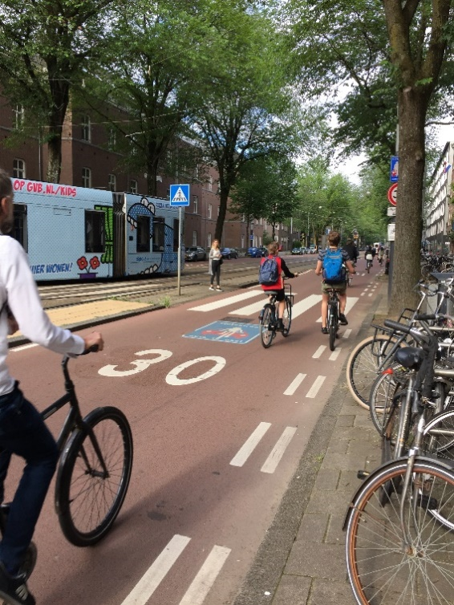While cycling in Amsterdam I experienced many street typologies that enhance their role as spaces for people. There were several scenarios that stood out to me that I think are directly relevant and could be translated to the New Zealand context. In the Netherlands, there is a trend away from traffic segregation, towards street design aimed at reducing vehicle speeds and increasing safety for vulnerable road users (Beitel, et al. 2016). Amsterdam streets are continually giving more priority and space to the cyclists, for example the ‘*gedeelde straat’* puts the car as the guest “Auto de gast” through signage. New Zealand residential streets would be a great place to implement these types of initiatives. Providing less space, slower speeds and restricted permeability for vehicles will enhance the liveability, safety and attractiveness of streets for people. Creating permeable streets could be as simple as converting some of our residential streets into one lane, one way for traffic and leaving them two way for cyclists. This contributes to slower streets which are safer for people and make it more difficult to drive. This simple intervention could help us to see children playing in our streets once again.

Figure 3 Sarphatistraat: an example of the Gedeele Straat near the University

***Conflict or Interaction?***

As I reflected each day in my diary it became clear these social interactions and the level of engagement I had while on the bike was what made my rides exciting and stimulating. I started to crave this stimulation and each day I would take myself to the busy streets and intersections to ‘dance’ on my bike with other fietsers. Cycling in the Netherlands introduced me to a high level of social connection that I had never experienced before.

These social interactions significantly influenced my feeling of happiness and livability while I was in Amsterdam. To survive in this hustle and bustle, I had to learn the informal rules of the Dutch. For example, a flick of the head or a straightened right leg might be the cue to indicate someone turning. Over time the Dutch developed these informal rules and a body language that enable shared spaces to operate almost seamlessly. I found that reading the body language and the cues of the Dutch provided me with constant stimulation. I very rarely felt bored or switched into auto pilot mode while cycling in Dutch cities. Te Brömmelstroet et al, 2017 discusses how cycling allows people to explore their spatial surroundings and offers constant opportunities for spontaneous interaction with other people.

It is also evident in Amsterdam that people on bicycles do not have all their decisions made for them through signs and signals. There is a requirement for cyclists to use ‘common sense’ in negotiating their way around the city. This is a skill that is fast becoming uncommon in other parts of the world. Often where ‘conflict’ zones are identified a traffic sign/signal will be installed to make it clear to people what to do in every potential ‘conflicting’ situation. These environments lead people to enter autopilot mode, which in turn can lead to a loss of common sense and an inability to know intuitively what to do in various situations. Although in Amsterdam signs and signals are used in high volume and high-risk situations, there are many places where people can make their own decision and navigate the crowds or traffic without being dictated to. Interactions enable people to both develop and exercise common sense, which in turn creates stimulating journeys and confident decisive users. This common sense is required so we can avoid undesirable interactions.

***How do we create an environment where informal rules and a body language can develop?***

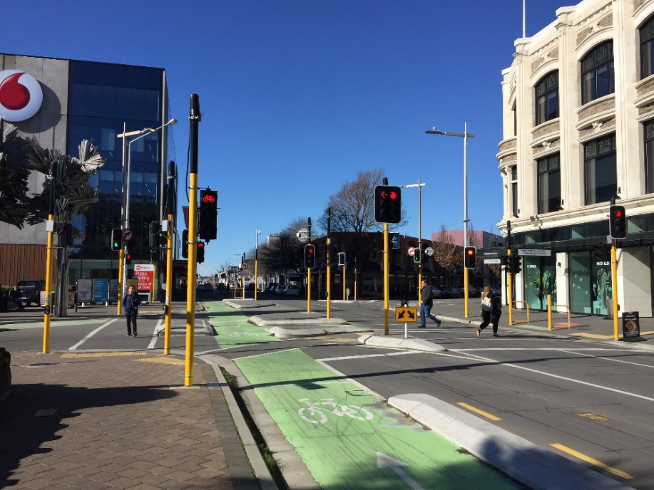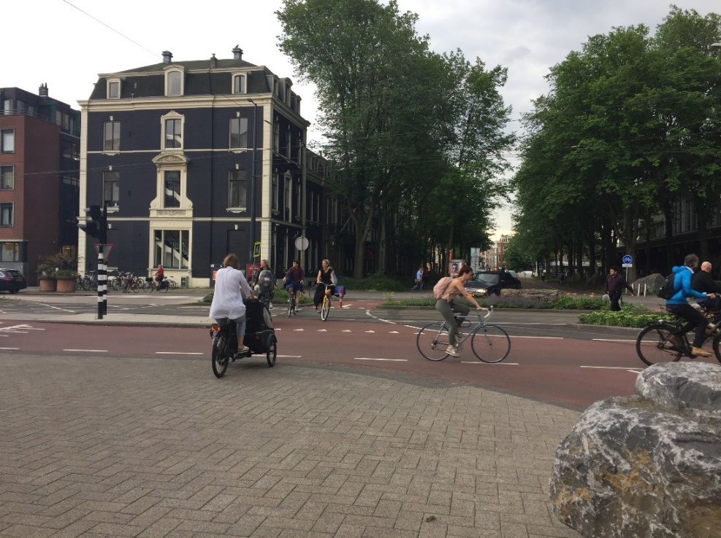In New Zealand cycleway design is often focused on creating complete separation from all other transport modes for safety. Road safety engineers typically place emphasis on minimising ‘conflicts,’ not just between vehicles and cyclists but also between cyclists and pedestrians. It is often said that cyclists and pedestrians cannot mix safely. Shared spaces are highlighted with a paraphernalia of signage and pavement markings that alert walkers and cyclists of these potential ‘conflict’ zones.

Figure 4 Example of Christchurch Intersection with 18 signal poles vs. an uncontrolled intersection in Amsterdam

I sat for hours at Amsterdam Centraal Station and other busy intersections, curiously watching shared spaces where cyclists and pedestrians cross paths. It is fair to say that there are very rarely any ‘conflicts.’ There is nothing more than a rhythmic ballet in which everyone participates. It is all about reading the informal rules, body language and joining in the flow....

When cycling I was conscious to not disturb the flow of others by maintaining a consistent pace which others could read and respond to. I loved to observe the different fietsers including the cautious cat, the meandering snail, the fearless bull or the ‘pannekoeks’ (aka Pancakes/ tourists). It never ceased to amaze me how well these spaces work with no signage, minimal pavement markings or controlled movements. Instead, subtle visual cues indicate a change in environment, allowing people to learn how to interact safely. The development of body language and informal rules are the communication methods that make these situations not only function but also become stimulating experiences. Cyclists weave in and around each other, slow down and/or pause in motion as required to navigate the crowds. The fastest cyclists together with the most vulnerable are given right of way. When a gaggle of tourists merge with the crowds, the flow is instantly lost, and the locals are left to re-find their choreographed steps and continue on as best as they can.

Through my experiences, there were three key principles that made these shared spaces work seamlessly, including: the development and exercise of common sense, differing speeds and development of informal rules. In New Zealand, we often design these opportunities out to reduce ‘conflict’ and maximise safety. What we haven’t realised is that by removing these principles we are creating less stimulating and enjoyable journeys for people, without improving safety or reducing actual conflict. It is clear there is no simple formula to develop a culture of safe interactions in shared zones. However, there are some key components where we in New Zealand can work together to create a more engaging and stimulating environment.

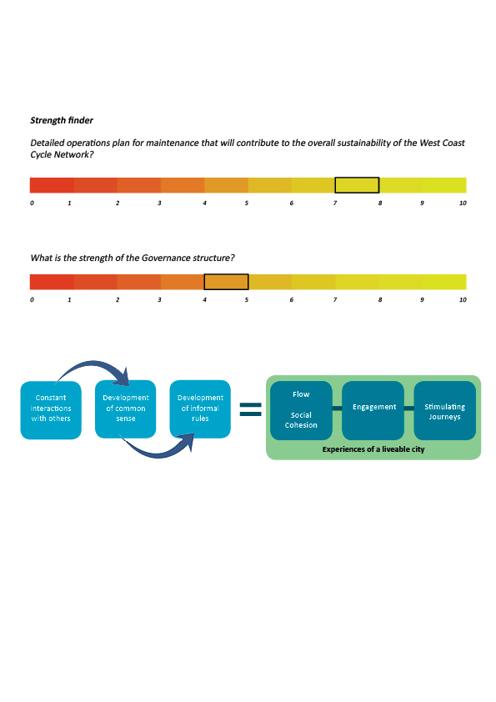

Figure 5 The formula of the factors that I experienced which contribute to the success of shared spaces in Amsterdam

**CONCLUSION**

The experience of happiness I felt while cycling in Amsterdam was like nothing I had experienced before. Dancing with other fietsers at busy intersections, the wind in my hair, the freedom to go anywhere and being a part of the hustle and bustle was a daily highlight. These experiences along with the course literature helped me to understand what a happy and liveable city really feels like.

As discussed in this paper, the experiences that bought me the happiness I felt on a bike in Amsterdam, which could be opportunities for New Zealand include:

1. Creating attractive public transport and active travel networks that are complementary – put people first in planning and provide the freedom of choice for mobility,
2. Developing a street priority hierarchy that puts people at the top of the pyramid – for more fairly distributed street space that is safer for everyone; and
3. Increasing interactions rather than reducing conflict in shared spaces – allowing people to dance and play in the streets.

Amsterdam has become a liveable city through putting people first in planning, providing freedom of choice for mobility and fairly distributing street space to allow people to dance and play in the streets. By incorporating these principles into urban planning in New Zealand we have an opportunity to make our cities happier than ever before. The result: a sociable and stimulating environment where riding a bike will be anything but lonely!

**REFERENCES**

Beitel, D. et al. (2017). *Exploring cyclist-pedestrian interactions in shared space using automated video conflict analysis*. Transportation Research Board Conference paper.

<http://docs.trb.org/prp/17-01960.pdf>

Canterbury District Health Board. (2016). *Canterbury Wellbeing Index Summary.* <<https://www.cph.co.nz/wp-content/uploads/CantyWellbeingIndexSept2016.pdf>>

Kager, R., Bertolini, L., & Te Brömmelstroet, M. (2016). Characterisation of and reflections on the synergy of bicycles and public transport. *Transportation Research Part A: Policy and Practice*, *85*, 208-219. <<http://www.sciencedirect.com/science/article/pii/S0965856416000240>>

Montgomery, C. (2013). *The Happy City: transforming our lives through urban design*

Te Brömmelstroet, M., Nikolaeva, A., Glaser, M., Nicolaisen, M. S., & Chan, C. (2017). *Travelling together alone and alone together: mobility and potential exposure to diversity.* Applied Mobilities, *2*(1), 1-15. <<http://www.tandfonline.com/doi/abs/10.1080/23800127.2017.1283122>>

United Nations. (2019). *World Happiness Report.* <<https://worldhappiness.report/>>

VanAcker, V., VanWee, B., Witlox, F. (2010). *When transport geography meets social psychology:toward a conceptual model of travel behavior*. Transp. Rev.30(2),219–240.

United Nations. (2019). *World Happiness Report.* <<https://worldhappiness.report/>>