**TRANSPORTATION 2020 CONFERENCE**

**PRACTICE PAPER**

**Two-aspect Roundabout Traffic Signal Metering Trial**

**This paper has been peer reviewed**

**Authors: Ann Fosberry (presenter):**

NZCE Civil, BE (Civil), DipEngMngmt, CMENGNZ, (Transportation Group and Traffic Signal Group member), Technical Director Aurecon NZ Ltd,

M 0274 988 518, [ann.fosberry@aurecongroup.com](mailto:ann.fosberry@aurecongroup.com)

**Mark Hollows:**

NZCE (Civil),

Contracts Manager for Tauranga Traffic Operations Centre,

M 022 595 3037. [mark.hollows@tauranga.govt.nz](mailto:mark.hollows@tauranga.govt.nz)

**Nigel D’Ath**:

BE, DipMEEC, CMENGNZ, Journey Manager BoP, Waka Kotahi.

M 027 277 6304. [nigel.dath@nzta.govt.nz](mailto:nigel.dath@nzta.govt.nz)

**Mark Edwards**:

Senior Engineer, Regulatory Service, Waka Kotahi.

0064 894 6389 [mark.edwards2@nzta.govt.nz](mailto:mark.edwards2@nzta.govt.nz)

**ABSTRACT**

Waka Kotahi NZ Transport Agency identified two state highway roundabouts in Tauranga where excessive peak period queuing was occurring.

Through investigation, traffic modelling and stakeholder workshops, signalised metering was recommended as the solution.

The design complied with the current rules and technical guidance.

Similar installations are in operation in Auckland; 3 aspect display, with lanterns on 24/7.

Within 4 days of commencing metering at the first installation, the signals were turned off as some drivers were interpreting the green signal to mean that they did not have to give way at the roundabout. Crashes occurred.

Investigation was undertaken to understand the differences between Tauranga and other sites in New Zealand and to compare with the Australian two-aspect method of roundabout metering. The result was that in Tauranga, drivers interpreted the green signal at or near a roundabout as meaning “go” without having to give way.

A trial to use the Australian system that displays only yellow and red signal aspects, was sought. Waka Kotahi were quick to respond and approved and gazetted the trial.

Three installations are being monitored in the trial; two in Tauranga and one in Wellington. Sites are SCATS controlled. The Traffic Operations Centres ensure that the sites work efficiently and safely, and Tauranga TOC have addressed a queue back safety issue by introducing a disabling function if certain conditions are met.

The trial ends in April 2020. Monitoring confirms journey time gains from the roundabout metering and the safety of the two-aspect display.

# **INTRODUCTION (How the project came to be)**

As part of their ongoing commitment to keeping traffic on our state highways moving as safely and as efficiently a practical, Waka Kotahi NZ Transport Agency identified two state highway roundabouts in Tauranga where excessive peak period queuing was occurring, and investigation under their Minor Efficiency Programme was recommended. These were:

* Barkes Corner Roundabout– the intersection of SH 29A, Pyes Pa Road and Cameron Road;
* Elizabeth Street Roundabout – the intersection of SH 2, Elizabeth Street and SH 2 right side off ramp to Elizabeth Street.

Queuing at Barkes Corner was extending west through the SH 36, SH 29A, Takitimu Road (toll road) roundabout in the evening peak, restricting southbound toll road users from exiting the toll road and contributing to slow journey times through Tauriko on SH 29. Pyes Pa Road local traffic was developing extended queuing northbound in the morning peak.

Queuing at Elizabeth Street Roundabout resulted in SH 2 morning peak southbound queues extending back over 1km north, to the Tauranga Harbour Bridge. The morning peak delays were having a significant effect on southbound freight leaving the Port of Tauranga, with the inbound commuter traffic to the CBD controlling the roundabout.

Aurecon investigated potential options to reduce the delays to traffic and undertook traffic modelling and stakeholder workshops. Within the budgetary limits of the Minor Efficiency Programme, signalised metering was recommended as an effective solution in the short to medium term.

For Barkes Corner, the first design was for three aspect metering signals, for the Pyes Pa Road northbound approach, to provide more through capacity for SH 29A eastbound traffic, to shorten the queue and relieve Takitimu Road Toll Road in the evening peak. Similarly, three aspect metering signals were designed for the SH 29A westbound approach to the roundabout to relieve queues on Pyes Pa Road in the morning peak.

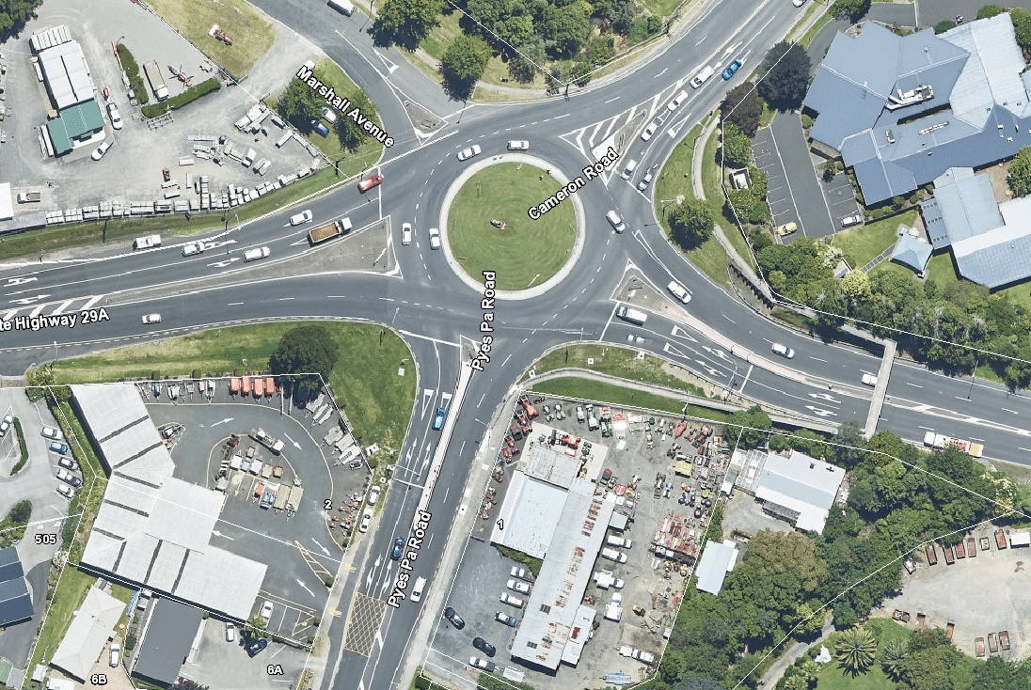

Signal metering limit line on metered approaches

Pyes Pa Rd n’bnd

SH29A w’bnd

*Figure 1 - Barkes Corner, with roundabout metering (Courtesy TCC Mapi)*

For Elizabeth Street metering signals were designed for the SH 2 off ramp to provide more through capacity for the SH 2 southbound traffic. The Elizabeth Street project included addressing evening peak queuing on Elizabeth Street, leaving the CBD via SH 2. Installing metering signal on this approach is currently on hold, awaiting Tauranga City network alterations.

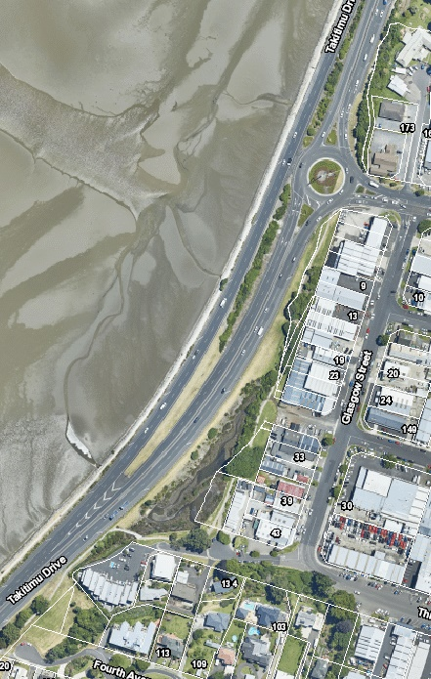

Signal metering limit line

Metered SH 2 off ramp

*Figure 2 – Elizabeth Street, SH 2 roundabout (Courtesy TCC Mapi)*

# **SAFETY ISSUE**

To understand the safety issues, we first need to be clear on how roundabout metering works. This is not the same as ramp metering on the motorway on-ramps; different rules apply. How they operate in New Zealand, is set down in the Traffic Control Devices Rule, and there is Traffic Note 60 that provides guidance on signs and signal pole placement.

* Signal displays are three aspect (red, yellow, green);
* A signal aspect must be displayed at all times (24/7, no option for the lanterns to be out);
* Signal poles can be as close as 30m to the roundabout give way limit line;
* When the green is displayed, it means that a driver does not have to stop at the metering location and normal give way rules at the roundabout apply.

Roundabout metering is also not the same as a signalised roundabout, of which there are three in Tauranga. Roundabout metering has been operating in New Zealand without any identified safety issues. There are installations in Auckland and Rotorua.

Barkes Corner was the first roundabout metering installation to be commissioned as part of this project. A Design Road Safety Audit had been completed. Metering signals were installed on the Pyes Pa Road and SH 29A westbound approaches to Barkes Corner. The signals commenced operation in September 2018.

Within 4 days of commencing metering at Barkes Corner, the signals were turned off as some drivers misunderstood what they meant. With safety being the primary focus it was essential that we understood what was happening and why. Issues were:

* Some drivers were interpreting the green signal to mean that they did not have to give way at the roundabout. Crashes occurred at the roundabout from both approaches, where drivers had continued into the roundabout without giving way;
* From comparing the camera footage from before the signals were operating to after operation commenced, entry speed into Barkes Corner roundabout increased, once the metering signals were turned on;
* Safety concerns were raised by school bus operators who feared that a driver would collide with a bus on the roundabout;
* On the SH 29A westbound approach, due to physical constraints, one of the signal poles (a tertiary display), was installed closer to the roundabout than the recommended minimum 30m;
* Social media showed mixed understanding with some understanding that you were meant to give way at the roundabout no matter what, while others believed green means I can proceed into the roundabout without giving way, even if the signal poles are not at the roundabout limit line.

# **Problem identification**

**So why is Tauranga different?**

As mentioned above, similar installations are in operation in Auckland and Rotorua. Checking crash data showed that driving through the green and into the roundabout without giving way was not an issue at the other locations.

**What are Tauranga drivers’ expectations?**

Tauranga has three fully signalised roundabout installations. One of these is at Brookfield, on local roads, managing a complex intersection which combines three off set T intersections into one. This is a busy intersection next to a popular shopping centre with schools nearby. Lots of local drivers are familiar with this intersection. The other two intersections are on SH 29A, one at Welcome Bay Road and one at Maungatapu. Both on the same state highway as Barkes Corner. If travelling from Te Maunga along SH 29A, one has driven through two signalised roundabouts before arriving at the metering signals at Barkes Corner, just 4.5km away.

This suggests a pre-existing condition and expectation that the roundabout metering installation is the same. The signal is green, so I have right of way.

There were media releases explaining how the metering would operate and how it was different. Variable message signs were in place on the two metered approaches advising motorists. Not everyone reads the media or signs and those that do, may not necessarily understand what it says. As professionals we understand it quite clearly, we designed it and know how it works, but will everyone else?

**Is there any useful research?**

There is very little comparable research data that specifically deals with roundabout metering in this manner. Roundabout metering in the UK is not necessarily installed for the same reasons or in the same manner. In the UK, signals are also placed within the circulatory when approaches are metered. Most of the research sighted relates to metering in conjunction with pedestrian crossing movements, which is not applicable to the Tauranga applications.

# **Solution**

**Now what are we going to do?**

We have an acceptable solution to address the queuing problem, but the NZ roundabout metering solution is resulting in safety issues.

A working group was convened, made up of NZ Transport Agency, Tauranga Traffic Operations Centre staff and Aurecon traffic signal designers and road safety experts.

Initially the group worked through the options to make the green signal less obvious with a view to maintaining compliance with TCD Rule. Options considered included:

* Removal of right-side secondary displays;
* Tilting signal heads forward, adding louvres to all greens, changing overhead green to 200mm – to reduce visibility of the green;
* Advance signs to remind drivers that the give way at the roundabout still applies;
* Increase width of give way line at roundabout;
* New secondary pole location on same side as primary and located so it visible from both stop line positions.

The group consensus was that if the green was still there, the risk remained that drivers would continue into the roundabout. We could spend a considerable amount of time, money and effort and not address the safety issue satisfactorily. This view was predominantly due to there being fully signalised roundabouts in Tauranga and drivers not understanding the difference.

The next step was to have a detailed look at how roundabout metering was managed in Australia. AS1742.14.2014 – Manual of Uniform Traffic Control Devices – Part 14 Traffic Signals. This is the underlying applicable Australian Standard. Section 7.4 that relates to roundabout metering, allows metering signals as close as 3m to the roundabout give way limit line and states “*green signal aspects are omitted as they could cause confusion with the requirement to give way at the roundabout holding line”.* The signals operate as follows:

* Two aspect signal (yellow and red);
* A green is not displayed at any time;
* When the NZ three aspect system would be green, in Australia there is no display. The driver sees an unlit two-aspect display;
* Multiple installations across different States.

Mainroads Western Australia “Roundabouts and Traffic Signals – Guidelines for the Selection of Intersection Control, November 2015” discusses the potential for increased rear end crashes due to drivers becoming confused by two sets of limit lines, but goes on to say that the use of two-aspect signals (red and amber) assists in preventing drivers from mistakenly driving through a green signal and failing to give way at the downstream give way line.

The working group agreed that the green signal was causing the safety issue, so not having it was the ideal solution. The only way to have a two-aspect display with no green that doesn’t show any signals at all when not metering, is via a Gazetted Trial.

Now it was time to seek a trial.

# **Gazetting the trial**

The NZ Transport Agency encourage anyone thinking about a trial to talk to them first.

A conference call was set up between members of the working group and Mark Edwards and Glenn Bunting (NZ Transport Agency Wellington), to discuss the Tauranga roundabout metering safety issues and our reasoning for a two-aspect trial.

When considering a trial, it is important to:

* Have a good understanding of the issue;
* Understand why the current solution doesn’t work;
* Have a logical story as to why the proposed trial, which is outside of the current legislation, will work;
* Understand how you will prove that it has worked.

We had these in place and the trial was the logical result. The more the logic and the thinking is done up front then the quicker a trial will be approved and legally permitted by gazette notice.

The NZ Transport Agency were quick to respond and approved and published the gazette [1]within three weeks of the first conversation.

The purpose of the trial is to:

* Enable the installation and operation of two-aspect traffic signals as an alternative to three-aspect traffic signals;
* Evaluate the safety and effectiveness of two-aspect traffic signal control at the approach to a roundabout when signal control is being used to periodically manage (meter) the traffic flow entering the roundabout;
* Assess driver understanding and compliance with two-aspect traffic signals;
* Assess driver behaviour at the approaches controlled by two-aspect traffic signals.

# **Implementation/Operation**

The Barkes Corner and Elizabeth Street roundabout designs were adjusted for the two-aspect displays. The tertiary pole that was closer to the limit line than desirable on the SH 29A approach to Barkes Corner was removed.

From a signal controller programming perspective, the programming did not have to change. When there is no green display on street, the controller still thinks it is green.

The two-aspect metering signals operate as follows:

* a steady yellow signal displayed for at least three seconds, followed by;
* a steady red signal, displayed for at least three seconds and timed to address the traffic delay issue, followed by;
* a blank display for at least three seconds, followed by the sequence commencing with the steady yellow, when appropriate;
* when metering is not required neither yellow nor red aspect is displayed.

**Barkes Corner – two-aspect operation commenced 12 December 2018**

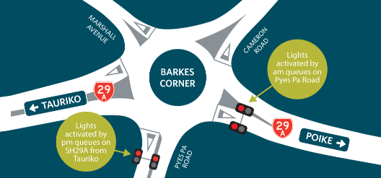

*Figure 3 - Layout of Barkes Corner Roundabout*

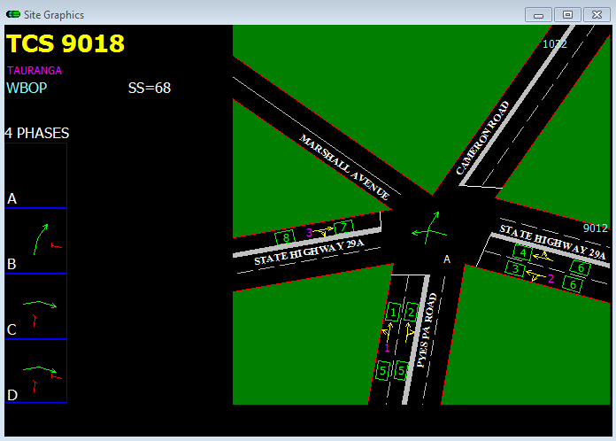

*Figure 4 – SCATS graphic user interface snip for the Barkes Corner (Courtesy TTOC)*

The green arrows in the SCATS snip in the phasing boxes in Figure 4 above, are “virtual greens” and are not displayed on street. The green arrows in the middle of the intersection show which approaches are metered.

The phasing of the Barkes Corner traffic signals involves:

* **Phase A** – no signal displays are lit, and the roundabout operates normally;
* **Phase B** – Metering control on the westbound SH 29A approach in the morning peak to assist Pyes Pa Road traffic;
* **Phase C** – Metering control on Pyes Pa Road in the evening peak to assist SH 29A eastbound traffic;
* **Phase D** – Meters both Pyes Pa Road and SH 29A westbound in the evening peak to assist SH 29A eastbound traffic, in the heaviest peak conditions when the queues on SH 29A are longest.

This requires the SCATS application (Sydney Coordinated Adaptive Traffic System) to operate the site, to prevent certain phases running when they should not. This helps maintain user understanding by avoiding metering occurring outside of when it is expected.

The Tauranga Traffic Operations Centre undertake regular monitoring and adjustments of the Barkes Corner metering. No issues have been identified that need changes or special routines to manage.

**Elizabeth Street – two-aspect operation commenced 11 April 2019**

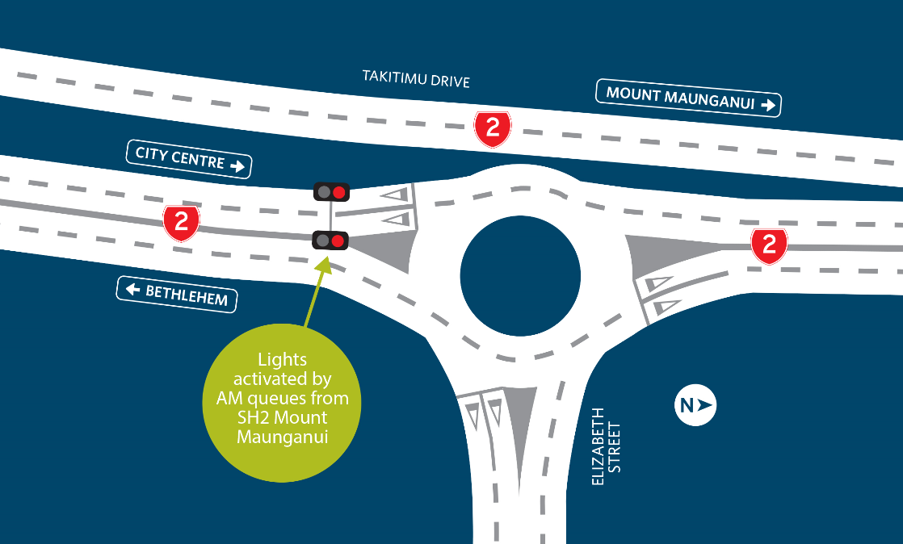

*Figure 5 – Layout of Elizabeth Street, SH 2 roundabout*

The phasing of the Elizabeth Street traffic signals involves a phase that operates in the morning peak only. This phase does not run during the evening peak as it would cause further congestion on the Elizabeth Street approach for commuter traffic leaving the CBD. SCATS also operates this site to ensure that the metering signals only run in the morning peak.

The signals software, termed “personality”, provides for disabling (turning off) the signals when a queue is detected (“queue detection”). However, this mechanism alone is sometimes too little too late. When a surge of traffic approaches the signals, a queue can form quickly and back out onto the 80 km/hr main road, creating a dangerous scenario. Initially, queuing back did occur on the odd occasion, causing safety concerns. The off ramp is on a sweeping right-hand bend, with limited forward sight distance of the exit point and any queue back that may occur.

Therefore, Tauranga Traffic Operations Centre (TTOC) used SCATS to turn the signals off when a surge was detected (“surge detection”), and to turn them back on again when the surge passed. In this way, the signals “anticipate” the formation of a dangerous queue and turn off to prevent it from happening.

The surge detection mechanism was fine-tuned to speed up the response to turn off, and to turn back on once the surge had passed.

**It is unusual for SCATS to be used as a safety mechanism—it is almost always used merely as an efficiency tool, running an intersection more efficiently while the controller software or “personality” contains the safety features. However, at the Elizabeth Street site, SCATS is being used as a safety tool.**

SCATS relies on communications with the site to operate, so the Elizabeth Street site is set to turn off when communications fail, and it is also set to turn off when one of four in-ground vehicle detectors, essential for surge detection, fails. In this way, the risk of SCATS being unable to control the site to provide the surge detection is mitigated.

Considerable monitoring of the Elizabeth Street site was carried out by TTOC to ensure that the surge detection was well calibrated to mitigate queue formation on the one hand, and to not have the lights turn off so much on the other, that their efficiency potential was lost.

The work that TTOC have undertaken to ensure safe operation of the Elizabeth Street metering has avoided the need for activated advanced warning signs on SH 2 approaching the off ramp.

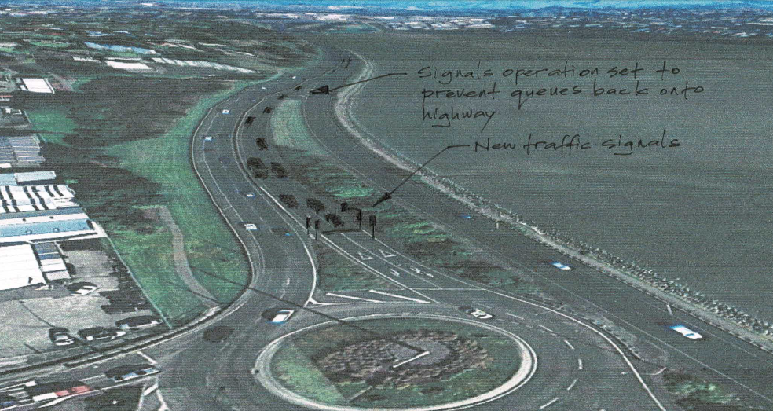

Figure 6 - Operation set to prevent queue back onto SH 2 through lane

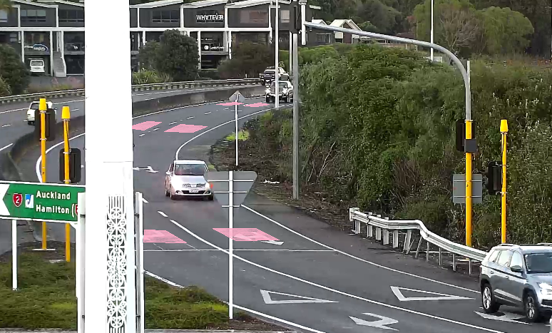Figure 7 - Off-ramp approach to traffic signals with in-ground detectors shown (pink) (TTOC camera)

# **Results**

**Driver recognition and compliance**

* No observed safety concerns or misinterpretation of roundabout give-way rules have been recorded during regular intervals of visual inspection of the roundabout operations, via remote cameras within the Tauranga Traffic Operations Centre (TTOC);
* There are a small number of instances of drivers not complying with the red signal, but still complying with the give-way rules;
* Visual observations of the trial observed drivers slowing when approaching the blank display and approaching the roundabout more cautiously and at a slower speed compared to the approach speeds during the three-aspect trial.

**Feedback from road users**

There is a noticeable reduction in customer complaints / comments between the pre-trial “full green” roundabout metering and the two-aspect trial. The change is from concerns over safety and understanding how to use the “full green” metering to comments on the operation benefits and traffic queuing.

**Operational issues and incidents**

Normal roundabout operation has continued since commencement of the two-aspect trial, with drivers giving way at the roundabout limit lines.

There have been no amendments necessary to the road layout or signal phasing since the start of the operation of the trial. Surge detection has been implemented at Elizabeth Street, SH 2 roundabout.

The signal timings and settings are being adjusted and refined during the trial by TTOC to improve traffic throughput during the metering phasing.

**Performance**

The benefits of the roundabout metering have been to reduce the high peaks of long delays approaching the roundabouts, to provide more reliable journey times. There is no data to suggest that there is any difference in the efficiency gains between a three aspect and two aspect display for roundabout metering.

Maximum travel times have been recorded for traffic travelling through the roundabout during peak periods, when the metering is operational.

At Barkes Corner roundabout (SH 29A) there is an overall 20% to 30% improvement in travel time with savings of around 100 seconds in both morning and evening peak.

At Elizabeth Street roundabout (SH 2) there is an overall 40% improvement with savings of around 190 seconds.

**Safety**

The number of recorded crashes since the two aspect signals have been operating is of a level similar or less than prior to the installation of the signals. There is a lower crash rate than during the three-aspect “full-green” operation.

Although there is some non-compliance with the red signal, this is not a safety issue as drivers are still proceeding with caution at the roundabout give way limit line. The failure to give at the roundabout observed during the 3-aspect display operation is not occurring with the 2 aspect displays. Crash data is continuing to be monitored.

Barkes Corner Crash Data:

* 2013 to 2018 (6-year CAS data prior to metering), 3 serious, 19 minor, 47 non-injury;
* No crashes have been recorded during the period that the two-aspect metering signals have been operating;
* A single crash has been recorded during this period. However, this crash occurred during the period the signals were not operational (i.e. not during peak travel times) and resulted from a driver on the Pyes Pa Road approach failing to give way at the roundabout.

Elizabeth Street Crash Data:

* 2014 to 2018 (5-year CAS data prior to metering), 1 serious, 1 minor, 26 non-injury;
* No crashes have recorded during the period that the two-aspect metering signals have been operating;
* A single crash has been recorded during this period. However, this crash occurred during the period the signals were not operational (i.e. not during morning peak travel times) and resulted from a driver crashing into the edge barrier and being redirected over the median, striking the barrier adjacent to the traffic signal. (Damaged barrier visible in Figure 7 above).

# **Conclusions**

Safety is paramount, and the issues at Barkes Corner and Elizabeth Street roundabouts were quickly recognised and responded to. Decisions were made quickly, and the good communications and collaboration between the NZ Transport Agency, TTOC and Aurecon resulted in effective outcomes.

TTOC have successfully used SCATS as a safety tool as well as its normal use for intersection efficiency.

Monitoring at both roundabouts confirms the efficiency gains of roundabout metering. Crash monitoring provides preliminary indication that the two-aspect signal display provides safety benefits compared to the three-aspect display, in Tauranga.

**What happens next?**

The trial officially ends in April 2020. The final report will present the findings of the trial. If the trial is deemed a success a recommendation is made to the Minister to include the trial device(s) in the Traffic Control Devices Rule. The trial sites remain permitted locations for using the device(s) until the Rule is formally amended, at which point the sites become compliant with the Rule. Should the trial not be determined to be successful or the Rule is not updated as recommended then the devices would need to be removed at the trial locations.

1. NZ Gazette 15 October 2018 - Land Transport Rule: Traffic Control Devices 2004—Two-aspect Roundabout Metering Traffic Signals Trial