**TRANSPORTATION 2020 CONFERENCE**

**Behaviour of Shared User Path Users**

**This paper has been peer reviewed**

**Ivy Hao**

PhD Candidate and Graduate Engineer (Auckland Transport)   
Department of Civil and Environmental Engineering, The University of Auckland

Email: [yhao210@aucklanduni.ac.nz](mailto:yhao210@aucklanduni.ac.nz)

**Dr Doug Wilson**

Senior Lecturer

Department of Civil and Environmental Engineering, The University of Auckland

Email: dj.wilson@auckland.ac.nz

**Dr Subeh Chowdhury**

Senior Lecturer  
Department of Civil and Environmental Engineering, The University of Auckland

Email: s.chowdhury@auckland.ac.nz

**Abstract**

Walking and cycling mode volumes have been rapidly growing in New Zealand where new infrastructure is being provided. Active transport modes encourage both health and environmental benefits. Shared User Paths (SUPs) that share pedestrians and cyclists are a common form of off-road infrastructure implementation where space and resource are inadequate for separated cycle and pedestrian paths.

However, the mixing of pedestrians and cyclists (including E-bikes) and now other micro-mobility devices (eg. E–Scooters that have recently been introduced *en masse* to Auckland and various cities in NZ) raises greater collision and conflict risk between the shared usage, related to the potential travel speed, space requirements and user behaviours. The infrastructure planning, design and management (including operations and maintenance asset cycles) of the SUPs also have significant safety performance and perception effects.

The increased number and usage of SUPs alongside an increasing growth in demand suggests that an evaluation is required of various existing SUP implementations, current design standards/guidelines to ensure both existing and future SUP user demands are appropriately and safely met. It is important that any new transport infrastructure that has changed user trends or new transport technologies or modes introduced is appropriately evaluated to ensure the safe use and operation of all users and especially those more vulnerable to incidents. An evaluation and better understanding of cyclist, pedestrian and other micro-mobility devices on SUPs will allow improved design and safety guidelines for SUPs to be implemented.

This study presents the findings of an analysis using online interviews surveys of SUP users in the Auckland region. The aim of this study is to seek users’ perceptions of various behaviours on SUP’s. The impact of geometric design features, functional and social factors on shared path users’ perception and the infrastructure level of service are explored and reported.

**Introduction**

Active modes are encouraged worldwide due to many potential environmental, health, societal and economic benefits for walking and cycling (Grzebieta, McIntosh et al. 2011, Beitel, Stipancic et al. 2018a). In Auckland from 2014 to 2018, the total number cycling has increased by 18%, while the frequently walking population has remained relatively consistent, around 68% (Auckland Transport 2018). The rapid growth in cycling population creates a greater demand for improved infrastructure as the attractiveness of cycling infrastructure has been shown to be related to cyclists’ safety perceptions. (Daley, Rissel et al. 2007; Chataway, Kaplan et al. 2014).

Shared User Paths (SUPs) are popular off-road amenities designed to be shared between cyclist and pedestrians, they may or may not have a centre line to divide and guide the users (Kabo, Hwang et al. 2015, Queensland Transport 2004). A SUP is a lower cost option of infrastructures to provide an off-road cycle facility (Mellifont, Ker et al. 2006) in order to minimise the interaction between cyclists and motor vehicles. SUPs can be used by many and varied active mode users including pedestrians (from the toddler to elderly), cyclists, joggers, dog walkers and micro-mobility users (Grzebieta, McIntosh et al. 2011).

While off-road cycling facilities are free of the conflict between motorised traffic and cyclists, if shared with other users, they may cause an increase of cyclists and pedestrians and/or other user accidents (Mellifont, Ker et al. 2006). The pedestrians and cyclists’ conflicts are infrequent and less severe when the densities are low. However, the potential conflicts among the users become more serious when the densities increase (Mellifont, Ker et al. 2006, Grzebieta, McIntosh et al. 2011, Kiyota, Vandebona et al. 2000).

The cyclists’ speeds generally decreases on SUPs when pedestrian density increases; the perceived risk does not decline with lower cycling speed (Kiyota, Vandebona et al. 2000). Walkers will travel significantly slower than commuting cyclists.(*Austroads- Guide to Road Design Part6A Paths for Walking and Cycling.* 2017). The difference in speed between cyclists and pedestrians may result in serious injuries to the pedestrian especially with conflicts with the very young and old. According to a speed survey in Australia, the average cycling speed for a commuting SUP route is between 20 - 30 km/h (Kabo, Hwang et al. 2015).  On reasonable lengths of downhill slopes, the speed can increase to over 50 km/h (Austroads 2009).

In addition, E-bike users are a fast-growing user group in Auckland and other urban areas in NZ and internationally. According to the market analysis, the sales of e-bikes increased rapidly from about 2,300 units in 2014 to about 14,000 in 2016. And the market is still showing a high growth trend (Lieswyn, Fowler et al. 2017). However, E-bike usage has a potential impact on safety, other than traditional bikes, e-bikes are generally faster (especially uphill creating more overtaking manoeuvres) and heavier and therefore people will have less reaction time and may also underestimate their speed (Dozza, Piccinini et al. 2016).

While shared paths are increasingly used in New Zealand and elsewhere, the concerns related to design standards and thus safety of SUPs have also increased(*Cycle network and route planning guide.* 2004) . There are limited studies exploring the safety of SUP compared with other transport environments (Kabo, Hwang et al. 2015). Simulated impacts of cyclist and pedestrian collisions have indicated that especially during high speed collisions, the pedestrians and/or other users can be seriously injured, particularly when elderly pedestrians are involved (Short, Grzebieta et al. 2007). However, the reported risk of a pedestrian’s fatality is very rare from a cyclist pedestrian’s collision (Grzebieta, McIntosh et al. 2011, Drummond 1989). The existing observational studies indicate the actual number of conflicts is minimal. However the attractiveness and user experience is influenced by the perceptions of conflict and collision (Kabo, Hwang et al. 2015). The users’ perception is related to their physical abilities, degree of experience, perception time and trip purposes (Grzebieta, McIntosh et al. 2011). Vulnerable shared user path users such as elderly pedestrians, children or vision impaired pedestrians have greater concern when sharing the path with cyclists (Kiyota, Vandebona et al. 2000; Kabo, Hwang et al. 2015). Elderly pedestrians were also found to be over-represented in collisions with cyclists (O’Hern, Oxley 2019). Whether the safety concern is real or perceived, it will influence people’s willingness to walk / use SUP especially if they have an alternative safer option to use (Mellifont, Ker et al. 2006).

The aim of this paper, which forms part of a larger research study at the University of Auckland, is to seek users’ perception of various behaviours on SUP infrastructure. The user survey was developed and undertaken by Auckland Transport in 2019. The impact of geometric design features, functional and social factors on shared path users’ perception and the infrastructure level of service are explored and reported.

The study is based on an online survey, which targeted users of the North-western shared path and Tamaki Drive shared path in Auckland (refer to Figure 1 SUPs’ Locations). The main objective was to investigate user perceptions and preferences towards various behaviours on SUP. This paper specifically seeks to explore the relationship between perceived risk and the users’ gender, age group and use frequency.

# Methodology

The survey was designed and undertaken by Auckland Transport in 2019, as part of the explore sprint[1] (Sprints are used to rapidly explore, design and develop projects that require a diverse team to deliver) of user behaviours on SUP. Only parts of the survey results have been discussed and presented in this paper.

## **Pre-survey interview**

In order to assist the design of the main survey questions and identify critical undesired behaviours, pre-design interviews were carried out with two groups to ensure a diversity of perspectives. The first group was regular path users with different trip purposes, transport mode and contained users with varying experience and backgrounds. The second group was carried out within a group of transportation, urban design and planning professionals who had been involved in shared path design or planning.

Questions began with an intention of gaining a basic understanding the extent of various user experience and perception of using SUPs. The interviews were a maximum of one hour, with mostly open-ended questions to maintain a free-flowing conversation. The aim of the pre-survey interviews was to seek interviewees’ opinion based on their own SUP experience in order to identify critical undesired behaviours in advance.

## **Survey design**

The web-based questionnaire was developed after the pre-survey interviews to measure the SUP users’ perception of safety and comfort. The survey was anonymous with the only requirement being that the participant had used the shared path previously. It included the following areas of interest:

1. User profile

This section included users’ age group, gender, SUP use frequency, trip purpose and their mode of transport (i.e. walking, cycle, e-bike, e-scooter etc.)

2. Frequency of notifying risk behaviours on the SUP

This section seek to understand the frequency of multiple risky behaviours that had been identified during the pre-design interviews and observations, which include behaviours across different users. The answer was categorised into five different frequency responses: never, sometimes, frequently, always and don’t know.

The risk behaviours include bike risk behaviour (e.g. overtaking at blind corner), bikes and scooters interaction (e.g. not altering while overtaking (ringing the bell), pass too close), pedestrians meandering and users interaction with e-scooter.

3. self-reported incidents including accidents or near-misses.

The questions asked for a more detail description of the accident or near-miss they have been involved on the SUP.

4. Open-ended questions related to suggested improvements

## **Location**

The survey conducted act as a case study among users of two specific SUPs throughout Auckland – Northwestern shared path and Tamaki Drive shared path. The two paths are different in terms of infrastructure, operation and typical user types and type of separation from adjacent vehicular traffic.

The Northwestern shared path is one of the busiest shared paths in the Auckland region. The cyclist numbers increased more than four times between 2010 to 2019(Auckland Transport Cycle Monitoring 2019). Site observation carried out during April 2019 showed 491 cyclists used the path (between Alexander St and Bright St) during morning peak (07:30 to 09:30). It is an off-road shared path that runs parallel with the North-western Motorway (State Highway 16) from Lincoln Road to Auckland City Centre. The Northwestern shared path connects a number of schools, residential areas and commercial business areas; therefore, the users consist of a significant portion of commuters and students. The path is generally 3 metre wide with a white centreline marked at certain locations, separating the users’ movement in both directions.

The Tamaki Drive shared path runs along the western side of the Tamaki Estuary connecting the eastern suburbs of Orakei, Mission Bay and Kohimarama. It is the busiest cycle route in the city(Auckland Transport Cycle Monitoring 2019). The Tamaki Drive shared path is on both sides of Tamaki Drive in some locations although the northern (seaboard) side is two-way, and the southern (rail) side is largely a one-way (City bound). Cyclist generally ride in the same direction as the motor vehicles, however, pedestrians and other SUP users generally use the sea side in both directions. The path is mainly used for both commuting and leisure purposes as it links to the city centre and other attractions. The path varies between 2.5 to 3 m width on each side, however in some constrained areas, it is narrower due to bridge or other infrastructure constraints or plant overgrowth. White centreline is provided on the seaboard path between pedestrians, and cyclists.

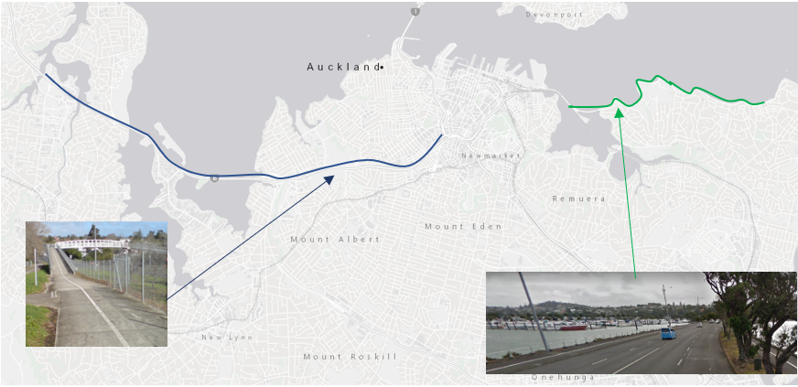Figure 1 SUPs’ Locations

# Results & Discussion

**Description of Survey Respondents**

The survey was completed by a total of 739 individuals, with 455 Northwestern shared path users, and 284 Tamaki Drive shared path users. Result demonstrated a similar demographic characteristic across the two SUPs. For both SUPs, majority of respondents were male (64.7% and 56.54% for Northwestern shared path and Tamaki Drive shared path respectively) and the main age group is between 35- 54 years old group.

As shown in Table 1 below, on the Northwestern shared path, cycling is the most popular mode of transport, with nearly half of the respondents being cyclists on the path (48.45%). On the other hand, Tamaki Drive shared path had similar proportion of cyclists and pedestrians (31.5% and 32.1% respectively). The higher proportion of cyclists on the North Western SUP is expected as the SUP functions predominantly as a commuter SUP whereas the Tamaki Drive SUP has a strong recreational attraction for pedestrians and other users of all age groups. Different pedestrian densities will likely reflect different crash related problems as cyclists normally adjust their behaviour and speed due to different operating conditions and levels of service (Kabo, Hwang et al. 2015, Beitel, Stipancic et al. 2018b). Although e- Scooter and e-bikes are relatively new modes on shared paths, the usage has grown rapidly since 2018 and are now become regular modes on SUPs. Especially for the Northwestern shared path, where approximately one fifth (20.6%) of the respondents are reported to be using e-bikes, which is the second largest mode of transport.

The primary trip purpose will likely influence the users’ mode of transport. Increasing e-mode trend shows an increase in cycling to work, where the number of commuting cyclists has grown by 5% from 2016 to 2018 (Auckland Transport 2018). Commuters have a clear destination and generally under greater time pressures. Amongst all the respondents of the Northwestern shared path, the main trip purpose is commuting to work / study (45.7%). Hence, the increasing e-mode trend accord with the previous result that commuters are more likely to choose a faster mode and often travel at a higher speed (Kabo, Hwang et al. 2015).

In comparison, 39.6% of Tamaki Drive respondents use the path for recreation and 34.5% for Sport and fitness purposes. Hence, trip purpose influences the users’ mode of transport. Leisure users are more likely to travel at a slower speed and it is more likely that their speed would conflict with commuters who aim for a continuous and efficient journey. The cyclists’ speed and aggressiveness on high commuting routes may increase the potential conflict and safety concerns.

|  |  |  |  |  |  |
| --- | --- | --- | --- | --- | --- |
|  |  | **NorthWestern Shared Path** | | **Tamaki Drive shared path** | |
|  |  | **Percentage** | **Count** | **Percentage** | **Count** |
| Age group | Under 18 years | 0.5% | 2 | 0.4% | 1 |
|  | 18 - 24 years | 4.4% | 19 | 4.6% | 12 |
|  | 25 - 34 years | 19.9% | 86 | 18.9% | 49 |
|  | 35 - 44 years | 33.3% | 144 | 28.1% | 73 |
|  | 45 - 54 years | 28.2% | 122 | 27.7% | 72 |
|  | 55 - 64 years | 10.9% | 47 | 12.3% | 32 |
|  | 65 - 74 years | 2.8% | 12 | 6.5% | 17 |
|  | 75 - 84 years | 0.2% | 1 | 1.5% | 4 |
|  | 85 years or older | 0.0% | 0 | 0.0% | 0 |
| Gender | Male | 64.7% | 280 | 56.5% | 147 |
|  | Female | 34.4% | 149 | 43.5% | 113 |
|  | Gender diverse | 0.9% | 4 | 0.0% | 0 |
| Transport mode | Cycle | 48.5% | 297 | 31.5% | 158 |
|  | E-Bike | 20.6% | 126 | 7.8% | 39 |
|  | Walk | 15.2% | 93 | 32.1% | 161 |
|  | Walking school bus | 0.7% | 4 | 0.0% | 0 |
|  | E-Scooter | 3.6% | 22 | 6.0% | 30 |
|  | Scooter (non-electric) | 1.1% | 7 | 1.4% | 7 |
|  | Run | 9.6% | 59 | 19.8% | 99 |
|  | Mobility scooter | 0.0% | 0 | 0.0% | 0 |
|  | Other | 0.8% | 5 | 1.4% | 7 |
| Main purpose | Going to work | 40.5% | 259 | 20.8% | 86 |
|  | Recreation | 21.9% | 140 | 39.6% | 164 |
|  | Going to university  /school | 5.2% | 33 | 1.5% | 6 |
|  | Sports and fitness | 27.5% | 176 | 34.5% | 143 |
|  | Other | 4.9% | 31 | 3.6% | 15 |

Table 1 Demographic Characteristic of Respondents

## **Relationship between response characteristic and perception of safety**

According to the previous survey undertaken by Auckland Transport, around 56% of cyclists are not confident about cycling in Auckland. (Auckland Transport 2018) The survey asked the respondents’ perception of SUP safety; the answer score range from 1 (very unsafe) to 7 (very safe).

Table 2 illustrates the respondents’ safety perceptions of SUPs. The safety perception distributions are similar between the two SUPs as standard deviation and variations are similar although significant differences are evident between the mean safety perception scores. Overall, Northwestern shared path users felt safer (mean = 4.8) compared to Tamaki Drive shared path users (mean = 3.8). Both paths are approx. 3 metre, however Northwestern users are likely to feel safer as the path constructed is completely separated from vehicles and Tamaki Drive shared path is separated by a kerb only. Moreover, more commuters on the Northwestern shared path reduces the speed variance between different user types, which in turn reduces potential conflicts between them. Tamaki Drive shared path users are more likely to have conflicts between user types due to the greater difference in user modes, trip purposes and speeds. Pedestrians need to cross transversely over the cyclist part of the SUP to get off the path, which may also influence users’ perception of safety.

|  |  |  |
| --- | --- | --- |
|  | Mean | Standard Deviation |
| Northwestern Shared path | 4.8 | 1.54 |
| Tamaki Drive shared path | 3.8 | 1.6 |

Table 2 Safety Perception Score of SUPs

Perceived safety is clearly related to gender perceptions as shown in Figure 2 Gender and Perceived Safety- North Western and Figure 3 Gender and Perceived Safety- Tamaki Drive. For both SUPs, females are more likely to report the SUP to be unsafe. Male users are linked to higher perceived safety in comparison with female users. Females generally also perceived lower Level of Service (Nikiforiadis, Basbas 2019) with the same amenity.

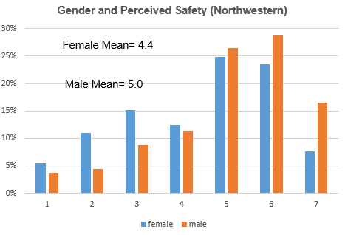

Figure 2 Gender and Perceived Safety- Northwestern

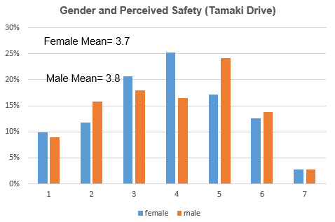

Figure 3 Gender and Perceived Safety- Tamaki Drive

Although other international research suggests that elderly users are more likely to feel unsafe the survey results shown in Figure 4 Age Group and Perceived Safety - Northwestern and Figure 5 Age Group and Perceived Safety - Tamaki Drive did not illustrate a clear relationship between age group and perceived safety.

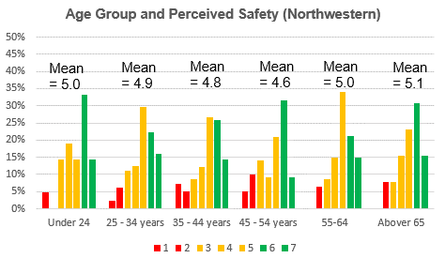

Figure 4 Age Group and Perceived Safety - Northwestern

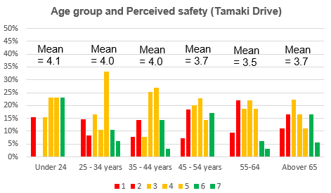

Figure 5 Age Group and Perceived Safety - Tamaki Drive

The mean safety perception is similar across SUP user frequency of use (refer to Figure 6 Use Frequency and Perceived Safety - Northwestern and Figure 7 Use Frequency and Perceived Safety - Tamaki Drive). However, for the Northwestern shared path, low-frequency users (less than monthly) feel relatively less safe. Alternatively, weekly users on Tamaki Drive shared path feel more unsafe than more regular users. Thus, the exposure on the path may not increase the user’s confidence in using the path.

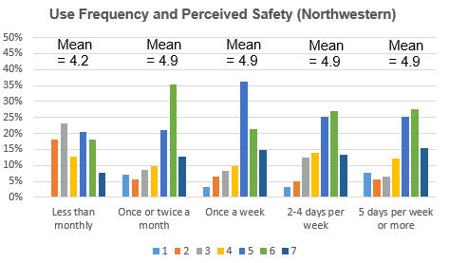

Figure 6 Use Frequency and Perceived Safety - Northwestern

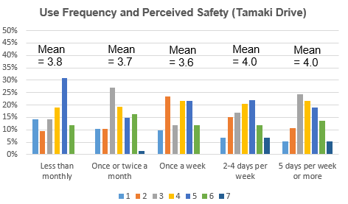

Figure 7 Use Frequency and Perceived Safety - Tamaki Drive

## **Frequency of behaviour**

Inappropriate user behaviour is one of the major causes of reported cyclist and pedestrians conflicts (Mellifont, Ker et al. 2006). Behavioural change is important in minimising conflicts on SUPs (Kabo, Hwang et al. 2015). Multiple risk behaviours were identified as a significant factor based upon the pre-interview and site investigation and subsequently the survey questions asked how often users observed this type of risky behaviour. The behaviours can be divided into two groups, behaviour that influences users’ perceived risk and behaviours resulting in actual safety risks to other users.

### **Perceived risk**

The respondents reported perception of behaviour that was considered as being dangerous, however, they may not be an actual safety risk. Although cyclists generally give way to pedestrians, they often pass too close, without slowing down or without warning. The main unsafe behaviour for the cyclist is not altering the cycle line and passing too close to other users.

On both SUP’s, over half of the respondents (53.6% for Tamaki Drive shared path and 55.8% for Northwestern shared path) ‘frequently’ or ‘always’ found that bikes or scooters do not alert other users (e.g. by using a bell). Pedestrians feel frightened when other users pass at high speed. And the more vulnerable pedestrians (e.g. elderly) feel less safe in comparison to others.

33.7% of Tamaki Drive users and 40.4% of Northwestern users reported that ‘sometimes’ cyclists pass too close to other users. The perceived safety concern is mainly related to the shy distance of passing (Hatfield, Prabhakharan 2016). The appropriate space between pedestrians and cyclists is largely influenced by pedestrians’ perceptions (Nikiforiadis, Basbas 2019). The presence of a centreline makes the overtaking riskier as cyclists try to overtake pedestrian whilst remaining in the left lane, which induces a greater risk of passing too close. Users perceive a higher risk when there is inadequate distance between them and high-speed users.

Apart from the distance concern, e-scooter is a new mode of transport that is increasingly using on SUPs. People are still unfamiliar with how to share the environment with e-scooters (Hardt, Bogenberger 2019). Both cyclists and pedestrians are concerned about e-scooters weaving between them. When the conflicts have occurred between e-scooters and pedestrians, pedestrians are often more likely resulting in a severe injury (Sikka, Vila et al. 2019).

### **Actual safety risk**

During the survey, 32.9% of all respondents reported that they had been involved in a collision or a near-miss.

A high volume of pedestrians on the shared path is not desirable from cyclists’ point of view(Kiyota, Vandebona et al. 2000). On the Northwestern shared user path, cyclists indicated that pedestrian always cross without checking for other users. Amongst all self-reported crashes and near misses for the two SUPs, a total of 46 self-reported conflicts were related to pedestrians unpredictable behaviours on the SUP, e.g. suddenly changing lane or pulling out in front. The conflict analysis in Amsterdam found multiple serious conflicts with pedestrians crossing inattentively in front of a cyclist (van der Horst, A Richard A, de Goede et al. 2014).

In addition, pedestrians meandering and failing to keep left could also increase the possibility of conflicts. Majority of pedestrians maintained their initial position during passing, however as they travel close to the centre, they are less likely to remain in their position and this can be risky as their movement is unpredictable(Hatfield, Prabhakharan 2016).

Another common type of self-reported conflict on the Northwestern shared path is related to dog walkers. Cyclists are concerned when they have to overtake pedestrians with a dog, especially dogs on a long leash or no leash at all. Pedestrians who do not provide adequate supervision of their companions can lead to critical safety issues (Hatfield, Prabhakharan 2016). According to the survey response, 13 reported conflicts were related to dogs.

On the Tamaki Drive shared path, a high number of self-reported crashes are related to the opening of vehicle doors due to the special layout of the shared path. Based on the fact that cyclist have to cycle next to parked vehicles. Cyclists felt unsafe with the layouts and they normally have a minimum reaction time to avoid after doors being opened. In fact, conflicts associated with door openings is one of the most common cyclist and motorised accidents on cycle lanes (Pai 2011).

Although cyclists overtaking at blind corners is not reported ‘frequently’ on SUP’s (refer to Figure 8 Frequency of Inappropriate Behaviour on Northwestern and Figure 9 Frequency of Inappropriate Behaviour on Tamaki Drive), the consequences of overtaking with limited visibility are serious. Moreover, cyclists overtaking while on opposite side of the path can also result in serious conflicts. On the Northwestern shared path, 33% of self-reported collisions involved a head-on collision with another cyclist during overtaking. During most of the time, the overtaking cyclist is on the wrong side or is too close to the centreline. Due to the speed of the cyclists, the collision may lead to a serious injury.

Figure 8 Frequency of Inappropriate Behaviour on Northwestern

Figure 9 Frequency of Inappropriate Behaviour on Tamaki Drive

**Limitations**

There are several limitations to this research. The survey is based on self-reported perceptions of SUPs. Respondents’ answers will be subject to errors of recall and bias as the questions do not have a specific timeframe for the crashes or near misses. Further, the survey data is confined to two shared user paths-Northwestern shared path, and Tamaki Drive shared path. Whilst these are two of the highest used shared paths in Auckland with a high exposure of different users’ types, they cannot be thought to be representative of all other shared user paths across New Zealand.  Moreover, although the survey has a reasonable number of respondents it may not be representative of the broader population of shared path users and non-shared user path users. In further research, the study will target a greater proportion of users and a wider range of SUP infrastructures across Auckland.

# Conclusions

This paper reported survey results from a study survey undertaken by Auckland Transport regarding SUP users’ safety perception for two popular SUP facilities in Auckland – Northwestern shared path and Tamaki Drive shared path. The SUPs were investigated via user safety perception of various users and different users’ behaviours. The survey received a greater proportion of male responses and the greatest proportion are within the 35-54 age groups. The study found the perception of safety is related to gender as female users are more likely to feel unsafe with the same infrastructure. However, the result found no relationship between perceived safety by age group or path use frequency. Inappropriate user behaviours can lead to an increase of perceived and actual risk. Although some behaviours may not result in a serious injury collision, the perception of safety directly affects users’ enjoyment and comfort. SUPs with high numbers of similar speed users may have fewer potential conflicts and users feel safer in comparison to a SUP with relatively low density but significant variation in user types and number.

Author is a graduate engineer in Auckland Transport. Author participated in the SUP pre-survey interview, survey design and explore sprint. A more comprehensive study exploring actual conflicts should be conducted in the future study.

**References**

Austroads- Guide to Road Design Part6A Paths for Walking and Cycling. 2017.

Cycle network and route planning guide. 2004. [Wellington] N.Z: Land Transport Safety Authority.

Auckland Transport, 2018. Measuring and growing active modes of transport in Auckland.

Auckland Transport Cycle Monitoring, 2019-last update, Monthly Cycle Monitoring. Available: <https://at.govt.nz/cycling-walking/research-monitoring/monthly-cycle-monitoring/>.

Beitel, D., Stipancic, J., Manaugh, K. and Miranda-moreno, L., 2018a. Assessing safety of shared space using cyclist-pedestrian interactions and automated video conflict analysis. Transportation research part D: transport and environment, 65, pp. 710-724.

Chataway, E.S., Kaplan, S., Nielsen, T.A.S. and Prato, C.G., 2014. Safety perceptions and reported behavior related to cycling in mixed traffic: A comparison between Brisbane and Copenhagen. Transportation research part F: traffic psychology and behaviour, 23, pp. 32-43.

Daley, M., Rissel, C. and Lloyd, B., 2007. All dressed up and nowhere to go?: a qualitative research study of the barriers and enablers to cycling in Inner Sydney. Road & Transport Research: A Journal of Australian and New Zealand Research and Practice, 16(4), pp. 42.

Dozza, M., Piccinini, G.F.B. and Werneke, J., 2016. Using naturalistic data to assess e-cyclist behavior. Transportation research part F: traffic psychology and behaviour, 41, pp. 217-226.

Drummond, A.E., 1989. Pedestrian casualties resulting from collisions with cyclists on footpaths.

Grzebieta, R.H., Mcintosh, A.M. and Chong, S., 2011. Pedestrian-cyclist collisions: issues and risk. A Safe System: Making it Happen, .

Hardt, C. and Bogenberger, K., 2019. Usage of e-scooters in urban environments. Transportation research procedia, 37, pp. 155-162.

Hatfield, J. and Prabhakharan, P., 2016. An investigation of behaviour and attitudes relevant to the user safety of pedestrian/cyclist shared paths. Transportation research part F: traffic psychology and behaviour, 40, pp. 35-47.

Kabo, F., Hwang, Y., Levenstein, M. and Owen-smith, J., 2015. Shared paths the issues. 47. Los Angeles, CA: SAGE Publications.

Kiyota, M., Vandebona, U., Katafuchi, N. and Inoue, S., 2000Bicycle and pedestrian traffic conflicts on shared pavements, Fourteenth Velo-city International Conference Proceedings, Munich 2000.

Lieswyn, J., Fowler, M., Koorey, G.F., Wilke, A. and Crimp, S., 2017. Regulations and safety for electric bicycles and other low-powered vehicles. Wellington, New Zealand: NZ Transport Agency.

Mellifont, D., Ker, I., Huband, A., Veith, G. and Taylor, J., 2006. Pedestrian-cyclest conflict minimisation on shared paths and footpaths. Austroads Research Report AP-R287/06.

Nikiforiadis, A. and Basbas, S., 2019. Can pedestrians and cyclists share the same space? The case of a city with low cycling levels and experience. Sustainable Cities and Society, 46, pp. 101453.

O’hern, S. and Oxley, J., 2019. Pedestrian injuries due to collisions with cyclists Melbourne, Australia. Accident Analysis & Prevention, 122, pp. 295-300.

Pai, C., 2011. Overtaking, rear-end, and door crashes involving bicycles: An empirical investigation. Accident Analysis & Prevention, 43(3), pp. 1228-1235.

Queensland Transport, 2004. Reducing conflict between bicycle riders and pedestrians. Cycle Note.

Short, A., Grzebieta, R. and Arndt, N., 2007. Estimating bicyclist into pedestrian collision speed. International journal of crashworthiness, 12(2), pp. 127-135.

Sikka, N., Vila, C., Stratton, M., Ghassemi, M. and Pourmand, A., 2019. Sharing the sidewalk: A case of E-scooter related pedestrian injury. The American Journal of Emergency Medicine, .

Van der horst, A Richard A, De Goede, M., De Hair-buijssen, S. and Methorst, R., 2014. Traffic conflicts on bicycle paths: A systematic observation of behaviour from video. Accident Analysis & Prevention, 62, pp. 358-368.

1. Author involved in the explore sprint as graduate engineer in Auckland Transport