# AUCKLANDS BUS NETWORK, CONNECTING REMOTE COMMUNITIES

**This paper has been peer reviewed**

Dave Hilson, Senior Service Network Planner

Auckland Transport

Dave.hilson@at.govt.nz

# Abstract

Between 2016 and 2019 Auckland Transport (AT) has introduced a new bus network to Auckland. This ‘New Network’ is simpler to understand than the previous offering with fewer routes but an emphasis on frequency and connectivity.

When looking at the success of the New Network, much of this has been looking at the frequent and rapid transit networks. What has probably been less apparent, other than to those who are directly affected, is the increased level of service to remote, sometimes rural or semi-rural, areas of Auckland. This paper will focus on two of these, Waiuku and Warkworth.

For Warkworth (57 km north of Auckland CBD) there had been no real public transport available previously, resulting in the need to drive to get anywhere or suffer a degree of isolation.

In all cases these new or enhanced services connect to the frequent and/or rapid transit networks. When implementing these services, it was always expected that they would help serve the needs of commuters. However, early on, during the consultation process, it became evident that these services would also be welcomed by those age groups outside of the ‘commuter market’ – the young, those too young to drive and the elderly who could no longer drive or chose not to. Anecdotally, and through data collection, we have seen that the services at the outskirts of the city are giving these people the ability to travel locally as well as being able to connect to the Auckland public transport network.

Waiuku (60 km south of Auckland CBD) did have some public transport prior to the New Network, however this was infrequent with only two buses a day (one out, one in). This is not particularly useful and is dependent on any intending passengers being able to catch the bus at that time otherwise risk being stranded.

**Introduction**

It is not unusual, when measuring the success of a public transport network, to focus on patronage, the number of passengers carried. To a degree, this is a necessary measure, particularly in urban centres where congestion is an issue and public transport passenger journeys are essential for taking cars off the road. There are also measures such as Farebox Recovery Ratios, which require carrying large numbers of passengers, thereby maximising revenue yield.

However, public transport also fulfils a social (sometimes described as coverage) need whereby services will carry fewer passengers but can provide an essential lifeline to residents in some of the more remote areas of a city. Some of those will be those for whom driving isn’t an option, particularly those too young to drive and the elderly who either cannot or would prefer not to drive.

Please note, when referring to coverage in this context it is not about straightening out routes in urban and suburban areas whereby people have a longer walk to the bus. This is looking at coverage whereby without these services, residents would have no public transport at all without having to drive to connect to the network.

This paper looks at where the bus transport network in Auckland has provided connections to some of the more remote areas of the city and the impact we have seen on some of the passengers who now use these services.

# Warkworth

Warkworth is a town approximately 57 kilometres north of the Auckland CBD with a population of around 4,890 as of June 2018. The Warkworth district is known as the Kowhai Coast, which includes the neighbouring towns of Snells Beach, Algies Bay, Matakana, Omaha and Point Wells.

Prior to the introduction of the New Network in September 2018, the only public transport in the area (other than school buses) was a service called the Kowhai Connection, which operated six days a week (Monday to Saturday) but only connected Warkworth with the local area. There had been five different variants of the original Kowhai Connection, generally no two consecutive trips ran the exact same route.

Connecting to the rest of the Auckland public transport network entailed driving 21 km to Waiwera to connect with a local bus, or a 26 km drive to Hibiscus Coast Station. From here, passengers could catch the Northern Express service connecting, through the Northern Busway, to the greater Auckland public transport network.

When the New Network for Warkworth and the Kowhai Coast was designed there were two main objectives. The first was to retain service to most of the towns previously covered by the Kowhai Connection, except for Whangateau, which had low usage. The other was to provide a connection between Warkworth and the rest of the region.

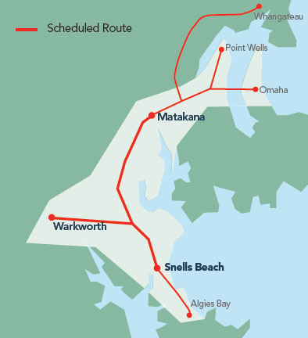

Figure 1. Kowhai Connection, pre-September 2018

The first objective was covered with routes 996 and 997, these connected Warkworth with the destinations covered by the Kowhai Connection, with the exception of Whangateau. This has been split into two distinctive routes, 996 and 997, both of which have consistent routes and operate seven days a week.

The second objective was covered with a new service, 995, connecting Warkworth with Hibiscus Coast Station. This service operates seven days a week, generally hourly but more frequently at peak times. Naturally this was having a benefit for commuters, as we would expect peak trips Monday to Friday are the busiest, but this does also have steady patronage through the day.

As much as possible, the timetables of the 996 and 997 are aligned with the 995 to try and enable connections to and from Hibiscus Coast Station. However, given the runtime, and due to both services being operated with a single bus, it is not possible to do this cleanly. It has also meant a trade-off between a timetable that suits passengers finishing work in Warkworth and those travelling form further afield.

There were also a number of primary school pupils using the Kowhai Connection to get to and from school. The timetable for routes 996 and 997 took this into account and there are trips in the morning and afternoon that have been timetabled specifically to take into account these journeys.

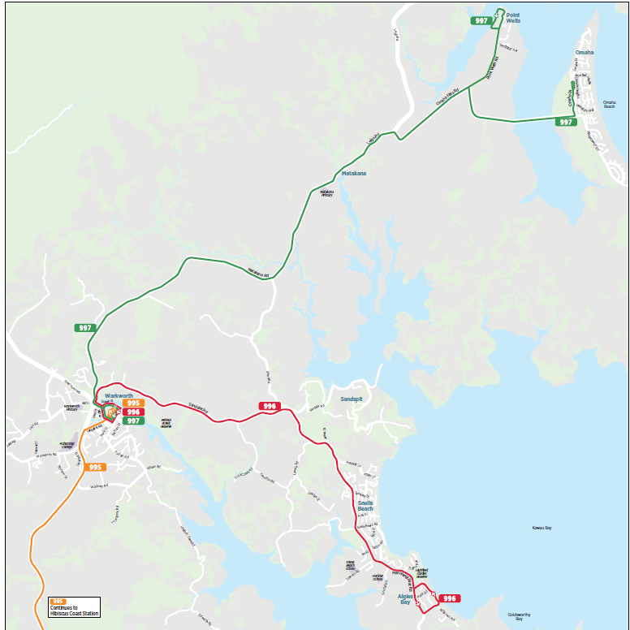

Figure 2. New Network for Warkworth and Kowhai Coast

Although not introduced as part of the New Network, a new service was added this year between Warkworth and Wellsford, a small town with a population of around 2,100 as of June 2018. This service was requested by Rodney Local Board and is funded out of a targeted transport rate that has been raised by that local board. Wellsford is around 20 km north-west of Warkworth and is the northernmost major settlement in the Auckland region.

The route 998, which was introduced in February 2019, runs hourly through the day, seven days a week.

# Waiuku

Waiuku is a small town southwest of Auckland CBD with a population of around 9,780 as of June 2018. As the crow flies it is 40 km south of the Auckland CBD, however given the geography of the area it is closer to 65 km by road.

Prior to the introduction of the New Network for South Auckland in October 2016, Waiuku was served by two bus trips a day, one each in the morning and afternoon peaks. These connected Waiuku with Papakura Station for onward journeys by train. If a passenger missed the bus there is a distance of 33 km between Waiuku and Papakura Station.

There had previously been a bus service between Waiuku and Pukekohe, a town of 31,400 people, which is around 20 km to the east. However, this timetable had been both infrequent and, like the Kowhai Connection in the north, had several different variants. The combination of these factors meant this service was never very well utilised and as a result had been discontinued.

When we went to consultation on bus services for Waiuku, we consulted on three options with the idea that we would choose one, based on feedback. Two of these options connected with Papakura, the other with Pukekohe. However, given feedback we received early on, it was decided to keep an open mind on which option we chose. There was a case for choosing more than one option with Papakura being considered the ideal for commuters wanting the train, however Pukekohe is a destination in its own right, as well as allowing rail connections. The main reason Papakura was considered best for train connections was because of better train frequencies but also because while most of the Auckland rail network is electrified, the section between Papakura and Pukekohe is not. Therefore, any passengers catching the train at Pukekohe and wanting to travel north of Papakura must change trains.

Once the consultation was completed, the numbers aligned with what we expected. We implemented a peak option to and from Papakura with two buses each morning and afternoon plus a service to Pukekohe at other times, including weekends. The routes opted for were routes 1 and 3 below although after feedback it was decided to run route 3 via Patumahoe, a small town between Pukekohe and Waiuku.

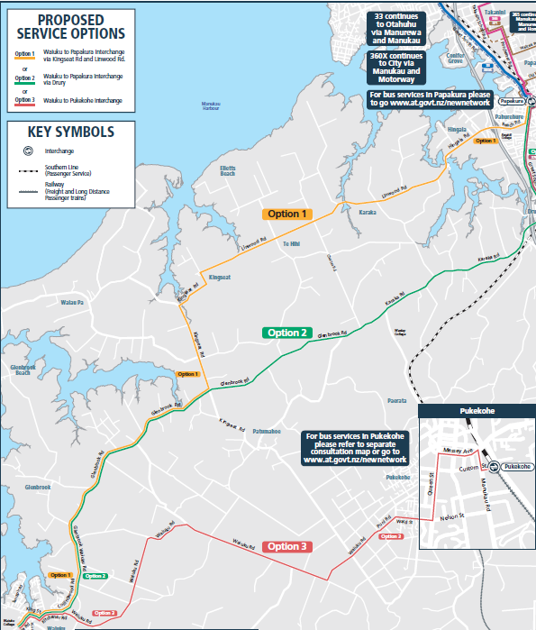

Patumahoe

Papakura

Waiuku

Pukekohe

Figure 3. Proposed routes for Pukekohe and Waiuku

# Indicative Feedback

Early indications were that these new services would be popular, as we would expect. For the purposes of this paper I will look specifically at the younger and older markets, those who can’t or choose not to drive and for whom public transport may make a significant difference.

When consulting on Waiuku services there was a public event with markets, fireworks etc. a family event. At that time AT had a bus which we used for consultation, we took this along to the event where we could give out information on the proposals and collect feedback. The noticeable interest at this event was from the youth/teenagers who came along to see us. They considered that there isn’t a lot for them in Waiuku and no option of going anywhere else, other than by car.

When AT implements new services, there will generally be information events where the public can come along, receive timetables and other information as well as being able to ask questions of us. Some of these events are on a weekday during the day and at a hall or similar facility. This means that unlike the event at Waiuku described above, the people coming to the event are going there specifically, as opposed to people who see the event in passing. The expectation of such events is that there will be a few people who turn up at the start then a trickle of people through the day. As the day goes on there is often the temptation to pack up early due to small numbers of people through.

With the Warkworth event, there was a team on site selling AT HOP cards and adding concessions where needed. AT HOP is the standard card for paying fares on AT services and necessary for SuperGold card holders to get free travel on public transport. This was offered at the Warkworth event as AT HOP wasn’t available on the previous Kowhai Connection service in the area.

The uptake that day exceeded all expectations. About 500 people came through to get AT HOP cards, to get a SuperGold concession loaded on their cards or for information. There were up to 50 people at any given time waiting to be seen. In contrast to other events where there was the temptation to finish early, at this one the doors had to be locked at the official closing time, it took close to an hour to process those already in the hall.

# Turning remote areas into destinations

Although people in these communities have generally been supportive of bus services, this hasn’t always been universal to start with. There have been complaints from local business associations and others that we are taking business away from these areas. However, we have been able to point out to them that although it does allow the local residents to go elsewhere for shopping etc., it does also help turn their town into a destination for passengers, bringing business into the area.

As an example, there is a historic tavern in Waiuku, which happens to be New Zealand’s longest continuously licenced pub. If in the past you had wanted to visit here by public transport, you would have to arrive the evening before you wanted to go there and leave the morning after – assuming it was a mid-week visit or you would have to stay even longer. Matakana on the Kowhai Coast has popular weekend markets, you could get there from Warkworth on the Kowhai Connection previously, now you can get there from further afield. Wellsford, which may not particularly be considered a tourist attraction, has a skate park, we were hearing that this would be a popular destination for people from Warkworth.

# Results

As expected, these services have been well adopted by those at the younger and older ends of the spectrum. Using August 2019 as an example, the percentage of overall passenger boardings was looked at comparing child/secondary and SuperGold use compared with the average across Auckland.

Waiuku service (Route 396):

|  |  |  |
| --- | --- | --- |
|  | Route 396 | Auckland average (all public transport) |
| Child and secondary students | 23.25% | 16.29% |
| SuperGold | 18.12% | 12.22% |

Warkworth and Kowhai Coast including Wellsford (Routes 995, 996, 997 and 998)

|  |  |  |
| --- | --- | --- |
|  | Routes 995, 996, 997 and 998 | Auckland average (all public transport) |
| Child and secondary students | 20–45%, average 27% | 16.29% |
| SuperGold | 15–20%, average 18.7% | 12.22% |

As can be seen, the use by the youth and SuperGold segments is above the Auckland average for all these services although admittedly the Kowhai Coast child percentage is in part due to the use to and from one of the local primary schools.

# Customer feedback

There have been two pieces of customer feedback that come to mind from these areas.

The first is from Patumahoe, this is a small town on the Waiuku – Pukekohe route. One of the pieces of feedback we had received, prior to finalising the routes, was that there was no need for a bus to travel via Patumahoe. Being a rural town, everyone has four-wheel-drives that they use to go everywhere. This was from a Patumahoe resident. Despite this, other feedback suggested that a service there would be appreciated. We have since heard from this person, at that stage they had a teenage daughter without a driving licence, the daughter was now enjoying being able to travel independently on the bus.

We also received a letter from a retired couple from Wellsford. They had moved up there to be with family but, both being unable to drive, relied on the family to get anywhere. In their words, when we introduced services up there, ‘our dreams came into reality’. They say they now use the bus all the time and travel as far afield as Onehunga and Waiheke Island.

# Patronage vs coverage

So, to return to the first paragraph, the New Network prides itself on more frequent services than ever before with ever increasing patronage. These services form a very important part of the network, giving access to employment, study and leisure. Auckland’s population is growing steadily and without such frequent services, traffic congestion would get out of hand. There are also other factors to consider such as farebox recovery ratio, meaning that AT should be recovering enough revenue through fares to recover half of the cost of running services, this can’t be done without carrying significant passenger numbers.

But it needs to be recognised that public transport is also there to fulfil a social function with services that are unlikely to ever come close to covering their costs. The usage figures in this paper show there are a good proportion of people on these services who would be less independent without such services – they make a real difference to their lives.

There is a necessity to find that balance. We know we have peak services which leave passengers behind, albeit on frequent routes where there will be another bus along in a matter of minutes. How do we measure the benefit of putting additional service on a peak route to reduce wait times as opposed to putting on an infrequent service to people who would otherwise not have a service? How do we measure success of a service giving people a greater level of independence and connectivity? We know it won’t be purely based on patronage.

An additional bus for the peak of the peak might always sound like a good idea, chances are this bus will always be full. However, if this bus wasn’t there chances are everyone who needed it would still get a bus, they might just have to wait a bit longer. It is inefficient, the bus might be full for a single trip, but it might spend the rest of the day sitting in the depot doing nothing. Therefore, the number of passengers carried by that bus in a day is limited to the capacity of that bus. If the money was used on a service that was less frequent with a smaller bus, there is the possibility of a better financial yield for that bus but, possibly more important, it gives connectivity to more people.

Services designed purely to carry lots of passengers are easy to measure, it is purely a numbers game. When we measure giving those who can’t drive connectivity to the rest of the region or bringing business to smaller, remote communities, it becomes more difficult. We may not be able to put a quantitative measure on this, but we should never underestimate the value of being able to change people’s lives.

# Conclusions

I was once in a meeting where evaluating bus services and, when looking at a route with low patronage, someone stated that if they were in business, they would not be operating that. Within the context of a Local Government agency, we need to remember that we are not in business. We are spending public money and with that comes the responsibility of doing so prudently. We do have to get value for money. However, that doesn’t necessarily mean that everything we do needs to run at a profit.

However, what we do does come down to balance. We need to run services that are focussed on patronage, carrying enough passengers to provide congestion relief and yield sufficient revenue to reduce the dependence on the public purse. On the other hand, there is a need to provide service to those who would be restricted in their ability to travel if such services weren’t available.

Patronage and farebox yield are easy to measure, the benefit to those reliant on public transport is less so. The challenges for the future could be to find a way to measure those benefits, then to convince those who can’t see beyond the quantifiable measures that these need to be taken into account when designing public transport networks.