**Golden Mile Bus Priority Improvements**

Let’s Get Wellington Moving is a joint initiative between Wellington City Council, Greater Wellington Regional Council and the NZ Transport Agency and is working with the people of Wellington to develop a transport system that supports their goals and aspirations for how the city looks, feels, and functions. The programme partners want to support Wellington’s growth while making it safer and easier for people to get around.

One of the early delivery goals of the project is to start moving more people with fewer vehicles and to make travelling by bus to the central city a faster and more reliable choice. Including the creation of a better environment for people walking and on bikes.

One of the key early delivery projects was to examine the Golden Mile Corridor and identify any initial improvements that could be made to the signal timings along the corridor to improve bus journey times and reliability whilst also maintaining or improving the pedestrian phases at each intersection.

The Golden Mile – Lambton Quay to Courtenay Place – is the heart of Wellington, the busiest pedestrian area and a key shopping and entertainment destination. It's also the main route for buses bringing 12,000 people to the central city every weekday. Travelling by bus along the Golden Mile is often slow and congested, making it an unreliable option for travel through the city centre and encouraging other mods of travel which impacts the wider City Centre transport network.

Our project in conjunction with Jacobs and WCC has identified the current SCATS signal timings along the corridor, and in combination with the current traffic volumes these have been assembled into a large LINSIG model which has allowed the whole corridor to be assessed, based upon the exact traffic signal timings. The resulting model of the existing situation has then used in conjunction with agreed future scenarios to identify a number of enhancements to the SCATS signal timings which also adhere to the principles of the project – to improve bus journey times and reliability along the corridor, whilst also maintaining or improving the pedestrian phases at each intersection.

**Author/Presenter: -**

James Hine

BEng (Hons)

MENgNZ

Senior ITS Engineer

Jacobs

Level 8, 1 Grey Street

Wellington 6011

James.hine@jacobs.com

**Co-author: -**

Claire Ashburn

BEng (Hons)

MENgNZ

Transport Engineer

Jacobs

Level 8, 1 Grey Street

Wellington 6011

Claire.ashburn@jacobs.com

**INTRODUCTION**

The authors were part of a team that was commissioned by Let’s Get Wellington Moving (LGWM) to identify and test bus priority of the signal operations along the ‘Golden Mile’ in Central Wellington.

The Golden Mile corridor is just over 2km in length and is encompasses the lengths of Lambton Quay, Willis Street, Manners Street & Courtenay Place and is a key north/south public transport corridor through the central Wellington area. There is a 30kph speed limit all the way along the corridor, which WCC are currently investigating the possibility of expanding throughout the Central wellington area.

Along the corridor there are thirteen separate signalised intersections and six mid-block crossings which currently provide varying degrees of bus priority – from a full segregated bus phase to just a shared general traffic phase. The corridor comprises of a mix of general traffic lanes, some segregated bus lane sections and some bus only sections.

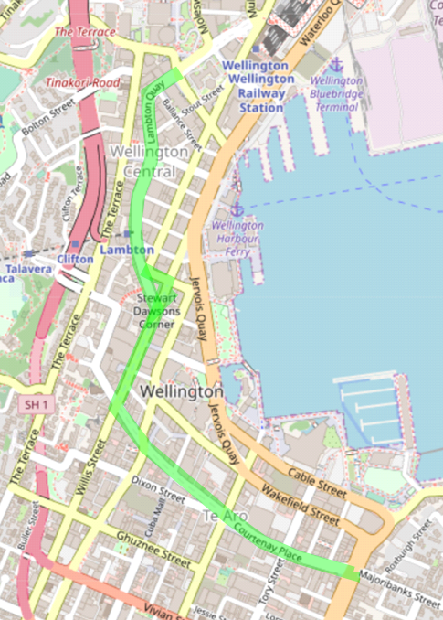

Wellington’s ‘Golden Mile’

*Map of the Golden Mile through Central Wellington.*

The project team have aligned the assessment with the objectives of LGWM, which are to:

* Enhance the liveability of the central city;
* Provide more efficient and reliable access for users;
* Reduce reliance on private vehicle travel;
* Improve safety for all users; and
* Be adaptable to disruptions and future uncertainty.

Whilst the objectives of this project were to:

* Improve bus travel times and reliability along the Golden Mile;
* Improve pedestrian amenity; and
* Maintain LOS for general road users.

These objectives align with most of the LGWM objectives as they improve efficiency, reliability and safety. These improvements are likely to lead to mode share shift which will reduce reliance on private vehicles, however assessing mode share was outside the scope of this project. The priority measures applicable to the Golden Mile which have been identified and tested include:

* Signal timing changes;
* Bus (B) phase Signals;
* Advanced detection; and
* Pedestrian countdown timers.

When providing benefits for buses, it is important that pedestrian amenity is at least maintained, if not also improved. This is because bus trips generate pedestrian trips and the entire journey should be attractive to users. In assessing bus priority along the Golden Mile, minimising the impacts on the Levels of Service (LoS) for the general traffic interacting with the Golden Mile was also considered.

# Improved Signal Phasing and Cycle Times

Linsig, a traffic modelling software package, was used to assess the performance of the signalised intersections along the ‘Golden Mile’. A base 2019 model for each of the AM peak (8:00-9:00), inter peak (12:00-13:00) and PM peak (16:30-17:30) with existing traffic flows and maximum lane flow values was developed in conjunction with the signals team at Wellington City Council (WCC). A calibration and validation exercise of the model development has not been undertaken, however these models were agreed based on checking the queue lengths, degrees of saturation on each approach and the average delays from the base model results by the signals team at WCC.

Once the base model was agreed, several different scenarios were developed for testing based on the above objectives. The existing phasing structure, pedestrian clearance times and operation of each intersection were retained with all timing adjustments being applied to the phase times.

The project objectives which the scenarios were based on are:

* Improved bus travel times and reliability along the Golden Mile;
* Improved pedestrian amenity; and
* Maintaining LOS for general road users.

The scenarios were:

* Scenario 1 – reduce the green time of minor roads until at least one lane has a degree of saturation of 80%, while maintaining the cycle time – additional green time goes to bus phase (improved travel time and maintaining existing LOS for other users).
* Scenario 1A – reduce the green time of minor roads until at least one lane has a degree of saturation of 80%, reduce green time of bus phases to maintain existing degree of saturation for these lanes – cycle time reduced (improved travel time, improved pedestrian amenity and maintaining LOS for other users).
* Scenario 2 – reduce phases which include pedestrians to have a green time equal to the pedestrian clearance time, leave any phases with no pedestrians at existing green time – cycle time reduced (improved pedestrian amenity). **This scenario was discounted as scenario 2A was determined to be more applicable**.
* Scenario 2A – reduce phases which include pedestrians to have a green time equal to the pedestrian clearance, unless phase has buses, in which case leave at existing green time, leave any phases with no pedestrians at existing green time – cycle time reduced (improved travel time and improved pedestrian amenity).
* Scenario 3 – half cycling of phases that don’t have buses running in them (improved travel time).
* Scenario 4 – reducing min green time (improved travel time). **This scenario was discounted as reducing the min green time would likely lead to an increased all red time for safety reasons, cancelling out any benefits.**
* Scenario 5 – maintaining cycle length, allowing Linsig to optimise the phase times across all intersections (improved travel time). **This scenario did not return any better results than current operations so has not been reported on.**

The Key Performance Indicators (KPIs) used to assess each scenario were: -

* The cycle time of the intersection;
* The green phase times on each approach; and
* Degree of saturation on the key intersection approaches.

Sensitivity testing was also carried out. This sensitivity testing involved increasing the bus flows along the Golden Mile to be equal to 10 passenger car units (pcus) per bus, leaving cycle and phase times as existing. Buses along the Golden Mile are often close to full during the peak times (capacity of 86 people). Passenger car units carry on average 1.5 people each. The sensitivity testing shows the impacts of 20% of bus capacity using private vehicles instead of buses.

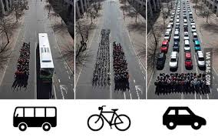

*Demonstrating the amount of road space required for each mode of transport (Credit: Humantransit.org)*

Most of the intersections along the Golden Mile had increased queueing on the arms that have buses in them. These queues proved detrimental to:

* i=110 – Whitmore / Lambton / Bowen
* i=200 – Lambton / Brandon (PM peak only)
* i=350 – Willis / Mercer (AM Peak and IP only)
* i=400 – Willis / Boulcott / Manners
* i=420 – Manners / Cuba
* i=450 – Taranaki / Courtenay / Manners / Dixon
* i=460 – Courtenay / Tory (AM Peak and PM Peak only)
* i=470 – Cambridge / Kent / Courtenay / Majoribanks

The sensitivity testing resulted in the maximum degree of saturation at these intersections being above 100%. This sensitivity testing shows how important it is that one vehicle carrying up to 86 people in the space of two cars, as if these people were in private vehicles, only 3 people would be getting through in that space.

It is important to note that in testing the above scenarios and in the sensitivity testing, rerouting of vehicles experiencing long delays was not considered. The modelling package used tests network interactions between intersections and a microsimulation model would be required to assess the impacts of changing behaviours due to scenarios tested.

## Modelling assessment summary and recommendations

Scenario 1A was generally identified as the option to best meet the overall project objectives of reduced and consistent bus journey times and reduced delays to pedestrians, while maintaining LOS for other road users. This was the only scenario which met all three objectives. This scenario also had the most consistent success rate against the KPIs.

The decision to select Scenario 1A as the preferred option to trial in the ‘real world’ SCATS signal timings operations was based upon the comparison of all the modelled Scenarios results and their relative impacts. Scenario 1A was clearly identified as the best blend of reduced cycle time, bus degree of saturation maintained, minimised pedestrian waiting times and relatively little disruption to other general traffic approaches.

Table 2.1 shows the resulting recommended cycle time changes to be implemented in SCATS.

## 

Table 2.1: Recommended New Cycle Times Compared to Existing Cycle Times (sec)

| Site | AM Peak | | Inter Peak | | PM Peak | |
| --- | --- | --- | --- | --- | --- | --- |
| Existing | Recommended | Existing | Recommended | Existing | Recommended |
| 110 | 107 | 107 | 78 | 72 | 98 | 86 |
| 160 | 48 | 48 | 48 | 48 | 52 | 52 |
| 170 | 44 | 44 | 43 | 43 | 49 | 49 |
| 200 | 65 | 59 | 59 | 55 | 66 | 59 |
| 280 | 38 | 38 | 35 | 35 | 40 | 40 |
| 290 | 75 | 75 | 67 | 67 | 72 | 72 |
| 310 | 76 | 70 | 67 | 65 | 72 | 70 |
| 320 | 78 | 70 | 70 | 65 | 75 | 70 |
| 327 | 39 | 39 | 39 | 39 | 45 | 45 |
| 350 | 78 | 71 | 70 | 68 | 80 | 74 |
| 400 | 78 | 71 | 81 | 68 | 81 | 74 |
| 410 | 79 | 71 | 80 | 68 | 81 | 74 |
| 420 | 61 | 61 | 66 | 66 | 55 | 55 |
| 450 | 168 | 160 | 168 | 158 | 176 | 165 |
| 455 | 56 | 56 | 57 | 57 | 61 | 61 |
| 460 | 112 | 98 | 106 | 104 | 146 | 130 |
| 463 | 95 | 95 | 72 | 72 | 73 | 73 |
| 466 | 57 | 57 | 65 | 65 | 64 | 64 |
| 470 | 116 | 100 | 109 | 80 | 118 | 96 |

It should be noted that the current modelling assessment is done by optimising the isolated signalised intersection. The benefit of the changes is already demonstrated. At the same time, it is understood that the Golden Mile corridor still has significant opportunities to further improve by further investigation and optimisation on the coordination of the signals and traffic redistribution impacts. These further studies will require a more sophisticated modelling tools such as micro simulation modelling and network assignment modelling, and these are recommended for the next stage of the investigation and operational design.

# B Signals

Bus priority signals (or B Signals) separate buses and other vehicles at some intersections with dedicated bus signals to provide a prioritised signal for buses travelling through the intersection.

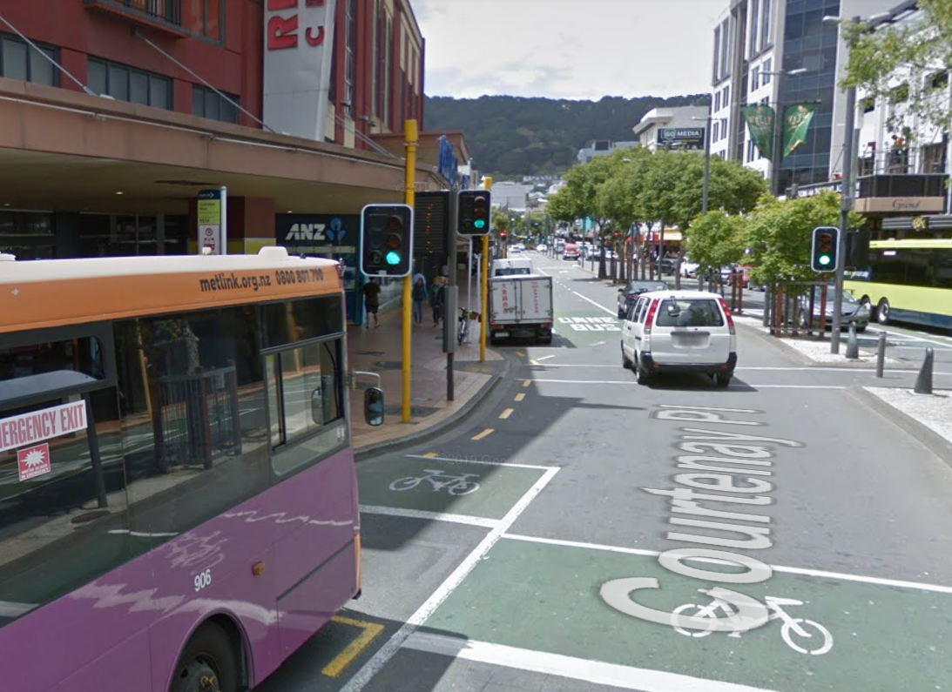

*B Signals on the signals on Courtenay Place outside the Reading Cinema complex*

B signals are attached to the normal traffic lights and they utilise a white B signal on a black background. Shortly before the usual traffic signals change to green, the B signal lights up white. All other vehicles stay in position while the buses may go. When the lights turn green other vehicles may then begin to move off.

Clause 6.4(10) of the Traffic Control Devices Rules (TCD) 2004 states that:

*‘If a bus lane traverses an area controlled by traffic signals, the road controlling authority:*

1. *Must include a white B signal and may include a yellow B signal in the display of traffic signals to indicate when a bus lane is permitted to turn, or proceed straight ahead, when other vehicles are not allowed to make these movements; or*
2. *Must include a red B signal in the display of traffic signals to indicate when a bus may not proceed from the bus lane when other vehicles are allowed to move in the same general direction; or*
3. *May include a column of white, yellow and red B signals in the display of traffic signals.’*

B signals help to provide some additional bus priority over the general traffic at an intersection, and where practicable are a useful addition to a signalised intersection.

## Assessment summaries and recommendations

The desktop assessment showed that there will unlikely be any benefits by providing additional B Signals along the Golden Mile corridor because buses often share general traffic lanes at intersections. However, the opportunities of providing additional B Signals with signal coordination and optimisation along the corridor should be considered as part of larger changes to this corridor. More detailed operational simulation modelling assessment with adaptive signal control functionality is recommended for the next stage of investigation.

# Advanced Detection

Advanced detection allows for buses to be detected prior to reaching an intersection so that the signal cycle can adjust accordingly for buses to gain priority.

Two methods of advanced detection have been considered for implementation along ‘The Golden Mile’. These are above ground radars and in ground loops.

Controller Information Sheet (CIS) refers to the need to update the signal personality of the intersection.

## Assessment summaries and recommendations

The assessment identified that the advance detectors are likely to provide extra traffic efficiency benefits at 10 of the signalised intersections along the Golden Mile corridor. The combination of Radar virtual loop and inground loop types of advance detection are considered for each of the intersections where it is appropriate. The additional detection is designed to provide only a dedicated bus detect and effectively screen out general traffic and will only provide advanced calls to the signals or extensions when a bus is detected. The majority of general traffic in the central Wellington area does not use the Golden Mile corridor and in the majority of cases passes across the corridor rather than along it.

Implementation of the advanced detections could also provide additional benefits on the signal coordination of the Golden Mile corridor as well as reduce the safety risks of rear end collisions.

Operational simulation modelling can be used in the next stage to investigate and design the operation regime of utilising these if the project is progressed further. The road works during the implementation of the physical loops could be interruptive to the traffic operation on the Golden Mile corridor, the Traffic Management Plans (TMP) should be carefully developed and the network wide traffic impacts should be minimised and monitored.

# Pedestrian Countdown Timers

Pedestrian countdown timers are used successfully in several existing intersections within the Central Wellington .

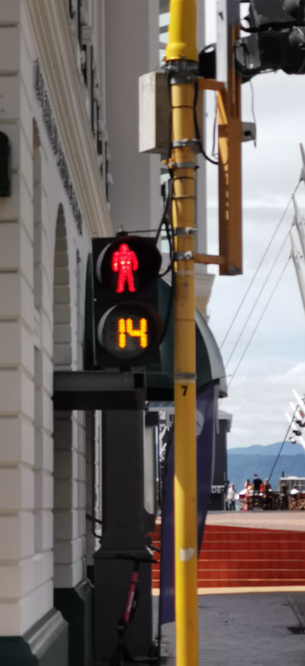

4.1 - Countdown timer in Central Wellington

They are used to provide crossing pedestrians a clear indication of the remaining pedestrian clearance and discourage late arriving pedestrians from beginning to cross. This provides both confidence to the crossing pedestrians that they have sufficient time to complete their crossing manoeuvre and increases pedestrian safety by decreasing the occurrences of late arriving pedestrians who would ordinarily begin to cross and find that the vehicle signals then turn to green before they have completed their road crossing.

The rules for governing the use of countdown timers are set out in Traffic Control Devices 2004, and Clause 6.6(3A) of the TCD 2004 states that:

*‘A countdown pedestrian signal, comprising a white or yellow display (conforming to the description in Schedule 3) showing the number of seconds remaining in the pedestrian clearance period, may only be installed beside pedestrian traffic signals at:*

1. *mid-block pedestrian traffic signals; or*
2. *intersections where all of the approaches to the area controlled by traffic signals are controlled by red signals at the same time while pedestrians are permitted to cross.’*

These rules limit the use of countdown timers at intersections to specific ones which run a dedicated pedestrian phase known as a ‘Scramble’ where all pedestrians movements occur together in one phase. WCC Signals Team have already installed countdown timers at many of the intersections within the Golden Mile and nearby Wellington CBD.

At pedestrian crossings within the CBD the crossing distances are generally so short that the use of countdown timers is only of a minor benefit as the clearances period that can be displayed is relatively short due to the short distances required to cross the road. The crossing distances at intersections are generally longer in length and therefore there is more significant benefits to be found using countdown timers at intersections.

## Assessment summaries and recommendations

The assessment showed that there are benefits to some intersections through the implementation of pedestrian countdown timers in addition to the existing ones along the Golden Mile corridor and surrounding roads. Additional scramble crossings were not part of the projects scope, due to the initial restrictions on retaining the existing intersection phasing, albeit with adjusted phase timings. The structure of the intersections along the Golden Mile will be examined in detail in the next phase of corridor improvements, which will also look into providing physical changes to the intersections and major revisions to the signal phasing.

However, not all intersections would benefit from pedestrian countdown timers. It is still worth recognising the opportunities of providing additional pedestrian countdown timers with the consideration of signal coordination and optimisation along the corridor. More detailed operational simulation modelling assessment with adaptive signal control functionality is recommended for the next stage of investigation if the project would like to be progressed further. The physical constraints and risks are also recommended to be assessed such as the road carriageway space, the location of signal poles and cables, the possible impacts on drainage and utility service lines etc.

# Conclusion

This assessment of the Golden Mile has looked at the various modifications that can be made at each intersection, including updating priorities and their resulting changes to signal timings, and the potential impacts or improvements to the general public, in all modes of transport be that in a bus, a car, by bicycle and or on foot.

The modelling scenarios have all been fully tested and analysed in the Linsig software across all 3 peak periods to allow an in-depth assessment of each individual scenario.

The key criteria used to assess each scenario were: -

* The cycle time of each intersection
* The green phase times on each approach
* Degree of saturation on the key intersection approaches
* Mean Max queues were compared against the existing queues

Scenario 1A was identified as the option to best meet the overall project objectives of reduced and consistent bus journey times and reduced delays to pedestrians.

The decision to select Scenario 1A as the preferred option to trial in the ‘real world’ with modified SCATS signal timings was based upon the comparison of all the modelled Scenarios results and their relative impacts. Scenario 1A was clearly identified as the best blend of reduced cycle time, bus degree of saturation maintained, minimised pedestrian wait times and relatively little disruption to other general traffic approaches. There is also a significant benefit in reduced wait times for pedestrians when these lower cycle times are implemented at an intersection as there are more cycles in that given hour and there is also additional pedestrian capacity as the pedestrian phases have more opportunities to operate per hour.

The cycle time savings for each modelled peak period showed a reduction would be possible at each intersection (excluding mid-block crossings), with impacts ranging from a few second savings, through to Kent/Cambridge and Terrace/Courtenay Place (i=470) which showed the most impact with a 16 second reduction in the AM peak, a 29 second reduction in the inter peak and a 32 reduction in the PM peak. To achieve this high level of saving at this intersection, it would need to be removed from the current State Highway 1 co-ordination plan which operates along Kent / Cambridge Terraces and previously forced the intersection to co-ordinate with the timings implemented at Cambridge Terrace / Vivian Street signals on SH1.

To gauge the overall effectiveness of the selected scenario it was decided to total up the delays to buses at every mid-block crossing and intersection in each direction along the entire length of the Golden Mile, and then compare these against the ‘Existing Situation’ scenario. It was felt that this would give a fairer representation of the cumulative impacts based on the potential cycle time savings at each intersection.

Table 5.1: Overall Reduction in Delay through entire Golden Mile

| Peak | NB Delay Reduction (sec) | SB Delay Reduction (sec) |
| --- | --- | --- |
| AM Peak | 15.3 | 43.5 |
| Inter Peak | 26.15 | 26.7 |
| PM Peak | 5.4 | 54 |

As the above table shows there is a significant reduction in overall delays in the modelled scenario from the Existing Situation. This delay reduction is greatest on the Southbound direction along the Golden Mile, with the greatest potential savings recorded in the PM Peak which could positively impact the largest number of bus passengers travelling through along the Golden Mile.

These timing changes will need to be implemented on a trial basis and monitored to ascertain if the timings can be left in place permanently or adjusted if required to maintain the current bus journey times through the Golden Mile.

Modelling suggests that there is very little impact on the existing traffic queues from the lower operating cycle times – due to the ceiling degree of saturation of 80% for any arm on each intersection preventing the modelling results showing over capacity intersections.

The improved green and cycle times have been introduced initially at the sites with the largest potential benefits shown by the modelling results to provide confidence in the modelling results, and this has been proved in the initial implementation results so far. Bus journey times along the corridor have been reduced from their previous averages and the implementation of the proposed advanced bus detection has also began with controller personality updates to allow the physical equipment to be installed and commissioned.

# Acknowledgment~~s~~

Joe Hewitt – WCC Project Lead

Tim Kirby – WCC Signals Team

Steen Bohanna – WCC Signals Team