# MULTI-MODAL TRAFFIC DYNAMICS OF CHRISTCHURCH CBD

**(This paper has been peer reviewed)**

**Hee Seung Lee**

*Main Author*

3rd pro Civil Engineering in completion of BE(Hons), BAS, PgDARCH

Department of Civil and Natural Resources Engineering, University of Canterbury, Christchurch

Email: hsl58@uclive.ac.nz

**Kyungrok Oh, Presenter**

*Main Author*

3rd pro Civil Engineering in completion of BE(Hons)

Department of Civil and Natural Resources Engineering, University of Canterbury, Christchurch

Email: kro65@uclive.ac.nz

**Dr. Mehdi Keyvan-Ekbatani, Senior Lecturer in Transport Engineering**

*Main Supervisor*

PhD, MSc, BSc

Department of Civil and Natural Resources Engineering, University of Canterbury, Christchurch

Email: Mehdi.ekbatani@canterbury.ac.nz

**Dr. Dong Ngoduy, Associate Professor in Transport Engineering**

*Co-supervisor*

PhD

Department of Civil and Natural Resources Engineering, University of Canterbury, Christchurch

Email: Dong.ngoduy@canterbury.ac.nz

**Mansour Johari**

*Associate Supervisor*

PhD Student

Department of Civil and Natural Resources Engineering, University of Canterbury, Christchurch

Email: Mansour.johariforoushani@pg.canterbury.ac.nz

# ABSTRACT

The urban traffic networks of cities are complex with many transport modes that share and compete for limited road space in the urban landscape. As part of An Accessible City (ACC) framework of Christchurch that was established in 2013, the Manchester Street upgrade project has been recently completed to improve accessibility in and around Christchurch CBD across a range of transport modes. New road layout and space allocation have been introduced in the network including a Bus Priority System (BPS) along the route. In collaboration with Christchurch City Council (CCC), Christchurch Transport Operations Centre (CTOC), and Environment Canterbury (ECAN), this research paper studies the performance of the network and multi-modal traffic dynamics of Christchurch Central Business District (CBD) using Aimsun, a microscopic traffic simulation program. The urban network of Christchurch CBD was modelled in Aimsun using the latest GIS map from Environment Canterbury. The traffic demand of the CBD during the peak morning period (7-9 AM) was generated using the latest Origin-Destination (O-D) matrix from the 2018 Christchurch Assignment and Simulation Traffic (CAST) model in SATURN program. 119 signalised intersections in the CBD were implemented in the Aimsun model using fixed signal phases that are based on the Sydney Coordinated Adaptive Traffic System (SCATS) of Christchurch. All existing bus routes and bus stops within the CBD have been implemented into the Aimsun simulation with the latest bus information from Metro bus company. Two simulation scenarios were explored in Aimsun to investigate the effects of BPS in the CBD network. The results show that the effects of BPS in the performance of the multi-modal traffic dynamics of Christchurch CBD are minimal. However, it is noted that the results are of the entire CBD network and the effects of BPS should be further investigated at the local scale to validate the results.

# INTRODUCTION

Throughout urban history, transportation has played a crucial role in the development of the city as well as human civilisation. However, it is only in the last century that the rapid proliferation of the automobile has given rise to a global phenomenon of traffic congestion. Traffic congestion is undoubtedly caused by traffic volume exceeding the network capacity (Parpageorgiou et al., 2003). As more vehicles are put on the streets, traffic congestion would continue to grow. According to Parpageorgiou et al. (2003), traffic congestion can result in excess delays, reduced safety and an increase in environmental pollution. Traffic congestion can be alleviated either by increasing the network capacity or by reducing the traffic demand in the system. This can be achieved through traffic control plans and traffic management strategies. Traffic congestion is particularly apparent in recent decades as many transport modes share and compete for limited road space in the urban landscape. With a global impetus in creating sustainable and liveable cities, through pedestrian-friendly and transit-oriented policies, the notion of a multi-modal transport network and the issue of equity in transportation would only continue to grow. Several studies have been carried out to investigate the connection between the performance of transport systems and general land allocation. However, space allocation for interacting modes of transport as well as its impact on the equity in transportation is an open research question.

## CHRISTCHURCH CBD

Not surprisingly, traffic congestion is a growing concern in Christchurch, the largest city in the South Island of New Zealand with an estimated population of 388,500 in 2018. As the car capital of New Zealand, 84 percent of the Greater Christchurch population drove to work on census day in 2013 compared to only 3.7 percent using the bus to get to work (Statistics New Zealand, 2015). According to an analysis conducted by the Christchurch Transport Operations Centre (CTOC) in 2018, the cost of traffic congestion in Christchurch amounts to about $440 million per year (Harris, 2018). This number is expected to increase with the growing population in Christchurch. Therefore, careful traffic control plans and management strategies need to be considered to mitigate the adverse effects of congestion in Christchurch.

As part of a city-wide strategy to re-establish Christchurch CBD as the primary activity centre for the greater Christchurch region and in the process to improve traffic congestion in the city, An Accessible City (AAC) framework has been prepared under the Christchurch Central Recovery Plan in 2013. The aim of ACC is to create a people-friendly city centre in Christchurch with an emphasis on accessibility for all people through a variety of different travel modes including walking, cycling, using public transportation, and driving (Canterbury Earthquake Recovery Authority, 2013). The recently completed Manchester Street upgrade project in 2018 is one of the flagship projects of AAC. It features a new road layout and space allocations from Kilmore Street to Lichfield Street. Most importantly, Manchester Street is designated as a public transport corridor with a Bus Priority System (BPS) along its route. There are currently five locations, including Manchester Street, where BPS has been implemented in the CBD of Christchurch. Figure 1 shows the locations of the BPS that are installed in the CBD area. The BPS in Christchurch consists of bus priority signals and bus priority lanes. In this report, BPS will be used inclusively to describe both systems. Within BPS, bus priority signals can be further divided into two types of detection-actuation processes. Most commonly, the bus priority signals are executed using the internal loop detectors that are installed on the roads to detect oncoming buses passing through the installation. Less frequently, Radio Frequency Identification (RFID) is used to identify oncoming buses and to call the bus priority phase at the associated intersection. No RFID system is currently operational in the CBD area and therefore, it has been excluded in the study.

## PROJECT OBJECTIVES

There are two primary objectives of this research paper. First, this paper investigates the use of Aimsun, a microscopic traffic simulation program, to model and simulate real-life traffic conditions of Christchurch CBD bounded by the four avenues. This is completed using real traffic data obtained

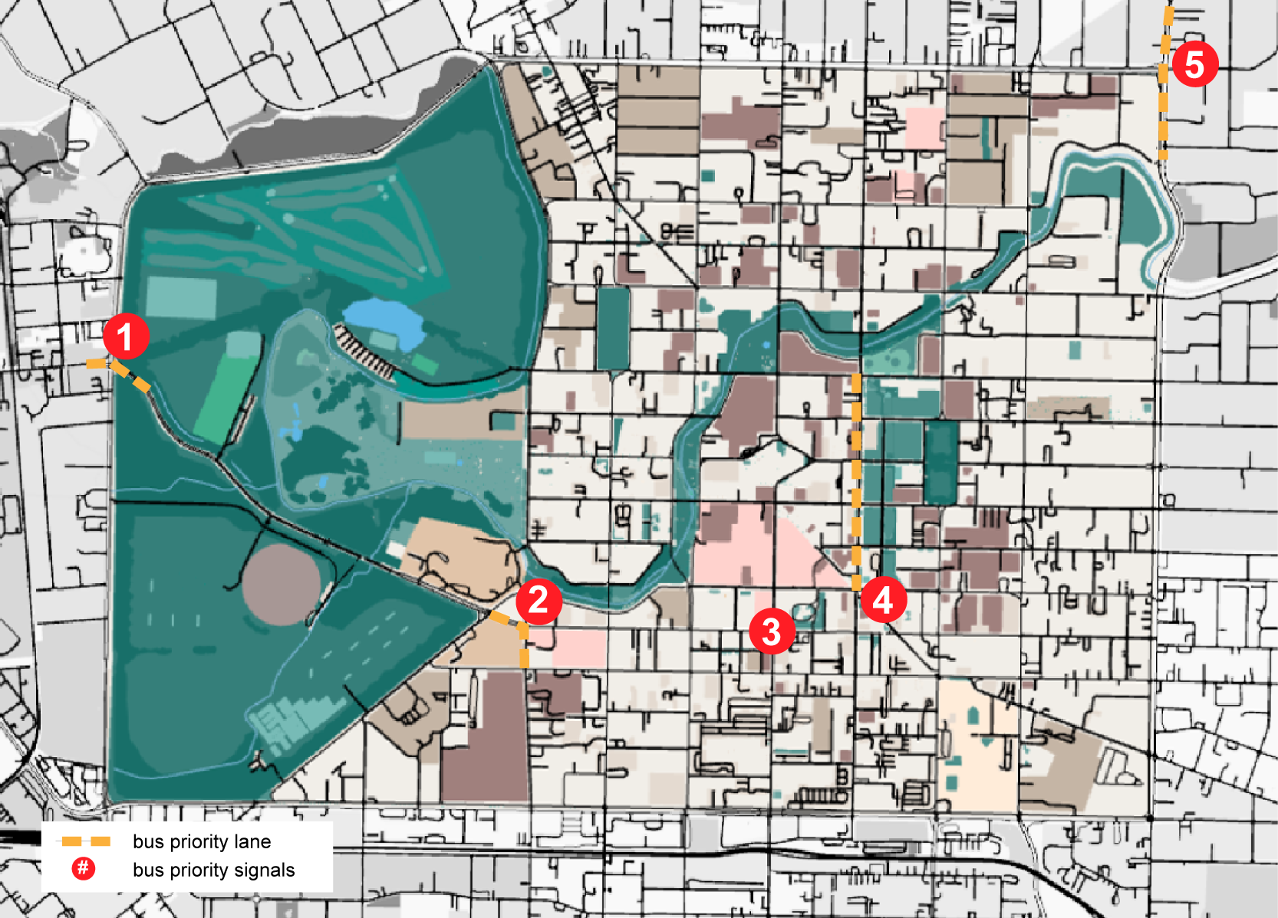

Figure 1**.** Map of BPS in Christchurch CBD adapted from OpenStreetMap using information gathered from CTOC (OpenStreetMap, 2019).

from various organisations in the public sector of Christchurch. Secondly, this paper investigates the effects of BPS, consisting of bus priority signals and bus dedicated lanes, in the multi-modal traffic dynamics of Christchurch CBD. The definition of ‘multi-modal traffic dynamics’ in this paper focuses exclusively on the relationship between cars and buses. Other transport modes have been excluded in the study due to various modelling limitations that are discussed further in the paper. Two simulation scenarios in Aimsun will be used to compare and explore the dynamic properties of BPS at the network scale. The first scenario will examine the multi-modal traffic dynamics with BPS in the CBD network and the second scenario will examine the network without any BPS in the network.

# LITERATURE REVIEW

Traffic control strategies can be divided into two main approaches: isolated or coordinated strategies. These strategies are categorised based on the applicable scale of the network. Isolated strategies consider only one intersection under undersaturated conditions, while coordinated strategies consider an urban zone with multiple intersections. According to Papageorgiou et al. (2003), coordinated strategies consist of fixed time coordinated control, coordinated traffic responsive strategies, model-based optimisation methods, store and forward based approaches, and integrated urban freeway traffic control. Notable time coordinated control strategies are MAXBAND and TRANSYST systems. MAXBAND is a traffic control strategy that tries to maximise the green wave duration to have more vehicles passing in the green time. TRANSYST is another fixed time strategy which iteratively finds the optimum signal timing based on historical data. However, these techniques have a significant drawback in real traffic conditions as they are heavily dependent on historical data. As a result, the fixed time coordinated controls perform poorly in abrupt changes to the traffic conditions and daily changing demands.

On the other hand, traffic responsive strategies, that are based on real traffic data, are more flexible and resilient to constantly changing traffic conditions. Sydney Coordinated Adaptive Traffic System (SCATS) is a traffic responsive control strategy that is being used in over 27 countries worldwide including New Zealand. SCATS is an urban traffic control system which optimises the traffic signals to minimise user travel time. SCATS follow a feedback algorithm which continuously modifies the signal phases and offsets the data collected from detectors to achieve optimal traffic condition. Many studies have concluded that SCATS is an effective tool in optimising the traffic flow of the urban network and minimising user travel time. (Chong-White and Shaw (2012); Martin and Stevanovic (2008); Slavin et al. (2013)). However, it should be noted that SCATS, as a fully actuated system, depend heavily on the detectors on the roads. In other words, the accuracy of the detector has a direct influence on the performance of the system. Moreover, it is widely regarded that SCATS perform poorly in oversaturated flow conditions (Keyvan-Ekbatani et al., 2019). According to Keyvan-Ekbatani et al. (2019), the inefficiency of SCATS can be alleviated with a gating control mechanism.

The Fundamental Diagram (FD) gives the relationship between the traffic speed (km/hr), traffic flux (veh/hr), and the traffic density (veh/km) of a road link. At free traffic flow, the FD, notably the flux‑density diagram, is characterised by a linear growth relationship between the flux and the density, where the slope represents the free-flow speed. Once critical density is reached, the link also reaches its maximum capacity. Beyond the maximum capacity, a congested flow would occur in the link and the relationship between the flux and density would decrease linearly until jam density is achieved. The Macroscopic Fundamental Diagram (MFD) is the application of the FD on a network scale. While the FD is a portrayal of the traffic performance of only one link, the MFD describes the traffic conditions of an entire road system in the network. As a result, the MFD is characterised with a range of associated critical densities in contrast to the FD with only one. MFD is also called the Network Fundamental Diagram (NFD), and in this paper, NFD will be used. The NFD is useful in analysing the traffic condition of the network. From the NFD, the average speed and the delay in the network can be easily identified. However, there are many weaknesses in the NFD, especially in freeway traffic conditions. Keyvan-Ekbatani et al. (2012) described the limitations of NFD under various traffic conditions. According to Keyvan-Ekbatani et al. (2012), NFD is stable when the traffic condition is homogenous, however, it is difficult for the freeway to have such conditions due to hysteresis phenomena that exist in the freeway system. This means that the NFD is not suitable in the analysis of freeways. Another weakness of the NFD can be found in a multi-modal network system in which it is unable to portray the relationship between different vehicle typology that exist in the system such as buses and cars. Thus, upon further research by Geroliminis et al. (2014), a new system was introduced by adding an extra dimension to the representation of 2D NFD to create a 3D NFD, which shows the bimodal properties of the urban network. With the application of 3D NFD, the dynamic relationship between cars and buses could be identified.

Aimsun is a dynamics traffic simulation software which provides various modes of network simulation including microscopic, mesoscopic and hybrid models (simulation of both microscopic and mesoscopic models). A distinct feature in Aimsun is its ability to reproduce dynamic traffic conditions in the microscopic simulation environment. It also provides extensive API tools to simulate diverse traffic conditions including BPS and SCATS. Aimsun also uses traffic assignment to distribute the traffic demand set from an O-D matrix by mimicking the user behaviours on path decisions. In Aimsun, stochastic route choices and dynamic user equilibrium are used to evaluate a traffic network. In this paper, Aimsun is used as the primary traffic simulation tool to model and evaluate the traffic dynamics of Christchurch CBD.

# METHODOLOGY

## DATA COLLECTION

Obtaining real traffic data is a critical step in simulating the real traffic conditions of an urban network. As illustrated in Figure 2, real traffic data was obtained from various organisations in the public sector of Christchurch. The 2018 Christchurch Assignment and Simulation Traffic (CAST) model was obtained from Christchurch City Council (CCC) to generate the traffic demand in the CBD. Latest GIS data and bus information was collected from Environment Canterbury (ECAN) and Metro bus. All SCATS signal plans and information on the signalised intersection in the CBD area was obtained from CTOC, a partnership of CCC, ECAN, and New Zealand Transport Agency (NZTA).

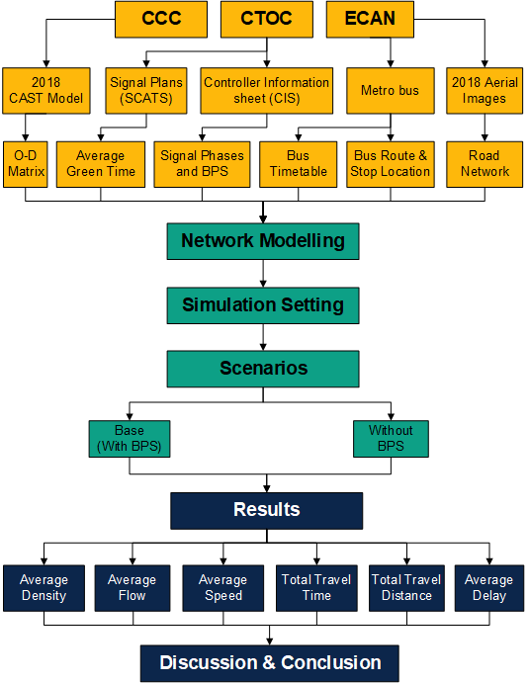

Figure 2. Diagram of research methodology.

## NETWORK MODELLING

To achieve an accurate replication of the CBD urban network in Aimsun, the most up-to-date aerial map (5 November 2018) of the CBD was used simultaneously with the latest imagery from Google Street View. Otherwise, a site visit was conducted to confirm the final road layout. Road speed limits were also implemented in the Aimsun network using the speed limit map from CCC (2019). The completed CBD network in Aimsun is depicted in Figure 4. The Origin-Destination (O‑D) matrix of the CBD has been imported in the Aimsun model from the 2018 CAST model. The CAST model is a macroscopic simulation model of Christchurch that has been developed using SATURN program and maintained by CCC since 2012. Figure 3 (a) shows the cordoned CAST model of the CBD with the associated O-D zones. To this end, as shown in Figure 4, a total of 203 centroids have been implemented in the Aimsun network to generate the traffic demand from the CAST model.

There is a total of 119 signalised intersections that were implemented in the Aimsun model using Controller Information Sheet (CIS) and SCATS History Viewer from CTOC. CIS consists of all signalised control information of the intersection, including the phase movements and the geometric design of the road intersection. SCATS History Viewer can be used to find historical signal data of all minimum, maximum, and average green time of the signal phases in all signalised intersection in Christchurch. The signal plans that are implemented in the Aimsun model are not coordinated and are programmed in fixed signal phases using the average green time generated from SCATS History Viewer. To represent a typical weekday setting of the traffic dynamics, as well as being consistent with the aerial imagery, a simulation date of 5 November 2018 was selected to base all the signal plans in the Aimsun network. It should be noted, that the effects of pedestrian and cyclist movements, in the multi-modal traffic landscape of the CBD, have been largely excluded in this paper. This is due to the limitations in the simulation process and the lack of reliable pedestrian and cyclist traffic data in Christchurch.

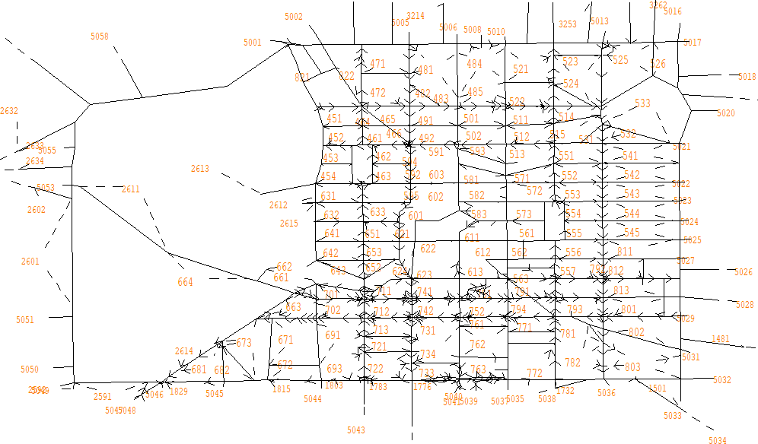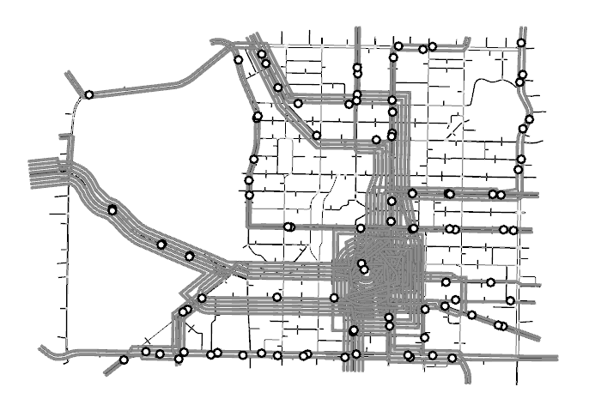

Figure 3. (a) Cordoned 2018 CAST model of CBD in SATURN, (b) The bus network of CBD modelled in Aimsun; bus routes (thick grey lines) and bus stop (circles).

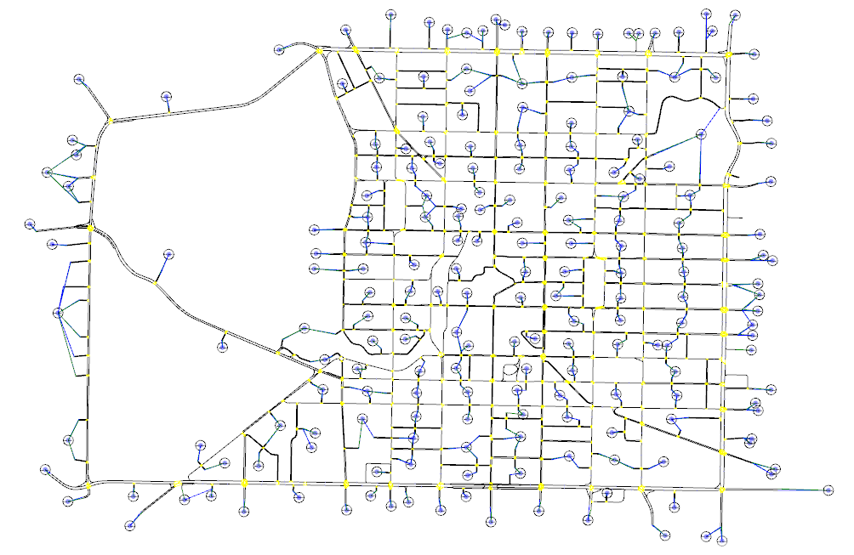

Figure 4. The urban network of CBD created in Aimsun.

An example of the modelling approach used to simulate a signalised intersection (Montreal/Salisbury/Victoria Street) in Aimsun is illustrated in Figure 5. Figure 5 shows that the right turning approach in phase A intersects with the forward approach. Therefore, the right turning movement is assigned a give way rule as defined in the New Zealand road code. A stop line was created in the middle of the intersection to allow turning vehicles to approach the intersection before they make the turn as observed in real-life Christchurch traffic. Figure 6 shows the signal cycle time implemented at Montreal/Salisbury/Victoria Street intersection with four seconds of yellow time as identified in CIS.

The latest Metro bus map and timetable have been used to simulate bus stops and bus routes in Aimsun. A total of 95 bus stops and 14 bus routes (north and south directions) were implemented in the CBD model. Figure 3 (b) shows the completed bus network in Aimsun. Thick grey lines indicate simulated bus routes and the circles show the location of all bus stops in Aimsun. Dwelling time of 30 ± 10 seconds have been used for all bus stops to simulate real bus dynamics during unloading and loading of passengers. The BPS in Christchurch, as identified in Figure 1, was also implemented in the Aimsun model. In the simulation, unlike other fixed signals, the priority signals were classified as actuated signals. As a result, the associated signal phases are only requested upon the detection of the buses that are equipped with the priority assignment.

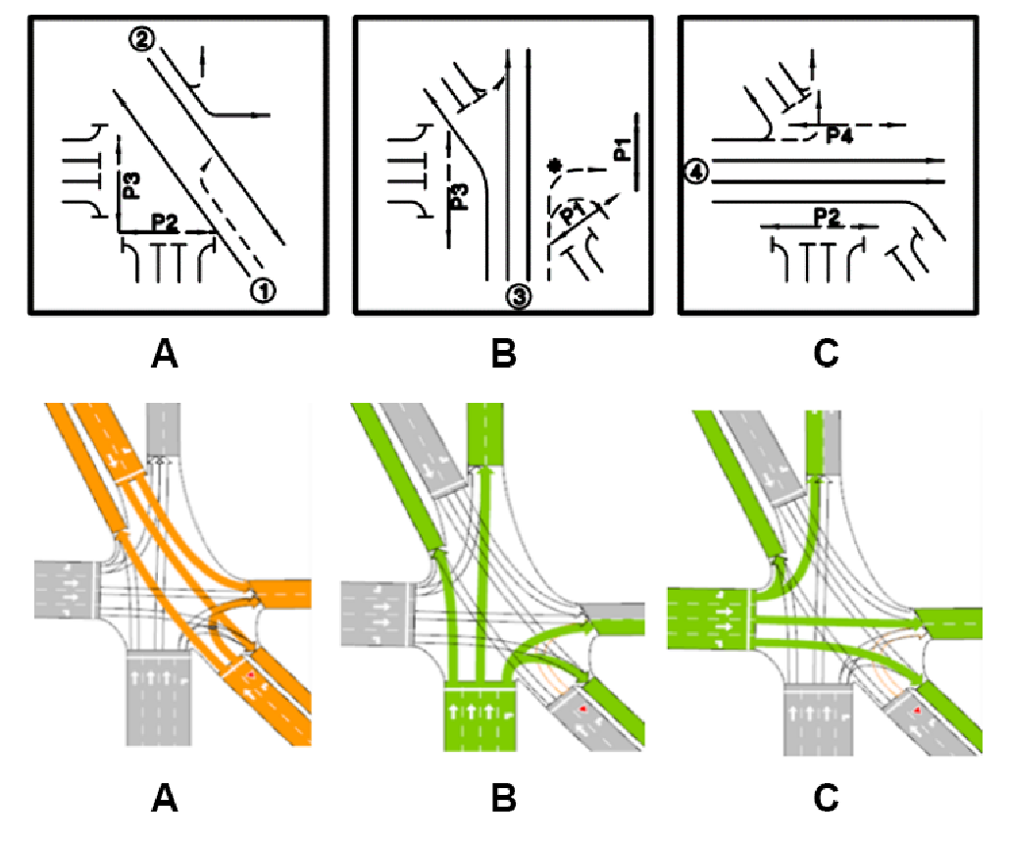

Figure 5. Comparison between signal phases in CIS (top) and modelled Aimsun signal phases (bottom).

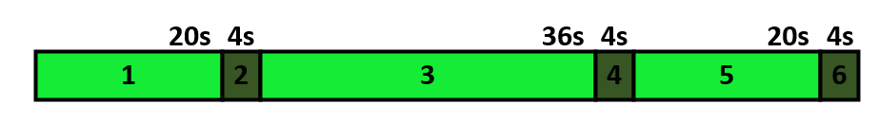

Figure 6. Fixed signal cycle time at Montreal/Salisbury/Victoria Street intersection.

## SIMULATION SETTINGS

The traffic demand profile of the morning peak period (7:00 AM – 9:00 AM) was introduced in the Aimsun model from the O-D matrix that was generated in the 2018 CAST model. Figure 7 shows the traffic demand profile of the two-hour duration with a gradual increase towards the peak demand of 12,870 veh/hr from 8:00 AM onwards. A total traffic demand of 46,382 vehicles was simulated. Detectors have been installed mid-way along each road section in the Aimsun model and measured every 90 seconds to collect the simulated data. Dynamic traffic assignment was enabled in the simulation with C-logit based route choice model updated every 90 seconds. Aimsun generates stochastic simulation results, therefore, 15 replications (different random seeds) were carried out to create the NFD of the CBD urban network. The replication seed numbers were used consistently for both scenarios for homogeneous comparison.

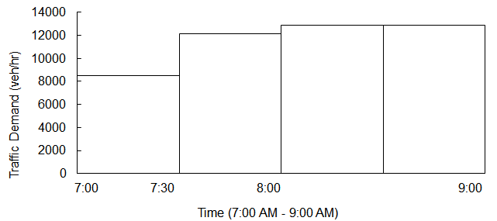

Figure 7. Demand profile (7:00 AM – 9:00 AM).

The NFD was created using the weighted averages of the results. Thus, Aimsun API was used. The main function of the API was to derive the average weighted density from the density generated from the detectors in the Aimsun network. In the API, Equations 1 and 2, developed by Geroliminis et al. (2008), were used to derive the average weighted values, where $q_{i}$ is the flow from each detector, $l_{i}$ is the length of each road section with detectors, and $k_{i}$ is the density generated from each detector. Equation 1 was used to derive the average weighted flow and Equation 2 was used for the average weighted density.

|  |  |  |
| --- | --- | --- |
|  | $$q^{w}=\frac{\sum_{i}{q_{i}l_{i}}}{\sum_{i}{l_{i}}}$$ | (1) |

|  |  |  |
| --- | --- | --- |
|  |  | (2) |

## SIMULATION SCENARIOS

Two simulation scenarios were considered in Aimsun to investigate the effects of BPS and the multi-modal traffic dynamics of the entire Christchurch CBD urban network. They are as follows:

* ***With BPS (base condition):*** The urban network model of Christchurch CBD based on the latest GIS data and simulation settings described in the previous section. This includes the five locations in the CBD where BPS have been implemented as indicated in Figure 1. The five locations are the intersections at Deans/Riccarton, Antigua/Tuam, Bus interchange/Tuam, Bealy/Fitzgerald and lastly, along Manchester Street from Lichfield Street to Armagh Street.
* ***Without BPS*:** The urban network model based on the above scenario without any BPS in the network. This model removes all BPS from the base condition including all dedicated bus lanes and bus priority traffic lights in the CBD.

# RESULTS

This section provides a summary of the findings of the simulations and provides an examination of the results to discuss further in the paper.

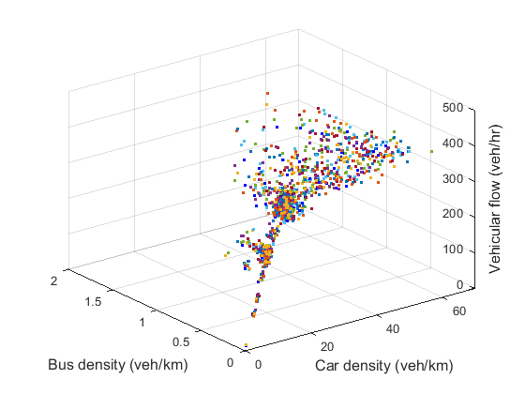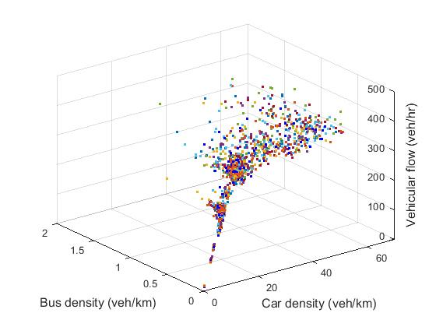

Figure 8. (a) 3D NFD – With BPS (base condition) model, (b) 3D NFD – Without BPS model.

**WITH BPS (BASE CONDITION)**

Figure 8 (a) shows the 3D NFD of the base CBD model. The different colours represent the 15 replications that were undertaken for the simulation of each scenario. The 3D NFD shows that the relationship between car density and vehicular flow follow an inverted curve shape that is a characteristic of the FD. The critical car density occurred in the range between 40 veh/km and 50 veh/km while the network capacity is approximately 410 veh/hr.

**WITHOUT BPS**

Figure 8 (b) shows the 3D NFD of the CBD network without BPS. Similar to Figure 8 (a), the relationship between the car density and vehicular flow follows an inverted curve shape. The critical car density occurred in the range between 40 veh/km and 50 veh/km while the network capacity is approximately 430 veh/hr. The network capacity is slightly higher in the network without BPS compared to the base model. However, the critical density is almost identical in the two scenarios.

## COMPARISON OF RESULTS

Figure 9 shows the NFD contour plot of the average bus to car density with a colour map depicting the vehicular flow for both scenarios. The contour plot represents the flow conditions influenced by the movements of buses and cars. From the contour plot of the two networks, it can be deduced that the network without BPS can sustain more vehicular flow with a higher bus density. When the car density is at 10 veh/km, the base network can hold a bus density of 0.6 veh/km while the network without BPS can hold up to a bus density of 0.9 veh/km. Moreover, this difference is outlined in the red dashed line in Figure 9 (b). This indicates that the network without BPS is more sustainable in its interaction between cars and buses and are able to serve more buses without the compromise of high capacity.

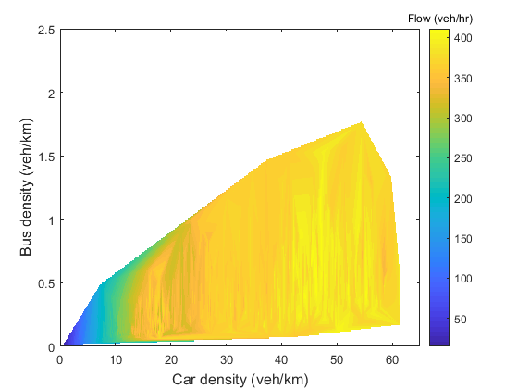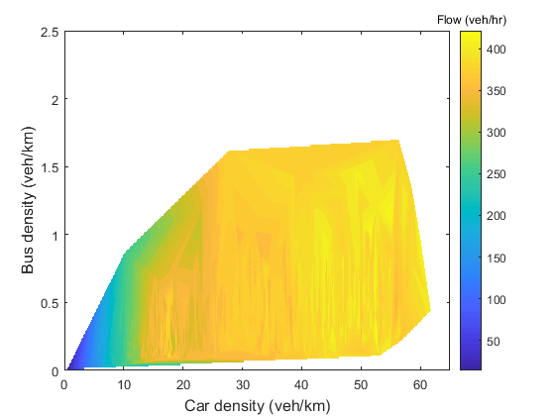

Figure 9. (a) NFD Contour plot – with BPS (Base condition), (b) NFD Contour plot – without BPS.

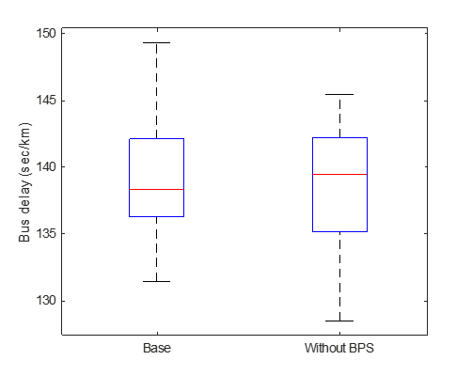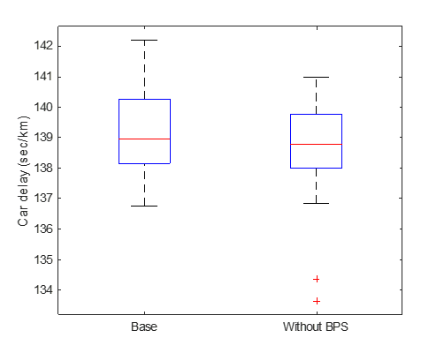

Figure 10. (a) Box plot of average bus delay, (b) Box plot of average car delay (red line showing the median, top and bottom of each box are 75th and 25th percentiles of the samples).

Figure 10 shows the box plot comparison of the two scenarios against the overall bus delay and car delay of the network. The base model has a median average bus delay of 138.4 sec/km while the model without BPS has 139.5 sec/km. The maximum bus delay in the base network is 149.4 sec/km, which is higher than the maximum bus delay in the network without BPS of 145.5 sec/km. The median car delay of the base model is 139.0 sec/km, which is slightly higher than the median of the model without BPS of 138.8 sec/km. Again, the difference is not significant enough to compare the performance of each network.

The discrepancy between the two scenarios is identified in Table 1. Similar to the box plot comparison, no clear differences can be observed from the results. However, the Total Travel Distance (TTD) of the car in the network without BPS was found as 85,852.7 km in contrast to the base network of 84,092.1 km. This result suggests that the throughput of cars in the network without BPS is higher by 1,760.6 km compared to the base network during the simulation period of two hours. However, it is noted that this difference is only two percent of the overall TTD in the entire network of the CBD, which compared to the number of cars in the system cannot be considered as a significant difference.

|  |  |  |
| --- | --- | --- |
|  | **With BPS (base condition)** | **Without BPS** |
| *Average Car Speed (km/hr)* | 20.4 | 20.4 |
| *Average Bus Speed (km/hr)* | 12.4 | 12.2 |
| *Total Travel Time of Car (hr)* | 4999.8 | 5035.8 |
| *Total Travel Time of Bus (hr)* | 42.1 | 42.3 |
| *Total Travel Distance of Car (km)* | 84092.1 | 85852.7 |
| *Total Travel Distance of Bus (km)* | 481.8 | 483.0 |

Table 1. Comparison of results (median).

# DISCUSSION

## FINDINGS

The results show that the effects of BPS in the simulated network of Christchurch CBD are minimal and for some instances, the network performance was slightly better in the network without BPS than the base model with BPS. Overall, it is difficult to find any significant differences between the two networks. This is contrary to the general assumption that BPS would improve the performance of the bus network in the system. However, this is somewhat expected, as the results are based on a relatively large network and the noise from such a large model would likely have masked any differences. Also, there are only five intersections with BPS implementation among 119 signalised intersections in the entire CBD network and its effects were unlikely to have propagated to the network level. Therefore, it should be noted that the results do not prove that BPS is ineffective within the multi-modal traffic network, but that its effects were simply not apparent within the larger traffic analysis of the CBD at the network scale. It is likely that the effects of BPS may have been localised along certain links in the CBD network. To this end, it is worth considering the effect of BPS on a local scale and compared to that of the network scale for further investigation.

One interesting observation that can be identified in the simulation is the sensitivity of simulation results related to buses. The number of buses during the simulation period is relatively small compared to the number of cars in the network. Therefore, even the smallest change to the delay in buses can produce contradicting results. On the other hand, due to the sheer number of cars in the network, any minor changes to the car dynamics in the network will not cause an overall change at the network scale.

## LIMITATIONS IN SIMULATION

Despite using real traffic data to develop a realistic traffic model of Christchurch CBD, the resultant traffic model in Aimsun is not a fully functioning replica of the real traffic network of Christchurch CBD. This is the result of the many limitations associated with the modelling and the simulation processes in the Aimsun environment. One important limitation of the developed Aimsun model is the fixed signal plans that were used in the model as opposed to a coordinated responsive traffic control mechanism of SCATS in real-life. The fixed signal plans in the model were created using the average green time that was generated in SCATS History Viewer. Therefore, even though the signal plans are based on SCATS, the dynamic properties of SCATS have been reduced to a simplified static representation of what is an active system. Also, as part of the simplification process, other aspects of the traffic signal system in the Aimsun model have been largely overlooked including the all-red phase in the signal cycle. To this end, it is worth considering the integration of SCATS in the developed Aimsun model of Christchurch CBD to enable a more accurate emulation of the adaptive control mechanism in Aimsun simulations.

Secondly, Aimsun is a traffic simulation tool that is inherently based on the vehicle traffic model. Therefore, the simulation of other modes of travel including the traffic dynamics of pedestrian flow is still in its infancy. Vehicular movements are complex, but they can be simulated through many traffic assignments such as the car-following model. On the other hand, pedestrian movements are difficult to predict through a mathematic model due to the dynamic and disordered behaviours on the streets. As a result, the traffic dynamics of pedestrians have been largely overlooked in the modelling process except in small instances where a dedicated signal phase was employed at the signalised intersection. It is noted, however, that the central city is driven by multi-modal traffic dynamics, especially the pedestrian flow. The pedestrian dynamics is fundamental in the simulation of the traffic behaviour in the central city due to their priority over vehicles. As more cities adopt city policies towards people-friendly cities, this notion will only continue to grow and its influence in the multi-modal traffic dynamics in the central city would be deemed too important to be excluded in the analysis.

Another important aspect to consider is the shared roads in the urban network of Christchurch CBD. During the simulation, it was observed that a significant number of vehicles travelled through the shared roads during the peak period. Initially, due to the low-speed limit (10km/hr), there was low usage of the shared roads for travel. However, with a gradual increase in the traffic demand of the network and as congestion started to form in the links, an increase in shared road usage was observed. This is within reason in the simulation environment as the simulated vehicles are programmed to seek the shortest path based on a stochastic mechanism. However, in real-life, cars are discouraged from using the shared pathway through various traffic control mechanism in the geometric as well as the behavioural design of shared roads. To simulate real conditions in Aimsun, the shared roads should be less attractive to path users.

Another limitation is related to the simulation of buses and their associated traffic behaviour in Aimsun. First, the bus dwell time in the simulation was assumed as 30 ± 10 seconds. In real-life, the dwell time will range between zero to a few minutes depending on the demand of the bus service. Also, it was observed during the simulation that a significant bus delay was experienced at the bus interchange exit on Lichfield Street. The localised bus delay was due to the simulated buses that were unable to enter a congested road at the interchange exit with a large queue of cars on Lichfield Street. This was especially observable when a give way assignment was set in Aimsun for the bus movement out of the bus interchange based on real traffic assignment at the site. However, in real life, the opposite would occur, and cars would give way to buses during congested road conditions. This behaviour may be cultural-specific but at least in New Zealand, a pseudo-rule exists among all drivers to give way to vehicles that struggle to enter the road during congested road conditions. In order to simulate this behaviour, the give way rule was removed for the interchange bus exit movement in Aimsun simulation. This shows the limitation of Aimsun to be flexible in simulating a cultural-specific behaviour of vehicle dynamics in New Zealand.

# CONCLUSION

This paper considers the multi-modal traffic dynamics of Christchurch CBD. The traffic network of Christchurch CBD was modelled in the microscopic simulation environment of Aimsun using real traffic data of Christchurch. Two simulated scenarios in Aimsun were used to investigate the effects of BPS in the urban network of Christchurch CBD. The first scenario was the simulation of the base condition, representing the current urban network of Christchurch CBD with BPS in the network. The second scenario was the traffic simulation of the CBD without BPS in the network for comparison and analysis against the base condition.

The traffic analysis of the two scenarios with and without BPS in the CBD network was found to be very similar with negligible differences between the two networks. This is somewhat expected, as the results are based on a relatively large network and any benefits of BPS from such a large model would likely have been masked. This is more likely the case in a network with only five BPS intersections among 119 signalised intersections in the entire CBD network. Therefore, it should be emphasised that the findings do not prove that BPS is ineffective in the system but that its effects were simply not apparent within the larger traffic network analysis at the CBD level. This is the limitation of this paper. It is likely that the effects of BPS may have been localised along critical bus routes with BPS, notably Manchester Street. However, further study would be warranted to validate this assumption.

It is important to note that the developed traffic simulation model of Christchurch CBD in Aimsun is not a fully functioning representative of the real traffic network of Christchurch CBD. There are many limitations to the modelling and simulation processes in Aimsun. First, the traffic simulation was carried out using fixed time signals whereas, in a real-life, SCATS is used. Second, the presence of other types of vehicles such as cyclists, pedestrians, ambulance and others were largely ignored in the simulation. There were also issues with modelling an appropriate and realistic driver behaviour along special road designations, notably the shared roads as well as simulating a culturally specific behaviour in the Aimsun environment, that is the pseudo-rule in New Zealand to give way to adjoining vehicles in congested road conditions. Furthermore, there was a lack of calibration used in the simulation process and further investigation is required to validate the findings in the paper for industry applications. Therefore, it should be also noted that the findings and the methodology developed in this paper are merely a start to wider research of the multi-modal traffic dynamics as well as the development of a realistic traffic simulation model of Christchurch CBD.

To this end, it is recommended to further develop the Aimsun model of Christchurch CBD for the better understanding of multi-modal traffic dynamics of the city, as well as contributing to the future transport planning of Christchurch. More specifically, the developed Aimsun model can be improved by integrating SCATS in Aimsun and emulating an adaptive traffic control system as experienced in real traffic network of Christchurch. Secondly, the current model is bi-modal and therefore, the inclusion of pedestrian, bicycle and other transport modes would give a broader understanding of the multi-modal traffic dynamics of the city. Thirdly, street parking assignment in Aimsun would give a more realistic simulation result and play a vital role in understanding the complex traffic dynamic of the CBD area. Lastly, the O-D matrix from the latest census data of Christchurch should be used to simulate the most up to date representation of traffic conditions in Christchurch CBD.

# ACKNOWLEDGMENTS

This project was only made possible through the collaboration between the University of Canterbury (UC), CTOC, CCC, and ECAN. A special acknowledgment to Chris Bealing from CTOC and Hamid Mirbaha from CCC in assisting the authors in the various tasks involved in the project including data collection and traffic software implementations.

# AUTHOR CONTRIBUTION STATEMENT

Hee Seung Lee and Kyungrok Oh are the main authors and have carried out the research (e.g. literature review, data collection, data analysis, modelling, simulation, results and discussion) under the supervision of Dr. Keyvan-Ekbatani (e.g. leading the research, developing research ideas and interpretation of results) along with co-supervisor Dr. Ngoduy (e.g. research discussion and interpretation of results) and associate supervisor Mansour Johari (e.g. data analysis and network modelling review).

# REFERENCES

Canterbury Earthquake Recovery Authority, 2013. *An Accessible City – Christchurch Central Recovery Plan: Replacement transport chapter – October 2013*,Christchurch, Canterbury Earthquake Recovery Authority.

Chong-White, C., & Shaw, S., 2012. *Indicative traffic control performance of the SCATS installation in New South Wales including Sydney*, paper presented at 19th ITS World Congress, Vienna, Austria, 22 October 2012 through 26 October 2012, viewed 17 May 2019.

Christchurch City Council, 2019. *Speed Limit Map*, viewed 9 September 2019, <<http://ccc.govt.nz/>>.

Geroliminis, N. and Daganzo, C.F., 2008. Existence of urban-scale macroscopic fundamental diagrams: Some experimental findings. *Transportation Research Part B: Methodological*, *42*(9), pp.759-770.

Geroliminis, N., Zheng, N. and Ampountolas, K., 2014. A three-dimensional macroscopic fundamental diagram for mixed bi-modal urban networks. *Transportation Research Part C: Emerging Technologies*, *42*, pp.168-181.

Harris, D., 2018. *Commuting in NZ’s car capital costs Christchurch drivers $10,000 a year*, viewed 16 May 2019, <https://www.stuff.co.nz/the-press/news/104351763/commuting-in-nzs-car-capital-costs-christchurch-drivers-10000-a-year>.

Keyvan-Ekbatani, M., Kouvelas, A., Papamichail, I. and Papageorgiou, M., 2012. Exploiting the fundamental diagram of urban networks for feedback-based gating. *Transportation Research Part B: Methodological*, *46*(10), pp.1393-1403.

Keyvan-Ekbatani, M., Gao, X., Gayah, V.V. and Knoop, V.L., 2019. Traffic-responsive signals combined with perimeter control: investigating the benefits. *Transportmetrica B: Transport Dynamics*, *7*(1), pp.1402-1425.

Martin, P.T. and Stevanovic, A., 2008. *Adaptive Signal Control V-SCATS Evaluation in Park City, Utah* (No. MPC Report No. 08-200).

OpenStreetMap, 2019, Christchurch CBD, 43°31'54.6"S 172°37'57.8"E, 2D map, viewed 15 May 2019, < https://www.openstreetmap.org/#map=15/-43.5303/172.6284>.

Papageorgiou, M., Diakaki, C., Dinopoulou, V., Kotsialos, A. and Wang, Y., 2003. Review of road traffic control strategies. *Proceedings of the IEEE*, *91*(12), pp.2043-2067.

Slavin, C., Feng, W., Figliozzi, M. and Koonce, P., 2013. Statistical study of the impact of adaptive traffic signal control on traffic and transit performance. *Transportation Research Record*, *2356*(1), pp.117-126.

Statistics New Zealand, 2015. *Commuting patterns in greater Christchurch: Trends from the Census of Population and Dwellings 2006 and 2013*, viewed 16 May 2019, <http://www.stats.govt.nz/>.