**AUTONOMOUS SHUTTLES AS MOBILITY AS A SERVICE**

Julia Lockhart, Final Year BE(Hons) in Civil Engineering Student, The University of Auckland, [jloc318@aucklanduni.ac.nz](mailto:jloc318@aucklanduni.ac.nz)

Arisha Zaman, Final Year BE(Hons) in Civil Engineering Student, The University of Auckland, azam538@aucklanduni.ac.nz

Douglas Wilson, PhD, BE(Civil), NZCE(Civil), CMEngNZ, Senior Lecturer, The University of Auckland, [dj.wilson@auckland.ac.nz](mailto:dj.wilson@auckland.ac.nz)

**ABSTRACT**

Shared autonomous vehicles (SAVs), could be an effective part of future transport system solutions that enable better access to mass transit systems. However, the effective and safe utilisation of such vehicles requires critical thinking on how to best implement them to ensure potential benefits are realised. An evaluation framework was developed in this research that analyses geospatial locations that could gain the greatest benefit for improving first and last km outcomes for transport journeys using SAVs in areas with limited public transport (PT) access. Services will act as Mobility as a Service (MaaS) for users, especially the transport disadvantaged, to comfortably and conveniently access the initial and final legs of their transport journeys. The possible absence of future drivers at some point in the future, means that crashes have the potential to be significantly reduced as the majority of current crashes have human error as a significant contributing factor. This, if managed appropriately, could also lead to a reduction in private vehicles on the road thereby reducing congestion and promoting sustainability. SAVs can allow the disabled, elderly and low-income individuals to have greater access to mass transit and therefore to increased opportunities for business, social or cultural purposes. This would allow greater integration and participation in communities with similar opportunities afforded to the transport advantaged. The goal is not only to achieve equity within our current transport infrastructure, but to grow thriving communities and improve PT ridership.

This paper will discuss the criteria that was considered in developing an evaluation framework. It will also explore areas in Auckland where SAVs should be trialled based upon scoring well against evaluation criteria developed.

**1.0 INTRODUCTION**

Transportation networks in cities often involve various forms of modal travel. In cities like Auckland, that have significant geospatial challenges and limited heavy permanent mass transit infrastructure, such as rail that does not extend far past the CBD and certain tributary lines, results inlimited potential PT patronage catchments and therefore ridership attractiveness. Current PT systems are supplemented with other forms of public travel such as an extensive bus network and a growing active mode network such as walking, cycling and shared user paths. Add to this, significant current and projected population growth requires innovative transport solutions. However, these routes are also limited which results in large suburban or remote areas having to rely on privatised travel predominantly by car. These areas are often futher away from economic opportunities and jobs, trip journeys are longer, and when combined with areas that are more socio-economically deprived a higher proportion of potential users are mobility disadvantaged. With users from these areas having to rely on non-subsidised car travel, this only makes their economic and accessibility situation worse

With the government heavily investing in intelligent transport systems (Ministry of Transport, 2014), considering autonomous vehicles (AVs) or driverless shuttles is a worthwhile option to cope with increased demands and facilitate vulnerable transport users to become more connected with their surrounding communities and the rapid transit network. Research into these AVs show a great benefit of reduction in cost and an increase in safety with full implementation. Integration of SAVs with our current infrastructure would provide a seamless way for users to complete the first and last legs, or “first km-last km” of their transport journeys. To achieve this, it is important to employ SAVs as MaaS, a model aimed at moving away from privately owned vehicles in favour of a single integrated mobility system consisting of various transport services that are readily accessible by all.

This study aimed to create an evaluation framework to analyse and numerically score potential areas and their viability for implementing SAVs, and use data analytics techniques to test the framework established.

**2.0 LITERATURE REVIEW**

**2.1 Introduction**

A literature review was undertaken to provide background research into the field of Autonomous Vehicles (AV’s) and Mobility as a Service (MaaS). A broad understanding of the topic was needed to identify gaps in previously conducted research, exploring areas where further studies could be undertaken.

**2.2 MaaS**

MaaS refers to a single transport service provider using various transport modes to form an integrated network that is readily accessible by users. It aims to shift away from conventional commuting that favours the use of private vehicles in order to encourage PT use based on flexibility, reliability and frequency. Conceptualised as a sustainable system that brings together private and PT modes, it provides great opportunities for shared travel to be more efficient, cheaper with a single payment model, and flexible in order to meet riders’ mobility needs (Signorile et al., 2018).

Mobility is a significant benefit in our society, as it allows access to job opportunities and public facilities to improve individuals’ lifestyles. AVs used for privatised use do not solve many congestion or traffic problems, and could create more. Using AVs as MaaS, such as SAV ride shares or shuttle means potentially less cars on the road, and increased access for people to city centres. An example of implementing such a service is in Singapore where it is envisaged that AVs form part of the PT network as complementary “first km-last km” services in the city (Huiling and Goh, 2017).

**2.3 Implementation**

There are many advantages associated with releasing AVs into our current transportation network; namely safety, efficiency, environmental and social outcomes which all affect the development of a country. These factors are discussed individually below.

*2.3.1 Safety*

In the U.S. alone, there are 5.5 million crashes a year, with 93% of them attributed to human error (Fagnant and Kockelman, 2015). It is estimated that the economic burden of this is roughly around $277 billon, halting economic growth and contributing to a more un-safe society. This cost does not take into consideration of the side effects of such crashes such as reduced productivity, congestion and damage to surrounding infrastructure and property. In New Zealand the social cost of crashes in 2017 was reported to be approximately $4.8 Billion (MoT, 2018).

A fully autonomous transport system (which is many decades away) has been reported as potentially resulting in a reduction of vehicle crashes by up to 64% (Olsen, P. November 2018), due to better prediction of road conditions and reduction in driver error (Bagloee1, S, A. Tavana, M. Asadi, M. Oliver, T. August 2016) (Sun, Y. Olaru, D. Smith, B. Greaves, S. Collins, A. 2017). It is also worth noting that the number of such incidents have gradually decreased over the years with the addition of more and more automated and safety driver assistance features into vehicles (Olsen, 2018). The effect of human drivers can be further displayed by considering Google’s self-driving car project, Waymo. It was revealed in a crash report that although their autonomous vehicles currently being trialled have been involved in a number of minor accidents, only one of them was directly due to the fault of the Waymo AV driving system?? (Marshall and Davies, 2018). There have however been a number of reported crashes that have occurred due to the non-continuous nature of operators / drivers interacting with the AV / driver assisted system. It is expected that these types of incidents will continue for some time as we learn from a semi automated / partly driver-less transport future where these human / automation interactions will be a complex and difficult transition.

*2.3.2 Efficiency*

SAVs can reduce congestion when all or at least 50% penetration of AV cars will be part of an integrated infrastructure network with the ability to forge out traffic conditions for many kilometres ahead as well as communicating with other vehicles. Shared autonomous vehicles are preferred over privatised AV’s, as they don’t require an additional empty journey to find parking or driving back to its origin. The reduced congestion of SAV’s is a direct result of the increased safety and therefore lowered crash rate discussed above as there will be more time and resources available to facilitate a more efficient network. The current capacity of roads will increase as the lanes will be more efficiently packed, resulting in smaller headways between vehicles and discreetly organised platoons (Fagnant and Kockelman, 2015).

*2.3.3 Environmental*

Due to emerging technologies, AVs will utilise enhanced and more energy efficient driving known as eco-driving or electric vehicle mode (hybrids and EV’s), examples of which include the widely-known cruise and now adaptive cruise control as well as more gradual acceleration and deceleration profiles. Studies have shown that this will improve fuel economy, with estimates ranging from 4% to 39% (Bagloee et al., 2016).

*2.3.4 Social outcomes*

According to BTS 2016, U.S. households with incomes below $25,000 are eight times as likely to not own a private vehicle compared to their richer counterparts (Martin, 2018). The utilisation of AVs will significantly improve these users’ quality of life as they will potentially have have greater shared access to more job opportunities as well as amenities and recreational facilities. It has been documented in the U.S. that vehicle ownership is decreasing, leaving room for vehicle sharing to rise (Bagloee et al., 2016).

**2.4 Legal policies**

There are currently limited rules and legal requirements for AVs worldwide due to its newness and developing technology. New Zealand in particular has lax legislation as a driver is not explicitly required for a vehicle to be used on roads, making it an ideal location to test AVs (Ministry of Transport, 2016). The Ministry of Transport recognises that AVs should be fully used to their potential and have subsequently released an action plan detailing how they will advocate Intelligent Transport Systems. They are intent on using them to help the transport disadvantaged in addition to other benefits such as increased efficiency, therefore reduced emissions, and enhanced safety (Ministry of Transport, 2014). New Zealand has however in recent years been slipping down the country ranking ‘readiness scale’ from 9 in 2018 to 11 in 2019 (KPMG, 2019) for preparedness of implementing connected and autonomous vehicles into our transportation system in comparison to comparable countries.

**2.5 Economic considerations**

With the use of a greater proportion of connected and autonomous vehicles, there potentially is a a decreased need for parking, due to vehicles being used as shared services or available as mobility on demand. Increased safety would decrease the price of insurance for vehicle companies and users, but until the system is fully implemented, the risk of AVs in the current system is shown to cause higher insurance prices (Sun, Y. Olaru, D. Smith, B. Greaves, S. Collins, A. 2017). It is predicted that the market for autonomous vehicle technology will grow up to $42 billion by 2025 and U.S. auto sales will drop by 40% in response to that (Ohnemus, M. Perl, A. 2016). There will be a high transition cost between old auto sales and AV technology, but the price of AVs should hope to drop from $100,000 to $10,000 after 10 years of mass production (Ohnemus, M. Perl, A. 2016).

**2.6 Public perception**

It has been widely discovered that AVs are more likely to be used and trusted by younger males out of any other demographic (Haboucha et al., 2017). This is likely because younger generations have grown up with technology and are inclined to trust it from an early age. Common fears include safety and any sort of malfunction, affordability, environmental factors and mobility (Haboucha et al., 2017).

A study by the Israel Institute of Technology (Haboucha et al., 2017) found 44% of users preferred regular cars and 32% were in favour of private AVs, leaving 24% wanting SAVs. As those with higher education leaned towards AVs, it is important to better educate the general public about AVs if employed as MaaS. Despite this, the existing carsharing models give a hopeful glimpse into the future of using AVs as MaaS. An investigation by Shaheen and Chan (2016) revealed that the car sharing industry has significantly grown since the 1980s, particularly in Europe with 2.2 million participants and North America with 1.6 million in 2014.

**2.7 Gaps in research**

There has been previous research undertaken into AVs and accessibility, however, nor reported research conducted in the evaluation of areas where AV shuttles could be successfully implemented for better accessibility for transport disadvantaged users.

**3.0 METHODOLOGY**

**3.1 Site Selection**

A framework was created to evaluate various criteria and rank different geo-spatial areas to assess whether an autonomous vehicle shuttle service would be feasible and beneficial to operate. The specific SAV vehicle types that were considered for the first km-last km journeys have the capacity for 12-14 people. A potential trial may be held in Auckland in early 2020 running these shuttles around the evaluated areas.

The main aim of the project was to assess the likelihood and success of implementing AV’s around Auckland, and providing prioritised justification to areas where AV’s would be needed. Therefore, this research method focuses on developing a detailed site specific framework. Two areas were selected to develop this framework, Mangere Bridge and West Harbour as seen in figure 1 below. Both of these areas were initially selected due to their mobility and/or economic disadvantages and high population growth.

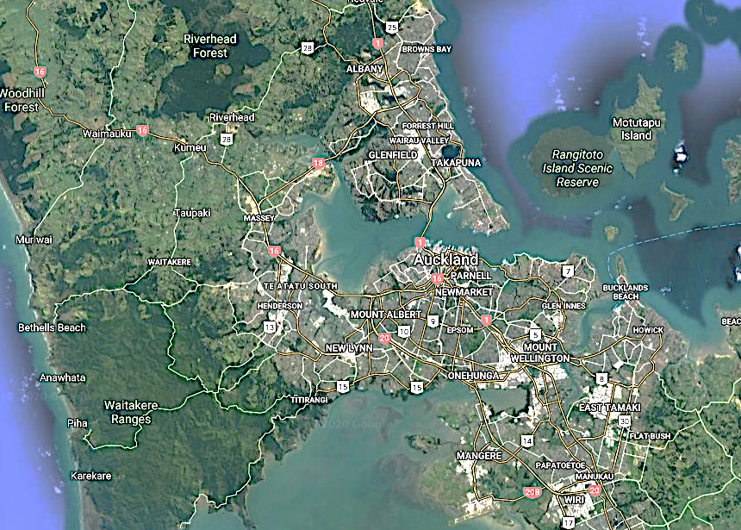

West Harbour

Mangere Bridge

Figure 1: Site selection locations across Auckland

**3.2 Factors Selected**

The specific AV vehicle that was considered when creating this framework, was the Olli shuttle by Local Motors. This vehicle is run using an electric motor, and cannot exceed grades above 14%. Therefore, one of the first factors identified was ensuring the area route which was chosen did not contain any grades exceeding this limit (factor 1). The AV shuttles are required to make multiple stops in order to pick up transport users, therefore there needs to be a sufficient number of collector roads (factor 3) for safety and convenience of passengers and to ensure not to adversely impede arterial road traffic.

The aim of this study was to ensure success in implementing the SAV’s in these areas. Areas which would benefit most from autonomous shuttles would be those with low employment (factor 7), low income (factor 5) and a high number of vulnerable transport users (factor 9). The goal of connecting mobility disadvantaged communities / users safely to mass transit will mean easier and quicker access to better job opportunities and public facilities. To make the most out of these shuttles a reasonably high population density (factor 2) is advantageous to the success of the SAV’s in these areas.

The SAV shuttles connect users to and from their homes to mass public transport. Therefore, the distance to the closest transport hub and access to other forms of transport such as micro-mobility devices (factor 11) were also factored into the evaluation framework. The safety of these other modes (factor 10) were also important to consider whether people would use the SAV’s provided for a connected travel journey. If people didn’t think other modes were safe or close enough they would most likely not bother using those first and last mile modes to access the public transport trip and drive personal cars instead, therefore car ownership (factor 8) and distance to mass PT (factor 4) was also included).

The last factor taken into account was land use type in the areas (factor 6). Areas which would mainly benefit from the implementation of SAV shuttles were suburban residential zones, as they often lacked connection to public transport. Areas with a variety of mixed land use types close to town centres typically have heavier traffic and therefore, better public transport options

**3.3 Ranking and Scoring of Factors**

After all the factors were identified, they were ranked in order of importance to the AV shuttles. The top 3 factors were Road Grades, Population Density and Number of Collector Roads, as they determined whether the AV shuttles would be able to run and if so whether they would have enough demand. These factors were ranked a 5.

The next 3 factors were Distance to Mass Public Transport, Household Income and Land Use Type, as they determined the need for AV shuttles in the area. These factors were ranked a 4. The next factor was unemployment rate which determined partly how necessary the AV’s would be and how beneficial they would be to the area. This factor ranked a 3.

The next 3 factors were Car Ownership, Vulnerable Transport Users and Safety to other modes, as these determined how successful and beneficial the AV’s shuttle would be to the area. These factors scored a rank of 2. The last factor was access to micro-mobility, whilst this factor played a part in determining how many people would use the AV’s if they had access to micro-mobility, the pool of access to micro mobility was limited to the CBD so it was ranked a 1.

A scoring system was based on the averages taken from the whole of Auckland’s population. Data was collected from STATS NZ 2013 Census, to determine these averages and provide statistics for Mangere Bridge and West Harbour.

The scores are assigned from 1-3, with 3 being the best for implementation of AV’s and 1 being the worst, with Auckland’s average at 2.

These assignments have been quantified where possible, or were determined using careful judgement.

The way that scores have been *quantified* is described below:

* Road grades: <14%
* Population density: 3 for >1300 p/km², 2 for 1000-1300 p/km², 1 for <1000 p/km²
* Number of collector roads: use judgement, sufficient for route.
* Distance to mass PT: 3 for 0-250m, 2 for 250-500m, 1 for 500-1000m
* HH income: 3 for >$35,000, 2 for $25,000-$35,000, 1 for <$25,000
* Land use type: Want more residential zones as a mix of land use types suggests heavy traffic to area indicating that PT around area is adequate. 3 for mixed land use, 2 for moderately mixed and 1 for residential
* Unemployment rate: 3 for <7%, 2 for 7-9%, 1 for >9%
* Car ownership: 3 for <2, 2 for 2, 1 for >2
* Vulnerable transport users: 3 for >35%, 2 for 25-35%, 1 for <25%
* Safety of other modes: 1 if adequate safety, 0 otherwise
* Access to micro-mobility: 1 if there is access using, 0 otherwise

In order to determine a final score, the factors rank was multiplied by a given score to the area based on the factors. The final score was then added to the total score if it provided a benefit or improved the feasibility of AV shuttles, or subtracted if it didn’t. The total score could then be calculated as seen below in Table 1.

*Table 1: Example of Total Score*

|  |  |  |  |  |
| --- | --- | --- | --- | --- |
| Factors to consider | Rank | Score | Final Score | +/- |
| Road grades (above 14%) | 5 | 0 | 5*0 = 0 | - |
| Population Density | 5 | 1 | 5*1= 5 | + |
| Number of collector roads | 5 | 3 | 5*3=15 | + |
| Distance to mass PT | 4 | 1 | 4*1= 4 | + |
| HH income | 4 | 2 | 4*2= 8 | + |
| Land use type | 4 | 1 | 4*1= 4 | - |
| Unemployment rate | 3 | 1 | 3*1= 3 | - |
| Car ownership | 2 | 2 | 2*2= 4 | - |
| Vulnerable transport users | 2 | 3 | 2*3= 6 | + |
| Safety of other modes | 2 | 1 | 2*1= 2 | - |
| Access to micro-mobility | 1 | 0 | 1*0= 0 | - |
| Total |  |  | 25 |  |

(Data sourced from developed framework matrix)

**3.4 Auckland Transport Data**

Invaluable AT Hop card data was provided for this research by Auckland Transport (AT) to evaluate the feasibility of chosen areas based on current AT Hop card patrons including freedom of travel, business destination, passenger journey and bus network capacity. This was presented in an unpublished, interactive framework that displayed maps, visual data, modes, total leg counts, and concession types. When assessing vulnerable transport users, those with concession types accessible, child, secondary student and SuperGold were included. Several features could be adjusted to get the preferred data including journey time increments, date, hour of day and starting location. Filters were applied based on our needs and the results were then displayed on the page in the form of graphs or tables, allowing it to be analysed.

**4.0 RESULTS**

**4.1 Selected Areas and Routes**

Using the framework created, Mangere Bridge and West Harbour were compared to the whole of Auckland using statistics from the 2013 Census data from STATS NZ. Averages from Auckland’s census data were taken based on the factors determined in creating the framework. The final scores of Mangere Bridge and West Harbour were then compared with the total scores of a nearby area with transport hubs, Mangere Centre and Westgate respectively. According to the framework developed, the higher the total score the better the area will be for implementing AV shuttles.

Mangere Bridge is located in south Auckland, with a population of 5952 people. The area was initially chosen due to a defined geographical area, significant areas of interest that could be linked together (eg. The esplanade and Ambury farm), lower density of housing and poor connections / frequency to mass transit options and a reasonably low economic development and low employment rates, and it’s unique potential for a future rail connection. An initial route was drafted (Figure 1) connecting the main shops, bus stops and houses, avoiding the Mangere domain due to large grades and limiting other housing area to keep a reasonable short circular frequency time. This route was used in the evaluation framework to determine the Mangere Bridges feasibility.

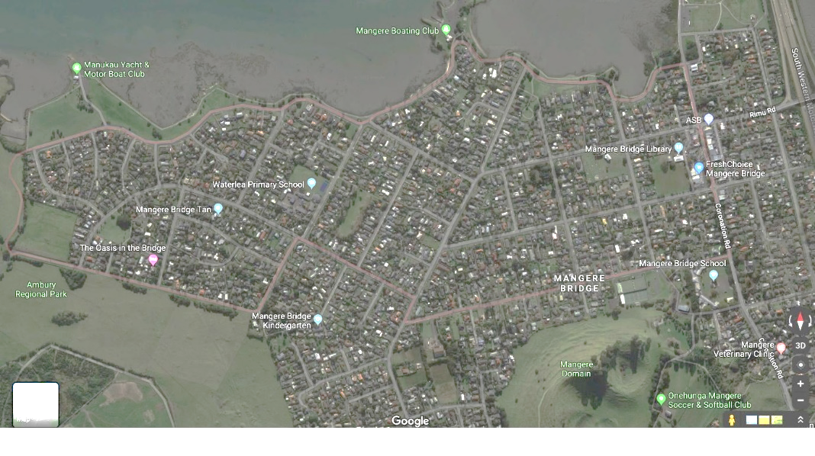

Figure : Proposed Route for Mangere Bridge

(Image sourced from google maps)

The proposed route in West Harbour is shown in pink in Figure 2. It covers approximately 2.1 km for one loop (measured using Auckland Council GeoMaps) and should therefore take 15 minutes at an average speed of 15 km/h accounting for traffic and on boarding/ off boarding. This suits the ferry departures every 20-30 minutes during peak periods. This route was used in the evaluation framework to determine the West Harbour area’s feasibility.

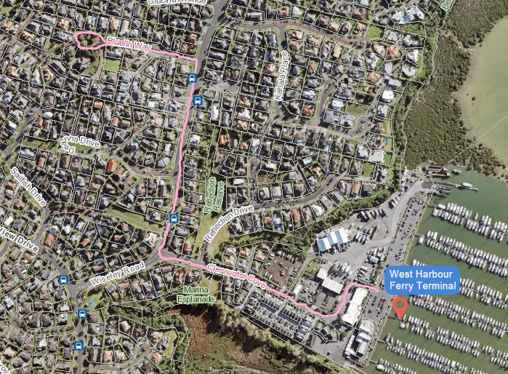

Figure : Proposed Route for West Harbour

(Image sourced from google maps)

**4.2 Framework Total Score**

The results below are shown with a webgraph produced from an excel spreadsheet of the matrix. This is to indicate the influence of each of the factors for the areas. The Mangere Bridge area received a score of 25 using the matrix with the number of collector roads being the most influential factor, shown in Figure 3. Information about each factor was obtained from either 2013 Census data from, Auckland Council GeoMaps, calculated or holistically judged. The scores for each factor were allocated based on the criteria developed. To gather an indication of whether this score was adequate, the nearest transport hub, located at Mangere Centre, was also analysed as seen in Figure 4. Mangere Centre was found to produce a much lower score of 9 as a major transport hub, showing that Mangere Bridge is a better location to trial SAVs to connect to existing and future transport routes than the Mangere Town Centre that has better current public transport connections.

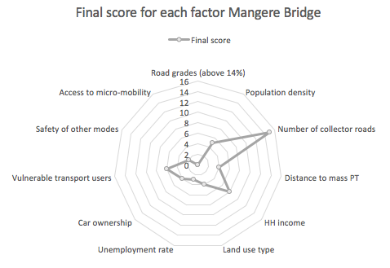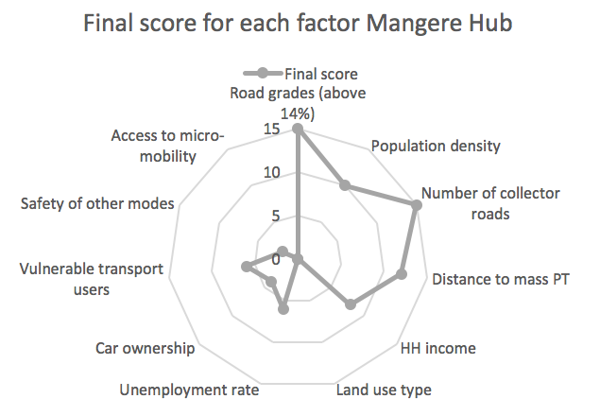

Figure : Mangere Bridge Factor Graph Figure : Mangere Centre Hub Factor Graphs

West Harbour also independently received a score of 25 using the matrix with population density, number of collector roads and distance to mass PT being the most influential factors, shown in Figure 5. The nearest transport hub, located at Westgate, was also analysed as seen in Figure 6. Westgate was found to produce a much lower score of 12 as a major hub, showing that West Harbour is also scores well for a potential location to trial SAVs.

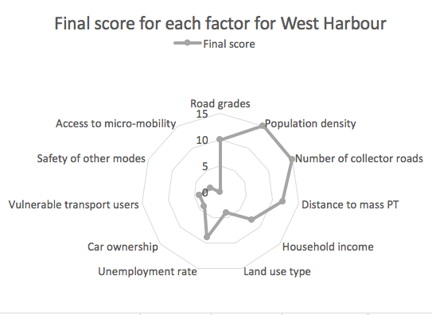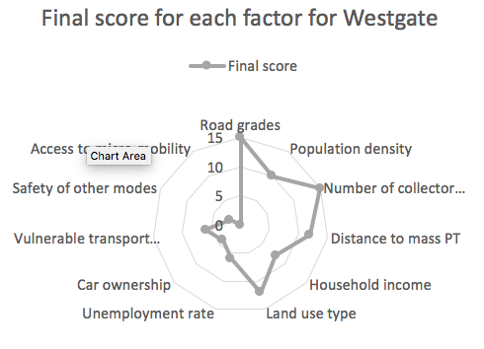

Figure : West Harbour Factor Graph Figure 6: Westgate Hub Factor Graphs

**4.3 Auckland Transport Data**

Both areas showed high scores using the framework developed. The framework was then further tested using Auckland Transport AT Hop card data collected from 1/03/2019 to the 31/03/2019. The location’s bus routes were determined and evaluated to see whether the implementation of autonomous vehicles would potentially help vulnerable transport users in the area and to determine the existing spare capacity in the existing transport options for potential additional patron journeys to be connected by SAV’s.

Figure 7 shows the bus routes for the selected areas. Bus routes 309, 309X, 313 and 380 were used to evaluate the feasibility of SAV’s in the Mangere Bridge area. Bus route 112 was used to determine if West Harbour could be an area for successful implementation of SAV’s.

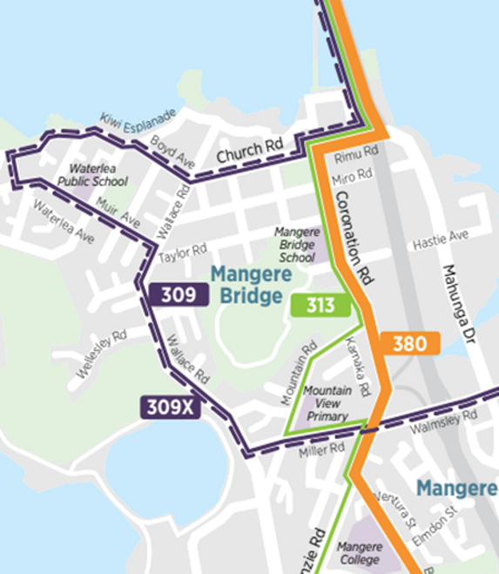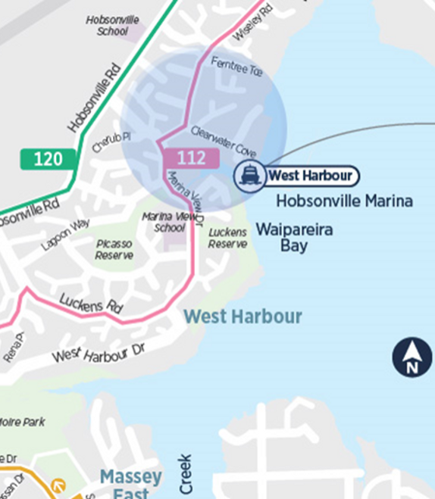

Figure 7: Bus Routes for Mangere Bridge and West Harbour

**4.3.1 Mangere Bridge**

The vulnerable transport users were determined by counting the number of child, secondary, super gold and accessible users on the journey. A percentage of vulnerable users taking these routes were calculated with more than 50% of passengers during the analysed period categorised as being vulnerable. This indicates that there is sufficient existing transportation in place for these vulnerable users in this area, which the matrix did not account for. The average time for most of these journeys range between 27 to 42 minutes. This means if a 15 minute circuit timed AV shuttle was used to connect the users to their first and last km journeys, the total length of their journey would remain under an hour.

All bus routes were shown to be under-utilised, with average daily? utilisations of 24%, 18.5%, and 19.6% for routes 309/309X, 313 and 380 respectively. These routes will therefore have sufficient capacity for an increase in number of users due to SAVs. By implementing AV shuttles to deliver users to their last and first km from mass transit, this will potentially increase the amount of people who will have access to public transport, therefore, increasing PT use if transfers are made easy in terms of access and time penalty.

The 309 runs every 30 minutes at off-peak times and weekends and every 5-10 minutes at peak weekday times. From the AT data, the bus time around the suggested route was under 15 minutes. Around the residential area the 309 buses usually had multiple stops and travelled under 25 km/hr. The AV shuttles could perform a similar service with similar timings and speed as the 309 around Mangere Bridge area. This allows the 309 to run a more direct service through Mangere Bridge centre, whilst still maintaining passengers of under 1 hour. The direct service of the 309 should arrive and run at the same times as the 313 and 380 which go every 15 minutes. This provides a more frequent and direct hub for passengers to travel via the AV shuttles from around the Mangere Bridge proposed route, where they will be able to access all three bus routes running at similar times.

There will however be a small increase in travel delay due to the need for passengers to switch transport modes from AV to buses at the Mangere Bridge Centre. Due to the high frequency of buses arrival times, the delay would be small, so would not have a great effect on the overall journey time.

The low utilisation of the bus services found in the AT data showed that there was sufficient capacity for further demand on these services. An update to the bus services for the 309 and 313 on the 22nd of September, stated there would be fewer off-peak trips in the weekends for these services. This shows the current bus route around Mangere Bridge is unnecessary for the demand. Therefore, a solution to implement the AV shuttles to replace the 309 service around Mangere Bridge route especially at off-peak periods, and create a more frequent and direct service through the Mangere bridge centre would be viable.

This solution would also help future proof a potential future light rail alignment which is currently being considered that will connect Mangere and Auckland Airport to the CBD. The SAVs will be able provide access to these improved development station areas and provide better and more efficient public transport links to the remaining residential areas.

**4.3.2 West Harbour**

A total of 15,076 Public Transport trips were undertaken in March from West Harbour, with 56% of these trips taking the ferry from West Harbour Ferry Terminal, reflecting the importance of this terminal to the surrounding community. 32% were trips by bus only while 10% involved taking a bus, then transferring to another bus. There were various other modes with 15 modes in total involving the ferry, bus and train. Vulnerable transport users were found to comprise 32% of these journeys, making them the second largest demographic after adults at 56%. This indicates there is a significant proportion of users that may benefit from a SAV service running through their neighbourhood. Over half the journeys took between 30 to 45 minutes, likely to be predominantly due to the ferry service. The trips taken in West Harbour mainly go to either Westgate or the city.

When analysing the ferry terminal directly, it was found that 77% of users were adults with only 8% vulnerable transport users. However, this is likely due to adults commuting to work as the ferry only goes directly to the CBD. If SAVs were introduced, this may encourage more vulnerable users to use the ferry and enjoy a day out in central Auckland. The typical time taken to get to the city is 30 to 45 minutes as it accounts for 89% of trips. The average time and length for a journey from West Harbour Ferry Terminal to the city was 38.1 minutes and 13.8 kms.

When analysing the bus network capacity, it was clear that services in general were significantly underutilised, including the 112 route that goes through the chosen area seen in Figure 1. Considering times from 5 am to 12 am with both inbound and outbound directions for Route 112, it was found that 93% of the time, it was not used as shown in Figure 6. Other bus routes are shown for illustrative purposes only.

The 112 bus services are typically always significantly under capacity, with an average daily utilisation of 19%. This is likely a result of the majority of residents using a private vehicle to commute to work, signifying the need to provide better PT accessibility as a more sustainable mode of travel.

The severe underutilisation of buses in the area mean that if AV shuttles were employed, they would not have much competition and could loop around the neighbourhood to collect willing patrons. SAVs can also be a solution to the capacity issue surrounding buses – if the services are stopped due to being used infrequently, SAVs can be used alternatively and will also have a lower capacity so that the potential for underutilisation is reduced. This would save financial resources and help reduce emissions whilst helping the transport disadvantaged in the community.

**5.0 CONCLUSIONS**

The research conducted was successful in achieving the objectives defined at the outset, as an evaluation framework was developed to score geo-spatial areas in terms of attractiveness to trial SAVs, which was then tested using AT data. West Harbour and Mangere Bridge were established as promising locations to conduct trials as they scored favourably and were justified by AT Hop card data. The framework can assist relevant authorities in the transportation sector when choosing potential locations to implement SAVs. Using AVs on roads seems to be a fast-approaching future, however it is vital to ensure that these new technologies and how the public engages or potentially uses the technologies are tested, evaluated and monitored to ensure positive transport outcome solutions are achieved.

**6.0 RECOMMENDATIONS**

This research study developed and tested an evaluation framework to determine the potential benefit of implementing SAVs as a first km-last km transport solution to better connect users to mass transit routes. Two case study areas of Auckland locations were evaluated and the following recommendations are made to help ensure future trials properly test locations where positive and a more shared mobility future is ensured:

* Refine evaluation framework with recent 2018 census data which was released October 2019. This will provide more accurate statistics for the areas, and will better identify potential successful locations for AVs.
* Incorporate the AT data analytics into the matrix, so the total score can factor in current bus capacity and demand.
* A previously developed pilot user perception survey can be improved and sent out to target users from the areas selected from the framework. Send the survey out digitally to residents in the area, and send paper forms to residents without computer access. This will help gain an accurate representation of the residents opinions and provide better feedback for the possible implementation of AVs.

**7.0 ACKNOWLEDGEMENTS and AUTHOR CONTRIBUTION STATEMENT**

The authors would like to express their gratitude to Auckland Transport and specifically Mike Shang and Colin Homan for providing AT Hop card data and analytic platforms to support the research. Thanks is also given to Local Motors and Olli for data sharing information on Shared Autonomous Vehicles and Sujith Padiyara of the University of Auckland for research support during the project.

Individual paper Author contributions are as follows:

Julia Lockhart: Literature review, Data analysis, Interpretation of results, Author of technical report, Prepared paper of report.

Arisha Zaman: Literature review, Data collection, Interpretation of results, Author of technical report.

Dr Douglas Wilson: Research Project Supervisor, Development of ideas/thoughts, Review paper of report.

**9.0 REFERENCES**

Bagloee, S.A., Tavana, M., Asadi, M., Oliver, T., 2016. Autonomous vehicles: challenges, opportunities, and future implications for transportation policies. J. Mod. Transp. 24, 284–303. https://doi.org/10.1007/s40534-016-0117-3

Fagnant, D.J., Kockelman, K., 2015. Preparing a nation for autonomous vehicles: opportunities, barriers and policy recommendations. Transp. Res. Part Policy Pract. 77, 167–181. https://doi.org/10.1016/j.tra.2015.04.003

Haboucha, C.J., Ishaq, R., Shiftan, Y., 2017. User preferences regarding autonomous vehicles. Transp. Res. Part C Emerg. Technol. 78, 37–49. https://doi.org/10.1016/j.trc.2017.01.010

Huiling, E., Goh, B., 2017. AI, Robotics and Mobility as a Service: the Case of Singapore. Inst. Veolia 5.

Marshall, A., Davies, A., 2018. Waymo’s Self-Driving Car Crash in Arizona Revives Tough Questions [WWW Document]. Wired. URL https://www.wired.com/story/waymo-crash-self-driving-google-arizona/ (accessed 4.30.19).

Martin, G., 2018. An Ecosocial Frame for Autonomous Vehicles. Capital. Nat. Social. 1–16. https://doi.org/10.1080/10455752.2018.1510531

Ministry of Transport, 2016. Testing Autonomous Vehicles in New Zealand.

Ministry of Transport, 2014. Intelligent Transport Systems Technology Action Plan 2014-18.

Ohnemus, M. Perl, A. 2016. Shared Autonomous Vehicles: Catalyst of New Mobility for the Last Mile? Built Environment, Volume 42, No. 4, 589-602.

Olsen, P., 2018. New Study Shows Automatic Braking Significantly Reduces Crashes and Injuries [WWW Document]. Consum. Rep. URL https://www.consumerreports.org/automotive-technology/automatic-braking-reduces-car-crashes-injuries-iihs-study/ (accessed 1.5.19).

Shaheen, S., Chan, N., 2016. Mobility and the Sharing Economy: Potential to Facilitate the First- and Last-Mile Public Transit Connections. Built Environ. 42, 573–588. https://doi.org/10.2148/benv.42.4.573

Signorile, P., Larosa, V., Spiru, A., 2018. Mobility as a service: a new model for sustainable mobility in tourism. Worldw. Hosp. Tour. Themes 10, 185–200. https://doi.org/10.1108/WHATT-12-2017-0083

Sun, Y. Olaru, D. Smith, B. Greaves, S. Collins, A. 2017. Road to autonomous vehicles in Australia: an exploratory literature review. Road and Transport Research, Volume 26, No 1.