**A FAIRER WAY TOWARDS TRANSPORT PRICING**

**This paper has been peer reviewed**

**DISCLAIMER**

This ‘think piece’ was prepared solely by the author in his personal capacity. The opinions expressed within are the author’s own and do not reflect the view of the author’s employer, the Transportation Group or any other group or individual the author is affiliated with. Any views expressed within are not intended to critique, criticise, or malign any group, agency, or public official. The paper is intended to provoke ideas and discussion respond to the conference theme of “Equity in Transportation” by introducing an opinion and reflecting on the key concepts of shaping travel choices.

**Author**

Nick Lovett (presenter). BDes (Hons), Member Transportation Group, Senior Transport Policy Planner, Christchurch City Council (Contact: [nick@lovett.nz](mailto:nick@lovett.nz) )

**ABSTRACT**

The funding model upon which our transportation system is built has created a vicious cycle of financial, social and environmental unsustainability. There is a widely held misconception that motorists ‘pay’ for the roads and therefore have an inalienable right to drive on them. This has resulted in contention within public discourse when it comes to building a transport system for the future.

Unlike most other network utilities, we have separated payment from access, which leads to the great tragedy of the commons known as congestion. Induced demand is widely recognised among the transport profession, and has come to be known as the fundamental law of traffic congestion. That said, we still naïvely disregard this principle when we pursue strategies of mode-shift in the absence of pricing mechanisms. Any freed up road capacity by people switching modes will simply be absorbed by more car travel in the long run.

As private motor vehicles become gradually more independent of fossil fuels for each kilometre travelled, we need to turn our attention towards a mechanism to replace property rates and fuel excise duties as our primary tool for funding infrastructure. There are several alternatives that hold promise, but will they leave us better or worse off? How much should we focus on efficiency at the expense of equity?

It is critical to understand how revenues are applied in order to achieve vertically equitable outcomes against the status quo. We are continually directing investment back into our roads and highways. Yet the marginal social cost of private vehicle travel is not even close to being captured in fuel taxes. If we want a fairer way of funding transport, we need to charge motorists a visible and marginal cost that reflects the negative externalities imposed on society. But most importantly, we shouldn’t be getting that money back in the form of new roads.

**INTRODUCTION**

In New Zealand, transport infrastructure if often the largest areas of both capital and operational expenditure for local governments. Whereas is comprises a much lower proportion of national government spending, given the large portfolios of health, welfare and education. Nevertheless, a combined spend with more than $5 billion (NZD) spent on land transport every year.

The land transport system in New Zealand is primarily funded through a combination of road users’ charges (such as fuel excise duties) and local property rates. While there is a common perception that roads are wholly funded through user charges, at an urban level the majority of funding often comes from property rates. This contrasts with a dominant perception that motorists pay to *use* the roads. When in fact motorists partially contribute to *fund* the roads. The reductive and transactional outlook of fuel taxes as ‘user fees’ can misrepresent the fundamental question of who and what transport investment is for. Consequently, this can lead to motorists believing they have a pre-eminent right to drive on roads above all other road users. The New Zealand Court of Appeal rejected this notion, stating that the 'liberty to drive' is not a natural right and that even the provisions in the legislation imposed restrictions and obligations, rather than granting rights (Brader v Ministry of Transport , 1981).

The transactional approach to land transport funding and investment also overlooks the social, economic and environmental externalities caused by motor vehicle travel. A 2006 study in Auckland, found that internal costs for driving covered less than 50% of total transport cost (Jakob, et al., 2006). The national transport investment regime has traditionally been designed to provide increasing level of service to motorists. In contrast, addressing the issues of climate change, housing affordability, road safety, and public health have fallen by the wayside. Our funding tools are primarily designed to efficiently raise revenue—they are not intended to reflect a marginal cost for accessing a service so subsequently there are no price incentives to influence consumer behaviour. Transport funds are frequently applied to projects with the objective of alleviating congestion but in the absence any visible costs, demand will always be higher than the capacity we are able to supply.

More recently, Central Government has acknowledged many of the reasons why we should move away from the traditional approach to transport funding. In 2019, the Minister for Transport addressed delegates at the 2019 ENZ Transportation Group Conference stating that as the national fleet is decarbonised, there will be a need to replace our current transport revenue system. More sophisticated revenue tools hold promise of smoothing demand during the peaks and pricing in the true costs of dispersed urban development (Twyford, 2019). However, universal network charging by, distance, route, vehicle, and time of day could be several years away. This may be too late for our towns and cities, which are facing mounting challenges with increasingly constrained budgets—particularly in meeting demands for infrastructure in high-growth areas and adapting to climate change (Productivity Commission , 2019).

**HOW DO WE DEFINE ‘FAIRNESS’?**

Determining what is fair or equitable in the context of transport policy, is an important but somewhat subjective question without a straightforward answer. (Levinson, 2010) points out that it is a matter of degree (a situation is more or less equitable) than an absolute (a situation is or is not equitable).

Notions of fairness in a transport sense are many and varied. In the provision of public goods, several dimensions and determinants are commonly discussed to quantify and qualify equity and fairness.

**Who decides?**

* ***Process Equity*** – Who decides what particular transport activities are to be funded
* ***Social Equity*** – The extent to which allocation is proportionate to need

**Who pays and who benefits?**

* ***Market Equity*** - The distribution of benefits to the wider public or any identifiable group or individual (or the benefit principle)
* ***Justice*** - The extent to which the actions of particular individuals or a group contribute to the need to undertake an activity (or the exacerbator principle)
* ***Intergenerational Equity*** - the extent to which benefits and losses are distributed to the present or the future generations

**How, and How Much to pay?**

* ***Horizontal Equit****y* – The consistent treatment of those at similar income levels, or similar circumstances
* ***Vertical Equity*** – Ability or capacity to pay (those with greater means to pay should pay more than those with less)
* ***Efficiency*** *–* How burdensome is it to collect the revenue

This paper does not seek to define fairness per se; instead, it discusses current, past and alternative funding arrangements considering the dimensions above. Additionally, the paper attempts to challenge the status quo and explore alternatives, while balancing considerations of efficiency, means of payment, and open access to the transport system.

**HOW IS TRANSPORT CURRENTLY FUNDED**

Just over three quarters of New Zealand’s land transport system is funded from central government from the National Land Transport Fund (NLTF)[1]. The remainder is spent by local and regional authorities from funds raised from rates revenue, debt, developer contributions and dividends from investments. It is often represented as a user pays fund as the majority of revenues are consumption taxes related to road use. I.e. Fuel Excise Duties (FED) and Road User Charges (RUC). However there are also substantial subsidies from non-users in the form of fixed fees, crown funding, and property rates.

Revenues from both central and local government combine to form the National Land Transport Programme (NLTP) –an agreed list of all transport projects and programmes that will be undertaken over a three-year period. Figure 1 illustrates how both national and local funding contribute to the NLTP.

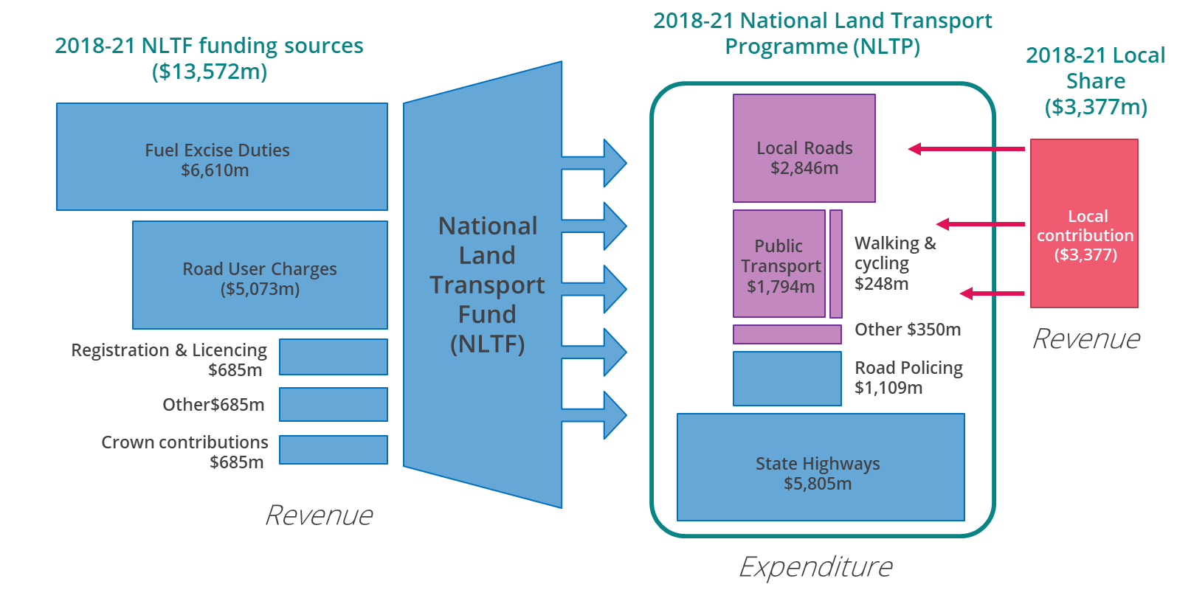

Figure 1 Overview of the NLTF and NLTP as of October 2019

State highways are entirely funded and operated through the NLTF. However they make up less than 12% of the national road network by length, and less than half the national network by volume. Urban centres in particular carry the highest density of traffic per lane kilometre and most of their transport funding comes from property rates—not the NLTF. Furthermore, increasing vehicle volumes at the local level places demand for associated infrastructure that is not NLTF funded such as parking facilities and management.

It is reasonable to challenge aspects of fairness with the status quo given the widely held belief that the hypothecation of FED and RUC is fair. However, the fuel efficiency of vehicles varies widely and some have suggested it is a regressive tax, disproportionately affecting low-income households (Blick, et al., 2018).

**THE DISPARITY ARISING WHEN DECOUPLING PAYMENT AND ACCESS**

While the public and to a lesser extent road users pay to fund the transport network, they do not pay to access it. This separation between access and payment is a subtle but important distinction and confusing the two can lead to a number of structural inequities within the urban transportation system.

1. **Public subsidies are transferred to motorists**

At the local level, there is an issue of horizontal equity because property rates fund the majority of transport department budgets. Consequently, a household that frequently travels in private vehicles within an urban area will receive a greater benefit than identical household that doesn’t–relative to how much they pay in property rates. Conversely, those who live centrally tend to have higher housing costs, but lower transport costs as they and walk and cycle for more of their transport. They end up subsidising the traffic infrastructure to support those living on the urban fringe who have cheaper houses and tend to rely on single occupant vehicle trips for mobility (Cervero & Kockelman, 1997). These subsides mean that motorists face marginal transport costs at a lower rate than wold be socially optimal, particularly as motor vehicles impose large external costs on society (See Figure 2).

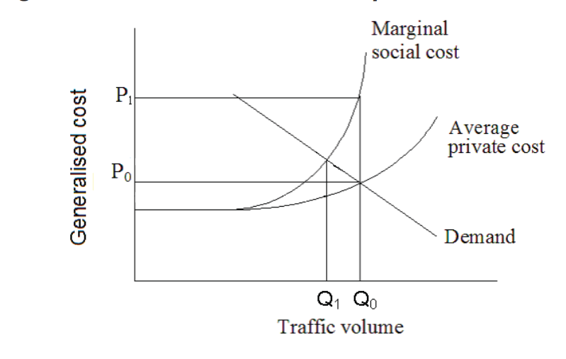

Figure 2 Relationship between costs and volumes (NZIER, 2009)

In other words, subsidies create a perverse incentive to travel more, which reinforces a land use pattern shaped around automobile dependant behaviours. Minimum parking requirements are a good example of this type of hidden subsidy. Most trips in a private car begin and end with a free parking space. The material cost of providing free parking mean that everyone ends up paying for it in the form of higher rents and house prices, consumer goods and lower wages.

1. **An unknown willingness to pay for unfettered mobility**

Overarching public subsidies for private motor vehicles conceal the true ‘willingness to pay’ for motor-vehicle travel. Some might argue that New Zealand’s high rates of vehicle ownership are evidence of the car as a preferred mode to cycling or public transport, but this assumption ignores the role public policy has in influencing individuals’ travel choices.

Occasionally a road controlling authority might consider tolling a new road, as was the case recently with Wellington’s Transmission Gulley. However, analysis revealed that tolls would simply discourage use of the new route and drivers would continue using the existing route. This would invalidate many of the anticipated travel time and safety benefits of constructing the link in the first place, so the decision was to leave the route untolled. However, this brings into question the value of travel time savings if the real-world willingness to pay for those savings is lower than their ascribed value. This can have consequences when tolls are used to finance roading projects.  Takitimu Drive (formerly Route K) in Tauranga and the Clem Tunnel in Brisbane both struggled to service debt from tolls—with the latter placed into receivership less than a year after the tunnel opened.

The financial failure of toll projects are in part due to the fact that there is nearly always a free, alternative route available. In New Zealand, this is a legal requirement. Decades of public policy has heavily subsidised the cost of personal mobility to the point where the willingness to pay is less than the cost to build and maintain the infrastructure. The long-term implications are that decision makers continue to fund transport projects that are deemed popular, rather than assessing the long-term economic, social or environmental outcomes. The unproven assumptions about peoples’ preferences ultimately perpetuate a vicious cycle of predict and provide transport planning. In turn, tilting the scales in favour of private motor vehicle travel above other modes. In the absence of comparable travel alternatives, it can be difficult or even impossible to determine the price people are willing to pay for our current transport system and land use paradigm.

1. **A tragedy of the commons**

The unique, and often overlooked fact about our road network, is that is a congestible or *rivalrous* good. That is, the more it is used the more people are ‘crowded out’ from efficient or free-flow journeys. Public roads and streets are indeed used by pedestrians, cyclists and buses—however their relative spatial efficiency means the congestion externalities are far less acute. Road (and parking) congestion has perhaps been, above all other transport problems, the major impetus driving transport investment policy in recent decades. Yet, until recently, we have lacked the technical capability or political will to price-in the costs of traffic delays by location, occupancy or time of day. Instead, policy has favoured building more capacity without exposing motorists to any visible or marginal costs to dissuade travel in times of peak demand. We know that in the absence of these pricing mechanisms, attempts to reduce road congestion will be futile. Any freed up capacity through either mode shift or new roads will simply mean a 1:1 increase in traffic in the long run (Noland, 2001).

Nevertheless, the case for internalising the externalities of motor vehicle travel goes far beyond just managing congestion. Other commonly cited externalities include:

* **Crash Risk** - The total social cost of motor vehicle fatal and injury crashes is estimated to be $4.8 billion annually (Ministry of Transport, 2019)
* **Air Quality** - Air pollutants from motor vehicle emissions are estimated to have an annual social cost amounting to $934 million (Kuschel, et al., 2012).
* **Urban form and Physical Inactivity** – As cities have sprawled to accommodate private vehicles as the dominant mode of transportation; much of the urban environment has become unconducive, and hostile to, active modes of transport such as walking and cycling. It is estimated that the social cost of physical inactivity is more than $1.3 billion annually (Market Economics, 2013)

A fairer way of pricing transport would be to put a price on transport that is more accurately reflects: the true cost of providing the service, the value of the benefits to the user, as well as the external costs imposed on others.

**BACKGROUND ON RAISING TRANSPORT REVENUE**

In the late nineteenth and early twentieth century, private motor vehicles were are rarity and transport funding in New Zealand relied more heavily on user fees. Toll gates were common up until 1922 when the main highways act was passed (Figure 3) (Walrond, 2016). The Main Highways Board collected taxes on tyres, fuels, car registrations and heavy traffic. Local authorities still relied on rates but also collected revenue from driver licencing (which they were responsible for) up until 1953.



Figure 3 – Toll gate in Taranaki in the 1920s - [Alexander Turnbull Library](http://natlib.govt.nz/) Reference: [1/2-048419; G](http://natlib.govt.nz/records/22308865)

As cars became more commonplace in the post-war era, road tolls re-emerged as a tool to help fund transport projects rather than rather than a mechanism to manage demand. Later, tolls were employed where the benefits of the infrastructure accrue to a specific subset of road users. This was the case for the Auckland Harbour Bridge and Lyttelton Tunnel with the latter intended to be tolled for 54 years to finance the construction costs. Although tolls were removed from the Lyttelton Tunnel in 1979, just 15 years after the tunnel opened (New Zealand Transport Agency, 2019).

The popularity of private motor vehicles in the mid-late twentieth century meant that motorists grew to comprise a substantial proportion of the electorate and the subject of tolls became increasingly political. Most of the country became ‘users’ by way of fuel taxes being imbedded in the cost of daily life and the hypothecated through National Land Transport Fund investments. This meant until recently, government policy held a very narrow view of what transport investments qualify as benefiting road users. This was done to uphold the implicit social contract of transport revenues as user charges rather than taxes. For instance, public transport and cycling improvements were seen as having a decongestion benefit, but rail freight and coastal shipping investments were not.

For more than 100 years, we have grown accustomed to a user-pays policy rationale that slowly evolved as motor vehicle ownership and use grew to be synonymous with the land transport funding. Consequently, the distinction between motorist and the general public has become highly conflated in the public discourse. This has resulted in a widely held belief that transport investments should continue to ensure personal car travel remains affordable, fast and convenient above investments in a transport system that is efficient, reliable and sustainable.

**OPTIONS AND ALTERNATIVES**

In the face of the mounting transport challenges within our towns and cities, alternatives to the funding status quo need to be explored and debated. A socially optimal solution to better internalise many of the externalities associated with driving through a Pigouvian tax. The method of collecting this tax should aim to make price signals more visible within the transport system so as to better understand peoples’ revealed preferences for driving. It is unlikely car trips would be as popular and dominant mode today if drivers were charged a greater share of the resource cost to providing the infrastructure. Instead, more accurate pricing would support the emergence of a more balanced transport system where the relative strengths and weaknesses of different modes were more clearly understood. The relative space-inefficiency of cars in urban areas (and subsequent high marginal social costs) are not widely understood by the public or policymakers. This would leave a much greater role for public transport, especially at peak times, and walking/cycling more generally within our transport system.

**Corridor or lane charging and tolling**

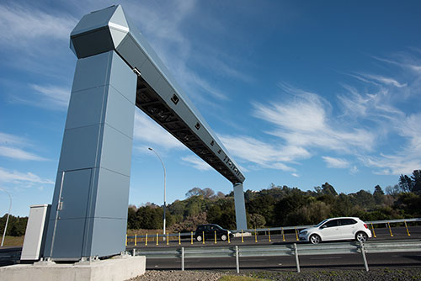Internationally, mechanisms such as electronic tolling can also be used to optimise demand management and trip suppression, but in New Zealand existing tolls do not vary by time of day, or passenger occupancy. Tolling aims to raise revenue and to change behaviour by adding a cost to a particular journey along a corridor. This cost is intended make drivers consider alternatives such as different routes, public transport, carpooling or not taking the journey. Tolls are typically collected at specific locations along roads, bridges or tunnels either manually or electronically. The tolls can be flat, variable at time of day or even lane specific. High-occupancy toll (HOT) lanes are a derivative whereby low-occupancy vehicles are charged a toll, and high-occupancy vehicles (HOVs) or low-emission vehicles may be allowed to use the lanes free or at a discounted toll rate.

The benefits of road tolls for funding infrastructure are that they are well understood and already in use in some areas of New Zealand. However, current legislation requires ministerial approval and that tolls can only be applied to new infrastructure provided there is an untolled alternative route. Additionally it is questionable whether the legislation allows for tolling, purely for managing demand, as opposed to financially contributing to the operation or construction of road that is being tolled.

Calculating an appropriate fee structure for a scheme is critical as a scheme that under-prices journeys may not be effective in managing demand. Conversely, if prices are too high if may force traffic to ‘rat-run’ on local streets creating bottlenecks and other localised impacts. The ability to collect revenue could also be limited if the tolls are restricted to a small proportion of the network (such as motorways, bridges or tunnels). Rather than use a flat fee or user charge, dynamic and variable tolls are the best ways to manage congestion externalities and demonstrate the effectiveness of time and location pricing. Infrastructure required to set up toll points can also be a sizable upfront cost, although technology such as Automatic Numberplate Recognition are continually reducing these costs (D’Artagnan Consulting, 2018).

**Cordon or area pricing**

Cordon charging is a tool that seeks to price in the negative impact of traffic on a particular area. It has a primary purpose changing behaviour and reducing congestion or emissions, but it can also raise substantial revenue. While road tolling is usually applied to a single link in the network (such as a motorway, tunnel or bridge) congestion pricing measures can be thought of as multiple toll points to create a tolled zone or usually in a downtown area[2].

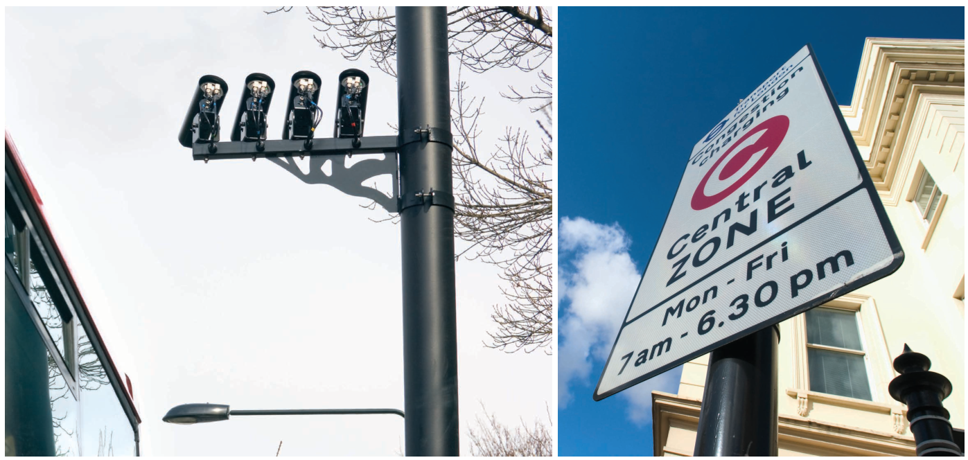

Cordon pricing has been implemented in a handful of cities worldwide, London, and Stockholm are often cited as successful examples of implementing the policy. Cordon pricing schemes usually require broad public support and can be a challenging concept for the public to buy into. However post implementation, people are generally more supportive once the benefits can be demonstrated. Along with road tolling, cordon or area schemes can be very time and resource intensive to implement, particularly if there are extensive rebates and exemptions to administer. It also does not incentivise users to minimise their car travel once they have entered the zone. For example, non price-sensitive road users such as taxis may continue to drive inside the zone after they have entered, exacerbating congestion effects.

**Electronic road user pricing**

Electronic road user pricing (ERP) seeks to charge for the full economic, environmental and social costs of road use, and places more of the true cost of driving back onto road users. Similar to electronic Road User Charges (eRUC), ERP would seek to charge variable rates by location and time of day, using Global Navigation Satellite System (GNSS) technology. The primary advantage of ERP is that is the only real alternative to completely replace fuel excise duties as a transport funding mechanism. ERP would have a much higher administration and compliance cost than fuel excise duties, but it could be designed in a way that was revenue neutral while still achieving significant environmental and economic benefits though demand management. Technological barriers to implementation are becoming lower and Singapore is set to introduce a GNSS based ERP scheme next year.

New Zealand already has a similar scheme in operation mostly used in commercial fleets, known as the Electronic Road User Charging (eRUC). The distance based road pricing scheme leverages on-board GNSS units although it doesn’t charge variable rates to manage demand. It is an elegant policy alternative to the status quo, although its implementation would be led by central government meaning it doesn’t provide an solution to local authorities looking to reduce reliance on property rates to fund infrastructure.

**Parking levies**

Aside from the pricing vehicles (through registration levies) or the right of way that they drive on, it is also possible to collect a levy on the space used to store and park vehicles. While transport planners dedicate most of their time and resources to understand the movement of vehicles, private cars actually spend 95% of their time parked (Shoup, 2005). Since the availability and cost of parking can be a key determinant of whether the car is used for a particular journey (McCahill, et al., 2016) parking levies may be an effective way to raise revenue while simultaneously managing demand for motor vehicle trips.

Workplace Parking Levies (WPLs) are gaining traction in the United Kingdom as a policy tool for reducing congestion. Because congestion is most acute during commuter peaks, levying a price on long-stay employer-provided parking is more effective at targeting congestion than a blanket parking tax or raising prices on short-stay commuter parking. Sydney, Perth and Melbourne have all introduced a broader type of downtown parking levy. Although it appears to have been less effective in mode shift because many commuters to not pay out of pocket and employers continue to lease large amounts of parking downtown (Hamer, et al., 2009).

However, Nottingham City Council in the UK is often cited as one of the more successful examples of where a WPL has been implemented. Essentially every employer with more than ten parking spaces is liable to pay a levy on each parking space. The intent is for workplaces to reduce the number of on-site spaces and pass the cost of the levy onto their employees. The WPL in Nottingham it appears to achieving well against stated policy objectives with a positive correlation in congestion reduction and the WPL with employers first removing spaces to avoid the liability of paying the fee. About half of all employers choose pass the cost of the levy onto employees directly. Researchers (Dale, et al., 2017) found that for a 1% reduction in the number of liable parking spaces correlated to a .55% reduction in congestion as measured in delay per vehicle Km travelled.

Under New Zealand tax regulations, parking spaces are not considered to be a taxable in-kind or fringe benefit. Consequently, 68% of commuters park in in off street employer provided parking spaces (Ministry of Transport, 2015). Previous research (Ommween & Wentink, 2012) has found that effective subsidies of workplace provided parking spaces these are considerable, leading to welfare losses and an oversupply of parking spaces.

In New Zealand, local authorities are much better equipped than the IRD to collect revenue from parking spaces. Additionally, the capability to levy a targeted rate on parking likely exists without any amendments to existing legislation. While the property owner would technically be the one liable to pay the levy, tax theory suggests when supply is elastic and demand is not, the incidence of the levy will be borne by the end user.

WPLs have also proven an effective tool in funding transport infrastructure. Nottingham has used revenues from the WPL scheme to part fund the city’s light rail line. The total quantum of revenue raised from a WPL will depend on the specifics of how it is designed and delivered. Table 1 uses data from the 2018 census and household travel survey to estimate of the revenue potential for New Zealand’s main centres. For roughly $2 per weekday or $500 per year a WPL could generate a substantial local share of revenue for transport investments without increasing household property rates.

Table 1 - Estimated revenue potential of a WPL for NZ main centres based on Census and HHTS data

|  |  |  |  |  |  |  |
| --- | --- | --- | --- | --- | --- | --- |
| City | Christchurch | Auckland | Hamilton | Tauranga | Wellington | Dunedin |
| Drive a private or company car, truck or van to work (2018 Census) | 145,374 | 576,033 | 61,707 | 51,585 | 49,554 | 43,734 |
| % of people that park at work/employer's car park (Household travel survey) | 65% | 63% | 70% | 63% | 42% | 53% |
| No of people who park at work/employer’s car park | 94,493 | 362,901 | 43,195 | 32,499 | 20,813 | 23,179 |
| Annual revenue potential with WPL of $500 per space | $47.2m | $181.4m | $21.6m | $16.2m | $10.4m | $11.6m |

**DISCUSSION**

Perhaps one of the main hurdles of moving towards alternative funding tools will be gaining the support of the general public. There is a two-part task in better communicating the problems with the status quo, while drawing a clear line of sight to the stated objectives. People are only likely to support an alternative funding scheme if there is collective agreement that it will leave them better off.

While road pricing can improve the efficiency of the transport system and deliver overall social benefits; it will almost certainly result in increased financial cost for many people. Some users may struggle to avoid these costs and have difficulty bearing them. It is therefore important to understand how costs and benefits are distributed between different individuals or groups in society and the requisite policy options to respond (Nunns, et al., 2019).

There will be winners and losers in any scheme so it is important to design a scheme that logically group the exacerbators and attempt to avoid harming groups that will be unfairly disadvantaged. Another key consideration in designing an alternative funding scheme is to understand how revenue is applied. If used effectively new transport revenue schemes could indeed be more coherent, efficient, and fair than the status quo.

Congestion pricing in various forms is beginning to enter the public discourse in New Zealand but electronic tolling and cordon pricing schemes would likely required legislation change in the near term. It is still unclear if alternative funding schemes would supplement transport investment at a national or local level. The Ministry of Transport and NZTA are naturally better placed to lead detailed investigations into Electronic Road User Pricing whereas there is a larger role for local government in parking levies and cordon schemes.

The potential for revenue generation will also vary widely, depending on the characteristics of each alternative mechanism. Cordon and area schemes tend to be implemented in larger cities that experience heavy congestion in their city centres. In this sense, the use case for cordon pricing may be less applicable in smaller cities or polycentric urban areas, which in turn limits the potential to replace the status quo.

Other second best revenue mechanisms such as increased fuel taxes, and vehicle registration levies are efficient but tend to be regressive and have little impact on managing demand. Land value taxes are another alternative to funding land transport infrastructure because they are effectively a spatial levy on the beneficiaries of public investment. This has advantages of capturing benefits at the end location (spatially). However, it would not necessarily price in externalities at the source and pass costs onto exacerbators.

**CONCLUSION**

A number of transport pricing mechanisms are likely to be a fairer alternative to the status quo funding regime. A comprehensive electronic road pricing system is likely the best alternative to fuel excise duties, although this would depend on the timing and method of implementation.

For local government, cordon pricing and corridor tolling are easy to understand but difficult to administer and implement. In this respect, Workplace Parking Levies appear to be a simpler and more cost effective mechanism for curbing demand while simultaneously funding transport initiatives. WPLs are efficiently scalable and applicable to medium and large cities without the need for large upfront capital investments. For this reason, the payback period will be shorter and produce an attractive benefit to cost ratio when comparing a range of transport pricing alternatives.

In terms of fairness, WPL’s could be designed to factor in underlying land values rather than a flat levy across the city. This would ensure the size of the levy would reflect the value of the parking space, correcting and existing distortion in the tax system. For example, salary workers in downtown areas (where parking costs are high), enjoy a much larger fringe-benefit tax exemption than blue collar wage workers on the city periphery. This inequity creates an inefficient allocation of resources, subsidising the cost of parking in downtown parking and producing more spaces than would be socially optimal under normal market conditions. WPLs could reduce the number of carparks in congested downtown areas, in turn freeing up more land that could be developed for higher and better uses.

Transport pricing schemes hold the potential to provide transformational levels of investment in towns and cities to help reduce emissions, and improve quality of the urban environment. There are many barriers and challenges to implementing alternatives, but concerns about equity and fairness shouldn’t hold us back from having these conversations. There is enormous inequity and numerable distortions within the current land transport funding system. We need to acknowledge these and explore how revenues could be applied to mitigate any negative effects that may arise. In the face of mounting challenges of climate change, housing affordability, road safety, and public health—we can no longer afford to accept the status quo as the best we can do.

# References

Blick, G., Comendant, C. & Davies, P., 2018. *Analysis of the regional fuel tax and increase,* Auckland: Saphere reserach group - Report prepared for the Independent Māori Statutory Board .

*Brader v Ministry of Transport* (1981).

Cervero, R. & Kockelman, K., 1997. Travel demand and the 3Ds: Density, diversity, and design. *Transportation Research Part D: Transport and Environment,,* pp. 199-219.

D’Artagnan Consulting, 2018. *8 Review of international pricing initiatives, previous reports and technologies for demand management purposes,* Wellington: Prepared for the Ministry of Transport.

Dale, S. et al., 2017. Evaluating the impact of a workplace parking levy on local traffic congestion: The case of Nottingham UK. *Transport Policy v59,* pp. 153-164.

Hamer, P., Currie, G. & Young, W., 2009. *Exploring travel and parking impacts of the Melbourne CBD parking levy.* Auckland, Proceedings of the 2009 Australasian Transport Research Forum (ATRF2009).

Jakob, A., Craig, J. & Fisher, G., 2006. Transport cost analysis: a case study of the total costs of private and public transport in Auckland. *Environmental Science & Policy, Volume 9, Issue 1,* pp. 55-66.

Kuschel, G. et al., 2012. *Updated Health and Air Pollution in New Zealand Study,* Auckland: Emission Impossible Ltd for Health Research Council of New Zealand, Ministry of Transport, Ministry for the Environment, and NZ Transport Agency.

Levinson, D., 2010. 'Equity Effects of Road Pricing: A Review. *Transport Reviews,* 30(1), pp. 33-57.

Market Economics, 2013. *Costs of physical inactivity. Toward a regional full-cost accounting perspective,* Hamilton: Waikato Regional Council.

McCahill, C. T., Garrick, N., Atkinson-Palombo, C. & Polinski, A., 2016. Effects of Parking Provision on Automobile Use in Cities: Inferring Causality.. *Transportation Research Record, 2543(1),* pp. 159-165.

Ministry of Transport, 2015. *Household Travel Survey,* Wellington: s.n.

Ministry of Transport, 2019. *Social cost of road crashes and injuries 2018 update,* Wellington: Ministry of Transport.

New Zealand Transport Agency, 2019. *Tunnel history and facts.* [Online]   
Available at: https://www.nzta.govt.nz/projects/lyttelton-tunnel/facts/

Noland, R. B., 2001. Relationships between highway capacity and induced vehicle travel. *Transportation Research Part A: Policy and Practice, Volume 35, Issue 1,* pp. Pages 47-72.

Nunns, P., Whitaker, E. & Donovan, S., 2019. *Social and distributional impacts of time and space-based road pricing,* Wellington: NZ Transport Agency - Research Report prepared by MRCagney Ltd.

NZIER, 2009. *Externalities - Methods for attributing costs between internal and external components (Prepared for the Ministry of Transport),* Wellington: Ministry of Transport.

Ommween, J.-V. & Wentink, D., 2012. The (Hidden) Cost of Employer Parking Policies. *International Economic Review,* pp. 965-977.

Parry, I., Walls, M. & Harrington, W., 2007. Automobile Externalities and Policies. *Journal of Economic Literature v45 n2,* pp. 373-399.

Productivity Commission , 2019. *Local government funding and financing: final report,* Wellington: Available from www.productivity.govt.nz.

Shoup, D., 2005. *The high cost of free parking.* Chicago: Planners Press.

Twyford, P., 2019. *Minister's opening speech to TG conference deledates.* [Online]   
Available at: https://www.tgconference.co.nz/s/Speech-to-ENZ.M4A  
[Accessed 1 December 2019].

Walrond, C., 2016. *'Roads - Funding road construction', Te Ara - the Encyclopedia of New Zealand.* [Online]   
Available at: http://www.TeAra.govt.nz/en/roads/page-5  
[Accessed 31 October 2019].

**ACKNOWLEDGEMENTS**

This think piece is based on a policy paper drafted during a during a two-week course in Urban Economics at VU Amsterdam. The author would like to acknowledge Stuart Donovan, who taught the course, and helped introduce the author to the key economic concepts behind the original policy paper.

1. [2018 Government Policy Statement on Land Transport](https://www.transport.govt.nz/assets/Uploads/Our-Work/Documents/c6b0fea45a/Government-Policy-Statement-on-land-transport-2018.pdf)
2. It is also likely that legislation would have to be amended to implement a cordon or area pricing scheme in New Zealand.