PPP innovation: learnings from pioneers

TRANSPORT GROUP 2020 CONFERENCE – PRACTICE PAPER

Author and presenter: Kathy Matete

Bachelor of Civil Engineering (Hons)

Committee member of the ENZ Transport Group Auckland, ITS NZ

Transport Planner, Arup

Email: kathy.matete@arup.com

# ABSTRACT

This paper discusses the model for future public private collaboration in city and transport planning for smart cities with the purpose of collating learnings from the pioneers. This paper will present case studies around the world to show innovation due to new public private collaboration type projects. It will cover the different roles played by the partners and explain how this creates an environment for innovative project design. This will show how the adoption of an approach that incorporates design thinking helps create equity in our transport system. Lastly, the paper will show how these new models can help achieve New Zealand’s’ sustainability, mode shift, wellbeing goals for future cities with a focus on the transport related outcomes.

# INTRODUCTION

The United Nations predicts that by 2050 more than two thirds of the human population will be living in cities (UN World Urbanisation Prospects, 2018). New Zealand is no exception with the population in urban areas predicted to rise significantly. Using 2013 baseline population statistics, Auckland is predicted to increase in population by 48%, 43% in Tauranga and 41% in Wellington by 2038 (Statistics New Zealand). With this continuing shift to urban living, cities are facing far greater social, economic, and environmental pressures. Issues on equity and particularly in the transport system are likely to be exacerbated if we don’t plan for a more sustainable and equitable transport system in our future smart cities.

In order to create smart cities, we need to look into not only what is being developed but how we develop and deliver the transport system. This paper compares the traditional public private collaboration (PPP) model with the smart PPP model. The aim is to illustrate using case studies the benefits of a smart PPP and how it can help achieve transport related outcomes.

# THE TRADITIONAL PPP AND WHY WE NEED INNOVATION IN THIS SPACE

Traditionally PPPs have historically been the solution to address infrastructure gaps. It is built on the principle that private sector expertise can provide increased efficiency and cost reduction to the public sector in large transport infrastructure projects. In New Zealand, the most common approach has been to leverage private financing to compensate for a lack of available public financing. In New Zealand, these include primarily road infrastructure projects such as Transmission Gully (MacKays to Linden) project and the Wellington Gateway Partnership (WGP).

Figure 1 below shows different levels of private sector engagement in PPP contracts. The last two rows show two types of PPP that involve financing. In New Zealand, the New Zealand Transport Agency guide to PPPs published in 2015 define their PPP contractual arrangements as Design/Build/Finance/Operate/Maintain.

It is important to note that none of these PPP contracts have the private sector involved in the propose solution stage. This illustrates a lost opportunity for innovation as the public sector are often restricted to off-the-shelf solutions which can constrain innovative thinking and can also result in a loss of opportunity to co-develop city centric solutions with the private sector.

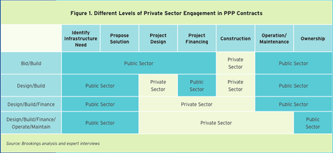

Figure 1: Different levels of private sector engagement in PPP contracts (European Commission)

Currently, much of the innovation in transport such as new mobility hardware and software which are able to collect and process big data or real-time mobility-based data among other things, have been led by the private sector. In relation to the public sector, the role of the private sector has primarily been a technology provider, rather than an active partner by providing financing and input in the planning stages for smart cities projects (Neirotti et al., 2014).

The issue with the traditional PPP model is that it does not allow for innovation in the planning, development and delivery stages. The traditional model is also tailored to infrastructure projects with little input on how PPP can be used to develop smart cities.

# SMART PPP

Smart PPP can be defined as the model for future public private collaboration in city and transport planning for smart cities. The influx in new technologies, digital connectivity and data create an opportunity to innovate in the public private collaborations. This opportunity is through the adoption of the Smart PPP.

The fast-changing nature of new technologies and software has been led by the private sector. This makes it difficult for local governments to drive the development of these new technologies in a way that allows them to match their government outcomes. This is often due to the lack of inhouse technical capacity. In addition to this is the lack of financial resources to implement complex smart technology projects which can be costly particularly due to the high risk and low economies of scale associated with new types of technology and software.

At the same time, technology and service providers from the private sector develop innovative solutions to today’s urban challenges and have the technical and financial capacity to translate innovation into products at the service of the cities. Therefore, local governments and private enterprises can engage in complementary and mutually beneficial smart PPP to drive technology **solutions in urban areas that would have been difficult to deliver in the traditional PPP.**

**To maximize the value of PPPs, we need new models for using assets and expertise from the private sector.** The innovation for these new PPP models lies within the shift in roles as well as in the delivery mechanism. These are explored in the sections below.

New roles in the smart PPP model

To allow for collaboration and innovation, the proposed roles in Figure 2 below are recommended. This Smart PPP allows for innovation and collaboration with PPP during the transport planning stage as it creates an environment for innovative city planning.

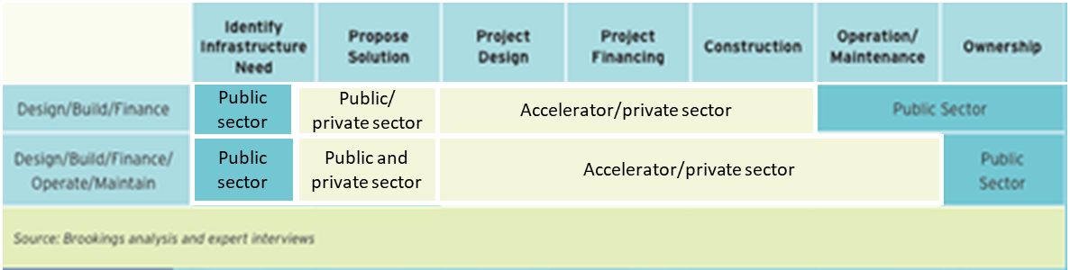

Figure 2: Smart PPP

# **CASE STUDY – WATERFRONT TORONTO MASTER PLAN**

Sidewalk Labs developed the masterplan for Toronto waterfront to turn the area into the "neighbourhood of the future" by implementing smart and sustainable infrastructure and services. This was a PPP collaboration with Waterfront Toronto and Sidewalk Labs. Sidewalk Labs was brought in as the innovation and funding partner to provide technical advice, innovation planning, design, implementation and project-management services to the Waterfront Toronto.

The extent of the project which is called the IDEA District in Figure 3 shows the proposed 77 hectare area which provides sufficient scale for urban innovations to realize ambitious quality-of-life outcomes in a financially sustainable way.

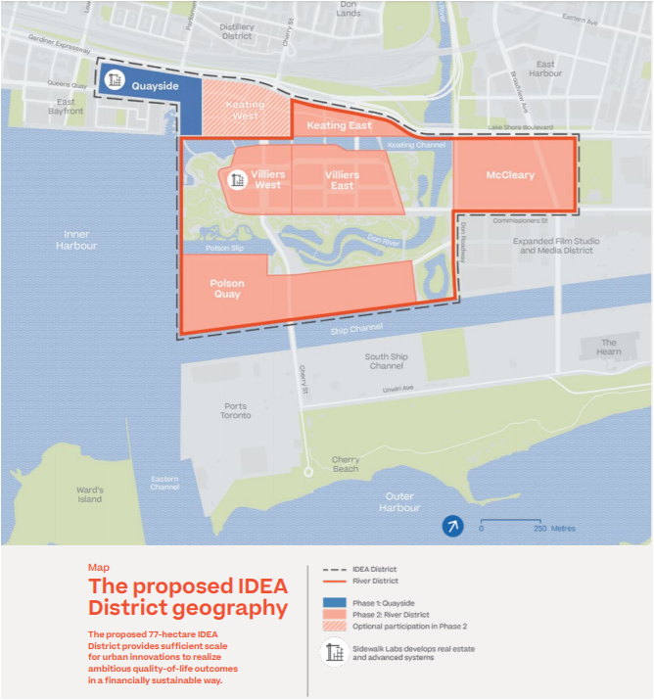

Figure 3: Waterfront Toronto IDEA District extent (Source: Toronto Tomorrow A new approach for inclusive growth Volume 2)

In this capacity, Sidewalk Labs role was to support the public administrator in devising and implementing a comprehensive innovation and development strategy. This utilises their capacity, resources, special technical and innovation expertise, particularly with respect to the technical specifications, deployment, iteration, and integration of advanced systems and performance outcomes.

As part of the technology deployment, Sidewalk Labs proposed to develop a limited number of key technological solutions for advancing mobility to achieve the government priority outcomes. The mobility aspect aimed to strengthen connections to the city’s public transit network, reducing the cost and climate impact of transportation options, and increasing convenience for travellers and goods movement. Their PPP collaboration as shown in Figure 2 allows for the harnessing of cutting-edge design and new technologies to improve quality of life, environmental sustainability and reduce traffic congestion.

This PPP allows for innovation and collaboration with PPP at transport planning stage during the preparation of the master plan at the develop solution phase of the PPP. Sidewalk Labs are also involved in the design and construction stage through the setup of an accelerator where they can develop, test and implement new technologies tailor made for the customers in the specific location and to their specific transport needs. This approach allows for the development of product and service design using design thinking principles. It brings in a human centred approach which focuses on solving real customer needs where a key aspect of design thinking is designing for all users. This approach helps create equity in the solutions developed.

# **CASE** STUDY - MANCHESTER CITYVERVE

In Manchester, The Manchester CityVerve is a PPP arrangement involving stakeholder organizations in both public/private sectors and academia. It includes the Manchester City Council, the University of Manchester, British Telcom, Cisco, and a host of others. This PPP was designed to deploy smart city services and infrastructure by leveraging the Internet of Things (IoT) to build a smarter and more connected Manchester city. The PPP model used here is shown in Figure 4 below.

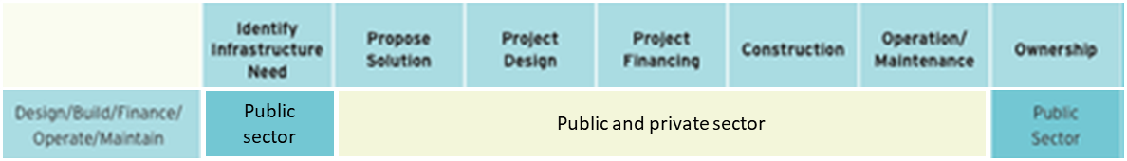

Figure 4: Manchester CityVerve PPP

This PPP model has allowed for the development and deployment of IoT solutions for talkative bus stops, smart lighting, smart air quality monitoring.

# THE BENEFITS OF THE SMART PPP

These new PPP models can help achieve New Zealand’s sustainability, mode shift, wellbeing goals for future cities. The elements that contribute to these include:

* The design thinking approach used by the accelerator helps understand the users and their needs, as well as making tailored solutions that fit the users in a particular geographic area.
* Involving the private sector in the ‘develop solutions’ phase of the PPP allows for the co-design of solutions with the public sector which the public sector might not have the mandate to do alone.

# CONCLUSIONS AND RECOMMENDATIONS

In conclusion, innovation in PPP could be beneficial for high exploratory smart city projects. There are key benefits to this. Firstly, it allows for innovation at the ‘develop solutions’ phase of the PPP due to the collaboration with the public and private sector. Secondly, the accelerator type approach brings in the human centred design thinking approach for the development of tailored solutions for citizens in that specific area.

It is recommended that the smart PPP is adopted for cities whose outcomes are to create a more equitable transport system, one where all users and their needs are considered in the planning and design and development of the transport system.

# REFERENCES

CityVerve, ‘*What is CityVerve’*, viewed 27 October 2019 <https://cityverve.org.uk/what-is-cityverve/>

European Commission, ‘*Different levels of private sector engagement in PPP contracts’*, viewed 27 October 2019 <https://ec.europa.eu/knowledge4policy/visualisation/different-levels-private-sector-engagement-ppp-contracts_en>

Neirotti, P., De Marco, A., Cagliano, A. C., Mangano, G., & Scorrano, F. (2014), ‘C*urrent trends in Smart City initiatives: Some stylised facts’*, Cities Journal, Volume 38, Pages 25-36.

Sidewalk Labs 2019, *‘Toronto Tomorrow A new approach for inclusive growth Volume 2 and Volume 3’ viewed 27 October 2019*

Statistics New Zealand

United Nations 2018, ‘*World Urbanisation Prospects The 2018 Revision’,* viewed 25 October 2019 <https://population.un.org/wup/Publications/Files/WUP2018-KeyFacts.pdf>

New Zealand Transport Agency 2015, *‘A guide to transport public private partnerships (PPPs)’*