**Global truths – learning from my holidays**

**This paper has not been peer reviewed**

**Author/presenter:**

Daniel Newcombe, Manager Strategic Projects: Central Access,

Auckland Transport; MNZPI, [daniel.newcombe@at.govt.nz](mailto:daniel.newcombe@at.govt.nz)

**ABSTRACT**

When on holiday, we all take notice of how other countries and regions design and operate their transport systems differently to NZ. Some of that comes from different histories or laws, but there are some global truths in the way people function within the transport system and respond to engineering designs. This paper uses a range of examples from across a holiday in Europe to show core road safety, mode share, universal access, speed and enforcement outcomes can be to tied to key engineering and planning factors. These are explored and referenced to the NZ context, so that the various global truths can be applied or used to support better practice in NZ. As well as assisting engineering practice, the paper may reassure NZ transportation practitioners that their colleagues the world over experience the same challenges and need to be resourceful in their efforts. If nothing else, this paper will remind you of all the amazing places and people around the world, and offer some variety to the other NZ-based papers.

**INTRODUCTION**

We all enjoy a good holiday. It opens our eyes to different cultures and experiences. As transport professionals, it is understandable that we take notice of how other countries and regions design and operate their transport systems differently to NZ.

This paper outlines some of those experiences in a way that seeks to identify some ‘global truths’ in the way people function within the transport system and respond to engineering designs – regardless of the different historical or legal backgrounds to the jurisdictions.

The discussion within this paper is based upon a range of examples from the author’s 2019 holiday to the United Kingdom, France, Greece and Switzerland. Although the holiday was a typical family and sight-seeing affair, the author suggests some core road safety, mode share, universal access, speed and enforcement outcomes can be to tied to key engineering and planning factors.

This discussion is referenced to the NZ context, so that the various global truths can be applied or used to support better practice in NZ.

**GLOBAL TRUTH #1**

*If you provide poor quality bike facilities (or none at all) only a few hardy males will cycle, but if you provide good bike facilities then many more people, especially women, will cycle.*

Throughout the world, there is a huge variety in the provision of cycling infrastructure – everything between none and physically separated two-way cycleways such as in Figure 1 below from central London.

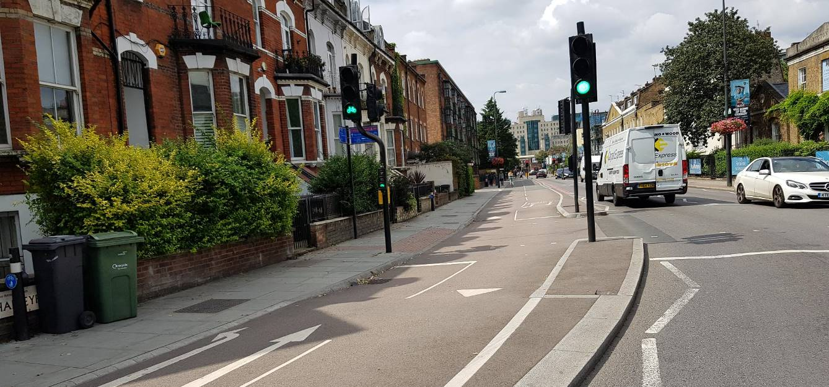

*Figure 1: Separated cycleway in south London*

Despite the variety in infrastructure, there is a certain truism – the better the quality, the more people who will use it. It is a version of “build it and they will come” but rather than being a binary situation, there is a spectrum of increasing usage based on increasing quality. This observation is obviously not statistically valid, but across Europe it was noticeable that a typical street without any cycle facilities had a lower number of cyclists than one that did, and where the quality was higher, the volume of users was higher.

It is well known from cycling research that there is usually a core group of hardy (usually) male cyclists (known as ‘fearless’) who will cycle regardless of infrastructure provision – typically 1-2% of road users. When cycling infrastructure is provided, this entices the ‘enthused and confident’ group, and when even greater infrastructure is provided this encourages the larger ‘interested but concerned’ group. This emergence of additional groups in relation to infrastructure was evident across Europe.

Another observation was that where infrastructure increased, more of these cyclists were female. Whilst transportation professionals often focus on just increasing volumes of users, it is worth acknowledging that the type of user is a major indicator of the success of a facility. If a facility looks and feels safe, is connected to places of interest and is part of an overall network, it entices people who want to cycle but may be concerned for their safety – which often is a group that represents a lot of women. In this way, the proportion of female cyclists is a reliable indicator of the quality (or not) of cycling infrastructure.

Another way to look at the situation is that where the public complain that there are ‘not enough’ cyclists on a street to justify investment in infrastructure, this knowledge shows that the users are out there and simply waiting for safe and connected infrastructure to be provided.

Across Europe there are a range of cycle lane/way designs but, building on the above observation, another truism is that ‘paint isn’t enough’. Only physically separated cycling facilities appear to entice additional users. This can be achieved fairly cheaply, as shown in the example below from central London with simple standalone kerbs. If the cycle lane in Figure 2 was a simple painted line, it would no doubt be more easily illegally parked over or driven into by passing vehicles.

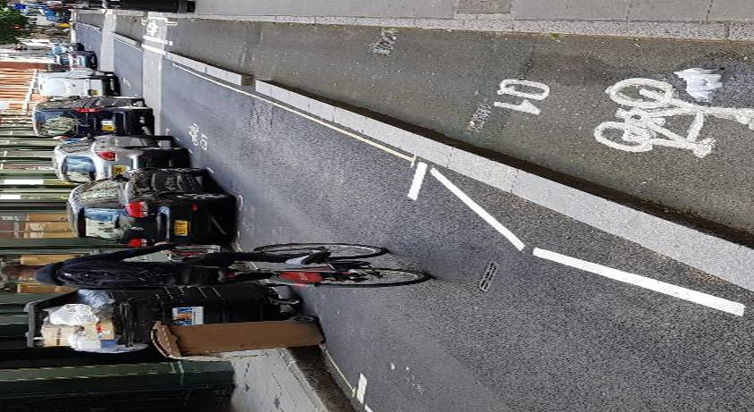

*Figure 2: Simple separated cycle lane in central London*

It is not only street-based cycling infrastructure which can entice greater or lesser volumes of users, but also supporting facilities. The author lived near Greenwich 15 years ago and as a cyclist was aware of how few other cyclists there were.

This recent holiday included a trip back to Greenwich, Figure 3 shows the very well used cycle parking at North Greenwich Underground station. As with on-street facilities, if end-of-journey facilities are not provided a proportion of would-be users will be discouraged from cycling. Nearby to this dedicated facility, chained to fences away from public areas (which used to be the only cycle parking option) are the remains of vandalised bicycles or bicycles with stolen parts – which was a common sight 15 years ago.

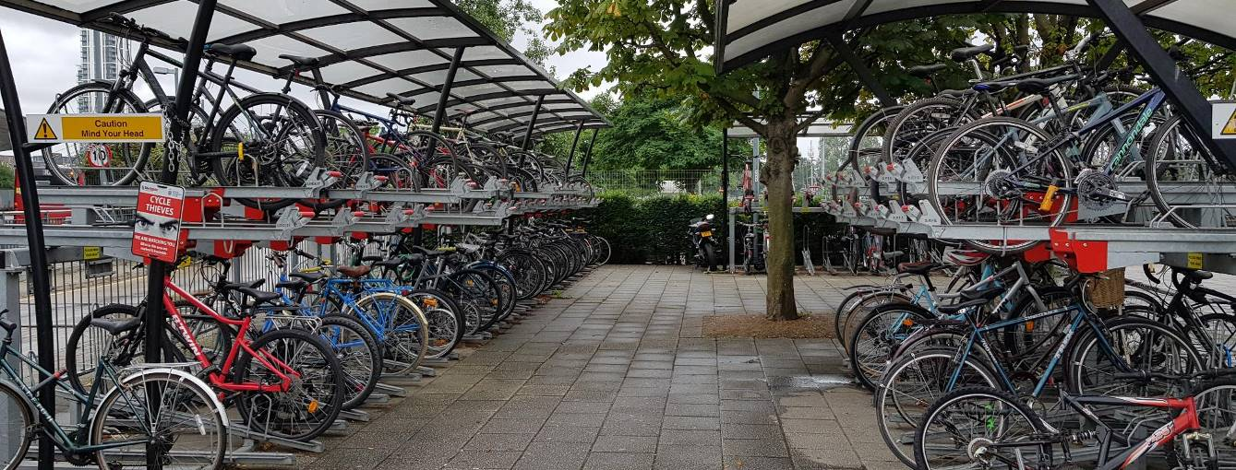

*Figure 3: Cycle parking at North Greenwich Underground station, London*

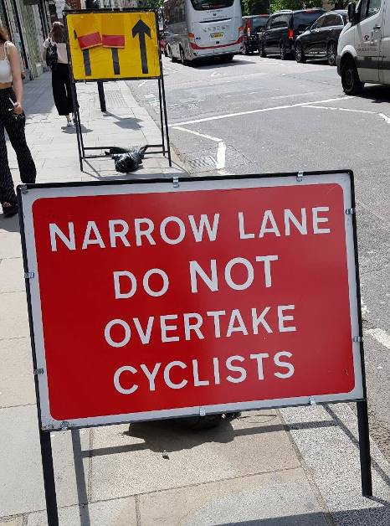Despite the significant provision of cycling infrastructure across most of Europe, there are still a vast number of busy roads in town centres and city centres (which would be expected to be used by significant numbers of people on bikes) with no cycling provision at all.

As shown in Figure 4, from an East London street, this situation can sometimes be acknowledged by transportation professionals. However, this sign in particular could be present in almost every other street in that part of East London, and it is only in place due to road works nearby.

Of note, the sign did not appear to be having a meaningful effect on traffic in terms of not overtaking those cyclists brave enough to take on three busy, narrow lanes of traffic.

*Figure 4: Sign at road works site in East London*

**GLOBAL TRUTH #2**

*Drivers will park anywhere – especially bus stops and footpaths.*

Many nations believe that their drivers are the worst, and many cities similarly seem to compete to claim that their drivers have the worst behaviour. In fact, across the world there are bad drivers everywhere, but - more relevantly - all drivers are human and will take advantage of opportunities where they think they can get away with them.

The author has not seen any country or city where drivers do not occasionally park on a bus stop or a footpath if they think they can get away with it (admittedly the author has not been to Japan, which is renowned for obedience). Every nation has drivers who will state ‘I only popped into the shops for a minute’ or I was being safe by keeping my car off the road’ or (the author’s favourite) ‘I put my hazard lights on’.

Some countries however have a particular culture (perhaps in some cases enabled by local bylaws) which sees drivers parking two wheels up on the footpath. As Figure 5 from Windsor shows, virtually every car in the street is parked two wheels up on the footpath, even though the street itself isn’t particularly narrow. Whilst this behaviour may benefit passing motorists, it obviously impinges on pedestrian space

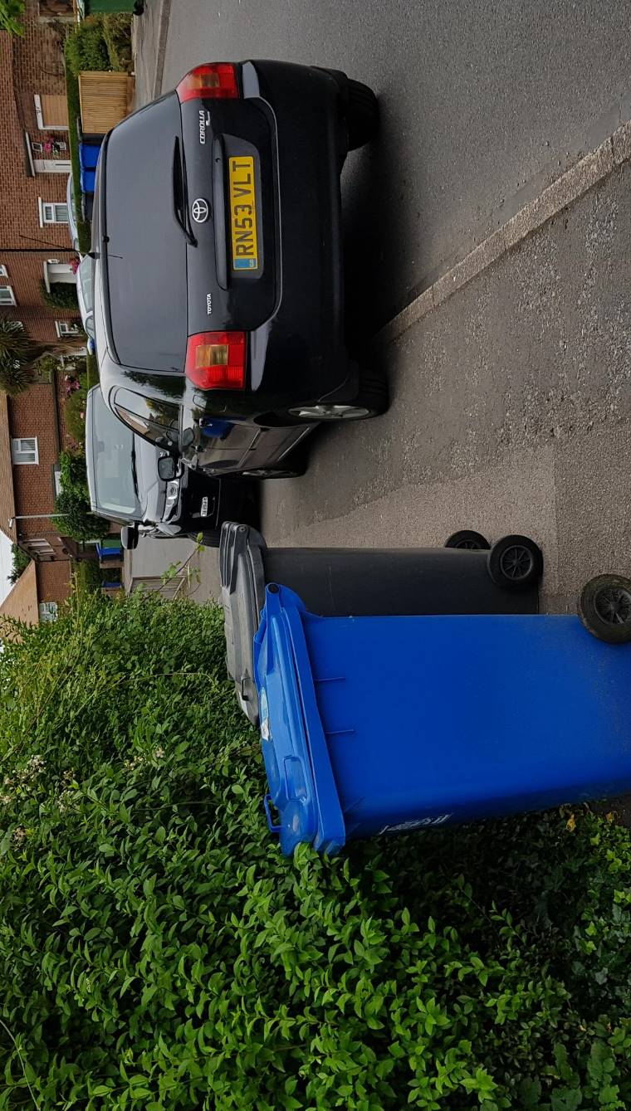

*Figure 5: Cars parked up on footpath in Windsor, UK*

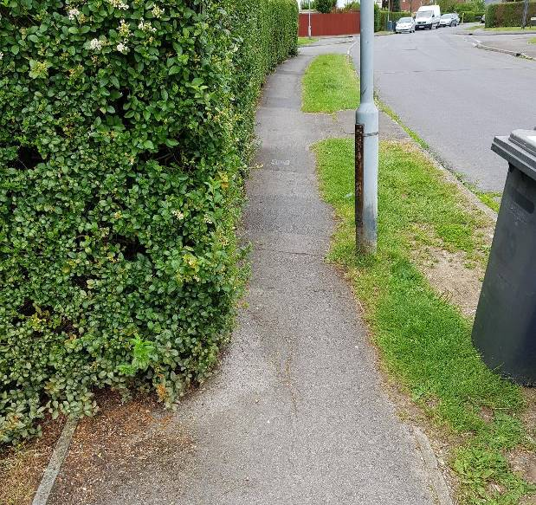

As Figure 6 shows (from the same street in Windsor), the footpath already contains permanent or temporary obstacles. It is therefore odd that local authorities allow (formally or informally) this parking to occur, when it will clearly make it harder for people to walk, push buggies or use mobility scooters, etc.

It also creates a maintenance issue, as the grass berms and footpath pavements are clearly damaged by the parked vehicles, which must create extra maintenance costs for local authorities.

*Figure 6: Narrow footpath in Windsor, UK*

An even more perverse situation occurs when the local authority actively provides for the footpath parking, as can be seen in Figure 7 (Lewisham, London). In this situation, there are painted parking boxes straddling the footpath and carriageway and signage outlines that the parking is for residents only.

Although in this location the carriageway is quite narrow, the footpath is also narrow and (as can be seen) cluttered with the usual array of streetlights, poles, rubbish bins and encroaching hedges.

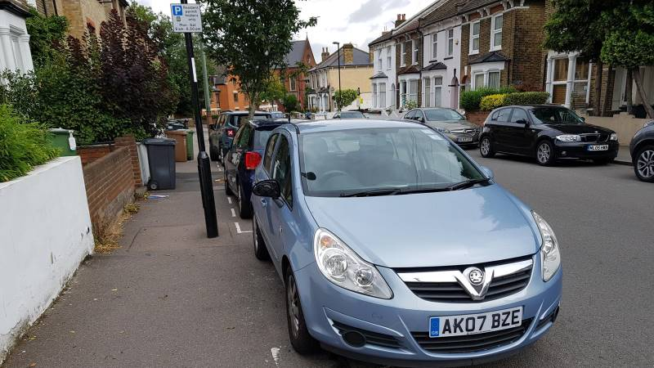

*Figure 7: Permitted footpath parking in Lewisham, London*

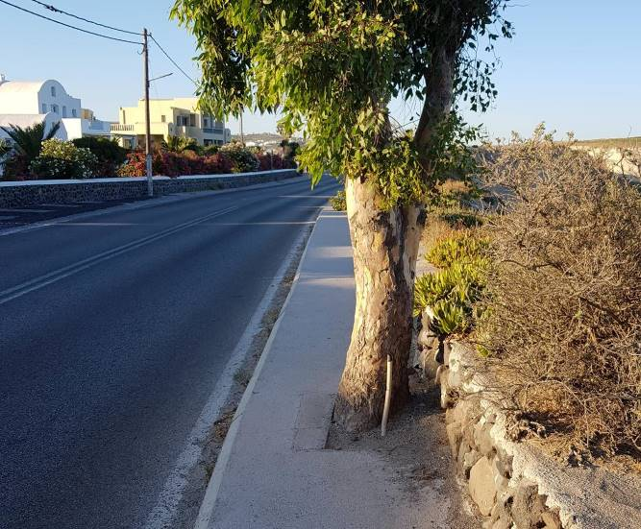Around the world, even some jurisdictions with less acceptance of footpath parking still struggle with adequate management of footpath space.

As Figure 8 (from Santorini) shows, tree placement can create another obstacle. Arguably, in this location, the tree was there before the footpath, but the its presence makes such a narrow pinchpoint that it renders the footpath pointless in this area. There are no pram crossing ramps or ways to easily pass around the tree, and the footpath on the other side of the road is even narrower.

*Figure 8: Tree in a footpath, Santorini*

**GLOBAL TRUTH #3**

*Shared spaces are tricky to get right. They may look nice but will fail if too much traffic passes through.*

Shared spaces – a flush surface shared by both pedestrians and vehicles – are an increasingly common treatment in town centres and city centres around the world. They can be a useful intervention to improve the amenity and safety of a street. Unfortunately they can also be applied – with the best of intentions – in inappropriate situations, and therefore the expected benefits never materialise and new problems arise.

Figures 9 and 10show Exhibition Road in West London, which was a project the author was working on in 2005, when shared spaces were still a poorly understood concept. The final design has now been in place for many years and street use has settled into a consistent pattern.

Whilst the materials and layout give a heightened amenity to the street, the high volume of vehicles (notably buses, which are usually not present in a shared space) means that pedestrians tend to confine themselves to the extreme sides of the street, rather than feel comfortable to walk across any part of the street (and in doing so ‘share’ the space with traffic). There are also large amounts of parking retained, which is also not something a shared space usually provides.

The outcome is that the original purpose of the shared space is not achieved – the ‘sharing’ aspect. Were this still to be pursued, the local authorities would seek to reduce traffic volumes, in particular buses, and look to redesign the space that invited pedestrians to use greater areas within the street. It is acknowledged that it will always be difficult to do this in a busy and popular location such as Exhibition Rd, in which case perhaps a shared space may not be the appropriate treatment.

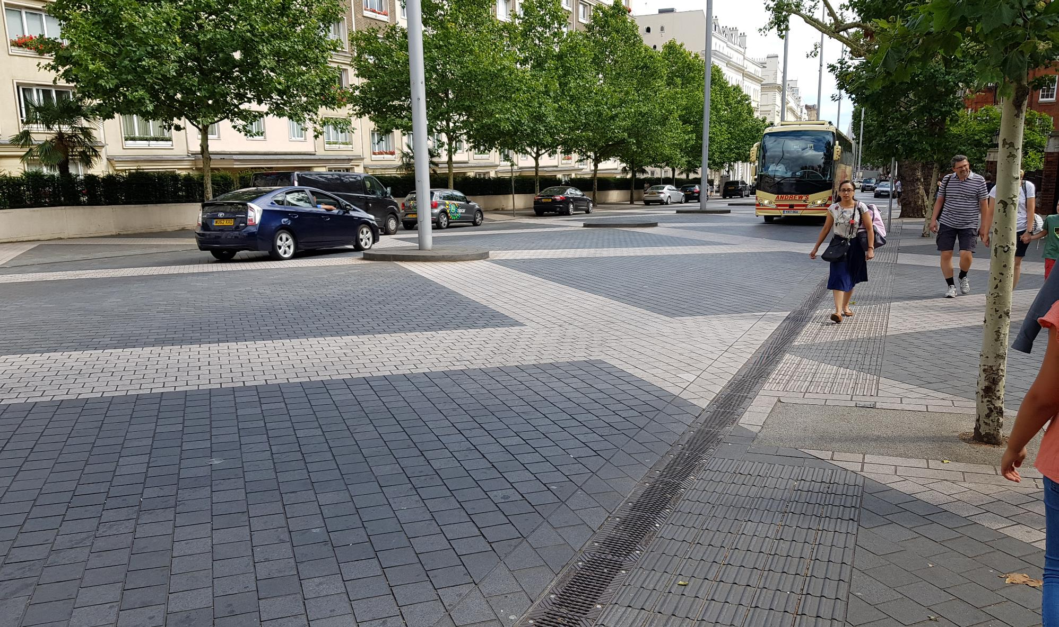

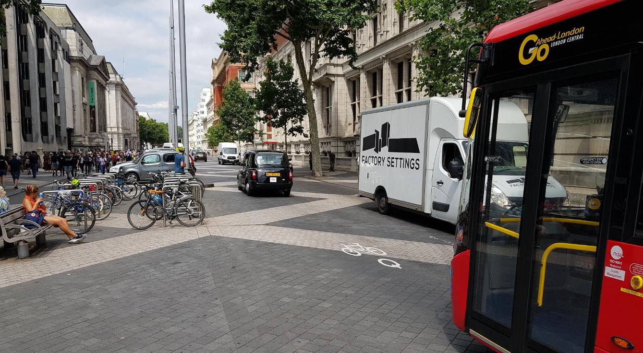

*Figures 9 and 10: Exhibition Road, West London, shared space still operating as a standard street*

**GLOBAL TRUTH #4**

*Narrow, obstructed lanes are not unsafe. They force traffic to go slow and look out for each other.*

Perhaps the most profound global truth experienced in the author’s recent trip was that a fundamental tenet of traffic engineering may not be as robust as thought. Traffic engineering design manuals, standards and planning guides are consistent in seeking sufficiently wide and unobstructed, so as to remove hazards and give drivers space and visibility to make decisions.

There are abundant examples from across Europe – particularly more historic urban areas – where streets have narrow and obstructed traffic lanes. Far from being dangerous and to be avoided at all costs, these streets tend to simply discourage extraneous traffic and encourage any remaining traffic to operate at a slower speed and with greater acknowledgement of other street users also needing be in that space. So – less traffic, slower traffic and greater driver awareness. Hence these streets tend to be more pleasant for all users – and perceived as safer than more modern roads built to ‘safe’ standards.

Figure 11 from Windsor town centre, shows an extremely narrow side street where the few vehicles which are tempted to entre must slow to a crawl to safely pass the parked cars. Vehicle speeds are almost walking-pace and traffic volumes are very low, despite linking two collector roads. The street layout (including parked cars) effectively becomes ‘traffic calming’ without any specific intervention.

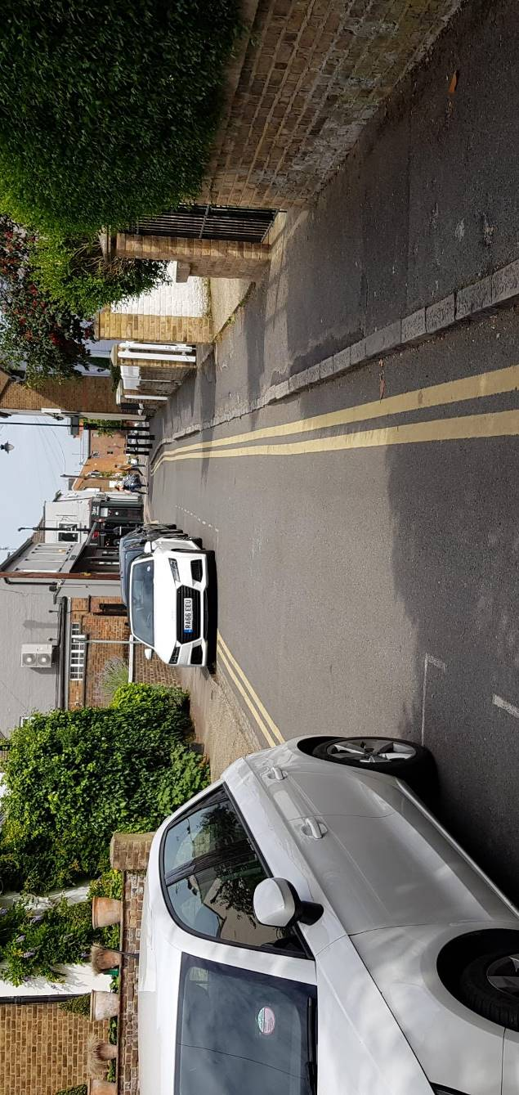

*Figure 11: Narrow street in Windsor town centre*

Several miles away in a more residential part of Windsor, Figure 12 shows another typical street layout where one of the lanes simply cannot be used without crossing the centreline. This means that traffic – in both directions – must look ahead for other vehicles and never travel so fast as to be unable to stop if a car unexpectedly pulls out of a driveway or side street. Whereas sections of this same route without this narrowness constraint – where traffic has clear travelling lanes – experience much higher speeds and are much more likely to have a worse safety record.

This is completely contrary to typical traffic engineering logic, which teaches that a wide clear traffic lane is better and safer than a narrow and obstructed lane. It is worth noting that many existing street designs would be impermissible if applied for using modern standards. Obviously if the traffic function and volumes are much higher then this situation will break down, either by overwhelming the ability of drivers to safely interact, or the traffic congestion from drivers waiting for each other to pass may become untenable.

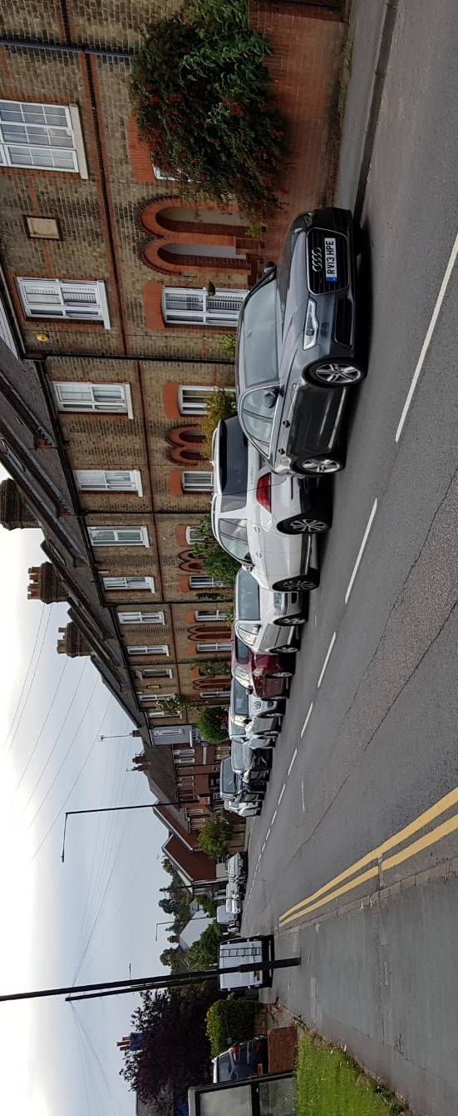

*Figure 12: Obstructed traffic lanes in residential Windsor street*

Perhaps it is time for traffic engineers to deliberately design some street to be narrow and obstructed – to get slower and safer traffic – rather than having wide clear streets but rely on roadside signs to advise motorists to drive slower and with care for other street users.

**GLOBAL TRUTH #5**

*Waterfront areas are hugely attractive. Reclaim them from traffic and parking.*

Traffic engineering in the 20th century has often considered waterfronts – along rivers or coastlines – as ideal locations for major roading projects, perhaps because of the relative lack of ‘side friction’ from land uses. This has resulted in many cities having busy traffic arterials alongside otherwise picturesque waterfronts.

Around Europe and, to a lesser extent, New Zealand, local authorities are starting to acknowledge that these spaces are far more valuable as ‘people spaces’ than roads. There are hundreds of roads across every city but very few waterfronts, so it is increasingly recognised that this space should be converted and improved to high amenity places that build off the watery environment.

Paris (as shown in Figures 13 and 14) has famously begun converting some of riverside infrastructure into urban parks and plazas. These are now highly popular places for tourists and locals alike to gather and enjoy, with both formal and informal activities. In the Paris example, sand is trucked in over summer to create ‘beaches’ in places that used to only provide for traffic.

The lesson for traffic engineers is to observe that some waterfront locations – despite being attractive routes for traffic projects – can actually have much a higher value to a city as spaces for people.

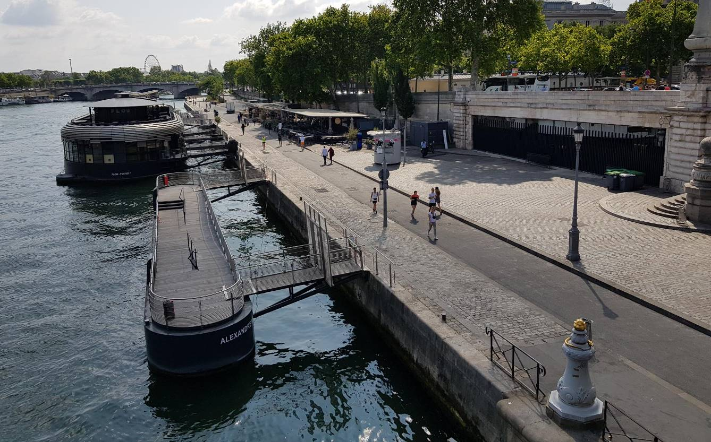

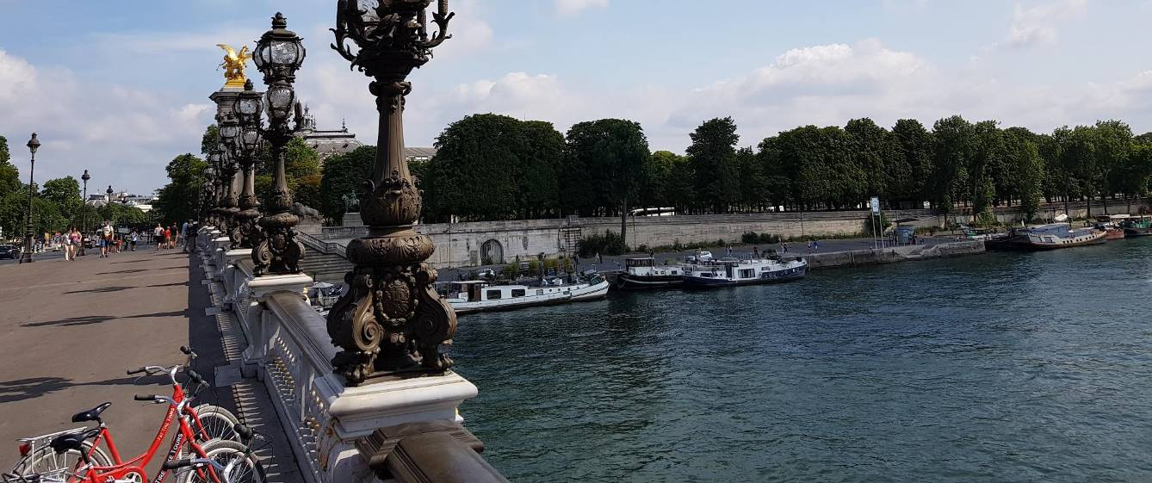

*Figures 13 and 14: Activity along the River Seine at the Pont Alexandre III in Paris*

**GLOBAL TRUTH #6**

*Barriers to prevent parking on footpaths can create new obstructions for pedestrians. Having a poor walking environment means your community excludes a chunk of society – the elderly, the disabled, people pushing buggies, etc.*

Acknowledging Global Truth #2 (people will park on footpaths), many cities use bollards along footpath edges. The presence of these bollards does deter illegal parking but creates new obstacles for pedestrians and can narrow down the usable space of already constrained footpaths.

One way to check whether the poor pedestrian environment is having an effect is to observe the diversity of users. If there is a scarcity of elderly, disabled people, and people with mobility requirements, then it can be considered that something in the pedestrian environment is deterring those users. Figure 15 shows a street where few elderly or disabled people were observed. This is similar to the presence of female cyclists in Global Truth #1, whereby good quality infrastructure allows a wider range of users to emerge.

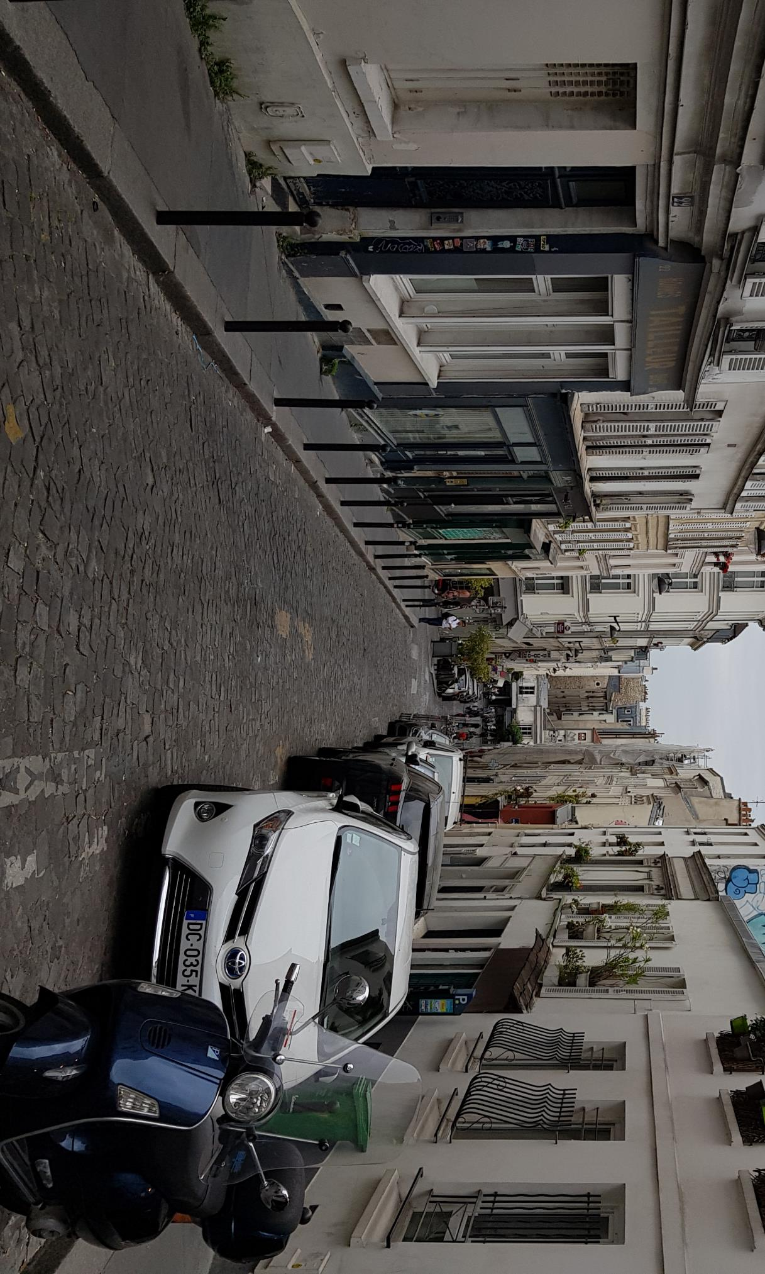

*Figure 15: Narrow footpath near Montmartre, Paris, where very few elderly or disabled people are seen.*

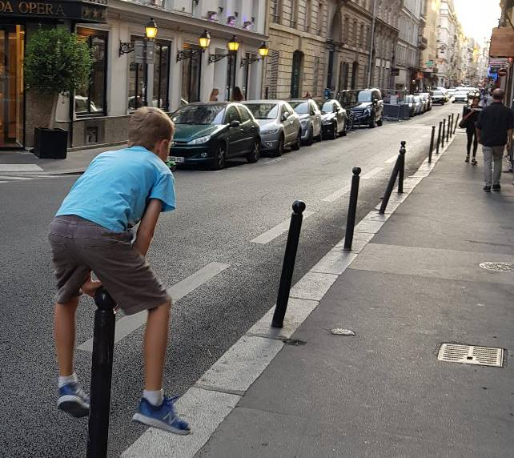

However, whilst bollards may obstruct some footpath users, they can also improve the experience for others.

Figure 16 shows the author’s 9-year-old son ‘leap-frogging’ over bollards along a central Paris street. These provided a sense of excitement and activity on an otherwise ordinary street. Bollards and other street furniture – whilst needing careful placement to avoid inadvertently impacting users – can obviously also add to street amenity and attractiveness.

*Figure 16: Making use of bollards in central Paris*

**GLOBAL TRUTH #7**

*You can ruin beautiful locations by jamming traffic into it. (Also known as: There is a point where providing vehicle access to a location starts to undermine the attractiveness of that location.)*

People travel to famous locations to experience the unique atmosphere and views. The local economies often rely on tourism and are therefore incentivised to increase visitor numbers. And often these same locations continue to be operating city or town centres, so have their own background activity.

All of this can lead to excessive levels of traffic, as people flock to see, experience, and do business in the location. For people who live at the location, the volume of traffic becomes’ the new normal’ but for tourists, this can undermine the quality of the experience and the original purpose of the visit.

Figure 17 shows the main square in Fira, Santorini, which throughout the summer months swells with thousands of tourists. It also hosts the main traffic route across the island, despite alternative routes being available. As the image shows, large vehicles (including coaches and construction traffic) pass through the square amidst wandering tourists, who often may not be expecting traffic. The experience of the traffic massively undermines the unique beauty of Santorini, as well as creates significant safety issues.

Although some servicing traffic can legitimately be expected to need to be in the area, the majority of the traffic passing through the square could be diverted elsewhere. This would inconvenience locals and make some tourist buses, taxis, etc. have access the area from further away, but it is unlikely this disbenefit would outweigh the uplift in experience. It is obviously unknown whether the local authorities will eventually acknowledge the situation and make changes, but street design in this part of the world is often baffling to outsiders, as shown in the next Global Truth.

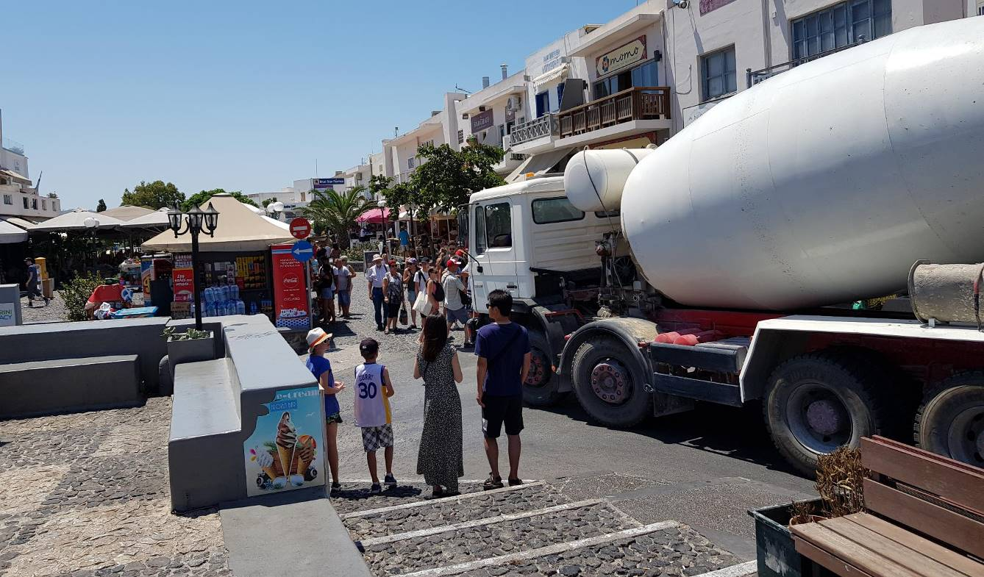

*Figure 17: Heavy traffic passes through main square in Fira, Santorini*

**GLOBAL TRUTH #8**

*Using tactile pavers does not make a place more accessible.*

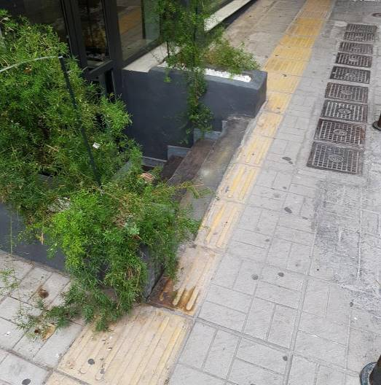Figure 18 is from Pireaus, Greece, a suburb of Athens which (like many Greek cities) has abundant tactile pavers. Presumably the local authorities have enthusiastically taken on the need for tactile pavers as an important part of street infrastructure, however the implementation of the pavers shows a possible lack of understanding as to the purpose and use of the tiles.

The first image (left) shows a row of yellow pavers, which stretches the length of the street, leading directly into a low concrete block wall and a fairly steep set of stairs to a basement doorway. The pavers are even halved lengthways to fit with the stairs. A blind or visually impaired person following the pavers is likely to strike the low wall and/or fall into the steep stairway.

*Figure 18: Tactile pavers leading into stairway in Pireasus, Athens*

Figure 19, from Santorini, shows tactile pavers on a narrow footpath – already impaired by bollards, power poles, an uneven surface and steep drop off on one side.

As with the Piraeus example, there are tactile pavers along the length of the street. Great care has been taken to slightly offset the alignment of the pavers at the power pole, but overall it appears that the investment in tactile pavers could have reaped greater benefits by instead being used to relocate the pole or widen the footpath.

Another aspect is that most of the footpaths around Santorini are either very uneven, narrow and obstructed (see Figure 18), have multiple steps, or are non-existent. In this respect, the usefulness of the investment in tactile pavers is up for debate.

The author observed only one blind person during their week-long stay in Santorini and that person was being led around the area by a caregiver. It is unlikely that the blind person would be able to use the tactile pavers to independently navigate around the island.

*Figure 19: Tactile pavers into a power pole on a narrow footpath in Santorini*

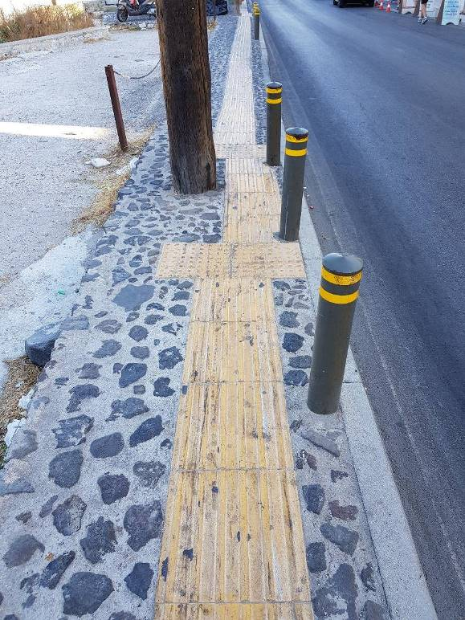

**GLOBAL TRUTH #9**

*Cheap ‘tactical urbanism’ treatments can work. But can just look shabby.*

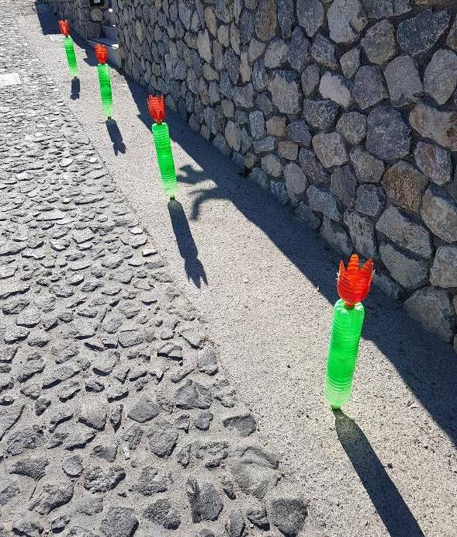‘Tactical urbanism’ is a growing trend of using cheap and quickly applied treatments to achieve urban realm outcomes, typically reallocating street space from traffic lanes or parking into attractive people-focused areas.

Whilst these can be an effective way to test different street layouts (and often advocates use tactical urbanism to ‘prove’ a layout works, the fact that the treatments are low cost and temporary can mean that the effect is somewhat less than what a permanent solution would be.

Figure 20, from a laneway in Santorini, shows some recycled plastic bottles, painted and cut to look like flowers, but actually acting as bollards to deter illegal parking against the wall. Clearly these were not officially installed, but would be cheap to replace and add a level of interest to the laneway.

*Figure 20: Homemade plastic flowers act as tactical urbanism bollards in Santorini*

A less successful tactical urbanism treatment is shown in the image below. The local supermarket in Fira, Santorini, has obviously struggled with motorists parking directly in front the entrance, so bolted road cones to the ground (presumably this was preceded by signs requesting the area was kept clear – to no avail). The remnants of these cones are still present but the rest have long been parked over. The current tactical urbanism treatment – which is working – is to stack wooden pallets against each other to block the area from traffic.

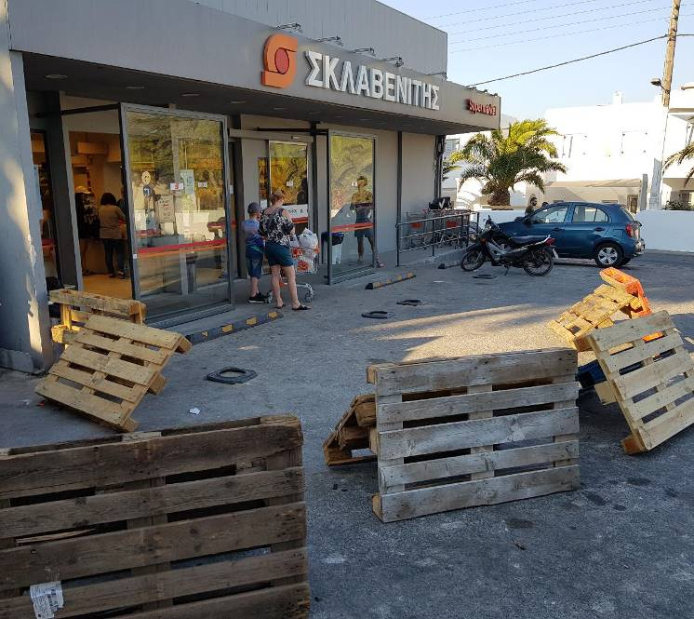As Figure 21 shows, customers are now able to safely walk into the supermarket entrance, and motorists must park further back, but the quality of the amenity is obviously reduced. On the plus side, the treatment is cheap and easily adjusted.

This experience shows both the good and bad of tactical urbanism. Done well and with an eye for improving the amenity, tactical urbanism can be a cheap and flexible way to change the use of a street. If it doesn’t work, the treatment can easily be adjusted or removed.

On the other hand, cheap treatments can reduce the amenity of the area and create ugly features or just look like dumped rubbish.

*Figure 21: Wooden pallets as tactical urbanism in Santorini*

**CONCLUSION**

These global truths cover a wide range of transportation issues and come from a variety of cultural experiences. These cover road safety, mode share, universal access, speed and enforcement outcomes.

Travel in new cultures opens our eyes to the different ways to treat street environments. Sometimes the history or regulations of a location will have created a unique street arrangement, but there are still lessons transport professionals can take and apply back in New Zealand.

Some of the possible improvements to local engineering practice from the global truths include a greater consideration of the walking environment (in terms of footpath obstacles and the use of tactile pavers) and an appreciation that shared spaces require particular conditions in order to be successful.

Other lessons include that the presence of female cyclists is an indication of good quality cycling infrastructure, and that allowing too much traffic into an attractive area can detract from the original reason for people coming to the location.

Even if these global truths offer little for specific NZ locations, this paper should at least reassure transportation professionals that their colleagues the world over experience the same challenges and need to be resourceful in their efforts.

And, if nothing else, the photos in this paper will remind you of all the amazing places and people around the world.