**MANAGING DOWNSTREAM EFFECTS OF THE CHRISTCHURCH NORTHERN CORRIDOR (CNC)**

(THIS PAPER WAS PEER REVIEWED)

**Dr Shane Turner, Technical Director**

PhD, BE (Hons), CPEng, CMEngNZ, IntPE(NZ)

Abley Ltd, 137 Victoria Street, Christchurch

E-Mail: [shane.turner@abley.com](mailto:shane.turner@abley.com)

**ABSTRACT**

The extension of the Christchurch Northern Arterial/Motorway (to the south) and upgrade of a section of Cranford Street (collectively called the Christchurch Northern Corridor, CNC) is expected to open later this year (2020). As a requirement of the CNC designation conditions this study examined the expected transport impacts of this new road link on the road network immediately downstream of the CNC and what measures need to be put into place to mitigate these effects. Transport modelling showed that the current 2-lane operation of Cranford Street south of the CNC is inadequate to accommodate the forecast traffic volumes when the CNC opens and through to 2030, which if untreated could result in considerable rat-running (>30% increase) in local streets. A key element of the study was to develop a plan of potential interventions (road upgrades and traffic calming) to encourage traffic to stay on the preferred (arterial) traffic routes and off the local roads. However, on its own this approach was deficient in addressing community concerns. Hence the study recommended that improvement also be made to 1) support safer cycling, 2) support safer access to school, 3) make streets healthier and 4) consider the safety and access issues around parks and commercial areas (shops) for all road users. The study also requires monitoring of traffic, safety and environmental changes through to 2030, triggering further improvements if adverse impacts do occur.

**INTRODUCTION**

With the population growth in the northern suburbs of Christchurch and satellite towns within the Waimakariri District (further north) traffic volumes have been growing on routes north of the central city. The displacement of some Christchurch residents from the eastern suburbs, as a result of the earthquake red zone, has led to an acceleration of this growth over the last 9 years. Since the 1950’s the cities transport planners have identified the need for a new route (called the northern arterial) to provide access between the city centre and northern suburbs and Waimakariri District.

Over recent years the current arterials routes to the north have reached capacity and in response the New Zealand Transport Agency and their partners designed and are constructing the Christchurch Northern Corridor (CNC). This corridor is due to be open in the second half of 2020. The CNC consists of the extension of the northern motorway south, to the east of the suburbs of Belfast and Redwood, through to the Christchurch ring road (QEII Drive), a four-lane greenfield link road (the northern arterial extension (NAE) from QEII to Cranford Street at a large three lane roundabout) and then four-laning of Cranford Street (CSU) to an upgraded traffic signals at Innes Road (see Figure 1). At the Cranford/Innes intersection some of the traffic will travel towards the south-west on Innes Road, while the majority will continue along Cranford Street, or other routes, into the city.

As shown in Figure 1 the CNC will reduce traffic on three routes (SH1/Johns Road, Main North Road and Marshlands Road), enabling these routes to accommodate local traffic growth as a result of new development. In the case of Main North Road, the additional traffic capacity will also be used to improve bus priority along this corridor. This is the key bus corridor to the north, given the population and employment densities along this route. A cycleway is also being constructed along the CNC which includes a separate cycle bridge over the Waimakariri River and connection to the Papanui Parallel cycleways to the south, which connects with the central city. To encourage car- pooling and increase bus patronage one of the two southbound lanes on the CNC down to just north of the Cranford Street roundabout will be for high occupancy vehicles (two or more passengers).

**Purpose of Downstream Effects Management Plan (DEMP) - CNC Designation Conditions**

During the notice of requirement proceedings on the CNC a number of concerns were raised by the public and other stakeholders about the downstream effects of the additional traffic that will use roads in the suburb of St Albans once the CNC opens. While traffic growth would still occur even if the CNC was not constructed, the CNC does concentrate this traffic onto Cranford Street, and the expectation is that this would overload that route south of Innes and drivers would rat-run through local streets. So, the commissioners made the development of a downstream effects management plan (DEMP), by a suitably qualified independent traffic expert, a requirement of the CNC designation.

The objectives of the investigation, as stated in Appendix A to the designation conditions, into the downstream effects are:

1. To identify preferred vehicle access routes, particularly for trucks, between the end of the Christchurch Northern Corridor and the Central City (that is between the end of the NAE/CSU and the City centre); and
2. To identify strategies to keep vehicles on preferred vehicle access routes; and
3. To discourage vehicles away from priority public transport routes and walking or cycling routes such as Main North Road / Papanui Road and Rutland Street corridors respectively.

These objectives appear to be limited in scope and motor vehicle centric, compared with best practice in transport planning. While c) looks to reduce the impact on a couple of public transport and cycling corridors it does not consider the direct impacts that the additional traffic will have on these road users, plus pedestrians, on other collector and arterial roads.

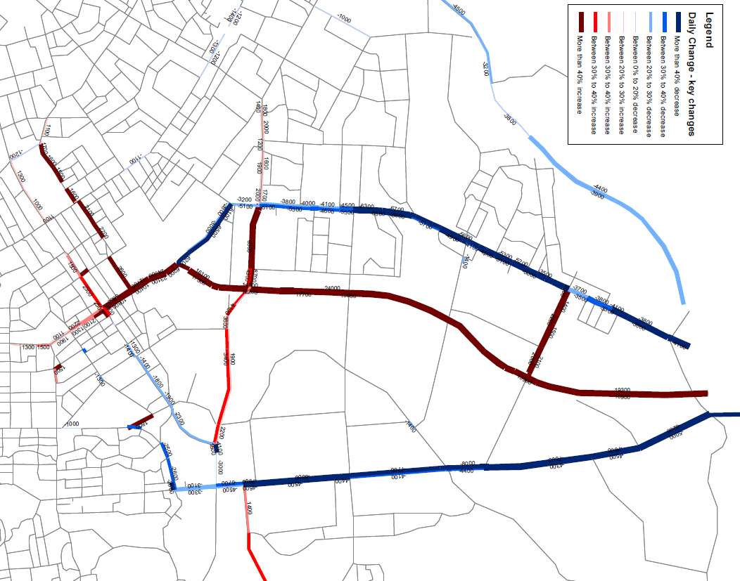

**Figure 1: Major changes in traffic volumes as a result of CNC (compared with no CNC) in 2031**

Fortunately, Appendix A to the Designation conditions also states that: This Management Plan is to ensure downstream effects are appropriately managed and to:

1. Assess the existence, nature, and extent of any increased traffic on streets adjacent to, or adjoining Cranford Street attributable to the NAE/CSU that might cause or contribute to a loss of service to any of these streets for up to 10 years after the opening date of the NAE/CSU;
2. Implement measures to avoid, remedy or mitigate such effects, where these are more than minor, in a timely and cost-effective manner and where appropriate and practicable; and
3. Monitor the efficacy of the measures for an appropriate period and implement further remedial action, if this is necessary and appropriate.

The designation condition stipulates that in order to be considered for improvements and/or traffic calming work a street must have experienced in excess of 30% increase on the traffic volume over what would have occurred without the operation of the CNC (i.e. underlying traffic growth is not included in the 30%).

Based on the Appendix A clauses the appointed independent traffic expert has been able to take a broader view on the measures that need to be undertaken to avoid, remedy, or mitigate the traffic effects. It is not just a matter of keeping the traffic on main roads and discouraging vehicle users from using local streets and routes currently prioritised for public transport (Main North Road) and cycling (Rutland Street), but also mitigating the effects on other transport modes of the increased traffic.

For example, the large increase in traffic on Cranford Street will impact 1) on safety of school children crossing the corridor to access St Albans School, 2) cyclists who use Cranford Street and 3) pedestrians and drivers who want to access the Westminster/Cranford local activity centre. Measures to mitigate these risks have been addressed in the DEMP (Turner, 2019)

**History of Northern Arterial and Community Concerns**

Various traffic corridor plans have been conceived in planning for the Christchurch northern arterial since the 1950s. In 1962 the Christchurch Regional Planning Authority proposed the Northern Arterial Concept Route; roughly following the path of the current Northern Arterial however extending further south through parts of St Albans. During the 2nd review of the Reports the corridor was changed so that new arterial would extend through to Bealey Avenue, where initially it was to be connected to an elevated structure between Barbadoes and Madras Streets, and latter to the one-way pair of Barbadoes and Madras Street. In the 1970s and 1980s there was a lot of community opposition to the proposed new arterial through St Albans and the urban portion of the designation was removed from the Christchurch City District Scheme in the early 1990s. For more details of the various schemes that were developed in the 20th century refer to Douglas (2000).

Clearly, there has been much discussion and investigation on a new north to south transport connection in Northern Christchurch for more than 60 years. During that time larger motorway connections (passing through urban Christchurch) have been considered, planned, and eventually withdrawn. The history of these decisions has been important in the preparation of Christchurch Northern Corridor (CNC, over the last 15 years) and the Downstreams Effects Management Plan (DEMP). The intention was not to re-litigate or reconsider past discarded options, or options of a similar nature and scale, (i.e. new arterial routes through the suburb of St Albans), which over many decades were not favoured by the local community.

Given the history and strong views of the local community, the DEMP was focused on utilising existing roads to carry the additional traffic associated with the CNC. It also sought to minimise the impact of any upgrades on private property and especially building structures within the urban area. An important part of the study was understanding the impact that the additional CNC traffic could have on the local community, and how this can be avoided, remedied or mitigated. This includes minimising the impact of the additional CNC traffic on safe access to parks, schools, businesses and housing. It is also important that the future transport network supports transport choice, and in particular walking, cycling, car-pooling and public transport. The main challenge was meeting requirements of the designation conditions, taking into account the impacts on the community and how these can be mitigated.

**UNDERSTANDING THE TRANSPORT IMPACTS**

The opening of the CNC will have a broad range of effects, both positive and negative on the Northern Christchurch road network and the communities this traffic will flow through, compared with the do-nothing option. The positive effects include less congestion on existing routes like Main North Road, and the ability to provide improved public transport services to northern suburbs such as Redwood and Belfast. The cycleway along the CNC corridor, and the connection with the Papanui Parallel cycleway also opens up safer cycling options for the northern suburbs of Christchurch and provides a separated cycle route to north of the Waimakariri River.

However, the main negative effects are around the impact of concentrating traffic at the southern end of the CNC onto the roads in the inner-north suburb of St Albans. To understand the amount of additional traffic and routes used by this CNC traffic modelling was undertaken using the Councils CAST Model, which is a SATURN model of greater Christchurch. Figure 1 shows the additional traffic that would be concentrated downstream to the central city, compared to the traffic growth with no-CNC, at a strategic road links level. Figure 2/3 below show the arterials/collectors (black) and local streets (orange) at a more localised level that are expected to have a 30% increase in traffic in the 2031 AM and PM peak periods if no change are made.

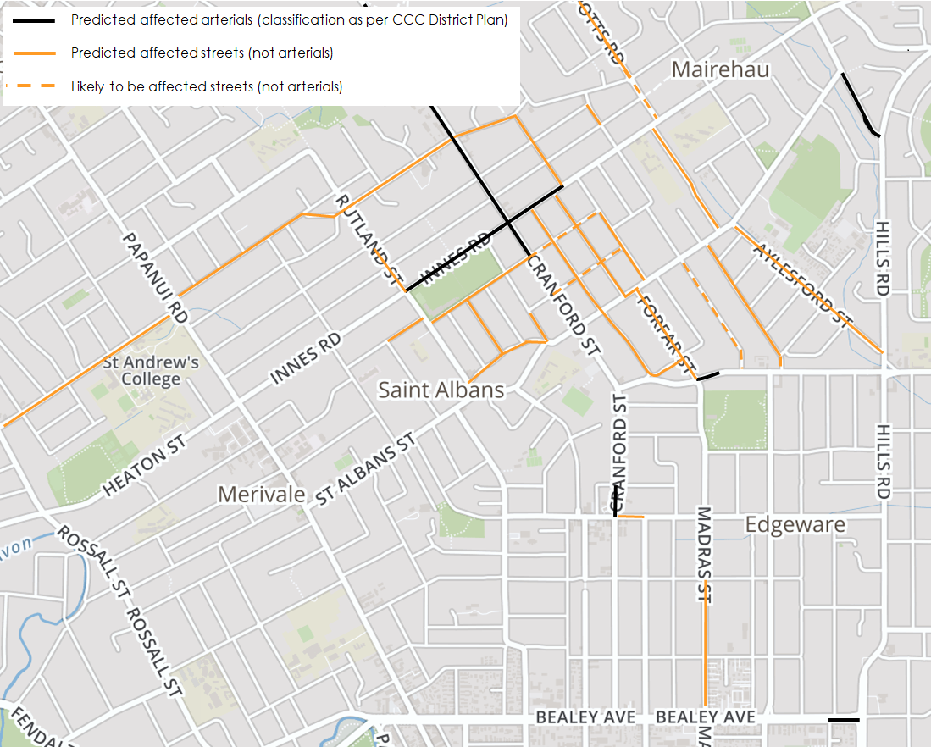

**Figure 2: 2031 AM Peak**

One of the difficult concepts to articulate to the public and stakeholders is that DEMP won’t solve all the problems caused by traffic growth in Northern Christchurch and within the suburb of St Albans. Its role is to mitigate, where possible, the impacts of concentrating more through traffic onto Cranford Street rather than distributed it across several corridors.

A strong theme from the consultation was that people living in the downstream area (between the end of the CNC and the city centre) did not want extra traffic through their communities, and wanted transport authorities like the CCC, ECan and the NZ Transport Agency to do more to put people first, before cars. That commuters needed to be encouraged to use buses and bicycles.

While the DEMP did not directly look at travel demand management and incentives to get people to change mode, as it was outside of the project scope, CCC and NZ Transport Agency have been actively promoting alternative modes and building infrastructure (e.g. cycleways and bus lanes) to encourage this change, especially over the last decade. Through the course of the DEMP development further commitments were made by the three road transport agencies and Waimakariri District Council around travel demand management and improving buses services. As already mentioned, the NZ Transport Agency is also introducing a high occupancy vehicles (HOVs) lane to one of the CNC southbound lanes to encourage more carpooling and therefore less cars. Council are considering whether to continue the HOV lanes further south and also install northbound HOV lanes.

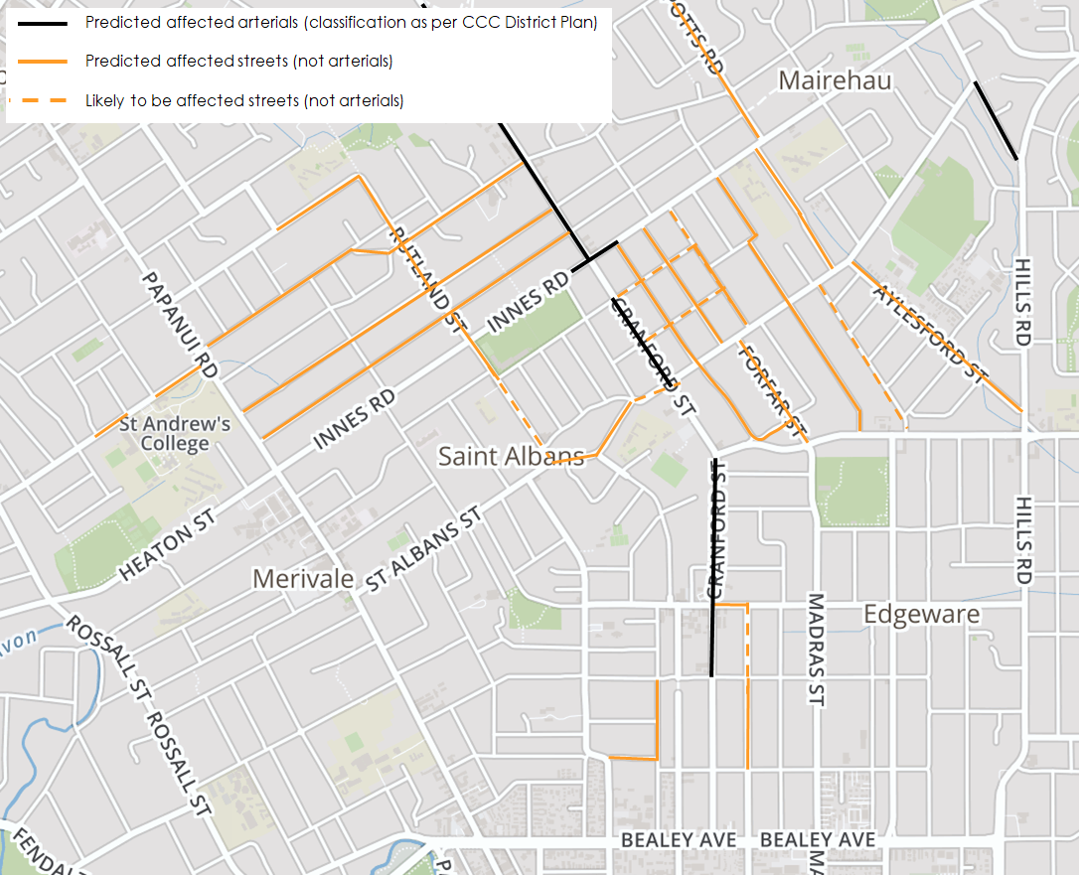

**Figure 3: 2031 PM Peak**

A number of other issues were raised by the public and stakeholders on the impact of the downstream traffic. These were collected through two rounds of consultation before the draft DEMP was produced, and one afterwards. In general terms these related to safety, access and social and environmental effects. The development of the DEMP has considered these issues and identified a range of options to mitigate many of these effects. Monitoring of transport effects is an important element of the DEMP, for the first ten years after the CNC is opened. It is expected that some unexpected effects will occur and require further intervention, due to the limitations in the analysis tools.

**COMPONENTS OF THE MANAGEMENT PLAN**

There are two key components of the management plan:

1. Managing additional CNC traffic so that it uses the preferred traffic routes rather than local streets
2. Mitigating the road safety, access, amenity and environmental impacts of the additional CNC traffic

Two strategies where developed for Component 1. The first was a ‘carrot approach’ of upgrading the capacity of arterials and some key collector routes to encourage drivers to use these preferred routes. The second was a ‘stick approach’ which consisted of traffic calming of local roads, lower speed limits (30 and 40km/h) and turning restrictions. A number of public concerns were raised around the safety impacts of additional traffic on local roads. Hence keeping the traffic on the preferred routes and reducing the amount and speed of traffic on local roads is a desired outcome.

Components 2 focuses on mitigating the transport effects of the additional CNC traffic across the road network by focusing on:

1. Safe access to school
2. Safer cycling
3. Access to parks
4. Access to commercial centres

Improvements are required to parts of the downstreams road network as more traffic can result in safety and access problems for pedestrian and cyclists. Many of the public and stakeholder concerns revolved around these four areas.

In addition to the targeted improvements a healthy streets assessment was required for a number of routes to understand (and where possible mitigate) the impact on pedestrian and cyclists of the additional traffic (see Figure 4 for criteria). The healthy streets assessment helped inform the design of several routes. Road safety audits (NZTA, 2013) and a safe system assessment framework (SSAF) assessment are also required for each project to maximise safety outcomes. A SSAF score (see Figure 5) is developed for each crash type and risk component (score of 1 to 4 for exposure, likelihood, severity). The three risk components are multipled together to give a maximum score of 64 (least safe). The intention of upgrade options is to lower the SSAF (safer system is 1).

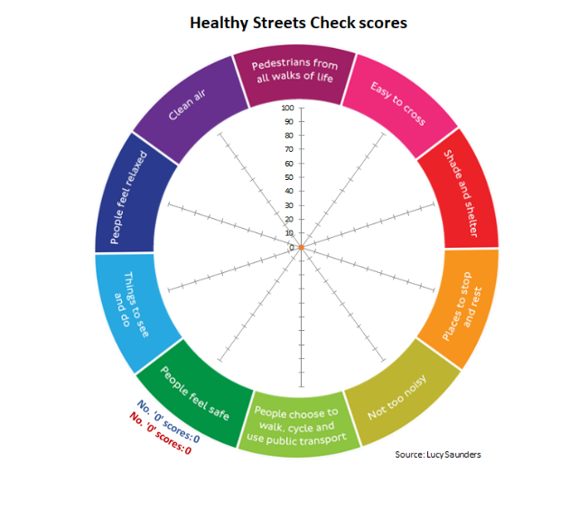

**Figure 4 – Healthy Streets criteria (TfL, 2017)**

**DEVELOPMENT OF THE UPGRADES**

**Arterial Upgrades and Traffic Calming of Local Streets**

As part of Component 1, a number of arterial and collector route upgrades were identified downsteam of the CNC. These consisted of additional link capacity through clearways and permanent 3 or 4-laning of some roads, and intersection upgrades (new and upgraded traffic signals). A list of options where modelled using the CAST model. The routes that were proposed to be upgraded are as follows (shown dotted in Figure 6):

1. Cranford Street (Innes to Berwick – red dots)
2. Cranford and Sherbourne Streets (Berwick to Bealey – red dots)
3. Berwick and Warrington Streets (Cranford to Barbadoes – only east to west route)
4. Madras and Forfar from Warrington to Bealey – blue dots)
5. Barbadoes Street from Warrington to Bealey – blue dots)

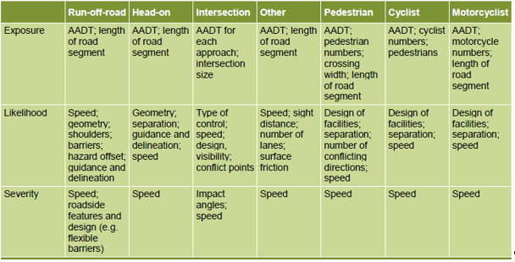

**Figure 5 – Safe System Assessment Framework Criteria (Austroads, 2016)**

The intersections upgrades are required along each of these routes to provide adequate capacity for the increased traffic. The more important intersection upgrades (blue circles on Figure 6) are required before the CNC opens are at the Westminster/Cranford and Berwick/Cranford traffic signals and the new traffic signals at the Forfar/Warrington roundabout and Barbadoes/Warrington priority controlled intersection. Other intersection upgrades are also required at the three signals on Edgeware Road and Bealey Avenue where they intersect with Sherbourne, Madras and Barbadoes Streets, depending on which route upgrades are selected.

The modelling looks at each element of the upgrades, including link upgrades and intersection upgrades heading south from the Cranford/Innes Intersection. Along Berwick and Warrington Street and Cranford north of Berwick there is only one preferred transport route, and so various options from clearways to 4-laning, and associated intersection upgrades were considered along these routes. South of Berwick Street there are three options 1) encourage all the additional traffic down Cranford and Sherbourne Street to Bealey Avenue, 2) encourage all the additional traffic down Madras and Barbadoes Streets and 3) to spread the traffic over both corridors. The modelling showed that the benefits of each of these options was similar

Even if these arterial and collector upgrades are made the modelling showed that there would still be rat running in several local streets when the CNC opens that would exceed the 30% threshold. Hence as a ‘stick’ traffic calming (or turning bans) have also been specified for a number of routes. At time of opening council are required to provide traffic calming (or suitable turning bans) as shown in Figure 6. To also discourage rat-running and to minimise the safety impacts if drivers do rat-run speed limits are to be dropped on at least local streets to at least 40km/h in the red-area in Figure 6.

To look more widely at the effects of each of the arterial upgrades and traffic calming schemes a multi-criteria analysis was undertaken of different options. Figure 7 shows the criteria used and an assessment of some of the options assessed. A traffic calming only and arterial upgrades only option along with the do-nothing option was also assessed. The analysis indicated that it was important to do both as the assessment of these options on their own lead to some negative effects (black and red). The effects of permanently 4-laning Cranford/Sherbourne Streets was also high in some places and lower (green) in others compared with the bulk of the schemes. Note that grey is a neutral effect and yellow and orange are a mild negative effect.

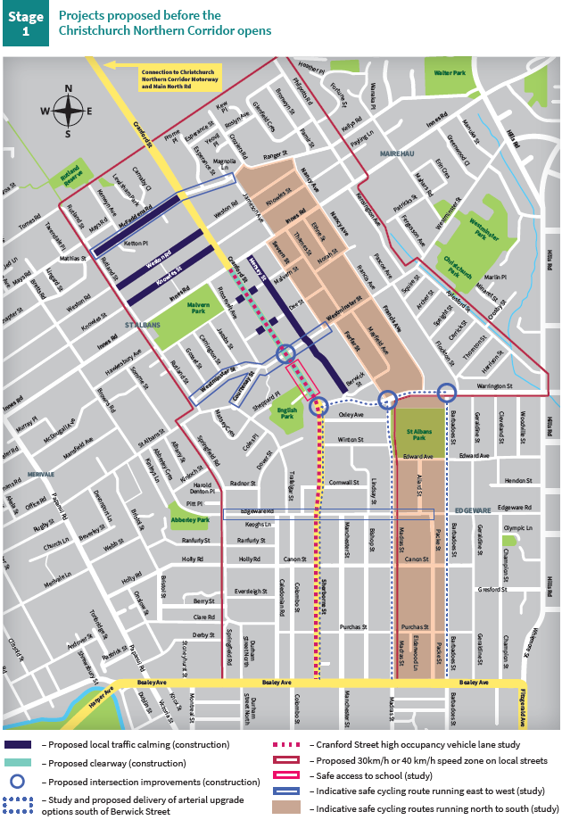

**Figure 6 – Proposed Upgrades (Stage 1)**



**Figure 7 – Multicriteria Analysis of DEMP upgrade options**

**Mitigation of Safety and Access Effects**

The combination of arterial upgrades and traffic calming will still result in adverse effects in terms of safety and access, especially across arterial roads. Some of the arterial upgrades do mitigate this through new and improved traffic signals. For example, access to St Albans Park to the north will be greatly improved for pedestrians and cyclists due to the new signals at Forfar/Warrington and Barbadoes/Warrington. There is a lot of detail provided in the DEMP report around mitigating these effects and only some of the key improvements can be listed here under the four topic areas

1. **Safe Access to School**

There are a number of schools in this part of Christchurch. The main school impacted by the additional CNC traffic is St Albans Primary school, as a number of their pupils have to cross Cranford Street to access the school. While traffic signals are provided at the Cranford/ Westminster and Cranford/Berwick intersections a combination of the young age of pupils (5 to 10yrs old) and prevalence of red light running (in part due to the lack of turning phases at the Westminster intersection) have led to a number of near misses between crossing school children and vehicles. Currently the school employees a crossing guard at the Cranford/Westminster intersection before and after school to supervise and highlight children are crossing.

The key issue around safe routes to school is to improve the safety of crossing pedestrians. The DEMP report recommends a number of improvements, some of which need to be implemented before the CNC opens, and others are dependent on the change in driver behaviour observed at the two intersections. At the Westminster intersection it is proposed to 1) install textured road surfacing, 2) introduce right turn bays on the Westminster’s street approaches and 3) introduce right turn signal phasing and early starts for crossing pedestrians. The addition of a mid-block crossing is also proposed north of the Berwick Road intersection, as this removes the turning vehicle conflict. A 40km/h speed limit is also proposed during the school drop-off and pick-up period on Cranford Street through both intersections. Other issues identified with the school are also to be addressed in a separate study of access to the school.

1. **Safer Cycling**

The St Albans community now have a high standard north-south separated cycleway travelling into the city, called the Papanui-Parallel Cycleway. The Council will be connecting this route to the CNC cycleway path, creating a high standard facility that extends all the way to Kaiapoi (north of the Waimakariri river). With the clearways on Cranford Street south of Innes, and the additional traffic Cranford will only be a route during peak period for the more confident cyclist. Hence the DEMP identifies a number of east-west secondary cycle links (mainly on-road cycle lanes – see Figure 6 for locations) to improve access to the Papanui Parallel facility and also an additional north-south route to the east utilising lower volume lower speed routes (or bicycle green-ways) and cycle lanes on Barbadoes and Madras (Forfar) Streets.

The strategy requires these improvements (secondary bicycle routes) to be in place no latter than three years after the opening of the CNC, and ideally as soon as possible. Council are planning to do the upgrades sooner rather than later. Having secondary routes in place will be important as traffic volumes and cycling numbers continue to increase in this area of the city, otherwise the number of crashes is expected to rise.

A controversial element of the scheme is the impact of peak period clearways on Cranford Street on the safety of cyclists using this route. Currently cyclists have space beside parked cars within a wide traffic lane. This space will still be available during off peak periods, where there will continue to be one through lane in each direction. However, when the clearway is operating, which is when most of the commuter cycling will occur, cyclists will be required to cycle in the clearway lane, and the width of the clearway lanes without road widening is below the desirable level for trucks and buses to ‘safely’ overtake cyclists.

The primary measure being proposed to reduce this risk is to encourage cyclists to use alternative routes, as not only will there be limited room for cyclists there will be more traffic on the corridor. Wayfinding is proposed to direct cyclists to alternative routes, such as the Papanui Parallel and other secondary routes specified in the DEMP. However, there will still be some cyclists that continue to use Cranford street including confident cyclists (often called road warriors) and those who live on or have a destination (e.g. shop) on the corridor.

The main constraint to widening the roadway is the relatively narrow road corridor, with footpath/berms of 3m or less. To stay within the corridor road/lane widening would result in narrowing of the berm. Footpath/berms below 3m are undesirable in older parts of the city where drivers may at times have to reverse out of their properties and where high fences restrict visibility. The issue being that reversing vehicles may already be entering the kerbside traffic lane (clearway) before they can see a cyclist on the road, and this may result in crashes. The options to address this are 1) widening the road designation and width of the traffic lane, 2) retain the road designation, widen the lane and narrow the berm and 3) allow cyclists to use the footpath (as occurs on part of Curletts Road - which many consider to be unsafe).

Initially the plan was to allow cyclists to use the footpath, which might work well for cyclists who are traveling at slower speeds, but not for the more confident cyclists who are generally travelling faster and where there are concerns that they may collide with pedestrians. Option 1) was discarded as not only would this require land purchase along the route it would also require either a compromise cross-section or removal/modification of buildings on the corner of Westminster and Cranford Street.

Council have decided to proceed with Option 2) which is to narrow the berm and widen the traffic lanes on Cranford Street. While there maybe some safety issues with the narrow berm the road widening does provide the extra width required for buses and trucks to pass cyclists ‘more safely’. It is expected where there are clearways, that there will be an increase in less confident cyclists cycling on the footpath (as this was observed on such routes in Auckland and Sydney), even though this is currently illegal. This behaviour will need to be monitored and measures taken if pedestrians are put in danger.

1. **Access to Parks and other Recreational Facilities**

Parks are an important part of our neighbourhoods and will become increasingly important in encouraging people to keep active as they age. The major park in this area is St Albans Park. Access to St Albans Park is already poor due to the width of Forfar and Barbadoes Streets and lack of signalised crossings where these roads intersect with Warrington Street (currently a roundabout and stop controlled intersection). Only access to the immediate south of the park is adequate. An increase in traffic on Warrington, Forfar/Madras and Barbadees will make it even more hazardous to cross over to the park, especially for younger children and for the elderly. The proposed two new traffic signals on Warrington Street will considerably improve safety for crossing pedestrians heading to the park. The installation of cycle lanes, narrower traffic lanes and median refuges on Forfar and Barbadoes Streets will also improve safety for pedestrian crossing to the park.

1. **Safe Access to Commercial Centres**

There are a number of smaller shopping areas (corner shops) in this part of Christchurch along with the Edgeware village (which has a supermarket and chemist). Safe access to these areas by different modes, and especially walking and cycling is important, especially as traffic volumes grow. Parking and loading facilities are also an issue at many of the centres where they rely on kerbside parking. Some of the kerbside parking is to be lost due to intersection upgrades and clearway operations. Poor access and both actual and perceived safety are key issues not only to business owners but also to the public who want to use local services, rather than drive to a mall or the central city. It is important to preserve access and make pedestrians and cyclists feel safe when using local shopping areas. Improving amenity through urban design and landscaping is also important in making vulnerable road users feel safer and more welcome.

The layout of the Edgeware Village means that most of the traffic from the CNC will bypass the centre. However, there is the potential for traffic to rat-run through the village when Sherbourne Street become busy. To minimise the rat-running and make the village more of a ‘place’ and less of a movement corridor the DEMP proposes a lower speed limit of 30km/h on parts of Edgeware Road and top of Colombo Street. As the Edgeware master plan is implemented some part of these roads may become shared spaces with an even lower speed limit. Lower speeds are also necessary as cyclists will use Edgeware Road to access the Papanui Parallel cycleways on Colombo Street.

The main smaller shopping centre effects from the additional CNC traffic are at the corner of Westminster Street and Cranford Street. This is a very vibrant shopping area that has become very popular, especially in the last five years. The centre currently has a parking problem with parking extending some distance from the shops during busy periods. This is despite a number of walking and cycling trips to the centre, as the centre does have some destination shops. While there will be impacts on Cranford Street due to the increase in traffic and the operation of the clearways the improvements along Westminster for cyclists (cycle lanes) and at the traffic signals will provide some benefits. The DEMP specifies the need for a management strategy for each centre impacted by the CNC traffic that considers safety, access and amenity for all road users using the centre.

**STAGING THE OPTIONS AND MONITORING THE EFFECTS**

The DEMP makes a large number of recommendations for the downstream roading network to mitigate the effects of the extra CNC traffic. These have been broken up into stages. Stage 1 projects are the most essential and need to be in place before the CNC opens. The projects are shown in Figure 6, and consist of arterial road upgrades, traffic calming schemes (including turning restrictions), speed limit changes and some of the improvements required to improve pedestrian and cycle safety. Council have decided to also bring forward provision of secondary cycle facilities (mainly on-road cycle lanes), and associated intersection improvement, along with new pedestrian refuges (e.g. on crossing desire-lines to St Albans Park) and bus stop improvements.

Stage 2 projects focus around the safer routes to school, safer cycling and better access to parks and commercial areas. These improvements need to be in -place within three years of opening of the CNC. Council have already decided to implement some of these improvements before the CNC opens or very shortly after, as noted above. Some improvements that benefit other road users will also occur as part of the arterial and collector road upgrades. Further improvements will come out of studies that require specific consultation with local residents, business owners and other stakeholders. Given that some of the impacts of the CNC won’t be fully known until the CNC opens there will also be a need to monitor and react to the impacts that occur and address any safety and access issues that arise. Where any safety or access effects are significant it is important to react to these as quickly as possible.

Stage 3 lists a number of improvements, like traffic calming of additional streets, which have been identified in the transport modelling and public consultation comments, that might be required in the ten years following the CNC opening and specifically from year four onwards. They are a result of traffic growth on the corridor. Which projects are actioned and the date of implementation will depend on the results of the monitoring. The monitoring may also identify other issues and potential improvements that are currently not listed in stage 3 (or 2). A decision on any extra works will be made by Council as the needs arise.

The monitoring regime for this project is extensive given the potential impacts of the CNC traffic across the wider St Albans road network. A key element of the monitoring is around traffic volumes and identifying any traffic volumes on local streets that increase by more than 30%, as a result of the CNC. Over fifty link counts have been collected across the network to capture the before traffic volumes (on some links multiple counts). Traffic counts at regular intervals are to be collected after the CNC is opened, especially on the links that are most likely to be impacted by the CNC. Other links (further form the Innes/Cranford intersection) will only be monitored after the CNC opens if there are public complaints about rat running.

Monitoring will also cover pedestrian and bicycle counts at key intersections, crashes, incident data involving pedestrians (from video) at the Cranford/Westminster intersection and air pollution, noise and vibration levels on some arterial and collector routes. The results of the monitoring will inform and help prioritise the Stage 2 and 3 works and any further work that might be required.

**CONCLUSION**

Developing a down-streams effects management plan (DEMP) for the CNC has been a challenging project given the limited routes and options that are available and their suitability to accommodate the additional traffic, especially north of Berwick Street, and the range of concerns raised by the public and stakeholders on how this traffic will impact on the community and the safety and access of other road users. There was a strong emphasis in the consultation, in part fuelled by the climate emergency declared by Council, on reducing the number of vehicles using the northern Christchurch transport network and especially travelling along the CNC and downstream of the CNC, and instead to focus on getting more people to use alternative modes, especially buses. Measures to reduce travel demand were never part of the scope of the DEMP, as specified by the CNC designation conditions. Never-the-less such measures, if successful, could reduce the downstream effects, and ideally should be considered in future transport plans of this type. In this case the Council have taken onboard the publics concerns and are working with their transport partners to develop and implement additional traffic demand management measures and improving public transport options.

The proposed network improvements, as required in the DEMP, to accommodate the expected additional traffic, consist of intersection upgrades, peak period clearways and traffic calming of local streets. However, some bottlenecks are still expected to occur, which is a good thing, as this helps encourage people to use other transport modes. Other measures, some of which will occur before the CNC opens and others in the years after, are proposed to mitigate the effects of the additional traffic on safety and access. This includes secondary cycle routes, upgrades to improve the safety of routes used by St Albans school children and improved access to parks and commercial areas (e.g. local shops).

**AUTHOR CONTRIBUTION STATEMENT**

This paper was prepared solely by Shane Turner. Shane was appointed as an independent transport expert to prepare the DEMP in line with the requirements of the CNC designation conditions. The DEMP report (and this paper) findings and recommendations are those of the author and of no other person or organisation, including Christchurch City Council. Shane did get assistance with the traffic modelling and the multi-criteria analysis from other transport professionals.

**REFERENCES**

Austroads (2016) Safe System Assessment Framework, <https://austroads.com.au/latest-news/safe-system-assessment-framework>

Douglass, M (2000) Christchurch City Centre: 40 Years of Change, Traffic, Planning (1959-1999), Christchurch City Council, New Zealand.

NZ Transport Guide (2013) Road Safety audit procedures for projects’, <https://www.nzta.govt.nz/assets/resources/road-safety-audit-procedures/docs/road-safety-audit-procedures-tfm9.pdf>

Transport for London (2017) ‘Guide to healthy streets indicators <https://healthystreets.com/2017/11/21/guide-to-the-healthy-streets-indicators/>

Turner, S (2019), CNC Downstream Effects Management Plan: Report and Recommendation (27th May), Abley Ltd, New Zealand.