# **Water Streets: transport infrastructure to make space for water**

**This paper has been peer reviewed**

Ed Clayton (presenter), Morphum Environmental Ltd

Senior Water Quality Scientist, BSc (hons), MSc (hons)

ed.clayton@morphum.com

Stu Farrant, Morphum Environmental Ltd

Water Sensitive Design Lead, BE (hons), BCom

stu.farrant@morphum.com

**abstract**

In Tāmaki Makaurau Auckland, there has been extensive commentary on “making space for water” in response to the flooding of 2023. Proposals including daylighting streams, creating blue-green networks, managed retreat and acquisition of high-risk properties, and increased resourcing for flood planning and modelling tools have all been put forward. However, we still struggle to address the generation of stormwater from impervious surfaces in our existing road reserves. So, the question arises, what do we expect from a transport network that is built to make space for water?

This paper examines this question through a thought exercise; placing a water lens across our transport infrastructure to explore form and function. To do this we consider the engineering design of street networks and the functions we need to achieve. Streets can be catchments and ecological networks; captured stormwater can irrigate sports fields, golf courses and green spaces, and green infrastructure can provide for habitat, pollinator spaces and ecological movement corridors. Streets can also be floodways; designed to store and move water during extreme storm events in such a manner that minimises destructive flooding of adjacent properties. Promotion of active modes can reduce pavement strength requirements, in turn increasing the allowance for permeable paving, soakage and aquifer recharge.

Building on examples both locally and overseas of water sensitive infrastructure we investigate the capacity for transport network to make space for water and, with a water-first perspective, look to a low-impact, multi-functional future.

“*Why should we tolerate a diet of weak poisons, a home in insipid surroundings, … , the noise of motors with just enough relief to prevent insanity? Who would want to live in a world which is just not quite fatal?*”

Paul Shepard, 1962

## **Urban development and our history with water**

The role of water in shaping the places we live cannot be overstated. As a dynamic and geologically young landmass the influence of water over millennia is clear to see across Aotearoa New Zealand. As tectonic uplift raised our central ranges the power of water eroded them down to create a landscape intersected by waterways which have deposited vast amounts of sediments to create coastal plains, estuaries and a variable landscape of freshwater wetlands, lowland forests, and waterways at all scales.

It is this landscape that informed and guided initial development and movements with early Māori explorers who quickly recognise the importance of living alongside these natural features. As sources of food and materials (mahinga kai), providing natural barriers to invaders, and useful pathways between coastal settlements and inland hunting grounds, water provided a wealth of resources and benefits.

The arrival of Europeans throughout the 1800’s brought a similar linkage with water albeit on the different scale. Initially seeking safe anchorage and protected harbours many coastal estuaries were favoured for early colonial settlements which often brought conflict with the resident Māori inhabitants who had long established Pa, kainga and mara in these same locales. Where streams and wetlands were not filled in or drained, they were used as open drains to convey human and commercial waste away from the growing towns and cities and the original Māori pathways (which often followed waterways) were gradually expanded as they progressed from walking paths to bridal tracks, bullock cart tracks and eventually roads to support the rapid ‘development’ of inland areas.

As communities grew and our connection with the natural environment which initially drew us to specific locations dwindled our urban infrastructure continued to be built across these once vibrant networks of waterways with streams piped, lowlands developed on and roads slicing across landscapes with limited consideration of flowpaths and flooding. This defines the position we now find ourselves in today with many of our urban centres built either on or adjacent to floodplains and our roading network either sitting above or transecting the natural flow of water. Layered on top of this is the spectre of a changing climate with increasing intensity of rainfall falling on increasingly impervious landcover. But these same communities are still existing within the bounds of a hydrological catchment and in many instances maintain linkages with freshwater ecosystems through upstream/downstream remnant waterways and the unique indigenous biodiversity that these support. These catchments and the waterways which once flourished in the landscape still have the potential to provide a sense of place for communities and have a clear role in how we strive to co-exist alongside nature.

## **Urban Stream Syndrome**

Regardless of whether streams are currently within pipes or flow openly, where they flow through urban and developed areas they are subject to a range of acute and chronic impacts as a direct result of urbanisation. Modified flow characteristics, discharge of urban contaminants and changes in the physical characteristics of the water combine to adversely impact on the health of these streams and the ability of them to support functioning ecosystems. Further, instability and persistent discharge of flashy flow in even small to moderate rainfall events cause ongoing undermining of public and private infrastructure resulting in often expensive (and impactful) to fix.

This results in “Urban Stream Syndrome” (Walsh et al, 2005), where paved areas create faster runoff, leading to streams that have higher flood peaks and more erosive power, transport more pollutants and sediment and have fewer species and less complex ecosystems. In turn, we have experienced a declining connection between communities and the waterways which define the catchments in which they live, work or travel through. Where streams have historically been piped, the urban stream syndrome is further compounded by the lack of any visual connection with waterways and in many instances a lack of awareness of the presence of waterways and the role they once played in defining the landscape and the ecosystem services that attracted people to the catchment all those years ago.

But when it rains these long-neglected streams rear their heads and make their presence felt at the surface of our urban centres.  Due to limited capacity of underground piped networks, development within overland flow paths and infilling of flood plains, these waterways re-engage the water landscape and again flow across our now highly modified landscape. Where once the presence of riparian/flood plain forests and deep, rich soils slowed down and adsorbed rainfall, the now increasingly impervious landcover results in increased volumes and flowrates of floodwaters. These are increasingly concentrated through restricted overland flow paths which are often aligned or intersected by road corridors.

## **Mitigating road water quality issues**

Mitigating the effects of road runoff has long dealt with altering the energy characteristics of stormwater in order to reduce the energy available for transporting pollutants or eroding stream channels (Shaheen, 1975). This results in such features as vegetated swales, rain gardens and constructed wetlands designed to filter and detain runoff, additionally allowing adsorption of contaminants and removal of sediments. The effectiveness of these devices varies with different reported factors of load or concentration reduction dependent on catchment, location, device and climate circumstances (Hatt et al, 2009). However effective they may be, these industry accepted solutions do nothing to change the underlying cause of road-derived pollution or water volumes – the transport activity and infrastructure materials themselves.

## **Three levers to improve our urban water**

To address our fractious and damaged relationship with urban freshwater we can use three tools that already exist, being the Water Sensitive City, Ecological Net-Gain concepts and Te Mana O Te Wai. Combining these approaches could deliver uniquely Aotearoa New Zealand cityscapes.

### **1. The Water Sensitive City**

The development of our modern cities can in part be traced through the socio-political drivers and resulting service delivery functions identified by Brown et al (2009, Fig 1). Understanding human society is in no small part understanding social progression as an evolving water culture as technological innovation is manifested in our control of, and relationship with, our water environments (Bijker, 2012). The continuum shown in Figure 1 shows the progressive delivery of infrastructure solutions as we develop urban areas. Eventually, to serve the functional needs of humans with due consideration of the wider ecological limits and constraints, we must be implementing urban designs that are multifunctional, equitable and resilient.

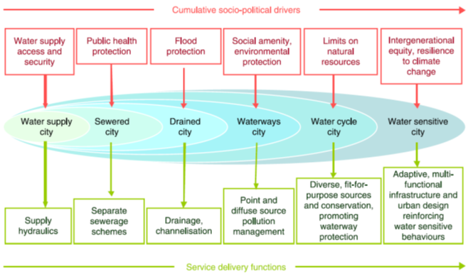*Figure 1. The urban water management transitions framework (from Brown et al, 2009)*

### **2. Ecological Net-Gain**

Our current relationship between mobility and ecological systems is defined by the Resource Management Act. This follows a biodiversity offsetting approach with the emphasis on avoiding impacts, remediation and mitigation. This allows for the pursuit of the “least worst” option, only slowing ecological decline (see Knight-Lenihan, 2019 and Simmonds et al, 2020 for a more detailed explanation). Yet we face a biodiversity crisis that is forecast to affect vital aspects of society and the ecosystem services we rely on (IPBES, 2019). This can be addressed through adopting an ecological net-gain approach to infrastructure (adopted from Knight-Lenihan, 2019).

Simply put, ecological net-gain requires that an improvement in ecological systems be realized as a result of the intended action (the ecological association of movement). It is proposed that adopting a strategy of “ecological net-gain mobility” is necessary. Ecological net-gain mobility would explicitly require improvements in receiving environments achieved through transport infrastructure and policy. This aligns with concepts of sustainable mobility, being the design of transport networks that remove the requirement to drive a car, incorporating transport into urban design (Bannister, 2008; Chatziioannou et al, 2020) and it incorporates non-movement, i.e. the removal of vehicle movement through enabling work-at-home practices.

### **3. Te Mana o te Wai**

Aotearoa New Zealand has a national direction governing water management. This demands immediate improvement to our freshwater systems and the need to bring waterways to a healthy state within a generation. Te Mana o te Wai is the central concept of this and sets out the direction's councils need to take to improve waterways. Key to this are the principles of governance and stewardship, where those with authority must prioritize (improving and enhancing where required) the health of waterways now and into the future to ensure the needs of future generations are sustained.

To give effect to Te Mana o te Wai councils must apply the hierarchies of obligation, being the following:

1. the health and well-being of water;
2. the health needs of people; and
3. the social, economic and cultural well-being of people and communities.

Following such directions, it can be reasonably interpreted that councils should take steps to ensure that infrastructure supports Te Mana o te Wai. For transport, we interpret this to mean building infrastructure that firstly has low pollutant generation, secondly can actively treat pollutant loads through sequestering contaminants within its structure (ensuring any discharged water is filtered and cleaned before entering the receiving environment) and thirdly manages storm event flows without creating damaging flooding to adjacent property. The requirements of Te Mana o te Wai legislation will place responsibilities on local government that creates conflict with building roads as normal.

## **A streetscape that makes space for water**

The concept of "making space for water” is increasingly being promoted across Aotearoa and internationally and specifically by Auckland Council’s Healthy Waters department following the damaging floods of early 2023. The concept recognises that flooding is both natural and expected to increase with future climate change and that there is therefore a need to ensure that communities are safe from potential harm and to minimise financial costs from damage to property and infrastructure. In part, it aims to increase resilience to flooding by creating blue and green networks through cities so that stormwater can safely move through the city, and to manage overland flow paths. This often encompasses existing open stream corridors and adjacent green spaces (such as sports fields) and from an engineering sense there is a tendency to look at achieving this through further modifying remnant streams to increase the available cross sections and manage the channels as flood conveyance 'drains’. This approach further degrades the ecological integrity of remnant streams and waterways and is counter to aspirations to enhance urban ecology and re-connect communities with natural freshwater environments.

Conspicuously absent from discussion has been the potential to appropriate the public streetscape to contribute to stormwater management. Mode share of transport is still dominated by private vehicle use, prioritizing individual transport needs rather than the best use of public space. With the knowledge that our streets have followed and built over streams in the past, and using the three levers we have identified above, here we explore how we could reimagine our streets to make space for water.

Making space for water requires us to examine the value that we place on stormwater. Rather than a nuisance, to be piped and conveyed “away” as fast as possible, what if our urban spaces could claim stormwater as a resource and amenity? The concept of ‘roads as a catchment’ reflects the fact that typically roads are characterised by extensive areas of impervious landcover within were what once natural stream catchments. This contributes to an increased volume of stormwater, particularly during small to moderate rainfall events which is often referred to as an “urban excess”. Given the need to capture and treat this stormwater to mitigate water quality impacts and the importance of retaining a portion of this increased volume there are clear opportunities to divert treated stormwater to nearby and adjacent demands for non-potable water. This can include large scale irrigation demands (such as sport fields, plant nurseries, community orchards or high amenity landscapes) or appropriate commercial users (such as water tanker refill, washdown or process water for suitable manufacturing activities).

Following damaging urban flooding in Copenhagen, Denmark in 2011 the municipality, stormwater managers and urban planners looked at the levers and barriers to providing more space for water within a highly constrained urban environment. This identified that existing road corridors were ideally located to collect, attenuate and convey stormwater but that these are largely managed solely for the transport function for which they were originally designed. To rectify this, changes were made to the national legislation to enable these road corridors to be managed for stormwater (as well as transport) and therefore enabling stormwater planners to consider projects to lower the surface levels and where appropriate intentionally increase the depth and extent of inundation within road corridors.  This approach has also been manifested in Gothenburg, Sweden, where the fact that it rains on average every three days has been claimed by city officials to create a “Regnlekplatsen (Rain Playground)”. Playgrounds are designed to retain rainwater as puddles for jumping in, with sheltered benches and tables. The winning design for a new school features a schoolyard that changes when it rains, with waterfalls, a canal and a marshland with real mud (Orange, 2021).

Taking this approach to a streetscape could look something like what has been proposed as a “stormwater greenway” in North America (Fig. 2, NACTO, 2017). The centre of the street features a daylighted channel, trees are planted to intercept rainfall and raingardens provide biofiltration functions. The reduction of car traffic reduces pollutant generation and bike paths are installed with permeable surfaces to promote infiltration. Pedestrian areas are elevated so that surface flooding affects these spaces last, this can be achieved with a cross section utilising an inverted crown so that all surface water flows towards the centre of the street (and hence the daylighted channel).

Importantly, utilising an inverse crown and centre channel can create a floodway. In less frequent, more extreme rainfall events this can extend to temporary flooding of one or more trafficable lanes with priority given to passage of public transport, emergency vehicles and pedestrians/active transport. The greater the intensity of rainfall and severity of the flood, the more of the cross section can be used to convey water. Signalised pedestrian crossings can recognise when it rains and increase the frequency at which pedestrian priorities are called, reducing the time that people wait in the rain.

Such an approach would also achieve objectives of the Aotearoa Urban Street Planning and Design Guide (Waka Kotahi NZ Transport Agency, 2022). This actively encourages street designs that work towards living environments that provide the unique context and value of their location. Our approach of streets that make space for water directly aligns with the document recognition that streets are public space and multidimensional, and that we need to realise that streets are ecosystems. One lever that could be applied to facilitate these adaptations would be for local authorities to recognize and plan for water streets in district plans.

These changes will necessitate a change in mindset where communities collectively recognise that private vehicle travel will be less convenient during extreme rainfall but that this contributes to reduced adverse impacts on private and public property and enables cities to be more resilient and able to return to ‘normal’ sooner. In turn, recognition of the increased resilience is reflected in reduced insurance premiums.

Put together, these approaches provide further intangible benefits. Increasing urban blue and green space is known to improve people’s wellbeing, even if it is only experienced through passive observation. Provision of street trees and native vegetation in nature-based stormwater devices such as raingardens, swales and pocket wetlands can encourage wildlife back into urban areas, allowing streets to function as ecological corridors. Increased pervious surfaces allows more water to seep back into groundwater, recharging local aquifers and providing more consistent stream baseflows and better aquatic habitats.

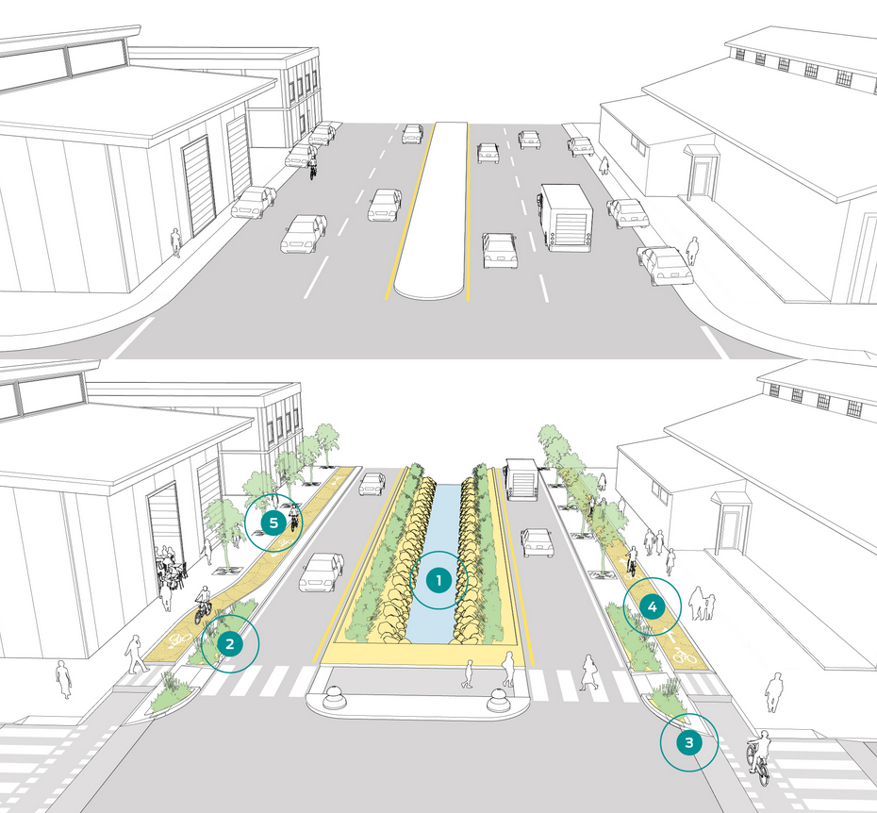*Figure 2. Conversion of an arterial road to a “stormwater greenway” street (NACTO, 2017), with (1) a daylighted channel, (2) kerbside green infrastructure, (3) raised pedestrian crossings to eliminate ponding where people walk, (4) bike paths with permeable paving and (5) street trees for canopy rainfall interception and shading.*

## **Developing an Ecological Build Zone**

Yet stormwater is not only generated from street surfaces with other major impervious surface contributions to stormwater from buildings and carparks which are typically co-located along roading corridors and within the same catchments. This spatial alignment and interest in more transport orientated developments can enable us to leverage the existing and future road corridors to create ‘Ecological Build Zones’ (EBZ) where planning/zoning restrictions are relaxed to support biological and environmental performance targets that make further space for water and support a range of tangible and intangible benefits.

An EBZ would be a permissive overlay where bonus development rights could be awarded if developments and buildings incorporate certain features that promote stormwater detention, retention and treatment functions with benefits across the wider catchment. Onsite mitigation of stormwater impacts within private lots could be through the integration of built elements such as green, green walls, raingardens, permeable paving or pocket wetlands alongside other site coverage such as increased use of indigenous canopy trees and biodiversity gardens. The intentional harvest of site generated stormwater can also be used to mimic the natural water balance and provide effective hydrological controls. Precedents for bonus development rights for green roofs exist in cities such as Portland, Oregon and Singapore. In Aotearoa New Zealand, where developers provide public pedestrian plazas or accessways through sites in the central city of Tāmaki Makaurau then they can build extra floors.

The primary driver to implement an EBZ would be reducing site runoff and improving water quality through a range of nature-based solutions. While rules in local planning documents already stipulate that new residential runoff needs mitigating through retention and detention devices, these requirements are almost always met through hard engineering designs such as pervious paving or rainfall retention tanks. Currently the Auckland Unitary Plan does allow for green roofs to be counted as pervious surfaces, meaning areas with a green roof do not count towards maximum site impermeability (generally 60% coverage). In Stormwater Management Area: Flow (SMAF) zones, building green roofs will not trigger stormwater management requirements and underground infrastructure and devices are not required to mitigate roof runoff.

These rules could apply to any building that incorporated a green roof, and to some extent external green walls and raingardens. It could be as simple as rewarding every square meter or kilogram of green mass with a square meter of extra floor area. Or, as a slightly more complex approach, the greater the coverage of the green roof and the greater the biological mass supported, then the greater the exemption from planning rules. A green roof that consisted of a publicly accessible terrace with small trees and lawn space would qualify for a greater exemption than a simple green roof, which in turn would receive greater exemption than a green wall. Alongside these initiatives floodable gardens and pocket parks could be built for attenuation and detention functions, bringing rainwater back into the public realm.

## **Conclusions**

Water and streams have fashioned our landscape through the erosive forces which have shaped the land. Our historic urban development reflects this, predominantly being connected directly to streams and the resources they have provided. Road corridors follow relic waterways and in many urban situations resulted in the infilling and piping of these streams.

Yet our urban infrastructure generates pollutants and contribute to Urban Stream Syndrome, with increased flashy floods, poor ecological value and more erosion. The occurrence of damaging flooding in Aotearoa New Zealand has recently increased awareness of the threats of climate change and helped create a conversation to “make space for water” but this hasn’t necessarily included our streetscapes. Through the use of te Mana o te Wai and ecological net-gain, we have the opportunity to put improved freshwater outcomes first when planning streetscapes, achieving the goals of Water Sensitive Cities in the process. Furthermore, such a process will achieve principles of the Aotearoa Urban Street Planning and Design Guide.

Integral to this approach will be the improvement of our connections with urban freshwater, visually, socially and culturally. Such an approach presents multiple benefits but will be challenging, requiring a shift in the way we place value in stormwater from nuisance to resource. Leveraging such future streetscapes in turn can provide a platform to consider wider urban stormwater generation through ecological build zones, where the provision of green infrastructure is rewarded with bonus development rights.

## **References**

Auckland Council, 2013, Auckland Unitary Plan stormwater management provisions: Technical basis of contaminant and volume management requirements, *Prepared by Auckland Council.* Auckland Council Technical Report, TR2013/035

Bannister D. (2008). The sustainability mobility paradigm, *Transport Policy*, 15, p.73-80

Bijker W. (2012). Do we live in water cultures? A methodological commentary. *Social Studies of Science.* 49(4), p.624-627

Brown R.R., Keath N. & Wong T.H.F. (2009). Urban water management in cities: historical, current and future regimes. *Water Science and Technology.* 59(5), p.847-855

Hatt B.E., Fletcher T.D. and Deletic A. (2009). Hydrologic and pollutant removal performance of stormwater biofiltration systems at the field scale. *Journal of Hydrology*, 365(3-4), p.310-321

IPBES (2019). Global assessment report on biodiversity and ecosystem services of the Intergovernmental Science-Policy Platform on Biodiversity and Ecosystem Services. E. S. Brondizio, J. Settele, S. Díaz, and H. T. Ngo (editors). *IPBES secretariat,* Bonn, Germany.

Knight-Lenihan S. (2019). Biodiversity net-gain in New Zealand: Adding biodiversity values. *Planning Quarterly,* New Zealand Planning Institute, Issue 214

Krause F. & Strang V. (2016). Thinking relationships through water. *Society and Natural Resources*. 29(6), p.633-638

National Association of City Transportation Officials (NACTO), 2017. *Urban Street Stormwater Guide.* Island Press, Washington. ISBN 978-1-61091-812-1

Orange, R. 2021. *Wetter the better: Gothenburg’s bold plan to be the world’s best rainy city*. The Guardian, [Wetter the better: Gothenburg’s bold plan to be world’s best rainy city | Sweden | The Guardian](https://www.theguardian.com/world/2021/may/06/wetter-the-better-gothenburgs-bold-plan-to-be-worlds-best-rainy-city)

Sajjad R.U., Kim K.J., Memon S., Sukhbaatar C., Paule M.C., Lee B.-Y. & Lee C.-H. (2015). Characterization of Stormwater Runoff from a Light Rail Transit Area. *Water Environment Research,* 87(9), p.813-822

Shaheen D.G. (1975). Contributions of Urban Roadway Usage to Water Pollution. *Environmental Protection Agency, Office of Research and Development*. Ohio, US

Shepard, P., in Carson, R. (1962) *Silent Spring,* (p.12), Houghton Mifflin, New York

Simmonds J.S., Sonter L.J., Watson J.E.M., Bennun L., Costa H.M., Dutson G., Edwards S., Grantham H., Griffiths V.F., Jones J.P.G., Kiesecker J., Possingham H.P., Puydarrieux P., Quetier F., Rainer H., Rainey H., Roe D., Savy C.E., Souquet M., ten Kate K., Victurine R., von Hase A. & Maron M. (2020). Moving from biodiversity offsets to a target-based approach for ecological compensation. *Conservation Letters*, 13

Waka Kotahi New Zealand Transport Agency (2022). Aotearoa urban street planning and design guide (online). Accessed May 28, 2024. ISBN 978-1-99-004434-2

Walsh C.J., Roy A., Feminella J., Cottingham P., Groffman P. & Morgan II R. (2005). The Urban Stream Syndrome: Current Knowledge and the Search For A Cure. Am. Benthol. Soc. 24. 706-723. 10.1899/0887-3593(2005)024\[0706:TUSSCK\]2.0.CO;2.