TRIPS DATABASE BUREAU (Incorporated)

**2024 ANNUAL MEETING AGENDA**

NOTICE of the Twentieth Annual General Meeting of the Trips Database Bureau to be held online via Teams, 12:30 pm, Wednesday 25th September 2024 was sent to all members of TDB via email and posted on the website 14th September 2024.

***CONFERENCE CALL DETAILS***

[Click here to join the meeting](https://teams.microsoft.com/l/meetup-join/19%3ameeting_NTEyYTJlYmEtZmU5My00NDQ4LThhNmYtODNjY2Q0YzNlM2Jk%40thread.v2/0?context=%7b%22Tid%22%3a%22bb0f7126-b1c5-4f3e-8ca1-2b24f0f74620%22%2c%22Oid%22%3a%223bdb36fe-5cc4-45c2-858a-dacb636b2fa4%22%7d)

**Or call in (audio only)**

[+64 4-280 2674,,518561683#](tel:+6442802674,,518561683# )   New Zealand, Wellington

Phone Conference ID: 518 561 683#

The business of the Twentieth Annual Meeting shall be:

1. Attendance, Contacts/Nominees and Apologies

*(Note only full member primary contact persons or their nominated representatives confirmed at the meeting may vote.)*

1. Consider and confirm the minutes of the Nineteenth Annual Meeting, via Teams 27th September 2022 at 12.30pm
2. Receive and adopt the Financial Statement for the period June 2023 - June 2024 and the 2023-24 Budget of Trips Database Bureau.

*(2022-23 Accounts are available on request)*

1. Receive the Annual Report of the Executive Officer and the Chair for 2023/2024.
2. Elect members to the Board as required by the Rules

*(The Board tenure rules of the Society result in two NZ Board members needing to stand down. They are free to stand for re-election. Nomination forms can be obtained on request).*

1. Any other business notified to the Chair

*Note: A quorum for the AGM is not less than 10 members.*

Caron Greenough

Executive Officer

**Items *draft* recommendations:**

1. **Apologies**

Apologies received:

*Recommendation 1:* That the above apologies be accepted.

1. **Minutes of the Nineteenth Annual Meeting held on the 12.30 pm, Tuesday 27th September 2022**

*Recommendation 2:* That the minutes of the Nineteenth Annual General Meeting be approved as a true and correct record.

1. **Financial Statement for the period June 2023 to June 2024 and the 2024-25 Budget of TDB**

*Recommendation 3:* That the Financial Statement for 2023-2024 be received and adopted and the 2024-25 Budget for the TDB be received and accepted.

1. **Annual Report of the Executive Officer and the Chair for 2023-2024**

*Recommendation 4:* That the Chair and Executive Officer’s Report for 2023/2024 be received.

1. **Elections for the Board**

Recommendation 7: That the nominations of +++, +++ and +++ as NZ board members and +++ as Australian board member be confirmed.

1. **Any General Business**
2. Incorporated Societies Act 2022 Trips Database Bureau Constitution 2024
3. Database update

*Recommendation 8:* That +++ (*as appropriate*)

**ATTACHMENT TWO**

**Minutes of the Nineteenth Annual Meeting**

**Via Teams 12:30 pm, Tuesday 27th September 2022**

**ATTACHMENT THREE**

**Financial Statement of TDB**

**for the period June 2023 to June 2024**

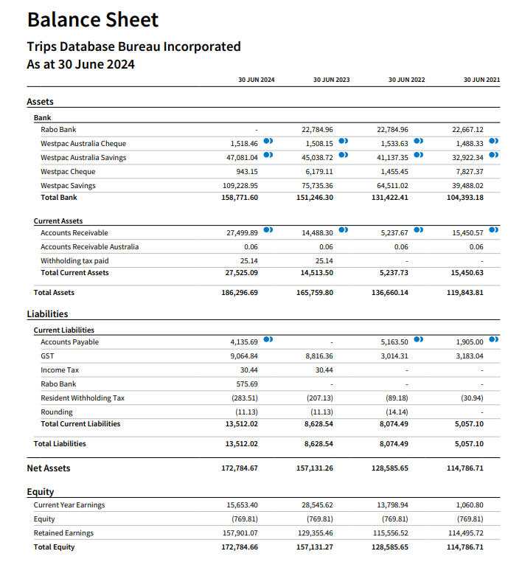

Note: Exchange rates used to convert foreign currency into NZD are shown below. Rates are provided by XE.com unless otherwise stated.

* **30 Jun 2024**

0.912677 AUD (Australian Dollar)

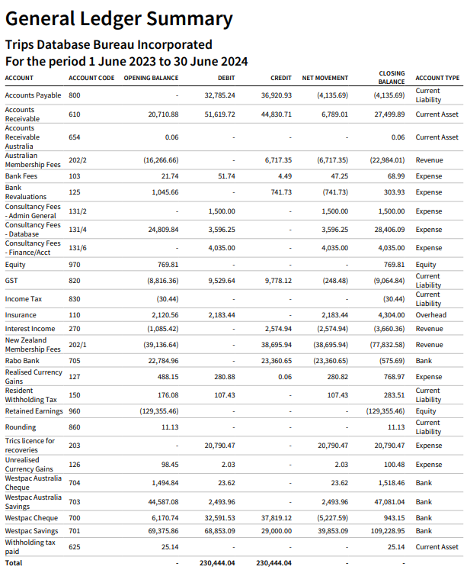

**ATTACHMENT FOUR**

**Annual Report of the Executive Officer and the Chair**

***TRIPS DATABASE BUREAU - TWENTIETH ANNUAL REPORT***

***For Year Ending 30 June 2024***

**To be presented to the Annual Meeting on 25th September 2024**

**Annual Report of the Executive Officer and the Chair**

**Appendix 1. List of Member Organisations**

**1. BOARD MEMBERSHIP AND MEETINGS**

The Board, established in 2002, had its first Annual Meeting as an Incorporated Society on 16th September 2003. Since the last Annual Meeting, held online 27th September 2022, the Board has held 5 formal Board meetings via teleconference and discussed key business via email.

Correspondence with members include an online survey with regard to TRICS usage in March 2024 and a follow up email to members in April 2024 with regard to TDB and TRICS.

**The Board for 2023 - 2024 comprised**:

Tony Brennand (Chairman Wellington) and six elected NZ members including Chris Freke (Auckland), Ranjan Pant (Auckland), Antoni Facey (Timaru), Phillip Brown (Auckland), Mark Gregory (Christchurch), Stuart Wood (Christchurch), and two Australian members including Peter McIntyre (Sydney) and Supun Perera (Sydney) together with support from Dave Smith (Technical and Research Support).

In terms of the society rules: Tony Brennand is required to stand down this year but has agreed to stand for reelection.

As no AGM was stood up last year by default Philip Brown, Mark Gregory, Peter McIntyre and Stuart Woods were all elected back onto the Board.

Invitations have been distributed to the ***TDB*** membership to secure further nominations to fill the elected Board vacancies.

We presently have two vacancies for a New Zealand position.

**2. *TDB* MEMBERSHIP**

As of June 2024:

NZ Members = 21

Australian Members = 6

Over the past year, we have gained a couple of small companies back after a couple left after Covid. We have lost one major consultancy in Australia (Aurecon) due to changes in personnel at the organisation and their finance team being extremely difficult to deal with.

Reasons for others leaving is mainly due to costs or in some cases where membership was linked to one or two people in the company and they have left or retired, and the company has chosen to not renew.

We still have limited local authority members, particularly the larger Authorities in New Zealand.

.

**3. NEWSLETTERS, TECHNICAL NOTES, CONTACTS and WEBSITE**

There have been no Newsletters sent out in the past year due to work pressures on the Board members and the Executive Officer. We have also been busy with the disassociation with TRICS and the TRIPS research being undertaken in Australian.

Current website access is via the TDB sub-group page on the Engineering NZ website. We are working on a new website and have commissioned work on this – watch this space.

**4. SEMINAR, DATABASE, SURVEY RESULTS and RESEARCH**

**Seminars and Workshops**

No workshops or seminars were run since 2022.

Our Executive Officer and Board member Mark Gregory presented to the MUGS conference in September 2023.

**Survey and Database Growth**

Due to resources the number of surveys undertaken has been low.

New surveys from NSW have been acquired and added to the database – these included surveys of golf clubs and marinas and a few others.

Before the disassociation with TRICS survey data collected still needed some manual processing.

TDB will continue to encourage members to contribute data and surveys, and introduce acceptable information into our database, in the ongoing basis on which TDB was initially founded.

**Research Projects**

It is understood that work in 2022 for NZTA is still to be incorporated into the PPM.

Research projects that have been undertaken since 2022 with the help of Ableys include:

1. The benefits of travel plans;

2. The correlation of parking rates to trip rates;

3. An update of the trip rates that are in RR453.

We are looking for ideas for other research and have been in contact recently with RMIT and the University of Canterbury.

Ideas include updating the full RR453 report – although that as partially done above. Also a piece on car ownership versus car use with regard to parking rates.

**5. FINANCES AND ANNUAL PLAN 2020/21**

**Audited Accounts**

The Annual Accounts are currently being audited and a report on the audit will be made available on the website when complete.

In the meantime summary of the main items are as follows:-

Overall the membership fees provided $45,413.29 compared with the $48,000 budgeted.

**Last year’s income from all sources (excluding GST):**

|  |  |
| --- | --- |
| **INCOME SOURCES** | **2023/24** |
| Membership Fees | $45,413.29 |
| Interest on Income | $2,574.94 |
| Total Gross Income | **$47,988.23** |

**Overall Income-Expenditure and Assets-Liabilities**

|  |  |
| --- | --- |
|  | **2023/24** |
| Total Gross Income (excl GST) | $47,988.23 |
| Total Expenses | $41,411.32 |
| Surplus inc Tax | **$6,576.91** |
| Current Assets | $173,067.41 |
| Less Current Liabilities | $9,064.84 |
| **Net Current Assets** | **$179,644.32** |

The Auditors are currently reviewing the accounts and the audit report will be available to members on our website. Based on previous audits and the figures above it is hoped that this provides the General Meeting confidence that the accounts are being managed responsibly.

**2023/2024 Performance against the Annual Plan.**

As there was no AGM in 2023 the budgets approved in 2022 were rolled over into 2023.

The performance against the Annual Plan presented to the 2022 Annual meeting is set out in the second and third columns of Appendix 2.

The objectives in the plan are:

Obj 1 – Grow Membership: Under by $1,000

Obj 2 – Revise Database: Underspend by $6,613.28

Obj 3 – Assist with Surveys/research: Underspent by about $15,000

Obj 4 – Administration: Overspent by about $8,600

Obj 5 – Research: Underspent by $0.00 (covered in Objective 3)

The total operational under expenditure was about $6,576.91.

This is due to:

* surveys not progressing this year as budgeted for.
* Higher than budgeted for Auditing expenses and increase in insurance fees.
* Lower than budgeted Australian membership fees but higher NZ membership fees.
* No contribution by TRICS for surveys as budgeted for.

**6. TDB SUPPORT SERVICES**

During the year, TDB continued to operate with the support of contracted and voluntary services. We are supported by Abley Transport Consultants, namely Dave Smith and his team and Phillip Brown and his team.

**7. 2023-2024 Budget**

TDB operates a July-June financial year. Our proposed 2023/24 Annual Plan and Budget are shown in Appendix 2 attached.

It has been based primarily on the budgets of previous years, with adjustments made to reflect a balancing between anticipated revenue and costs, and the changing nature of the survey programme. We are looking to balance the budget against expenses this year and include both surveys and research so no profit is expected. We are not raising our fees this year either. Work will also be undertaking on transitioning our database from TRICS to something else.

Once again, this budget has been based on the principles of:

* A balanced budget
* Modest to low growth in membership
* No rise in subscription
* Looking for a new auditor due to high fees.

The overall total budget is around $50,00.00. A $50,000.00 budget is still a considerable undertaking and requires careful and judicious management to provide value to our members.

The membership fees revenues based on the membership subscription levels along with the subscription fees are:

|  |  |  |
| --- | --- | --- |
| **Category** | **Category description** | **Current NZ/Aus Fees (ex GST)**  **(NZ$)** |
| A1 | National/State Government Transport agency | $6,084 |
| B0 | Council or Council Controlled Entities over 500,000 population | $6,084 |
| B1 | Council over 100,000 population | $3,092 |
| B2 | Council 20,000 - 100,000 population | $1,618 |
| B3 | Council under 20,000 population | $881 |
| C1 | Consultancy – over 3 offices | $3,092 |
| C2 | Consultancy 2-3 offices | $1,618 |
| C3 | Consultancy – single office operation | $881 |
| C4 | Consultancy – sole trader | $518 |
| D1 | Private Person | $518 |
| D2 | Professional grouping/interest groups | $518 |

Overall, we start the year in a sound financial position, and have no looming or significant financial difficulties which would need major budgetary manipulation and management.

**9. CONCLUSION**

We look forward to the Annual General Meeting to be online Wednesday 25th September 2024 and the presentation by Abley to follow.

This is the twentieth Annual General Meeting of TDB. The year has reflected another challenging year in terms of general busy-ness of our Board members but we are hoping to progress more surveys this year. We continue to welcome surveys from our Australian connections namely via Vince Taranto at Transport for New South Wales.

**10. CHAIR’S FINAL COMMENTS**

As with the previous year, this year’s activities have been limited by the COVID 19 pandemic. The Board has now made the decision to step up the survey programme.

It is clear that there have been fundamental changes in travel behaviours which raises questions regarding whether what was previously (pre-COVID) regarded ‘normal’ is still ‘normal’ or whether this ‘normal’ will ever return again? Are we now in an age of a new ‘normal?’

These questions show the importance of TBD’s mission and in these times we have a more urgent need to understand the importance of gathering good data supported by robust analysis.

TDB continues to work well with its sister organisation TRICS in the UK in its reciprocal relationship. This allows us to understand trip generation using a more global perspective and data analysis to understand trip generation in in a broader perspective.

TDB has continued its research programme and has undertaken some useful pieces of work concerning the effectiveness of travel planning in the context of regulatory regime. The research question considered the impact on trip numbers and mode choice.

The conclusion I draw is the mission of TDB not only remains important to the transport sector but is even more important in these uncertain times.

I extend my thanks and appreciation to Board members and our management team led by Caron Greenough. A considerable amount of work undertaken by these people continues in the background. Also there has been significant pieces of work undertaken by private organisations to support TDB’s activities which I am grateful.



**Chairman of the *TDB* Board for 25th September 2024**



**Executive Officer - *TDB*APPENDIX 1 - MEMBERSHIP REGISTER**

**The following is the list of members of Trips Database Bureau at June 2024**

|  |
| --- |
| New South Wales RMS |
| Christchurch City Council |
| BECA |
| Stantec |
| Abley Limited |
| Jacobs NZ Ltd |
| Traffic Engineering & Management Ltd |
| Traffic Planning Consultants Ltd |
| Novo Group Ltd |
| Bloxam Burnett and Olliver Ltd |
| Harrison Grierson Consultants Ltd |
| Gray Matter Ltd |
| Hawthorn Geddes |
| QTP |
| Flow Transportation Specialists Ltd |
| Arrive Ltd |
| Harrison Transportation |
| Carriageway Consulting Ltd |
| Traffic Solutions Limited |
| Transoft Solutions (Australia) Pty Ltd |
| Australian Road Research Board |
| RMIT  MRCagney  Luke Benner Ltd |

**APPENDIX 2 - PROPOSED PLAN 2024/2025** (GST excluded and figures rounded)

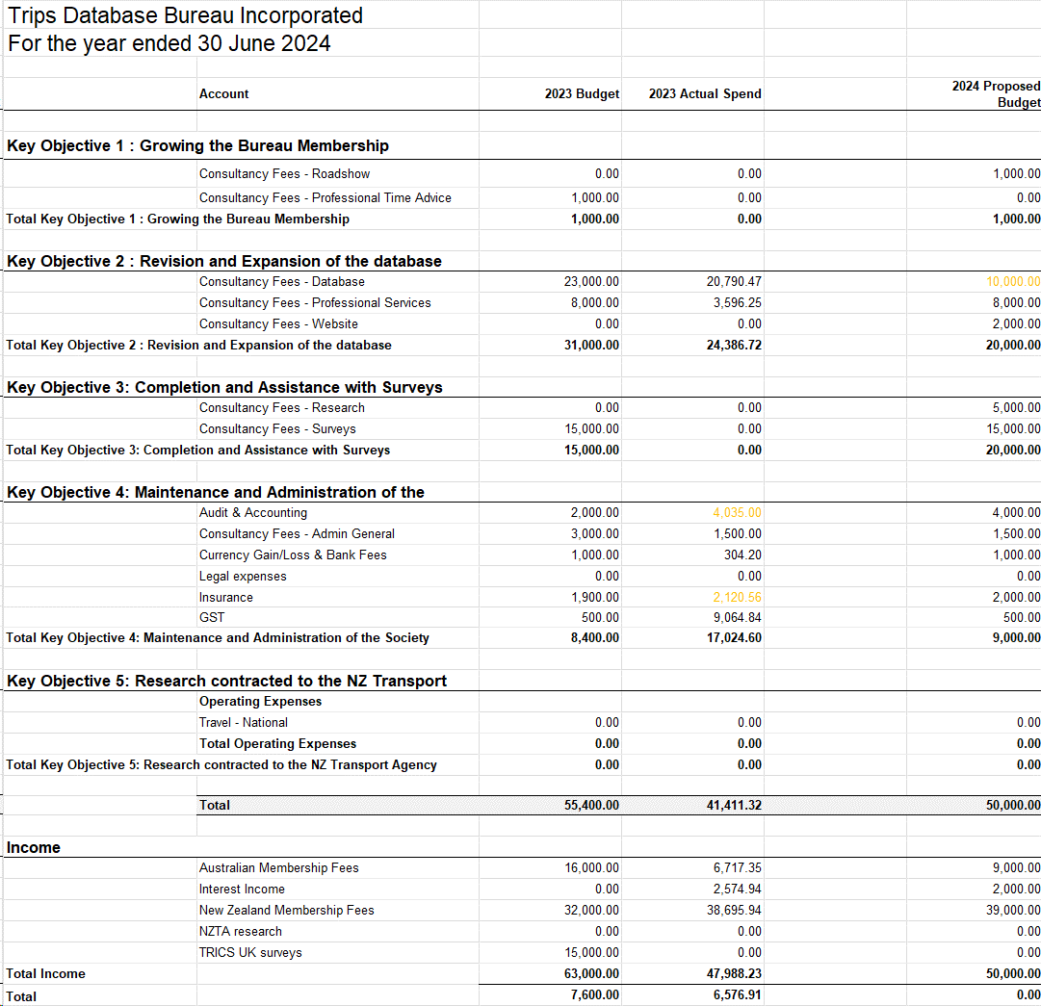

ATTACHMENT FIVE

**TDB NOMINATION FORM**

**FOR CHAIR AND BOARD MEMBER**



***NOMINATION FORM FOR BOARD MEMBER AND CHAIRMAN***

**Nominator**: - I, _________________________________________________________,

(Print Name) (Signature)

being a ***TDB*** Contact Person or a TDB Associate, from

___________________________________________________________

(Name of organisation, firm or Person being a financial member of TDB)

**Seconder**: - I, _________________________________________________________,

(Print Name) (Signature)

being a ***TDB*** Contact Person or a TDB Associate, from

___________________________________________________________

(Name of organisation, firm or Person being a financial member of TDB)

**Nominate**: - ___________________________________________________________

(Print Name)

As a candidate for election as a Board Member/Chairman (delete as appropriate) of the Trips Database Bureau at its Annual General Meeting, to be held on:

________________________ at ________________________________

|  |  |
| --- | --- |
| Candidates (Job) Position or Title |  |
| Business Address |  |
|  |  |
|  |  |
| Telephone Number |  |
| Fax No. |  |
| Email Address |  |
| **Signed by Nominee** |  |
| **Date:** |  |

Note 1: The candidate need not belong to the nominator’s organisation and can belong to any organisation or agency which is a member of ***TDB***.

Note 2: This form shall be returned (physically or electronically), duly signed by the nominator, the seconder and the candidate, to the Chairman or the Executive Officer at least 24 hours prior to the Annual General Meeting of the election for that nomination.

Note 3: The form shall be accompanied by a CV or a brief biographical summary of the nominees experience outlining the candidate’s suitability to be a member of the ***TDB*** Board.

ATTACHMENT SIX

**INCORPORATED SOCIETIES ACT 2022**

**TRIPS DATABASE BUREAU CONSTITUTION 2024**